Supplementary
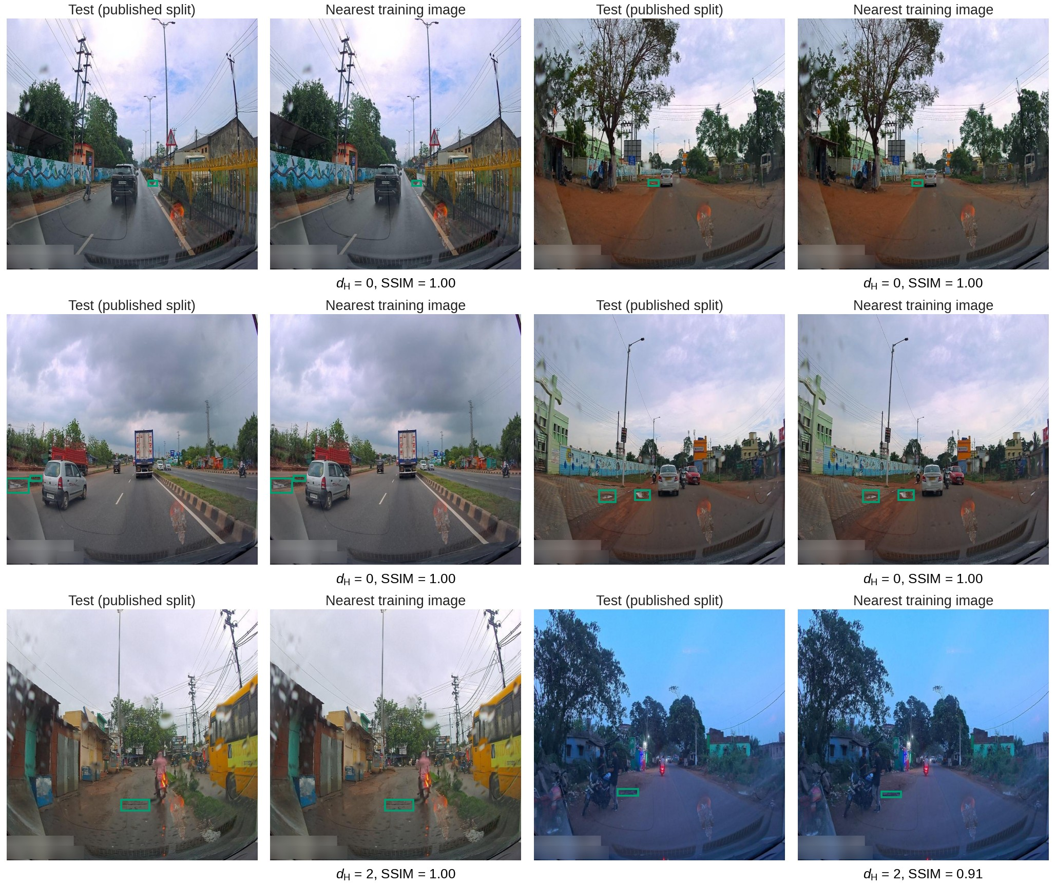
Fig. S1 Published test images (left of each pair) and their nearest training image (right). Green boxes: ground truth. d_{H}: Hamming distance between perceptual hashes; SSIM on 128 × 128 grey thumbnails
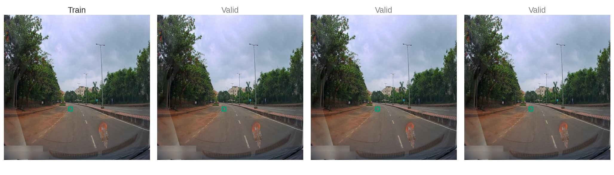
Fig. S2 All released files that share one source frame (four export copies), with the subset of the published split each was assigned to. Green boxes: ground truth
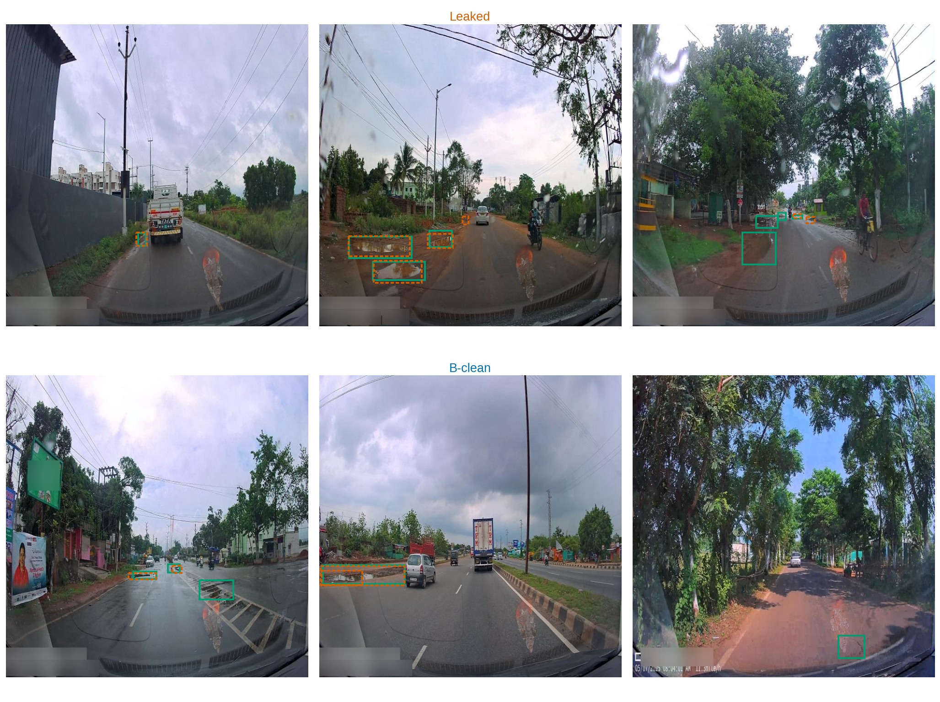
Fig. S3 YOLO26n trained on the published split (Protocol A) on test images with a near-duplicate in training (Leaked, top) and without (B-clean, bottom). Green: ground truth; orange dashed: predictions with confidence ≥ 0.25
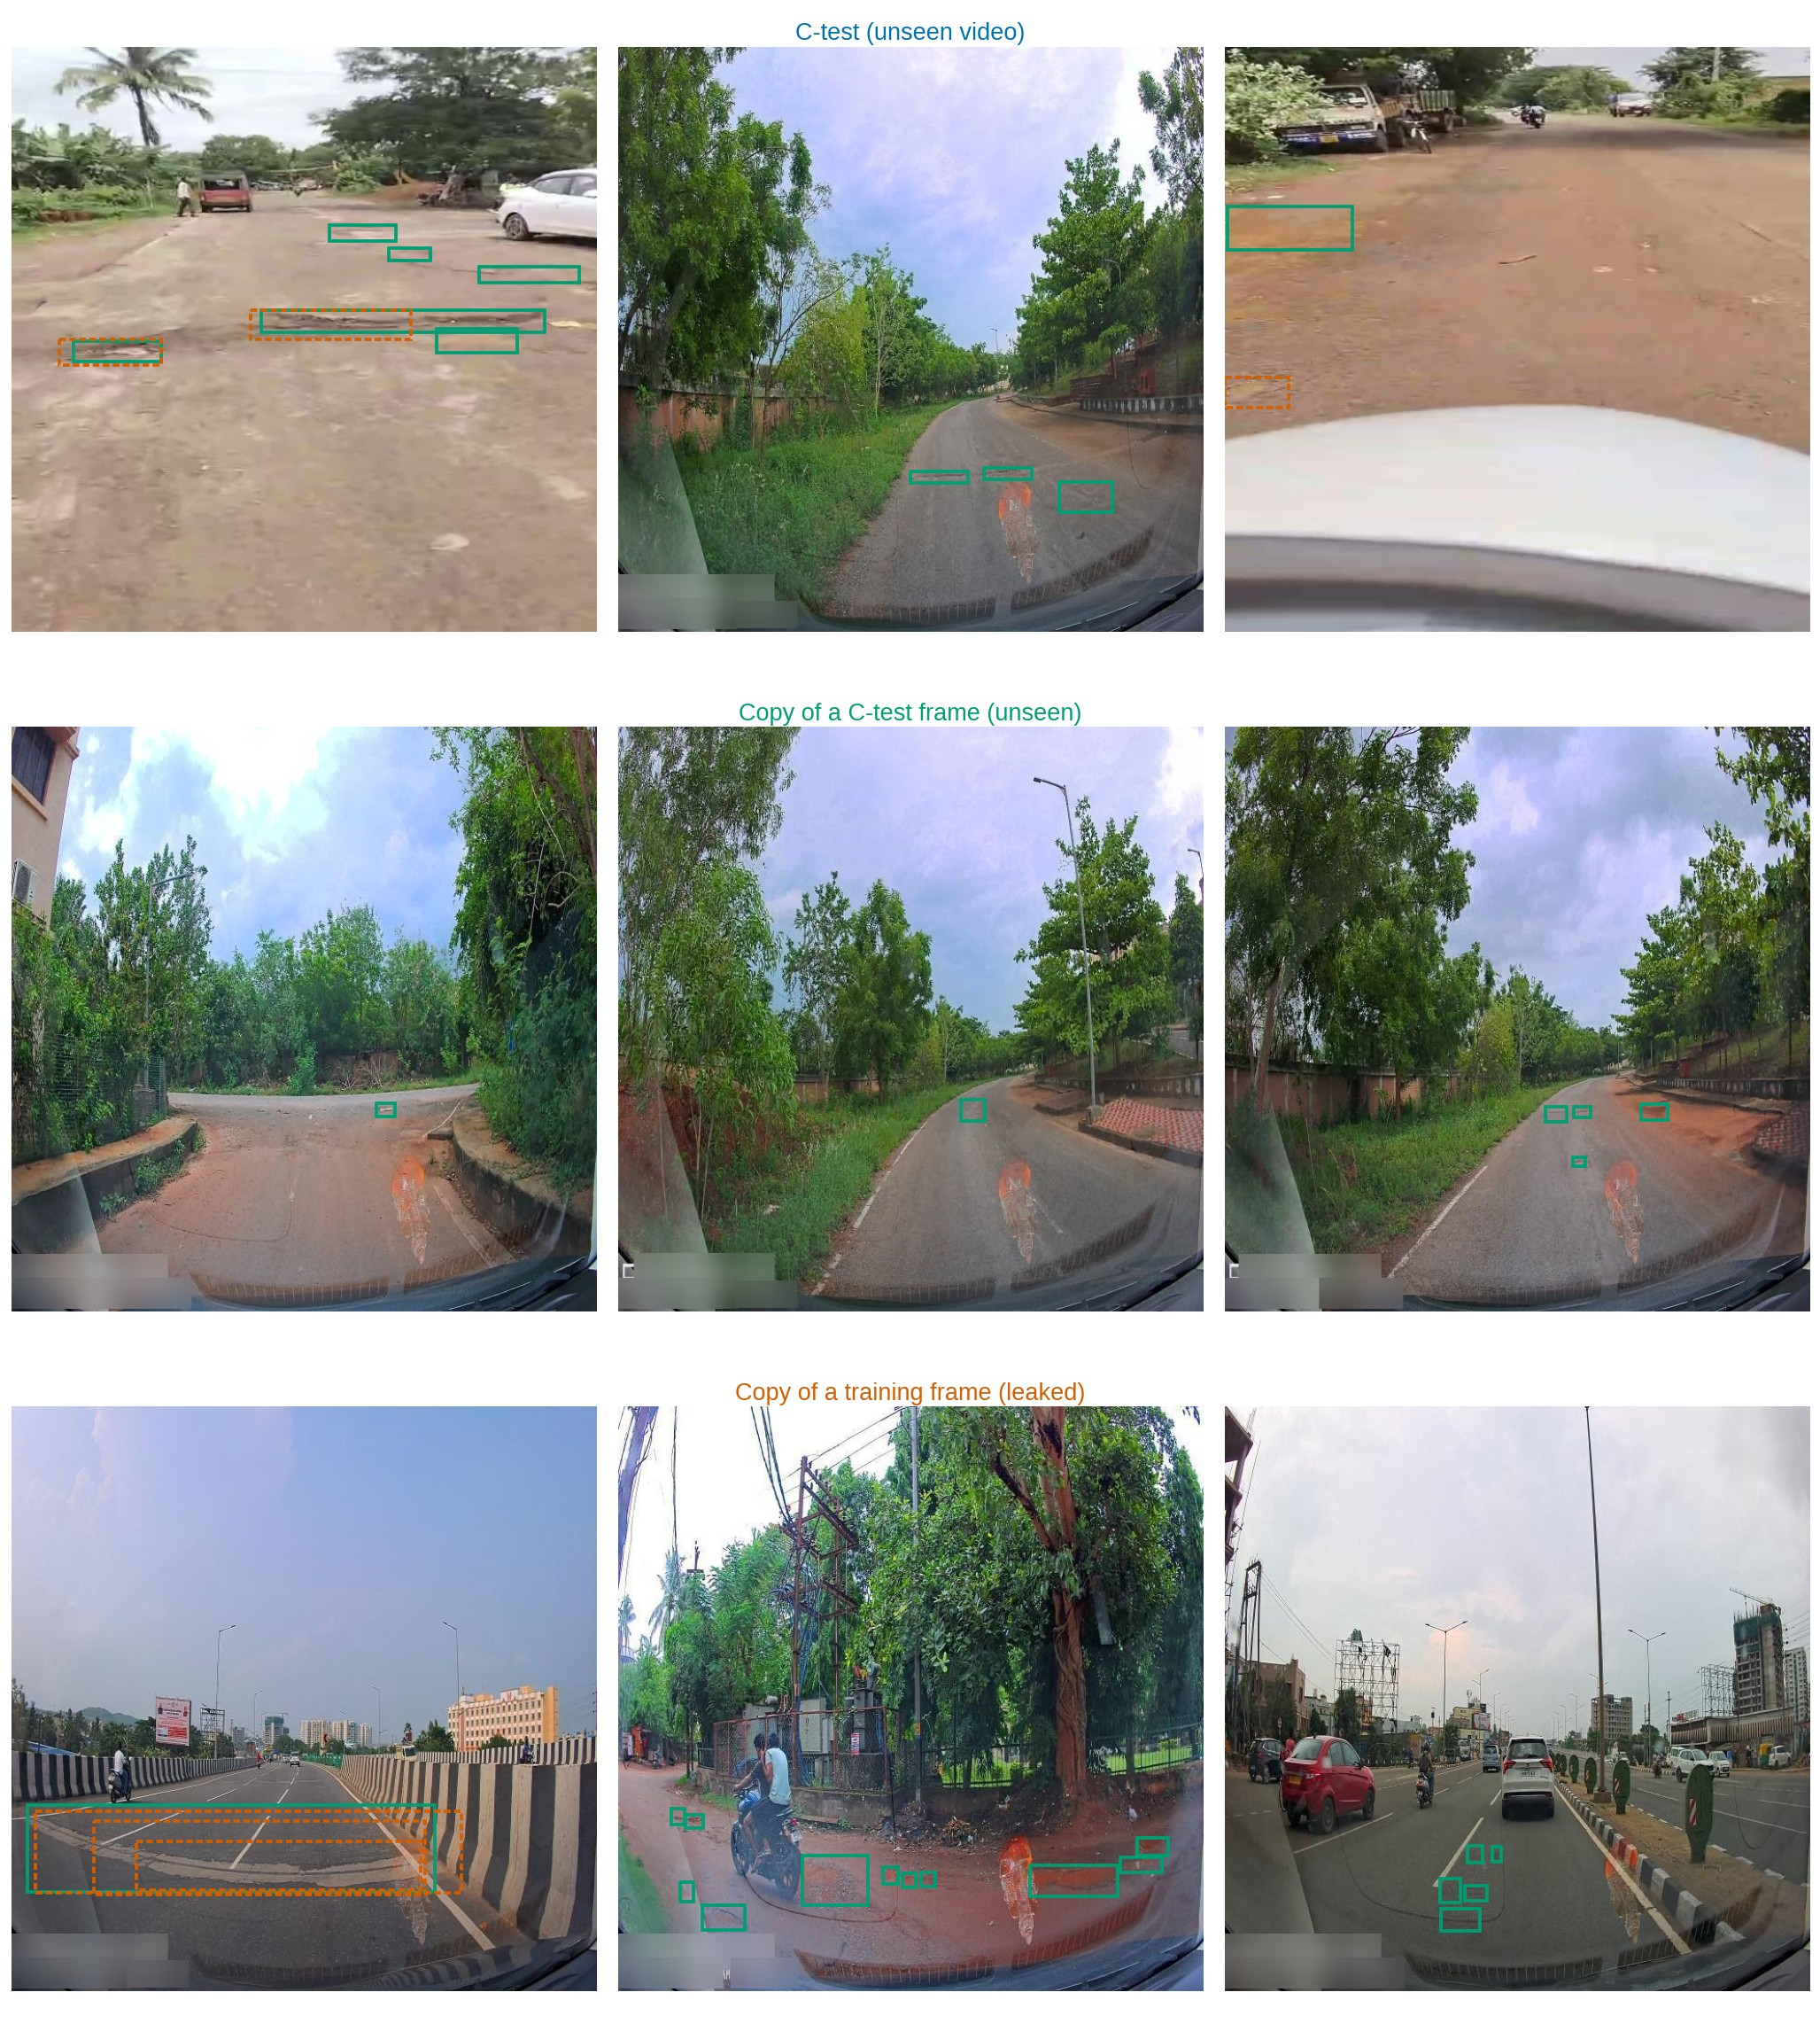
Fig. S4 Controlled contamination test: YOLO26n trained on the video-disjoint split (Protocol C) on C-test images (top), export copies of unseen C-test frames (middle) and export copies of its own training frames (bottom). Green: ground truth; orange dashed: predictions with confidence ≥ 0.25
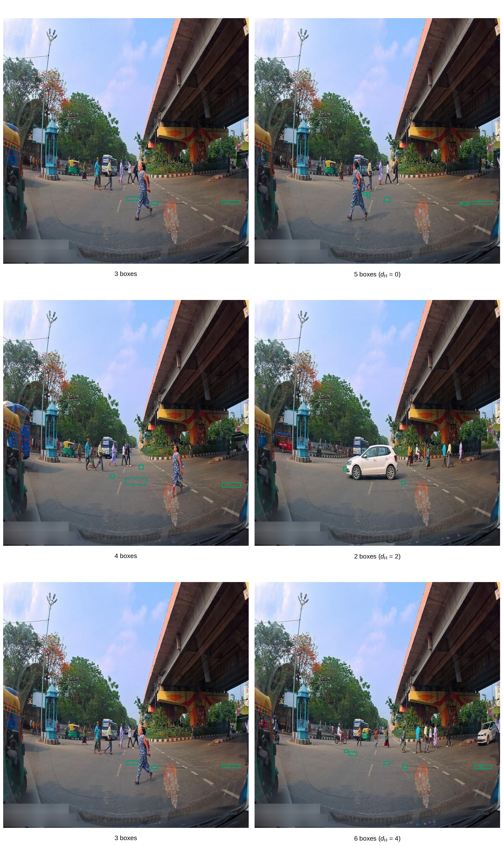
Fig. S5 Pairs of near-identical unique frames (d_{H} ≤ 4) whose annotations differ by two or more boxes. Green boxes: ground truth
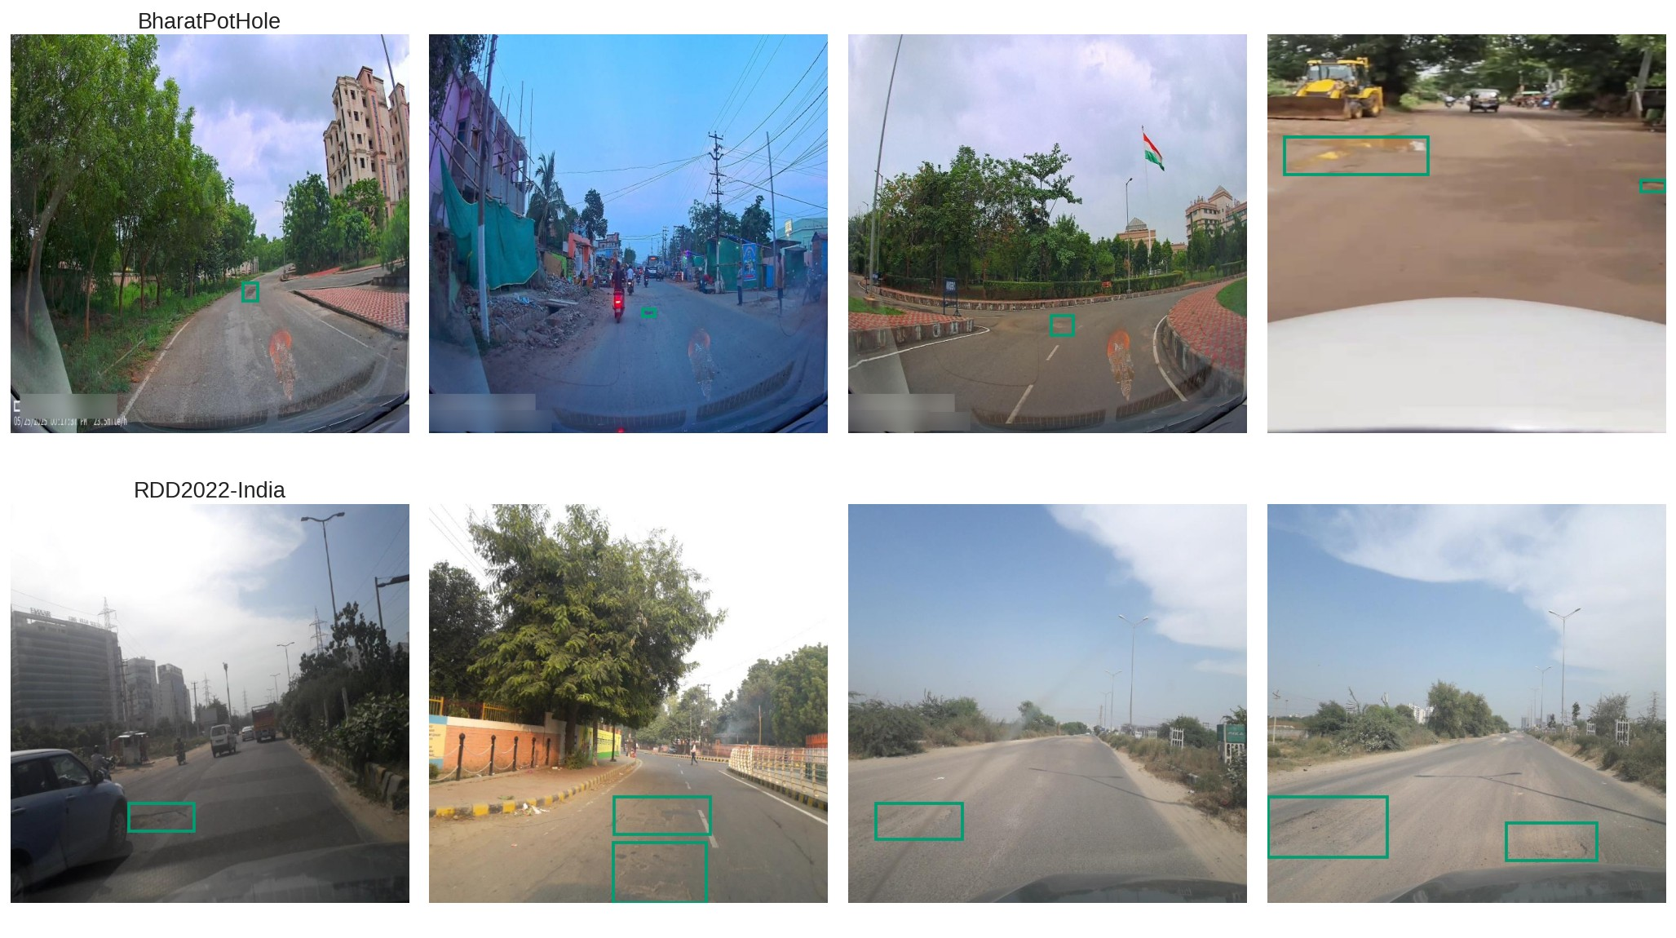
Fig. S6 Random positive images from BharatPotHole (top) and from the RDD2022-India pothole subset (bottom). Green boxes: ground truth (class D40 for RDD2022)

