Additional file 1
Supplementary Notes 1–7, Supplementary Methods and Supplementary Figures S1–S5 for: Growth fitness, more than drug tolerance, explains most pre-treatment prediction of cancer cell fate
Rabeya Noor and Khairum Jahan Roza

Supplementary Notes
Supplementary Note 1. Graph model and hyperparameter sweep. We built a cell–cell k-nearest-neighbour graph within each sample and trained a GraphSAGE-style network [1]. Its encoder was optionally pretrained with a contrastive loss [2] that pulls pre-treatment sisters together, excluding test cells. The idea was that sister pairs mark the heritable part of the state, which is what the ceiling analysis says a predictor must use. Across three seeds, sister-pair pretraining improved a matched MLP slightly in every arm (by 0.004–0.014; MLP 0.700–0.738, pretrained MLP 0.708–0.742). Message passing over the graph did not help. The graph network with pretraining reached 0.696–0.734 (seed s.d. ≤ 0.005), slightly below the pretrained MLP and below logistic regression (0.708–0.747) in every arm (Fig. S1). In replicate hold-out, the graph network scored 0.68–0.74, against 0.70–0.76 for logistic regression. Smoothing features over the same graph before logistic regression changed AUROC by at most 0.005. A one-at-a-time sweep of the graph network without pretraining over the number of layers, hidden width, dropout, learning rate, weight decay and neighbourhood size (Table S18 in Additional file 2) gave 0.727–0.739 for carboplatin, 0.722–0.733 for olaparib, 0.695–0.714 for NK and 0.667–0.700 for control, never above logistic regression. The neural models therefore recovered the same signal as the linear model, and no more.
Supplementary Note 2. Pre-specified marker panel and the IGF axis. To check this at the level of individual genes, we fixed a panel of 28 marker genes in advance, covering proliferation, G1 arrest, senescence, quiescence and previously reported persister markers (Fig. S3; 24 were among the retained genes). In the control contrast, recovered cells expressed markedly less of the CDK inhibitors CDKN1A (p21; z = −4.8, FDR < 10⁻⁴), CDKN1B and CDKN1C, which fits a proliferative fitness state. Beyond the control contrast, the replication and mitosis genes CDK1, PCNA, MCM2 and E2F1 were lower in pre-resistant cells in all three drug arms (z between −1.2 and −4.3). Individually, however, only CDK1 and PCNA for NK cells passed correction (FDR 0.017 and 0.003). Senescence-associated secretory genes (IL6, CXCL8, SERPINE1) were not higher in pre-resistant cells, and CDKN1C was only modestly and non-significantly higher. The drug-specific state therefore looks like slower cycling among otherwise fit cells rather than senescence, although at the level of single genes the evidence is weak.
Among the drug-specific genes were several members of the insulin-like growth factor axis. IGFBP7 and IGF2BP1 were drug-specific for both carboplatin (FDR 0.002 and 0.015) and olaparib (FDR 0.001 and < 0.001), and IGF2 for olaparib (FDR < 0.001). None was drug-specific for NK cells. IGFBP7 passed the test of difference from the control contrast (FDR 0.039) but not the drug contrast itself, so it is starred in Fig. S3 without being called drug-specific (Table S16 in Additional file 2), and IGFBP2 itself was not drug-specific in any arm (in the olaparib arm it was differentially expressed, FDR 0.012, but not significantly differently from the control contrast, FDR 0.78). IGF-1 receptor signalling supports drug-tolerant persisters [3], and IGFBP2 confers afatinib tolerance in triple-negative breast cancer [4]. We note the overlap as a hypothesis, not a finding. CD44, which marked multi-treatment resistance in melanoma [5], was lower, not higher, in pre-resistant cells in all three drug arms (FDR ≤ 3 × 10⁻⁶) and was not differentially expressed in the control arm (FDR 0.45). The difference from the control contrast was significant for olaparib and NK cells (FDR 0.006 and 0.007) but not for carboplatin (FDR 0.12). In melanoma, CD44-high cells resisted MAPK inhibitors and hypoxic stress, whereas CD44-low cells were more resistant to doxorubicin [5], so the direction of a pre-existing marker may depend on the kind of stress.
Supplementary Note 3. Inferred copy-number subclones. Dai et al. [6] reported that InferCNV subclone A was enriched among pre-resistant cells under all treatment conditions, especially carboplatin and olaparib. Its signature was also positively associated with the treatment pre-resistance signatures and negatively with the control pre-survival signature. Per-cell subclone calls are not public, so we inferred copy-number profiles ourselves with infercnvpy (11,883 genes, 970 genomic windows) and clustered them (k = 6, chosen by silhouette). The clusters were only weakly separated (silhouette 0.21). Still, the largest cluster reproduced the published pattern. It was over-represented among pre-resistant cells in the carboplatin (odds ratio 2.24), olaparib (2.04) and NK (1.34) arms (all FDR < 10⁻³), but not in the control arm (1.14, p = 0.14).
Cluster identity alone predicted the labels poorly (AUROC 0.54–0.60). Within clusters, the expression model kept most of its performance (0.69–0.72), and expression added strongly to a model that already contained cluster identity (likelihood-ratio p < 10⁻⁵⁰ in every arm). Copy-number composition thus accounts for a small, largely treatment-specific part of the labels. It is one plausible source of the drug-specific component, but not of the shared transcriptional signal.
Supplementary Note 4. The original study's pathway and HRD findings, revisited. Dai et al. [6] described pre-resistant cells as marked by proteostatic and mRNA-surveillance programmes, and found their pre-resistance signatures negatively connected to a signature of homologous-recombination deficiency (HRD), which suggested that HRD-like states prime cells for sensitivity to olaparib and carboplatin. Their published fold changes include the untreated arm, so each finding can be scored there as well (Table S30 in Additional file 2, Supplementary Methods). The mRNA-surveillance programmes were present without any drug. Nonsense-mediated decay, cytoplasmic translation and protein targeting to the ER were enriched among control cells whose sisters were recovered (normalised enrichment scores 1.64–1.76, p < 0.001), though less than in the drug arms (1.75–2.25). They stayed enriched after the control fold change was subtracted (1.51–2.28, p ≤ 0.008), and the unfolded protein response, which did not differ in the control arm (p = 0.54), was lower beyond it in all three drug arms (p ≤ 0.013). These programmes therefore combine a fitness part with a part that goes beyond it, in line with the small drug-specific component estimated in the main text.
The HRD connection did not separate the arms in this way. With the HRD signature from the isogenic COV362 cell pair, the connectivity in the untreated arm (−1.52) was as strong as in the drug arms (−1.54 to −1.76), so on its own it is not evidence of priming for a DNA-damaging drug. With the HRD signature derived from TCGA tumours, neither its up- nor its down-regulated genes were enriched in any arm (all p > 0.3). The connection persisted after subtracting the control fold change (−1.41 to −1.73), which leaves room for a drug-related part, but that part does not single out the two DNA-damaging treatments; as the original authors also noted, the NK arm showed the strongest connection. Our reanalysis supports their proteostatic findings in part and suggests that the HRD link is largely shared with recovery without a drug.
Supplementary Note 5. The second lineage system, with transfer between treatments, an independent reanalysis, and why there is no ceiling. Predictions transferred only between similar treatments (Fig. 6b of the main text). Scores trained on one treatment's labels ranked another treatment's labels at 0.48–0.63, in two blocks. The two MAPK inhibitors transferred to each other (0.565 and 0.568) better than to anything else, and the four stress and chemotherapy arms transferred among themselves (0.548–0.627). The original authors saw the same grouping in the transcriptomes of resistant cells; here it appears in what can be predicted beforehand.
While this work was in preparation, Aviv [7] released a preregistered reanalysis of the same data, which also found that "clone abundance dominates". It then asked a different question. For a given clone, under which of the six conditions is it detected? Holding clone abundance and condition identity fixed, a model in which the effect of cell state differed between conditions ranked the conditions within a clone better than a model with one shared state effect, by 0.052 in within-clone AUROC (95% CI 0.037–0.066, permutation p < 0.001). The two analyses fit together. Averaged over conditions, state is worth little next to size; once size and condition are fixed, a small condition-specific part remains. That figure is not directly comparable with the drug-specific gain we measure in ReSisTrace (0.014–0.025), because it ranks conditions within one clone rather than cells within one arm, but the two point the same way. In both systems, the part of the pre-treatment state that is specific to the treatment is small next to the part that is not.
The ceiling analysis could not be repeated here. Cells that share a lineage in the untreated sample descend from one barcoded cell through about five doublings of growth (20 days [5]), not one division, and they share far less state. The mean intraclass correlation over the first ten principal components was 0.18, against 0.75 for ReSisTrace sisters, and model scores correlated only 0.17–0.21 between clone-mates, against 0.63–0.81. Extrapolating from such weak correlations failed openly, and in three of the six treatments the implied correlation exceeded one (Table S23 in Additional file 2). We therefore report no ceiling for this data set. Only the sister design, in which the two cells are one division apart, makes the bound estimable.
Supplementary Note 6. Substitutes for an untreated arm. The comparison at the centre of the paper needs an untreated arm, and almost no study has one. We therefore asked whether something built from the treated arms alone can stand in for it. ReSisTrace is the only data set in which this can be checked, because the real control arm is there for comparison. We tried two substitutes that use no control-arm labels, the label-free density score and a model trained on the other drug arms. In this comparison, all gains were computed without the size matching used in the main text, so the values for the real control arm are slightly larger than those reported there.
Neither substitute reproduced the control arm, and they failed in opposite directions (Fig. S4, Table S26 in Additional file 2). Measured against the real control model, the drug-specific gain was 0.022 for carboplatin, 0.031 for olaparib and 0.027 for NK cells. Measured against the density score, it was roughly two to three times larger (0.043–0.090), because density is a weaker measure of fitness and leaves more of it to be counted as drug-specific. Measured against the other drug arms, it nearly vanished (0.0045–0.0065). This was mostly a matter of training size. Those models learnt from two to five times as many labelled cells as the control model, and at equal training size a model trained on the other drug arms took up only a fifth to a third of the gain (Fig. 3d of the main text).
In all three arms, the true value lay between the two substitutes, so where no untreated arm exists, reporting both may give a rough bracket, with the other-arm baseline as a low estimate and the density score as a high one. This ordering is not guaranteed, however. In the second lineage system, the two substitutes gave a sensible bracket only for the two MAPK inhibitors (0.007–0.025 and 0.086–0.089); for the other four treatments they crossed or turned negative (−0.024 to 0.033 and −0.038 to 0.047). A substitute can show that a pre-resistance signal is mostly fitness, but it cannot say by how much.
Supplementary Note 7. The estimators checked against a known answer. The main results rest on two estimators, the size-matched drug-specific gain and the sister ceiling. To check them, we simulated sister experiments in which the true answer is known. The simulations set how much of survival is general fitness, how much is drug-specific, how similar sisters are, and whether fate depends on the treated cell's own state or only on the state the sisters share. We ran the full analysis blind on 25 independent experiments for each setting (Fig. S5, Supplementary Methods, Table S24 in Additional file 2).
The drug-specific gain was estimated accurately (Fig. S5a). With no drug-specific effect, the estimate was −0.001 and only 2 of 25 experiments gave an interval excluding zero, close to the 5% expected. When an effect was present, it was recovered with a bias of +0.001 to +0.005, and with a bias below 0.003 at every level of label noise tried (0, 10 and 20%). A technical confound acting on both the measurement and the chance of recovery, imitating the sequencing-depth effect in the real data, did not bias it either (−0.002, against a true gain of 0.015).
Simple intervals were too narrow (Fig. S5b). Intervals that resample families but do not refit the models covered the true value in only 52% to 88% of experiments instead of 95%, with or without the depth confound; they were too narrow by a factor of 1.2 to 1.9. This is why we quote intervals from the slower bootstrap that refits the whole procedure. It is also a general caution. A bootstrap placed around a cross-validated score measures how much the evaluation would move, not how much the whole procedure would move.
The ceiling was accurate when its assumption held and erred upwards when it did not (Fig. S5c). When fate depended on the treated cell's own state, as the estimator assumes, the implied AUROC was within 0.005 of what a model actually achieved on that cell. As fate shifted towards depending only on the state the sisters share, the estimate drifted upwards, by 0.052 at the halfway point and by 0.114 at the extreme. The error is one-sided, which we also show analytically (Supplementary Methods), so the sister costs reported in the main text are upper bounds.

Supplementary Methods
Graph network and sister-pair pretraining. The graph was a symmetric 15-nearest-neighbour cosine graph built within each sample on the principal components and row-normalised. The graph-smoothed baseline replaced each cell's components with the average of its own and its neighbours' values (weight 0.5). The graph network consisted of a two-layer MLP encoder (128 → 64), two residual mean-aggregation layers and a linear output. It was trained full-batch with weighted binary cross-entropy, dropout 0.3 and AdamW (learning rate 10⁻³, weight decay 10⁻⁴) for at most 200 epochs, with early stopping (patience 25 epochs) on the AUPRC of a grouped 15% validation split, on the subgraph of the samples in each split. Contrastive pretraining used the NT-Xent loss (temperature 0.1) over pre-treatment sister pairs from all samples, excluding cells in the test set, plus an augmentation-only term on unpaired cells (weight 0.5). The encoder was then fine-tuned at 0.3 times the learning rate.
Foundation-model embeddings. For Geneformer [8, 9], raw counts of each pre-treatment cell were rank-value encoded as in Geneformer. Counts were scaled to 10,000 per cell, divided by each gene's median in the pretraining corpus, and genes were ranked, keeping the top 4,094 plus the <cls> and <eos> tokens (16,019–16,517 genes per sample were in the model vocabulary). The cell embedding was the mean over gene positions of the penultimate hidden layer (768 dimensions), Geneformer's default. The forward pass ran in half precision on one NVIDIA T4 GPU (Kaggle). For scGPT [10], the input was the raw counts of the 5,005 genes stored for every pre-treatment cell, of which 4,682 are in the scGPT vocabulary. Cells were embedded as in scGPT's own cell-embedding routine (version 0.2.4). A <cls> token is prepended, each cell's non-zero counts are binned into 51 bins, at most 1,200 genes per cell are kept (sampled at random beyond that, as in scGPT), and the L2-normalised output at the <cls> position is the 512-dimensional cell embedding. Because the scGPT package imports a library (torchtext) that no longer installs with current PyTorch, the model and data-collator source files of the 0.2.4 release were loaded directly; all encoder weights were loaded, and only the classification head, which is not used for embeddings, was not. The forward pass ran on one NVIDIA T4 GPU (Kaggle). Neither model was fine-tuned.
Intervals for the size-matched gain. The evaluation-only interval came from 1,000 paired family-level bootstrap resamples. Each resample reweighted whole families, and the seed-averaged ΔAUROC was recomputed with both scores on the same resampled cells. We used this bootstrap rather than a DeLong test because sisters are not independent observations. It resamples families to re-score models that were fitted once, so it describes how much the evaluation would move and not how much the whole procedure would move; in the synthetic experiments it covered the truth less often than its nominal rate, and this interval, listed in Table S19 in Additional file 2, should therefore be read as a lower bound on the uncertainty. The refitting interval quoted in the main text used 200 replicates that resampled whole families separately in the control arm and the drug arm, three training subsamples per replicate, and the basic (pivotal) interval, because resampling with replacement leaves fewer distinct families to train on and can shift the replicate distribution away from the estimate. The one-sided p-value is the fraction of resamples with ΔAUROC ≤ 0. An earlier, simpler estimate (five random training sets, scored on the held-out drug-arm cells) gave similar values and is reported in Table S3 in Additional file 2. For the three-model comparison, point estimates averaged five training subsamples, and intervals came from 200 bootstrap replicates that resampled families separately in the control arm, the scored arm and the other arms, refitted all three models (three subsamples each) and used the basic interval. We first tried a single multi-task logistic model with shared, treated-arm and per-arm blocks of weights, but its fit hardly changed across block penalties (mean AUROC 0.7285–0.7299) while the split between the treated-arm and per-arm blocks moved from one extreme to the other, so the penalties rather than the data decided the split; we did not use it.
Genes unique to one drug. For drug arm $k$, the replicate-combined z-scores of the drug contrast were compared with the mean of the other two drug arms, $z_{\text{unique}}=(z_{k}−{\overset{‾}{z}}_{j≠k})/\sqrt{1.5}$, which is standard normal under the null when the three arms' z-scores are independent. Genes with FDR < 0.05, the same sign in both replicates of arm $k$ and the same sign as the drug contrast were called drug-unique, and $z_{\text{unique}}$ was used for preranked Hallmark GSEA. Before running the test we fixed two hypotheses, enrichment of DNA repair for olaparib and carboplatin, and of interferon-γ response or allograft rejection for NK cells. These four tests were corrected among themselves (Benjamini–Hochberg).
Published claims. Per-gene log2 fold changes (pre-resistant versus pre-sensitive, every arm including the control) and the HRD-versus-HR-proficient fold changes from TCGA and from the isogenic COV362 pair were taken unchanged from Supplementary Data 2 and 4 of Dai et al. [6]. Gene Ontology terms [11] named in their claim, from the Enrichr GO Biological Process 2021 library [12], were tested by preranked GSEA (GSEApy, 1,000 permutations) on each arm's fold change and on each drug arm's fold change minus the control's, which is their own control-contrast signature. For HRD, the 100 genes with the largest and the 100 with the smallest fold change among those with adjusted p < 0.05 formed up- and down-sets, scored in the same way, and connectivity was $({NES}_{\text{up}}−{NES}_{\text{down}})/2$ when the two sets moved in opposite directions and 0 otherwise, the rule of the PharmacoGx connectivity score [13] that the original study used, after the Connectivity Map [14]. Their gene sets and enrichment implementation differed from ours, so our values approximate theirs rather than reproduce them. The analysis was repeated on our z-scores (Table S30 in Additional file 2).
Copy-number clusters. Genes detected in at least 10% of cells in every sample and located on GENCODE v44 autosomes or chromosome X (11,883 genes) were normalised and log-transformed. Each sample was analysed with infercnvpy [15] (window of 100 genes, step 10), following the approach of InferCNV [16], against one fixed reference panel of 200 random cells from each pre-treatment sample. Profiles were pooled, reduced to 20 principal components and clustered by k-means, with k from 2 to 8 chosen by silhouette. Enrichment was tested with Fisher's exact test and Benjamini–Hochberg correction. Confound tests compared grouped out-of-fold predictions from cluster identity, expression and both, within-cluster AUROC, and a likelihood-ratio test for expression beyond cluster identity.
Barcodes in the second lineage system. Lineage barcodes of Schaff et al. [5] are stored in GEO (GSE279162 [17]) as features of type "Custom" alongside the genes, so no separate barcode file is needed. Barcodes with at least five UMIs across all samples were kept, and those whose per-cell count vectors were near-parallel (cosine at least 0.55), which arise when sequencing errors split one barcode in two, were merged by connected components; this left 2,118 barcode groups, the largest containing nine barcodes. A cell was assigned the barcode holding at least two UMIs and more than half of its barcode UMIs, and was left unassigned otherwise, so a cell split evenly between two barcodes is dropped rather than guessed. This is simpler than the authors' Bayesian assignment and our clone counts are not identical to theirs; the results were repeated at merge thresholds of 0.70 and 0.85 and at a stricter assignment rule (three UMIs, 60%) and did not change materially (Table S22 in Additional file 2).
Synthetic experiments. To check the estimators against a known answer we generated lineage experiments from a model in which every quantity they estimate has a closed form. A family carries a latent state $z∼N(0,I_{10})$, and its two sisters are measured with independent noise,
$$x_{A}=z+s ε_{A}, x_{B}=z+s ε_{B}, ε∼N(0,I_{10}),$$
so that sisters correlate at $1/(1+s^{2})$ in each dimension. Whether the treated sister survives follows a liability built from
$$u=f x_{B}+(1−f) z, L=a u_{1}+b u_{2}+\sqrt{1−a^{2}−b^{2}} η, η∼N(0,1),$$
with $b=0$ in the control arm, so dimension 1 is a generic fitness axis and dimension 2 is drug-specific. The parameter $f$ decides whether fate is driven by the treated cell's own realised state ($f=1$, which is what the ceiling assumes) or only by the state the sisters share ($f=0$). A cell is a positive when $L$ exceeds its $(1−p)$ quantile, and a fraction of true positives is then flipped to negative to imitate a sister that was not recovered. Because every variable is jointly Gaussian, the best possible score of the sequenced sister is the linear predictor $E[L∣x_{A}]=x_{A}^{⊤}β$ with $β=Cov(x_{A})^{−1}Cov(x_{A},L)$, which has a closed form. Without the depth confound it is proportional to $a x_{A1}+b x_{A2}$ for the drug arm and to $x_{A1}$ for the fitness model; with it, both also read the shared depth term from the remaining dimensions. The population value of every reported quantity therefore follows from one large draw. We swept the drug-specific strength (including zero), label noise, the number of families, sister similarity, a sequencing-depth confound, and f, running 25 independent experiments per setting and comparing the framework's estimates with the population values.
Experiment design. The standard error of the size-matched gain was calibrated on those runs as
$$se(Δ) = \frac{κ}{\sqrt{n_{\text{eff}}}}\sqrt{\frac{p_{0}(1−p_{0})}{p(1−p)}}, n_{\text{eff}}=\frac{2}{ 1/n_{\text{drug}}+1/n_{\text{control}} },$$
where $n_{\text{drug}}$ and $n_{\text{control}}$ are family counts, $p$ is the label prevalence and $p_{0}=0.1$ the prevalence at which $κ$ was calibrated. The effective size is the harmonic mean because the drug model is trained down to the control arm's size, so adding drug families alone stops helping. The constant $κ$ was fitted to the spread of the estimate across independent synthetic experiments rather than to the width of the reported interval, which the same study shows is too narrow. The resulting calculator returns the families per arm needed to detect a given gain at a given power, and is provided in the package; planning grids for a range of effect sizes, label prevalences and arm splits are in Table S25 in Additional file 2.
Why the ceiling is an upper bound. The ceiling (Methods of the main text) assumes that the sequenced sister bears on its sibling's fate only through the state the two share, that is $S_{A}⟂L_{B}∣S_{B}$. The assumption is not innocuous, and when it fails the error has a known sign. Taking $(S_{A},S_{B},L_{B})$ jointly Gaussian and standardised, and writing $ρ_{AB⋅B}$ for the partial correlation of $S_{A}$ and $L_{B}$ given $S_{B}$,
$$ρ_{\text{obs}} = c ρ_{\text{fate}} + ρ_{AB⋅B} \sqrt{(1−c^{2})(1−ρ_{\text{fate}}^{2})}.$$
The conditional-independence assumption is exactly $ρ_{AB⋅B}=0$, in which case $ρ_{\text{obs}}/c$ recovers $ρ_{\text{fate}}$ and the bound is tight. Whenever the sequenced sister carries information about its sibling's fate beyond the sibling's own score — which is what happens when fate is driven by the state the two share rather than by the treated cell's own realised state — that partial correlation is positive, so $ρ_{\text{obs}}>c ρ_{\text{fate}}$, and since $g$ is increasing the estimate exceeds the truth. The reported ceilings are therefore upper bounds on what a perfect model of the treated cell could achieve, and the sister costs are upper bounds on what is lost by reading the wrong cell; neither is understated. Fig. S5c measures the size of this error as the driver of fate is moved from the cell's own state to the shared one, and tests/test_ceiling_bound.py checks the ordering numerically. The estimate is not identifiable at all when $ρ_{\text{obs}}≥c$, since $ρ_{\text{fate}}$ would have to exceed one; those cases are flagged as saturated and not reported, which is what happens in three of the six treatments of the second data set.

Supplementary Figures
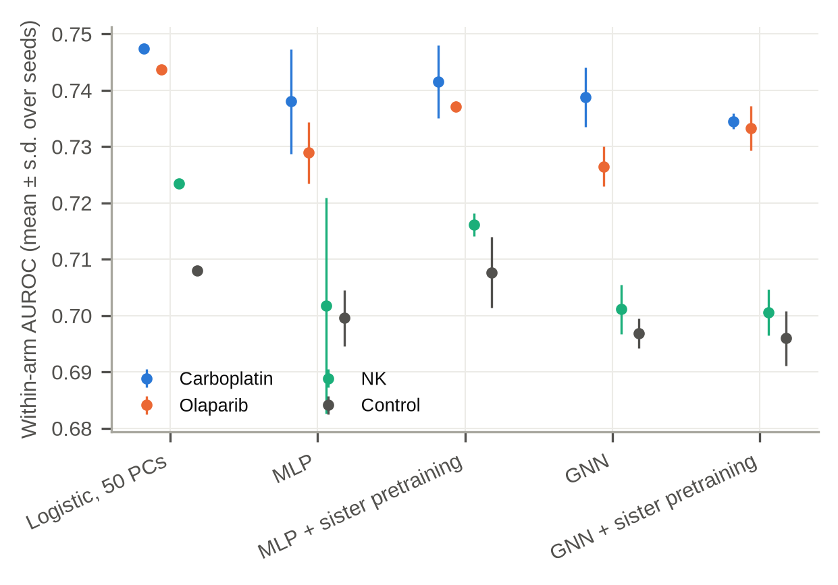
Fig. S1 Graph model ablation. Within-arm AUROC for logistic regression, an MLP, an MLP with sister-pair pretraining, the graph network, and the graph network with pretraining (mean ± s.d. over seeds).
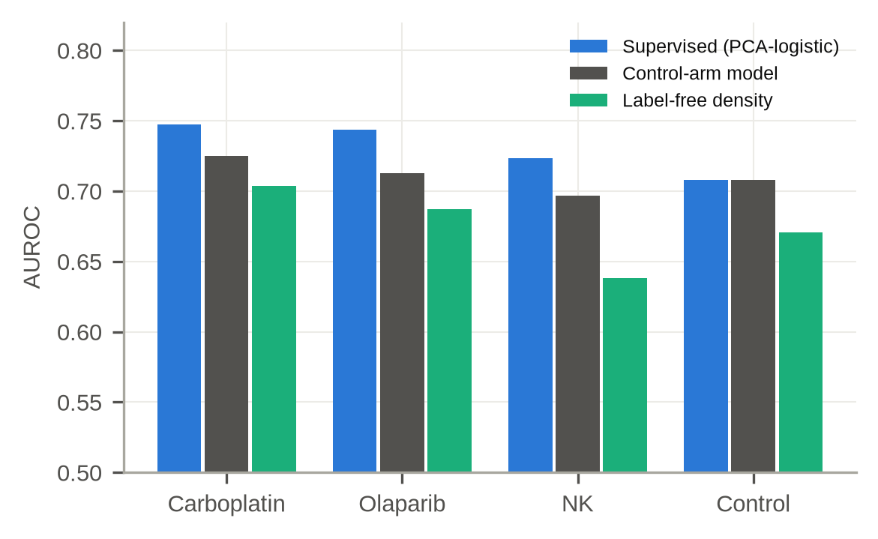
Fig. S2 Label-free typicality. AUROC of the local-density score (negative mean distance to the 15 nearest neighbours within the sample), compared with the supervised PCA-logistic model and the control-arm (fitness) model, for each arm.
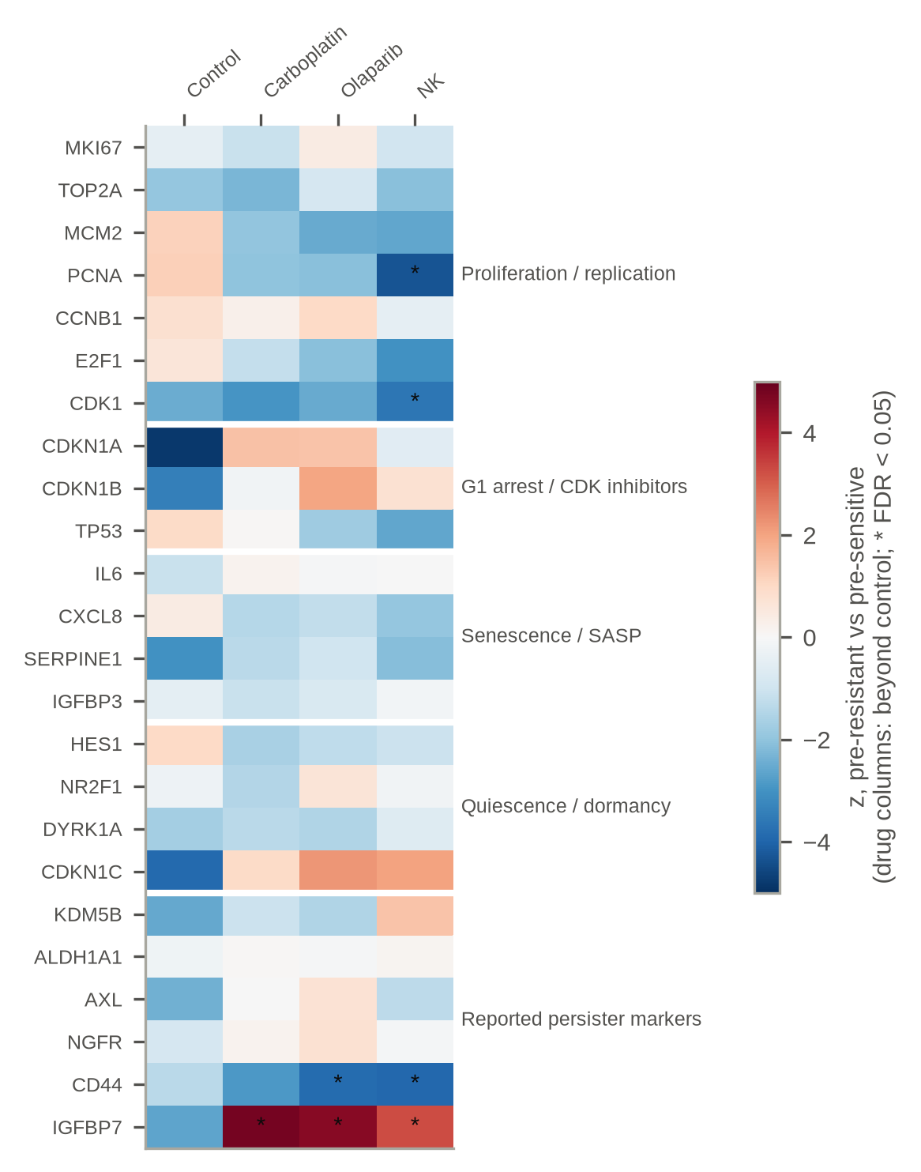
Fig. S3 Pre-specified marker panel. z-scores for pre-resistant versus pre-sensitive cells. The control column shows the control (fitness) contrast; the drug columns show the difference from the control contrast, $z_{\text{diff}}=(z_{\text{drug}}−z_{\text{control}})/\sqrt{2}$. Asterisks mark FDR < 0.05 for z_diff. Genes not among the 5,005 retained genes (CDKN2A, RB1, GLB1, KDM5A) are omitted.
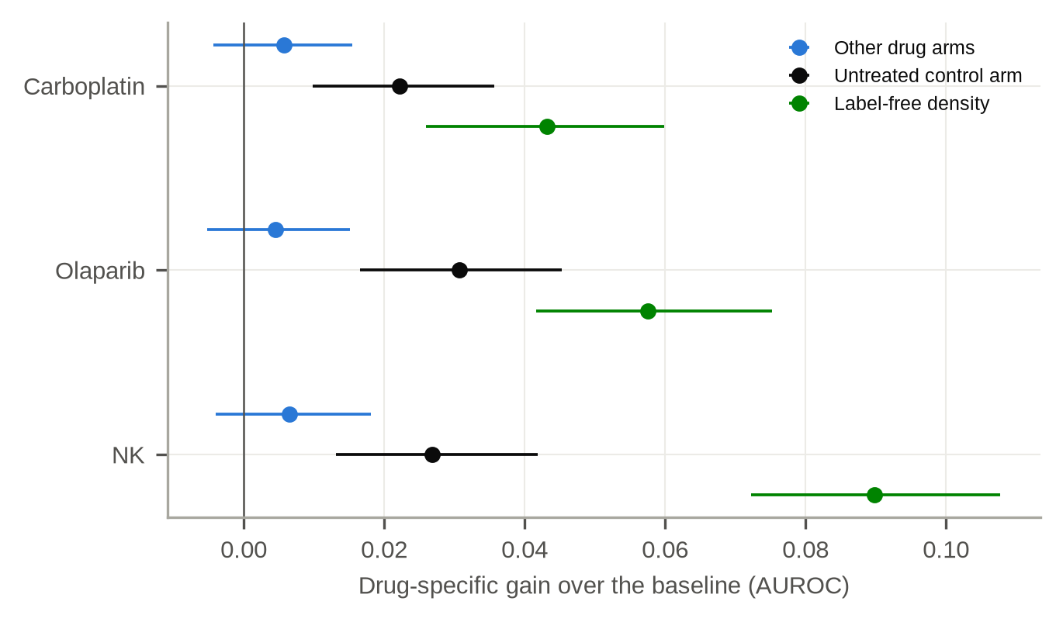
Fig. S4 Substitutes for an untreated arm. For each drug arm of ReSisTrace, the drug-specific gain measured against the real control-arm model (black) and against two substitutes that use no control-arm labels, a model trained on the other drug arms (blue) and the label-free density score (green). Error bars are 95% family-bootstrap intervals. The control-arm value lies between the two substitutes in every arm.
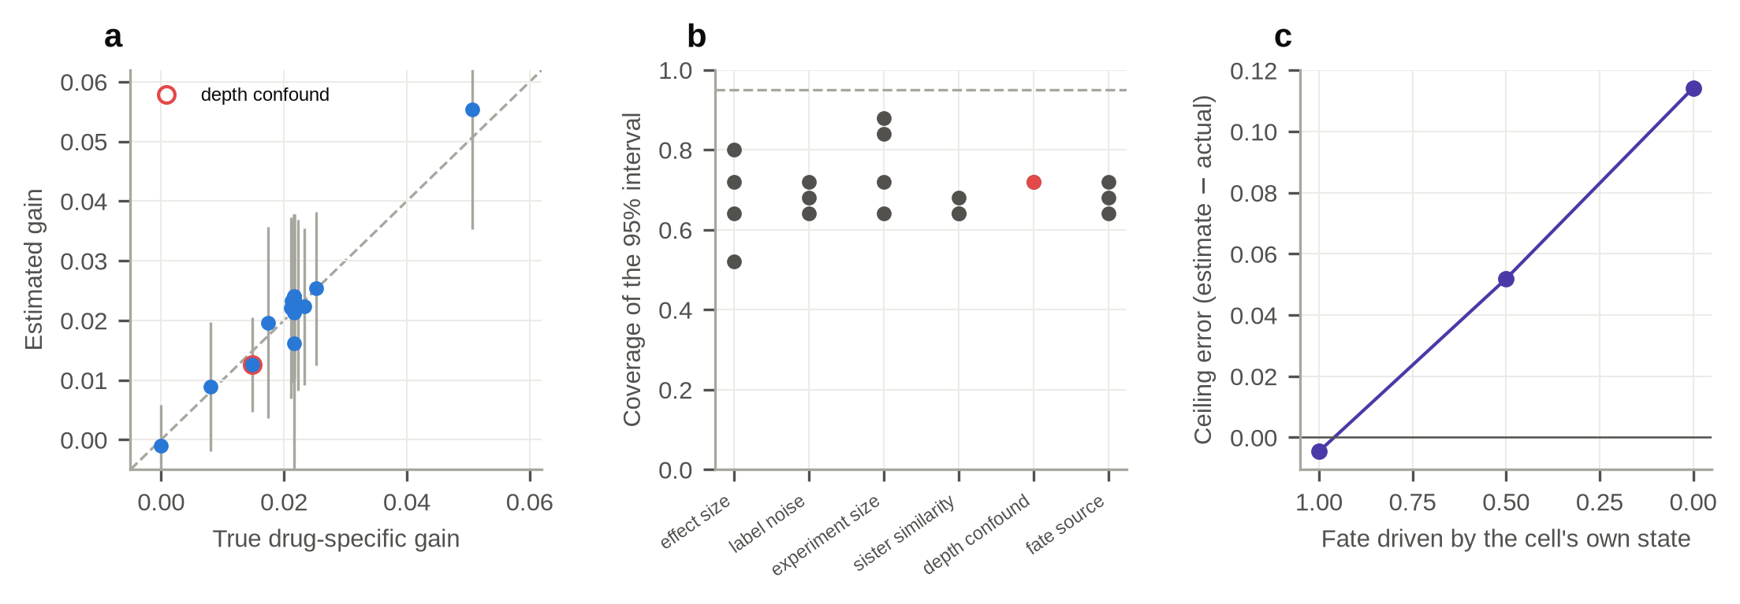
Fig. S5 The estimators checked against a known answer. a, Estimated against true drug-specific gain across synthetic settings; the line is equality and bars are the spread over 25 independent experiments. b, Coverage of the nominal 95% interval that resamples families without refitting the models, in each setting; the dashed line is 0.95. c, Estimated minus actual AUROC if the treated sister were scored, as fate moves from depending on the treated cell's own state (left, the estimator's assumption) to depending only on the state the sisters share (right).

References
1. Hamilton WL, Ying R, Leskovec J. Inductive representation learning on large graphs. In: Advances in Neural Information Processing Systems 30. 2017. https://arxiv.org/abs/1706.02216.
2. Chen T, Kornblith S, Norouzi M, Hinton G. A simple framework for contrastive learning of visual representations. In: Proceedings of the 37th International Conference on Machine Learning. 2020. https://arxiv.org/abs/2002.05709.
3. Sharma SV, Lee DY, Li B, Quinlan MP, Takahashi F, Maheswaran S, et al. A chromatin-mediated reversible drug-tolerant state in cancer cell subpopulations. Cell. 2010;141:69-80. https://doi.org/10.1016/j.cell.2010.02.027.
4. Pellecchia S, Franchini M, Viscido G, Arnese R, Gambardella G. Single cell lineage tracing reveals clonal dynamics of anti-EGFR therapy resistance in triple negative breast cancer. Genome Med. 2024;16:55. https://doi.org/10.1186/s13073-024-01327-2.
5. Schaff DL, White PE, Cote CJ, Watterson GE, Lin KZ, Fasse AJ, et al. Pre-existing cell states predict resistance to multiple treatments. Cell Genom. 2026;6:101191. https://doi.org/10.1016/j.xgen.2026.101191.
6. Dai J, Zheng S, Falco MM, Bao J, Eriksson J, Pikkusaari S, et al. Tracing back primed resistance in cancer via sister cells. Nat Commun. 2024;15:1158. https://doi.org/10.1038/s41467-024-45478-7.
7. Aviv H. Pretreatment transcriptional state carries condition-specific information about future clonal detection in a lineage-traced melanoma line. Zenodo. 2026. https://doi.org/10.5281/zenodo.22850050.
8. Theodoris CV, Xiao L, Chopra A, Chaffin MD, Al Sayed ZR, Hill MC, et al. Transfer learning enables predictions in network biology. Nature. 2023;618:616-624. https://doi.org/10.1038/s41586-023-06139-9.
9. Chen H, Venkatesh MS, Gόmez Ortega J, Mahesh SV, Nandi TN, Madduri RK, et al. Scaling and quantization of large-scale foundation model enables resource-efficient predictions in network biology. Nat Comput Sci. 2026;6:450-463. https://doi.org/10.1038/s43588-026-00972-4.
10. Cui H, Wang C, Maan H, Pang K, Luo F, Duan N, et al. scGPT: toward building a foundation model for single-cell multi-omics using generative AI. Nat Methods. 2024;21:1470-1480. https://doi.org/10.1038/s41592-024-02201-0.
11. Ashburner M, Ball CA, Blake JA, Botstein D, Butler H, Cherry JM, et al. Gene Ontology: tool for the unification of biology. Nat Genet. 2000;25:25-29. https://doi.org/10.1038/75556.
12. Kuleshov MV, Jones MR, Rouillard AD, Fernandez NF, Duan Q, Wang Z, et al. Enrichr: a comprehensive gene set enrichment analysis web server 2016 update. Nucleic Acids Res. 2016;44:W90-W97. https://doi.org/10.1093/nar/gkw377.
13. Smirnov P, Safikhani Z, El-Hachem N, Wang D, She A, Olsen C, et al. PharmacoGx: an R package for analysis of large pharmacogenomic datasets. Bioinformatics. 2016;32:1244-1246. https://doi.org/10.1093/bioinformatics/btv723.
14. Lamb J, Crawford ED, Peck D, Modell JW, Blat IC, Wrobel MJ, et al. The Connectivity Map: using gene-expression signatures to connect small molecules, genes, and disease. Science. 2006;313:1929-1935. https://doi.org/10.1126/science.1132939.
15. infercnvpy: infer copy number variation (CNV) from scRNA-seq data. https://github.com/icbi-lab/infercnvpy. Accessed 10 Oct 2026.
16. Patel AP, Tirosh I, Trombetta JJ, Shalek AK, Gillespie SM, Wakimoto H, et al. Single-cell RNA-seq highlights intratumoral heterogeneity in primary glioblastoma. Science. 2014;344:1396-1401. https://doi.org/10.1126/science.1254257.
17. Pre-existing cell states predict resistance to multiple treatments. Gene Expression Omnibus. 2024. https://www.ncbi.nlm.nih.gov/geo/query/acc.cgi?acc=GSE279162. Accessed 10 Oct 2026.

