Highly Sensitive Near-Infrared SERS Nanoprobes for In Vivo Imaging using Gold-assembled Silica Nanoparticles with Controllable Nanogaps
Sungje Bock^{1, ‡}, Yun-Sik Choi^{2, ‡}, Minhee Kim^{1,‡}, Yewon Yun¹, Xuan-Hung Pham¹, Jaehi Kim¹, Bomi Seong¹, Wooyeon Kim¹, Ahla Jo¹, Kyeong-Min Ham¹, Sung Gun Lee², Sang Hun Lee³, Homan Kang⁴, Hak Soo Choi⁴, Dae Hong Jeong², Hyejin Chang^{5,*}, Dong-Eun Kim^{1,*}, and Bong-Hyun Jun^{1,*}
‡ These authors contributed equally to this work.
*Correspondence: Hyejin Chang, hjchang@kangwon.ac.kr; Dong-Eun Kim, kimde@konkuk.ac.kr; Bong-Hyun Jun, bjun@konukuk.ac.kr
¹Department of Bioscience and Biotechnology, Konkuk University, Seoul 05029, South Korea
⁵Division of Science Education, Kangwon National University, Chuncheon 24341, south Korea
Full list of author information is available at the end of the article

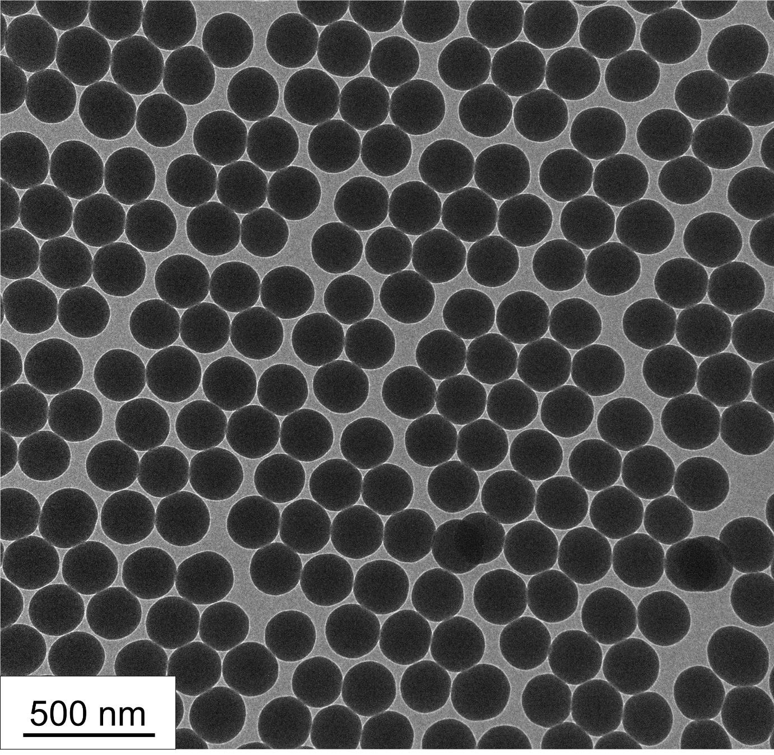
Figure S1. TEM image of SiO₂ NPs.

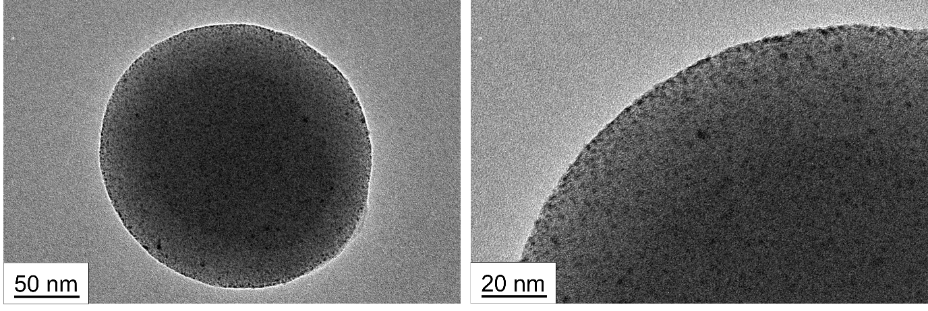
Figure S2. TEM images of SiO₂@Au used as a seed.

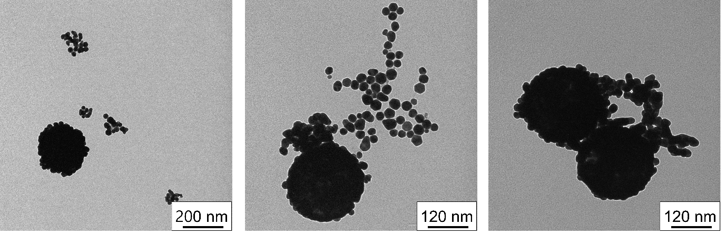
Figure S3. TEM images of SiO₂@Au@Au synthesized with 600 μM gold(III) chloride hydrate.

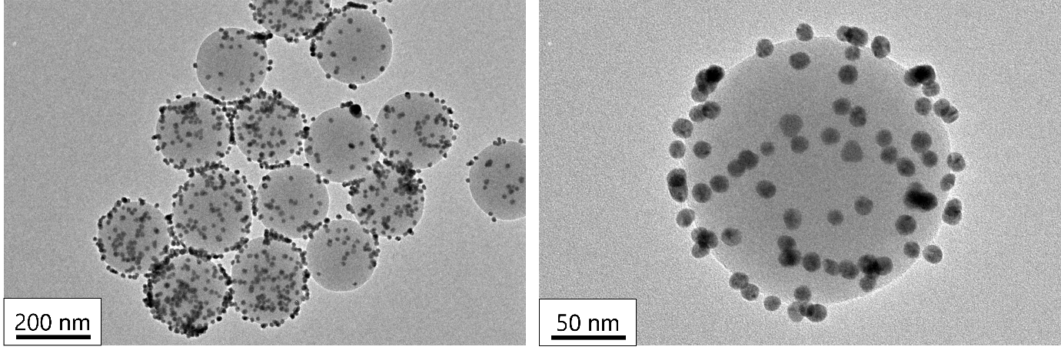
Figure S4. TEM images of SiO₂@Au synthesized by directly attaching large Au NPs (10–15 nm) to aminated silica (not a growth method).

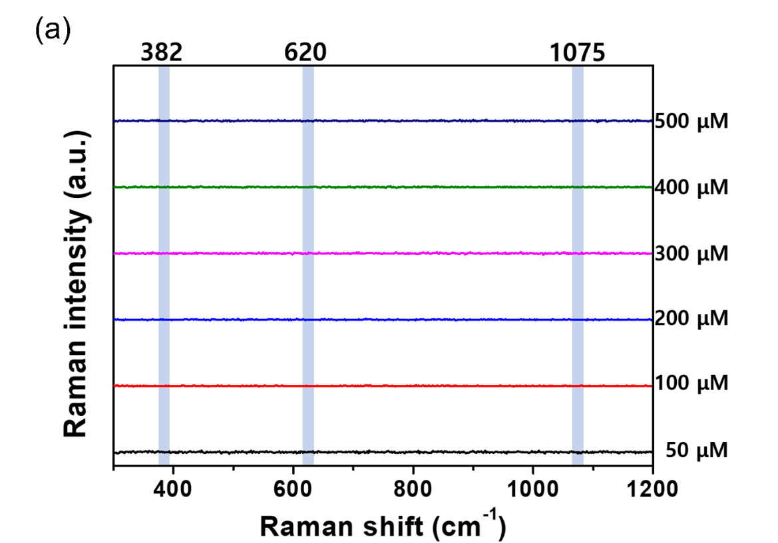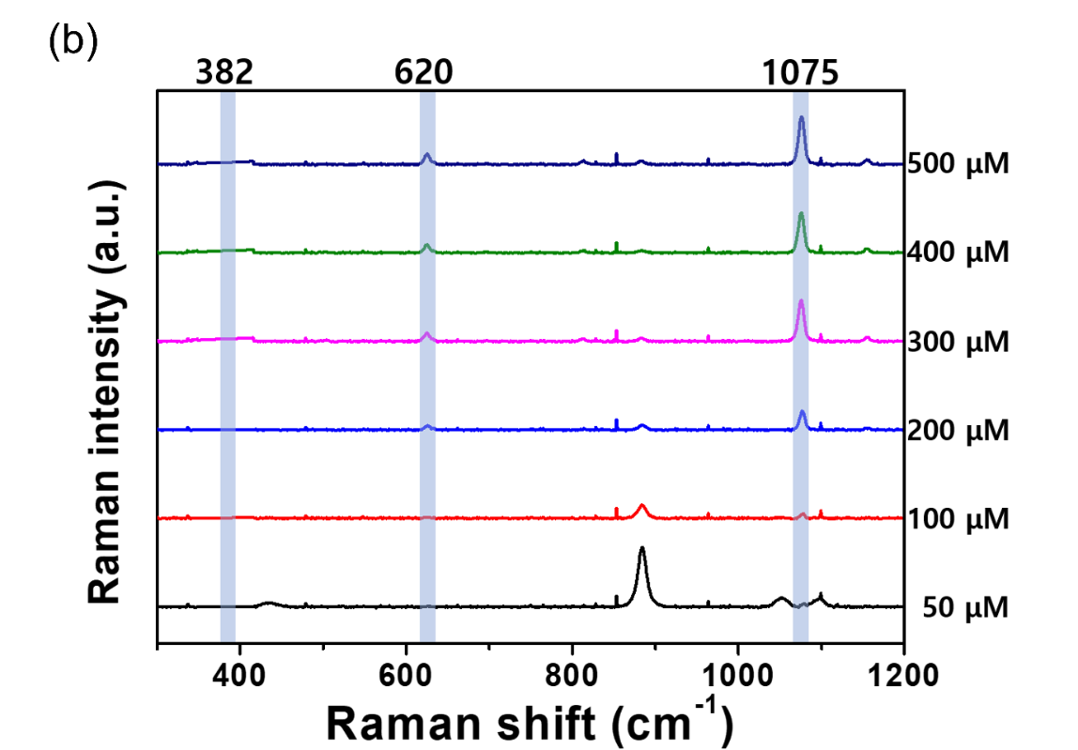
Figure S5. SERS intensities of SiO₂@Au@Au_{4-FBT} with various concentrations of gold(III) chloride hydrate determined using (a) blue visible light (wavelength, 532 nm) and (b) red visible light (wavelength, 660 nm).

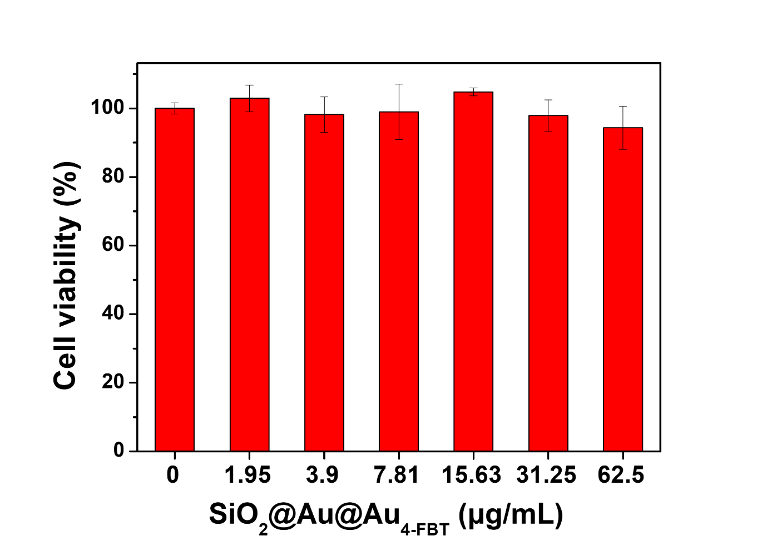
Figure S6. SERS intensities of SiO₂@Au@Au_{4-FBT} with various concentrations of gold(III) chloride hydrate determined using (a) blue visible light (wavelength, 532 nm) and (b) red visible light (wavelength, 660 nm).
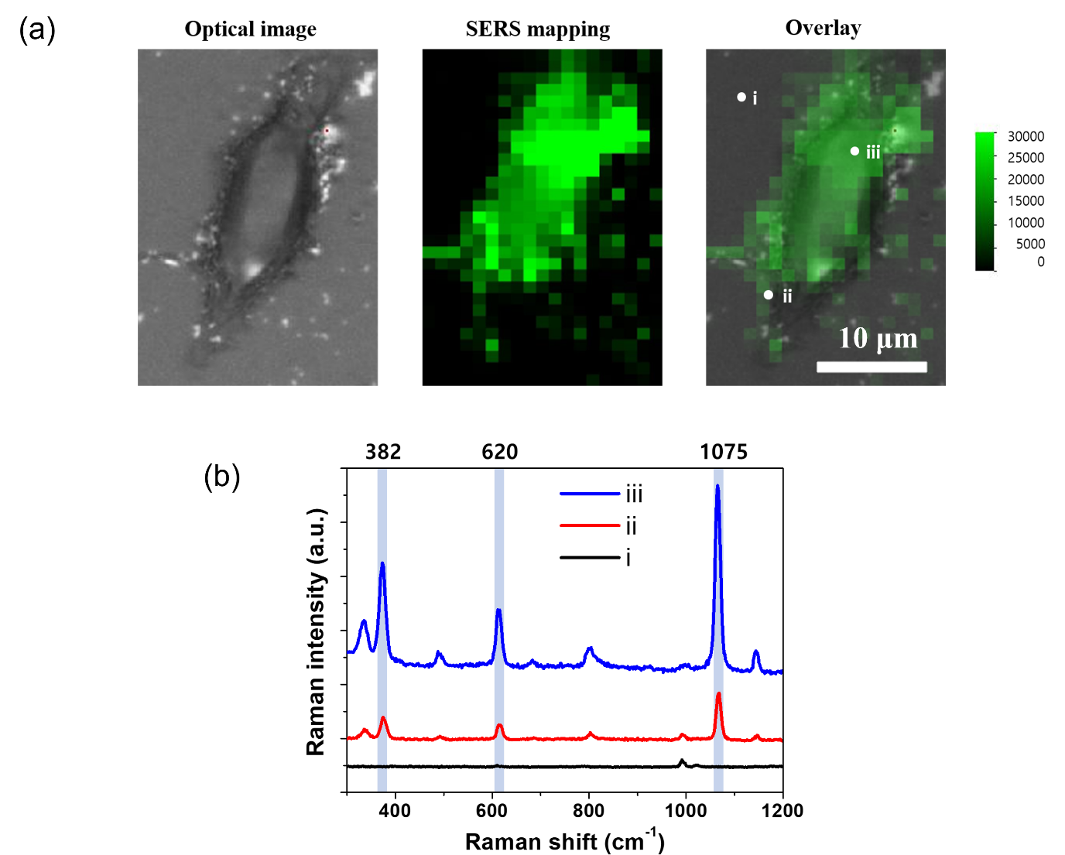
Figure S7. (a) Optical image, SERS mapping image, and overlay image toward human colon carcinoma (HCT 116) cells incubated with 50 μg/mL SiO₂@Au@Au. (b) Raman intensities at indicated points, location outside the cell (i), on the cell surface (ii), and inside the cell (iii), corresponding to the overlay images shown in (a).

