Supplementary materials

Draft genome of Tanacetum coccineum: genomic comparison of closely related Tanacetum-family plants

Takanori Yamashiro^{1,3}, Akira Shiraishi², Koji Nakayama¹, Honoo Satake^{2,3} *

¹ Dainihon Jochugiku Co., Ltd., 1-1-11 Daikoku-cho, Toyonaka, Osaka 561-0827, Japan
² Bioorganic Research Institute, Suntory Foundation for Life Sciences, Kyoto 619-0284, Japan
³ Department of Chemical Science and Engineering, Graduate School of Engineering, Kobe University, 1-1 Rokkodai-cho, Nada-ku, Kobe, Hyogo 657-8501, Japan

*CORRESPONDING AUTHOR:
Honoo Satake
Address: Bioorganic Research Institute, Suntory Foundation for Life Sciences, 8-1-1 Seikadai, Seika-cho, Souraku, Kyoto 619-0284, japan
E-mail: satake@sunbor.or.jp
TEL: +81-50-3182-0704
FAX: +81-774-98-6262

Legends to Supplementary Figures.
Figure S1. Size estimation of T. coccineum genome by flow cytometric analysis (A) and k-mer counting (B). (A) Estimation of relative nuclear DNA amount (genome size) of T. coccineum. The histogram of relative DNA content was obtained after flow cytometric analysis of propidium iodide-stained nuclei of C. seticuspe and T. coccineum. C. seticupe ‘gojo-0’ (3 pg/1C) served as internal reference standard. The peak of C. seticuspe was adjusted to be positioned near 100, with a final positioning at 106.10. The T. coccineum peak was positioned at 330.75; therefore, the 1C DNA amount of T. coccineum was estimated as 9.4 pg/1C. count: nuclei counts; FL2: relative DNA content. (B) k-mer spectrogram estimated from paired-end (PE) reads of T. coccineum.

Figure S2. Amino acid sequence alignment of proteins encoded by loci corresponding to known pyrethrin-related genes. The amino acid sequence alignment of T. coccineum proteins corresponding to the T. cinerariifolium proteins TciLOX1, TciADH2, TciALDH1, TciCDS, TciGLIP, TciJMH, TciPYS, TciCCH, and TciCCMT are shown. These alignments are generated by using CLUSTAL W-MPI 0.13. While the T. coccineum Tco_0863779 protein appears to lack the N-terminal region corresponding to the TciLOX1 homolog, the absence of this sequence reflects the lack of the corresponding sequences at the end of the scaffold assembly. Asterisks, colons, dots and hyphens denote conserved amino acids, conserved substitutions, semi-conserved substitutions and gaps, respectively. Tci: T. cinerariifolium; Tco: T. coccineum; ADH2: alcohol dehydrogenase 2; ALDH1: aldehyde dehydrogenase 1; CCMT: 10-carboxychrysanthemic acid 10-methyltransferase; CDS: chrysanthemyl diphosphate synthase; CHH: chrysanthemol 10-hydroxylase; GLIP: GDSL (Gly-Asp-Ser-Leu motif) lipase; JMH: jasmone hydroxylase; LOX1: 13-lipoxygenase; PYS: pyrethrolone synthase.

Figure S3. Amino acid sequence alignment of RICIN domain of ribosome-inactivating proteins. The amino acid sequence alignment of Sambucus nigra agglutinin I (SNA-I, accession No. O22415.1), T. cinerariifolium Tci_399175 (accession No. GEY27201.1), and T. coccineum Tco_1336120 is shown. This alignment is generated by using CLUSTAL W-MPI 0.13. RICIN domains are indicated by green bars. Asterisks, colons, dots and hyphens denote conserved amino acids, conserved substitutions, semi-conserved substitutions and gaps, respectively.

Figure S1. Genome size estimation of T. coccineum genome by flow cytometric analysis (A) and k-mer counting (B).
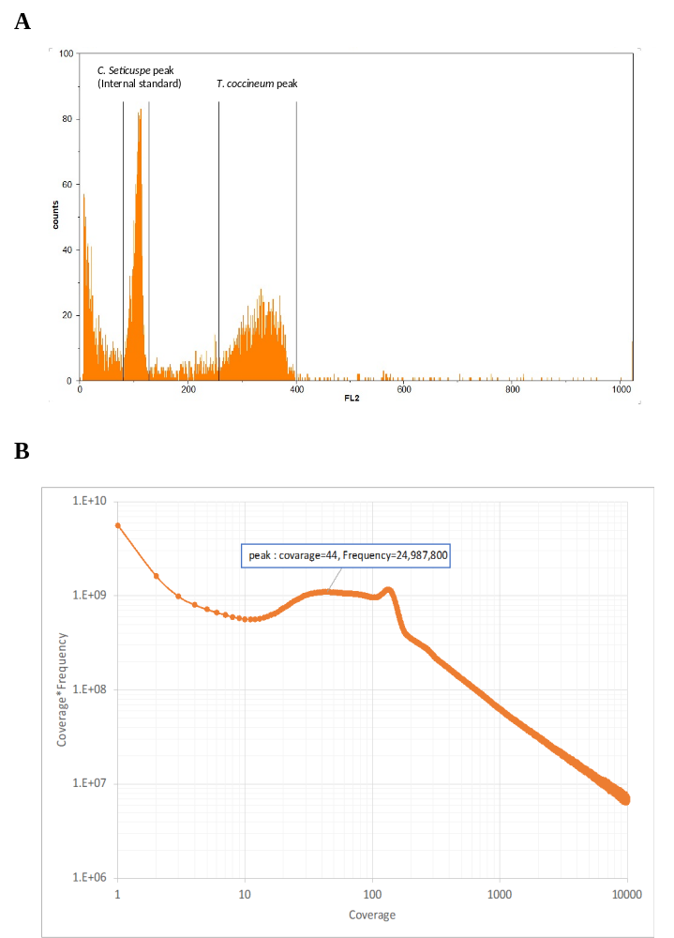

Figure S2. Amino acid sequence alignment of genes corresponding to known pyrethrin related genes.
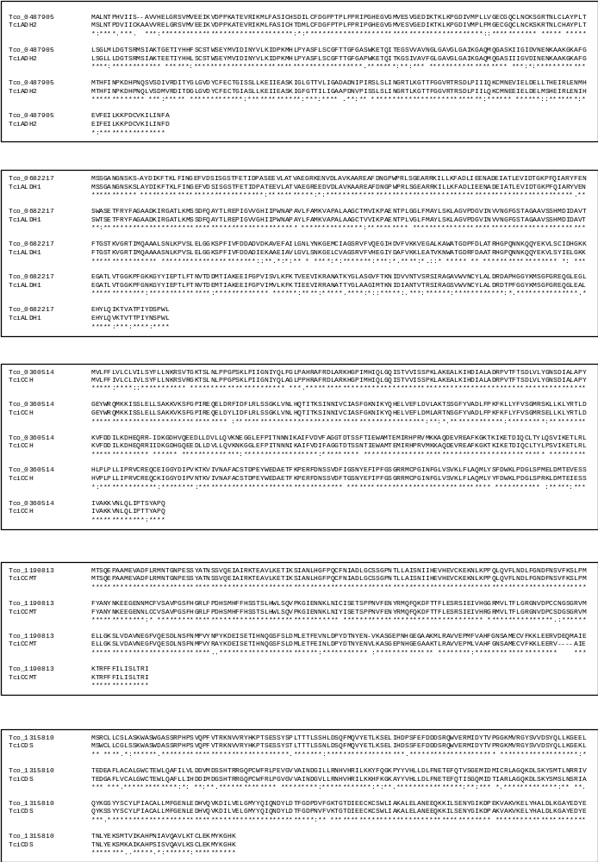

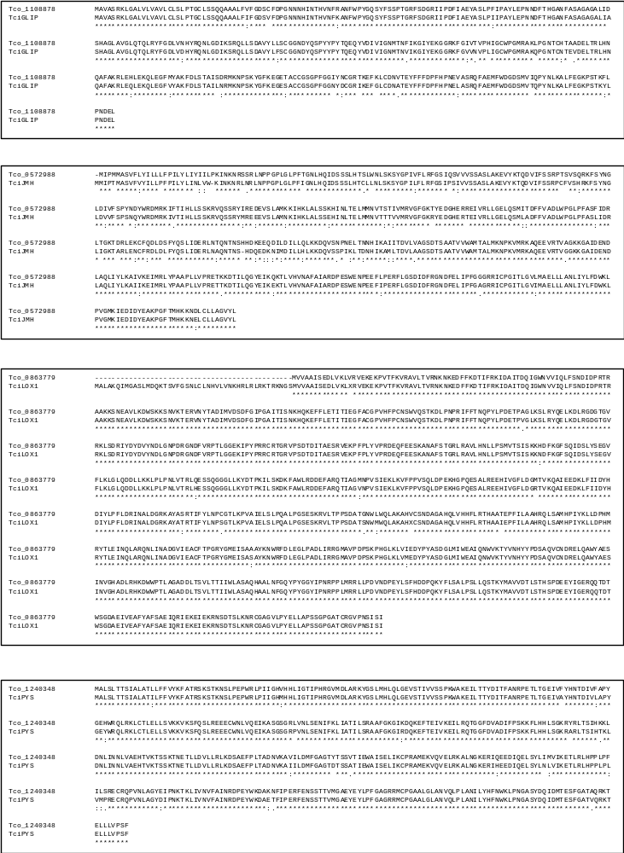

Figure S3. Amino acid sequence alignment of RICIN domain of ribosome-inactivating proteins.
