Figure 1 SEM and EDS images of samples before cleaning
after 168h immersion test - 0% Strain
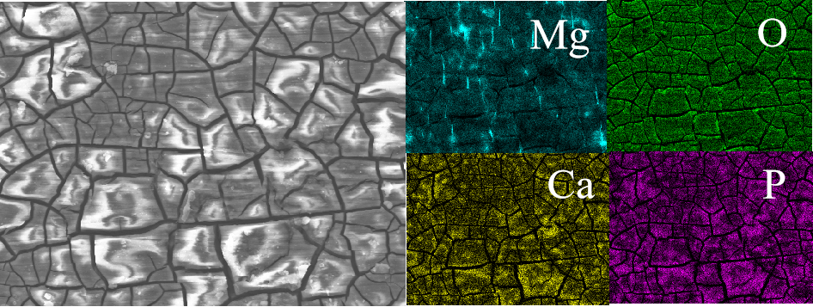
Figure 2 SEM and EDS images of samples before cleaning
after 168h immersion test - 10% Strain
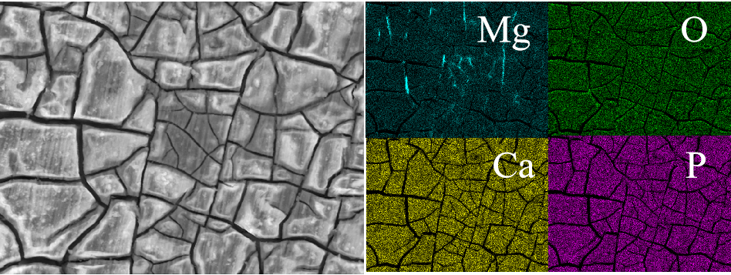
Figure 3 SEM and EDS images of samples before cleaning
after 168h immersion test - 15% Strain
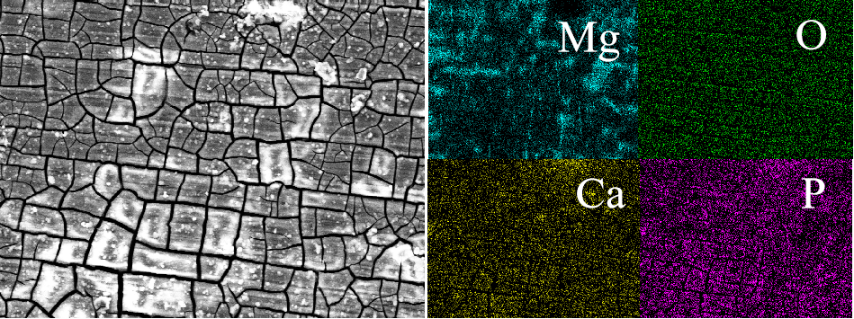
Figure 4 SEM and EDS images of samples before cleaning
after 168h immersion test - 20% Strain
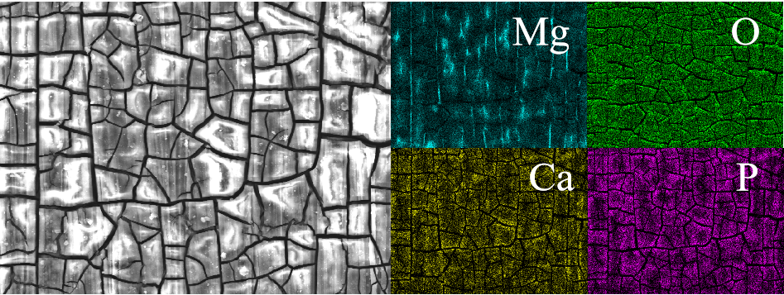
Figure 5 SEM and EDS images of samples before cleaning
after 168h immersion test - 25% Strain
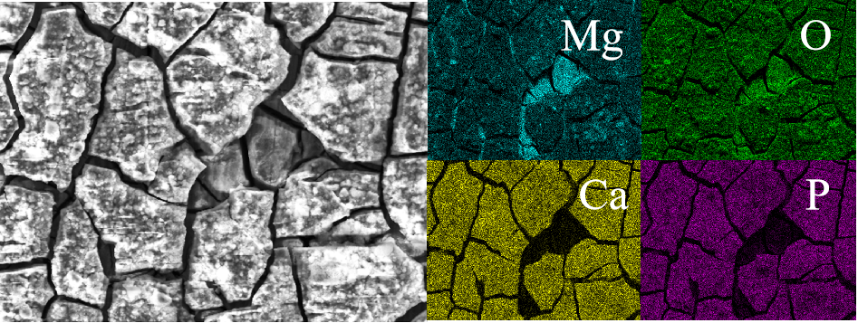
Figure 6 SEM and EDS images of samples before cleaning
after 168h immersion test - 10Turn
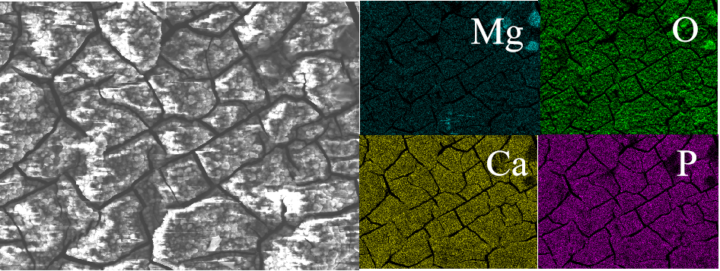
Figure 7 SEM and EDS images of samples before cleaning
after 168h immersion test - 15Turn
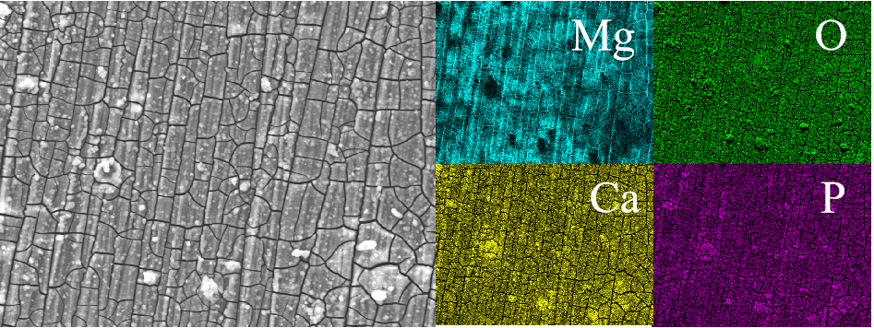
Figure 8 SEM and EDS images of samples before cleaning
after 168h immersion test - 20Turn
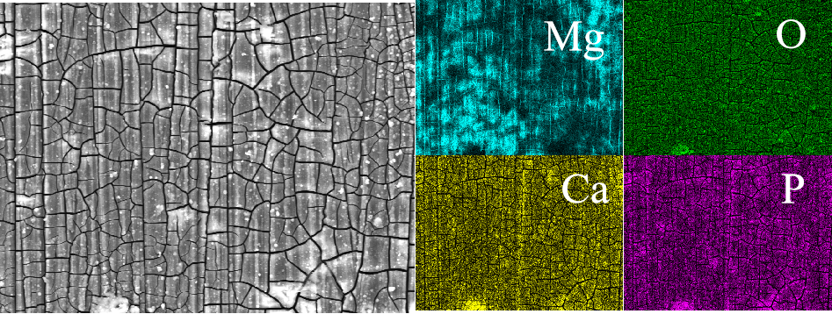
Figure 9 SEM and EDS images of samples before cleaning
after 168h immersion test - 25Turn
Figure 10 SEM and EDS images of samples after 168h immersion test cleaning - 0% Strain
Figure 11 SEM and EDS images of samples after 168h immersion test cleaning - 10% Strain
Figure 12 SEM and EDS images of samples after 168h immersion test cleaning - 15% Strain
Figure 13 SEM and EDS images of samples after 168h immersion test cleaning - 20% Strain
Figure 14 SEM and EDS images of samples after 168h immersion test cleaning - 25% Strain
Figure 15 SEM and EDS images of samples after 168h immersion test cleaning - 10Turn
Figure 16 SEM and EDS images of samples after 168h immersion test cleaning - 15Turn
Figure 17 SEM and EDS images of samples after 168h immersion test cleaning - 20Turn
Figure 18 SEM and EDS images of samples after 168h immersion test cleaning - 25Turn
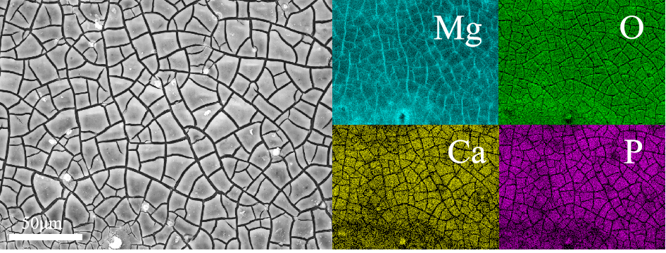
Figure 19 Electrochemical test sample SEM and EDS images - 0% Strain
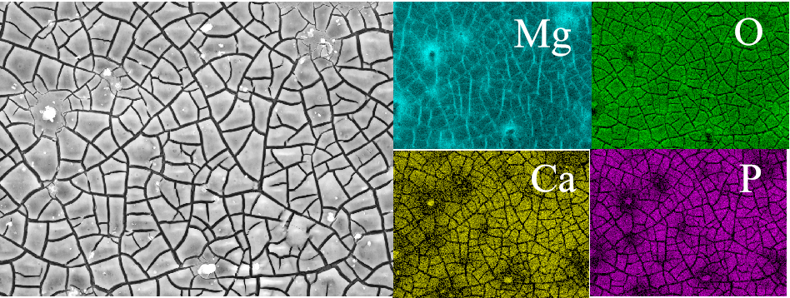
Figure 20 Electrochemical test sample SEM and EDS images - 10% Strain
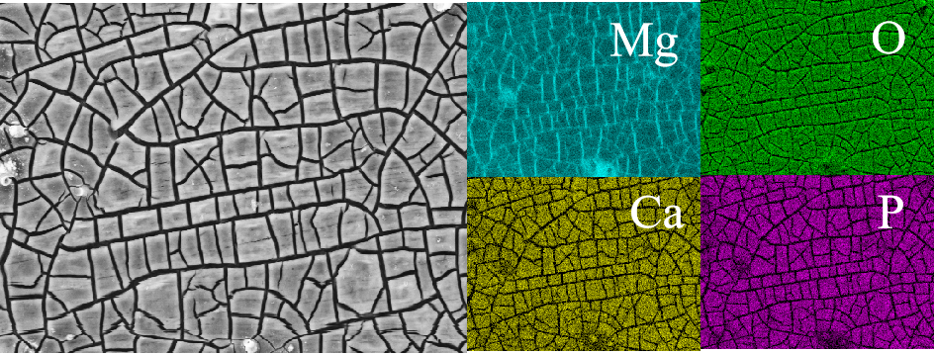
Figure 21Electrochemical test sample SEM and EDS images - 15% Strain
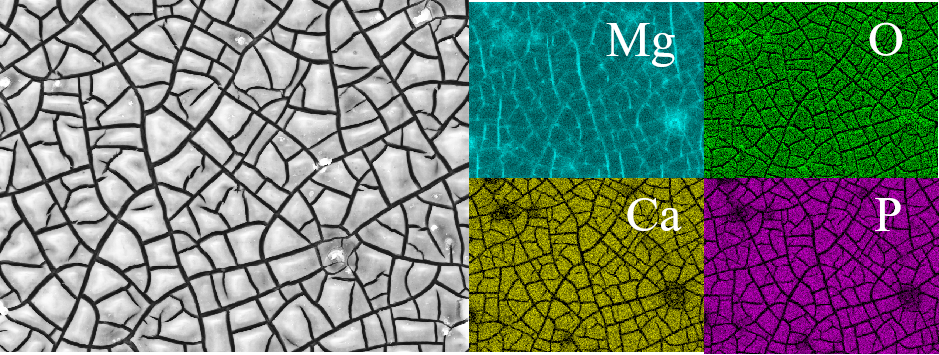
Figure 22 Electrochemical test sample SEM and EDS images - 20% Strain
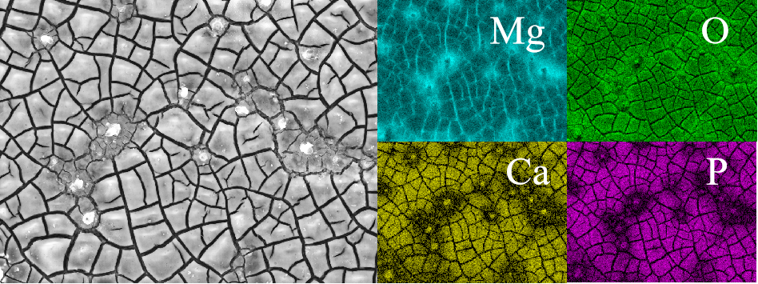
Figure 23 Electrochemical test sample SEM and EDS images - 25% Strain
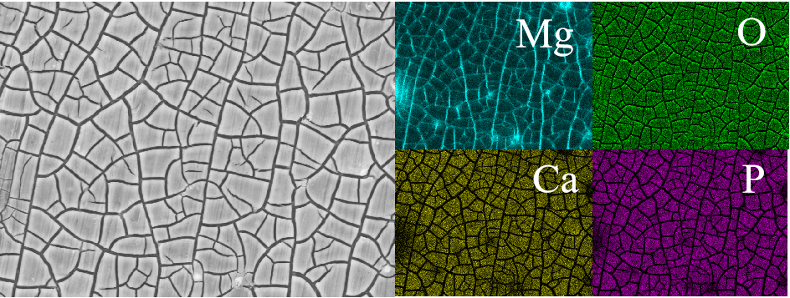
Figure 24 Electrochemical test sample SEM and EDS images - 10Turn
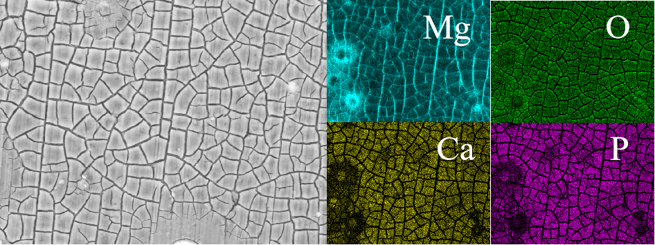
Figure 25 Electrochemical test sample SEM and EDS images - 15Turn
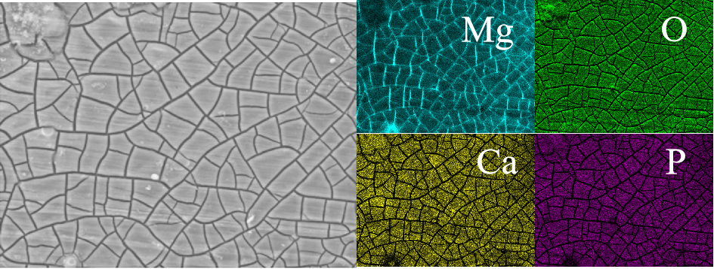
Figure 26 Electrochemical test sample SEM and EDS images - 20Turn
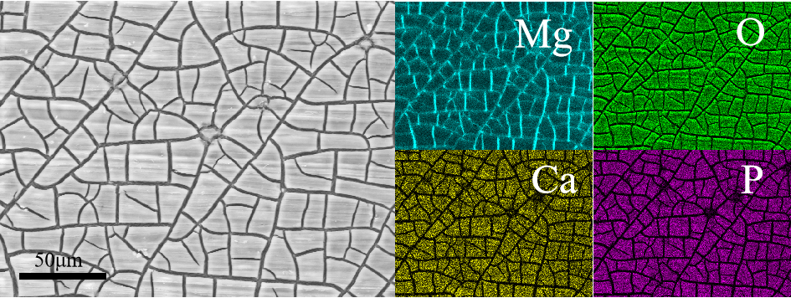
Figure 27 Electrochemical test sample SEM and EDS images - 25Turn

