ROCker models for reliable detection and typing of short read sequences carrying β-lactamases
Si-Yu Zhang^{1,2*}, Brittany J. Suttner^{1*}, Luis M. Rodriguez-R^{1,3,4*}, Luis H. Orellana⁵, Jessica L. Rowell^{6,7}, Hattie E. Webb^{6,7}, Amanda J. Williams-Newkirk⁶, Andrew Huang⁶, Konstantinos T. Konstantinidis^{1,3}
1. School of Civil and Environmental Engineering, Georgia Institute of Technology, Atlanta, GA 30332, USA
2. School of Ecological and Environmental Sciences, East China Normal University, Shanghai, 200241, China
3. School of Biological Sciences, Georgia Institute of Technology, Atlanta, GA 30332, USA
4. Department of Microbiology and Digital Science Center (DiSC), University of Innsbruck, Innsbruck, Tyrol, Austria
5. Max-Planck-Institut für Marine Mikrobiologie, Bremen, Germany
6. Enteric Diseases Laboratory Branch, Centers for Disease Control and Prevention, Atlanta, GA, USA
7. Weems Design Studio, Suwanee, GA, USA

* These authors contributed equally to this work.
Corresponding author: Konstantinos T. Konstantinidis
E-mail: kostas@ce.gatech.edu
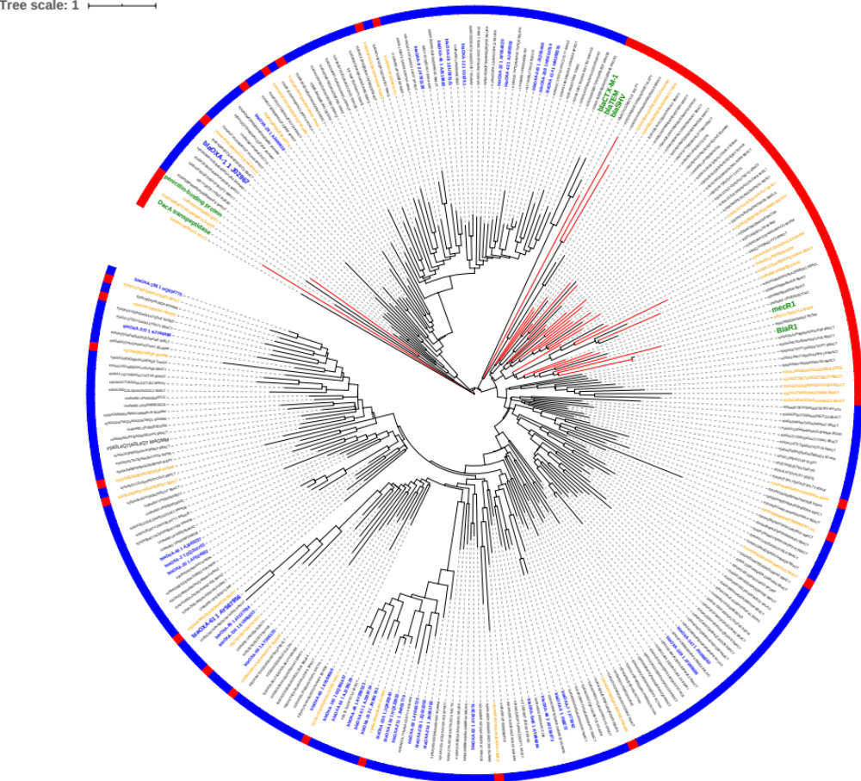
Figure S1. Phylogenetic relationship of verified class D β-lactamases (BLs, blue) with verified, non-target proteins (green) and other related proteins from the UniRef90 database. The verified class D BL sequences in blue were used to search against the UniRef90 database. Matches with >90% query length coverage by the alignment were de-replicated at 50% amino acid identity using cd-hit and one representative per resulting cluster was used with the verified class D BLs and non-targets proteins to build the phylogenetic tree shown using the maximum likelihood algorithm as implemented in RAxML version 7.7.2. UniRef90 proteins that show homology to and group together with positive reference class D BL sequences but lack at least one of the three conserved domains of class D BLs have orange labels and were removed from the ROCker model building as their functionality remains speculative (except for those with red branches). Red branches indicate UniRef90 proteins that were included in the negative reference set for ROCker model building because they form a branch with verified non-target proteins (green labels). The remaining UniRef90 proteins that are homologous to positive reference class D sequences (blue labels) and share the three conserved domains were included in the positive set. The outer bar surrounding the tree emphasizes target (blue) and non-target (red) proteins.
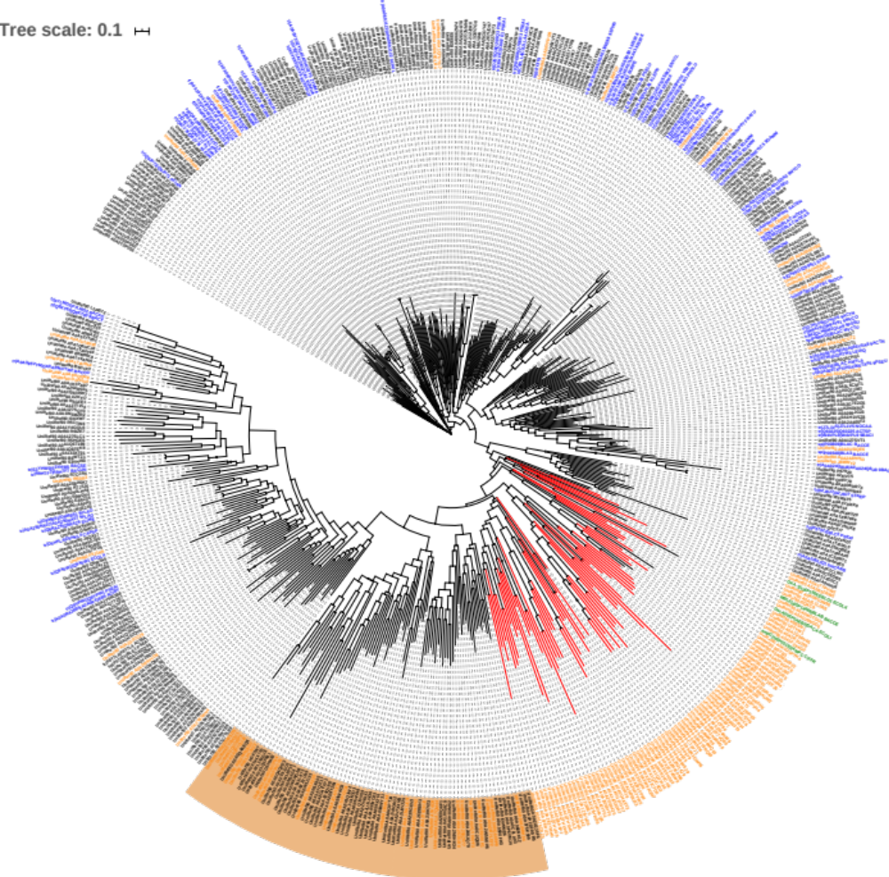
Figure S2. Phylogenetic relationship of verified class A BLs (blue) with verified non-target proteins (green) and other related proteins from the UniRef90 database. The verified class A BL sequences in blue labels were used to search against the UniRef90 database. Matches with >70% query length coverage by the alignments were de-replicated at 50% identity using cd-hit and one representative per resulting cluster was used, along with the verified class A BLs and non-targets proteins, to build the phylogenetic tree shown using FastTree version 2.1.7 (approximately-maximum-likelihood tree). FastTree was used here because of its computational efficiency in building large phylogenies, with little (and in some cases no) degradation in tree accuracy, as compared to RAxML [1]. A more relaxed alignment length cut-off for finding putative class A BLs in UniRef90 was used (70%) compared to other BLs (90%) in order to capture as many class A BL sequences as possible given that their sequence length varied substantially between 266 - 375 amino acids. During model building, we noticed that some genomes of the positive references downloaded from UniProt database, which are used to simulate reads for the training data set creation step, carry more than one class A BL. These sequences caused the low accuracy of the resulting model due to not being tagged as positive references by ROCker. To deal with this issue, four additional class A BLs (Uniprot ID: C6YWK1, B0TZF6, A0A0B3VEE7 and A0EL75), which were carried by the same genomes carrying class A BL C6YW16, B0TXT1, A0A0B3VPP7 and Q7BEB3, were included in the positive reference set. Proteins from UniRef90 database that were missing at least one of the three conserved domains have the orange labels and were removed from the ROCker model building (except for those with red branches). Proteins highlighted in orange backgrounds were also removed from ROCker model building because they did not form a branch with either verified target or non-target proteins (thus, it was challenging to decide on the substrate specificity of such sequences). Red branches indicate proteins that were included in the negative reference set for ROCker model building because they formed a branch with verified non-target proteins; the remaining sequences (blue and black labels) were included in the positive set. The reference sequences used for model building are available online at the website mentioned in the main text.
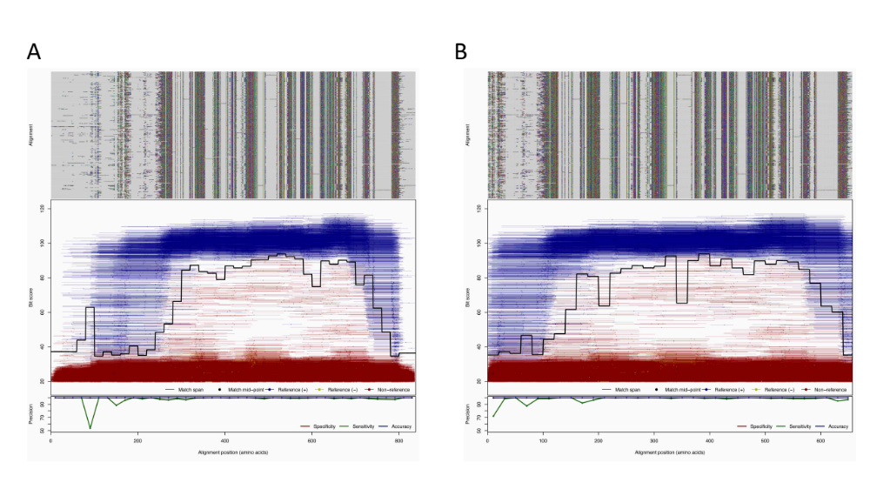
Figure S3. Plot of the untrimmed (A) and trimmed (B) 150 bp ROCker model of Class A BL using DIAMOND search. These models were built using the same pipeline as described in the main text except that the first 150 and last 30 columns of the alignment were removed (i.e. trimmed) to improve model performance and reduce the number of false positives since this region was highly variable among the positive sequence set. The same alignment was used to compile both the 150 bp and 250 bp models. The trimmed 250 bp model is not shown here but is available on the web (http://enve-omics.ce.gatech.edu/rocker/models#fam:BLA). The top panels display the sequence alignments with amino acids encoded in different colors and gaps in light grey. The middle panels represent the bit score (y-axis) of the reads of the 150 bp training data set against the positive reference sequences used to build the ROCker model carrying positive reference (blue), negative reference (yellow), or non-target sequences (red). Each matching read is represented as a line based on the coordinates of the alignment of the positive reference sequences to which the read maps, and dots represent the midpoint of each read. The solid black traversing line represents the calculated ROCker best bit scores thresholds for consecutive windows of variable length. The bottom panels summarize statistics on the performance of model, i.e. the sensitivity, specificity and accuracy were 98.5%, 99.9%, 99.9% and 98.1%, 99.9%, 99.9% for the untrimmed and trimmed models, respectively.
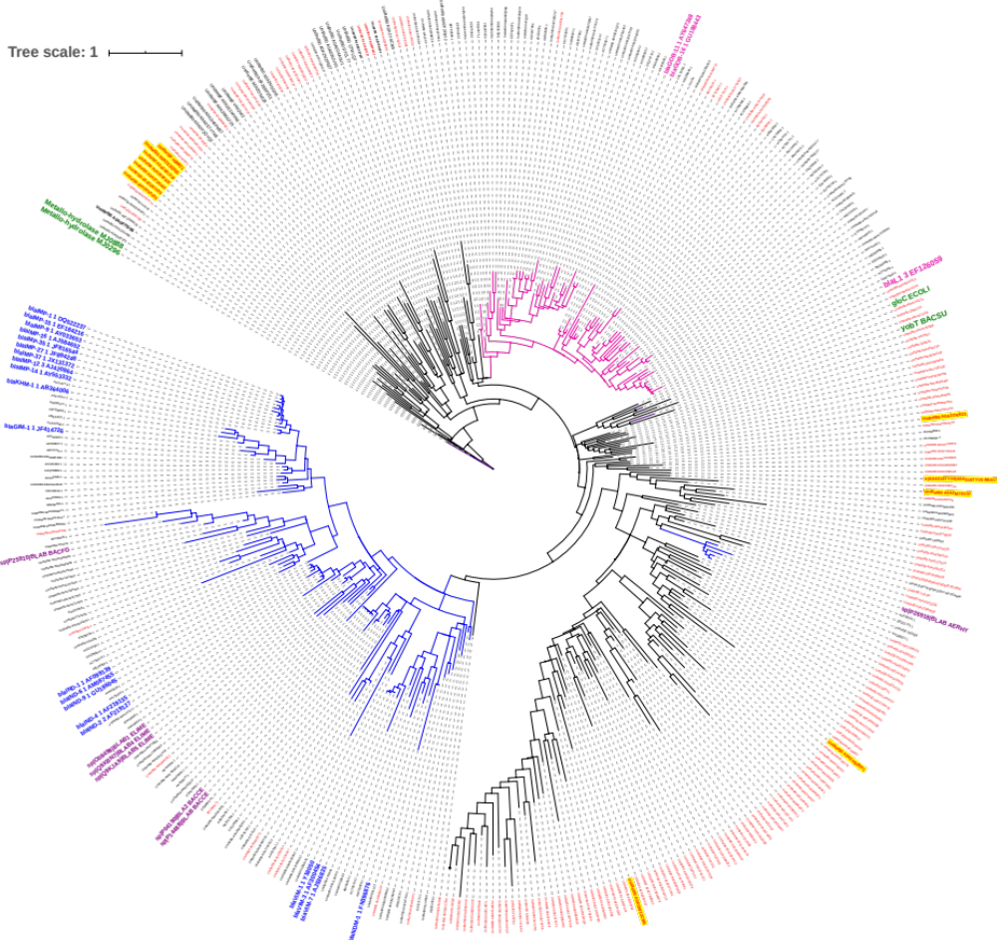
Figure S4. Phylogenetic relationship of the verified metallobeta-lactamases (MBLs, blue) with verified non-target proteins (green) and other related proteins from the UniRef90 database. Blue, purple, and pink labels are functionally-verified MBL subtypes 1, 2, and 3, respectively. The verified MBL subtypes 1, 2, and 3 sequences were used to search against the UniProt90 database. Matches with >90% query length coverage by the alignments were de-replicated at 50% identity using cd-hit and one representative per resulting cluster was used, along with the verified MBLs and non-targets proteins (green labels), to build the phylogenetic tree shown using the maximum likelihood algorithm as implemented in RAxML version 7.7.2. Leaf labels highlighted with yellow background are functionally verified outgroups and were included in the negative reference set for ROCker model building along with proteins highlighted in orange. Red labels are missing at least one conserved domain and were excluded from model building (because it was challenging to decide on the substrate specificity of such sequences), except for the ones highlighted in yellow, which were included in the negative reference set for ROCker model building along with the functionally verified outgroups (green labels). Only sequences in pink and blue branches were included in the positive reference set in ROCker model building for the total MBL model and for the separate models by subtype (see below). The reference sequences used for model building are available online at the website mentioned in the main text.
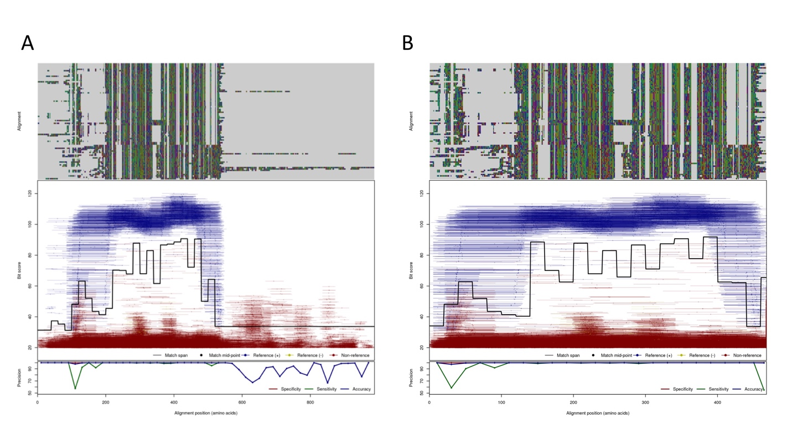Figure S5. Plot of the untrimmed (A) and trimmed (B) 150 bp ROCker model of Metallobeta-lactamase (MBL) subtypes 1, 2, and 3 combined using DIAMOND search. These models were built using the same pipeline as described in the main text except that the first 80 and last 440 columns of the alignment were removed (i.e. trimmed) to improve model performance and reduce the number of false positives since this region was highly variable among the positive sequence set. The same alignment was used to compile both the 150 bp and 250 bp models. The trimmed 250 bp model is not shown here but is available on the web (http://enve-omics.ce.gatech.edu/rocker/models#fam:BLA). The top panels display the sequence alignments with amino acids encoded in different colors and gaps in light grey. The middle panels represent the bit score (y-axis) of the reads of the 150 bp training data set against the positive reference sequences used to build the ROCker model carrying positive reference (blue), negative reference (yellow), or non-target sequences (red). Each matching read is represented as a line based on the coordinates of the alignment of the positive reference sequences to which the read maps, and dots represent the midpoint of each read. The solid black traversing line represents the calculated ROCker best bit scores thresholds for consecutive windows of variable length. The bottom panels summarize statistics on the performance of model, i.e. the sensitivity, specificity and accuracy were 36.3%, 99.5%, 96.7% and 97.8%, 99.1%, 99.1% for the untrimmed and trimmed models, respectively.
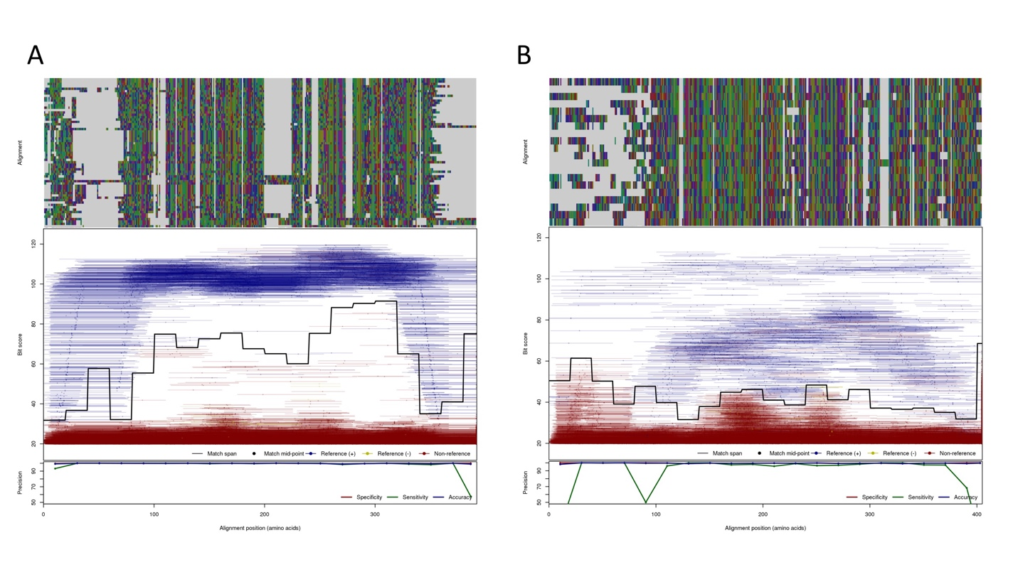Figure S6. Plot of 150 bp ROCker model of metallobeta-lactamase (MBL) subtypes 1 and 2 combined (A), and subtype 3 (B) using DIAMOND search. These models were built using the same pipeline as described in the main text and a subset of the original collection of references as described in Figure S10 (the MBL tree), except that for the subtypes 1 and 2 combined model, the first 91 and last 101 columns of the alignment were removed (i.e., trimmed); for the subtype 3 model, the first 107 and last 445 of the alignment were removed (i.e., trimmed) to improve model performance and reduce the number of false positives since this region was highly variable among the positive sequence set. The same alignment was used to compile both the 150 bp and 250 bp models. The 250 bp models are not shown here but are available online (http://enve-omics.ce.gatech.edu/rocker/models#fam:BLA). The top panels display the sequence alignments with amino acids encoded in different colors and gaps in light grey. The middle panels represent the bit score (y-axis) of the reads of the 150 bp training data set against the positive reference sequences used to build the ROCker model carrying positive reference (blue), negative reference (yellow), or non-target sequences (red). Each matching read is represented as a line based on the coordinates of the alignment of the positive reference sequences to which the read maps, and dots represent the midpoint of each read. The solid black traversing line represents the calculated ROCker best bit scores thresholds for consecutive windows of variable length. The bottom panels summarize statistics on the performance of model, i.e. the sensitivity, specificity and accuracy were 99.0%, 99.8%, 99.7% and 94.3%, 99.8%, 99.6% for the S1/S2 and S3 models, respectively.
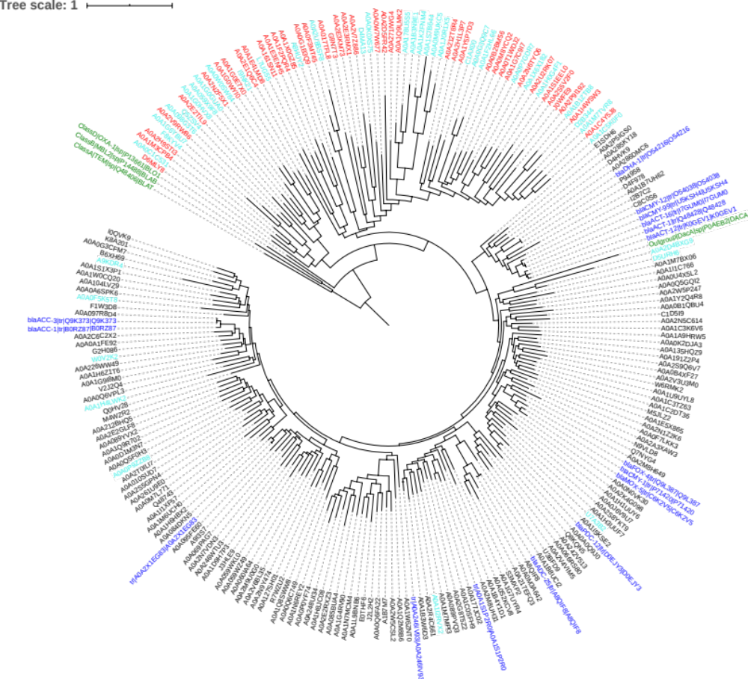
Figure S7. Phylogenetic relationship of the verified class C BLs (blue) with verified non-target proteins (green) and other related proteins from the UniRef90 database. The verified class C BL sequences in blue were used to search against the UniRef90 database. Matches with >90% query length coverage by the alignments were de-replicated at 60% identity using cd-hit and one representative per resulting cluster were used, along with the verified class C BLs and non-targets proteins, to build the phylogenetic tree shown using approximately-maximum-likelihood algorithm as implemented in FastTree version 2.1.7 (approximately-maximum-likelihood tree). FastTree was used here because of its computational efficiency in building large phylogenies, with little (and in some cases no) degradation in tree accuracy, as compared to RAxML [1]. The matching (putative) class C BL sequences were de-replicated at a higher amino acid identity (60%) compared to other BLs (50%) in order to include as many class C BLs as possible given that some regions of class C BL sequences show relative low sequence identity within the class, i.e. around 30% amino acid identity. During model building, we noticed that some genomes of the positive and negative references downloaded from UniProt database, which are used to simulate reads for the training data set creation step, carry more than one class C BL and multiple proteins that closely related to the class C BLs, sharing around 30% identity to true class C BLs. These sequences caused the low accuracy of the resulting model due to not being tagged appropriately by ROCker (e.g., a class C BL was treated as a negative sequence during creating data sets for training purposes). To deal with this issue, three additional class C BLs (Uniprot ID: A0A0A1FAN2, A0A191YQC7 and P00811), which were carried by the same genomes carrying protein A0A0A1FE92 (class C BL), A0A191Z2P4 (class C BL) and P0AEB2 (DacA), were included in the positive reference set. The opposite also occurred a few times. That is, protein sequences forming a branch with verified non-target proteins, if their corresponding genomes carried proteins closely related to class C BLs, these negative sequences were marked in cyan labels and removed from the ROCker model building because the class BLs co-occurring in the genome caused the lower the accuracy of ROCker (or required manual work to remove or tag appropriately these sequences). The remaining sequences were marked in red labels and were included in the negative reference set for ROCker model building. Proteins forming a deep branch within the clade of verified class C BLs were also removed from model building if they were missing at least one of the three conserved domains (T[LI]F⁶⁰[ED][LIV]GS[VIL]SK, RxY¹⁵⁰xN and K³¹⁵TG) (cyan labels), as it was challenging to decide on the substrate specificity of such sequences (conservative approach). The blue and black labels indicate proteins that included in the positive set. The reference sequences used for model building are available online.
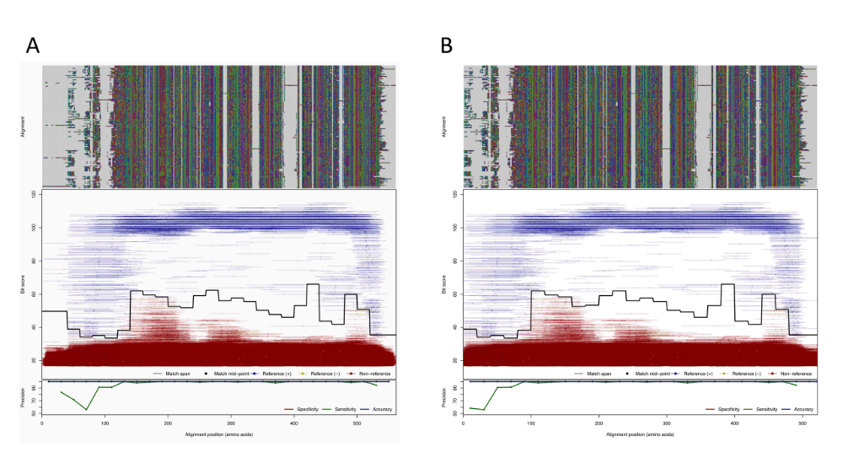
Figure S8. Plot of the untrimmed (A) and trimmed (B) 150 bp ROCker model of class C BL using BLASTx search with default settings. These models were built using the same pipeline as described in the main text except that the first 40 columns of the alignment were removed (i.e. trimmed) to improve model performance and reduce the number of false positives since this region was highly variable among the positive sequence set. The same alignment was used to compile both the 150 bp and 250 bp models. The trimmed 250 bp model is not shown here but is available on the web (http://enve-omics.ce.gatech.edu/rocker/models#fam:BLA). The top panels display the sequence alignments with amino acids encoded in different colors and gaps in light grey. The middle panels represent the bit score (y-axis) of the reads of the 150 bp training data set against the positive reference sequences used to build the ROCker model carrying positive reference (blue), negative reference (yellow), or non-target sequences (red). Each matching read is represented as a line based on the coordinates of the alignment of the positive reference sequences to which the read maps, and dots represent the midpoint of each read. The solid black traversing line represents the calculated ROCker best bit scores thresholds for consecutive windows of variable length. The bottom panels summarize statistics on the performance of model, i.e. the sensitivity, specificity and accuracy were 98.1%, 99.9%, 99.9% and 98.1%, 99.9%, 99.9% for the untrimmed and trimmed models, respectively.
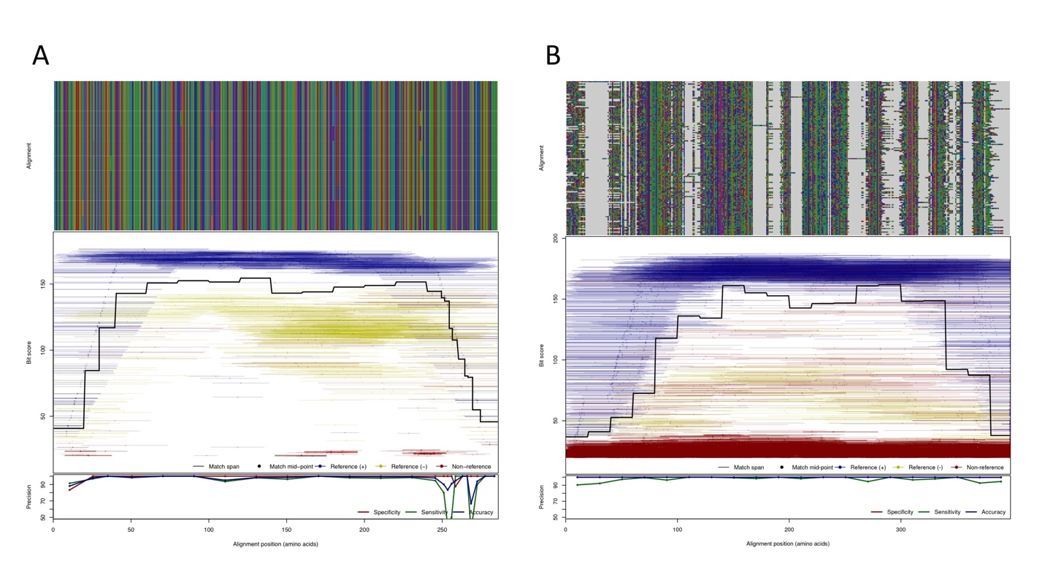
Figure S9. Plots of the 250 bp ROCker model of (A) TEM using a DIAMOND search and (B) the class D BL model after trimming of the 5’ conserved end of the alignment. The top panels display the sequence alignments with amino acids encoded in different colors and gaps in light grey. The middle panels represent the bit score (y-axis) of the reads of the 250 bp training data set against the positive reference sequences used to build the ROCker model carrying positive reference (blue), negative reference (yellow), or non-target sequences (red). Each matching read is represented as a line based on the coordinates of the alignment of the positive reference sequences to which the read maps, and dots represent the midpoint of each read. The solid black traversing line represents the calculated ROCker best bit scores thresholds for consecutive windows of variable length. The bottom panels summarize statistics on the performance of model, i.e. the sensitivity, specificity and accuracy were 96.5%, 99.3%, 97.9% and 97.4%, 99.9% 99.9% for the TEM and class D BL model, respectively.
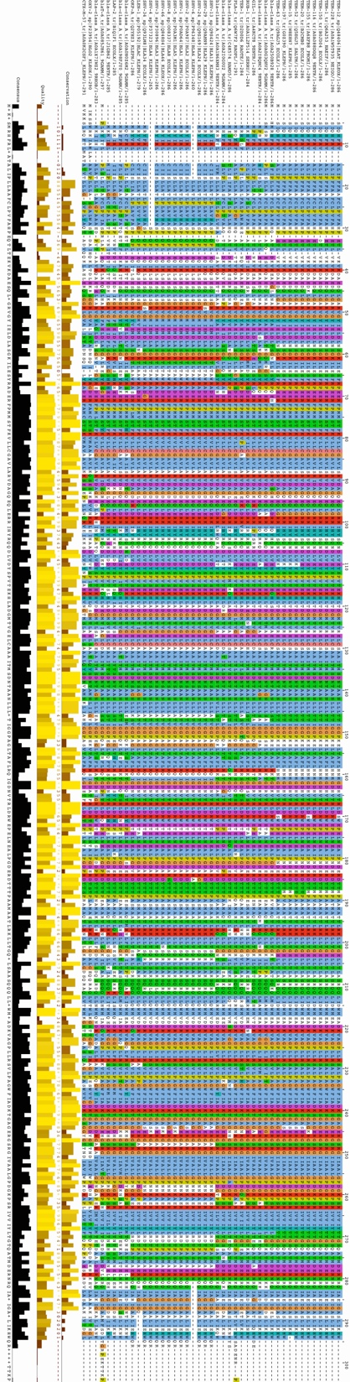
Figure S10. Alignments of the 11 positive TEM protein references (top) and 32 negative protein references from other (non-target in this case) clades of class A BLs (bottom). The amino acid reference sequences of the BLs were aligned using MAFFT version 7.407. The KPC in the reference set of the ROCker model was excluded from the phylogenetic tree because there was no corresponding nucleotide sequence for the gene encoding this protein in the EMBL database, which was needed for nucleotide-based short read placement.
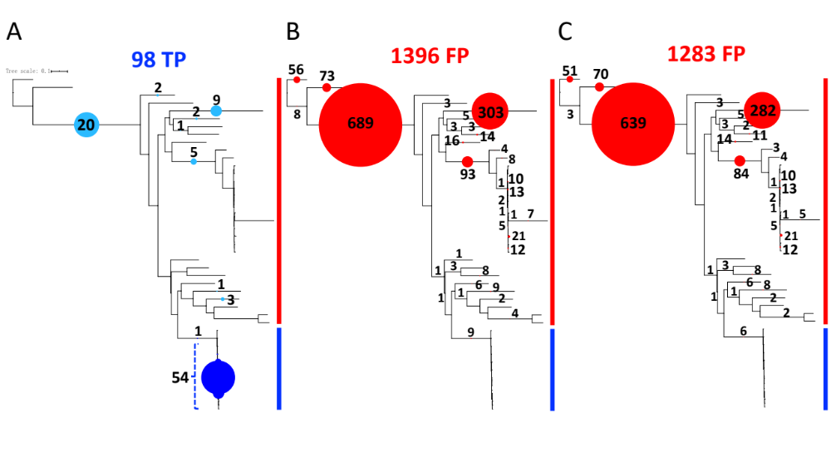Figure S11. Phylogenetic placement of the bla_{TEM}-carrying and false positive reads (from non-target genes) identified in the 250 bp mock dataset by different approaches. The bar to the right of each tree emphasizes clades made up of target (blue) and non-target (red) reference proteins. The colored circles represent the number of reads that were placed on the corresponding branches. The number of reads that make up each circle are provided for direct comparison between the trees (the filled circles on the same tree are proportional to the number of reads and directly comparable to each other, but not directly comparable between trees). The positive references used to build the TEM ROCker model are colored in blue (reads originating from these sequences are target reads and are included in the blue circles as TP) and negative references used to build TEM ROCker model are displayed in red (reads originating from these sequences are non-target reads and are included in the red circles as FP). (A) Mapping of 98 true positive reads identified in common by ROCker, BLASTx search (e-value < 10⁻⁵) and searches with a custom-built TEM HMM (e-value < 0.1). Note that several of these reads (in light blue) were (erroneously) mapped to non-target clades due to lack of phylogenetic signal (e.g., the reads sampled highly conserved regions between target and non-target references proteins) or sequence errors that confused the placement pipeline. The former reads were usually mapped on ancestral nodes while the latter to the terminal nodes. (B) Mapping of 1396 false positive reads identified by BLASTx search with e-value < 10⁻⁵. (C) Mapping of 1283 false positive reads identified by searches with a custom-built TEM HMM with e-value < 0.1. Note that a small number of these FP reads (n=9 for BLASTx search with e-value < 10⁻5 and n=6 for custom-built TEM HMM with e-value < 0.1) were (erroneously) mapped on the clade made up of target sequences due to inadequate phylogenetic signal. The phylogenetic tree was constructed using maximum likelihood in RAxML version 7.7.2 with the GTRGAMMA model. Reads were mapped on the phylogenetic tree as described in the Materials and Methods section. Note that no false negatives (i.e., bla_{TEM}-carrying reads that were not detected by the tools) were observed by ROCker, BLASTx search (e-value < 10⁻⁵) and searches with a custom-built TEM HMM (e-value < 0.1) for this BL family.

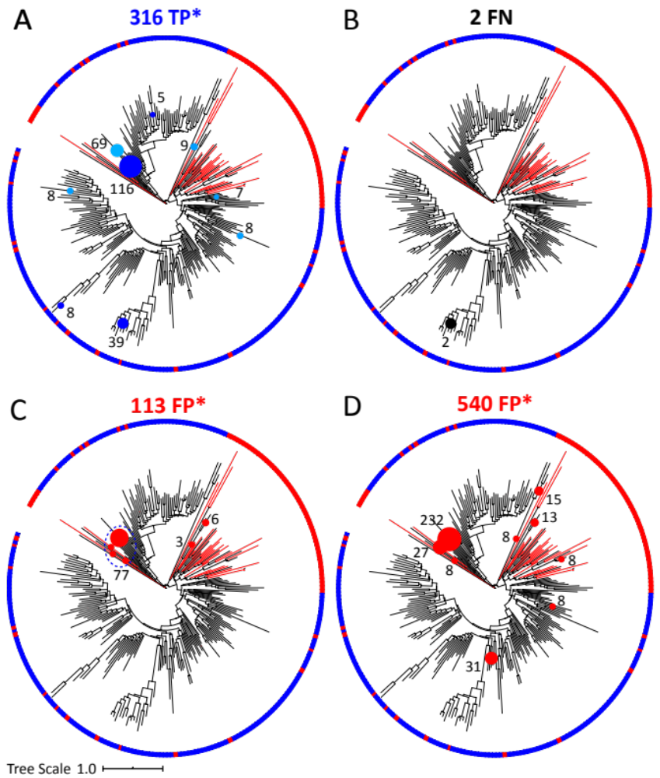Figure S12: Phylogenetic placement of the class D BL gene-carrying and false positive reads (from non-target genes) identified in the 250 bp MOCK dataset by different approaches. The same methods and parameters were used as described for Figure S11 but a circular tree was chosen due to the higher number and more diverse sequences of class D BLs, and in panels A, C, and D (denoted by an asterisk), not all identified reads are shown for demonstration purposes (e.g., many clades recruited only a couple reads). In addition, red branches indicate non-target proteins that were included in the negative reference set for ROCker model building (see also a more detailed class D BL phylogeny in Supplementary Figure S1). (A) True positive reads (n=316; 47 reads in 26 clades are not shown) detected by BLASTx search (e-value < 10⁻⁵). (B) False negative reads (n=2) missed by ROCker (i.e. reads carrying class D BLs that ROCker did not detect). (C) False positive reads (n=113; 27 reads in 22 clades are not shown) detected by BLASTx search (e-value < 10⁻⁵). (D) False positive reads (n=540; 189 reads in 89 clades are not shown) detected by the custom-built class D BL HMM. Circles in light blue denote reads that were placed onto non-target genes or clade(s) due to inadequate phylogenetic signal.
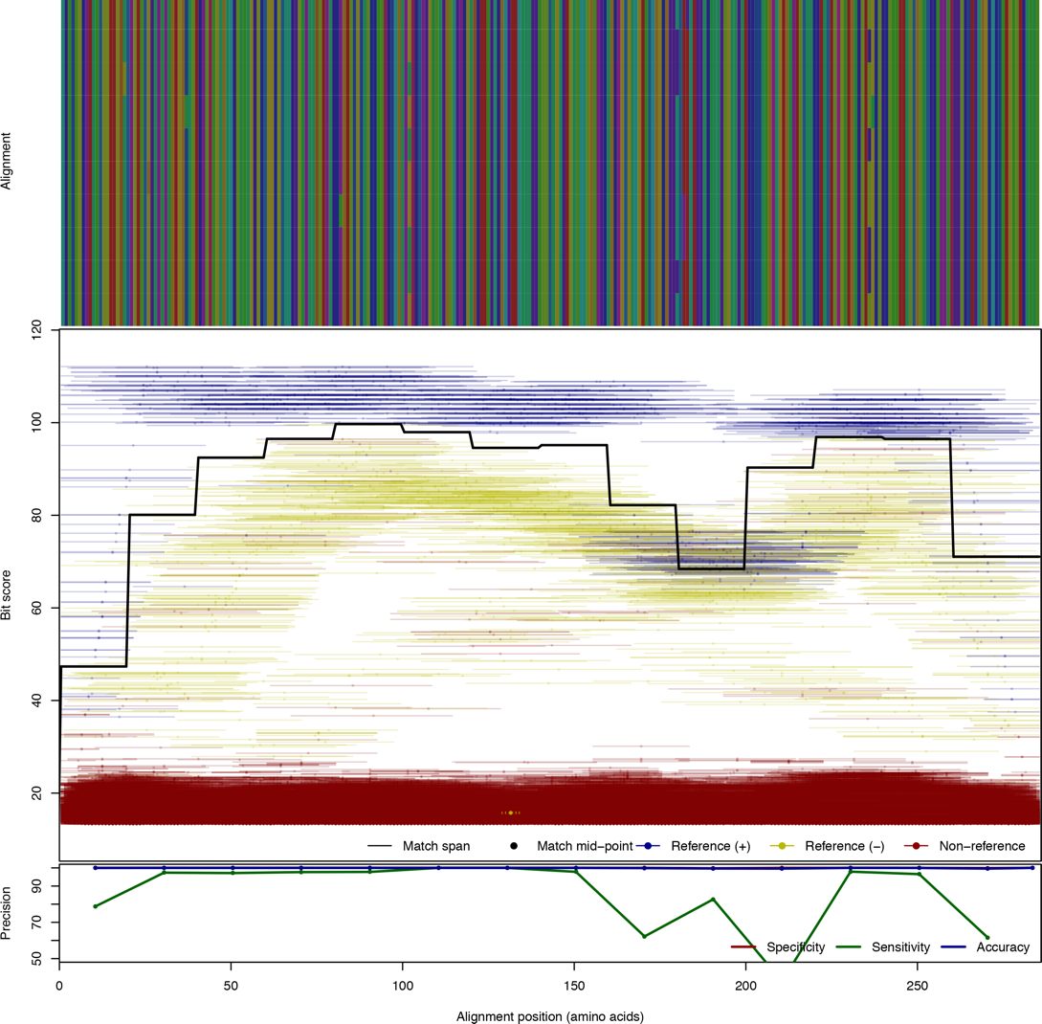
Figure S13. Plot of the 150 bp ROCker model of TEM using BLASTx search with default settings. The top panels display the sequence alignments with amino acids encoded in different colors and gaps in light grey. The middle panels represent the bit score (y-axis) of the reads of the 150 bp training data set against the positive reference sequences used to build the ROCker model carrying positive reference (blue), negative reference (yellow), or non-target sequences (red). Each matching read is represented as a line based on the coordinates of the alignment of the positive reference sequences to which the read maps, and dots represent the midpoint of each read. The solid black traversing line represents the calculated ROCker best bit scores thresholds for consecutive windows of variable length. The bottom panels summarize statistics on the performance of model. According to the plot, there is an unexpected drop of the bit score threshold around positions 150 to 250 of the alignment. Further examination showed that the corresponding target reads were assigned a lower bit score than expected due to a blast filter for low-complexity sequence.

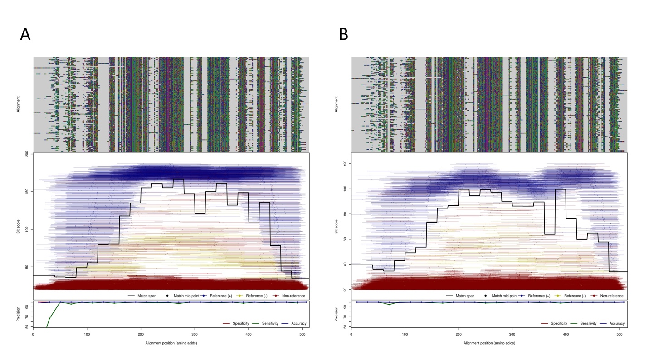
Figure S14. Plot of the original, untrimmed 150 bp (A) and 250 bp (B) ROCker models of class D BL using DIAMOND search. The top panels display the sequence alignments with amino acids encoded in different colors and gaps in light grey. The middle panels represent the bit score (y-axis) of the reads of the 150 bp or 250 bp training data set against the positive reference sequences used to build the ROCker model carrying positive reference (blue), negative reference (yellow), or non-target sequences (red). Each matching read is represented as a line based on the coordinates of the alignment of the positive reference sequences to which the read maps, and dots represent the midpoint of each read. The solid black traversing line represents the calculated ROCker best bit scores thresholds for consecutive windows of variable length. The bottom panels summarize statistics on the performance of model, i.e. the sensitivity, specificity and accuracy were 99.0%, 99.8%, 99.8% and 98.4%, 100%, 100% for the 150 bp and 250 bp model, respectively.

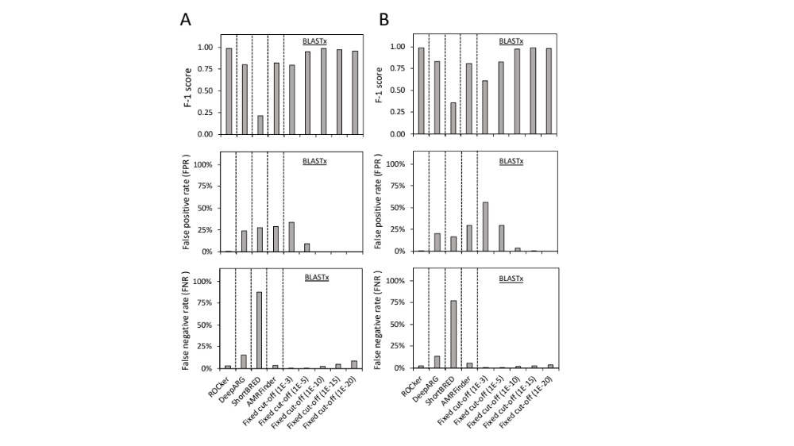

Figure S15. Performance of the ROCker model on 150 bp (A) and 250 bp (B) mock data sets compared with alternative methods. Alternative methods included DeepARG, ShortBRED, AMRFinder and BLASTx search using a fixed e-value (10⁻³, 10⁻⁵, 10⁻¹⁰, 10⁻¹⁵ and 10⁻²⁰). The false positive rate [FPR = FP/(TP+FP)], the false negative rate [FNR = FN/(TP+FN)], and the F1-score [2*precision*recall/(precision+recall)].

REFERENCES CITED
1. Liu K, Linder CR, Warnow T. RAxML and FastTree: comparing two methods for large-scale maximum likelihood phylogeny estimation. PloS one. 2011;6(11).

