Supplementary materials for

Insights on anaerobic digestion foaming via association between bacterial metabolism and variations in microbiota

Jian-Lu Duan¹, Yue Feng¹, Li-Juan Feng¹, Jing-Ya Ma¹, Xiao-Dong Sun¹, Qian Wang¹, Xiang-Yu Li¹, Fu Xiao¹, Peng-Cheng Xu¹, Ru-Kang Tian¹, Wen-Lin Sun¹, Xian-Zheng Yuan^{1, *}

¹ Shandong Key Laboratory of Water Pollution Control and Resource Reuse, School of Environmental Science and Engineering, Shandong University, Qingdao, Shandong 266237, P. R. China.

Number of pages: 17
Number of Figures: 9
Number of Tables: 4

Corresponding authors:
Xian-Zheng Yuan
School of Environmental Science and Engineering, Shandong University
72 Rd. Binhai, Qingdao, Shandong 266237, P. R. China
E-mail: xzyuan@sdu.edu.cn
Contents
Texts
Text S1. Details of metabolic profiling analysis

Figures
Figure S1. Scheme of foaming test apparatus.
Figure S2. Observation of reactor foaming performance in AGS system. The foaming phenomena were found in holistic reactors (a) and single (b) reactor. Photos of comparison between reactor with 0.47 g VS/L·d and that with 18.68 g VS/L·d (c).
Figure S3. Time-dependent surface tension values of solutions in AGS (a) and FS (b) systems.
Figure S4. Specific methane production, hydrogen production and pH values in AGS and FS systems. Less methane production (a for AGS and b for FS) and more hydrogen production (c for AGS and d for FS) indicates lower pH values in AGS (e) and FS (f) systems.
Figure S5. Analysis of the composition of microbial community and correlation between the reactor performance and the genera. Bacterial community profiles based on the relative abundance of phyla (a) and genera (b) at different OLRs. Low abundance phyla and genera (< 1% in all samples) are not represented. Correlation between the reactor performance and the genera in AGS (c) and FS (d) systems. “L”, “M” and “H” refer to low, medium and high OLR, respectively. The differences were considered significant at p < 0.05, and are referred to as *p < 0.05, **p < 0.01.
Figure S6. PCA and OPLS-DA of metabolites in AGS. PCA of metabolites in (a) positive and (b) negative mode. OPLS-DA of metabolites in (a) positive and (b) negative mode. (Q2= 0.846 and R2= 0.997 for positive metabolites, Q2= 0.977 and R2= 0.997 for negative metabolites).
Figure S7. The relative abundance of metabolites confirmed by secondary ion mass spectrometry.
Figure S8. Metabolite and genus joint loadings plot.
Figure S9. Co-occurrence network of metabolite and genus.

Tables
Table S1. Characteristics of digesters.
Table S2. Mobile phase condition parameter.
Table S3. The parameters of mass spectrum.
Table S4. Matched information of metabolites detected in SMPs.

Text S1 Details of metabolic profiling analysis
An UPLC HSS T3 column (1.7 μm, 2.1×100 mm, Waters) was used in Liquid chromatography. The mobile phase was combined with solvent A (0.1% formic acid aqueous solution) and solvent B (acetonitrile) for positive model and solvent A (5 mM ammonium acetate aqueous solution with pH value as 9.0) and solvent B (acetonitrile) for negative model. The UPLC elution conditions (injection volume: 1 μL) were set as Table S2. The flow rate of mobile phase remained at 400 μL/min after equilibration for 2 min. The injection volume of each sample was 4 μL. Metabolites were detected in MS and MS2. The mass spectrum parameters are as Table S3. Quality control samples were injected after the detection of 6 samples to evaluate the stability of LC/MS.
Raw data was converted into mzML format by ProteoWizard software. Then the XCMS analysis was used for data processing. For filter data, only the metabolites detected in more than 50% of samples were remained. The self-designed R package and self-built database of secondary ion mass spectrometry were used for identification. The cutoff is 0.2 for matching with secondary ion mass spectrometry.

Figure S1.

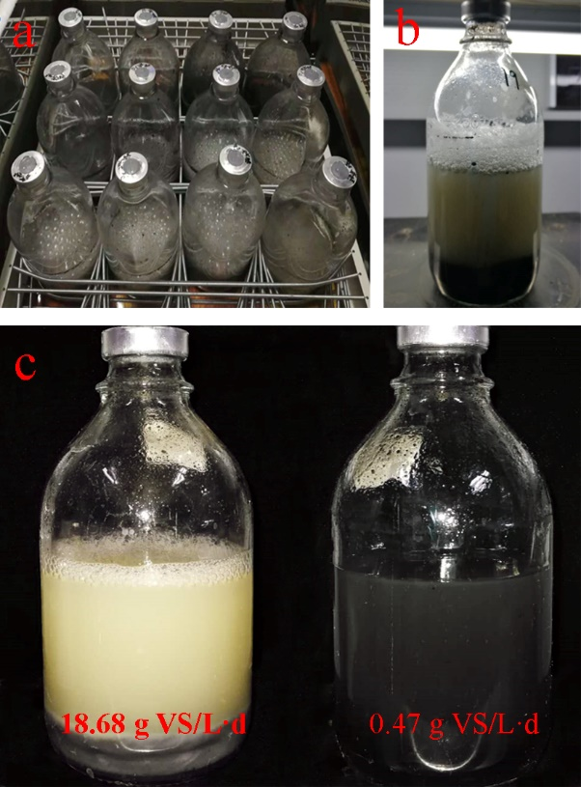
Figure S2.

Figure S3.

Figure S4.

Figure S5.

Figure S6.

Figure S7.

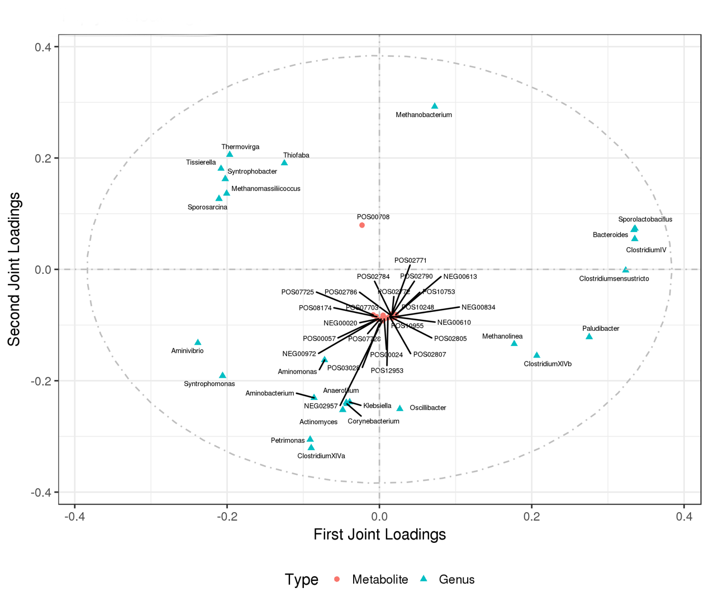
Figure S8.

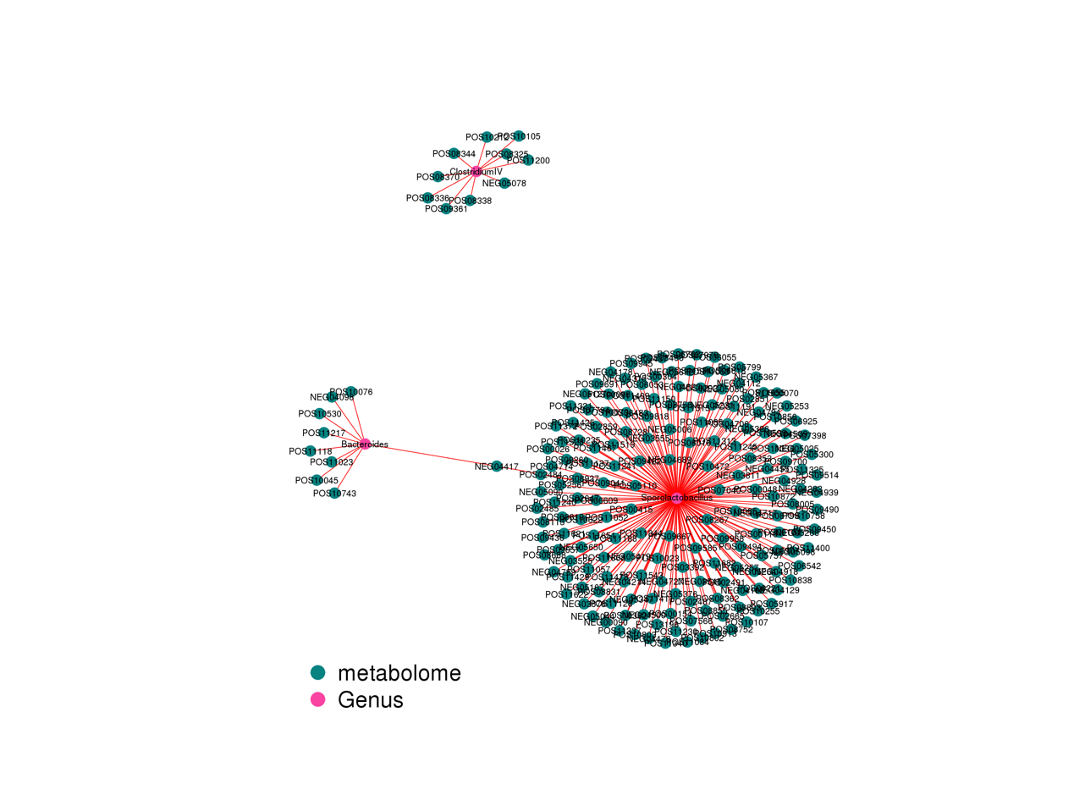
Figure S9.

Table S1.
Parameters | Values
Parameters | Total solids (% of WWª) | Volatile solids (% of WWª) | Glucose/Sludge (calculated by VS) | OLR  (g VS/L·d) | Ratio of C: N: P | NaHCO₃  (mol/L)
FS | 9.45 | 5.31 | \ | \ | \ | \
AGS | 7.41 | 6.06 | \ | \ | \ | \
Synthetic wastewater in steady stage^{b}  (14 days) | \ | \ | 1 | 0.47 | 200:5:1 | 2
Synthetic wastewater in foaming stage^{b}  (10 days) | \ | \ | 1 | 0.47 | 200:5:1 | 2
Synthetic wastewater in foaming stage^{b}  (10 days) | \ | \ | 10 | 4.67 | 200:5:1 | 2
Synthetic wastewater in foaming stage^{b}  (10 days) | \ | \ | 30 | 14.01 | 200:5:1 | 2
Synthetic wastewater in foaming stage^{b}  (10 days) | \ | \ | 40 | 18.68 | 200:5:1 | 2
a. WW: wet weight.
b. Compositions of Synthetic wastewater and the weight of sludges (calculated by volatile solids) were same for both FS and AGS system. The hydraulic retention time was 2 days.

Table S2.
Time (min) | Flow rate (μL/min) | A% | B%
0 | 500 | 99 | 1
1.0 | 500 | 99 | 1
8.0 | 500 | 1 | 99
10.0 | 500 | 1 | 99
10.1 | 500 | 99 | 1
0 | 500 | 99 | 1

Table S3.
Parameters | Set value | Parameters | Set value
The voltage of ESI | 3800V (positive ion mode) and -3100V (negative ion mode) | MS2 resolution | 17500
Capillary temperature | 320 °C | The value of step energy intensity | 3
Sheath gas velocity | 45Arb | Step energy | 20eV, 40 eV, 60 eV
Auxiliary gas velocity | 15Arb | Scan rate | 7Hz
Scanning range | 70-1000m/z | Scanning ranges of Fullms ddMS2 | 70-200, 190-400, 390-600 and 590-1000

Table S4.
Index | MS2 name | Formula | Mz | MS2 score | SuperClass | Peak intensity
 |  |  |  |  |  | GA-L（ave） | GA-H（ave）
POS | Lysine | C6H14N2O2 | 147.11 | 1.00 | Organic acids and derivatives | 295904 | 23305531
POS | N-Methyl proline | C6H11NO2 | 130.09 | 1.00 | Organic acids and derivatives | 2644892 | 20805038
POS | 4-Aminobutanoate | C4H9NO2 | 104.07 | 0.97 | Organic acids and derivatives | 2667772 | 249737047
POS | Cysteinyl-Cysteine | C6H12N2O3S2 | 224.86 | 0.96 | Organic acids and derivatives | 811067 | 6624371
POS | Ethyl acetate | C4H8O2 | 89.06 | 0.69 | Organic acids and derivatives | 4643923 | 37182900
NEG | trans-Aconitate | C6H6O6 | 172.03 | 0.97 | Organic acids and derivatives | 78101 | 14221440
NEG | Hydroxyphenyllactic acid | C9H10O4 | 180.06 | 0.82 | Phenylpropanoids and polyketides | 3140 | 13437038
POS | Ethyl hydrogen fumarate | C6H8O4 | 144.07 | 0.66 | Lipids and lipid-like molecules | 2754192 | 9091650
NEG | Nonanoic acid | C9H18O2 | 157.12 | 1.00 | Lipids and lipid-like molecules | 1083677 | 13508037
NEG | 19(20)-EpDPE | C22H32O3 | 343.23 | 1.00 | Lipids and lipid-like molecules | 2237976 | 11897252
NEG | 3-Hydroxy-3-methylglutarate | C6H10O5 | 160.06 | 0.69 | Lipids and lipid-like molecules | 367699 | 27101172
POS | Sedoheptulose | C7H14O7 | 232.12 | 1.00 | Organic oxygen compounds | 795962 | 10891693
POS | 3-Buten-2-one | C4H6O | 71.05 | 0.68 | Organic oxygen compounds | 69091 | 9929455
POS | 1-O-Galloylglycerol | C10H12O7 | 244.08 | 0.99 | Benzenoids | 993976 | 29348468
POS | Atovaquone | C22H19ClO3 | 366.13 | 0.99 | Benzenoids | 575123 | 11843079
POS | 1,2,3,4-Tetrahydro-2-methyl-b-carboline | C11H8N2 | 186.19 | 1.00 | Organoheterocyclic compounds | 3205386 | 22096196
POS | Thymine | C5H6N2O2 | 127.05 | 0.99 | Organoheterocyclic compounds | 1356285 | 13665054
POS | Morpholine | C4H9NO | 88.08 | 0.84 | Organoheterocyclic compounds | 4040283 | 186541945
POS | 4-HYDROXY-6-METHYLPYRAN-2-ONE | C6H6O3 | 127.04 | 1.00 | Organoheterocyclic compounds | 4340538 | 35062431
POS | Benzenesulfinylbenzene | C12H10OS | 202.07 | 1.00 | Organoheterocyclic compounds | 680565 | 151329636
POS | N-Acrylylglycine methyl ester | C6H9NO3 | 144.07 | 1.00 | Organoheterocyclic compounds | 2021072 | 94024686
POS | 1,2-Epoxybutane | C4H8O | 73.07 | 0.99 | Organoheterocyclic compounds | 1126586 | 58181586
POS | Lactamide | C3H7NO2 | 90.06 | 0.99 | Organoheterocyclic compounds | 4137567 | 266447357
POS | 2-Hydroxymethylclavam | C6H9NO3 | 144.07 | 0.98 | Organoheterocyclic compounds | 4407298 | 33019190
POS | Diuron | C9H10Cl2N2O | 269.99 | 0.98 | Organoheterocyclic compounds | 540426 | 38783679
POS | 11-(4-methylphenyl)sulfonyl-7,11-diazatricyclo[7.3.1.02,7]trideca-2,4-dien-6-one | C18H20N2O3S | 344.14 | 0.92 | Organoheterocyclic compounds | 4192 | 8995855
POS | 1,5-Anhydro-4-deoxy-D-glycero-hex-3-en-2-ulose | C6H8O4 | 144.07 | 0.73 | Organoheterocyclic compounds | 2579545 | 31277965
POS | 4-amino-2-(2,6-dioxopiperidin-3-yl)isoindole-1,3-dione | C13H11N3O4 | 273.09 | 0.70 | Organoheterocyclic compounds | 35165 | 8721387
POS | 2S-hydroxy-Hexanedioic acid | C6H10O5 | 162.08 | 0.68 | Organoheterocyclic compounds | 644071 | 8842011

