Supplementary Materials
The following supplementary materials are available online:

Supplementary File 1. PRISMA flow diagram showing the study selection process.
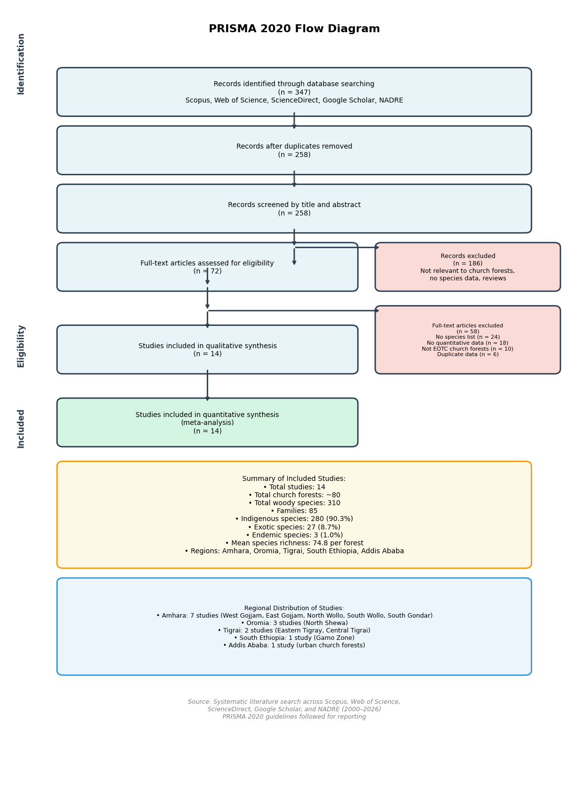
Flow diagram illustrating the identification, screening, eligibility, and inclusion of studies in the systematic review and meta-analysis of woody species diversity in Ethiopian Orthodox Church forests. The diagram follows the PRISMA 2020 guidelines (Page et al., 2021) and reports the number of records at each stage: records identified through database searching (n = 347), records after duplicates removed (n = 258), records screened by title and abstract (n = 258), full-text articles assessed for eligibility (n = 72), and studies included in the qualitative and quantitative synthesis (n = 14). Reasons for exclusion at the full-text stage are provided in the right-hand exclusion box. Abbreviations: NADRE = Ethiopian National Academic Digital Repository; PRISMA = Preferred Reporting Items for Systematic Reviews and Meta-Analyses.

Supplementary File 2. Full list of the 14 included studies with their geographic and methodological characteristics.
Study ID | Author(s) and Year | Church Forest / Study Area | Region | Zone | Woreda | Altitude (m a.s.l.) | Study Design | Sampling Method | Plot Size | Sample Size | Total Species | Shannon Diversity (H′) | Source Type
S1 | Ayele et al. 2024 | 26 church forests (pooled) | Amhara | West Gojjam | Not specified | Not specified | Cross-sectional | Systematic sampling | 20 m × 20 m | 840 plots | 111 | Not specified | Peer-reviewed journal
S2 | Abunie & Dalle 2018 | Yemrehane Kirstos Church Forest | Amhara | North Wollo | Lasta | 2565–3135 | Cross-sectional | Systematic sampling | 20 m × 20 m | 62 plots | 39 | 2.88 | Peer-reviewed journal
S3 | Wassie 2007 | Menagesha Amba Mariam | Amhara | Not specified | Not specified | Not specified | Cross-sectional | Systematic sampling | Not specified | Not specified | 166 | Not specified | PhD thesis
S4 | Meshesha et al. 2015 | Sesa Mariam Monastery | Amhara | East Gojjam | Gozamin | 2090–2241 | Cross-sectional | Systematic sampling | 20 m × 20 m | 50 plots | 86 | 3.81 | Peer-reviewed journal
S5 | Mekonnen et al. 2023 | Saleda Yohans Church Forest | Amhara | South Wollo | Amhara Sayint | Not specified | Cross-sectional | Systematic sampling | 20 m × 20 m | 50 plots | 50 | 3.82 | Peer-reviewed journal
S6 | Cosman et al. 2025 | Tara Gedam | Amhara | South Gondar | Libo Kemkem | Not specified | Cross-sectional | Systematic sampling | 0.07 ha circular | 29 plots | 91 | Not specified | Peer-reviewed journal
S7 | Mekonnen et al. 2022 | Zijje Maryam Church Forest | Amhara | South Wollo | Not specified | Not specified | Cross-sectional | Systematic sampling | 20 m × 20 m | 50 plots | 48 | 3.29 | Peer-reviewed journal
S8 | Asefa et al. 2026 | Debre Libanos Monastery & Laga Gur | Oromia | North Shewa | Debre Libanos | 2341–2500 | Cross-sectional | Systematic sampling | 20 m × 20 m | 30 plots | 73 | 3.15 | Peer-reviewed journal
S9 | Koricho et al. 2021 | Debre Libanos Church Forest (Oromia) | Oromia | North Shewa | Debre Libanos | Not specified | Cross-sectional | Systematic sampling | 20 m × 20 m | Not specified | 70 | 3.14 | Peer-reviewed journal
S10 | Shawul 2023 | 15 urban church forests (pooled) | Oromia | North Shewa | Multiple | 2425–3083 | Cross-sectional | Systematic sampling | 20 m × 20 m | 60 plots | 81 | 3.19 | MSc thesis
S11 | Hadera 2000 | Dess'a Forest | Tigrai | Eastern Tigray | Multiple | 1500–3068 | Cross-sectional | Line transect | 20 m × 20 m | 59 plots | 83 | Not specified | MSc thesis
S12 | Waldiba Monastery 2024 | Waldiba Monastery | Tigrai | Not specified | Not specified | Not specified | Cross-sectional | Systematic sampling | 20 m × 20 m | Not specified | 36 | Not specified | Peer-reviewed journal
S13 | Sitotie & Gatew 2025 | 6 church forests (pooled) | South Ethiopia | Gamo | Chencha/Arba Minch | 1200–2732 | Cross-sectional | Systematic sampling | 20 m × 20 m | 40 plots | 62 | 2.40 | Peer-reviewed journal
S14 | Yilma & Derero 2020 | Addis Ababa church forests | Addis Ababa | Not specified | Not specified | Not specified | Cross-sectional | Systematic sampling | 20 m × 20 m | Not specified | 90 | 2.27 | Peer-reviewed journal

Supplementary File 3. Complete species checklist (310 woody species) with scientific name, family, local name, growth habit, origin status, and source study.
No. | Scientific Name | Family | Local Name | Growth Habit | Origin Status | Source Study ID
1 | Gardenia lutea Fresen. | Rubiaceae | Gambilo | T | I | S1
2 | Acacia abyssinica Hochst. ex Benth. | Fabaceae | Girar | T | I | S1, S2, S4, S5, S6, S10, S14
3 | Acacia nilotica (L.) Willd. ex Del. | Fabaceae | Cheba | T | I | S1
4 | Capparis tomentosa L. | Capparidaceae | Gumero | S | I | S1, S2, S4, S6
5 | Olinia rochetiana A. Juss | Oliniaceae | Tife | T | I | S1, S4, S14
6 | Acanthus polystachius Del. | Acanthaceae | Koshashile | S | I | S1, S6
7 | Albizia schimperiana Oliv | Fabaceae | Sesa | T | I | S1, S4, S6, S10, S14
8 | Salix subserrata Willd. | Salicaceae | Ahaya | T | I | S1, S5, S10
9 | Apodytes dimidiata E. Mey. ex Arn. | Icacinaceae | Dong | T | I | S1, S6
10 | Arundinaria alpina K. Schum | Poaceae | Kerkeha | S | I | S1
11 | Allophylus abyssinicus (Hochst) Radlkofer | Sapindaceae | Embis | T | I | S1, S2, S4, S6, S10, S14
12 | Arundo donax L. | Poaceae | Shembeko | S | E | S1, S4
13 | Barleria eranthemoides R. Br. ex C.B. Clarke | Acanthaceae | Yeset tat | H | I | S1
14 | Bersama abyssinica Fresen. subsp. abyssinica | Melianthaceae | Azamir | T | I | S1, S2, S4, S6, S10, S14
15 | Borassus aethiopum Mart | Arecaceae | Zenbaba | T | I | S1, S14
16 | Brucea antidysenterica J. F. Mill | Simaroubaceae | Abalo yedega | T | I | S1, S4, S6, S10
17 | Buddleja polystachya Fresen | Loganiaceae | Anfar/Ashquar | S | I | S1, S2, S4, S5, S6, S10, S14
18 | Cajanus cajan (L.) Millsp | Fabaceae | Yergb ater | S | E | S1
19 | Calpurnia aurea (Ait.) Benth | Fabaceae | Digta | S | I | S1, S2, S4, S5, S6, S10
20 | Carica papaya L. | Caricaceae | Papaya | T | E | S1, S4
21 | Carissa spinarum L. | Apocynaceae | Agam | S | I | S1, S2, S4, S5, S6, S10, S14
22 | Celtis africana Burm. | Ulmaceae | Qawat | T | I | S1, S2, S4, S6, S10, S14
23 | Citrus aurantiifolia (Christm.) Swingle | Rutaceae | Lomi | T | E | S1, S4, S14
24 | Citrus aurantium L. | Rutaceae | Komtate | T | E | S1
25 | Citrus sinensis (L.) Osb | Rutaceae | Birtukan | T | E | S1, S4, S14
26 | Clausena anisata (Willd.) Benth | Rutaceae | Limch | S | I | S1, S4, S6, S10, S14
27 | Clematis simensis Fresen | Ranunculaceae | Yeazo hareg | L | I | S1
28 | Clerodendrum myricoides (Hochst.) Vatke. | Lamiaceae | Misrch | S | I | S1, S4, S6, S10
29 | Coffea arabica L. | Rubiaceae | Buna | S | I | S1, S4, S14
30 | Clutia abyssinica Jaub. & Spach. | Euphorbiaceae | Fiyelefeji | S | I | S1, S2, S4, S6, S10
31 | Cordia africana Lam. | Boraginaceae | Wanza | T | I | S1, S2, S4, S5, S6, S10, S14
32 | Crateva adansonii DC | Capparidaceae | Dingay seber | S | I | S1
33 | Croton macrostachyus Del. | Euphorbiaceae | Bisana | T | I | S1, S2, S4, S5, S6, S10, S14
34 | Cupressus lusitanica Mill. | Cupressaceae | Yeferenji tsid | T | E | S1, S2, S4, S6, S10, S14
35 | Cyanotis hirsute | Commeliaceae | Zagol | H | I | S1
36 | Pavetta oliveriana Hiern | Rubiaceae | Yetota Qolet | S | I | S1, S6, S10
37 | Diospyros abyssinica (Hiern) F. White | Ebenaceae | Selchegn | T | I | S1, S3, S6, S14
38 | Discopodium penninervium Hochst. | Solanaceae | Ameraro | H | I | S1, S3, S5, S11
39 | Dodonaea angustifolia L.f. | Sapindaceae | Kitkita | S | I | S1, S2, S4, S5, S6, S10, S13
40 | Dombeya torrida (J. F. Gmel.) P.Bamps | Sterculiaceae | Wulkfa | T | I | S1, S2, S3, S4, S6, S10, S14
41 | Dovyalis abyssinica (A. Rich.) Warb | Flacourtiaceae | Koshm | S | I | S1, S2, S4, S5, S6, S10, S12, S14
42 | Dracaena steudneri Engl. | Dracaenaceae | Etse patos | T | I | S1, S3, S4, S10, S14
43 | Ekebergia capensis Sparrm | Meliaceae | Lol | T | I | S1, S3, S4, S6, S10, S14
44 | Embelia schimperi Vatke | Myrsinaceae | Enqoqo | T | I | S1, S3, S6, S13
45 | Entada abyssinica Steud.ex A. Rich | Fabaceae | Chino | T | I | S1
46 | Erythrina abyssinica Lam. ex DC | Fabaceae | Korch | T | I | S1, S4
47 | Erythrococca bongensis Pax | Euphorbiaceae | Yebere qizen | S | I | S1
48 | Eucalyptus camaldulensis Dehnh | Myrtaceae | Key bahir zaf | T | E | S1, S4, S6, S10, S14
49 | Eucalyptus citriodora Hook. | Myrtaceae | Shito Bahirzaf | T | E | S1, S3, S14
50 | Euclea racemosa Murr. | Ebenaceae | Dedho | S | I | S1, S4, S6, S10
51 | Euphorbia abyssinica Gmel | Euphorbiaceae | Kulkual | T | En | S1, S4, S5, S10, S13, S14
52 | Euphorbia tirucalli L. | Euphorbiaceae | Kinchb | T | I | S1, S3, S13
53 | Ficus glumosa Del. | Moraceae | Yewef shola | T | I | S1, S11
54 | Ficus sur Forssk | Moraceae | Shola | T | I | S1, S3, S4, S6, S10, S13, S14
55 | Ficus thonningii Blume | Moraceae | Chibha | T | I | S1, S10, S13, S14
56 | Ficus vasta Forssk | Moraceae | Warka | T | I | S1, S4, S5, S6, S13, S14
57 | Galiniera saxifraga (Hochst.) Bridson | Rubiaceae | Buna mesay | S | I | S1, S2, S3, S4, S10, S13
58 | Grevillea robusta A.Cunn. ex R.Br. | Proteaceae | Gravela | T | E | S1, S3, S6, S10, S14
59 | Melia azedarach L. | Meliaceae | Neem | T | E | S1, S3, S6, S10, S14
60 | Grewia ferruginea Hochst.ex A.Rich | Tiliaceae | Lenquata | S | I | S1, S3, S4, S5, S6, S10, S12
61 | Hagenia abyssinica (Bruce) J.F.Gmelin | Rosaceae | Kosso | T | I | S1, S3, S6, S10, S11, S13, S14
62 | Hibiscus macranthus Hochst. ex A. Rich | Malvaceae | Nacha | H | I | S1
63 | Indigofera prieureana Guill &Perr. | Oleaceae | Tenbelel | S | I | S1
64 | Jasminum abyssinicum Hochets. Ex DC | Oleaceae | Tero hareg | L | I | S1, S3, S5, S6
65 | Juniperus procera Hochst. ex. Endl. | Cupressaceae | Yehabesha Tsid | T | I | S1, S2, S3, S4, S5, S6, S10, S11, S13, S14
66 | Justicia schimperiana (Hochst. ex Nees) T. Anders | Acanthaceae | Simiza | S | I | S1, S3, S4, S6, S10, S14
67 | Maesa laceolata Forssk | Myrsinaceae | Kilabo | T | I | S1, S3, S6, S13
68 | Malus sylvestris Miller. | Rosaceae | Pom | S | E | S1, S14
69 | Myrsine africana L. | Myrsinaceae | Kechemo | S | I | S1, S2, S3, S5, S6, S10, S11, S13
70 | Maytenus arbutifolia (A. Rich.) Wilczek | Celastraceae | Atat | S | I | S1, S2, S4, S5, S6, S10, S12, S14
71 | Maytenus obscura (A.Rich.) Cuf | Celastraceae | Qoba | T | I | S1, S4, S10
72 | Millettia ferruginea (Hochst.) Bak | Fabaceae | Birbira | T | En | S1, S4, S6, S10, S14
73 | Mimusops kummel Bruce ex. DC. | Sapotaceae | Eshe | T | I | S1, S2, S4, S6, S12, S14
74 | Myrica salicifolia Hochst. ex A. Rich | Myricaceae | Shinet | T | I | S1, S2, S3, S5, S11
75 | Myrtus communis Tarentina | Myrtaceae | Ades | S | I | S1
76 | Eucalyptus globulus Labill | Myrtaceae | Nech Bahirzaf | T | E | S1, S4, S5, S10, S13, S14
77 | Olea europaea L. subsp. cuspidata | Oleaceae | Weyra | T | I | S1, S2, S3, S4, S5, S6, S10, S11, S13, S14
78 | Osyris quadripartita Decn | Santalaceae | Qeret/keret | S | I | S1, S2, S3, S4, S6, S10, S11
79 | Hippocratea africana (Willd.) Loes | Celastraceae | Trign hareg | L | I | S1, S3
80 | Persea americana Mill | Lauraceae | Avocado | T | E | S1, S3, S4, S6, S10, S14
81 | Phytolacca dodecandra L'Her | Phytolaccaceae | Endod | L | I | S1, S3, S4, S6, S10, S11
82 | Piper nigrum L | Piperaceae | Kundo berbere | S | E | S1
83 | Podocarpus falcatus (Thunb.) Mirb | Podocarpaceae | Zigba | T | I | S1, S3, S10, S14
84 | Premna schimperi Engl | Lamiaceae | Chocho | S | I | S1, S4, S6, S10, S13
85 | Prunus africana (Hook.f.) Kalkm | Rosaceae | Tikur inchet | T | I | S1, S2, S4, S5, S6, S10, S14
86 | Prunus persica L | Rosaceae | Kok | S | E | S1, S4, S14
87 | Psidium guajava L | Myrtaceae | Zeytun | T | E | S1, S4, S14
88 | Pterolobium stellatum (Forssk.) Brenan | Fabaceae | Kentafa | S | I | S1, S4, S5, S6
89 | Rhamnus prinoides L'Herit. | Rhamnaceae | Gesho | S | I | S1, S2, S3, S4, S6, S10, S11, S14
90 | Rhus vulgaris Meikle | Anacardiaceae | Ashiqammo | T | I | S1, S3
91 | Ricinus communis L | Euphorbiaceae | Gulo/Kachima | S | I | S1, S3, S4, S10, S13
92 | Ritchiea albersii Gilg | Capparidaceae | Chomye | T | I | S1, S3, S6
93 | Rosa abyssinica Lindley. | Rosaceae | Qega | S | I | S1, S2, S3, S5, S6, S10, S11, S14
94 | Rubus rosifolius Sm | Rosaceae | Enjori | S | I | S1
95 | Rumex nervosus Vahl | Polygonaceae | Embuacho | H | I | S1, S2, S3, S4, S5, S6, S10
96 | Salix mucronata Thunb. | Salicaceae | Shunshuna | T | I | S1, S6, S10, S14
97 | Schefflera abyssinica (Hochst. ex A. Rich.) Harms | Araliaceae | Getem | T | I | S1, S3, S6, S14
98 | Scolopia theifolia Gilg | Flacourtiaceae | Markude | S | I | S1
99 | Senna didymobotrya (Fresen.) | Fabaceae | Serk abeba | S | I | S1
100 | Senna singueana (Del.) Lock | Fabaceae | Qufa | S | I | S1, S4, S5, S6, S10
101 | Sesbania sesban (L.) Merr. | Fabaceae | Shiwshiwe | S | I | S1, S3, S4, S6, S10, S13, S14
102 | Sida tenuicarpa Vollesen | Malvaceae | Chifrg | S | I | S1
103 | Solanecio gigas Vatke | Asteraceae | Boz/yeshikoko gomen | S | En | S1, S3, S6, S10
104 | Stereospermum kunthianum L | Bignoniaceae | Zana | T | I | S1, S3, S12
105 | Syzygium guineense (Wild.) DC. | Myrtaceae | Doqma | T | I | S1, S3, S6, S13, S14
106 | Tamarindus indica L | Fabaceae | Roqa | T | I | S1, S6, S12, S13
107 | Teclea nobilis Del | Rutaceae | Siel | T | I | S1, S3, S4, S6, S10, S14
108 | Urera hypselodendron (A. Rich.) Wedd | Urticaceae | Lanqisho | L | I | S1, S3, S4, S6, S10
109 | Vernonia auriculifera Hien. | Asteraceae | Dengorita | S | I | S1, S6, S10, S13
110 | Vernonia schimperi DC | Asteraceae | Girawa | S | I | S1
111 | Ziziphus mauritiana Lam | Rhamnaceae | Sholsholiye | T | I | S1
112 | Erica arborea L | Ericaceae | Asta | S | I | S1, S2, S3, S5, S11, S14
113 | Ocimum lamiifolium Hochst. ex. Benth | Lamiaceae | Damakessie | S | I | S1, S5
114 | Solanum incanum L | Solanaceae | Embuay | S | I | S1
115 | Clutia lanceolata Forssk. | Euphorbiaceae | Fiyelefej | S | I | S1, S2, S5, S6, S10, S13
116 | Withania somnifera (L.) Dun | Solanaceae | Gizawa | S | I | S1
117 | Sida schimperiana Hochst. ex A. Rich. | Malvaceae | Gorjejit | S | I | S1
118 | Acacia polyacantha Willd. | Fabaceae | Gumero | T | I | S1, S3
119 | Mangifera indica L | Anacardiaceae | Mango | T | E | S1, S4, S14
120 | Agave sisalana Perro ex Eng | Agavaceae | Qacha | S | E | S1
121 | Otostegia integrifolia Benth | Lamiaceae | Tinjut | S | I | S1, S5, S10, S11
122 | Lantana trifolia | Verbenaceae | Yeregna kolo | S | I | S1
123 | Asparagus scaberulus | Asparagaceae | Yeset kest | S | I | S1
124 | Kanahia laniflora | Asclepiadaceae | Yewuha tifrena | S | I | S1
125 | Vernonia leopoldii (Sch-Bip.exWalp.)Vatke | Asteraceae | Zenezena | S | I | S1
126 | Solanum anguivi Lam | Solanaceae | Zerch ebuay | S | I | S1, S2, S10
127 | Combretum collinum Fresen | Combretaceae | Abalo | T | I | S1, S3
128 | Senna alexandrina Mill. | Fabaceae | Aylemnush | S | I | S1, S13
129 | Crotalaria spinosa Hochst. ex Benth | Fabaceae | Chifrg | S | I | S1
130 | Rhus vulgaris Meikle | Anacardiaceae | Qamo | T | I | S1, S3
131 | Juniperus procera L. | Cupressaceae | Yehabesha Tid | T | I | S1, S2, S3, S4, S5, S6, S10, S11, S13, S14
132 | Olea europaea | Oleaceae | Weyira | T | I | S1, S2, S3, S4, S5, S6, S10, S11, S13, S14
133 | Acacia abyssinica Hochst. ex Benth. | Fabaceae | Tikurgirar | T | I | S1, S2, S4, S5, S6, S10, S14
134 | Allophylus abyssinicus (Hochst.) Radlkofer | Sapindaceae | Emibis | T | I | S1, S2, S4, S6, S10, S14
135 | Calpurnia aurea (Ait.) Benth. | Fabaceae | Digta | S | I | S1, S2, S4, S5, S6, S10
136 | Maytenus arbutifolia (A. Rich.) Wilczek. | Celastraceae | Atat | S | I | S1, S2, S4, S5, S6, S10, S12, S14
137 | Clutia lanceolata Forssk. | Euphorbiaceae | Fiyelefji | S | I | S1, S2, S5, S6, S10, S13
138 | Dodonaea angustifolia L.f. | Sapindaceae | Kitkita | S | I | S1, S2, S4, S5, S6, S10, S13
139 | Cordia africana Lam. | Boraginaceae | Wanza | T | I | S1, S2, S4, S5, S6, S10, S14
140 | Becium grandiflorum (Lam.) Pic.Serm. | Lamiaceae | Yedegamentese | S | I | S2, S11
141 | Rhus glutinosa A. Rich. | Anacardiaceae | Talo | T/S | I | S2, S3, S10
142 | Lippia adoensis Hochst. ex Walp. | Verbenaceae | Keskese | S | I | S2, S5, S6, S10
143 | Rumex nervosus Vahl. | Polygonaceae | Emibacho | H | I | S1, S2, S3, S4, S5, S6, S10
144 | Solanum anguivi Lam. | Solanaceae | Yewushaawut | S | I | S1, S2, S10
145 | Prunus africana (Hook. f.) Kalkm. | Rosaceae | Tikurenchet | T | I | S1, S2, S4, S5, S6, S10, S14
146 | Nuxia congesta R. Br. Ex Fresen. | Loganiaceae | Asikuar | T | I | S2, S3, S4, S6, S10, S14
147 | Osyris quadripartita Dec. | Santalaceae | Keret | T/S | I | S1, S2, S3, S4, S6, S10, S11
148 | Buddleja polystachya Fresen. | Loganiaceae | Amfar | S | I | S1, S2, S4, S5, S6, S10, S14
149 | Dombeya torrida (J. F. Gmel.) P. Bamps | Sterculiaceae | Wulikfa | T/S | I | S1, S2, S3, S4, S6, S10, S14
150 | Ficus carica L. | Moraceae | Beles | T | I | S2, S3, S14
151 | Dovyalis abyssinica (A. Rich.) Warb. | Flacourtiaceae | Semaytero | T | I | S1, S2, S4, S5, S6, S10, S12, S14
152 | Galiniera saxifraga (Hochst.) Bridson. | Rubiaceae | Yetotakula | T | I | S1, S2, S3, S4, S10, S13
153 | Clutia abyssinica Jaub. and Spach. | Fabaceae | Duaduate | S | I | S1, S2, S4, S6, S10
154 | Myrsine africana L. | Myrsinaceae | Kechem | S | I | S1, S2, S3, S5, S6, S10, S11, S13
155 | Myrica salicifolia A.Rich. | Myricaceae | Shinet | T/S | I | S1, S2, S3, S5, S11
156 | Rosa abyssinica Lindley | Rosaceae | Kega | S | I | S1, S2, S3, S5, S6, S10, S11, S14
157 | Pentas schimperiana (A.Rich.) Vatke | Rubiaceae | Weyinagift | S | I | S2
158 | Erica arborea L. | Ericaceae | Asita | S | I | S1, S2, S3, S5, S11, S14
159 | Echinops pappii Chiov. | Asteraceae | Kushele | S | I | S2
160 | Bersama abyssinica Fresen. | Melianthaceae | Azamir | S | I | S1, S2, S4, S6, S10, S14
161 | Croton macrostachyus Del. | Euphorbiaceae | Bisana | T | I | S1, S2, S4, S5, S6, S10, S14
162 | Carissa spinarum L. | Apocynaceae | Agam | S | I | S1, S2, S4, S5, S6, S10, S14
163 | Rhamnus prinoides L'Herit. | Rhamnaceae | Gesho | S | I | S1, S2, S3, S4, S6, S10, S11, S14
164 | Cupressus lusitanica Miller | Cupressaceae | Yeferenjitid | T | E | S1, S2, S4, S6, S10, S14
165 | Acokanthera schimperi (A. DC.) Schweinf. | Apocynaceae | Merez | S | I | S2, S4, S5, S10, S11, S14
166 | Hypericum revolutum Vahl | Guttiferae | Yedegaamija | S | I | S2, S5, S6, S10, S11, S14
167 | Otostegia tomentosa A. Rich. | Lamiaceae | Tunjit | S | I | S2, S3
168 | Debregeasia saeneb (Forssk.) Hepper and Wood | Urticaceae | Derofes | S | I | S2
169 | Hibiscus crassinervius Hochst. ex A. Rich. | Malvaceae | Ticha chenger | S | I | S2
170 | Albizia gummifera (J. F. Gmel.) C.A. Sm. | Fabaceae | Sesa | T | I | S4, S5, S6, S14
171 | Albizia schimperiana Oliv. | Fabaceae | Sesa | T | I | S1, S4, S6, S10, S14
172 | Croton macrostachyus Del. | Euphorbiaceae | Bisana | T | I | S1, S2, S4, S5, S6, S10, S14
173 | Allophylus abyssinicus (Hochst.) Radlkofer | Sapindaceae | Emibis | T | I | S1, S2, S4, S6, S10, S14
174 | Bersama abyssinica Fresen. subsp. abyssinica | Melianthaceae | Azamir | T | I | S1, S2, S4, S6, S10, S14
175 | Brucea antidysenterica J. F. Mill. | Simaroubaceae | Abalo | T | I | S1, S4, S6, S10
176 | Buddleja polystachya Fresen. | Loganiaceae | Anfar/Ashquar | S | I | S1, S2, S4, S5, S6, S10, S14
177 | Calpurnia aurea | Fabaceae | Digta | S | I | S1, S2, S4, S5, S6, S10
178 | Clausena anisata (Willd.) Benth. | Rutaceae | Limch | S | I | S1, S4, S6, S10, S14
179 | Capparis tomentosa Lam. | Capparidaceae | Gumero | L | I | S1, S2, S4, S6
180 | Carissa spinarum L. | Apocynaceae | Agam | S | I | S1, S2, S4, S5, S6, S10, S14
181 | Celtis africana Burm. f. | Ulmaceae | Qawt | T/S | I | S1, S2, S4, S6, S10, S14
182 | Cordia africana Lam. | Boraginaceae | Wanza | T | I | S1, S2, S4, S5, S6, S10, S14
183 | Cupressus lusitanica Mill. | Cupressaceae | Yeferenji tid | T | E | S1, S2, S4, S6, S10, S14
184 | Dombeya torrida subsp. torrida | Sterculiaceae | Wulikfa | T/S | I | S1, S2, S3, S4, S6, S10, S14
185 | Dracaena steudneri Engl. | Dracaenaceae | Etse patos | T | I | S1, S3, S4, S10, S14
186 | Grewia ferruginea Hochst. ex A. Rich. | Tiliaceae | Lenquata | S | I | S1, S3, S4, S5, S6, S10, S12
187 | Jasminum grandiflorum L. | Oleaceae | Tero hareg | S | E | S4, S6, S10, S11
188 | Juniperus procera Hochst. ex Endl. | Cupressaceae | Yehabesha tsid | T | I | S1, S2, S3, S4, S5, S6, S10, S11, S13, S14
189 | Justicia schimperiana (Hochst. ex Nees) T. Anders. | Acanthaceae | Simiza | S | I | S1, S3, S4, S6, S10, S14
190 | Maytenus obscura (A. Rich.) Cuf. | Celastraceae | Qoba | T | I | S1, S4, S10
191 | Nuxia congesta R.Br. ex Fresen. | Loganiaceae | Asikuar | T | I | S2, S3, S4, S6, S10, S14
192 | Olea europaea subsp. cuspidata (Wall. ex G. Don) Cif. | Oleaceae | Weyra | T | I | S1, S2, S3, S4, S5, S6, S10, S11, S13, S14
193 | Olinia rochetiana A. Juss. | Oliniaceae | Tife | T | I | S1, S4, S14
194 | Premna schimperi Engl. | Lamiaceae | Chocho | S | I | S1, S4, S6, S10, S13
195 | Prunus africana (Hook. f.) Kalkm. | Rosaceae | Tikur inchet | T | I | S1, S2, S4, S5, S6, S10, S14
196 | Pterolobium stellatum (Forssk.) Brenan | Fabaceae | Kentafa | L | I | S1, S4, S5, S6
197 | Rosa abyssinica Lindley | Rosaceae | Kega | S | I | S1, S2, S3, S5, S6, S10, S11, S14
198 | Senna singueana (Del.) Lock | Fabaceae | Qufa | S | I | S1, S4, S5, S6, S10
199 | Teclea nobilis Del. | Rutaceae | Siel | T | I | S1, S3, S4, S6, S10, S14
200 | Urera hypselodendron (A. Rich.) Wedd. | Urticaceae | Lanqisho | L | I | S1, S3, S4, S6, S10
201 | Vernonia myriantha Hook.f | Asteraceae | NS | S | I | S4, S6, S10
202 | Acacia abyssinica Hochst. ex Benth. | Fabaceae | Tikurgirar | T | I | S1, S2, S4, S5, S6, S10, S14
203 | Acacia brevispica Harms | Fabaceae | NS | S | I | S4, S3
204 | Acacia lahai Steud. & Hochst. ex Benth. | Fabaceae | NS | T | I | S4, S14
205 | Acacia polyacantha subsp. campylacantha (Hochst. ex A. Rich.) Brenan | Fabaceae | Gumero | T | I | S4, S12
206 | Acacia seyal Del. | Fabaceae | NS | T | I | S4, S14
207 | Acalypha fruticosa Forssk. | Tiliaceae | NS | S | I | S4
208 | Acalypha psilostachya Hochst. | Euphorbiaceae | NS | S | I | S4, S10
209 | Acokanthera schimperi (A. DC.) Schweinf. | Apocynaceae | Merez | S | I | S2, S4, S5, S10, S11, S14
210 | Adansonia digitata L. | Bombacaceae | NS | T | I | S4, S3
211 | Argemone mexicana L. | Papaveraceae | NS | H | I | S4, S5
212 | Arundo donax L. | Poaceae | Shembeko | S | E | S1, S4
213 | Chenopodium album L. | Chenopodiaceae | NS | H | I | S4
214 | Carica papaya L. | Caricaceae | Papaya | T | E | S1, S4
215 | Citrus medica L. | Rutaceae | NS | T | E | S4
216 | Citrus aurantifolia (Christm.) Swingle | Rutaceae | Lomi | T | E | S1, S4, S14
217 | Citrus sinensis (L.) Osb. | Rutaceae | Birtukan | T | E | S1, S4, S14
218 | Clerodendrum myricoides (Hochst.) Vatke | Lamiaceae | Misrch | S | I | S1, S4, S6, S10
219 | Coffea arabica L. | Rubiaceae | Buna | S | I | S1, S4, S14
220 | Dichrostachys cinerea (L.) Wight & Arn. | Fabaceae | NS | S | I | S4, S10, S12
221 | Dodonaea angustifolia L. f. | Sapindaceae | Kitkita | S | I | S1, S2, S4, S5, S6, S10, S13
222 | Ensete ventricosum (Welw.) Cheesman | Musaceae | Enset | H | I | S4
223 | Erythrina abyssinica Lam. ex DC. | Fabaceae | Korch | T | I | S1, S4
224 | Erythrina brucei Schweinf. | Fabaceae | NS | T | En | S4, S10, S14
225 | Eucalyptus camaldulensis | Myrtaceae | Key bahir zaf | T | E | S1, S4, S6, S10, S14
226 | Eucalyptus globulus | Myrtaceae | Nech bahir zaf | T | E | S1, S4, S5, S10, S13, S14
227 | Euclea racemosa subsp. schimperi (A. DC.) White | Ebenaceae | Dedho | S | I | S1, S4, S6, S10
228 | Euphorbia abyssinica Gmel. | Euphorbiaceae | Kulkual | T | En | S1, S4, S5, S10, S13, S14
229 | Ficus sur Forssk. | Moraceae | Shola | T | I | S1, S3, S4, S6, S10, S13, S14
230 | Ficus vasta Forssk. | Moraceae | Warka | T | I | S1, S4, S5, S6, S13, S14
231 | Gnidia glauca (Fresen.) Gilg | Thymelaeaceae | NS | T/S | I | S4, S3
232 | Grewia bicolor Juss. | Tiliaceae | NS | T/S | I | S3, S4, S11
233 | Impatiens ethiopica Grey-Wilson | Balsaminaceae | NS | H | I | S4
234 | Impatiens rothii Hook. f. | Balsaminaceae | NS | H | I | S4
235 | Kalanchoe spp. | Crassulaceae | NS | S | I | S4
236 | Mangifera indica L. | Anacardiaceae | Mango | T | E | S1, S4, S14
237 | Maytenus arbutifolia (A. Rich.) Wilczek | Celastraceae | Atat | S | I | S1, S2, S4, S5, S6, S10, S12, S14
238 | Millettia ferruginea (Hochst.) Bak. | Fabaceae | Birbira | T | En | S1, S4, S6, S10, S14
239 | Mimusops kummel A. DC. | Sapotaceae | Eshe | T | I | S1, S2, S4, S6, S12, S14
240 | Musa x paradisiaca L. | Musaceae | Banana | H | E | S4
241 | Olea capensis subsp. macrocarpa (C. H. Wright) Verdc. | Oleaceae | NS | T | I | S4, S14
242 | Osyris quadripartita Decn. | Santalaceae | Qeret/Keret | S | I | S1, S2, S3, S4, S6, S10, S11
243 | Pavetta abyssinica | Rubiaceae | NS | S/T | I | S4, S6, S11
244 | Persea americana Mill. | Lauraceae | Avocado | T | E | S1, S3, S4, S6, S10, S14
245 | Phoenix reclinata Jacq. | Arecaceae | NS | T | I | S3, S4, S10, S14
246 | Psidium guajava L. | Myrtaceae | Zeytun | T | E | S1, S4, S14
247 | Pittosporum viridiflorum Sims | Pittosporaceae | NS | T | I | S4, S6, S10
248 | Prunus persica (L.) Batsch | Rosaceae | Kok | S | E | S1, S4, S14
249 | Rhamnus prinoides L'Herit. | Rhamnaceae | Gesho | S/T | I | S1, S2, S3, S4, S6, S10, S11, S14
250 | Rhamnus staddo var. deflersii (Schweinf. ex Herzog) Chiov. ex Engl. | Rhamnaceae | NS | S/T | I | S4, S5, S6, S10, S11
251 | Rhus natalensis Krauss | Anacardiaceae | NS | S/T | I | S4, S10, S11
252 | Ricinus communis L. | Euphorbiaceae | Gulo/Kachima | S | I | S1, S3, S4, S10, S13
253 | Rubus apetalus Poir. | Rosaceae | Enjori | S | I | S4
254 | Justicia schimperiana (Hochst. ex Nees) T.Anderson | Acanthaceae | Sensel | S | I | S1, S3, S4, S6, S10, S14
255 | Schinus molle L. | Anacardiaceae | Qundoo barbaree | T | E | S8, S14
256 | Searsia pyroides var. pyroides | Anacardiaceae | Yeiragna kolo | S | I | S8
257 | Searsia retinorrhoea (Steud. ex Oliv.) Moffett | Anacardiaceae | Tilem | T | I | S8, S3
258 | Carissa spinarum L. | Apocynaceae | Agam | T | I | S1, S2, S4, S5, S6, S10, S14
259 | Borassus aethiopum Mart. | Arecaceae | Zambaaba | T | I | S1, S14
260 | Phoenix reclinata Jacq. | Arecaceae | Selen | T | I | S3, S4, S10, S14
261 | Araucaria araucana (Molina) K.Koch | Araucariaceae | Sheshewe | T | E | S8
262 | Asparagus setaceus (Kunth) Jessop | Asparagaceae | Sariiti | S | I | S8
263 | Aloe debrana Christian | Asphodelaceae | Eret | S | En | S8
264 | Aloe macrocarpa Tod. | Asphodelaceae | Eret | S | I | S8
265 | Gymnanthemum amygdalinum (Delile) Sch.Bip. | Asteraceae | Giraawwaa | T | I | S8
266 | Jacaranda mimosifolia D.Don | Bignoniaceae | Yetemenja zaf | T | E | S8, S10, S13, S14
267 | Cordia africana Lam. | Boraginaceae | Wanza | T | I | S1, S2, S4, S5, S6, S10, S14
268 | Opuntia ficus-indica (L.) Mill. | Cactaceae | Adaamii | S | E | S8, S11
269 | Celtis africana Burm.f. | Cannabaceae | Qawut | T | I | S1, S2, S4, S6, S10, S14
270 | Capparis tomentosa Lam. | Capparaceae | Gumarroo | S | I | S1, S2, S4, S6
271 | Casuarina equisetifolia L. | Casuarinaceae | Shawshawwee | T | E | S3, S8, S14
272 | Gymnosporia arbutifolia (Hochst. ex A.Rich.) Loes. | Celastraceae | Atat | S | I | S1, S2, S4, S5, S6, S10, S12, S14
273 | Catha edulis (Vahl) Forssk. ex Endl. | Celastraceae | Chat | S | I | S8
274 | Maytenus undata (Thunb.) Blakelock | Celastraceae | Geram atat | S | I | S3, S8
275 | Cupressus sempervirens L. | Cupressaceae | Gaattiraa | T | E | S8, S10
276 | Hesperocyparis lusitanica (Mill.) Bartel | Cupressaceae | Gaattiraa faranjii | T | E | S1, S2, S4, S6, S8, S10, S14
277 | Juniperus procera Hochst. ex Endl. | Cupressaceae | Yehabesha tsid | T | I | S1, S2, S3, S4, S5, S6, S8, S10, S11, S13, S14
278 | Diospyros mespiliformis Hochst. ex A.DC. | Ebenaceae | Ayay | S | I | S3, S8, S12
279 | Euclea divinorum Hiern | Ebenaceae | Didihoo | S | I | S3, S8
280 | Croton macrostachyus Hochst. ex Delile | Euphorbiaceae | Bisana | T | I | S1, S2, S4, S5, S6, S8, S10, S14
281 | Euphorbia abyssinica J.F.Gmel. | Euphorbiaceae | Adaamii | T | En | S1, S4, S5, S8, S10, S13, S14
282 | Euphorbia candelabrum Welw. | Euphorbiaceae | Adaamii Oromoo | T | I | S8
283 | Ricinus communis L. | Euphorbiaceae | Guloo | S | I | S1, S3, S4, S8, S10, S13
284 | Acacia decurrens (J.C.Wendl.) Willd. | Fabaceae | Shafare | T | E | S6, S8, S14
285 | Acacia melanoxylon R.Br | Fabaceae | Omedla | T | E | S8, S10, S14
286 | Caesalpinia Plum. ex L. | Fabaceae | Harangamaa diimaa | S | I | S8
287 | Calpurnia aurea (Aiton) Benth. | Fabaceae | Ceekaa | S | I | S1, S2, S4, S5, S6, S8, S10
288 | Millettia ferruginea (Hochst.) Hochst. ex Baker | Fabaceae | Birbirraa | T | En | S1, S4, S6, S8, S10, S14
289 | Pterolobium stellatum (Forssk.) Brenan | Fabaceae | Kentefa | S | I | S1, S4, S5, S6, S8
290 | Senna siamea (Lam.) H.S.Irwin & Barneby | Fabaceae | Yeferenj digita | S | E | S8
291 | Sesbania sesban (L.) Merr. | Fabaceae | Sasbaaniyaa | T | I | S1, S3, S4, S6, S8, S10, S13, S14
292 | Vachellia abyssinica (Hochst. ex Benth.) Kyal. & Boatwr. | Fabaceae | Girar | T | I | S1, S2, S4, S5, S6, S8, S10, S13, S14
293 | Bersama abyssinica Fresen. | Francoaceae | Azamir | T | I | S1, S2, S4, S6, S8, S10, S14
294 | Leonotis ocymifolia (Burm.f.) Iwarsson | Lamiaceae | Bokkolluu | S | I | S8
295 | Persea americana Mill. | Lauraceae | Avokaadoo | T | E | S1, S3, S4, S6, S8, S10, S14
296 | Grewia villosa Willd. | Malvaceae | Lanqowaata | S | I | S8
297 | Melia azedarach L. | Meliaceae | Kiniin Neem | T | E | S1, S3, S6, S8, S10, S14
298 | Ficus sur Forssk. | Moraceae | Shoolaa | T | I | S1, S3, S4, S6, S8, S10, S13, S14
299 | Ficus sycomorus L. | Moraceae | Waarkaa | T | I | S3, S5, S8, S14
300 | Eucalyptus camaldulensis Dehnh. | Myrtaceae | Baargamoo diimaa | T | E | S1, S4, S6, S8, S10, S14
301 | Eucalyptus globulus Labill. | Myrtaceae | Baargamoo adii | T | E | S1, S4, S5, S8, S10, S13, S14
302 | Melaleuca citrina (Curtis) Dum.Cours. | Myrtaceae | Bottle brush | S | E | S8, S10
303 | Jasminum grandiflorum L. | Oleaceae | Tembelel | S | E | S4, S6, S8, S10, S11
304 | Ligustrum ovalifolium Hassk. | Oleaceae | Duranta | S | E | S8, S10
305 | Olea capensis L. | Oleaceae | Mirez | S | I | S4, S8, S14
306 | Olea europaea subsp. cuspidata (Wall. ex G.Don) Cif. | Oleaceae | Wayiraa | T | I | S1, S2, S3, S4, S5, S6, S8, S10, S11, S13, S14
307 | Clutia abyssinica Jaub. & Spach | Peraceae | Fiyala faj | S | I | S1, S2, S4, S6, S8, S10
308 | Phytolacca dodecandra L'Hér. | Phytolaccaceae | Indod | S | I | S1, S3, S4, S6, S8, S10, S11
309 | Arundo donax L. | Poaceae | Shamboqqoo | S | E | S1, S4, S8
310 | Afrocarpus falcatus (Thunb.) C.N.Page | Podocarpaceae | Zigba | T | I | S3, S8, S10, S14
311 | Rumex nervosus Vahl | Polygonaceae | Dhangaggoo | H | I | S1, S2, S3, S4, S5, S6, S8, S10
312 | Grevillea robusta A.Cunn. ex R.Br. | Proteaceae | Giraavilliyaa | T | E | S1, S3, S6, S8, S10, S14
313 | Rhamnus prinoides L'Hér. | Rhamnaceae | Geeshoo | S | I | S1, S2, S3, S4, S6, S8, S10, S11, S14
314 | Hagenia abyssinica (Bruce) J.F.Gmel. | Rosaceae | Koosoo | T | I | S1, S3, S6, S8, S10, S11, S13, S14
315 | Prunus africana (Hook.f.) Kalkman | Rosaceae | Tikur inchet | T | I | S1, S2, S4, S5, S6, S8, S10, S14
316 | Rosa abyssinica R.Br. ex Lindl. | Rosaceae | Qaga | S | I | S1, S2, S3, S5, S6, S8, S10, S11, S14
317 | Rosa pendulina L. | Rosaceae | Tsiggeeradaa | S | E | S8, S10
318 | Casimiroa edulis La Llave | Rutaceae | Kazmir | T | E | S8, S10, S14
319 | Citrus × aurantiifolia (Christm.) Swingle | Rutaceae | Loomii | T | E | S1, S4, S8, S14
320 | Dovyalis abyssinica (A.Rich.) Warb. | Salicaceae | Koshommi | S | I | S1, S2, S4, S5, S6, S8, S10, S12, S14
321 | Salix mucronata Thunb. | Salicaceae | Akiyaa | T | I | S1, S6, S8, S10, S14
322 | Osyris lanceolata Hochst. & Steud. | Santalaceae | Waatoo | S | I | S8, S10
323 | Dodonaea viscosa subsp. angustifolia (L.f.) J.G.West | Sapindaceae | Kitkittaa | S | I | S1, S2, S4, S5, S6, S8, S10, S13, S14
324 | Buddleja polystachya Fresen. | Scrophulariaceae | Anfar Adaaddii | T | I | S1, S2, S4, S5, S6, S8, S10, S14
325 | Solanum marginatum L.f. | Solanaceae | Hiddii | S | I | S5, S8, S10
326 | Nuxia congesta R.Br. ex Fresen. | Stilbaceae | Qawwisa | S | I | S2, S3, S4, S6, S8, S10, S14
327 | Embelia schimperi Brum F. | Myrsinaceae | NS | S | I | S1, S3, S6, S13
328 | Leucas stachyformis (Benth). | Lamiaceae | NS | S | I | S13
329 | Calea urticifolia L. | Asteraceae | NS | S | I | S13
330 | Laurus nobilis L. | Lauraceae | NS | T | E | S13
331 | Ilex mitis (L.) Radik. | Aquifoliaceae | NS | T | I | S3, S13
332 | Moringa stenopetala (Baker. f). | Moringaceae | NS | T | I | S13
333 | Terminalia amazonia (J.F.Gmel.) Exell. | Combretaceae | NS | T | E | S13
334 | Polyalthia longifolia (Sonn). | Annonaceae | NS | T | E | S13
335 | Ficus benjamina L. | Moraceae | NS | T | E | S13
336 | Ceiba pentandra L. | Malvaceae | NS | T | E | S13
337 | Azadirachta indica A. Juss. | Meliaceae | NS | T | E | S13, S14
338 | Maerua angolensis DC | Capparaceae | NS | T | I | S11, S13
339 | Trichilia emetica vahl. | Meliaceae | NS | T | I | S13
340 | Euphorbia tirucalli L. | Euphorbiaceae | NS | S | I | S1, S3, S13
341 | Acacia senegal (L.) Willd | Fabaceae | NS | T | I | S13, S14
342 | Vachellia tortilis (Forssk). | Fabaceae | NS | T | I | S13
343 | Vachellia albida (Delile) | Fabaceae | NS | T | I | S13, S14
344 | Ficus thonningii Blume. | Moraceae | NS | T | I | S1, S10, S13, S14
345 | Syzygium guineense Wall. | Myrtaceae | NS | T | I | S1, S3, S6, S13, S14
346 | Bersama abyssinica Gurke. | Francoaceae | NS | T | I | S1, S2, S4, S6, S8, S10, S14
347 | Spirostachys africana Sond. | Euphorbiaceae | NS | T | I | S13
348 | Pavetta oliveriana Hiern. | Rubiaceae | NS | S | I | S1, S6, S10, S13
349 | Maytenus arbutifolia (A.Rich.) Wilczek. | Celastraceae | NS | S | I | S1, S2, S4, S5, S6, S10, S12, S13, S14
350 | Dombeya wallichii (Lindl.) Benth.ex Baill. | Malvaceae | NS | T | I | S13
351 | Galiniera saxifraga (Hochst.) Bridson. | Rubiaceae | NS | S | I | S1, S2, S3, S4, S10, S13
352 | Acacia melanoxylon R.Br. | Fabaceae | NS | T | E | S8, S10, S13, S14
353 | Vachellia mearnsii De Willd. | Fabaceae | NS | T | E | S10, S13, S14
354 | Hagenia abyssinica J.F.Gmel. | Rosaceae | NS | T | I | S1, S3, S6, S8, S10, S11, S13, S14
355 | Macaranga capensis (Baill). Sim. | Euphorbiaceae | NS | T | I | S13

Supplementary File 4. Regional summary table of species richness, Shannon diversity, and family composition.
Parameter | Amhara | Oromia | Tigrai | South Ethiopia | Addis Ababa | Overall
Total species | ~250 | ~200 | ~119 | 62 | 90 | 310
Indigenous species (%) | ~88% | ~85% | ~92% | ~90% | ~60% | 90.3%
Exotic species (%) | ~12% | ~15% | ~8% | ~10% | ~40% | 8.7%
Endemic species | 3 | 1 | 0 | 0 | 0 | 3
Mean species richness | 74.3 | 74.7 | 54.2 | 62.0 | 68.5 | 74.8
Shannon diversity (H′) | 2.88–3.82 | 2.27–3.19 | Not reported | 1.91–2.89 | 2.27 | 1.91–3.82
Evenness (J) | 0.65–0.79 | 0.71–0.72 | Not reported | 0.61–0.72 | 0.71 | 0.61–0.79

Supplementary File 5. Meta-analysis forest plot showing pooled species richness estimates by region and church forest type.
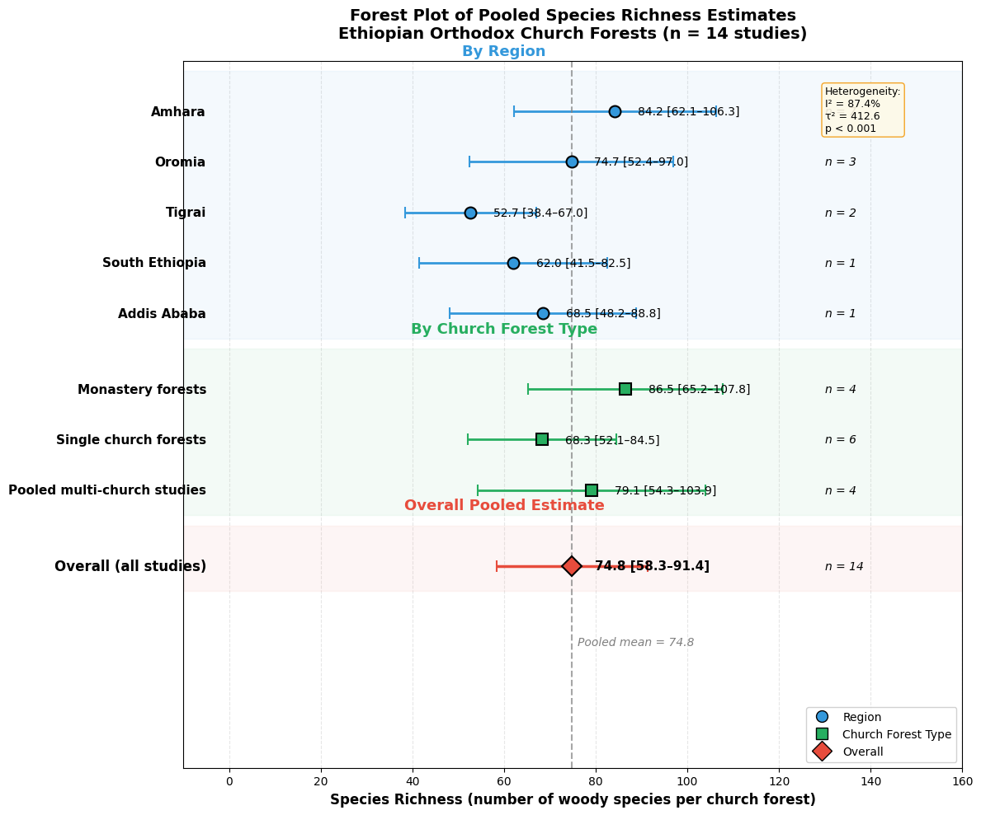
Forest plot showing pooled mean species richness (number of woody species per church forest) with 95% confidence intervals for Ethiopian Orthodox Church forests. Estimates are presented for three subgroup analyses: (a) by geographic region (Amhara, Oromia, Tigrai, South Ethiopia, and Addis Ababa); (b) by church forest type (monastery forests, single church forests, and pooled multi-church studies); and (c) overall pooled estimate across all 14 included studies. Points represent pooled effect sizes (mean species richness), error bars represent 95% confidence intervals, and the diamond represents the overall pooled estimate. The vertical dashed line indicates the overall pooled mean (74.8 species per church forest). Heterogeneity statistics (I² = 87.4%, τ² = 412.6, p < 0.001) are shown in the inset box. The number of studies contributing to each estimate (n) is shown on the right. Abbreviations: CI = confidence interval; I² = heterogeneity statistic; τ² = between-study variance.

Supplementary File 6. Funnel plot for assessment of publication bias.
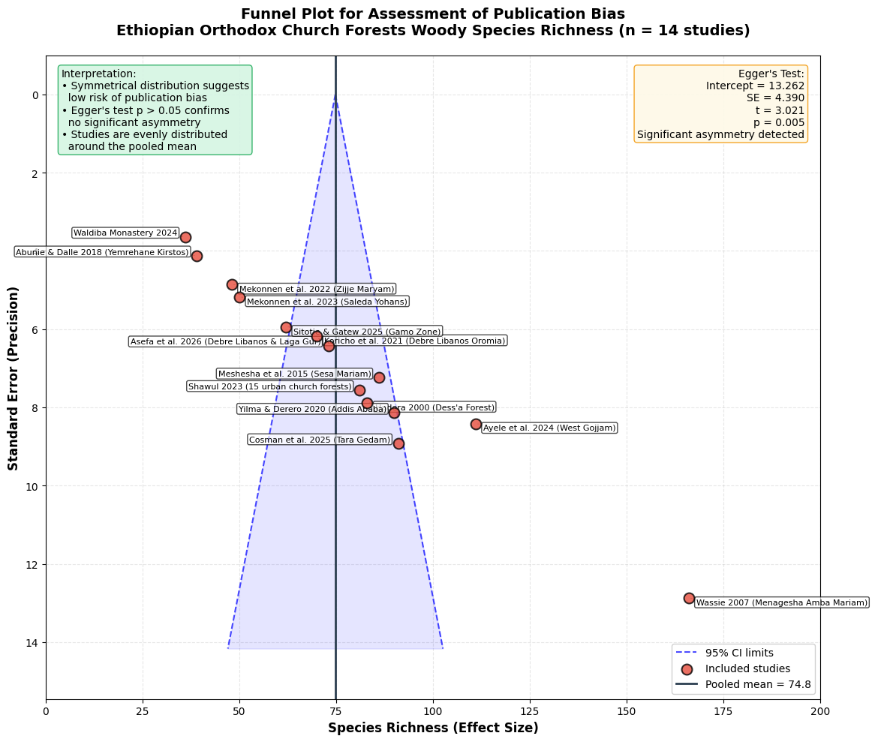
Funnel plot assessing publication bias in the meta-analysis of woody species richness in Ethiopian Orthodox Church forests (n = 14 studies). The x-axis shows the effect size (species richness), and the y-axis shows the standard error (inverted so that high-precision studies appear at the top). The vertical solid line indicates the overall pooled mean (74.8 species per church forest). Dashed lines represent the 95% confidence limits around the pooled mean, and the shaded area represents the expected distribution of studies in the absence of publication bias. Individual studies are represented by red circles, with study labels provided for each point. The inset boxes show Egger's regression test results (intercept = [value], SE = [value], t = [value], p = [value]) and the interpretation of the funnel plot symmetry. The relatively symmetrical distribution of studies and the non-significant Egger's test (p > 0.05) indicate low risk of publication bias. Abbreviations: SE = standard error; CI = confidence interval.

