Supplementary Material
Distinct transcriptomic programs and proximal AKT activation associated with AKT1 E17K and PIK3CA hotspot mutations in HR-positive/HER2-negative breast cancer
Contents: Supplementary Tables S1-S10 and Supplementary Figures S1-S6.
Data presentation: This PDF contains reviewer-readable statistical tables. Very large sample-level and transcriptome-wide result matrices can be regenerated using the separately provided Supplementary Code folder and are not reproduced in this PDF.
Contents
Item | Content
Table S1 | Sample flow, mutation frequencies, and mutual exclusivity
Table S2 | Complete clinicopathologic characteristics by cohort
Table S3 | Expression preprocessing, sample counts, and differential-expression summary
Table S4 | Cross-cohort gene-level replication
Table S5 | Pathway discovery and independent replication
Table S6 | Core pathway scores and candidate-gene effects
Table S7 | Genomic context and robustness analyses
Table S8 | Survival analyses
Table S9 | Immune and stromal analyses
Table S10 | TCGA RPPA analyses
Figures S1-S6 | Pathway, survival, immune, and expression-QC figures
Supplementary page 1

Supplementary Table S1
Sample flow, mutation frequencies, and mutual-exclusivity statistics. Cohorts are reported separately. Confidence intervals for mutation frequencies are Wilson 95% intervals; mutual exclusivity used two-sided Fisher exact tests.
S1A. Sample flow
Cohort | Analysis step | N
METABRIC | Clinical samples | 2,509
METABRIC | Primary samples | 2,509
METABRIC | Mutation evaluable | 2,433
METABRIC | Expression available | 1,904
TCGA | Clinical samples | 818
TCGA | Primary samples | 817
TCGA | Mutation evaluable | 816
TCGA | Expression available | 816
S1B. Hotspot mutation frequencies
Cohort | Population | Gene | Events/total | Frequency | 95% CI
METABRIC | Full | AKT1 | 79/2433 | 3.2% | 2.6-4.0%
METABRIC | Full | PIK3CA | 733/2433 | 30.1% | 28.3-32.0%
TCGA | Full | AKT1 | 19/816 | 2.3% | 1.5-3.6%
TCGA | Full | PIK3CA | 210/816 | 25.7% | 22.9-28.8%
METABRIC | HR+/HER2- | AKT1 | 54/1369 | 3.9% | 3.0-5.1%
METABRIC | HR+/HER2- | PIK3CA | 505/1369 | 36.9% | 34.4-39.5%
TCGA | HR+/HER2- | AKT1 | 16/447 | 3.6% | 2.2-5.7%
TCGA | HR+/HER2- | PIK3CA | 139/447 | 31.1% | 27.0-35.5%
METABRIC | Luminal AB | AKT1 | 45/1140 | 3.9% | 3.0-5.2%
METABRIC | Luminal AB | PIK3CA | 407/1140 | 35.7% | 33.0-38.5%
TCGA | Luminal AB | AKT1 | 16/428 | 3.7% | 2.3-6.0%
TCGA | Luminal AB | PIK3CA | 142/428 | 33.2% | 28.9-37.8%
S1C. AKT1/PIK3CA mutual exclusivity
Cohort | Population | Both | AKT1 only | PIK3CA only | Neither | OR (95% CI) | P value
METABRIC | Full | 0 | 79 | 733 | 1621 | 0 (0-0.11) | 4.98e-13
AKT1 E17K vs PIK3CA hotspot mutations in breast cancer Supplementary page 2

Cohort | Population | Both | AKT1 only | PIK3CA only | Neither | OR (95% CI) | P value
TCGA | Full | 1 | 18 | 209 | 588 | 0.16 (0.00-1.00) | 0.036
METABRIC | HR+/HER2- | 0 | 54 | 505 | 810 | 0 (0-0.11) | 1.80e-11
TCGA | HR+/HER2- | 1 | 15 | 138 | 293 | 0.14 (0.00-0.94) | 0.028
METABRIC | Luminal AB | 0 | 45 | 407 | 688 | 0 (0-0.15) | 2.12e-09
TCGA | Luminal AB | 1 | 15 | 141 | 271 | 0.13 (0.00-0.85) | 0.027
AKT1 E17K vs PIK3CA hotspot mutations in breast cancer Supplementary page 3

Supplementary Table S2
Complete clinicopathologic characteristics according to mutation group. Continuous variables are median [Q1, Q3]; categorical variables are n (% among non-missing observations). P values compare all three groups.
S2A. METABRIC
Characteristic | Level | AKT1-mut | PIK3CA-mut only | Pair-WT | P value
Age at diagnosis, years | Median [Q1, Q3] | 65.2 [53.6, 72.3] | 62.4 [52.8, 70.7] | 60.5 [50.0, 69.6] | <0.001
Age at diagnosis, years | Missing | 0 (0.0%) | 3 (0.4%) | 8 (0.5%)
Menopausal status | Premenopausal | 11 (17.5%) | 112 (18.8%) | 288 (23.1%) | 0.081
Menopausal status | Postmenopausal | 52 (82.5%) | 483 (81.2%) | 958 (76.9%)
Menopausal status | Missing | 16 (20.3%) | 138 (18.8%) | 375 (23.1%)
ER status | Positive | 69 (87.3%) | 610 (84.7%) | 1099 (68.9%) | <0.001
ER status | Negative | 10 (12.7%) | 110 (15.3%) | 495 (31.1%)
ER status | Missing | 0 (0.0%) | 13 (1.8%) | 27 (1.7%)
PR status | Positive | 45 (71.4%) | 403 (67.7%) | 561 (45.0%) | <0.001
PR status | Negative | 18 (28.6%) | 192 (32.3%) | 685 (55.0%)
PR status | Missing | 16 (20.3%) | 138 (18.8%) | 375 (23.1%)
HER2 status | Positive | 0 (0.0%) | 54 (9.1%) | 182 (14.6%) | <0.001
HER2 status | Negative | 63 (100.0%) | 541 (90.9%) | 1064 (85.4%)
HER2 status | Missing | 16 (20.3%) | 138 (18.8%) | 375 (23.1%)
PAM50 subtype | LumA | 31 (50.8%) | 298 (50.2%) | 350 (28.2%) | <0.001
PAM50 subtype | LumB | 14 (23.0%) | 109 (18.4%) | 338 (27.2%)
PAM50 subtype | HER2-enriched | 7 (11.5%) | 66 (11.1%) | 147 (11.8%)
PAM50 subtype | Basal | 2 (3.3%) | 20 (3.4%) | 177 (14.2%)
PAM50 subtype | Normal-like | 3 (4.9%) | 62 (10.4%) | 75 (6.0%)
PAM50 subtype | Claudin-low | 4 (6.6%) | 39 (6.6%) | 156 (12.6%)
PAM50 subtype | Missing | 18 (22.8%) | 139 (19.0%) | 378 (23.3%)
Histologic type | IDC/NST | 62 (82.7%) | 516 (72.6%) | 1195 (77.5%) | <0.001
Histologic type | ILC | 4 (5.3%) | 58 (8.2%) | 126 (8.2%)
Histologic type | Mixed | 8 (10.7%) | 111 (15.6%) | 146 (9.5%)
Histologic type | Other | 1 (1.3%) | 26 (3.7%) | 74 (4.8%)
Histologic type | Missing | 4 (5.1%) | 22 (3.0%) | 80 (4.9%)
Pathologic stage | 0 | 1 (1.8%) | 3 (0.6%) | 12 (1.1%) | 0.601
Pathologic stage | I | 16 (28.1%) | 185 (34.6%) | 403 (35.5%)
Pathologic stage | II | 37 (64.9%) | 303 (56.7%) | 614 (54.1%)
Pathologic stage | III | 3 (5.3%) | 39 (7.3%) | 99 (8.7%)
Pathologic stage | IV | 0 (0.0%) | 4 (0.7%) | 6 (0.5%)
AKT1 E17K vs PIK3CA hotspot mutations in breast cancer Supplementary page 4

Characteristic | Level | AKT1-mut | PIK3CA-mut only | Pair-WT | P value
Pathologic stage | Missing | 22 (27.8%) | 199 (27.1%) | 487 (30.0%)
Histologic grade | 1 | 5 (6.7%) | 105 (14.9%) | 100 (6.5%) | <0.001
Histologic grade | 2 | 44 (58.7%) | 343 (48.8%) | 558 (36.0%)
Histologic grade | 3 | 26 (34.7%) | 255 (36.3%) | 892 (57.5%)
Histologic grade | Missing | 4 (5.1%) | 30 (4.1%) | 71 (4.4%)
Tumor size, mm | Median [Q1, Q3] | 22.0 [16.0, 30.0] | 22.0 [17.0, 30.0] | 23.0 [17.9, 30.0] | 0.204
Tumor size, mm | Missing | 1 (1.3%) | 20 (2.7%) | 122 (7.5%)
Positive lymph nodes, n | Median [Q1, Q3] | 1.0 [0.0, 2.0] | 0.0 [0.0, 2.0] | 0.0 [0.0, 2.0] | 0.290
Positive lymph nodes, n | Missing | 5 (6.3%) | 39 (5.3%) | 146 (9.0%)
Tumor cellularity | Low | 3 (4.8%) | 77 (13.2%) | 120 (10.0%) | 0.081
Tumor cellularity | Moderate | 23 (36.5%) | 228 (39.1%) | 460 (38.2%)
Tumor cellularity | High | 37 (58.7%) | 278 (47.7%) | 624 (51.8%)
Tumor cellularity | Missing | 16 (20.3%) | 150 (20.5%) | 417 (25.7%)
S2B. TCGA
Characteristic | Level | AKT1-mut | PIK3CA-mut only | Pair-WT | P value
Age at diagnosis, years | Median [Q1, Q3] | 50.0 [44.0, 57.0] | 60.0 [50.0, 71.0] | 59.0 [48.5, 67.0] | 0.008
Age at diagnosis, years | Missing | 0 (0.0%) | 0 (0.0%) | 1 (0.2%)
Menopausal status | Premenopausal | 5 (27.8%) | 45 (22.7%) | 114 (20.9%) | 0.054
Menopausal status | Perimenopausal | 2 (11.1%) | 8 (4.0%) | 20 (3.7%)
Menopausal status | Postmenopausal | 8 (44.4%) | 140 (70.7%) | 390 (71.6%)
Menopausal status | Indeterminate | 3 (16.7%) | 5 (2.5%) | 21 (3.9%)
Menopausal status | Missing | 1 (5.3%) | 11 (5.3%) | 43 (7.3%)
ER status | Positive | 19 (100.0%) | 180 (91.4%) | 401 (71.7%) | <0.001
ER status | Negative | 0 (0.0%) | 17 (8.6%) | 158 (28.3%)
ER status | Missing | 0 (0.0%) | 12 (5.7%) | 29 (4.9%)
PR status | Positive | 16 (88.9%) | 166 (84.3%) | 339 (60.9%) | <0.001
PR status | Negative | 2 (11.1%) | 31 (15.7%) | 218 (39.1%)
PR status | Missing | 1 (5.3%) | 12 (5.7%) | 31 (5.3%)
HER2 status | Positive | 1 (5.9%) | 32 (18.0%) | 107 (20.9%) | 0.289
HER2 status | Negative | 16 (94.1%) | 146 (82.0%) | 406 (79.1%)
HER2 status | Missing | 2 (10.5%) | 31 (14.8%) | 75 (12.8%)
PAM50 subtype | LumA | 13 (76.5%) | 108 (68.8%) | 185 (44.9%) | <0.001
PAM50 subtype | LumB | 3 (17.6%) | 33 (21.0%) | 86 (20.9%)
PAM50 subtype | HER2-enriched | 1 (5.9%) | 12 (7.6%) | 38 (9.2%)
PAM50 subtype | Basal | 0 (0.0%) | 4 (2.5%) | 103 (25.0%)
AKT1 E17K vs PIK3CA hotspot mutations in breast cancer Supplementary page 5

Characteristic | Level | AKT1-mut | PIK3CA-mut only | Pair-WT | P value
PAM50 subtype | Missing | 2 (10.5%) | 52 (24.9%) | 176 (29.9%)
Histologic type | IDC/NST | 15 (78.9%) | 144 (68.9%) | 418 (71.1%) | 0.013
Histologic type | ILC | 2 (10.5%) | 46 (22.0%) | 79 (13.4%)
Histologic type | Other | 2 (10.5%) | 19 (9.1%) | 91 (15.5%)
Pathologic stage | I | 6 (33.3%) | 39 (19.2%) | 95 (16.5%) | 0.487
Pathologic stage | II | 7 (38.9%) | 116 (57.1%) | 337 (58.5%)
Pathologic stage | III | 5 (27.8%) | 44 (21.7%) | 135 (23.4%)
Pathologic stage | IV | 0 (0.0%) | 4 (2.0%) | 9 (1.6%)
Pathologic stage | Missing | 1 (5.3%) | 6 (2.9%) | 12 (2.0%)
Pathologic T category | T1 | 9 (47.4%) | 63 (30.1%) | 147 (25.0%) | 0.102
Pathologic T category | T2 | 6 (31.6%) | 105 (50.2%) | 347 (59.0%)
Pathologic T category | T3 | 3 (15.8%) | 32 (15.3%) | 70 (11.9%)
Pathologic T category | T4 | 1 (5.3%) | 9 (4.3%) | 23 (3.9%)
Pathologic T category | TX | 0 (0.0%) | 0 (0.0%) | 1 (0.2%)
Pathologic N category | N0 | 9 (47.4%) | 104 (49.8%) | 269 (45.7%) | 0.878
Pathologic N category | N1 | 7 (36.8%) | 66 (31.6%) | 204 (34.7%)
Pathologic N category | N2 | 3 (15.8%) | 22 (10.5%) | 60 (10.2%)
Pathologic N category | N3 | 0 (0.0%) | 15 (7.2%) | 43 (7.3%)
Pathologic N category | NX | 0 (0.0%) | 2 (1.0%) | 12 (2.0%)
AKT1 E17K vs PIK3CA hotspot mutations in breast cancer Supplementary page 6

Supplementary Table S3
Expression preprocessing, model sample counts, and differential-expression summary. Complete transcriptome-wide result matrices can be regenerated using the separately supplied Supplementary Code.
S3A. Expression preprocessing
Cohort | Input genes | Duplicates collapsed | Processed genes | Matrix samples | Eligible primary samples | Transformation
METABRIC | 20592 | 218 | 20374 | 1980 | 1904 | Downloaded normalized Illumina microarray expression
TCGA | 20440 | 9 | 18089 | 817 | 816 | log2(RSEM + 1); retained raw RSEM > 1 in at least 82 samples (10%)
S3B. Model sample counts
Cohort | Population | Model | AKT1-mut | PIK3CA-mut only | Pair-WT
METABRIC | HR+/HER2- | adjusted | 52 | 504 | 807
METABRIC | HR+/HER2- | basic | 54 | 505 | 810
METABRIC | Luminal AB | adjusted | 45 | 407 | 688
METABRIC | Luminal AB | basic | 45 | 407 | 688
TCGA | HR+/HER2- | adjusted | 14 | 102 | 203
TCGA | HR+/HER2- | basic | 16 | 138 | 293
TCGA | Luminal AB | adjusted | 16 | 141 | 271
TCGA | Luminal AB | basic | 16 | 141 | 271
S3C. Differential-expression result counts
Cohort | Contrast | Genes tested | FDR < 0.05 | FDR < 0.05 and |log2FC| >= 0.5
METABRIC | AKT1-mut vs PIK3CA-mut only | 20,374 | 360 | 35
METABRIC | AKT1-mut vs Pair-WT | 20,374 | 1447 | 100
METABRIC | PIK3CA-mut only vs Pair-WT | 20,374 | 4554 | 33
TCGA | AKT1-mut vs PIK3CA-mut only | 18,089 | 1 | 1
TCGA | AKT1-mut vs Pair-WT | 18,089 | 252 | 202
TCGA | PIK3CA-mut only vs Pair-WT | 18,089 | 1964 | 495
AKT1 E17K vs PIK3CA hotspot mutations in breast cancer Supplementary page 7

Supplementary Table S4
Cross-cohort gene-level replication. All 53 genes shown were discovered in METABRIC at FDR<0.05 and showed same-direction nominal replication in TCGA for the primary AKT1-mut versus PIK3CA-mut-only comparison. No gene passed transcriptome-wide TCGA FDR correction.
S4A. Cross-cohort summary
Contrast | Common genes | METABRIC FDR genes | Direction concordant | TCGA nominal replications | Spearman rho
AKT1-mut vs Pair-WT | 16,620 | 1356 | 1175 | 442 | 0.343
PIK3CA-mut only vs Pair-WT | 16,620 | 4219 | 3919 | 2208 | 0.625
AKT1-mut vs PIK3CA-mut only | 16,620 | 341 | 280 | 53 | 0.226
S4B. Same-direction nominally replicated genes
Gene | METABRIC log2FC | METABRIC FDR | TCGA log2FC | TCGA P | TCGA FDR
AKT1 | 0.45 | 9.39e-06 | 0.32 | 0.025 | 0.596
PIK3R3 | 0.24 | 3.47e-05 | 0.61 | 0.005 | 0.479
MYO3B | 0.45 | 2.54e-04 | 2.12 | 0.003 | 0.415
FOXO4 | -0.31 | 2.54e-04 | -0.75 | 5.89e-05 | 0.102
YPEL3 | -0.38 | 6.53e-04 | -0.50 | 0.021 | 0.583
ABTB1 | -0.31 | 0.001 | -0.49 | 0.011 | 0.545
SND1 | 0.29 | 0.001 | 0.22 | 0.049 | 0.652
PDK4 | -0.61 | 0.004 | -0.92 | 0.034 | 0.621
PLA2G4F | 0.34 | 0.004 | 1.16 | 0.003 | 0.403
GALE | 0.42 | 0.004 | 0.49 | 0.044 | 0.648
MYC | -0.63 | 0.004 | -1.00 | 9.21e-04 | 0.310
PDIA4 | 0.29 | 0.004 | 0.43 | 0.005 | 0.510
CEBPD | -0.51 | 0.004 | -0.67 | 0.045 | 0.648
SLC22A18AS | 0.44 | 0.004 | 1.33 | 5.42e-04 | 0.278
P4HB | 0.31 | 0.005 | 0.43 | 0.011 | 0.545
JARID2 | -0.28 | 0.005 | -0.42 | 0.007 | 0.516
FGD5 | -0.40 | 0.005 | -0.54 | 0.035 | 0.626
IDH2 | 0.45 | 0.005 | 0.51 | 0.039 | 0.636
GAD1 | 0.68 | 0.008 | 1.66 | 0.009 | 0.533
MARK1 | 0.24 | 0.009 | 0.90 | 0.025 | 0.596
ANXA2P3 | 0.19 | 0.011 | 0.67 | 0.007 | 0.512
ETNPPL | 0.24 | 0.011 | 1.30 | 0.018 | 0.567
PLXNA3 | 0.37 | 0.012 | 0.35 | 0.050 | 0.652
AKT1 E17K vs PIK3CA hotspot mutations in breast cancer Supplementary page 8

Gene | METABRIC log2FC | METABRIC FDR | TCGA log2FC | TCGA P | TCGA FDR
EXOSC5 | -0.22 | 0.014 | -0.61 | 4.01e-04 | 0.275
ANKS1A | -0.20 | 0.014 | -0.29 | 0.022 | 0.583
CHPF | 0.36 | 0.014 | 0.42 | 0.028 | 0.603
MLEC | 0.27 | 0.014 | 0.35 | 0.040 | 0.636
CALCOCO1 | -0.17 | 0.016 | -0.38 | 0.007 | 0.512
IRS1 | -0.40 | 0.019 | -0.68 | 0.012 | 0.545
PLCH1 | 0.19 | 0.021 | 1.57 | 0.025 | 0.595
ATP13A4 | 0.11 | 0.021 | 1.43 | 0.026 | 0.599
KMO | 0.29 | 0.021 | 1.62 | 0.001 | 0.325
MOCS1 | -0.28 | 0.022 | -0.44 | 0.031 | 0.604
RCL1 | -0.18 | 0.023 | -0.30 | 0.050 | 0.652
TXNIP | -0.37 | 0.024 | -0.56 | 0.019 | 0.567
NUSAP1 | 0.38 | 0.026 | 0.52 | 0.043 | 0.645
MGME1 | -0.19 | 0.026 | -0.33 | 0.013 | 0.550
DEDD2 | -0.17 | 0.032 | -0.31 | 0.024 | 0.594
CNOT11 | 0.21 | 0.032 | 0.26 | 0.015 | 0.555
ZBTB16 | -0.46 | 0.033 | -1.37 | 0.018 | 0.567
RBP7 | -0.43 | 0.033 | -0.82 | 0.024 | 0.595
GSR | 0.29 | 0.036 | 0.72 | 0.018 | 0.567
AP1B1 | 0.21 | 0.036 | 0.29 | 0.045 | 0.648
IVD | 0.23 | 0.038 | 0.45 | 0.006 | 0.512
C1orf53 | 0.37 | 0.041 | 0.75 | 0.014 | 0.550
ADM2 | 0.20 | 0.043 | 0.59 | 0.046 | 0.652
HMGN5 | 0.25 | 0.043 | 0.61 | 0.049 | 0.652
LAMA2 | -0.32 | 0.043 | -0.75 | 0.026 | 0.598
CLSTN2 | -0.44 | 0.045 | -1.06 | 0.021 | 0.579
PLCL1 | 0.21 | 0.045 | 0.74 | 0.050 | 0.652
DNAJC12 | -0.68 | 0.045 | -0.96 | 0.046 | 0.651
GALT | -0.24 | 0.048 | -0.53 | 0.010 | 0.543
SYAP1 | 0.31 | 0.048 | 0.37 | 0.036 | 0.628
AKT1 E17K vs PIK3CA hotspot mutations in breast cancer Supplementary page 9

Supplementary Table S5
Hallmark and Reactome pathway discovery and independent replication. Independent replication required concordant direction and TCGA FDR<0.05.
S5A. Pathway-level analysis summary
Contrast | Collection | Pathways | METABRIC FDR | Direction  concordant | TCGA  nominal | TCGA FDR replicated | Spearman rho
AKT1-mut vs Pair-WT | Hallmark | 50 | 2 | 2 | 1 | 1 | 0.247
AKT1-mut vs Pair-WT | Reactome | 1398 | 27 | 27 | 21 | 6 | 0.418
PIK3CA-mut only vs Pair-WT | Hallmark | 50 | 18 | 18 | 15 | 14 | 0.931
PIK3CA-mut only vs Pair-WT | Reactome | 1398 | 135 | 133 | 105 | 77 | 0.810
AKT1-mut vs PIK3CA-mut only | Hallmark | 50 | 13 | 3 | 2 | 2 | 0.295
AKT1-mut vs PIK3CA-mut only | Reactome | 1398 | 31 | 27 | 14 | 7 | 0.306
S5B. Nine independently replicated pathways
Pathway | Collection | METABRIC direction | METABRIC z | METABRIC FDR | TCGA z | TCGA FDR
G2M checkpoint | Hallmark | Up | 3.63 | 0.002 | 3.54 | 0.003
Glycolysis | Hallmark | Up | 2.64 | 0.034 | 3.66 | 0.003
COPI-dependent Golgi-to-ER retrograde traffic | Reactome | Up | 3.58 | 0.022 | 3.53 | 0.008
COPI-mediated anterograde transport | Reactome | Up | 3.51 | 0.025 | 3.08 | 0.023
ER-to-Golgi anterograde transport | Reactome | Up | 3.40 | 0.034 | 4.01 | 0.002
Eukaryotic translation elongation | Reactome | Down | -6.24 | 6.32e-07 | -3.10 | 0.022
Golgi-to-ER retrograde transport | Reactome | Up | 3.45 | 0.030 | 3.91 | 0.002
Nonsense-mediated decay | Reactome | Down | -4.89 | 2.94e-04 | -3.21 | 0.016
Resolution of sister-chromatid cohesion | Reactome | Up | 3.62 | 0.021 | 4.04 | 0.001
AKT1 E17K vs PIK3CA hotspot mutations in breast cancer Supplementary page 10

Supplementary Table S6
Core pathway-score and exploratory candidate-gene effects. Effects are adjusted standardized differences for AKT1-mut versus PIK3CA-mut-only tumors in HR+/HER2-analyses.
S6A. Core pathway-score effects
Cohort | Pathway | n AKT1 / PIK3CA | Effect (SD) | 95% CI | P value | FDR
METABRIC | G2M checkpoint | 52/504 | 0.26 | 0.02 to 0.49 | 0.034 | 0.043
METABRIC | Glycolysis | 52/504 | 0.52 | 0.25 to 0.79 | 1.55e-04 | 2.80e-04
METABRIC | Eukaryotic translation elongation | 52/504 | -0.27 | -0.55 to 0.01 | 0.056 | 0.063
METABRIC | Nonsense-mediated decay | 52/504 | -0.25 | -0.53 to 0.02 | 0.073 | 0.073
TCGA | G2M checkpoint | 14/102 | 0.17 | -0.28 to 0.62 | 0.455 | 0.455
TCGA | Glycolysis | 14/102 | 0.50 | -0.03 to 1.03 | 0.065 | 0.153
TCGA | Eukaryotic translation elongation | 14/102 | -0.25 | -0.81 to 0.30 | 0.373 | 0.420
TCGA | Nonsense-mediated decay | 14/102 | -0.33 | -0.88 to 0.23 | 0.247 | 0.317
S6B. Candidate-gene effects
FDR values are adjusted across the three displayed candidates and are not transcriptome-wide TCGA FDR values.
Cohort | Gene | n AKT1 / PIK3CA | Effect (SD) | 95% CI | P value | Focused-panel FDR
METABRIC | GALE | 52/504 | 0.64 | 0.36 to 0.92 | 8.71e-06 | 2.61e-05
METABRIC | CHPF | 52/504 | 0.57 | 0.29 to 0.85 | 7.72e-05 | 1.16e-04
METABRIC | NUSAP1 | 52/504 | 0.46 | 0.21 to 0.70 | 2.70e-04 | 2.70e-04
TCGA | GALE | 14/102 | 0.57 | 0.02 to 1.12 | 0.043 | 0.048
TCGA | CHPF | 14/102 | 0.62 | 0.07 to 1.17 | 0.027 | 0.048
TCGA | NUSAP1 | 14/102 | 0.48 | 0.01 to 0.95 | 0.048 | 0.048
AKT1 E17K vs PIK3CA hotspot mutations in breast cancer Supplementary page 11

Supplementary Table S7
Genomic context and robustness analyses. Genomic analyses compared AKT1-mut and PIK3CA-mut-only HR+/HER2- tumors within each cohort.
S7A. GATA3 co-mutation comparison
Cohort | AKT1-mut | PIK3CA-mut only | Odds ratio | 95% CI | P value | FDR
METABRIC | 16/54 | 72/505 | 2.53 | 1.25 to 4.93 | 0.006 | 0.233
TCGA | 7/16 | 9/138 | 10.82 | 2.76 to 42.73 | 2.22e-04 | 0.004
S7B. Genomic-burden comparisons
Cohort | Metric | n AKT1 / PIK3CA | Median AKT1 | Median PIK3CA | Difference | P value | Primary FDR
METABRIC | tmb | 54/505 | 6.538 | 6.538 | 0 | 0.208 | 0.389
METABRIC | cna fraction altered | 54/505 | 0.162 | 0.183 | -0.021 | 0.260 | 0.389
METABRIC | cna fraction high level | 54/505 | 0.017 | 0.017 | 5.55e-04 | 0.499 | 0.499
METABRIC | cna fraction amplified | 54/505 | 0.017 | 0.016 | 5.99e-04 | 0.528 | NA
METABRIC | cna fraction deleted | 54/505 | 4.44e-05 | 8.87e-05 | -4.44e-05 | 0.394 | NA
TCGA | tmb | 16/138 | 0.767 | 0.967 | -0.200 | 0.402 | 0.588
TCGA | cna fraction altered | 16/138 | 0.215 | 0.289 | -0.074 | 0.299 | 0.588
TCGA | cna fraction high level | 16/138 | 0.005 | 0.005 | 2.02e-04 | 0.588 | 0.588
TCGA | cna fraction amplified | 16/138 | 0.005 | 0.003 | 0.002 | 0.964 | NA
TCGA | cna fraction deleted | 16/138 | 9.00e-05 | 4.50e-05 | 4.50e-05 | 0.828 | NA
AKT1 E17K vs PIK3CA hotspot mutations in breast cancer Supplementary page 12

S7C. Clinical-plus-genomic robustness models
Cohort | Type | Feature | n AKT1 / PIK3CA | Effect (SD) | 95% CI | P value | FDR
METABRIC | Candidate gene | GALE | 52/504 | 0.68 | 0.41 to 0.94 | 9.23e-07 | 6.46e-06
METABRIC | Candidate gene | CHPF | 52/504 | 0.61 | 0.33 to 0.89 | 2.68e-05 | 4.70e-05
METABRIC | Candidate gene | NUSAP1 | 52/504 | 0.50 | 0.28 to 0.72 | 8.12e-06 | 2.84e-05
METABRIC | Pathway | G2M checkpoint | 52/504 | 0.30 | 0.11 to 0.49 | 0.002 | 0.003
METABRIC | Pathway | Glycolysis | 52/504 | 0.55 | 0.31 to 0.80 | 1.22e-05 | 2.84e-05
METABRIC | Pathway | Eukaryotic translation elongation | 52/504 | -0.29 | -0.57 to -0.01 | 0.044 | 0.051
METABRIC | Pathway | Nonsense-mediated decay | 52/504 | -0.26 | -0.54 to 0.02 | 0.066 | 0.066
TCGA | Candidate gene | GALE | 14/102 | 0.48 | -0.14 to 1.09 | 0.129 | 0.193
TCGA | Candidate gene | CHPF | 14/102 | 0.61 | 0.04 to 1.18 | 0.038 | 0.132
TCGA | Candidate gene | NUSAP1 | 14/102 | 0.68 | 0.19 to 1.18 | 0.007 | 0.051
TCGA | Pathway | G2M checkpoint | 14/102 | 0.35 | -0.11 to 0.82 | 0.135 | 0.193
TCGA | Pathway | Glycolysis | 14/102 | 0.38 | -0.13 to 0.89 | 0.138 | 0.193
TCGA | Pathway | Eukaryotic translation elongation | 14/102 | -0.19 | -0.78 to 0.39 | 0.515 | 0.515
TCGA | Pathway | Nonsense-mediated decay | 14/102 | -0.25 | -0.83 to 0.33 | 0.390 | 0.454
AKT1 E17K vs PIK3CA hotspot mutations in breast cancer Supplementary page 13

Supplementary Table S8
Survival endpoint audit and adjusted Cox-model results. The displayed Cox results are the primary HR+/HER2- AKT1-mut versus PIK3CA-mut-only comparisons. TCGA effects were non-estimable when the AKT1-mut group had no events.
S8A. Endpoint audit
Cohort | Endpoint | Group | N | Events | Censored | Median follow-up, months
METABRIC | OS | pair WT | 810 | 470 | 340 | 118.1
METABRIC | OS | PIK3CA mut only | 505 | 297 | 208 | 126.6
METABRIC | OS | AKT1 mut | 54 | 28 | 26 | 145.3
METABRIC | DSS | pair WT | 810 | 235 | 575 | 118.1
METABRIC | DSS | PIK3CA mut only | 504 | 142 | 362 | 126.5
METABRIC | DSS | AKT1 mut | 54 | 16 | 38 | 145.3
METABRIC | RFS | pair WT | 810 | 311 | 499 | 104.6
METABRIC | RFS | PIK3CA mut only | 504 | 194 | 310 | 112.0
METABRIC | RFS | AKT1 mut | 54 | 18 | 36 | 134.3
TCGA | OS | pair WT | 293 | 29 | 264 | 27.5
TCGA | OS | PIK3CA mut only | 138 | 12 | 126 | 25.1
TCGA | OS | AKT1 mut | 16 | 0 | 16 | 25.3
TCGA | DFS | pair WT | 275 | 24 | 251 | 25.0
TCGA | DFS | PIK3CA mut only | 128 | 10 | 118 | 23.9
TCGA | DFS | AKT1 mut | 16 | 0 | 16 | 25.3
S8B. Adjusted Cox models
Cohort | Endpoint | N | Events | Events  AKT1/PIK3CA | HR (95% CI) | P value | FDR
METABRIC | OS | 529 | 306 | 27/279 | 0.80 (0.54-1.21) | 0.290 | 0.435
METABRIC | DSS | 528 | 151 | 16/135 | 1.00 (0.59-1.70) | 0.996 | 0.996
METABRIC | RFS | 528 | 200 | 18/182 | 0.83 (0.51-1.37) | 0.475 | 0.651
TCGA | OS | 150 | 12 | 0/12 | Not estimable | NA | NA
TCGA | DFS | 140 | 10 | 0/10 | Not estimable | NA | NA
AKT1 E17K vs PIK3CA hotspot mutations in breast cancer Supplementary page 14

Supplementary Table S9
Cross-cohort immune and stromal analyses. Effects are adjusted standardized differences for AKT1-mut versus PIK3CA-mut-only tumors. No feature met the prespecified cross-cohort replication rule.
S9A. Immune-feature effects
Method | Feature | METABRIC effect | METABRIC FDR | TCGA effect | TCGA FDR | Direction  concordant | TCGA nominal replication
ESTIMATE | StromalScore | -0.35 | 0.016 | -0.13 | 0.990 | Yes | No
ESTIMATE | ImmuneScore | -0.31 | 0.023 | 0.11 | 0.990 | No | No
ESTIMATE | ESTIMATEScore | -0.36 | 0.016 | -0.00 | 0.990 | Yes | No
MCP-counter | T cells | -0.16 | 0.510 | -0.11 | 0.835 | Yes | No
MCP-counter | CD8 T cells | -0.12 | 0.510 | -0.20 | 0.835 | Yes | No
MCP-counter | Cytotoxic lymphocytes | -0.14 | 0.510 | -0.12 | 0.835 | Yes | No
MCP-counter | B lineage | -0.27 | 0.483 | -0.34 | 0.835 | Yes | No
MCP-counter | NK cells | 0.08 | 0.635 | 0.20 | 0.835 | Yes | No
MCP-counter | Monocytic lineage | -0.17 | 0.510 | 0.10 | 0.835 | No | No
MCP-counter | Myeloid dendritic cells | -0.12 | 0.510 | 0.13 | 0.835 | No | No
MCP-counter | Neutrophils | 0.06 | 0.652 | 0.05 | 0.835 | Yes | No
MCP-counter | Endothelial cells | -0.22 | 0.510 | -0.24 | 0.835 | Yes | No
MCP-counter | Fibroblasts | -0.11 | 0.510 | -0.07 | 0.835 | Yes | No
ssGSEA | HALLMARK INTERFERON ALPHA RESPONSE | -0.24 | 0.086 | 0.01 | 0.963 | No | No
ssGSEA | HALLMARK INTERFERON GAMMA RESPONSE | -0.27 | 0.068 | 0.11 | 0.963 | No | No
ssGSEA | HALLMARK INFLAMMATORY RESPONSE | -0.32 | 0.055 | 0.10 | 0.963 | No | No
ssGSEA | HALLMARK IL6 JAK STAT3 SIGNALING | -0.38 | 0.037 | -0.04 | 0.963 | Yes | No
ssGSEA | HALLMARK COMPLEMENT | -0.27 | 0.068 | 0.16 | 0.963 | No | No
AKT1 E17K vs PIK3CA hotspot mutations in breast cancer Supplementary page 15

Supplementary Table S10
TCGA RPPA protein and signaling-domain effects. Effects are age- and PAM50-adjusted standardized differences for AKT1-mut versus PIK3CA-mut-only HR+/HER2-tumors.
S10A. Signaling-domain effects
Domain | n AKT1 / PIK3CA | Effect (SD) | 95% CI | P value | FDR
AKT activation | 12/112 | 0.98 | 0.41 to 1.56 | 8.34e-04 | 0.003
AKT substrates | 12/112 | -0.16 | -0.74 to 0.41 | 0.577 | 0.866
mTOR effectors | 12/112 | -0.02 | -0.59 to 0.56 | 0.953 | 0.953
S10B. Individual-protein effects
Protein | Module | Measurement | Effect (SD) | 95% CI | P value | FDR
PI3K p110alpha | PI3K/PTEN | Total | 0.38 | -0.21 to 0.96 | 0.207 | 0.474
PTEN | PI3K/PTEN | Total | 0.32 | -0.27 to 0.91 | 0.283 | 0.474
AKT total | AKT core | Total | -0.08 | -0.66 to 0.51 | 0.798 | 0.887
AKT pS473 | AKT core | Phospho | 1.00 | 0.41 to 1.59 | 8.21e-04 | 0.011
AKT pT308 | AKT core | Phospho | 0.90 | 0.32 to 1.49 | 0.003 | 0.017
PRAS40 pT246 | AKT substrates | Phospho | 0.05 | -0.54 to 0.64 | 0.866 | 0.938
GSK3A/B pS21/S9 | AKT substrates | Phospho | -0.26 | -0.84 to 0.33 | 0.388 | 0.743
GSK3 pS9 | AKT substrates | Phospho | -0.17 | -0.76 to 0.42 | 0.572 | 0.743
TSC2 total | AKT substrates | Total | 0.31 | -0.27 to 0.90 | 0.296 | 0.474
TSC2 pT1462 | AKT substrates | Phospho | -0.19 | -0.77 to 0.40 | 0.531 | 0.743
mTOR total | mTOR effectors | Total | 0.35 | -0.24 to 0.93 | 0.245 | 0.474
mTOR pS2448 | mTOR effectors | Phospho | 0.18 | -0.41 to 0.76 | 0.555 | 0.743
p70S6K total | mTOR effectors | Total | 0.05 | -0.54 to 0.63 | 0.874 | 0.887
p70S6K pT389 | mTOR effectors | Phospho | -0.35 | -0.93 to 0.24 | 0.245 | 0.743
S6 total | mTOR effectors | Total | 0.66 | 0.07 to 1.25 | 0.027 | 0.218
S6 pS235/S236 | mTOR effectors | Phospho | -0.01 | -0.60 to 0.58 | 0.971 | 0.971
S6 pS240/S244 | mTOR effectors | Phospho | 0.20 | -0.39 to 0.79 | 0.502 | 0.743
4E-BP1 total | mTOR effectors | Total | -0.04 | -0.63 to 0.54 | 0.887 | 0.887
4E-BP1 pS65 | mTOR effectors | Phospho | -0.06 | -0.65 to 0.52 | 0.832 | 0.938
4E-BP1 pT37/T46 | mTOR effectors | Phospho | -0.23 | -0.82 to 0.35 | 0.439 | 0.743
4E-BP1 pT70 | mTOR effectors | Phospho | 0.20 | -0.39 to 0.79 | 0.504 | 0.743
AKT1 E17K vs PIK3CA hotspot mutations in breast cancer Supplementary page 16

Supplementary Figure S1
Full pathway-enrichment discovery and independent validation. Hallmark and Reactome pathway enrichment for AKT1-mut versus PIK3CA-mut-only HR+/HER2- tumors, including cross-cohort concordance and discovery-to-validation counts.
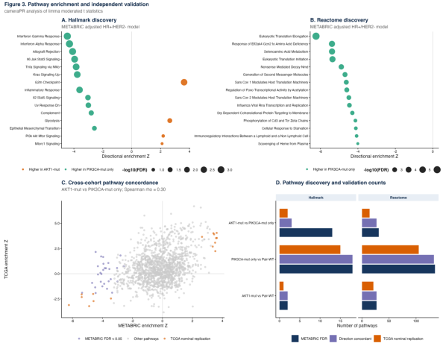
AKT1 E17K vs PIK3CA hotspot mutations in breast cancer Supplementary page 17

Supplementary Figure S2
Mutation groups and clinical outcomes. Kaplan-Meier estimates, log-rank tests, and adjusted Cox models for available METABRIC and TCGA endpoints.
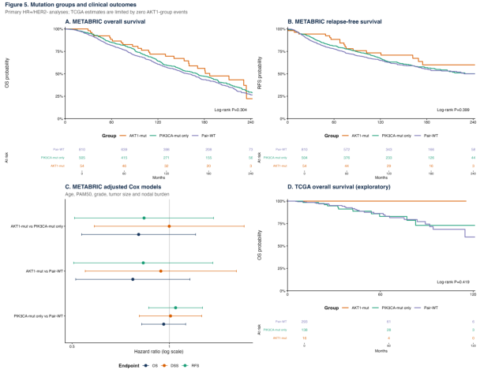
AKT1 E17K vs PIK3CA hotspot mutations in breast cancer Supplementary page 18

Supplementary Figure S3
Formal immune and stromal scoring by mutation group. Age- and PAM50-adjusted MCP-counter, ESTIMATE, and ssGSEA comparisons in METABRIC and TCGA.
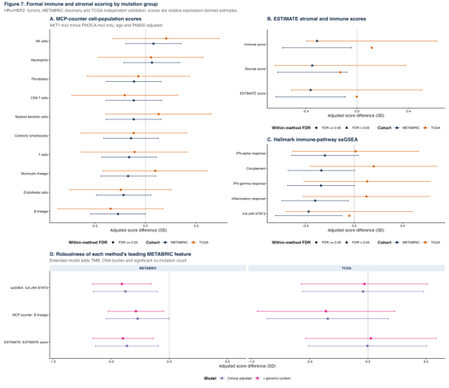
AKT1 E17K vs PIK3CA hotspot mutations in breast cancer Supplementary page 19

Supplementary Figure S4
Immune infiltration landscape by mutation group. (A) Individual-tumor MCP-counter profiles for AKT1-mutant and PIK3CA-mutant-only HR-positive/HER2-negative tumors in METABRIC and TCGA. (B) Median within-cohort standardized MCP-counter, ESTIMATE, and ssGSEA scores across AKT1-mutant, PIK3CA-mutant-only, and pair-wild-type groups. (C) ESTIMATE immune- and stromal-score distributions with age- and PAM50-adjusted AKT1-mutant versus PIK3CA-mutant-only effects. Expression-derived estimates do not represent absolute cell fractions.
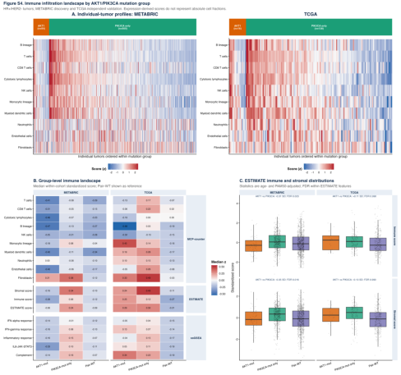
AKT1 E17K vs PIK3CA hotspot mutations in breast cancer Supplementary page 20

Supplementary Figure S5A
METABRIC HR+/HER2- expression-quality-control PCA.
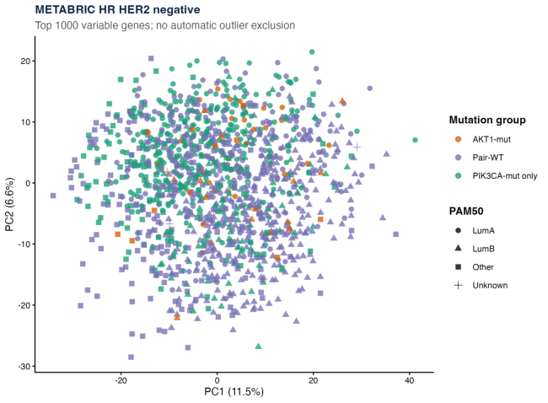
AKT1 E17K vs PIK3CA hotspot mutations in breast cancer Supplementary page 21

Supplementary Figure S5B
TCGA HR+/HER2- expression-quality-control PCA.
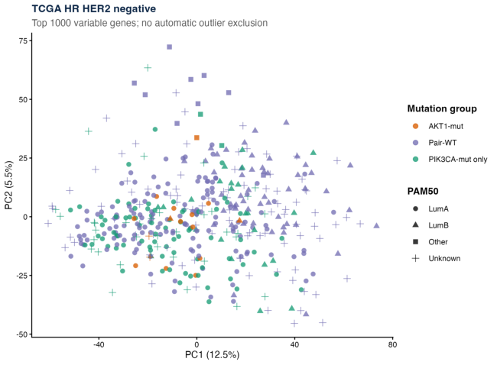
AKT1 E17K vs PIK3CA hotspot mutations in breast cancer Supplementary page 22

Supplementary Figure S5C
METABRIC Luminal A/B expression-quality-control PCA.
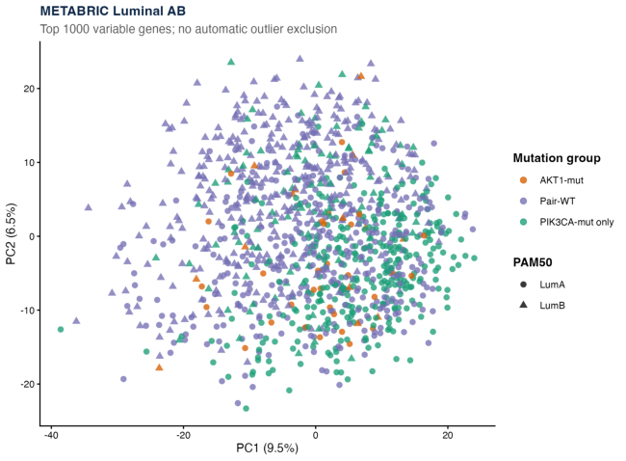
AKT1 E17K vs PIK3CA hotspot mutations in breast cancer Supplementary page 23

Supplementary Figure S5D
TCGA Luminal A/B expression-quality-control PCA.
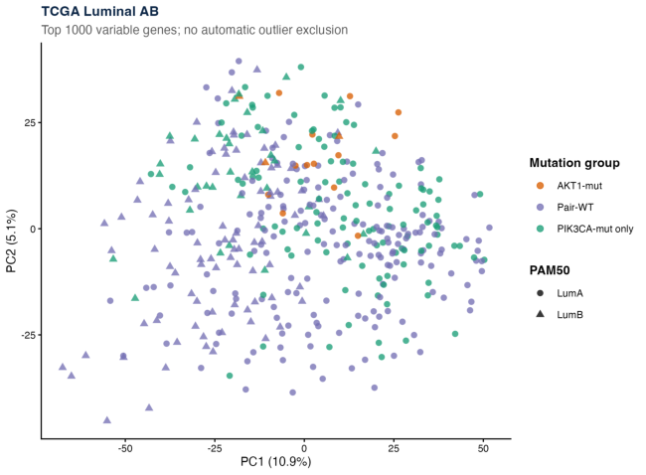
AKT1 E17K vs PIK3CA hotspot mutations in breast cancer Supplementary page 24

Supplementary Figure S6
Expression-analysis group counts and quality-control summary. Numbers of eligible samples across cohorts, analysis populations, mutation groups, and adjusted models.
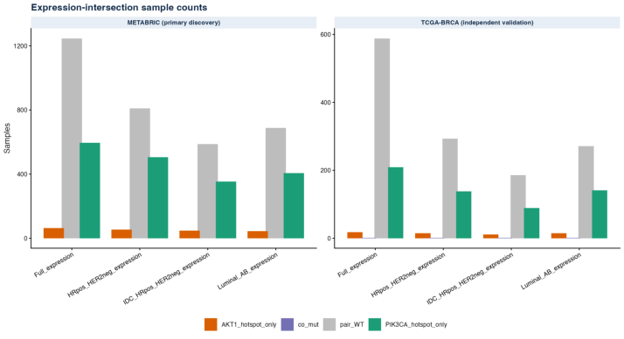
AKT1 E17K vs PIK3CA hotspot mutations in breast cancer Supplementary page 25

