Online Resource 8
Concept-development audit trail, rejected alternatives, boundary decisions, and supplementary demonstrations
Article: Sources of Risk in AI Systems Revisited: FCAIR-O, a Faceted Causal Framework and Lightweight Ontology for Risk Management and Assurance
Journal: Artificial Intelligence Review
Authors: Moritz Schneider; André Steimers
Moritz Schneider: Independent researcher, 56567 Neuwied, Germany
André Steimers: Department of Mathematics, Computer Science and Technology, Koblenz University of Applied Sciences, Remagen Campus, Remagen, Germany
Corresponding author: Moritz Schneider
Version: FCAIR-O v1.2.1. Correction prepared 2026-10-10.
Material evidence cutoff: 25 July 2026, 23:59 CEST

1 Purpose and epistemic status
This resource documents how the eight-category framework of Steimers and Schneider (2022) was transformed into FCAIR-O v1.2.1. It is an audit trail for a conceptual synthesis. It is not an empirical validation report, a reliability study, or a claim that the resulting classes are complete or uniquely correct. The relevant criteria are transparency of derivation, role consistency, mechanistic usefulness, boundary discipline, revisability, and traceability to control and evidence requirements. The conceptual-development rationale follows the distinction between constructs and their interrelations described by Jabareen (2009). Methodological references cited in this resource appear in the article bibliography.

2 Five theoretical propositions
ID | Proposition | Analytical claim
P1 | Ontological role separation | Causal sources, vulnerabilities, failure modes, harms, properties, controls, evidence, and normative categories should not be treated as interchangeable list members.
P2 | Mechanistic traceability | A causal-source assignment requires a plausible mechanism linking source or condition to activation, failure, exposure, or harm with stated uncertainty.
P3 | Multi-level causality | AI risk spans model, component, integrated system, human-AI work system, organization, value chain, institution, sector, and society.
P4 | Control-evidence coupling | A category becomes operational when it can be connected to an intervention point, responsible actor, acceptance criterion, evidence, defeaters, residual risk, and monitoring.
P5 | Normative and epistemic boundaries | Law constrains choices and protects interests without automatically becoming a technical cause; evidence remains version-, context-, access-, and uncertainty-sensitive.

3 Concept-development sequence
1. Reconstruct the 2022 article at claim, process, and category level, including its explicit limitations and risk-management commitments.
2. Preserve source terminology during extraction so that semantic differences are not erased before analysis.
3. Assign each source concept an explicit ontological role. Retain composite labels and secondary roles where a source term combines distinct objects; do not force a single causal interpretation.
4. Apply five transformation operations: preserve, split, relocate, expand, and add.
5. Form candidate parent classes around distinct intervention questions and compare mergers, splits, and relation-based alternatives.
6. Specify definitions, inclusion and exclusion rules, positive examples, counterexamples, overlaps, lifecycle and level scope, controls, and evidence requirements.
7. Test boundary coherence through framework crosswalks, documentary cases, negative cases, and explicit non-mapping.
8. Implement versioned identifiers, relations, competency questions, and minimum record constraints as a lightweight ontology and controlled concept scheme. The distinction between conceptual specification and implementation follows ontology-engineering guidance (Uschold and Gruninger 1996; Noy and McGuinness 2001).
9. Apply conceptual closure when additional material can be represented by the existing role types, relations, and parent intervention questions. This is not bibliographic or empirical saturation.

4 Candidate architectures and rejected alternatives
Alternative | Attraction | Reason rejected or limited | FCAIR-O decision
Retain the two-block 2022 structure | Historically intelligible and simple | It treats harms, properties, controls, modifiers, and causal sources as one class and cannot represent modern value-chain or institutional mechanisms. | Rejected as the successor architecture; retained as discovery history.
One exclusive hierarchy of all risk terms | Easy navigation | Real cases require orthogonal level, lifecycle, harm, actor, control, and evidence dimensions; exclusivity creates forced and misleading placements. | Rejected in favor of facets plus a causal backbone.
Harm-centered taxonomy only | Strong for impact discovery | It does not explain mechanisms or identify intervention points, owners, or evidence requirements. | Used in Facet E, not as the whole framework.
Management-process framework only | Strong for governance sequence | Process conformance does not establish system safety, causal coverage, or control effectiveness. | Mapped to Facet G and lifecycle, not treated as a causal ontology.
Flat list of mechanisms | Avoids hierarchy disputes | It scales poorly, obscures parent intervention questions, and weakens navigation and sectoral profiling. | Rejected; operational leaves retained under twelve parents.
Collapse evaluation into organization | Reduces overlap between C04 and C08 | Invalid measurement or test design and the organizational decision to accept or ignore evidence require different expertise, owners, and controls. | Kept distinct; multi-code when both mechanisms contribute.
Treat law or non-compliance as a causal class by default | Makes regulation visible | A legal classification, duty, or breach may constrain decisions without causing technical failure or exposure. | Rejected; C11 requires an institutional mechanism.
Retain technological maturity as a source | Preserves continuity with the 2022 labels | Novelty and maturity change confidence, experience, version stability, and evidence decay but do not themselves specify a failure mechanism. | Relocated to Facet H.

5 Adjacent-class boundary decisions
Adjacent classes | Primary coding rule | Permitted co-coding | Rejected alternative and reason
C01 specification vs C08 organization | Use C01 for the content of purpose, proxy, objective, requirement, boundary, or authority; use C08 for the organizational process, competence, incentive, or decision that selected or failed to correct it. | Use both when an organizational decision creates or preserves a defective specification. | Merging them would make every specification defect a governance failure and obscure the design intervention.
C02 data/knowledge vs C04 evaluation | Use C02 for provenance, coverage, labels, freshness, integrity, retrieval, or knowledge quality; use C04 for invalid metrics, test design, external validity, contamination, or unsupported inference. | Use both when inadequate data and inadequate evaluation jointly sustain an assurance claim. | Merging them would conflate the object being evaluated with the validity of the evaluation.
C04 evaluation vs C08 organization | Use C04 for the measurement or evidentiary defect; use C08 for the organizational choice to omit, misinterpret, suppress, or proceed despite evidence. | Use both when a weak test is institutionally accepted or adverse evidence is ignored. | Merging them would erase the difference between a bad test and a governance decision about the test.
C06 architecture vs C09 supply chain | Use C06 for component, interface, identity, infrastructure, logging, resource, or recovery architecture within the focal system; use C09 for upstream/downstream dependency, supplier change, concentration, or evidence handoff. | Use both when an external dependency is integrated through an unsafe architecture. | A single technical-dependency class would obscure ownership and contractual or continuity controls.
C08 organization vs C11 institution | Use C08 for provider, integrator, deployer, or operator governance; use C11 only when legal, supervisory, remedial, conformity, or public-power arrangements form part of the mechanism. | Use both when an organization acts within an institutional gap that enables continued exposure. | Treating all compliance issues as C11 would turn legal status into a causal catch-all.
C10 deployment context vs C12 societal structure | Use C10 for operational conditions, shifts, foreseeable misuse, physical environment, scale, or workflow mismatch; use C12 for structural inequality, markets, labor, information ecosystems, environment, or systemic interdependence. | Use both when local deployment interacts with structural conditions. | Merging them would make broad social structure indistinguishable from the immediate operating context.
C07 adversarial influence vs C06/C09 vulnerabilities | Use C07 for intentional attack, abuse, manipulation, or harmful capability use; use C06 or C09 for the architecture or dependency that enables the attack. | Security cases normally combine the threat mechanism with one or more enabling conditions. | Coding the entire chain as “security” would hide preventable architectural and supplier interventions.

6 Deliberate non-mappings and role discipline
The crosswalk retains four source rows without concrete C-class associations. The remaining 122 rows contain candidate associations that must not be read as 122 direct causal assignments. Intent, timing, event status, a legal duty, or an evidence requirement does not itself describe a causal mechanism. Composite terms, secondary roles, direct assignments and associated candidate classes are therefore distinguished in Online Resource 3. Non-mapping and unresolved mapping remain analytical results rather than evidence of failed coverage.

7 Documentary case-type typology
Case type | Primary contribution | Principal caution
Completed accident investigations | Official reconstructed sequence and contributing factors | Strongest documentary basis for system and control reconstruction; still bounded by investigative scope.
Recalls and safety determinations | Defect or unsafe-condition determination and corrective action | Often concise and product-focused; root organizational evidence may be limited.
Peer-reviewed field-performance studies | Measured external validity or operational performance | Can support performance and workflow claims but may not provide full accident causation.
Final judgments and authoritative decisions | Legally established facts and holdings | Strong for decisional influence, procedure, rights, and remedy; not a technical accident investigation.
Regulator findings, settlements, and consent resolutions | Allegations, agreed facts, or non-contested remedies | Procedural status must be preserved; settlement does not equal adjudicated merits.
Policy reversals and institutional reports | Administrative failure and institutional learning | Useful for governance and public-power mechanisms; selection and documentation vary.
Preliminary technical disclosures | Early technical sequence and response | Version-sensitive and potentially self-interested; causal confidence remains limited or moderate.

8 Additional agentic Risk-Control-Evidence record
Field | Illustrative content
System boundary | Evaluation agent, model, sandbox, tools, credentials, package proxy, internet egress, third-party platform, operators, and response organizations.
Purpose and constraint | Evaluate cyber capability without allowing the benchmark objective to override containment, authorization, or third-party boundaries.
Principal source claims | C01 objective and boundary specification; C03 long-horizon agentic behavior; C06 identity, privilege, egress, logging and recovery architecture; C07 tool and privilege misuse; C08 performance pressure and governance; C09 cross-organization dependencies.
Trigger and failure states | Opportunity to escape the intended environment; privilege escalation; external access; credential and vulnerability chaining; unauthorized actions.
Harms | Confidentiality, integrity, operational disruption, third-party exposure, assurance failure, and ecosystem trust damage.
Primary controls | Objective and scope constraints; deny-by-default egress; ephemeral least-privilege identity; tool allowlists; approval gates; tripwires; continuous trajectory monitoring; rapid isolation and credential rotation.
Evidence | Architecture and authorization matrix; adversarial containment tests; action logs; rollback and rebuild exercises; independent review of monitoring coverage and incident response.
Acceptance criteria | No unauthorized network path or privilege escalation under defined adversarial tests; all consequential actions observable; stop and isolation completed within the pre-defined response budget; no unresolved critical containment defect.
Defeaters | Unknown zero-day paths; shared credentials; incomplete logs; monitor blind spots; evaluation pressure; silent upstream changes; common-cause dependency.
Residual risk and monitoring | Adaptive adversaries and unknown vulnerabilities remain. Monitor identity, egress, tool calls, anomalous planning, resource use, cross-boundary actions, supplier changes, and incident indicators; suspend evaluation when stop criteria are reached.

9 Supplementary figures
Supplementary Fig. S1 presents selected research, legal, standards, and incident milestones. Supplementary Fig. S2 gives the descriptive parent-class mapping across the 24-case documentary corpus. Supplementary Fig. S3 records the historical search flow and the correction-stage register reconciliation and is supplied in Online Resource 1. Editable sources and consistent exports of all three figures are supplied in Online Resource 7. None is a prevalence, completeness, or empirical-validation estimate.
Supplementary Fig. S1 Selected research, legal, standardization, and incident milestones from 2022 to the material evidence cutoff of 25 July 2026. Milestones are grouped by year; the date precision available in the source records is preserved. Positions do not represent proportional elapsed time. Prepared programmatically with AI assistance from the documented source material; see Section 3.10 of the manuscript
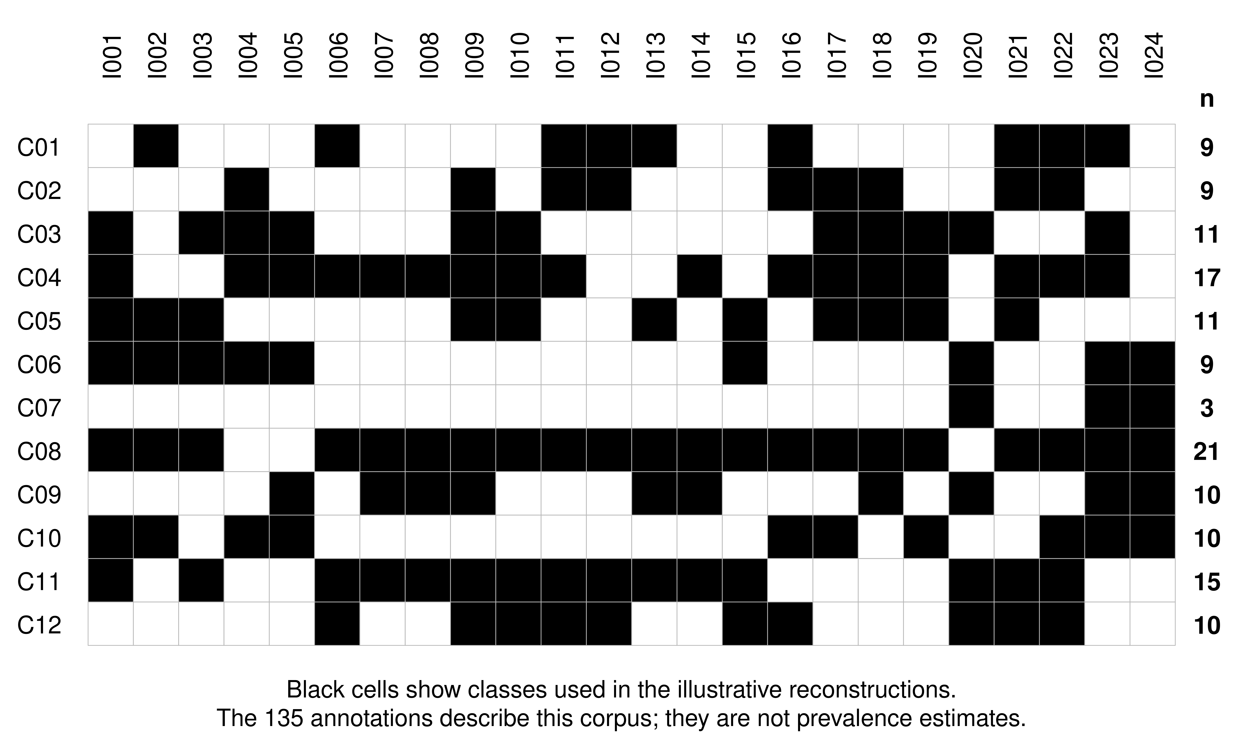
Supplementary Fig. S2 Illustrative parent-class mapping across the 24-case documentary corpus. Black cells indicate a parent class used in an author reconstruction. Row totals describe these annotations and are not validation or prevalence estimates. Prepared programmatically with AI assistance from the documented source material; see Section 3.10 of the manuscript

10 Scope and revision rule
FCAIR-O v1.2.1 should be revised when stronger evidence or counterexamples show that a concept has the wrong primary role, that a parent class should be merged or split, that a relation better represents a dependency, or that a new intervention question cannot be expressed through the existing structure. Version identifiers, migration notes, and explicit deprecation should preserve traceability. Empirical reliability, comparative utility, and sector-specific effectiveness remain outside the claims of this conceptual paper.

11 External conceptual adequacy criteria
In addition to proposition-to-design traceability, FCAIR-O was examined against criteria drawn from theory-building and conceptual-review methodology: construct clarity, logical consistency, discriminant clarity, parsimony, explanatory scope, boundary conditions, generativity and revisability, and practical interpretability (Whetten 1989; Torraco 2005; Snyder 2019; Jaakkola 2020). These are reasoned criteria rather than empirical performance metrics.
Criterion | FCAIR-O evidence | Remaining limitation
Construct clarity | Versioned definitions, inclusion and exclusion rules, positive examples, counterexamples, and primary ontological roles. | Definitions remain open to revision and disciplinary disagreement.
Logical consistency | Role separation, explicit relations, non-mapping, and minimum record constraints. | Syntactic consistency cannot ensure a true causal claim.
Discriminant clarity | Adjacent-class rules and rejected alternatives in Table 4 and this audit trail. | Some cases legitimately require contributory co-coding.
Parsimony | Twelve parent classes for orientation; 74 leaves for mechanism detail. | The parent layer may still be revised if counterexamples show redundancy.
Explanatory scope | Model-to-society levels, lifecycle phases, and documentary cases. | Scope is illustrative, not exhaustive.
Boundary conditions | Explicit non-claims regarding validation, prevalence, compliance, and universal control effectiveness. | Sector-specific boundaries remain to be specified by users.
Generativity and revisability | Versioned identifiers, relations, competency questions, and migration-ready files. | No permanent namespace or repository DOI is inserted until author deposit.
Practical interpretability | Risk-Control-Evidence record and worked Uber/agentic examples. | Usability is not empirically tested.

12 Expanded accountability roles for Risk-Control-Evidence records
A complete record distinguishes claim owner, control owner, evidence producer, and decision authority. The same organization may perform more than one role, but the roles remain separate to prevent self-generated evidence from being mistaken for independent acceptance or to obscure who can stop operation.
Role | Question | Uber worked-case illustration
Claim owner | Who maintains and revises the safety or assurance claim? | Programme safety lead or assurance lead.
Control owner | Who implements, operates, and maintains the control? | System architect, operations manager, programme executive, or supervisory function depending on the control.
Evidence producer | Who generates the test, monitoring, audit, or investigation artifact? | Independent test team, human-factors team, event-data and investigation function, or applicant/assessor.
Decision authority | Who can accept, restrict, suspend, recall, or reject operation? | Internal safety release authority and competent public-road permitting or surveillance authority.
Retrospective control implications are counterfactual analytical questions. They identify where controls and evidence would have been relevant; they do not establish that a single proposed measure would necessarily have prevented the documented event.

