- Appendix

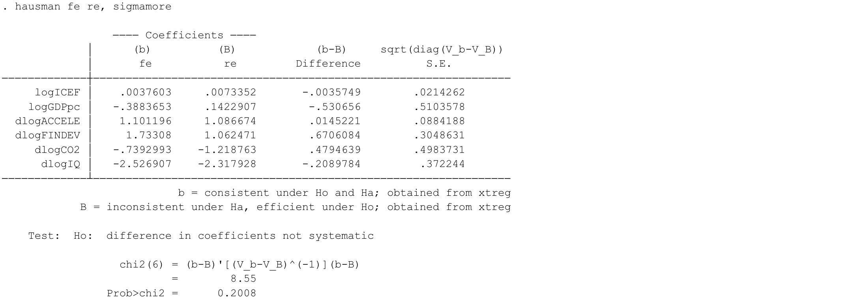
Results from the Random Effect Model.
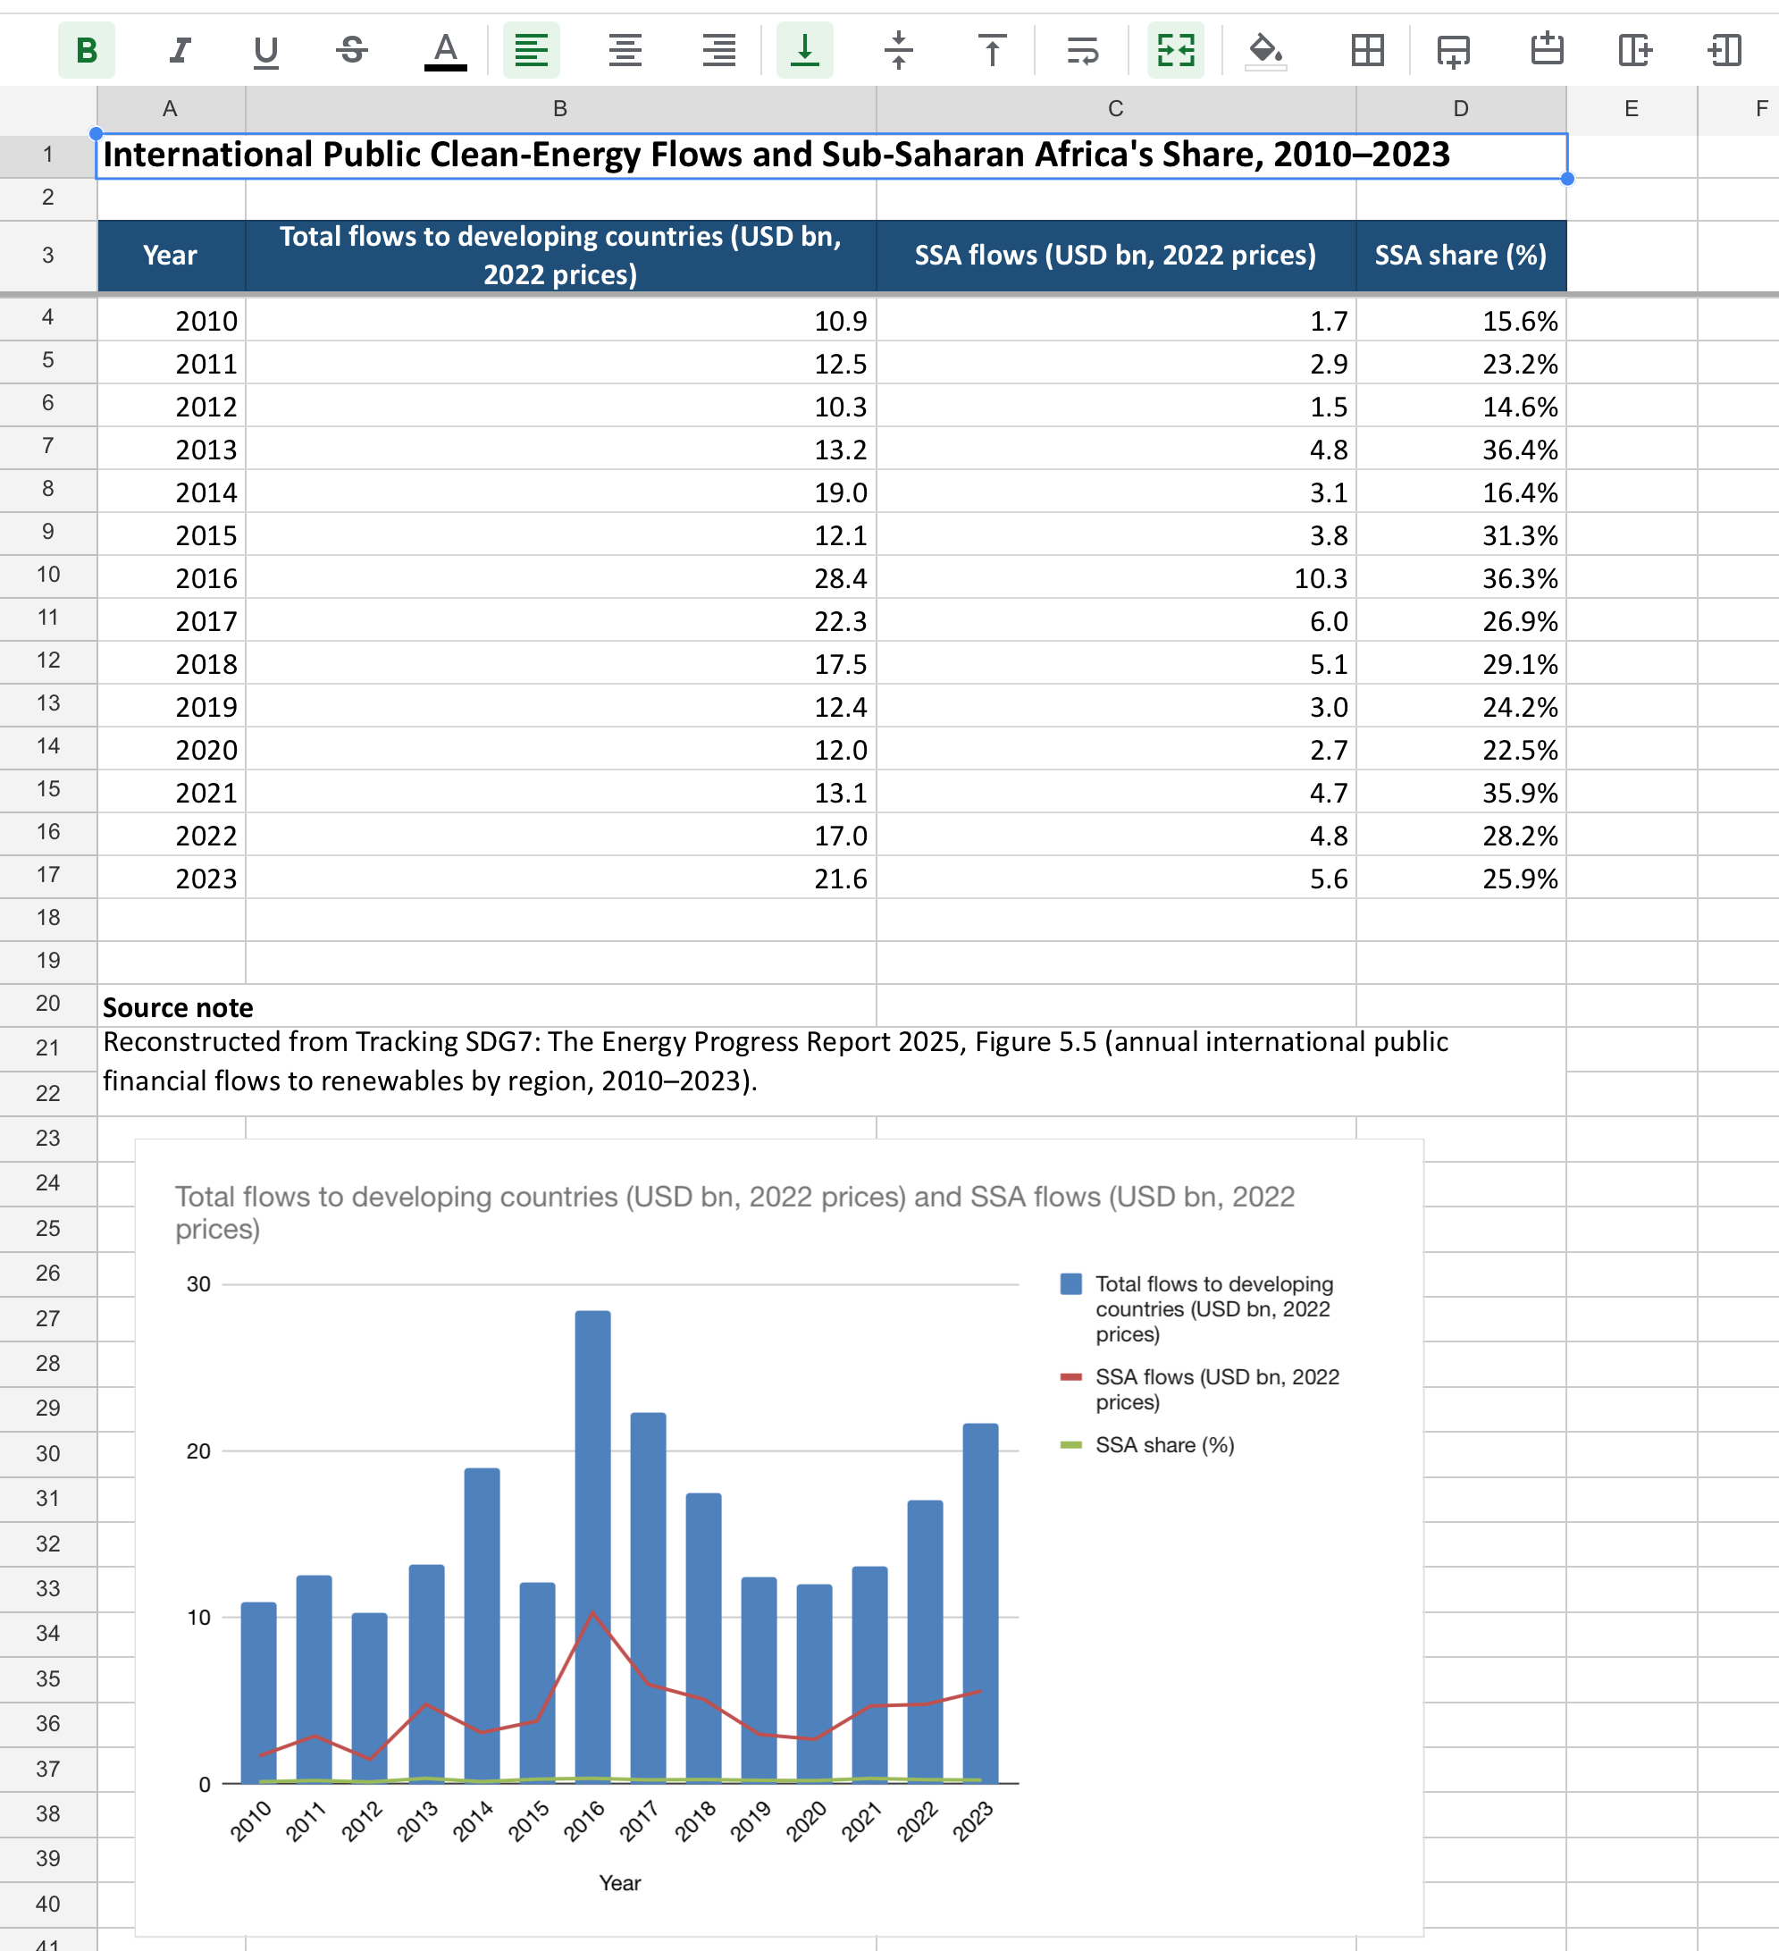
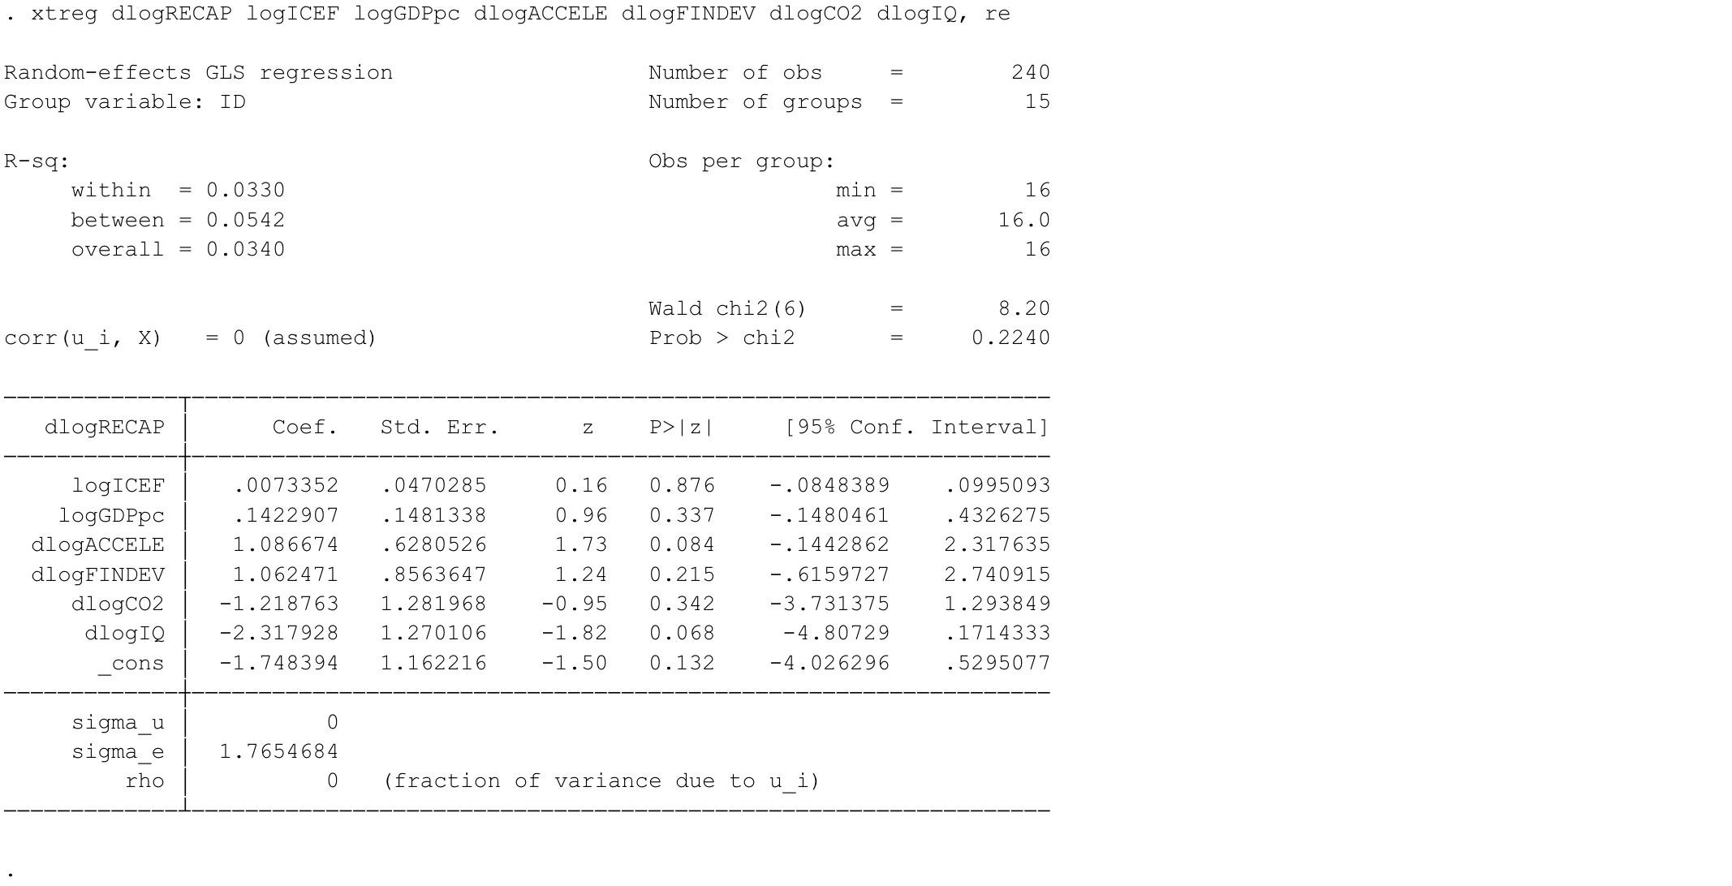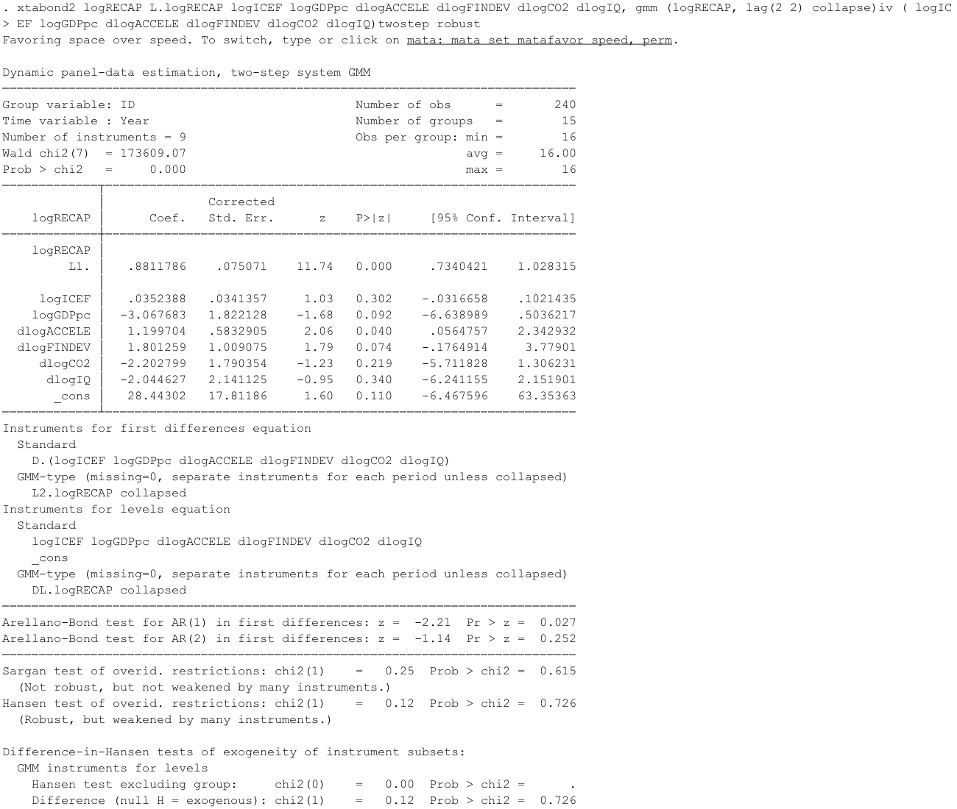
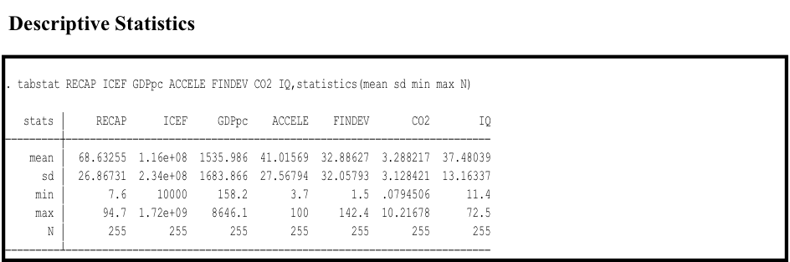

Descriptive Statistics
Variable | Obs | Mean | Std. Dev. | Min | Max
dlogRECAP | 240 | -.541 | 1.77 | -6.9 | 11.5
logICEF | 255 | 16.625 | 2.556 | 9.21 | 21.264
logGDPpc | 255 | 6.944 | .821 | 5.064 | 9.065
dlogACCELE | 240 | .055 | .185 | -.758 | .956
dlogFINDEV | 240 | .031 | .136 | -.541 | .533
dlogCO2 | 240 | .018 | .09 | -.373 | .343
dlogIQ | 240 | -.009 | .092 | -.252 | .354
Source: Stata 15 output

