Online Supplement
A 13-Variable Hour-24 Model for 7-Day ICU Mortality in Neurocritical Care: Strong Cross-Database Discrimination with Unit-Level Calibration Differences

Supplementary Methods

Outcome and Risk Set
The estimand was ICU death after hour 24 and by hour 168 among adults alive and still in ICU at hour 24. Alive ICU discharge before hour 168 and survival in ICU through hour 168 were non-events. This was a fixed-time binary ICU-mortality estimand, not a post-discharge or competing-risk time-to-event estimand. Outcomes were not imputed and were classifiable for every primary-cohort admission.

Modeling Sequence
Eligibility and outcome derivation preceded feature construction. Plausibility filters and same-time median collapse preceded partitioning. Imputation, standardization where applicable, finite-grid tuning, and fitting occurred within training partitions. Hospital-patient connected components remained intact. The full eICU pipeline was locked before MIMIC-IV scoring.

Candidate Families and Selection
Six selectable families represented regularized linear effects, spline nonlinearity, bagged trees, and three boosting implementations. A prevalence-only model and six-variable clinical logistic model were nonselectable benchmarks. Inner log loss and fixed within-family and across-family one-standard-error rules determined the final pipeline. These choices were fixed before the final reported rerun. Outer outcomes and MIMIC-IV outcomes did not select the family.

Metric Definitions
Average precision used sklearn average_precision_score, not trapezoidal precision-recall area. Calibration-in-the-large was the intercept estimated with logit predicted risk as an offset (slope fixed at 1). Calibration slope came from a separate unpenalized logistic regression on logit predicted risk with a free intercept; that intercept was not calibration-in-the-large. These assessments did not refit the prognostic model, including within care-setting strata. The integrated calibration index was the mean absolute difference between predicted risk and local-linear LOWESS-smoothed observed risk (frac=2/3, it=0, delta=1% of the prediction range). Exact tied predictions shared their empirical event rate before smoothing. Point estimates and bootstrap replicates used the same definition.

Uncertainty
Internal intervals resampled whole hospital-patient connected components and averaged metrics across complete repeats. Transport intervals resampled MIMIC-IV patients. A replicate was excluded only when the metric was not estimable; valid counts are retained in the machine-readable tables.

APACHE IVa Context
The selected-family mean repeated cross-fitted eICU probability and native APACHE IVa ICU-mortality probability were evaluated on the same score-available stays after filtering apachePatientResult to exact apacheversion=IVa rows and reading predictedicumortality. Only AUROC and average precision were summarized. The native endpoint differs from the study endpoint; APACHE IVa was not a predictor, tuning input, candidate family, or MIMIC-IV score. Field definitions are given in the eICU table documentation.[1]

Updating and Clinical Interpretation
Patient-grouped recalibration and approximate temporal setting-offset updating used target outcomes and were sensitivity analyses. Decision curves were retrospective. Neither analysis demonstrates deployment readiness or clinical benefit. The temporal update was logit(p_updated) = logit(p_eICU) + α + γ × I(Neuro SICU). Only α and γ were fitted, using L-BFGS-B with bounds [−8, 8]. Fitting required at least 40 events and both care-setting levels; evaluation required at least 50 events and both outcome classes. A coefficient within 10⁻⁶ of a bound made the update non-evaluable. A two-sample patient-cluster bootstrap independently resampled earlier-era fitting patients and later-era evaluation patients, refitted both update coefficients, and then evaluated later-era performance. Replicates with optimizer failure, a boundary solution, loss of an estimable outcome or care-setting contrast, or evaluation failure were omitted. Reported valid counts refer to finite metric estimates after these checks.

Privacy and Release Scope
The aggregate archive contains Tables 1–7, Supplements S1-S21, all figure source data, protocol dictionaries, configuration, runtime versions, and hashes. A separate specification gives the fitted regression equation, knots, scaling values, and coefficients. Neither release contains patient rows, hospital identifiers, credentials, private prediction vectors, or the serialized fitted pipeline.

Supplementary Tables
Table S1. Complete cohort flow
Database | Order | Screening step | Prior | Retained | Excluded
MIMIC-IV v3.1 | 0 | all source icu stays | 94458 | 94458 | 0
MIMIC-IV v3.1 | 1 | linkable admission and patient | 94458 | 94458 | 0
MIMIC-IV v3.1 | 2 | first icu per hospital admission | 94458 | 85242 | 9216
MIMIC-IV v3.1 | 3 | adult | 85242 | 85242 | 0
MIMIC-IV v3.1 | 4 | in icu beyond 24h | 85242 | 67222 | 18020
MIMIC-IV v3.1 | 5 | alive at 24h | 67222 | 67001 | 221
MIMIC-IV v3.1 | 6 | initial neurologic careunit allowlist | 67001 | 6821 | 60180
MIMIC-IV v3.1 | 7 | primary outcome evaluable | 6821 | 6821 | 0
eICU-CRD v2.0 (declared) | 0 | all source unit stays | 200859 | 200859 | 0
eICU-CRD v2.0 (declared) | 1 | linkable system stay and patient | 200859 | 200859 | 0
eICU-CRD v2.0 (declared) | 2 | first icu per hospital admission | 200859 | 166355 | 34504
eICU-CRD v2.0 (declared) | 3 | adult | 166355 | 165795 | 560
eICU-CRD v2.0 (declared) | 4 | in icu beyond 24h | 165795 | 115941 | 49854
eICU-CRD v2.0 (declared) | 5 | alive at 24h per unit discharge | 115941 | 115941 | 0
eICU-CRD v2.0 (declared) | 6 | neurologic illness identified by 24h | 115941 | 20810 | 95131
eICU-CRD v2.0 (declared) | 7 | classifiable unit discharge status | 20810 | 20810 | 0
eICU-CRD v2.0 (declared) | 8 | primary outcome evaluable | 20810 | 20810 | 0
Counts are admissions unless otherwise specified. Zero exclusions are retained to preserve the locked sequence.
Table S2. Locked 13-predictor dictionary
Order | Predictor | Domain | Type | Window | Aggregation
1 | Age, years | demographic | continuous | landmark | value
2 | Male sex | demographic | binary | landmark | value
3 | Minimum Glasgow Coma Scale | neurological | continuous | 0–24h | minimum
4 | Maximum heart rate, beats/min | vital | continuous | 0–24h | maximum
5 | Minimum mean arterial pressure, mmHg | vital | continuous | 0–24h | minimum
6 | Maximum respiratory rate, breaths/min | vital | continuous | 0–24h | maximum
7 | Minimum oxygen saturation, % | vital | continuous | 0–24h | minimum
8 | Last creatinine, mg/dL | laboratory | continuous | 0–24h | last valid
9 | Sodium range, mmol/L | laboratory | continuous | 0–24h | maximum minus minimum
10 | Minimum bicarbonate, mmol/L | laboratory | continuous | 0–24h | minimum
11 | Maximum glucose, mg/dL | laboratory | continuous | 0–24h | maximum
12 | Maximum white blood cell count, ×10⁹/L | laboratory | continuous | 0–24h | maximum
13 | Minimum platelets, ×10⁹/L | laboratory | continuous | 0–24h | minimum
Source-item mappings, implemented unit conversions, plausibility limits, duplicate handling, and complete selection settings are reported in Additional file 3.
Table S3. Complete candidate-family and benchmark comparison
Model family | Role | Outer log loss, mean (SD) | Outer AUROC, mean (SD) | Full-development inner log loss, mean (SE) | 1-SE eligible | Selected
CatBoost | selection candidate | 0.12774 (0.00923) | 0.8826 (0.0127) | 0.12797 (0.00168) | Yes | No
LightGBM | selection candidate | 0.12779 (0.00950) | 0.8814 (0.0117) | 0.12774 (0.00177) | Yes | No
XGBoost | selection candidate | 0.12801 (0.00973) | 0.8825 (0.0114) | 0.12616 (0.00202) | Yes | No
cubic B-spline ridge logistic regression | selection candidate | 0.12954 (0.01022) | 0.8777 (0.0146) | 0.12730 (0.00171) | Yes | Yes
random forest | selection candidate | 0.13047 (0.01072) | 0.8751 (0.0167) | 0.13075 (0.00212) | No | No
elastic-net logistic regression | selection candidate | 0.13344 (0.01084) | 0.8651 (0.0154) | 0.13301 (0.00234) | No | No
complete nested selection procedure | full selection procedure | 0.12971 (0.01060) | 0.8769 (0.0142) | Not applicable | No | No
six-variable clinical logistic model | benchmark | 0.13827 (0.01123) | 0.8470 (0.0196) | Not applicable | No | No
prevalence-only model | benchmark | 0.17657 (0.01373) | 0.5000 (0.0000) | Not applicable | No | No
Outer-resample SD is descriptive. Selection used full-development inner log loss and the locked one-standard-error rule.
Table S4. Final selected-pipeline parameters
Parameter | Locked value
C | 0.1
degree | 3
n_knots | 4
These values are read directly from the locked results registry.
Table S5. Sample-size assessment
Method | Criterion | Available N | Events | Candidate df | Required N | Decision
20-event-per-df stress test | 20 events per candidate df | 20810 | 885 | 73 | 34331 | Stress test not met
Riley binary-outcome equations | Global shrinkage | 20810 | 885 | 73 | 12772 | Pass
Riley binary-outcome equations | Nagelkerke R-squared optimism | 20810 | 885 | 73 | 4762 | Pass
Riley binary-outcome equations | Overall risk precision | 20810 | 885 | 73 | 63 | Pass
Riley binary-outcome equations | Maximum across Riley criteria | 20810 | 885 | 73 | 12772 | Pass
Published Riley criteria and the conservative 20-events-per-parameter stress test are shown separately. Riley inputs were an anticipated Cox-Snell R-squared of 0.05, maximum R-squared of 0.29657, target shrinkage of 0.90, and risk-margin bound of 0.05. df, degrees of freedom. This is an unadjusted regression-design check; it does not quantify the effective complexity of the tree-model searches or adjust the sample size for correlated admissions. The anticipated explained variation was a planning assumption, not an observed model performance estimate.
Table S6. Complete primary internal and direct transport performance
Metric | eICU nested selection procedure (95% CI) | MIMIC-IV cubic B-spline ridge logistic regression transport (95% CI)
N (events) | 20810 (885) | 6821 (203)
AUROC | 0.8765 (0.8626 to 0.8872) | 0.9037 (0.8873 to 0.9204)
Average precision (AP) | 0.3091 (0.2711 to 0.3525) | 0.2949 (0.2346 to 0.3638)
Brier score | 0.03407 (0.02945 to 0.03921) | 0.02456 (0.02161 to 0.02764)
Log loss | 0.12930 (0.11460 to 0.14704) | 0.09489 (0.08469 to 0.10570)
Calibration-in-the-large | −0.0031 (−0.1506 to 0.1387) | −0.0200 (−0.1807 to 0.1278)
Calibration slope | 0.9861 (0.9355 to 1.0344) | 0.9750 (0.8913 to 1.0711)
ICI | 0.00488 (0.00374 to 0.00856) | 0.00591 (0.00390 to 0.00953)
O/E ratio | 0.9976 (0.8882 to 1.1128) | 0.9842 (0.8637 to 1.1050)
Internal and transport estimates target different procedures and populations; their numerical difference is not a transport-drop estimate. All eight interval metrics had 1,000 valid bootstrap replicates in each database.
Table S7. Direct MIMIC-IV threshold behavior
Threshold | Sensitivity | Specificity | PPV | NPV | Net benefit | Net reduction/100
2% | 89.2% | 75.5% | 10.0% | 99.6% | 0.02169 | 57.45
5% | 70.4% | 88.9% | 16.2% | 99.0% | 0.01528 | 69.51
10% | 53.7% | 93.7% | 20.6% | 98.5% | 0.00914 | 78.46
15% | 42.4% | 96.1% | 24.8% | 98.2% | 0.00586 | 83.48
20% | 33.5% | 97.4% | 28.5% | 97.9% | 0.00370 | 86.60
Decision analysis is retrospective and has no clinical-workflow costs. NPV, negative predictive value; PPV, positive predictive value. At threshold t, net benefit is TP/N − (FP/N) × t/(1−t). Net reduction per 100 is 100 × (net benefit of the model − net benefit of assessing all) / [t/(1−t)]. The figure labels “Treat all” and “Treat none” denote additional assessment for all or none, not treatment allocation. Thresholds are illustrative, not validated clinical cutoffs.
Table S8. Direct MIMIC-IV care-setting performance
MIMIC-IV population | N (events) | Observed | Predicted | AUROC (95% CI) | Slope (95% CI) | O/E (95% CI)
All neurologic units | 6821 (203) | 2.98% | 3.02% | 0.9037 (0.8873 to 0.9204) | 0.9750 (0.8913 to 1.0711) | 0.9842 (0.8637 to 1.1050)
Neuro SICU | 1338 (165) | 12.33% | 7.77% | 0.8175 (0.7849 to 0.8484) | 0.7828 (0.6737 to 0.9069) | 1.5876 (1.3836 to 1.7924)
Neuro Intermediate/  Stepdown | 5483 (38) | 0.69% | 1.87% | 0.8845 (0.8528 to 0.9128) | 0.7947 (0.6750 to 0.9282) | 0.3714 (0.2608 to 0.4915)
Intermediate/stepdown combines Neuro Intermediate and Neuro Stepdown. Both strata use the initial care-unit label. In the eICU source, the exact Neuro ICU stratum included 9,021 admissions and 267 deaths, compared with 11,789 admissions and 618 deaths in other ICUs with qualifying neurologic evidence. Descriptive O/E ratios were 0.8608 and 1.0710, respectively. These source-stratum point estimates used mean repeated cross-fitted risks without refitting; they do not use the primary complete-repeat metric estimand and have no reported O/E intervals.
Table S9. Selected-model explanation stability
Feature | Mean rank | Rank SD | Top-10 fraction | Outer resamples
Minimum Glasgow Coma Scale | 1.00 | 0.00 | 1.00 | 25
Maximum glucose, mg/dL | 2.48 | 0.59 | 1.00 | 25
Age, years | 2.88 | 0.73 | 1.00 | 25
Last creatinine, mg/dL | 4.44 | 1.08 | 1.00 | 25
Maximum heart rate, beats/min | 5.44 | 1.36 | 1.00 | 25
Maximum white blood cell count, ×10⁹/L | 6.40 | 1.94 | 1.00 | 25
Minimum oxygen saturation, % | 6.52 | 1.29 | 1.00 | 25
Maximum respiratory rate, breaths/min | 8.00 | 1.32 | 1.00 | 25
Minimum platelets, ×10⁹/L | 8.28 | 1.28 | 1.00 | 25
Minimum bicarbonate, mmol/L | 10.20 | 1.41 | 0.64 | 25
Sodium range, mmol/L | 10.96 | 0.84 | 0.28 | 25
Minimum mean arterial pressure, mmHg | 11.44 | 0.65 | 0.08 | 25
Male sex | 12.96 | 0.20 | 0.00 | 25
Ranks are conditional on fitting the selected family and do not identify causal or algorithm-independent clinical importance.
Table S10. Post hoc eICU APACHE IVa contextual comparison
Metric | Selected-family risk (95% CI) | APACHE IVa (95% CI) | Paired difference (95% CI) | Valid bootstrap
AUROC | 0.8845 (0.8711 to 0.8956) | 0.8836 (0.8717 to 0.8961) | 0.0009 (−0.0110 to 0.0116) | 1000
Average precision (AP) | 0.3346 (0.2882 to 0.3878) | 0.3433 (0.2954 to 0.3996) | −0.0087 (−0.0378 to 0.0200) | 1000
Coverage | 18312/20810 (88.0%) | Different native endpoint | Not a superiority test | 1000
Both scores used the same available eICU stays and paired connected-component bootstrap draws. Native APACHE IVa ICU mortality and the study post-landmark day-7 endpoint are not interchangeable.
Table S11. Approximate temporal model-updating audit
Evaluation period | Model | N (events) | Metric | Estimate (95% CI where available) | Valid bootstrap | Status
approximate pre2020 interval fit | care setting logit offset | 3467 (119) | update alpha | −0.9675 (-1.4925 to −0.5735) | 1000 | Exploratory updating
approximate pre2020 interval fit | care setting logit offset | 3467 (119) | update gamma neuro sicu | 1.8548 (1.3783 to 2.4603) | 1000 | Exploratory updating
approximate 2020 or later interval evaluation | direct transport | 2526 (60) | Mean predicted risk | 0.0309 | 0 | Exploratory updating
approximate 2020 or later interval evaluation | direct transport | 2526 (60) | AUROC | 0.9136 (0.8895 to 0.9371) | 1000 | Exploratory updating
approximate 2020 or later interval evaluation | direct transport | 2526 (60) | Average precision (AP) | 0.3082 (0.1870 to 0.4331) | 1000 | Exploratory updating
approximate 2020 or later interval evaluation | direct transport | 2526 (60) | Brier score | 0.01977 (0.01531 to 0.02421) | 1000 | Exploratory updating
approximate 2020 or later interval evaluation | direct transport | 2526 (60) | Log loss | 0.07900 (0.06460 to 0.09408) | 1000 | Exploratory updating
approximate 2020 or later interval evaluation | direct transport | 2526 (60) | Calibration-in-the-large | −0.3363 (−0.6746 to −0.0898) | 1000 | Exploratory updating
approximate 2020 or later interval evaluation | direct transport | 2526 (60) | Calibration slope | 0.9800 (0.8405 to 1.1391) | 1000 | Exploratory updating
approximate 2020 or later interval evaluation | direct transport | 2526 (60) | ICI | 0.00935 (0.00641 to 0.01447) | 1000 | Exploratory updating
approximate 2020 or later interval evaluation | direct transport | 2526 (60) | O/E ratio | 0.7676 (0.5828 to 0.9327) | 1000 | Exploratory updating
approximate 2020 or later interval evaluation | care setting offset updated | 2526 (60) | Mean predicted risk | 0.0345 | 0 | Exploratory updating
approximate 2020 or later interval evaluation | care setting offset updated | 2526 (60) | AUROC | 0.9311 (0.9068 to 0.9535) | 1000 | Exploratory updating
approximate 2020 or later interval evaluation | care setting offset updated | 2526 (60) | Average precision (AP) | 0.3680 (0.2526 to 0.4984) | 1000 | Exploratory updating
approximate 2020 or later interval evaluation | care setting offset updated | 2526 (60) | Brier score | 0.01983 (0.01558 to 0.02413) | 1000 | Exploratory updating
approximate 2020 or later interval evaluation | care setting offset updated | 2526 (60) | Log loss | 0.07508 (0.06027 to 0.09003) | 1000 | Exploratory updating
approximate 2020 or later interval evaluation | care setting offset updated | 2526 (60) | Calibration-in-the-large | −0.5558 (−0.9777 to −0.1738) | 1000 | Exploratory updating
approximate 2020 or later interval evaluation | care setting offset updated | 2526 (60) | Calibration slope | 0.8429 (0.7189 to 1.0054) | 1000 | Exploratory updating
approximate 2020 or later interval evaluation | care setting offset updated | 2526 (60) | ICI | 0.01217 (0.00721 to 0.01989) | 1000 | Exploratory updating
approximate 2020 or later interval evaluation | care setting offset updated | 2526 (60) | O/E ratio | 0.6879 (0.5224 to 0.8876) | 1000 | Exploratory updating
All evaluated rows are exploratory target-data updating followed by approximate temporal evaluation, not independent external validation. The fitting sample excluded 48 earlier admissions from 35 patients also present in the later evaluation, reducing the earlier-era sample from 3,515 to 3,467 admissions. Long machine-readable status values are retained in Supplement S19. A valid-bootstrap count of 0 for mean predicted risk denotes a point estimate without a requested bootstrap interval, not a metric failure.
Table S12. Outer-resampling leakage audit
Repeat | Fold | Validation N | Events | Components | Group overlap | Hospital overlap | Patient overlap
0 | 0 | 3777 | 185 | 25 | 0 | 0 | 0
0 | 1 | 4103 | 169 | 25 | 0 | 0 | 0
0 | 2 | 4329 | 177 | 25 | 0 | 0 | 0
0 | 3 | 3947 | 176 | 25 | 0 | 0 | 0
0 | 4 | 4654 | 178 | 25 | 0 | 0 | 0
1 | 0 | 4787 | 173 | 25 | 0 | 0 | 0
1 | 1 | 3994 | 194 | 25 | 0 | 0 | 0
1 | 2 | 4088 | 166 | 25 | 0 | 0 | 0
1 | 3 | 4022 | 176 | 25 | 0 | 0 | 0
1 | 4 | 3919 | 176 | 25 | 0 | 0 | 0
2 | 0 | 4542 | 216 | 25 | 0 | 0 | 0
2 | 1 | 4207 | 171 | 25 | 0 | 0 | 0
2 | 2 | 4004 | 161 | 25 | 0 | 0 | 0
2 | 3 | 4185 | 167 | 25 | 0 | 0 | 0
2 | 4 | 3872 | 170 | 25 | 0 | 0 | 0
3 | 0 | 3909 | 164 | 25 | 0 | 0 | 0
3 | 1 | 4046 | 190 | 25 | 0 | 0 | 0
3 | 2 | 4301 | 159 | 25 | 0 | 0 | 0
3 | 3 | 4066 | 213 | 25 | 0 | 0 | 0
3 | 4 | 4488 | 159 | 25 | 0 | 0 | 0
4 | 0 | 3673 | 159 | 25 | 0 | 0 | 0
4 | 1 | 4631 | 167 | 25 | 0 | 0 | 0
4 | 2 | 3814 | 180 | 25 | 0 | 0 | 0
4 | 3 | 4278 | 189 | 25 | 0 | 0 | 0
4 | 4 | 4414 | 190 | 25 | 0 | 0 | 0
A valid partition has zero resampling-group, hospital, and patient overlap between assessment and analysis sets.
Table S13. Diagnosis composition
Database | Diagnosis group | N | Fraction | Source/use
eICU-CRD v2.0 (declared) | Brain tumor | 797 | 3.8% | Evidence available by hour 24; may describe development eligibility
eICU-CRD v2.0 (declared) | Central nervous system infection | 356 | 1.7% | Evidence available by hour 24; may describe development eligibility
eICU-CRD v2.0 (declared) | Intracerebral hemorrhage | 351 | 1.7% | Evidence available by hour 24; may describe development eligibility
eICU-CRD v2.0 (declared) | Ischemic stroke | 5005 | 24.1% | Evidence available by hour 24; may describe development eligibility
eICU-CRD v2.0 (declared) | Other Neuro ICU admission | 2801 | 13.5% | Evidence available by hour 24; may describe development eligibility
eICU-CRD v2.0 (declared) | Other neurocritical illness | 3584 | 17.2% | Evidence available by hour 24; may describe development eligibility
eICU-CRD v2.0 (declared) | Status epilepticus | 3547 | 17.0% | Evidence available by hour 24; may describe development eligibility
eICU-CRD v2.0 (declared) | Subarachnoid hemorrhage | 874 | 4.2% | Evidence available by hour 24; may describe development eligibility
eICU-CRD v2.0 (declared) | Traumatic brain injury | 3495 | 16.8% | Evidence available by hour 24; may describe development eligibility
MIMIC-IV v3.1 | Brain tumor | 259 | 3.8% | Full-admission coded descriptor; not used for eligibility or prediction
MIMIC-IV v3.1 | Central nervous system infection | 118 | 1.7% | Full-admission coded descriptor; not used for eligibility or prediction
MIMIC-IV v3.1 | Intracerebral hemorrhage | 933 | 13.7% | Full-admission coded descriptor; not used for eligibility or prediction
MIMIC-IV v3.1 | Ischemic stroke | 1556 | 22.8% | Full-admission coded descriptor; not used for eligibility or prediction
MIMIC-IV v3.1 | Other Neuro ICU admission | 1394 | 20.4% | Full-admission coded descriptor; not used for eligibility or prediction
MIMIC-IV v3.1 | Other neurocritical illness | 1167 | 17.1% | Full-admission coded descriptor; not used for eligibility or prediction
MIMIC-IV v3.1 | Status epilepticus | 352 | 5.2% | Full-admission coded descriptor; not used for eligibility or prediction
MIMIC-IV v3.1 | Subarachnoid hemorrhage | 332 | 4.9% | Full-admission coded descriptor; not used for eligibility or prediction
MIMIC-IV v3.1 | Traumatic brain injury | 710 | 10.4% | Full-admission coded descriptor; not used for eligibility or prediction
Groups are mutually exclusive. MIMIC-IV diagnosis composition may use full-admission or discharge-coded information and is descriptive only; diagnosis group was not a predictor. If any group was below 10, all counts and fractions for that database were suppressed together.
Table S14. Machine-readable supplement inventory
File ID | Machine-readable file | Purpose
S1 | Supplement_S1_Cohort_Flow.csv | raw-source-to-primary-analytic-risk-set flow
S2 | Supplement_S2_Feature_Dictionary.csv | locked 13-feature primary dictionary
S3 | Supplement_S3_External_Mapping_Missingness.csv | complete core, extended and coupling cross-database mapping and missingness audit
S4 | Supplement_S4_Sample_Size_Assessment.csv | Riley-equation and conservative complexity calculations
S5 | Supplement_S5_Full_Distributions.csv | full core-feature distributions
S6 | Supplement_S6_Outcome_Overlap.csv | component overlap and first-event composition
S7 | Supplement_S7_Nested_Fold_Performance.csv | all aggregate outer-fold performance rows
S8 | Supplement_S8_Hyperparameter_Search.csv | exhaustive locked finite-grid search audit, including outer-procedure and full-development selection counts
S9 | Supplement_S9_Subgroup_Details.csv | small-cell-protected subgroup details
S10 | Supplement_S10_Sensitivity_Analyses.csv | mandatory MIMIC care-setting strata and explicitly exploratory patient-grouped updating analyses; neither changes the fixed direct-transport primary estimand
S11 | Supplement_S11_Explanation_Stability.csv | outer-fold explanation stability
S12 | Supplement_S12_Reproducibility_Manifest.md | private/public artifact separation and reproducibility note
S13 | Supplement_S13_Paired_Model_Comparisons.csv | descriptive paired contrasts of mean cross-fitted risks across repetitions; these are not the primary repeat-metric performance estimand and are not used for selection
S14 | Supplement_S14_Careunit_Spectrum_Transport.csv | fixed model direct transport to the full three-label MIMIC initial neurologic-care target population, with mandatory Neuro SICU and other-care-setting strata, plus five formal Neuro-SICU-minus-other contrasts using patient-cluster percentile bootstrap intervals and no MIMIC fitting or reselection
S15 | Supplement_S15_Endpoint_Completeness.csv | linked at-risk, observable, unresolved, event and non-event counts for primary and selected secondary endpoints
S16 | Supplement_S16_Outcome_Definition_Audit.csv | explicit 24-hour landmark, 168-hour horizon, terminal alive-discharge rule and zero-unresolved audit for the primary endpoint
S17 | Supplement_S17_Resampling_Audit.csv | aggregate audit of five unique fixed-quota hospital-patient connected-component outer partitions, including assessment-fold sizes, event counts, leakage checks and partition hashes
S18 | Supplement_S18_CareSetting_Era_Outcome.csv | aggregate eICU care-setting composition in its fixed source period plus MIMIC approximate-admission-interval margins for the complete target; the sparse MIMIC care-by-era cross-product is deliberately not released
S19 | Supplement_S19_Temporal_Model_Updating.csv | explicit early-era model-updating and later-era evaluation audit with optimizer-boundary failure closure and per-metric effective-bootstrap counts; never labelled untouched external validation
S20 | Supplement_S20_APACHE_IVa_Posthoc_Reference.csv | eICU-only post-hoc contextual comparison, excluded from model selection, of the selected-family mean repeated cross-fitted risk and native APACHE IVa ICU-mortality probability on the same available stays; reports only AUROC and average precision (stored under the legacy metric token auprc) with paired hospital-patient connected-component bootstrap intervals, explicitly records endpoint mismatch and privacy-release state, and cannot enter predictors, tuning, family selection, or MIMIC scoring
S21 | Supplement_S21_Diagnosis_Composition.csv | outcome-free aggregate diagnosis-group composition only: eICU groups describe diagnosis or eligibility evidence available by the 24-hour landmark, whereas MIMIC groups may use full-admission/discharge-coded top-three ICD information with an initial-careunit fallback and are descriptive only; diagnosis group is never a predictor or a MIMIC target-eligibility criterion
M1 | Final_Spline_Model_Equation.csv | full-precision transformed-term coefficients
M2 | Final_Spline_Model_Knots_and_Imputation.csv | raw predictor order, medians, and spline knot sequences
M3 | Final_Spline_Model_Metadata_and_Verification.json | intercepts, model settings, hashes, and equivalence checks
M4 | Final_Spline_Model_README.md | implementation instructions for the fitted equation
M5 | NI46_Revision_Evidence_Manifest.csv | size and SHA-256 manifest for the model-specification files
M6 | Table1_Privacy_Safe_Display.csv | privacy-safe aggregate values displayed in Main Table 1
M7 | Table1_Privacy_Safe_Display_Audit.json | derivation and disclosure audit for the protected Table 1 cells
File IDs follow the locked archive and do not renumber the reader-facing tables in this document. All listed files were loaded and schema-checked before generation.
Table S15. Paired internal AUROC comparisons for the selected spline family
Comparator | Spline AUROC | Comparator AUROC | Paired difference | 95% CI | Valid bootstrap
CatBoost | 0.8799 | 0.8839 | −0.0040 | −0.0086 to 0.0015 | 1000
elastic-net logistic regression | 0.8799 | 0.8645 | 0.0155 | 0.0099 to 0.0212 | 1000
LightGBM | 0.8799 | 0.8831 | −0.0032 | −0.0089 to 0.0026 | 1000
random forest | 0.8799 | 0.8781 | 0.0018 | −0.0052 to 0.0091 | 1000
XGBoost | 0.8799 | 0.8842 | −0.0043 | −0.0095 to 0.0015 | 1000
Differences are selected spline minus comparator and are descriptive; they did not determine family selection. AUROC, area under the receiver operating characteristic curve; CI, confidence interval.
Table S16. Complete final spline-model specification
For each admission, missing raw predictors are replaced by the medians in Panel A. The 12 continuous predictors are expanded with the listed cubic B-spline knots; sex is linear. If bⱼ is transformed term j, then zⱼ=(bⱼ−μⱼ)/sⱼ and p=1/[1+exp{−(β₀+Σβⱼzⱼ)}], where β₀=−4.240658082893. An equivalent raw-basis equation uses the last column of Panel B and intercept -4.455050752119. The full-precision machine-readable equation reproduced the locked pipeline in 20,810 eICU and 6,821 MIMIC-IV admissions, with maximum absolute probability difference below 8 × 10⁻¹⁶ in both databases.
Panel A. Raw predictor order, imputation medians, and spline knot sequences
Predictor | Imputation median | Base knot sequence, including boundary knots | Basis
Age, years | 63.0000 | 18.0000, 55.0000, 71.0000, 90.0000 | Cubic B-spline; 4 knots; linear extrapolation
Male sex | 1.0000 | Not applicable | Linear
Minimum Glasgow Coma Scale | 13.0000 | 3.0000, 12.0000, 14.0000, 15.0000 | Cubic B-spline; 4 knots; linear extrapolation
Maximum heart rate, beats/min | 104.0000 | 45.0000, 96.0000, 113.0000, 248.0000 | Cubic B-spline; 4 knots; linear extrapolation
Minimum mean arterial pressure, mmHg | 62.0000 | 20.0000, 56.0000, 68.0000, 126.0000 | Cubic B-spline; 4 knots; linear extrapolation
Maximum respiratory rate, breaths/min | 28.0000 | 8.0000, 25.0000, 31.0000, 80.0000 | Cubic B-spline; 4 knots; linear extrapolation
Minimum oxygen saturation, % | 91.0000 | 50.0000, 89.0000, 93.0000, 100.0000 | Cubic B-spline; 4 knots; linear extrapolation
Last creatinine, mg/dL | 0.8500 | 0.1000, 0.7600, 0.9700, 20.6000 | Cubic B-spline; 4 knots; linear extrapolation
Sodium range, mmol/L | 0.0000 | 0.0000, 0.0000, 0.0000, 49.0000 | Cubic B-spline; 4 knots; linear extrapolation
Minimum bicarbonate, mmol/L | 24.0000 | 2.0000, 23.0000, 25.0000, 48.0000 | Cubic B-spline; 4 knots; linear extrapolation
Maximum glucose, mg/dL | 140.0000 | 29.0000, 125.0000, 160.0000, 1382.0000 | Cubic B-spline; 4 knots; linear extrapolation
Maximum white blood cell count, ×10⁹/L | 10.6000 | 0.1000, 9.3000, 12.0000, 198.1000 | Cubic B-spline; 4 knots; linear extrapolation
Minimum platelets, ×10⁹/L | 196.0000 | 2.0000, 177.0000, 217.0000, 1575.0000 | Cubic B-spline; 4 knots; linear extrapolation
The four base knots (a, b, c, d) are quantiles estimated in the complete eICU development fit, including the boundaries. Set hL = b − a and hR = d − c. The full knot vector is (a − 3hL, a − 2hL, a − hL, a, b, c, d, d + hR, d + 2hR, d + 3hR). Cubic basis functions follow scikit-learn 1.9.0 SplineTransformer ordering: indices 0–4 are retained and the last basis function is omitted (include_bias=False). Extrapolation is linear. Repeated knots are retained without perturbation. For sodium range, hL = 0 and the full vector is (0, 0, 0, 0, 0, 0, 49, 98, 147, 196). Male sex is coded 1 and female sex 0; this linear term follows the 60 spline terms, giving 61 transformed terms.
Panel B. Scaling parameters and fitted coefficients
Transformed term | Scaler mean | Scaler scale | Coefficient on z | Raw-basis coefficient
age_years_sp_0 | 0.00901593 | 0.02696699 | −0.18430906 | -6.83461612
age_years_sp_1 | 0.09865682 | 0.17002885 | −0.03984651 | −0.23435148
age_years_sp_2 | 0.31551621 | 0.23959585 | −0.15163171 | −0.63286448
age_years_sp_3 | 0.40442678 | 0.23976508 | −0.09726502 | −0.40566801
age_years_sp_4 | 0.15718436 | 0.22049185 | 0.15460124 | 0.70116531
gcs_total_min_sp_0 | 0.01693931 | 0.04246196 | 0.30385720 | 7.15598651
gcs_total_min_sp_1 | 0.11331558 | 0.19310418 | 0.48036500 | 2.48759506
gcs_total_min_sp_2 | 0.21572816 | 0.21656289 | −0.10639704 | −0.49129860
gcs_total_min_sp_3 | 0.38657741 | 0.30919201 | 0.24711497 | 0.79922819
gcs_total_min_sp_4 | 0.22875621 | 0.28727304 | −0.63820441 | -2.22159516
heart_rate_max_sp_0 | 0.00166072 | 0.00613968 | 0.06355612 | 10.35170161
heart_rate_max_sp_1 | 0.05460977 | 0.09266777 | −0.09873952 | -1.06552174
heart_rate_max_sp_2 | 0.61765014 | 0.17014156 | 0.00348089 | 0.02045879
heart_rate_max_sp_3 | 0.30708322 | 0.18675919 | −0.02661022 | −0.14248410
heart_rate_max_sp_4 | 0.01850016 | 0.04318207 | 0.20341471 | 4.71062910
map_min_sp_0 | 0.00505420 | 0.01937541 | 0.05297242 | 2.73400342
map_min_sp_1 | 0.06933005 | 0.13187964 | 0.03753741 | 0.28463386
map_min_sp_2 | 0.50643307 | 0.19739012 | 0.00222811 | 0.01128784
map_min_sp_3 | 0.38364451 | 0.21660668 | −0.00778844 | −0.03595660
map_min_sp_4 | 0.03448008 | 0.06746265 | −0.01879680 | −0.27862535
resp_rate_max_sp_0 | 0.00068798 | 0.00322981 | 0.01566556 | 4.85030714
resp_rate_max_sp_1 | 0.04279326 | 0.06896882 | 0.09229078 | 1.33815228
resp_rate_max_sp_2 | 0.60695376 | 0.22400028 | −0.09059855 | −0.40445730
resp_rate_max_sp_3 | 0.30424632 | 0.18480136 | 0.10149402 | 0.54920603
resp_rate_max_sp_4 | 0.04151158 | 0.10337205 | −0.03895853 | −0.37687685
spo2_min_sp_0 | 0.00339146 | 0.01653621 | 0.06704964 | 4.05471701
spo2_min_sp_1 | 0.03713312 | 0.09658262 | −0.02883458 | −0.29854830
spo2_min_sp_2 | 0.23477845 | 0.19710775 | 0.07306897 | 0.37070572
spo2_min_sp_3 | 0.61204308 | 0.22672911 | −0.04890476 | −0.21569688
spo2_min_sp_4 | 0.10500356 | 0.16858020 | 0.09203726 | 0.54595532
creatinine_last_sp_0 | 0.00220877 | 0.00837507 | 0.14771990 | 17.63804904
creatinine_last_sp_1 | 0.05856829 | 0.10070295 | −0.21182675 | -2.10348113
creatinine_last_sp_2 | 0.86741291 | 0.13383541 | 0.00590412 | 0.04411482
creatinine_last_sp_3 | 0.06736957 | 0.09780011 | 0.19982878 | 2.04323672
creatinine_last_sp_4 | 0.00421562 | 0.02542506 | −0.07628986 | -3.00057711
sodium_range_sp_0 | 0.00000000 | 1.00000000 | 0.00000000 | 0.00000000
sodium_range_sp_1 | 0.00000000 | 1.00000000 | 0.00000000 | 0.00000000
sodium_range_sp_2 | 0.93745931 | 0.12876706 | −0.04430254 | −0.34405184
sodium_range_sp_3 | 0.05779961 | 0.11373724 | 0.09363278 | 0.82323762
sodium_range_sp_4 | 0.00459114 | 0.01867051 | 0.03464684 | 1.85569807
bicarbonate_min_sp_0 | 0.00086675 | 0.00497504 | −0.05228087 | -10.50863321
bicarbonate_min_sp_1 | 0.02157961 | 0.05355868 | 0.12098241 | 2.25887598
bicarbonate_min_sp_2 | 0.51079072 | 0.14785763 | −0.02983242 | −0.20176452
bicarbonate_min_sp_3 | 0.45242550 | 0.15735326 | 0.00067787 | 0.00430793
bicarbonate_min_sp_4 | 0.01382536 | 0.04075125 | 0.03574991 | 0.87727163
glucose_max_sp_0 | 0.00122756 | 0.00408208 | 0.08036896 | 19.68821534
glucose_max_sp_1 | 0.05573670 | 0.08677798 | −0.25275218 | -2.91263023
glucose_max_sp_2 | 0.82008207 | 0.11302877 | −0.02301921 | −0.20365794
glucose_max_sp_3 | 0.11844621 | 0.11343503 | 0.22574343 | 1.99006804
glucose_max_sp_4 | 0.00438210 | 0.01814325 | −0.12891433 | -7.10535932
wbc_max_sp_0 | 0.00270807 | 0.01029485 | 0.16591946 | 16.11674093
wbc_max_sp_1 | 0.05984064 | 0.10627123 | −0.18965567 | -1.78463788
wbc_max_sp_2 | 0.86601201 | 0.10255521 | 0.04829006 | 0.47086890
wbc_max_sp_3 | 0.07029149 | 0.06510362 | 0.16372066 | 2.51477050
wbc_max_sp_4 | 0.00111196 | 0.00930978 | 0.02507369 | 2.69326214
platelets_min_sp_0 | 0.00372765 | 0.01398063 | 0.17354070 | 12.41293703
platelets_min_sp_1 | 0.05709483 | 0.11372735 | −0.02929639 | −0.25760196
platelets_min_sp_2 | 0.79282555 | 0.11707362 | 0.02660188 | 0.22722355
platelets_min_sp_3 | 0.14324214 | 0.10510716 | −0.03634388 | −0.34577928
platelets_min_sp_4 | 0.00304584 | 0.01260328 | 0.06605806 | 5.24134085
sex_male | 0.53892359 | 0.49848265 | 0.07134646 | 0.14312728
The model used L2-penalized logistic regression (C=0.1). Values in Panel B are rounded to eight decimal places for display; machine-readable CSV files available from the corresponding author on request preserve full floating-point precision. No patient rows are included.

Supplementary Figures
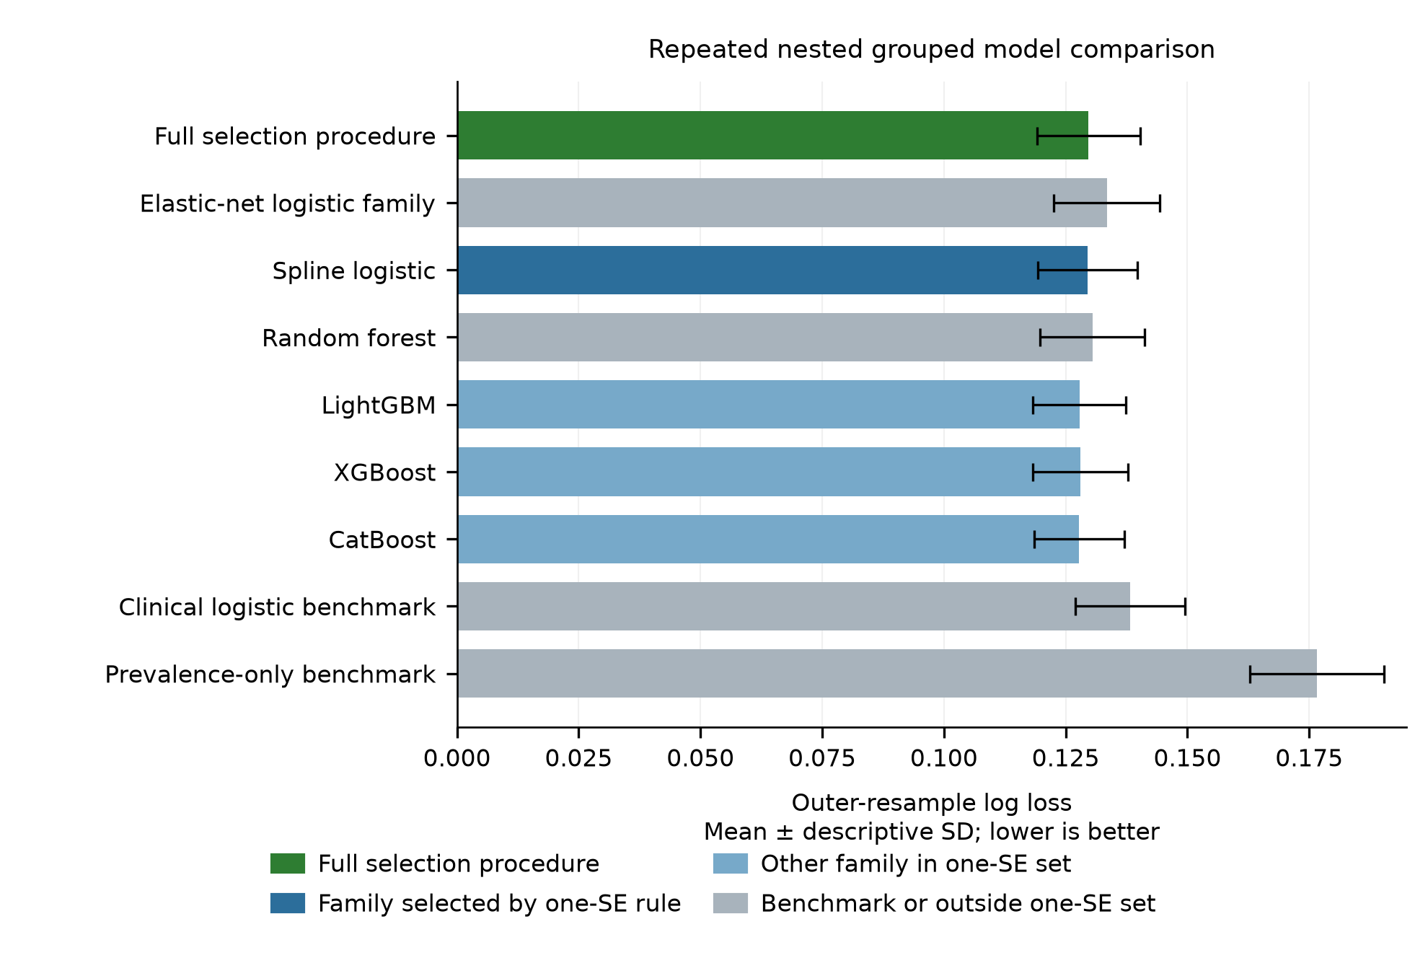
Figure S1. Training-only nested-resampling comparison across selectable model families and nonselectable benchmarks. Repeated-fold variability is descriptive; family selection used the locked full-development inner one-standard-error rule.
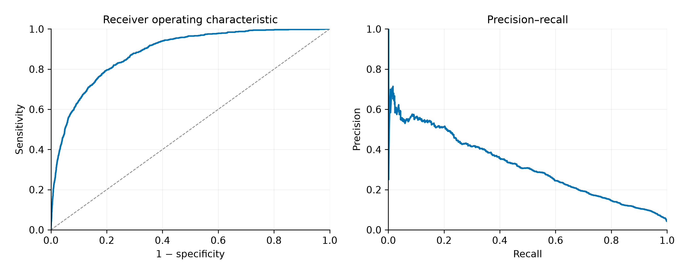
Figure S2. Internal receiver operating characteristic and precision-recall curves using each admission’s mean repeated out-of-fold risk from the complete nested selection procedure, not the fixed spline family.
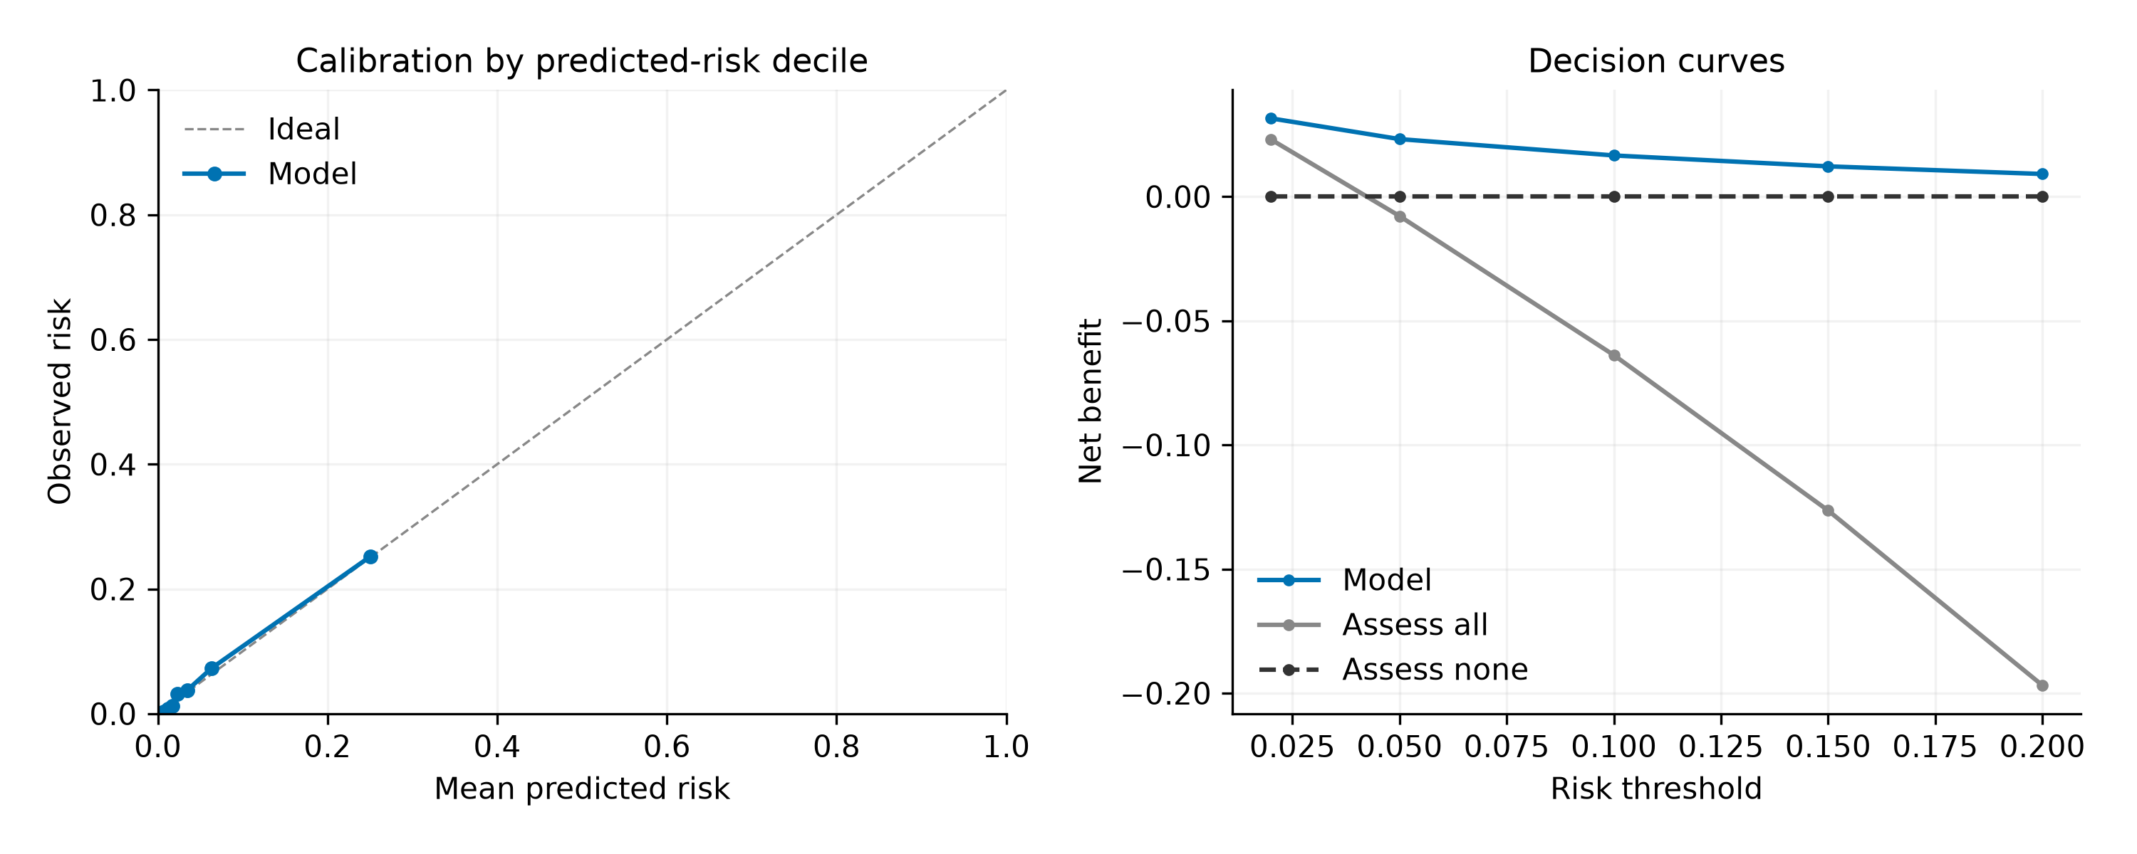
Figure S3. Internal calibration and retrospective decision curves for the complete nested selection procedure. Calibration uses each admission’s mean repeated out-of-fold risk, grouped into 10 predicted-risk quantiles; no bin confidence intervals are shown. Decision-curve estimates are calculated within each complete repeat and then averaged. “Assess all” and “Assess none” mean additional clinical assessment for all or none. These analyses do not establish clinical benefit.
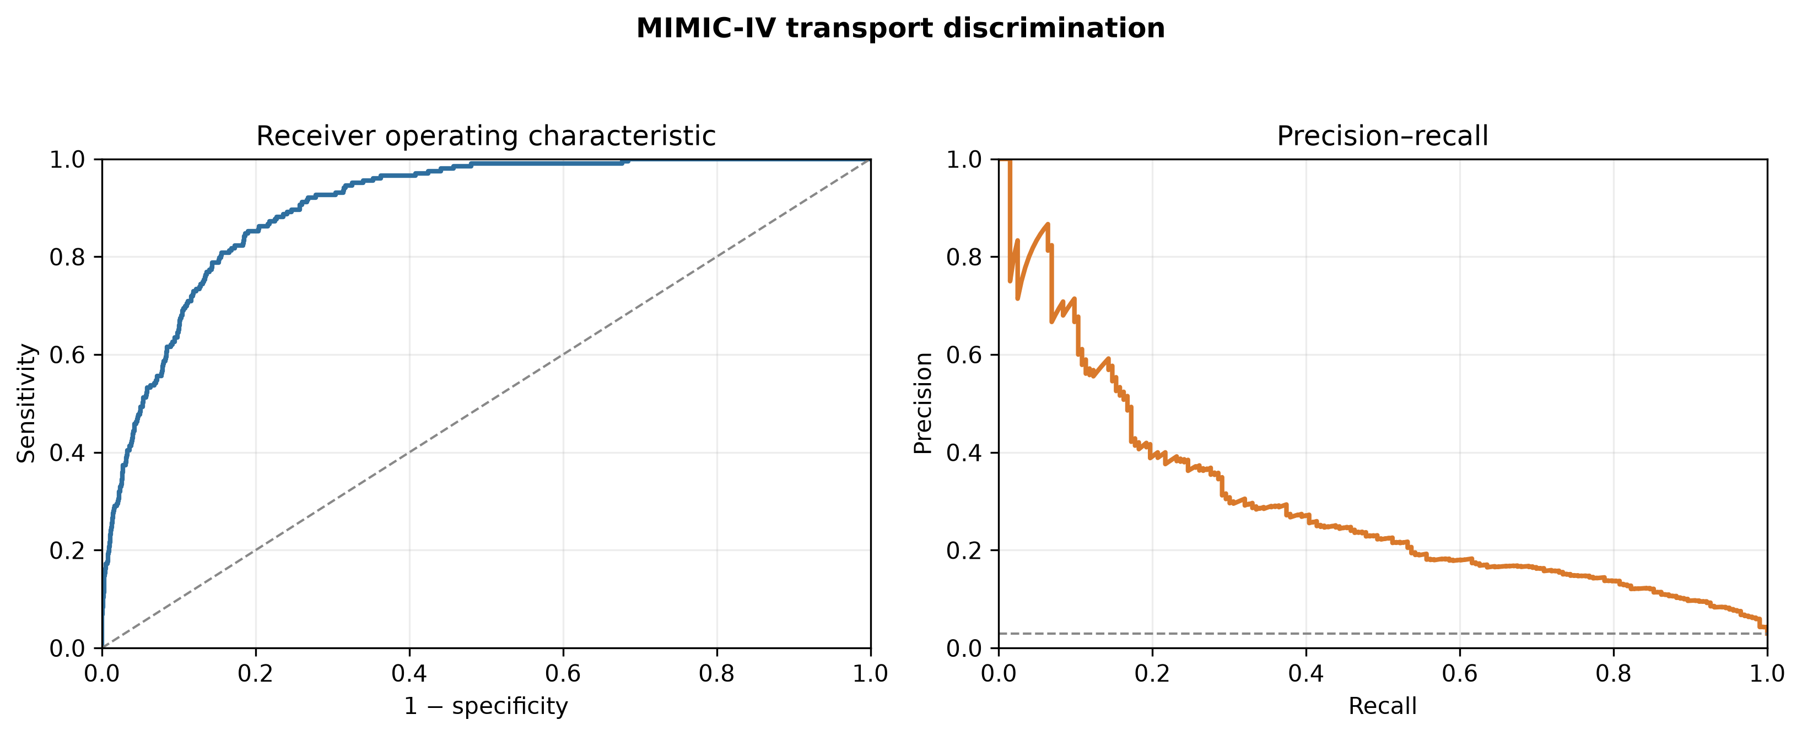
Figure S4. Receiver operating characteristic and precision-recall curves after direct MIMIC-IV transport. No MIMIC-IV outcome was used to refit or reselect the transported pipeline.
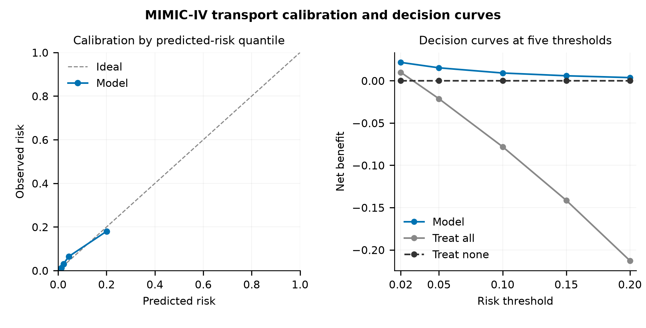
Figure S5. Calibration and retrospective decision curves after unchanged MIMIC-IV transport of the final spline model. Calibration groups predictions into up to 10 quantiles; no bin confidence intervals are shown. “Treat all” and “Treat none” mean additional assessment for all or none. These retrospective analyses do not establish clinical benefit.

Supplementary reference
1. MIT Laboratory for Computational Physiology. eICU Collaborative Research Database: apachePatientResult. https://eicu.mit.edu/eicutables/apachepatientresult/. Accessed 10 October 2026.

