Supplementary Information (Online Resources 1–11)
Minimally invasive and nephron-sparing surgery for renal cell carcinoma: a nationwide analysis of 228,185 nephrectomies in Germany, 2011–2024
Contents
Online Resource 1. RECORD statement checklist
Online Resource 2. CONSORT cohort flow (335,124 → 228,185)
Online Resource 3. Complete baseline characteristics by surgical approach
Online Resource 4. Baseline characteristics by procedure type (partial vs radical)
Online Resource 5. Mean within-hospital minimally invasive share per year by centre-volume band
Online Resource 6. Minimally invasive adoption drift (covariate-by-year interaction odds ratios)
Online Resource 7. Adjusted odds ratios (MIS vs open) across all 18 perioperative outcomes
Online Resource 8. Crude outcome rates by institutional robotic experience (learning curve)
Online Resource 9. Adjusted length of stay (log-linear model; geometric mean ratio MIS vs open)
Online Resource 10. Partial versus radical nephrectomy, 1:1 propensity-score-matched odds ratios within each volume tertile
Online Resource 11. Partial nephrectomy selection drift (covariate-by-year interaction odds ratios)

Online Resource 1. RECORD statement checklist
No. | Item | Location in manuscript
Title and abstract
1 | (a) Indicate the study’s design with a commonly used term in the title or the abstract. (b) Provide in the abstract an informative and balanced summary of what was done and what was found. | Title page; Abstract
RECORD 1.1 | The type of data used should be specified in the title or abstract. When possible, the name of the databases used should be included. | Abstract, Methods; Section 2, Data source and ethics
RECORD 1.2 | If applicable, the geographic region and timeframe within which the study took place should be reported in the title or abstract. | Title page (Germany, 2011–2024); Abstract, Methods
RECORD 1.3 | If linkage between databases was conducted, this should be stated in the title or abstract. | Not applicable. No linkage was performed
Introduction
2 | Explain the scientific background and rationale for the investigation being reported. | Section 1, paragraphs 1–3
3 | State specific objectives, including any prespecified hypotheses. | Section 1, final paragraph. No hypotheses were prespecified
Methods
4 | Present key elements of study design early in the paper. | Abstract, Methods; Section 2, Data source and ethics
5 | Describe the setting, locations and relevant dates, including periods of recruitment, exposure, follow-up and data collection. | Section 2, Data source and ethics. All German acute-care hospitals, 2011–2024. Observation ends at discharge
6 | (a) Give the eligibility criteria and the sources and methods of selection of participants; describe methods of follow-up. (b) For matched studies, give matching criteria and number of exposed and unexposed. | (a) Section 2, Cohort; Online Resource 2. (b) Section 2, Statistical analysis; Online Resource 10
RECORD 6.1 | The methods of study population selection, such as codes or algorithms used to identify subjects, should be listed in detail. | Section 2, Cohort and Exposures. OPS 5-553 and 5-554 with terminal digits, ICD-10 C64–C66, exclusion of OPS 5-554.7/.8/.9; Online Resource 2
RECORD 6.2 | Any validation studies of the codes or algorithms used to select the population should be referenced. | Section 2, Exposures. The terminal-digit structure was verified against every annual OPS catalogue from 2011 to 2024. No external validation study of these codes exists
RECORD 6.3 | If the study involved linkage of databases, consider a flow diagram to demonstrate the linkage process. | Not applicable. Single data source; cohort flow in Online Resource 2
7 | Clearly define all outcomes, exposures, predictors, potential confounders and effect modifiers. | Section 2, Exposures, Covariates and Outcomes
RECORD 7.1 | A complete list of codes and algorithms used to classify exposures, outcomes, confounders and effect modifiers should be provided. | Section 2, Exposures, Covariates and Outcomes. Principal codes are listed there; the complete code list is held in the analysis script and is available from the authors
8 | For each variable of interest, give sources of data and details of methods of assessment. | Section 2, Data source and ethics; Covariates. All variables derive from the same mandatory discharge record
9 | Describe any efforts to address potential sources of bias. | Section 2, Statistical analysis; Section 4.6
10 | Explain how the study size was arrived at. | Section 2, Data source and ethics; Section 3.1. Full national census
11 | Explain how quantitative variables were handled in the analyses. | Section 2, Exposures and Covariates; Section 2, Statistical analysis
12 | (a) Describe all statistical methods, including those used to control for confounding. (b) Subgroups and interactions. (c) Missing data. (d) Loss to follow-up. (e) Sensitivity analyses. | Section 2, Statistical analysis. Analyses were complete-case; observation ends at discharge, so no loss to follow-up arises
RECORD 12.1 | Describe the extent to which the investigators had access to the database population used to create the study population. | Section 2, Data source and ethics. Anonymised microdata inside the secure processing environment of the Research Data Centre; only disclosure-checked aggregates were released
RECORD 12.2 | Provide information on the data cleaning methods used in the study. | Section 2, Cohort and Exposures; Online Resource 2
RECORD 12.3 | State whether the study included person-level, institutional-level or other data linkage across two or more databases. | No linkage was performed. Episodes were grouped by anonymised hospital identifier for the random-effects models
Results
13 | (a) Report numbers of individuals at each stage. (b) Reasons for non-participation. (c) Consider a flow diagram. | Section 3.1; Online Resource 2
RECORD 13.1 | Describe in detail the selection of persons included, including filtering based on data quality, data availability and linkage. | Section 3.1; Online Resource 2. Episodes without a codable surgical approach (n = 930) are identified in the footnote to Table 1
14 | (a) Characteristics of participants. (b) Number with missing data. (c) Follow-up time. | Table 1; Online Resources 3 and 4. Index admission only
15 | Report numbers of outcome events or summary measures over time. | Table 2; Figures 2A and 3A
16 | (a) Unadjusted and confounder-adjusted estimates with precision. (b) Category boundaries. (c) Absolute risk. | Sections 3.3 and 3.4; Figures 2B and 3B; Online Resource 9
17 | Report other analyses done, e.g. subgroups, interactions and sensitivity analyses. | Sections 3.2 and 3.4; Online Resources 6, 10 and 11; Online Resources 5, 7 and 8
Discussion
18 | Summarise key results with reference to study objectives. | Section 4, opening paragraph
19 | Discuss limitations, taking into account sources of potential bias or imprecision. | Section 4.6
RECORD 19.1 | Discuss the implications of using data that were not created or collected to answer the specific research question, including misclassification bias, unmeasured confounding, missing data and changing eligibility over time. | Section 4.6. Coding depth and reimbursement incentives, misclassification of surgical approach and robot assistance, absence of tumour stage and performance status, and the stability of the OPS catalogue are each addressed
20 | Give a cautious overall interpretation of results. | Sections 4.1–4.5
21 | Discuss the generalisability of the study results. | Sections 4.1 and 4.2. Complete national census
Other information
22 | Give the source of funding and the role of the funders. | Title page; Declarations
RECORD 22.1 | Provide information on how to access any supplemental information such as the study protocol, raw data or programming code. | Declarations, Data sharing. The microdata remain within the secure environment of the Research Data Centre, where they are available to researchers under its access rules (DOI 10.21242/23141.2011.00.00.1.1.0 to 10.21242/23141.2024.00.00.1.1.0). The consolidated statistical analysis code is available from the authors on request
Checklist of items, extended from the STROBE statement, that should be reported in observational studies using routinely collected health data. Benchimol EI, Smeeth L, Guttmann A, et al. PLoS Med 2015;12:e1001885. Checklist licensed CC BY.

Online Resource 2. CONSORT cohort flow (335,124 → 228,185)
Step | Episodes, n
All DRG cases (after optional prefilter) | 335 124
NX index OPS (5-553.* or 5-554.*) | 335 124
NX AND renal malignancy (C64/C65/C66 anywhere) | 229 944
NX AND C64/C65/C66 AND adult (>=18 y) | 228 381
minus donor/graft NX (5-554.7/.8/.9) | 196
thereof: partial nephrectomy (PN, 5-553) | 96 828
thereof: radical/simple nephrectomy (5-554.4/.a) | 94 242
thereof: nephroureterectomy (UTUC, 5-554.5/.6/.b) | 38 056
thereof: MIS approach (laparoscopic incl. robotic) | 78 976
of which robotic (5-987) | 37 683
thereof: open approach | 148 279
Final RN cohort | 228 185
Hierarchical classification (mutually exclusive)
Partial nephrectomy | 96 828
Radical or simple nephrectomy | 92 896
Nephroureterectomy or unspecified | 38 461
Total | 228 185
Donor and graft nephrectomies (OPS 5-554.7/.8/.9) were excluded. Counts listed under “thereof” are code flags: an episode carrying more than one procedure code appears in more than one row, so these rows are not mutually exclusive and sum to 229 126. The hierarchical classification used throughout the Results and in Online Resource 4 resolves such episodes by assigning any episode with both a partial and a radical code to partial nephrectomy (n = 1 346), and it is therefore mutually exclusive and sums to the final cohort. The residual category additionally contains nephrectomies whose OPS terminal digit does not specify the procedure.

Online Resource 3. Complete baseline characteristics of 227,255 nephrectomies with a codable surgical approach, by minimally invasive versus open access
Characteristic | Minimally invasive  n = 78 976 | Open  n = 148 279 | SMD  ᵈ
Age, yr, median [IQR] | 68 [59–76] | 69 [60–76] | -0.07
Male sex, n (%) | 52 478 (66.4) | 96 900 (65.3) | 0.02
van Walraven score, median [IQR] | 4 [4–9] | 7 [4–14] | -0.35
Procedure performed, n (%)ᵃ
Partial nephrectomy | 37 659 (47.7) | 58 854 (39.7) | 0.16
Radical or simple nephrectomy | 27 201 (34.4) | 65 446 (44.1) | -0.20
Nephroureterectomy or unspecified | 14 116 (17.9) | 23 979 (16.2) | 0.05
Robot-assistedᵇ | 37 683 (47.7) | 730 (0.5)
Comorbidityᶜ, n (%)
Arterial hypertension | 49 053 (62.1) | 95 538 (64.4) | -0.05
Diabetes mellitus | 15 257 (19.3) | 31 986 (21.6) | -0.06
Chronic kidney disease | 10 761 (13.6) | 25 432 (17.2) | -0.10
Coronary artery disease | 9 083 (11.5) | 19 501 (13.2) | -0.05
Atrial fibrillation or flutter | 7 176 (9.1) | 16 333 (11.0) | -0.06
Obesity | 7 345 (9.3) | 15 022 (10.1) | -0.03
Chronic obstructive pulmonary disease | 3 379 (4.3) | 8 226 (5.5) | -0.06
Peripheral vascular disease | 1 877 (2.4) | 4 251 (2.9) | -0.03
Congestive heart failure | 1 582 (2.0) | 3 802 (2.6) | -0.04
Previous stroke | 789 (1.0) | 2 308 (1.6) | -0.05
Anaemia | 1 219 (1.5) | 3 871 (2.6) | -0.07
Malnutrition | 686 (0.9) | 2 676 (1.8) | -0.08
Solitary kidney | 1 569 (2.0) | 4 622 (3.1) | -0.07
Inferior vena cava thrombus | 74 (0.1) | 2 539 (1.7) | -0.17
Concomitant procedure, n (%)
Adrenalectomy | 1 048 (1.3) | 5 756 (3.9) | -0.16
Retroperitoneal lymphadenectomy | 2 243 (2.8) | 8 347 (5.6) | -0.14
Caval thrombectomy | 11 (0.0) | 330 (0.2) | -0.06
Index admission
Length of stay, d, median [IQR] | 7 [5–9] | 10 [8–13] | -0.53
IQR = interquartile range; SMD = standardised mean difference.
Data are n (%) unless stated otherwise. Patients whose OPS terminal digit did not specify the surgical approach (n = 930 of 228 185, comprising 315 partial, 249 radical or simple and 366 other procedures) are not shown. Expands Table 1 of the main manuscript.
ᵃ Procedure type was assigned hierarchically: episodes carrying both a partial and a radical code were classified as partial, and nephroureterectomies together with procedures not further specified form the residual category. The three categories are therefore mutually exclusive and sum to the column total. They correspond to the hierarchical classification given at the foot of Online Resource 2 and not to the code flags listed above it.
ᵇ Robot assistance was identified by the OPS add-on code 5-987. Cases recorded alongside an open index code reflect coding of the add-on without a minimally invasive terminal digit.
ᶜ Comorbidities were derived from secondary ICD-10 diagnoses and concomitant procedures from OPS codes of the index admission.
ᵈ Standardised mean difference between groups. Values above 0.10 in absolute terms indicate a relevant imbalance. No significance tests are reported because every difference would reach significance at this sample size.

Online Resource 4. Baseline characteristics by procedure type (partial vs radical)
Characteristic | Partial  n = 96 828 | Radical or simple  n = 92 896 | SMD
Patient
Age, yr, median [IQR] | 66 [58–74] | 69 [60–77]
Male sex, n (%) | 65 657 (67.8) | 59 175 (63.7) | 0.09
van Walraven score, median [IQR] | 4 [4–9] | 8 [4–15]
Comorbidity, n (%)
Arterial hypertension | 60 065 (62.0) | 60 652 (65.3) | -0.07
Diabetes mellitus | 19 133 (19.8) | 20 447 (22.0) | -0.06
Chronic kidney disease | 11 193 (11.6) | 16 657 (17.9) | -0.18
Coronary artery disease | 10 538 (10.9) | 12 039 (13.0) | -0.06
Congestive heart failure | 1 788 (1.8) | 2 649 (2.9) | -0.07
Anaemia | 1 553 (1.6) | 2 466 (2.7) | -0.07
Solitary kidney | 2 791 (2.9) | 2 249 (2.4) | 0.03
Inferior vena cava thrombus | 62 (0.1) | 2 346 (2.5) | -0.22
Index admission
Length of stay, d, median [IQR] | 8 [6–10] | 9 [7–12]
IQR = interquartile range; SMD = standardised mean difference. Nephroureterectomies for upper tract urothelial carcinoma are not included. SMD is reported for binary variables only.

Online Resource 5. Mean within-hospital minimally invasive share per year by centre-volume band (adoption penetration)
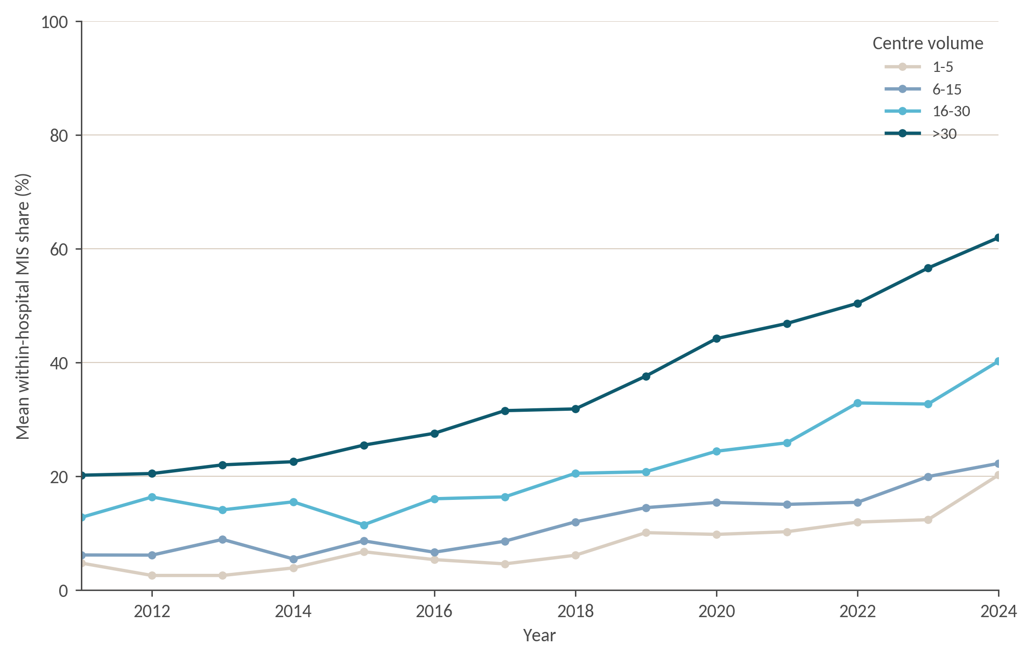
Mean share of minimally invasive procedures per hospital and calendar year, by annual centre volume. Error bars denote one standard deviation across hospitals.

Online Resource 6. Minimally invasive adoption drift (covariate-by-year interaction odds ratios)
Covariate | Interaction OR (95% CI) | p value
Age, per year | 1.00 (1.00–1.00) | 0.674
van Walraven score, per point | 1.00 (1.00–1.00) | <0.001
Charlson comorbidity index, per point | 0.99 (0.99–1.00) | <0.001
Chronic kidney disease | 0.97 (0.96–0.98) | <0.001
Congestive heart failure | 0.99 (0.97–1.00) | 0.085
Chronic obstructive pulmonary disease | 1.01 (1.00–1.02) | 0.042
Diabetes mellitus | 1.00 (0.99–1.00) | 0.360
Metastatic disease | 0.98 (0.97–0.99) | <0.001
Anaemia | 0.97 (0.95–0.99) | <0.001
Partial nephrectomy | 1.09 (1.09–1.10) | <0.001
CI = confidence interval; MIS = minimally invasive surgery; OR = odds ratio. Covariate-by-year interaction term of a separate logistic model per row. OR > 1 = covariate increasingly associated with MIS over time; OR < 1 = decreasingly so. Estimates are per calendar year and compound across the study period.

Online Resource 7. Adjusted odds ratios (MIS vs open) across all 18 perioperative outcomes (GLMM, random hospital intercept; magenta p < 0.05)
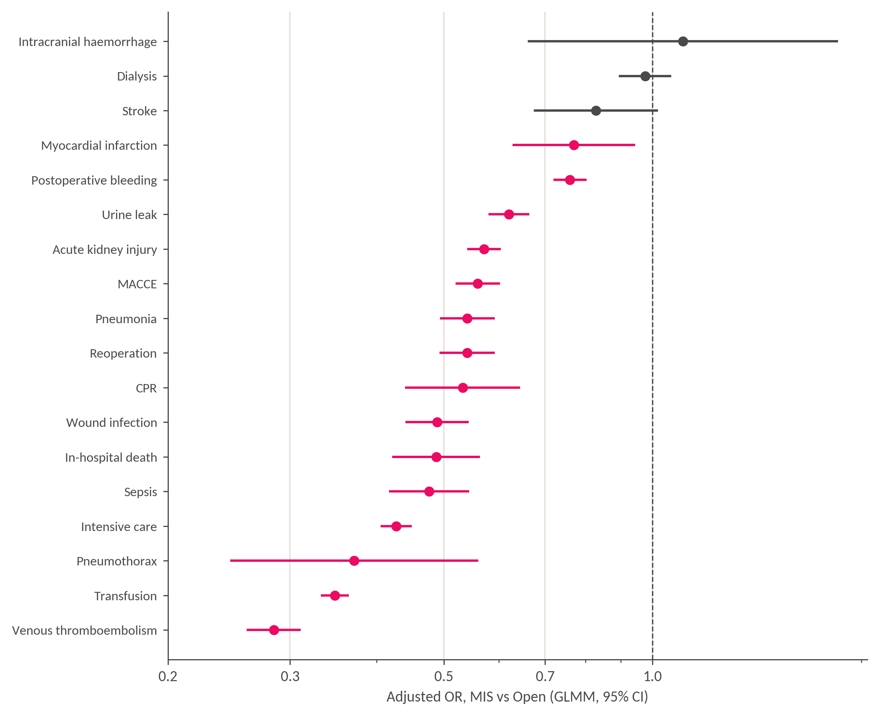
GLMM = generalised linear mixed model; MIS = minimally invasive surgery; OR = odds ratio. Each outcome modelled separately, adjusted for procedure type, age category, sex, van Walraven score, log annual centre volume and calendar year. Dashed line: OR = 1.

Online Resource 8. Crude outcome rates by institutional robotic experience, all outcomes (learning curve)
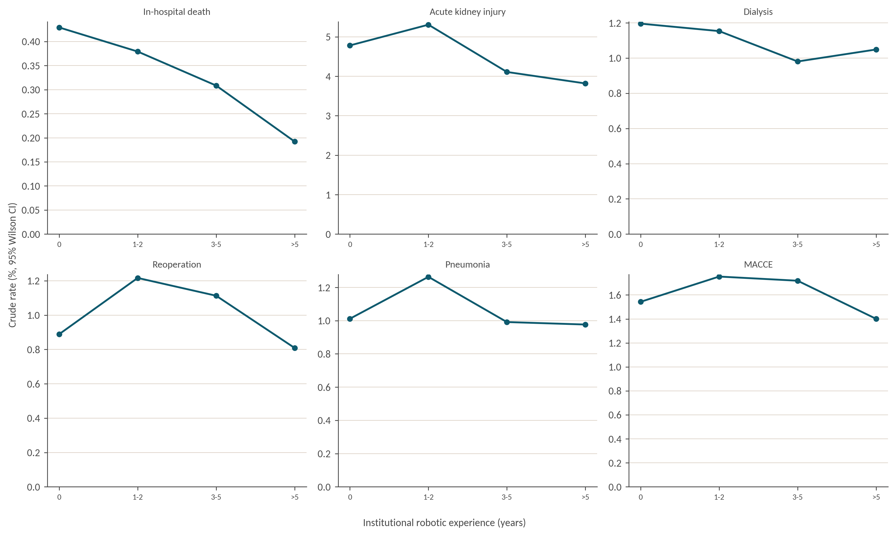
Robot-assisted procedures only. Experience is the number of years elapsed since the first robotic case of the treating centre. Estimates for outcomes with few events should be interpreted with caution.

Online Resource 9. Adjusted length of stay (log-linear model; geometric mean ratio MIS vs open)
Term | GMR (95% CI) | p value
Minimally invasive vs open access | 0.737 (0.734–0.739) | <0.001
Age, per year | 1.004 (1.004–1.005) | <0.001
Female vs male sex | 1.036 (1.032–1.040) | <0.001
van Walraven score, per point | 1.026 (1.025–1.026) | <0.001
CI = confidence interval; GMR = geometric mean ratio; MIS = minimally invasive surgery. Linear model of log-transformed length of stay. GMR < 1 = shorter stay. Reference: open access, male sex.

Online Resource 10. Partial versus radical nephrectomy, 1:1 propensity-score-matched odds ratios within each volume tertile
Outcome | Adjusted OR (95% CI) | p value
Volume tertile 1 (partial n = 2 516, radical n = 5 152, matched n = 5 032)
Acute kidney injury | 0.59 (0.46–0.75) | <0.001
Dialysis | 0.43 (0.27–0.68) | <0.001
In-hospital death | 0.70 (0.39–1.25) | 0.228
MACCE-RN | 1.01 (0.77–1.32) | 0.949
Red blood cell transfusion | 0.79 (0.66–0.93) | 0.006
Reoperation | 0.92 (0.67–1.27) | 0.616
Pneumonia | 1.22 (0.85–1.75) | 0.293
Volume tertile 2 (partial n = 20 006, radical n = 26 427, matched n = 40 012)
Acute kidney injury | 0.89 (0.82–0.97) | 0.006
Dialysis | 0.50 (0.42–0.61) | <0.001
In-hospital death | 0.56 (0.44–0.71) | <0.001
MACCE-RN | 0.81 (0.73–0.91) | <0.001
Red blood cell transfusion | 0.76 (0.72–0.81) | <0.001
Reoperation | 0.80 (0.69–0.92) | 0.002
Pneumonia | 1.17 (1.02–1.34) | 0.029
Volume tertile 3 (partial n = 73 991, radical n = 61 065, matched n = 122 130)
Acute kidney injury | 0.89 (0.85–0.94) | <0.001
Dialysis | 0.35 (0.32–0.38) | <0.001
In-hospital death | 0.57 (0.50–0.65) | <0.001
MACCE-RN | 0.74 (0.69–0.79) | <0.001
Red blood cell transfusion | 0.68 (0.66–0.71) | <0.001
Reoperation | 0.64 (0.59–0.69) | <0.001
Pneumonia | 1.12 (1.04–1.21) | 0.004
CI = confidence interval; OR = odds ratio. Tertiles of annual caseload were formed over the 6 766 hospital-years of 2011–2024 and not over patients, so each tertile contains the same number of hospital-years but very different numbers of patients. Median annual caseload was 3, 25 and 59 nephrectomies in tertiles 1, 2 and 3, which comprised 2 256, 2 255 and 2 255 hospital-years and 10 037, 57 647 and 160 501 episodes of the full cohort. Of the 189 157 partial and radical nephrectomies compared here, 7 668 (4.1%), 46 433 (24.5%) and 135 056 (71.4%) fall into the three tertiles. Nearest-neighbour matching on the propensity score logit (calliper 0.2 standard deviations) with a doubly robust outcome model. Reference: radical or simple nephrectomy. Matching was anchored on the smaller of the two groups within each tertile, which is partial nephrectomy in tertiles 1 and 2 (2 516 versus 5 152 and 20 006 versus 26 427) but radical nephrectomy in tertile 3 (61 065 versus 73 991), where partial procedures already outnumber radical ones. The exposure variable is coded identically in all three models, so every odds ratio compares partial with radical nephrectomy and none is inverted. What the anchor changes is the composition of the matched sample, which resembles the patients treated by partial nephrectomy in tertiles 1 and 2 and those treated radically in tertile 3. Magnitudes are therefore not strictly comparable across tertiles, although the direction of effect is, and it is the same for every outcome in all three.

Online Resource 11. Partial nephrectomy selection drift (covariate-by-year interaction odds ratios)
Covariate | Interaction OR (95% CI) | p value
Age, per year | 1.00 (1.00–1.00) | <0.001
van Walraven score, per point | 1.00 (1.00–1.00) | <0.001
Charlson comorbidity index, per point | 1.00 (1.00–1.00) | <0.001
Chronic kidney disease | 0.98 (0.97–0.99) | <0.001
Congestive heart failure | 0.98 (0.97–1.00) | 0.019
Chronic obstructive pulmonary disease | 1.00 (0.99–1.01) | 0.567
Diabetes mellitus | 1.00 (1.00–1.01) | 0.189
Metastatic disease | 0.99 (0.97–1.00) | 0.023
Anaemia | 0.95 (0.93–0.96) | <0.001
CI = confidence interval; OR = odds ratio. Covariate-by-year interaction term of a separate logistic model per row. OR > 1 = covariate increasingly associated with partial nephrectomy over time; OR < 1 = decreasingly so. Estimates are per calendar year. These values underlie Fig. 3d.

