Supplementary Information
Bundibugyo virus carries a genus-exclusive four-position VP24 configuration and a predicted cell-type ordering of interferon restriction
Wenhao Huang, Nanning No.3 High School, Nanning, Guangxi, China
Corresponding author: Wenhao Huang; penicillinw@foxmail.com

This supplement reports the external analyses that test the interferon (IFN) tone axis and define the boundaries of the claim. Three panels ask whether baseline tone tracks responsiveness, followed by the probe-aggregation grid and the paired contrast built on the one functional panel. The remaining analyses cover the filovirus anchor, the tissue-level extension with its composition analysis, the paired mRNA–protein layer, and a primary polarised epithelial panel released at the close of the census described in the main text. Values it quotes from the analyses below appear here. Values it quotes from the auxiliary robustness, resampling and geometry calculations are indexed in Supplementary Note 4 and in the analysis outputs listed under Data availability. The cross-sample IFN trial reported in the Limitations (GEO GSE107549) is retained there as a test that was looked for and did not pass.

Supplementary Note 1 The score measures a baseline tone, not IFN responsiveness
Three panels test whether the score can be read as responsiveness, with baseline and response measured in the same cells. The first comprises ten human cancer cell lines profiled on one platform with matched control and IFN-α-2a arms in triplicate [12]. The response there was binary, with no graded values: five lines induced the module by +0.89 to +1.56 log units, and five did not respond at all, by +0.02 to +0.04. Pooling the two strata gives a negative correlation between the baseline score and the response (-0.69), but the sign belongs to the stratification. Within the five responsive lines the eleven-gene module gives +0.40 and the two-gene priming term at the centre of our score gives -0.90. Within the non-responsive lines it is -0.80, on ranks that carry no information. The baseline score reproduces across replicates (reliability 0.997), so the measurement is not the problem. The material is. A genuine shutdown of induction and a ceiling artefact therefore remain available explanations of the same numbers. A binary responder and non-responder structure is also what pathway lesions produce, and such lesions are common in transformed lines. The panel is therefore a material control, not a test of a graded relationship, and the link between baseline expression and responsiveness stays untested here. Testing that link requires non-transformed human material, organoids, differentiated primary epithelium or primary immune subsets spanning several lineages, with matched untreated controls in one experiment on a platform with unclipped dynamic range. A second panel lacks this defect: nine immortalised lines profiled together with primary Macrophages and primary CD4 T cells, untreated and after type-I IFN on one platform [11]. Every cell type responds, between 2.8 and 4.2 log units, with a largest consecutive gap of 1.2-fold. Baseline IFN tone explains essentially none of the variation in response. The baseline IFN-stimulated module is unrelated to its own induction (-0.08, exact permutation p = 0.84), the composite score is +0.20 (p = 0.61), and a housekeeping module through the same pipeline moves more than either (-0.37). What the baseline score tracks is the induced level, not the increase (+0.88, p = 0.003). That is what a near-constant fold-change would produce. The third panel uses primary material and settles the sign, though not the interpretation. Six healthy donors were profiled across five populations, untreated and after IFN-α, in one experiment [13]. The relationship is present and reversed: the higher the baseline IFN tone, the smaller the additional response. Pooled within cell type the Spearman correlation is -0.95 (permutation p below 5x10-5), and it holds across every check: per population -0.94 to -1.00; leave-one-donor-out -0.92 to -0.98; partial correlation controlling a housekeeping module -0.92; disjoint gene halves -0.86. The value sits at the 100th percentile of a random fourteen-gene null. The same reversed relation reproduces in an independent cohort from a different study, where monocytes give -1.00 for IFN-α and for IFN-β (exact p = 0.017). There only the Monocytes have enough donor-to-donor spread in baseline to be tested [14]. The pattern behind it is convergence, not desensitisation: after IFN-α the donors occupy a much narrower range of IFN-stimulated transcript levels than before, so cells that start high have least headroom. Two readings follow, and they make opposite predictions. If the cost of a defective VP24 scales with the additional IFN response a cell can mount, the gradient runs opposite to the one we draw below. If it scales with the absolute antiviral state the cell reaches, the baseline score is a usable proxy, since baseline tone does track the induced level (+0.88, p = 0.003, in the second panel). Nothing in our data decides between them, so the partition below is an ordering hypothesis, not a settled prediction. The functional panel described next leans towards one of the two. The score is therefore not a validated proxy for IFN responsiveness: as a predictor of the additional response it points the wrong way. Which of the two quantities a phenotype follows can be asked directly wherever a functional readout accompanies the expression data. The panel above states in its own record which of its members become restricted to HIV-1 after IFN and which remain permissive [11]. A second implementation, sharing no code with the first, separated three properties of the three candidate quantities (Fig. S2a, b). The level reached after IFN is the only one whose discrimination is invariant to probe collapsing. Across seven equally defensible rules of the same seventeen-gene module it gives an AUC of 0.90 in every one, and 0.83 in every one when the two partially resistant lines are counted with the permissive group. Over the same genes and samples fold induction moves between 0.50 and 0.77, and baseline tone between 0.67 and 0.80. The level is also the highest of the three in all eleven leave-one-cell-out resamplings. Against that, it cannot be separated from baseline tone here. Their paired difference is two to three pairings out of twenty, the exact paired-difference p is 0.22 and 0.058 when the partially resistant lines are counted with the permissive group, the null interval includes zero, and the two quantities correlate at 0.92. The third property limits where the level reading applies. It holds for IFN-stimulated effector modules, including one that excludes ISG15 and MX1 and on which the level reaches an AUC of 1.00 (exact p = 0.008). It reverses on the two components this score is built from: for the two-gene priming term and for the receptor complex, baseline tone is the better of the three under every probe rule. The contrast involves nine units under the strict definition, or eleven when the two partially resistant lines are counted with the permissive group, the phenotype is HIV-1 restriction, not filovirus restriction, and the rival quantities are separated by about one log unit. What this panel supports is a baseline-tone axis whose operational reading is the absolute level a cell attains (Fig. S3a, b). It does not support the stronger claim that the score tracks the level as distinct from the baseline it is computed from. The exact permutation p for the level advantage is 0.03 to 0.04 across the two implementations, and searching the continuum of contrasts before the family-wise correction gives a best value that no longer reaches significance (p = 0.056 over the nine-unit panel, 0.063 over the eleven-unit panel). The functional form of the score was tested, not assumed. In the same panel the equal-weight three-component score separates restricted from permissive cells better than any single component. The AUC is 0.87 against 0.70, 0.80 and 0.77 for type-I receptor capacity, type-III receptor capacity and baseline IFN-stimulated priming, its three equal-weight components. Fitting the three weights improves the fitted value but loses on leave-one-out cross-validation (0.90 fitted against 0.63 out of sample), so equal weighting is the defensible choice at this sample size. The score's components also differ between evidence layers, and that comparison was redone in a paired resource, not against annotation text. In 29 healthy human tissues profiled for both mRNA and protein, the genome-wide median mRNA–protein correlation is only 0.335. MX1, one of the two priming genes, sits at the 99.5th percentile. The full layer comparison is in Supplementary Note 4.

Supplementary Note 2 A filovirus functional anchor for the level reading
The column-to-treatment map of this series was read from its metadata, never inferred from expression values. On that map, the type-I-stimulated level orders how strongly the cells inhibit in one time block and not in the other. IFN-γ raises the panel to a lower level than IFN-λ at both time points (6.65 against 7.19 in log2 counts per million), yet at six hours IFN-γ inhibits as much as IFN-β and more than IFN-λ. At twenty-four hours the two orderings agree, with IFN-β and IFN-λ inhibiting similarly and both more than IFN-γ. IFN-γ is also the class whose panel rises most between the two time points (+1.07 log2) while its reported inhibition is unchanged. Two boundaries limit that reading. The four classes were applied at doses differing by more than an order of magnitude, so a comparison of module levels across classes is not a like-for-like test of the level reading. The two untreated batches differ by 1.50 log2 in panel level, so arm comparisons are made within batch. The same dataset does support the third component of the score, because these cells respond to IFN-λ about as strongly as to IFN-α, the panel rising by 2.711 against 2.886 log2 above the batch-matched untreated control. The filovirus anchor therefore leaves the level reading conditional, not established, and is one reason the partition below is stated as an ordering hypothesis.

Supplementary Note 3 A primary polarised epithelium separates type I from type III IFN
GSE342661 (GEO; series public 25 September 2026, with data files released on 26 September 2026, the closing day of this study's census) profiles primary differentiated human nasal epithelial cells grown at an air-liquid interface. The cells were treated at a single mass concentration of 25 ng/ml with IFN-β1 or with each of IFN-λ1, -λ2, -λ3 and -λ4, delivered either to the apical surface alone or to both the apical and the basal chambers. Treatments ran at 6, 24 and 72 hours against untreated controls, with five biological replicates in each of the 36 treatment-by-time-by-route cells (180 samples, no empty cell). The five replicates are cultures from five biological donors, and the controls are donor-matched. Using the same seventeen-gene IFN-stimulated module as above, and referring every treated sample to its own untreated control, the type-I arm exceeded the type-III arms under basal delivery. Pooled over the three time points (n = 15 paired samples) IFN-β1 raised the module 2.27 log2 units above the mean of IFN-λ1 to -λ3 (exact sign-flip p = 6.1 x 10-5; 15 of 15 pairs positive). The per-isoform differences were +2.09, +2.52 and +2.20 log2 units. The individual inductions were 5.40, 6.02 and 5.73 log2 units for IFN-β1 against 3.60, 3.60 and 3.69 for IFN-λ1, 3.51, 3.01 and 3.07 for IFN-λ2 and 3.58, 3.32 and 3.65 for IFN-λ3. IFN-λ4 produced no measurable response at this concentration (+0.04, +0.13 and +0.13 log2 units; no gene passed a paired test at five per cent false discovery rate with a one-log2 floor in any IFN-λ4 arm). Basal access was required: when the IFNs were applied apically only, the type-I advantage fell to +0.74 log2 units and was no longer significant (exact sign-flip p = 0.12; 11 of 15 pairs positive). The untreated controls showed no apical-versus-basal difference (-0.07 to +0.002 log2 units), so the gate is specific to IFN treatment. Two modules were flat over all 36 cells as negative controls: the housekeeping module (7.95 to 8.61 log2 units) and the receptor module itself (4.39 to 4.68). Within that receptor module the type III subunit has the lowest baseline of the four in the untreated controls (mean IFNLR1 2.10 against IFNAR2 4.99, IFNAR1 5.55 and IL10RB 5.57 log2 units), the ordering the source study reports, so a flat receptor control is compatible with the weaker type III arm. Against 2,000 expression-matched random seventeen-gene modules the type-I-minus-type-III statistic pooled over both routes had a median of -0.01 log2 units and a 95 per cent interval of [-0.07, +0.09], and the observed +1.51 sat at the extreme edge of that distribution (Fig. S4a and d). The panel reproduces the source study's own conclusions, which acts as a positive control on the pipeline, not as circular evidence. The panel does not test the restriction axis: there is no virus in these data and no BDBV-versus-EBOV comparison within one cell type. The source study does report a virus-side read-out in the same cultures, an H3N2 influenza infection in which dual-chamber IFN-β1 lowered viral titre by 0.86 log10 at 25 ng/ml, but that is an influenza phenotype rather than a filovirus comparison, so it supports the type I arm being the functionally stronger one without serving as a functional anchor for the gradient. Because every treated sample is referred to its own untreated control, the level and fold readings of this contrast are arithmetically identical, so it cannot arbitrate between them. With five replicates per cell and a single mass concentration, the smallest attainable two-sided p value for a single cell is 0.0625 and no potency ordering can be derived. The panel therefore constrains the host-side epithelial reading, not the viral defect.

Supplementary Note 4 Additional method and coverage detail
Seven further public datasets carrying those cell types (urothelial, retinal pigment epithelial, photoreceptor, Sertoli and choroid-plexus cells) were added under the same conventions and Cell Ontology mapping. Three limits remain. The reference-side mapping covers 97 of the 154 cell types and excluded both photoreceptor types. Curated retinal mappings connect them, and both then carry the assigned sign (rods -1.00 against -1.17 over 62,523 cells, cones -1.21 against -0.92 over 1,777 cells, in independent human eye atlases), with one exception, Müller glia, which reverses. Whether that repair raises or lowers agreement depends on the convention (0.568 to 0.605 over 38 to 44 labels on the frozen rule, 0.545 to 0.548 over 41 to 49 without it). Both pairs are computed on the seven added datasets alone, so they are not comparable with the pooled values above; it is a coverage repair, not an improvement. Two further resources were set aside. Both matrices label columns by author well identifiers and publish no key, and an independent check disagrees on the shared EBOV condition by 2.73 log2 units, so no readout was taken. A human retinal pigment epithelial line infected with EBOV at 24 hours has a usable host transcriptome [21]. In that transcriptome the IFN-stimulated module rises by 1.53 log2 while the receptor components do not move. The evidence layer is a coverage limit, not a directional one. In 29 healthy human tissues profiled for both mRNA and protein, the genome-wide median mRNA–protein correlation is only 0.335, so low concordance is the norm and not a property of this score. MX1, one of the two priming genes, sits at the 99.5th percentile. The two immunohistochemistry-layer genes, IRF9 and KPNA1, sit at the 29th percentile, inside the normal range, and the gap is gene-specific. In the paired resource the protein is undetected in over half of the tissues for IFNAR1, IFNAR2 and KPNA5. In the only public cell-type-resolved proteomic resource (HPA deep visual proteomics, 27 cell types from 14 tissues, v25.1 [S1]) IL10RB and IFNAR1 are quantified in 8 and 1 of those 27 cell types. IFNLR1 appears in none of the 27 cell types (0 of 128 sample-level rows) and IFNAR2 in 2 of 128. Three limits travel with it: a single healthy donor, depth-limited detection, so that non-detection is not absence, and a v25.1 release whose preprint is not peer reviewed. The receptor arm therefore cannot be tested, because no more than one of the 27 cell types carries a quantified value for any of the other three genes. The fourth, IL10RB, is uninformative, not positive or negative: its six matched groups fall below the 80% power detection floor of Spearman 0.92. Three compartments that could not be tested before can be tested now. In an independent human eye atlas the retinal pigment epithelium, rod and cone photoreceptors sit at -1.03, -1.17 and -0.92 standard deviations (11 labels), which is the predicted direction for all three. The rival importin-α account is likewise unvalidated against a biological outcome. Cross-atlas coverage is bounded. The atlases used here carry airway and myeloid cells but no urothelial, retinal pigment epithelial, photoreceptor, Sertoli or choroid-plexus cells. Extending the cross-atlas test from the nineteen datasets screened earlier to twenty-six (the nineteen plus the seven low-end atlas resources added here) raises the matched-pair count from 162 to 198; pooled agreement is essentially unchanged (Spearman 0.528 against 0.519 over the original 162, label-permutation p = 0.0002) and no weaker where the addition was aimed: 0.59 over the 28 low-end pairs and 0.41 over the remaining 169. Those two subsets cover 197 of the 198 pairs. The 198th pair, choroid-plexus epithelium matched in the choroid-plexus atlas, is a constructive zero — that atlas carries a single matched label, so its z-score has no contrast — and is held out of the low-end subset rather than counted with it. The lowest compartment is independently lowest: retinal pigment epithelial cells score -1.03 in a human eye atlas against -1.02 in the reference. The low end replicates among the added pairs: cardiomyocytes, ranked 147th of 154, sit at -1.21 over 3,007 cells of an independent human cell landscape. The urothelium, whose compartment median ranks second (Fig. 2c), is not recovered the same way: it sits within 0.06 standard deviations of its own atlas mean over the three urothelial labels of an adult ureter atlas. The choroid plexus remains uninformative, not negative, its single label not standardisable internally, and the term appears in none of the nineteen local atlases, although 33 of the 1,629 public human datasets screened in CELLxGENE Discover carry choroid-plexus epithelium, 22 carry retinal pigment epithelium, 18 and 17 carry cone and rod photoreceptors, 7 carry urothelium and 5 and 4 carry Leydig and Sertoli cells. That gap is local, not global. Every added dataset is unstimulated, so the test covers the ordering of the axis, not the IFN response. Under resampling and weighting noise alone the share of perturbed assignments is 26.9% for choroid-plexus epithelium and 0.0% for enterocytes, urothelial cells, plasmacytoid dendritic cells, macrophages, rods and retinal pigment epithelium. In the wider grid of gene sets, transformations, standardisation sets and weightings it rises to 46.5% for ependymal cells and 32.7% for choroid-plexus epithelium, and among the six guaranteed extremes to 11.3% for macrophages and 0.4 to 2.9% for the remaining five. Of the 886 Bundibugyo VP24 copies recovered by a record-by-record recount, 860 are callable at all four positions: 858 carry the complete configuration and 2 carry a single-position departure (S83L, A141V). The remaining 26 are not callable at one or more of the four positions (19 uncalled at all four, 6 at one, 1 at three) and are counted as unresolved, not as negative. They are excluded from every denominator in this paragraph, and not treated as evidence against the configuration. Two tiers of evidence would be needed before either departure could be called a signal. At the level of a single record, an independent extraction or library preparation of the same sample would be needed, with depth above 100x after primer trimming and de-duplication and base and mapping quality at least 30. The call would also need an allele fraction of at least 0.90, so that it is a consensus replacement and not a mixed site, support from both strands with no strong strand bias, and no clustering at read ends, primer sites or low-complexity sequence. Both records fail this first tier, because a consensus-only deposit cannot be evaluated for any of those properties. At the level of the population, the same departure would have to be technically confirmed in at least two carriers that are not epidemiologically linked, preferably drawn from different transmission chains or different independent processing batches. A more conservative standard would require three such carriers spanning at least two outbreaks. Two records from one outbreak cannot supply two independent occurrences. Neither departure reaches the first tier, so neither reaches the second, and the observations are reported descriptively. The zero-count bounds quoted in the main text use each species' own callable count: 3,253 for EBOV, 146 for Sudan virus, 27 for Reston virus, 10 for Bombali virus and 4 for Tai Forest virus. They do not use the 886 copies of the aggregation instance and do not include records with an uncalled position. Two further checks bound how much the residue calls can be asked to carry. With only two distinct BDBV protein sequences, an invariance statistic computed inside the species has no power: a specified set of four positions is expected to be invariant C(250,4)/C(251,4) = 98.4% of the time by chance alone. The four positions are also not a co-varying unit. Within every species each of the six pairwise mutual informations is zero because a single state is observed; pooling the genus gives mutual informations of 0.068 to 0.081 bits (permutation p = 0.0001), the association disappears when the permutation is stratified by species (p = 1.000), and mutual information between a position and the species identity accounts for 0.988 to 1.000 of that position's entropy. The BDBV VP24 census behind the merged configuration statement returns 32 records: 31 full-length sequences plus one 95-residue fragment that does not span the four-position window and is therefore excluded from the denominator, not scored as negative. Of the 31 full-length sequences, nine come from Uganda in 2007, including ACI28626 from FJ217161, ALT19774, AKB09567 and the RefSeq protein YP_003815439. Twenty-two come from the 2012 Isiro outbreak in the Democratic Republic of the Congo, including AGL73476, deposited as EboBund-14 2012, and the Isiro-2012 series.

Supplementary Note 5 Spleen reconstruction and its coverage limits
The spleen was the one compartment with no member cell type, so its side of the score was rebuilt from a spleen-tissue single-cell reference. Eight broad splenic classes, from Erythroid progenitors and Dendritic cells (62 to 66 cells each) up to Plasma cells (11,669 cells), carry values on the frozen scale. Their ordering agrees with the reference panel across twenty shared cell types (Spearman 0.615 on the frozen reference scale, label-permutation p = 0.0040 over 5,000 draws, and none of the 184 scoreable expression-matched random six-gene modules reached it, 16 of the 200 being absent from the atlas panel). The absolute position does not transfer: the same transform over-estimates on this resource by about half a z unit and under-estimates on an independent spleen atlas. The compartment is therefore reported as an interval (about +0.5 to +0.65 on the calibrated scale), not as a rank. The named spleen-specific populations — Marginal-zone B cells, Red-pulp macrophages and the white pulp — are unavailable, not outstanding. The first two have no Cell Ontology annotation in any of the 2,236 indexed public single-cell datasets (1,629 of them human), and the third names a region, not a cell type. An independent adult spleen atlas reproduces the ordering only to Spearman 0.49 over the six shared labels, below the smallest detectable correlation at that number (0.92), so it is a power limit, not agreement or disagreement.

Supplementary Note 6 An analysis that bounds the framework
The analysis below bounds the framework rather than tests its central prediction. The main text carries a one-sentence pointer to it.

A multiplicity-matched hepatocyte dataset places BDBV 3 to 13 fold below EBOV
One dataset permits a directional check on the prediction (Fig. S2c), although public data do not permit the decisive test (Fig. S2d). A four-virus infection series in a hepatocyte-lineage line profiled the seven viral mRNAs at 1–3 days post-infection [S2]. The source study used all four viruses at the same multiplicity of infection (0.1) in single infections, which removes inoculum dose as an explanation for differences in output. Summing the seven viral transcripts, BDBV produced 2,344, 42,497 and 188,428 reads at days 1, 2 and 3, against 30,012, 518,797 and 559,072 for EBOV; the BDBV-to-EBOV ratio was therefore 0.078, 0.082 and 0.337. BDBV was indistinguishable from Reston virus, which is the species that binds KPNA with EBOV-like affinity. The relative abundance of the seven transcripts was otherwise closely similar between BDBV and EBOV, the largest deviation being a lower GP share at days 2 and 3. An earlier comparison found that BDBV reached one to two orders of magnitude lower yields than EBOV in human peripheral blood mononuclear cells [S3]. Hepatocytes sit in the upper quartile of the IFN axis (Δ rank 34 of 154), so on that axis alone the direction of this difference is the one the gradient predicts. The importin-α account predicts no VP24-driven penalty here, because Hepatocytes carry low importin-α levels and fall in the quadrant where the two axes disagree. The same dataset carries a second warning sign: the species that BDBV matched in output, Reston virus, is the one whose VP24 is not defective in this pathway, the opposite of the match expected if the output differences were driven by VP24. The series therefore supports the IFN axis on its own and not the importin-α account, and it measures viral output, not the host response. Both points are carried into the limitations.

Supplementary Figures
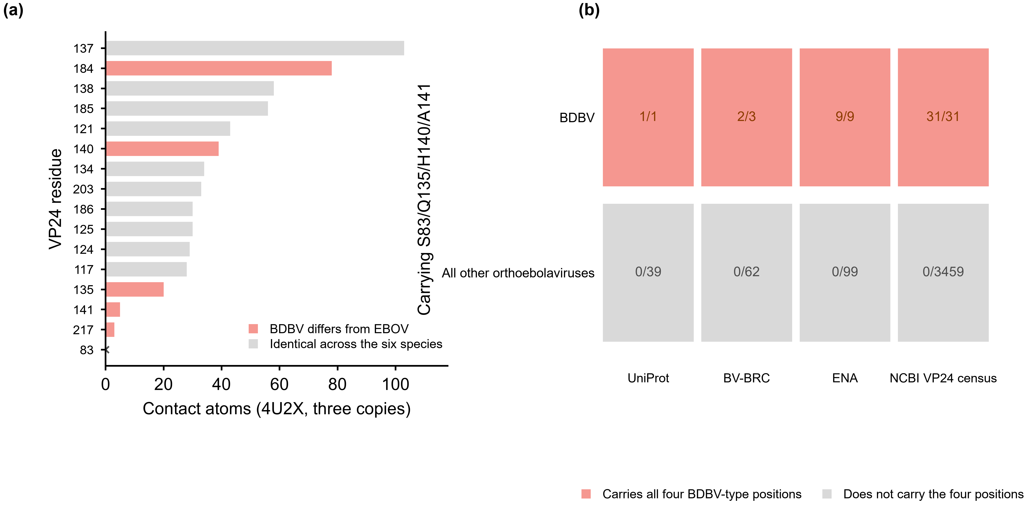
Fig. S1. Two quantitative supports for the BDBV four-position configuration. (a) The experimental VP24–KPNA5 interface (PDB 4U2X), ranked by heavy-atom contacts summed over the three cognate copies; warm bars mark the five positions at which BDBV differs from EBOV (Q184R, R140H, N135Q, V141A and A217V), four of which contact KPNA5, and pale bars mark positions identical across the six species. Q184R has the second-largest contact footprint, and position 83, which mutagenesis shows is functionally required, makes no contact and is marked with an x. (b) The same configuration counted in four independent sequence sources as records carrying S83/Q135/H140/A141 over records examined, with the denominator defined per source. Contact footprints are heavy-atom counts in the experimental complex, not energy or affinity estimates. Each ratio counts records carrying the configuration over records examined, with the denominator defined per source: all retrieved records for BV-BRC, whose third record could not be read, and all sequences assessed for the NCBI census, which counts 3,459 non-BDBV sequences of which 3,440 carry a call at all four positions. BDBV counts are UniProt 1/1, BV-BRC 2/3, ENA 9/9 and NCBI VP24 census 31/31; all other orthoebolaviruses are 0/39, 0/62, 0/99 and 0/3459. No inferential statistic is reported for this figure. PDB, Protein Data Bank; x, no contact.
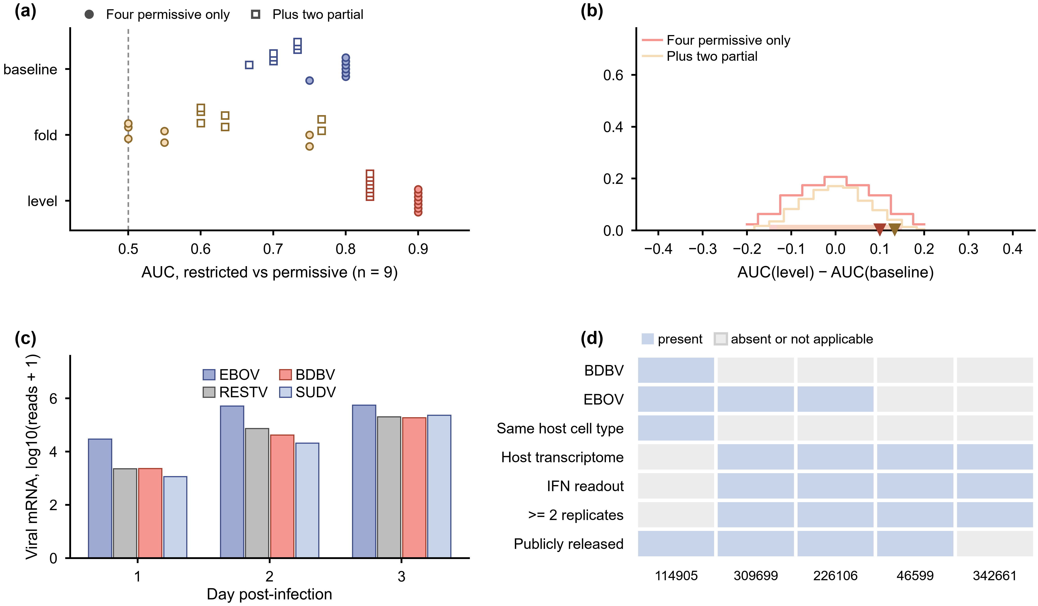
Fig. S2. The framework is bounded by insensitive read-outs and a missing decisive dataset. (a) Rank discrimination of baseline IFN tone, fold induction and post-IFN level in the one functional panel, GSE46599 (n = 9); each point is one probe-collapsing rule under one of two pre-specified negative-group definitions (filled circles, four permissive only; open squares, plus two partial). (b) Exact null distribution of the paired difference AUC(level) − AUC(baseline) over the 126 enumerated label assignments; triangles mark the observed differences. (c) Total viral mRNA reads per virus per day in GSE114905 and the BDBV-to-EBOV ratio under each day. (d) Which public dataset supplies each of the seven requirements of the decisive test. The multiplicity-matched comparison is GSE114905 in Huh7 cells at an MOI of 0.1, one library per virus per day, a consistency check, not a host-response measurement. Panel (a): level 0.90 under every probe rule, 0.83 with partial responders included; fold induction spans 0.50–0.77. Panel (b): dAUC = +0.10, p = 0.22 for four permissive only and +0.13, p = 0.058 with the two partial cells included. Panel (c): BDBV-to-EBOV ratios 0.078, 0.082 and 0.337. Panel (d): GSE114905 (4/7), GSE309699 (5/7), GSE226106 (5/7), GSE46599 (4/7) and GSE342661 (3/7) requirements met; pale = absent or not applicable; 309699 = human keratinocytes (IFN-α/β/γ/λ, EBOV read-outs); no dataset satisfies all seven. Panels (a), (c) and (d) report no inferential statistic. AUC, area under the receiver-operating-characteristic curve; dAUC, difference between two AUC values; MOI, multiplicity of infection. The AUC intervals in Fig. 3 are the 2.5th-97.5th percentiles of 5,000 stratified bootstrap draws (seed 20260930), a different calculation from the 5,000 label permutations of the splenic comparison in Supplementary Note 5.
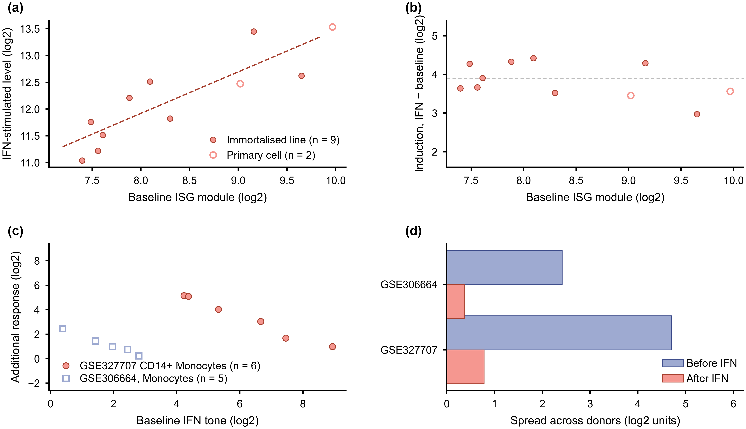
Fig. S3. Baseline IFN tone tracks the IFN-stimulated level rather than induction size. (a) In GSE46599, baseline IFN-stimulated expression and the level reached after IFN; open circles are two primary cell types shown but not entered. (b) The same baseline values against induction size, with a housekeeping module through the same pipeline. (c) Primary material across five populations from six healthy donors and an independent monocyte cohort. (d) The spread across donors before and after IFN in the two cohorts. The source panel used universal type-I IFN for 24 hours; the primary panel used IFN-α, and the second monocyte cohort came from a different study. Baseline and response come from the same cultures, and each treated sample is referred to its own untreated control. Level = baseline + induction on the log2 scale. Panel (a): rho = +0.88, exact p = 0.003, n = 9 immortalised lines. Panel (b): rho = −0.08, exact p = 0.84, n = 9; housekeeping control rho = −0.37 on the same axis. Panel (c): CD14+ monocytes rho = −1.00 in both cohorts (exact two-sided p = 0.003 and 0.017), and the pooled correlation across the five populations (30 units) is rho = −0.95. Panel (d): donor spread in GSE327707 is 4.71 before against 0.78 after IFN and 2.41 against 0.36 in GSE306664, with no inferential statistic reported. n, number of cell types or donors; rho, Spearman rank correlation coefficient; p, exact permutation probability.
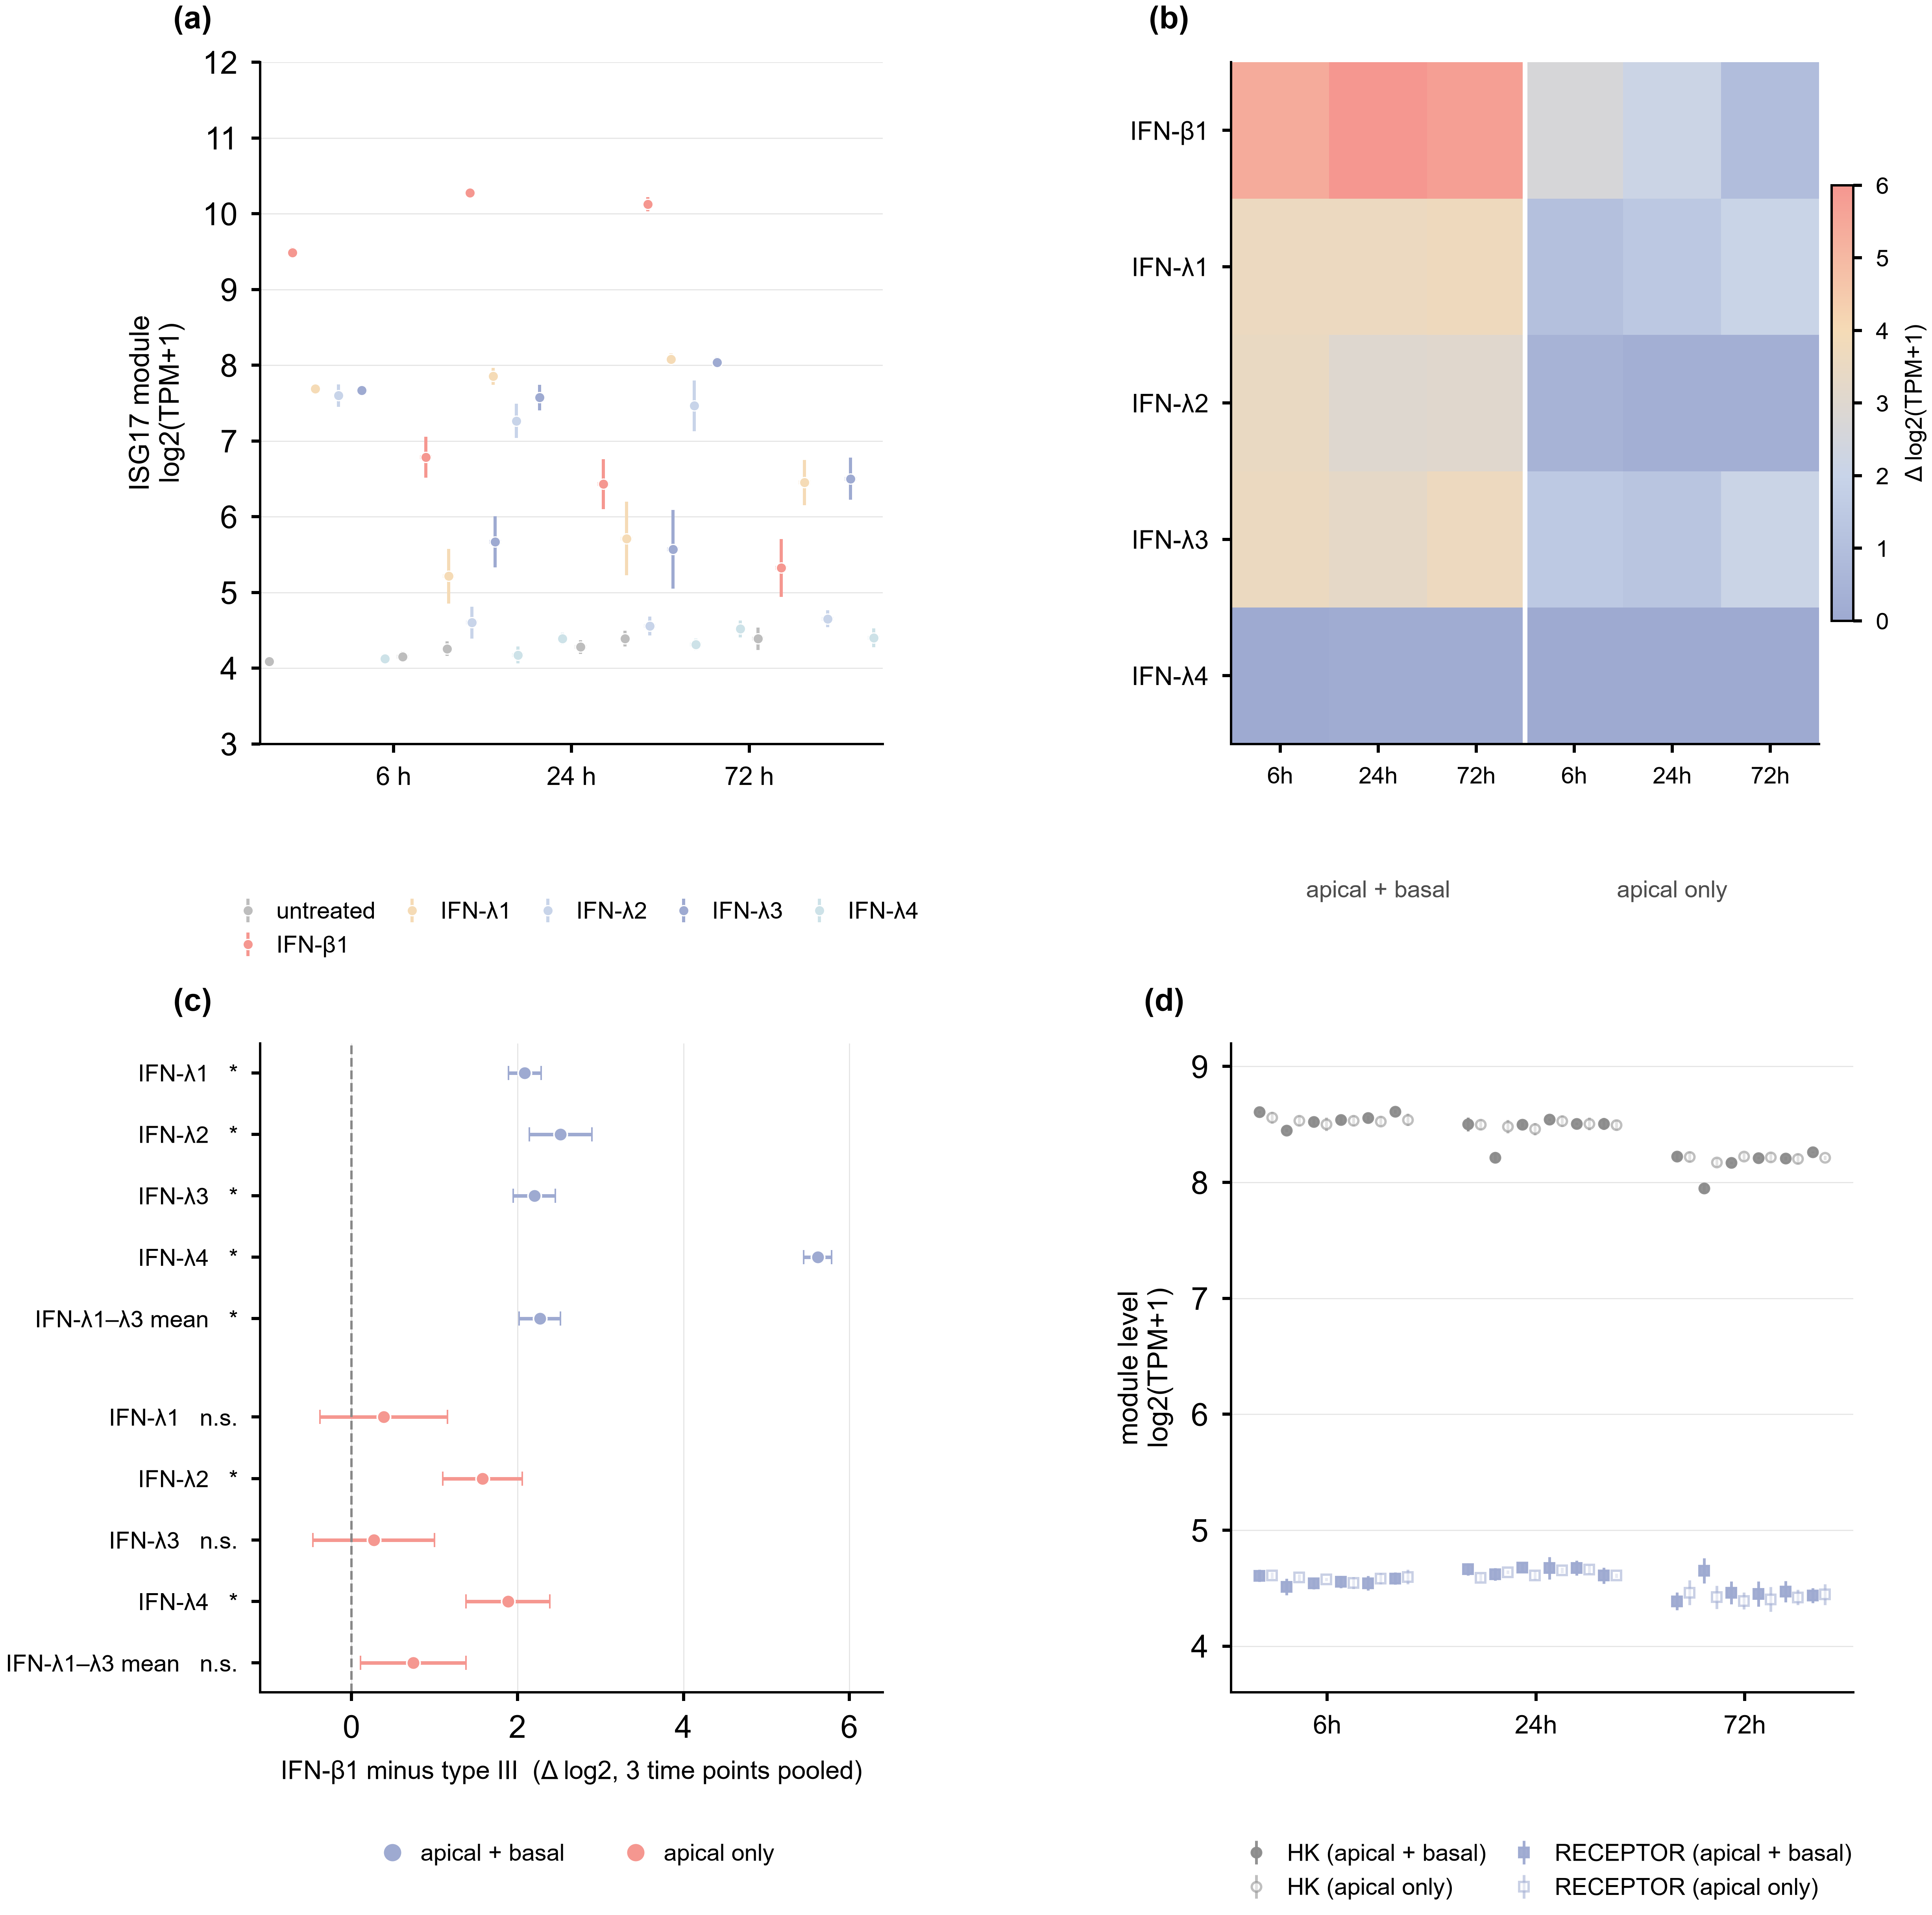
Fig. S4. Primary nasal epithelium separates type I from type III IFN at equal mass concentration. (a) Level of the seventeen-gene IFN-stimulated module in human nasal epithelial cells (hNEC) at the air-liquid interface, for every treatment, route and time point; each point is the mean of five replicates from five biological donors and the vertical bar is the standard error, the left dot is apical + basal delivery and the right dash is apical-only delivery. (b) Induction above each treated sample’s own paired untreated control on the same grid, in log2 units; the individual cell values are tabulated in Supplementary Note 3. (c) IFN-β1 minus type III, pooled over the three time points (n = 15 paired samples), separately for delivery to both chambers and to the apical surface alone; the bottom row of each block is the pooled IFN-λ1 to -λ3 contrast, and the horizontal bar is the 95% confidence interval of the paired mean difference. (d) The same grid for the six-gene housekeeping module and the four-gene receptor module. GSE342661, public 25 September 2026; five biological replicates in each of the 36 treatment-by-time-by-route cells, 180 samples in total. All module values are means of log2(transcript per million + 1). Panel (c) uses an exact sign-flip test on paired differences; asterisks mark p < 0.001 and n.s. marks p > 0.05. Panels (a), (b) and (d) report no inferential statistic. n, number of paired samples; n.s., not significant.

Supplementary Table S1
Table S1. Baseline IFN-tone score, Δ, for the 154 reference human cell types, ranked from highest to lowest. Δ is the equal-weight mean of the three components defined in Methods. The two blocks read left to right.
Rank | Cell type | Δ | Rank | Cell type | Δ
1 | extravillous trophoblasts | 1.7743 | 78 | respiratory basal cells | 0.0669
2 | pdcs | 1.4140 | 79 | cytotrophoblasts | 0.0607
3 | esophageal apical cells | 1.3885 | 80 | endometrial luminal cells | 0.0395
4 | plasma cells | 1.3707 | 81 | tuft cells | 0.0340
5 | enterocytes | 1.2837 | 82 | mesothelial cells | 0.0280
6 | neutrophils | 1.2004 | 83 | salivary basal cells | 0.0247
7 | urothelial cells | 1.1309 | 84 | basal keratinocytes | 0.0160
8 | hofbauer cells | 1.0186 | 85 | neuroendocrine cells | 0.0033
9 | kupffer cells | 1.0144 | 86 | melanocytes | -0.0019
10 | monocytes | 1.0018 | 87 | enteric stem cells | -0.0146
11 | macrophages | 0.9482 | 88 | astrocytes | -0.0184
12 | prostatic club cells | 0.8258 | 89 | somatotrophs | -0.0475
13 | b-cells | 0.7781 | 90 | monocyte progenitors | -0.0582
14 | microglia | 0.7595 | 91 | salivary myoepithelial cells | -0.0623
15 | migrating cytotrophoblasts | 0.7587 | 92 | alveolar cells type 2 | -0.0680
16 | vascular endothelial cells | 0.7253 | 93 | peritubular myoid cells | -0.0695
17 | pancreatic duct cells | 0.7085 | 94 | choroid plexus epithelial cells | -0.0800
18 | epididymal basal cells | 0.7053 | 95 | breast lactating cells | -0.0808
19 | fallopian secretory cells | 0.7031 | 96 | papillary tip epithelial cells | -0.0894
20 | colonocytes | 0.6965 | 97 | vascular smooth muscle cells | -0.0906
21 | epididymal efferent duct ciliated cells | 0.6892 | 98 | mast cells | -0.1035
22 | cdc | 0.6358 | 99 | neutrophil progenitors | -0.1115
23 | goblet cells | 0.6336 | 100 | renal collecting duct principal cells | -0.1203
24 | salivary duct cells | 0.6152 | 101 | pituicytes/fscs | -0.1325
25 | fallopian tube ciliated cells | 0.5974 | 102 | medullary thymic epithelial cells | -0.1939
26 | prostatic hillock cells | 0.5759 | 103 | corticotrophs | -0.2173
27 | granulosa cells | 0.5724 | 104 | breast hormone-responsive cells | -0.2176
28 | respiratory ciliated cells | 0.5720 | 105 | gonadotrophs | -0.2273
29 | ocular epithelial cells | 0.5707 | 106 | oligodendrocytes | -0.2324
30 | foveolar cells | 0.5287 | 107 | respiratory deuterosomal cells | -0.2561
31 | t-cells | 0.5245 | 108 | endometrial stromal cells | -0.2610
32 | thymocytes | 0.5197 | 109 | lactotrophs | -0.2763
33 | epididymal efferent duct absorptive cells | 0.4930 | 110 | renal collecting duct intercalated cells | -0.3092
34 | hepatocytes | 0.4669 | 111 | müller glia | -0.3121
35 | alveolar cells type 1 | 0.4639 | 112 | thyrotrophs | -0.3143
36 | esophageal suprabasal cells | 0.4210 | 113 | respiratory ionocytes | -0.3301
37 | epididymal principal cells | 0.4202 | 114 | leydig cells | -0.3560
38 | submucosal glandular cells | 0.4154 | 115 | podocytes | -0.3597
39 | respiratory secretory cells | 0.3965 | 116 | smooth muscle cells | -0.3722
40 | pancreatic acinar cells | 0.3797 | 117 | pituitary stem cells | -0.4287
41 | schwann cells | 0.3761 | 118 | loop of henle epithelial cells | -0.4550
42 | basal prostatic cells | 0.3587 | 119 | renal connecting tubule cells | -0.4789
43 | other brain neurons | 0.3568 | 120 | bergmann glia | -0.5343
44 | gastric progenitor cells | 0.3323 | 121 | distal convoluted tubule cells | -0.5620
45 | lacrimal acinar cells | 0.3107 | 122 | hepatic stellate cells | -0.5728
46 | esophageal basal cells | 0.2893 | 123 | undifferentiated spermatogonia | -0.6236
47 | nk-cells | 0.2748 | 124 | retinal amacrine cells | -0.6418
48 | salivary acinar cells | 0.2705 | 125 | myosatellite cells | -0.6419
49 | brain inhibitory neurons | 0.2483 | 126 | epicardial cells | -0.6426
50 | salivary ionocytes | 0.2469 | 127 | hematopoietic stem cells | -0.6522
51 | paneth cells | 0.2422 | 128 | proximal tubule cells | -0.6551
52 | pericytes | 0.2404 | 129 | sertoli cells | -0.6769
53 | endometrial secretory cells | 0.2363 | 130 | late spermatids | -0.7089
54 | decidual stromal cells | 0.2209 | 131 | myonuclei | -0.7099
55 | innate lymphoid cells | 0.2195 | 132 | retinal bipolar cells | -0.7438
56 | mucous neck cells | 0.2149 | 133 | early spermatids | -0.7902
57 | endometrial glandular cells | 0.2022 | 134 | differentiating spermatogonia | -0.7944
58 | parietal cells | 0.1994 | 135 | megakaryocyte progenitors | -0.8223
59 | gastric chief cells | 0.1931 | 136 | fibro-adipogenic progenitors | -0.8304
60 | ovarian stromal cells | 0.1909 | 137 | megakaryocytes | -0.8655
61 | ependymal cells | 0.1903 | 138 | adrenal cortex cells | -0.8899
62 | lymphatic endothelial cells | 0.1869 | 139 | megakaryocyte-erythroid progenitors | -0.9184
63 | pancreatic islet cells | 0.1553 | 140 | retinal horizontal cells | -0.9251
64 | brain excitatory neurons | 0.1488 | 141 | oocytes | -0.9300
65 | prostatic glandular cells | 0.1407 | 142 | rod photoreceptor cells | -0.9999
66 | oligodendrocyte progenitor cells | 0.1320 | 143 | retinal pigment epithelial cells | -1.0246
67 | suprabasal keratinocytes | 0.1286 | 144 | erythrocyte progenitors | -1.0374
68 | breast secretory cells | 0.1285 | 145 | adrenal medulla cells | -1.0481
69 | epididymal clear cells | 0.1250 | 146 | platelets | -1.0529
70 | enteric transient amplifying cells | 0.1235 | 147 | cardiomyocytes | -1.0551
71 | breast myoepithelial cells | 0.1190 | 148 | late primary spermatocytes | -1.1150
72 | syncytiotrophoblasts | 0.1057 | 149 | adipocytes | -1.1312
73 | fibroblasts | 0.1039 | 150 | early primary spermatocytes | -1.1793
74 | transitional alveolar cells | 0.0972 | 151 | cone photoreceptor cells | -1.2095
75 | conjunctival goblet cells | 0.0961 | 152 | thymic myoid cells | -1.2599
76 | cholangiocytes | 0.0743 | 153 | retinal ganglion cells | -1.2906
77 | endometrial ciliated cells | 0.0674 | 154 | erythrocytes | -2.0368

Supplementary Methods

Test of the proxy assumption
GEO series GSE21158 tests whether baseline expression predicts responsiveness. Ten human cancer cell lines were profiled on one platform with matched control and IFN-α-2a arms in triplicate at 24 hours, plus a 4 hour treated arm with no matched 4 hour control. Genes were resolved against the platform annotation by symbol, by synonym, and through an explicit legacy-alias table, because the array carries ISG15 as G1P2, IFNLR1 as IL28RA and GAPDH as GAPD with an empty synonym column. IFIT3, RSAD2 and IFI6 have no probe on the platform and were excluded, with no value assigned. The module was the eleven resolvable IFN-stimulated genes, and each component of Δ was tested on its own. A line was called a responder on the response axis alone, at an induction of 0.3 log units or more at 24 hours, so that no baseline value enters the classification. Associations are Spearman correlations, reported pooled and within stratum, and the reliability of the baseline score across the three control replicates was estimated as an intraclass correlation. The modules were fixed before any value was correlated. The responder threshold was set after the distribution of the response was seen, and is reported as a post hoc boundary.

Matched panels: the quantity the score tracks
Three further series were used because untreated and IFN-treated expression come from the same cultures. In GSE46599, nine immortalised human lines were profiled together with primary CD4+ T cells and primary Macrophages, untreated and after 1000 U/mL universal type-I IFN for 24 hours on the Illumina HumanHT-12 v4 array. Each line was run in two replicate experiments and each primary cell type in three. The series' own annotation records each member's resistance to HIV-1 after IFN treatment, the only functional phenotype available alongside matched expression. All 27 requested genes resolved by symbol on this platform, so no alias table was needed. Module scores were the mean of the listed genes averaged over replicates. The modules were the seventeen-gene IFN-stimulated set, the two-gene IFN-stimulated priming term, the type-I and type-III receptor capacity terms and a four-gene receptor module. A six-gene housekeeping module was carried through every analysis as a negative control. For each module three rival response quantities were computed from the same cells: the level reached after IFN, the induction, and the additional response. The induced level and the induction differ only by the baseline value, so a comparison between them compares two contrasts on one axis, not two independent measurements. Associations are Spearman correlations over cell types, with exact permutation p values where the permutation space allowed enumeration and otherwise Monte Carlo with 200,000 draws and a fixed seed. The smallest correlation detectable at 80 per cent power is reported alongside every n. A per-gene ceiling check recorded each module member against the top of the array's range, and is reported because three genes reach it. Two properties of that panel were posed as questions in advance. All six module definitions were crossed with two definitions of the negative group, in which the two partially resistant members were either excluded from it or assigned to it, and all twelve resulting cells are reported, not the favourable one alone. The contrast was also swept continuously over the family of linear combinations of the standardised baseline and induced level. The p value quoted is therefore that of the maximum statistic over the whole sweep, not that of the best single point. Two independent primary-cell cohorts were used for the same question. GSE327707 profiles whole PBMC and four sorted populations (CD14+ monocytes, CD4+ T cells, CD8+ T cells and B cells) from each of six healthy donors, untreated and after IFN-α for 48 hours. Baseline and response therefore come from the same donor, the same population and the same experiment, and the modules were identical to those used above. Correlations were computed within cell type across donors and pooled with ranks taken within cell type first, so that a difference between populations cannot manufacture the association. The pooled value was compared against a null of 1,000 random gene sets of the same size drawn from the detectable genes. Four checks were pre-specified: leave-one-donor-out, partial correlation controlling a housekeeping module, a split into disjoint gene halves for the predictor and the response, and the same test against the induced level, not the induction. GSE306664 replicates the design in a second laboratory: five donors with enriched B, Monocyte, NK and T cells, profiled after 21 hours of IFN-α, IFN-β, IFN-γ or IFN-λ1 by fixed single-cell RNA profiling. Samples passed a pre-specified filter of at least 200 UMIs, 100 genes and 50 cells, and pseudobulk was formed per sample. The donor-level test was confined to populations in which the donors actually differ in baseline tone. That rule was declared after the between-donor spread had been inspected, was applied unchanged to both cohorts, and is reported as exploratory.

Tissue-level extension and tissue composition
A tissue-level version of the score was aggregated from the same cell-type values and tested against the only multi-organ infection series available, a rhesus macaque natural-history study of 21 animals across 17 tissues with host RNA sequencing and matched viral load. Five score forms were crossed with nine readouts and evaluated against a criterion fixed before the values were computed. No combination met it, and the outcome is reported as a negative result for the organ-level unit, not as a qualified positive one. Tissue composition was then estimated by deconvolution against a reference class table, because a bulk profile could in principle carry the signal through its immune infiltrate and not through its parenchyma. Two reliability anchors were fixed in advance: agreement between the top-ranked cell type at tissue level and an independent marker-based assignment, and the correlation between the estimated immune fraction and an immune marker index. Both were evaluated on the executed class table and on a re-run restricted to the pre-specified class count, 42 classes executed against 40 pre-specified, and the anchor that failed is reported together with both of its values. Three composition conventions and one deconvolution-free marker proxy were carried through the main comparison, with none selected over the others. Gene-level values for this series require the row annotation distributed with the study, because the deposited count matrix carries sequential numeric row names and the study's own conversion table is a query output whose row order does not correspond to the matrix. The annotation used here was taken from the study's deposited SummarizedExperiment object and verified against known tissue anchors before any IFN comparison was run.

Filovirus functional anchor
GSE309699 profiles normal human skin keratinocytes held at the telomerase-immortalised NHSK-1 line, pre-treated with type I, type II or type III IFN for 6 or 24 hours and then challenged with EBOV lacking VP30 or with rVSV/EBOV-GP. The deposited supplementary matrix labels its columns by author well identifier, and the series metadata records the treatment and the batch of every library, for example the record for column A1 carries “IFN alpha 6h treatment 1”. The column-to-treatment map was therefore read from the metadata and never inferred from expression values. The design it recovers is 8, 8, 5, 8 and 15 libraries, with two untreated batches (20200722 and 20200820) that pair with the β and γ arms and with the α and λ arms respectively, as the source publication states. Those two batches differ by 1.50 log2 in panel level, so arm comparisons are made within batch. Counts were converted to counts per million over the full library and log2-transformed, and the panel is the set of IFN-stimulated genes listed with the analysis code. The inhibition values compared here are not a deposited numeric table: they are the areas under the dose-response curves read from the published figure panels and, for the twenty-four-hour ordering, the ordering stated in the text of the source publication. They are used only as an ordering, never as an effect size. Immunostaining and titre readouts from the same study were not used [28].

Primary polarised epithelial panel
GSE342661 was analysed from its deposited processed matrix, 62,754 rows by 180 columns of transcript per million. The matrix column names are file-level identifiers, not the sample titles, so the column-to-condition map was taken from the paired sample_description and sample_title fields of the series metadata. The map was built under a criterion fixed in advance: every column had to resolve and the 6 x 3 x 2 x 5 design had to be complete. 180 of 180 columns resolved with no duplicate and no empty cell, and the route field was checked against the per-sample route characteristic for four libraries covering both routes. Rows carry versioned Ensembl gene identifiers. Symbols were attached through the complete HGNC set, which resolved 42,082 of 62,754 rows (67.1 per cent), with three ambiguous identifiers dropped and every module member checked individually. The one member whose current symbol differs from the one used here, DDX58 against RIGI, was routed by previous symbol, not silently lost. All seventeen module genes, all six housekeeping genes, all four receptor genes and both priming genes resolved. A sample's module value is the mean log2 of transcript per million plus one over the module's genes, and a treated sample is referred to the untreated control from the same time, route and replicate. Differences were tested with the exact sign-flip test on paired differences and, alongside it, the exact Wilcoxon and paired t tests. Every test is reported with its n and with the smallest two-sided p value attainable at that n, which is 0.0625 for a single cell of five replicates and 6.1 x 10-5 for a pooled set of fifteen. Two null distributions were computed: 2,000 random seventeen-gene modules drawn within expression deciles, and 2,000 permutations of the treatment label within time-by-route blocks. In our reanalysis of the deposited matrix, gene-level calls used a paired t test at five per cent false discovery rate with a one-log2 fold-change floor. The source study used DESeq2 at an adjusted p value below 0.05 without a fold-change floor, so the two gene lists differ in stringency rather than in direction: for dual-chamber IFN-β1, dropping our floor raises the count from 490, 1,092 and 1,024 genes at 6, 24 and 72 hours to 4,030, 4,641 and 4,574, of the same order as the source study's 4,040, 6,752 and 7,169.

Supplementary references
S1. Human Protein Atlas v25.1. Deep Visual Proteomics, single-cell section: 27 cell types from 14 tissues quantified by mass spectrometry. Stockholm: HPA; 2026. Data: https://www.proteinatlas.org/download/tsv/dvp_cell_type.tsv.zip. Accompanying preprint: https://doi.org/10.64898/2026.05.26.727663 (openRxiv; not peer reviewed).
S2. Albariño CG, Wiggleton Guerrero L, Chakrabarti AK, Nichol ST. Transcriptional analysis of viral mRNAs reveals common transcription patterns in cells infected by five different filoviruses. PLoS One. 2018;13(8):e0201827. Data: GEO GSE114905. https://doi.org/10.1371/journal.pone.0201827
S3. Gupta M, Goldsmith CS, Metcalfe MG, Spiropoulou CF, Rollin PE. Reduced virus replication, proinflammatory cytokine production, and delayed macrophage cell death in human PBMCs infected with the newly discovered Bundibugyo ebolavirus relative to Zaire ebolavirus. Virology. 2010;402(1):203-8. https://doi.org/10.1016/j.virol.2010.03.024

