Microporous Polymer Adsorptive Membranes with Unprecedented Processing Capacity for Molecular Separation

Zhenggong Wangª, Xiaofan Luo^{b}, Kuan Lu^{c}, Shouwen Zhuª, Yanshao Yang^{b}, Zejun Song^{b}, Yatao Zhang,^{d} Wangxi Fang,^{b}* and Jian Jinª*
ªInnovation Center for Chemical Science, College of Chemistry, Chemical Engineering and Materials Science & Collaborative Innovation Center of Suzhou Nano Science and Technology, Soochow University, Suzhou 215123, China.
^{b}i-Lab, Suzhou Institute of Nano-Tech and Nano-Bionics, Chinese Academy of Sciences, Suzhou 215123, China.
^{c}State Key Laboratory of Coal Conversion, Institute of Coal Chemistry, Chinese Academy of Sciences, Shanxi 030001, China.
^{d}School of Chemical Engineering and Energy, Zhengzhou University, Zhengzhou 450001, China.
E-mail: wxfang2017@sinano.ac.cn (W. Fang); jjin@suda.edu.cn (J. Jin)

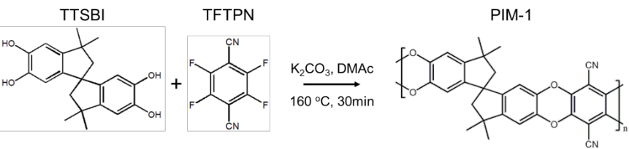
Figure S1. Synthesis route of PIM-1.

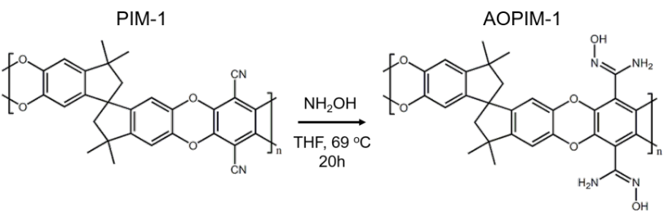
Figure S2. Synthesis route of AOPIM-1.

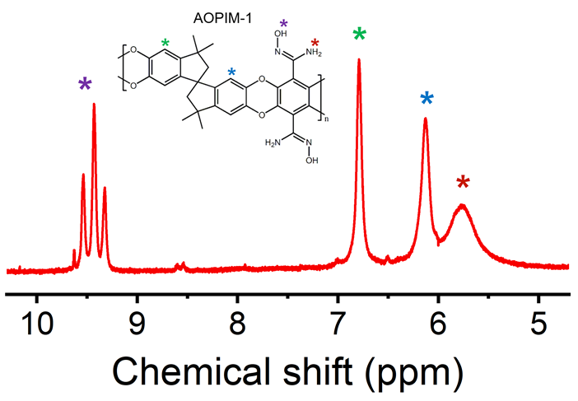
Figure S3. ¹H NMR spectrum of AOPIM-1.

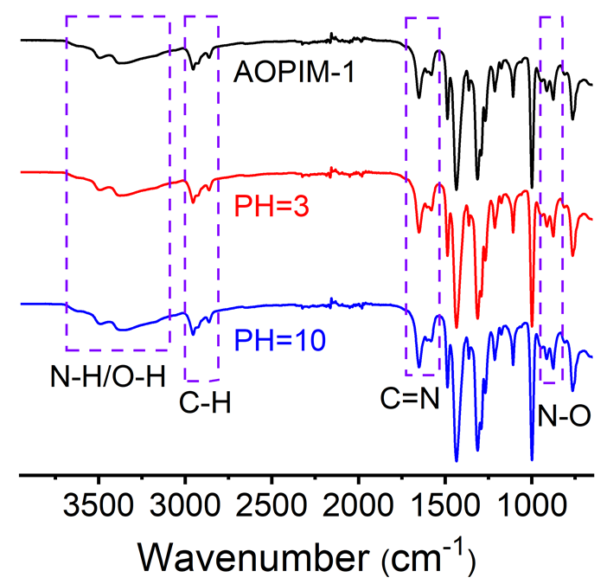
Figure S4. FTIR-ATR spectra of AOPIM-1 as-prepared and after immersing in acid (pH = 3) or base (pH = 10) for at least 24 h.

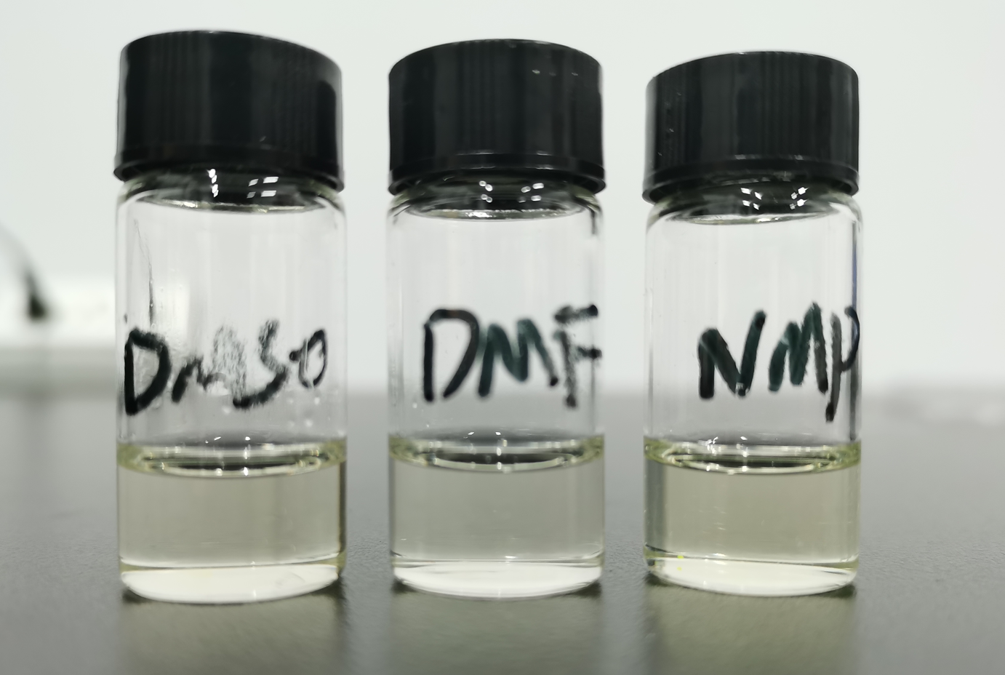
Figure S5. Optical photo of AOPIM-1 solved in different polar solvents.

Figure S7. Selective adsorption of AOPIM-1 in MO/MB mixed solutions at different pH conditions and corresponding UV-Vis spectra before and after adsorption.

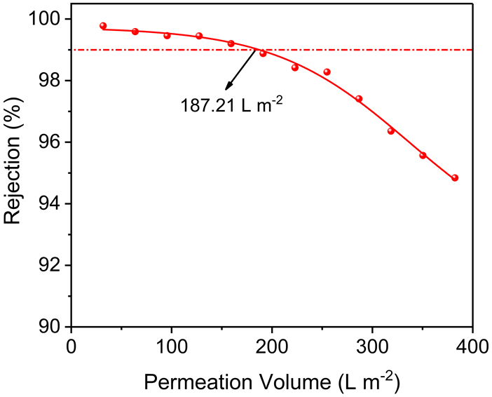
Figure S8. Processing capacity of AOPIM-1 membranes (coagulation bath composition: H₂O:EtOH=100:0).

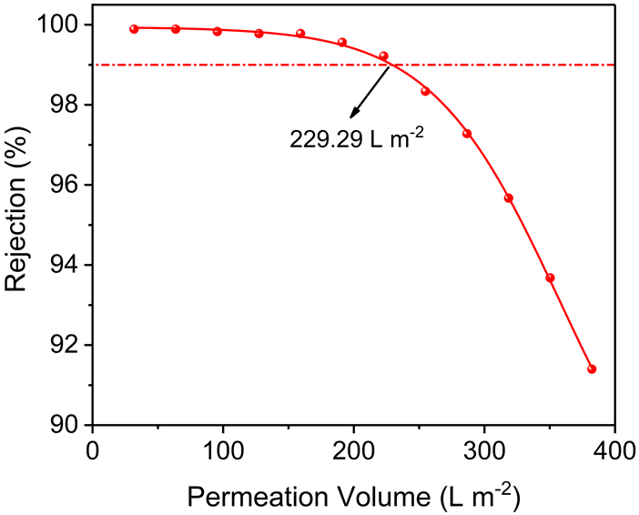
Figure S9. Processing capacity of AOPIM-1 membranes (coagulation bath composition: H₂O:EtOH=50:50).

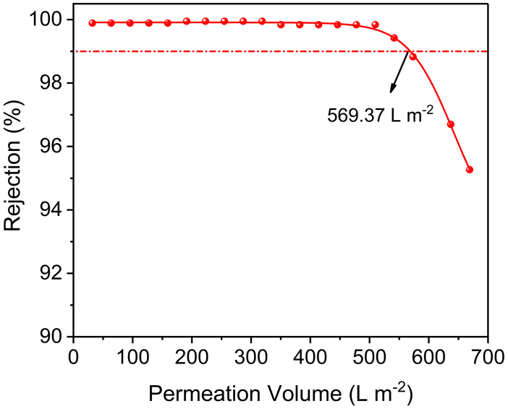
Figure S10. Processing capacity of AOPIM-1 membranes (coagulation bath composition: H₂O:EtOH=0:100).

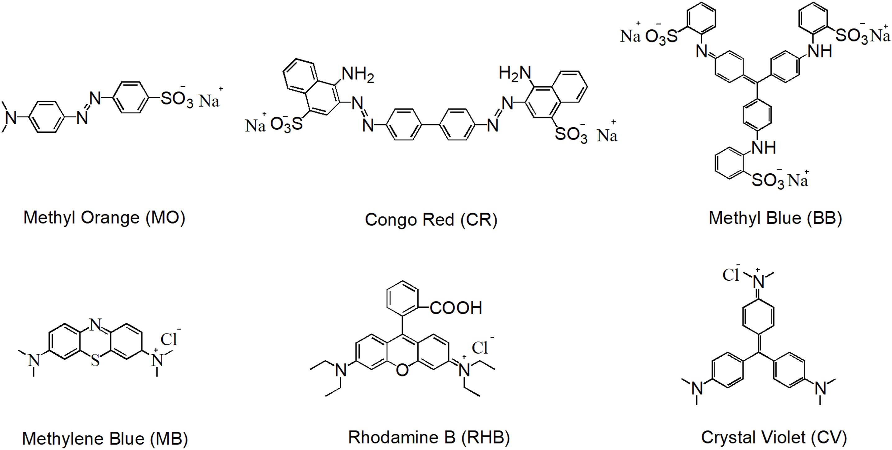
Figure S11. Molecular formulas of different dyes referred in this work.

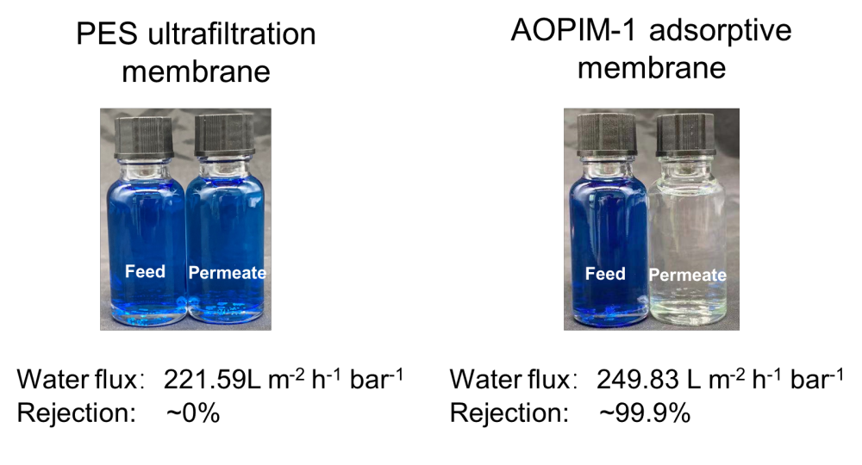
Figure S12. Separation performance of polyethersulfone ultrafiltration membrane and AOPIM-1 membrane.

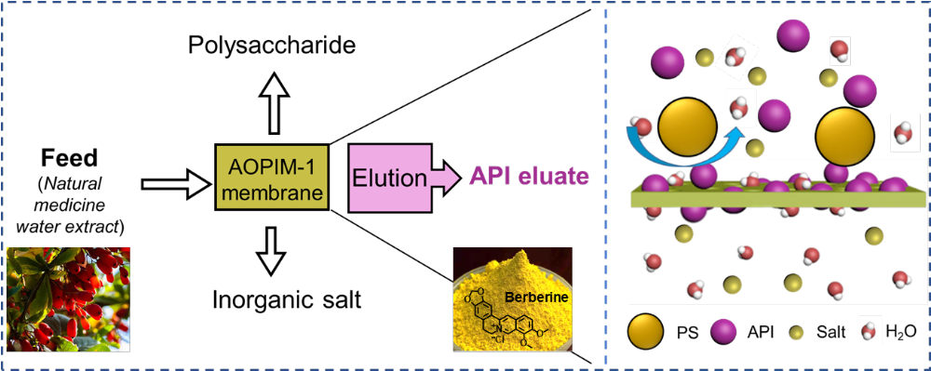
Figure S13. Separation mechanism of natural medicine water extract (APIs/polysaccharides/salt) by AOPIM-1 membranes.

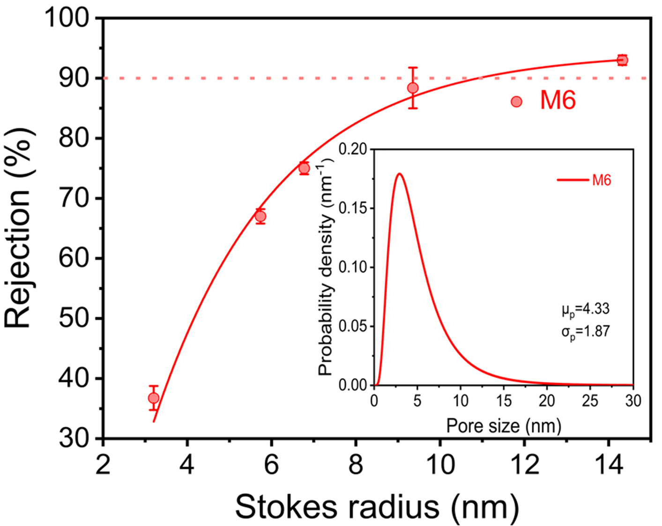
Figure S14. MWCO curve and pore size distribution of M6.

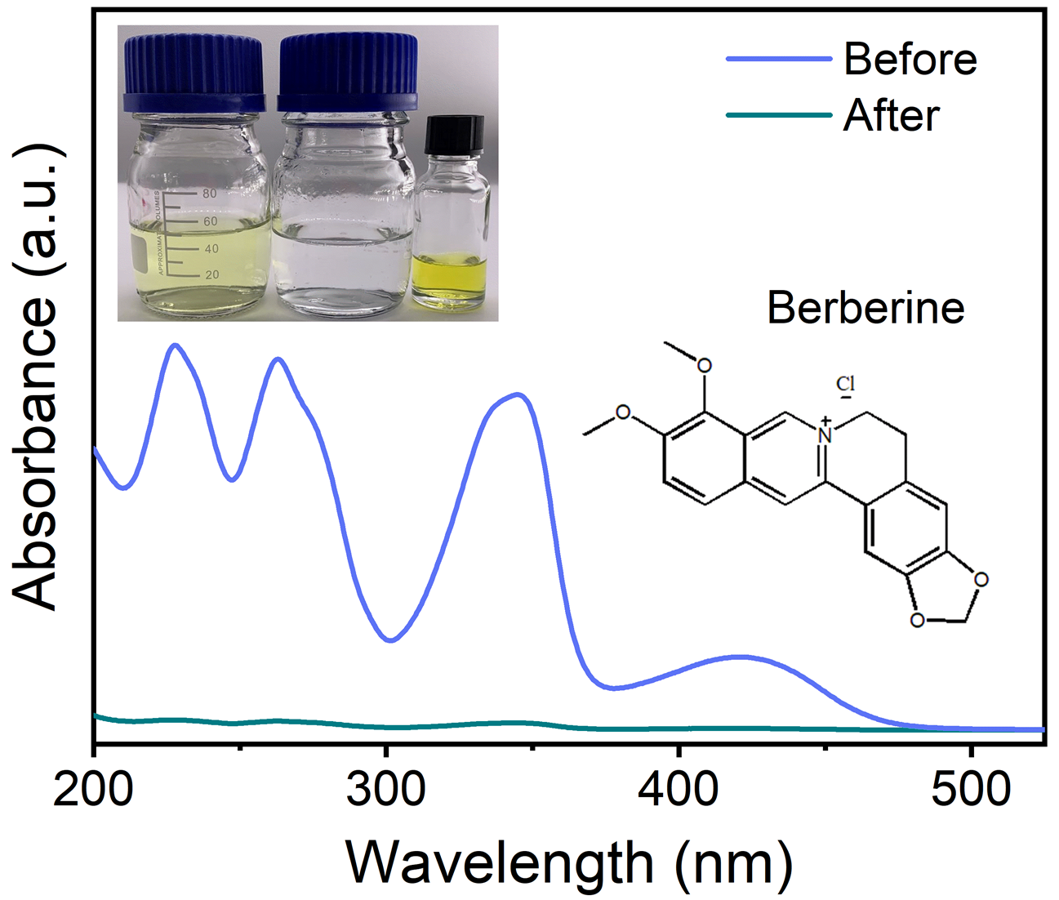
Figure S15. UV-Vis absorption peaks of the stock solution and filtrate before and after the treatment of 50 mL feed. The inset is the optical photos of the stock solution, filtrate, and eluate from left to right, respectively.

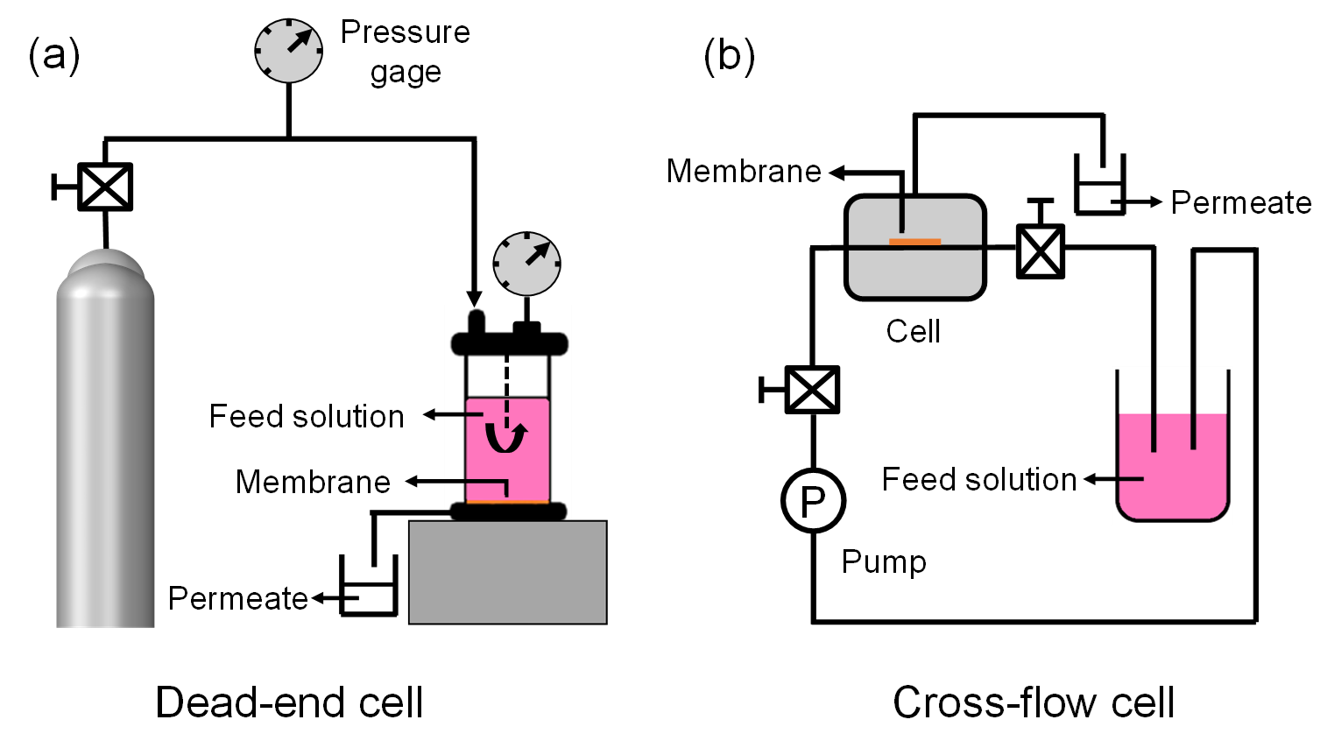
Figure S16. Schematic diagram of Dead-end cell and cross-flow cell used in dynamic membrane adsorption.
Table S1. Comparison of adsorption capacity of various adsorbents reported in the literature.

Adsorbents | Chargeability | Specific surface area (m² g⁻¹) | Adsorption capacity (mg g⁻¹) | Adsorbate | Ref.
NH₂-UIO-66 | Positive | 1035 | 697.7 | CR | 18
MIL-100 (Cr) | Negative | 3100 | 507.7 | CV | 18
ZIF-8@CS sponge | Negative | - | 987.0 | CR | 36
Hydrolyzed PIM-1 | Positive | - | 424.8 | MB | 30
 |  |  | 42.3 | MO
PIM-1 | Neutral | 786 | ~4 | MB | 30
 |  |  | ~1 | MO
Ethanolaminemodified PIM-1 | Negative | -- | 525 | Acid Red I | 37
AOPAN nanofibrous | pH-response | -- | ~72 | MO | 38
AOPIM-1 | pH-response | 550 | 491.63 | MO | This work
 |  |  | 765.09 | MB

Table S2. Properties of asymmetric membranes under different preparation conditions.
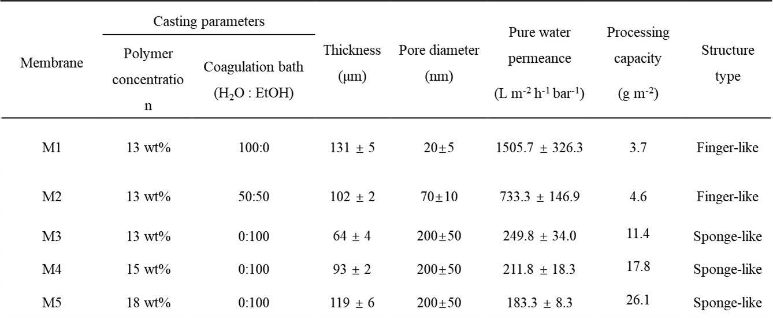

Table S3. Comparsion of processing capacity of various membrane adsorbents reported in the literature.
Membrane adsorption | Adsorbate | Concentration | Pure water Permeance (L m⁻² h⁻¹ bar⁻¹) | Processing capacity (g m⁻²) | Reference
ZIF-8 hybrid aerogels | Dyes | 3 ppm | 480-650 | 0.48-1.0* | 22
β-CDP-40% | BPA | 10 ppm | 400 | 1.150* | 23
β-CDP composite porous membrane | BPA | 10 ppm | 1300 | 0.440 | 24
CNF-100 | MB | 20PPM | 5300 | 2 | 25
PES | MB | 20PPM | 221.6 | ~0 | This work
AOPIM-1 | RHB | 20 ppm | 249.8 | 11.4 | This work
 |  |  | 211.8 | 17.8 | This work
 |  |  | 183.3 | 26.1 | This work

Table S4. Summary of the dynamic adsorption performance of AOPIM-1 membrane.
pH condition | Dyes | Concentration (ppm) | Molecular weight (Da) | Permeance (L m⁻² h⁻¹ bar⁻¹) | Rejection (%)
pH = 3 | MO | 20 | 327.3 | 203.82 ± 2.46 | 99.9
pH = 3 | CR | 20 | 696.6 | 180.92 ± 4.17 | 99.9
pH = 3 | BB | 20 | 799.8 | 192.50 ± 0.89 | 99.9
pH = 10 | MB | 20 | 319.8 | 177.9 ± 2.11 | 99.9
pH = 10 | RHB | 20 | 479.0 | 191.31 ± 1.17 | 99.9
pH = 10 | CV | 20 | 407.9 | 170.00 ± 1.85 | 99.9

Table S5. Composition of synthetic water extract feed solution.

Materials | Concentration (ppm)
NaCl | 1000
Polysaccharide | 200
Berberine | 20

