SUPPLEMENTAL MATERIAL

Title: Evergreen abundance drives ground beetle diversity and density in eastern temperate forests

Authors: Janey R. Lienau^{1,3}*, Robert W. Buchkowski², Meghan G. Midgley¹

Affiliations:
1 Center for Tree Science, The Morton Arboretum, 4100 Illinois Route 53, Lisle, IL, USA 60532
2 Department of Biology, Western University, London, ON, Canada
3 Yale School of the Environment 195 Prospect Street, New Haven CT, 06511

Corresponding author:
janey.lienau@yale.edu

ORCIDs:
Lienau - 0000-0002-4681-235X
Midgley - 0000-0002-1195-1608
Buchkowski - 0000-0001-6381-8609

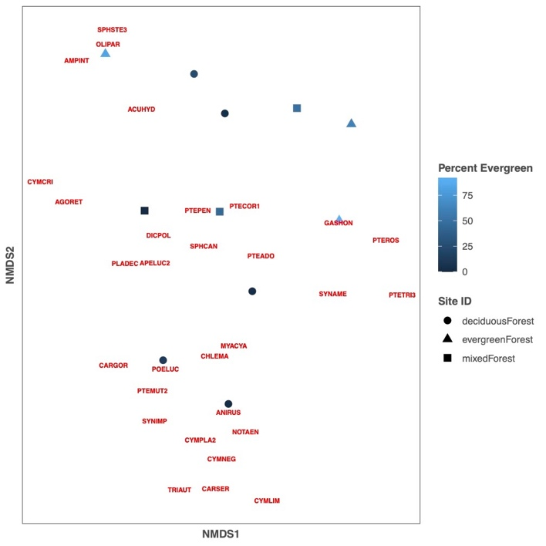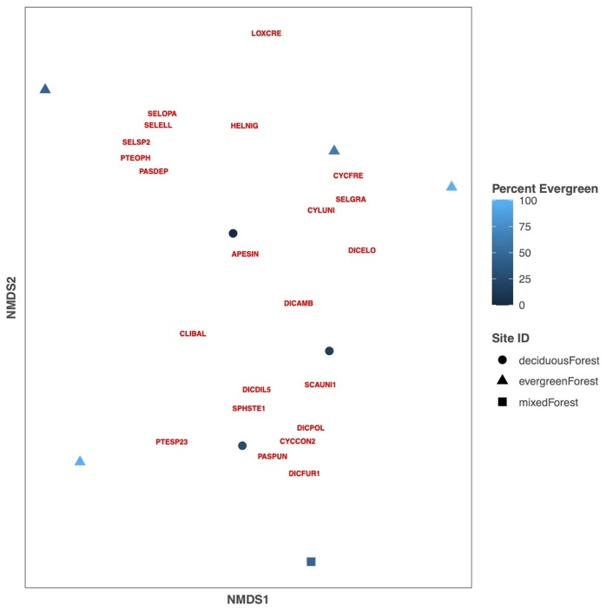

Supplemental Fig. 1 Harvard Forest (a), and Talladega Forest (b) community composition by percent evergreen cover

