Circulating chemokine levels and the development of allergic phenotypes from infancy to adolescence: a population-based birth cohort study

Johanna Huoman MSc¹*, Sadia Haider PhD²*, Angela Simpson MD PhD³, Clare S Murray MD³, Adnan Custovic MD PhD FAAAI^{2†} and Maria C Jenmalm PhD^{1†}

¹ Division of Inflammation and Infection, Department of Biomedical and Clinical Sciences, Linköping University, Linköping, Sweden
³ National Heart and Lung Institute, Imperial College London, UK
³ Division of Infection, Immunity and Respiratory Medicine, Faculty of Biology, Medicine and Health, Manchester Academic Health Sciences Centre, University of Manchester and University Hospital of South Manchester NHS Foundation Trust, Manchester, UK

*shared first authorship
†shared senior authorship

SUPPLEMENTARY APPENDIX

RESULTS – SUPPLEMENTARY FIGURES, TABLES & LEGENDS
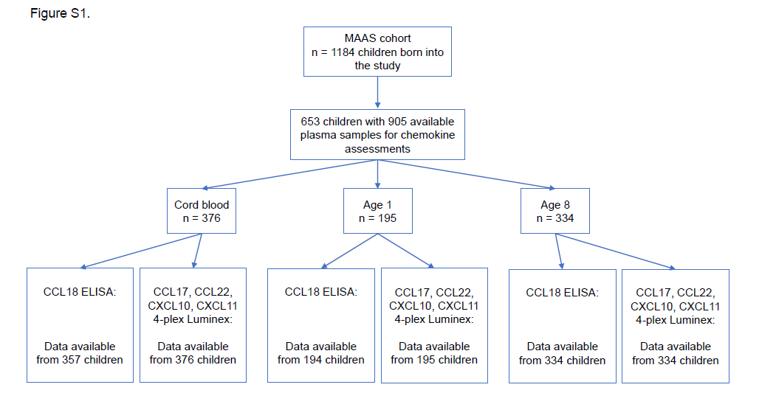
Figure S1.

Figure S1. A summarising flow chart of children from the MAAS cohort included in study. Measurements of chemokines were performed at birth, age 1 and age 8. Concentrations of CXCL10, CXCL11, CCL17 and CCL22 were investigated using an in-house 4-plex Luminex, whereas CCL18 was measured by means of an in-house ELISA. Missing data points in the CCL18 ELISA derive from limited sample availability for reruns.

Figure S2.
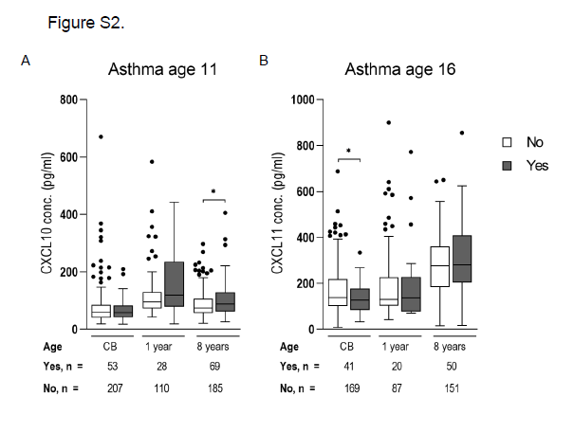
Figure S2. Associations of the Th1-associated chemokines CXCL10 and CXCL11 asthma development. Plasma concentrations of CXCL10 are displayed in relation to development of asthma at age 11 in A. and levels of CXCL11 at age 16 in B. Asthma was defined as having at least two out of three symptoms at the investigated time point: current wheeze, current use of asthma medication, or physician-diagnosed asthma. The data are illustrated as medians with interquartile ranges. Mann-Whitney U tests were performed to survey statistical significance. * p < 0.05. CB – cord blood.

Figure S3.
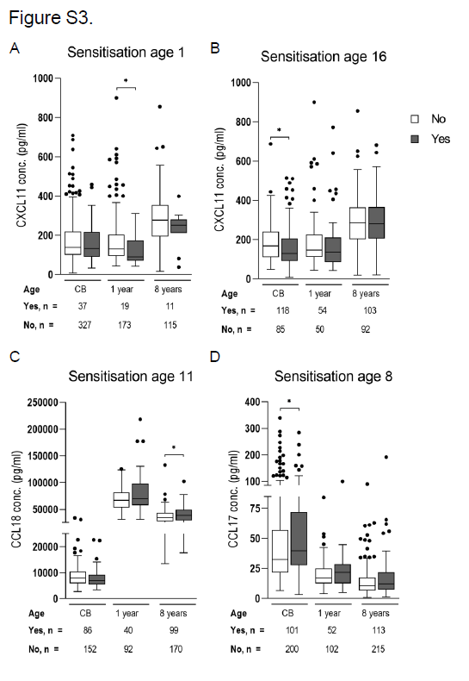
Figure S3. Associations of the chemokines CXCL11, CCL18 and CCL17 to allergic sensitisation. Plasma concentrations of the Th1-associated chemokine CXCL11 are displayed in relation to development of sensitisation, at age 1 in A. and age 16 years in B. Circulating levels of the Th2/Treg-associated chemokine CCL18 in relation to sensitisation at age 11 years is illustrated in C. In E. CCL17 levels are stratified based on sensitisation at age 8 years. Sensitisation status was determined by means of skin prick testing. The data are illustrated as medians with interquartile ranges. Mann-Whitney U tests were performed. * p < 0.05. CB – cord blood.

Characteristics | MAAS cohort (n=1184) | Included samples (n=653) | Excluded samples (n=531) | P-value
Sex (girls) | 542/1184 (45.8) | 303/653 (46.4) | 239/531 (45.0) | 0.633
Birth length (cm),  mean (95%CI) | 53.5 (53.3-53.7) | 53.5 (53.3-53.8) | 53.4 (53.0-53.8) | 0.630
Birth weight (g),  mean (95% CI) | 3465 (3436-3495) | 3485 (3446-3524) | 3439 (3394-3484) | 0.128
Maternal age at birth | 30.4 (30.1-30.7) | 30.5 (30.0-30.7) | 30.4 (30.0-30.9) | 0.760
Maternal smoking | 174/1177 (14.8) | 100/652 (15.3) | 74/525 (14.1) | 0.551
Paternal smoking | 312/1181 (26.4) | 178/653 (27.3) | 134/528 (25.4) | 0.466
Maternal atopy | 682/1146 (59.5) | 420/637 (65.9)* | 262/509 (51.5)* | <0.001
Paternal atopy | 716/1137 (63.0) | 445/635 (70.1)* | 271/502 (54.0)* | <0.001
Maternal asthma ever | 235/1184 (19.8) | 145/653 (22.2)* | 90/531 (16.9)* | 0.024
Paternal asthma ever | 163/1182 (13.8) | 103/653 (15.8)* | 60/529 (11.3)* | 0.028
Day-care attendance | 741/1087 (68.2) | 440/627 (70.2) | 301/460 (65.4) | 0.097
Cat owner | 240/1160 (20.7) | 118/644 (18.3)* | 122/516 (23.6)* | 0.026
Dog owner | 201/1160 (17.3) | 106/644 (16.5) | 95/516 (18.4) | 0.383
Table S1: Demographic characteristics compared between children included in and excluded from the chemokine analyses presented in this paper. Comparisons were made using Chi-quare tests for dichotomous variables, or unpaired t-tests for the continuous variables. Dichotomous variables are expressed as n/N (%), whereas continuous variables are expressed as mean (95% CI). Significances are denoted with an asterisk * and bold italics.

Table S2: Prevalence of sensitisation among children who attended follow-ups at ages 1, 3, 5, 8, 11 and 16 years (All children) and among them in those with chemokines measured in cord blood at birth (CB), and at ages 1 year and 8 years. Comparisons were performed between the chemokine cohort samples at the different ages in relation to the whole cohort, using a Chi-square test. Sensitisation was defined as having a positive skin prick test towards any of the seven allergens tested.
 | Sensitisation
 | All children |  | Chemokines in CB |  |  | Chemokines at age 1 yr |  |  | Chemokines at age 8 yrs
Age | n/N | % | n/N | % | P-val | n/N | % | P-val | n/N | % | P-val
1 | 56/504 | 11.1 | 37/364 | 10.2 | 0.656 | 19/192 | 9.9 | 0.644 | 11/126 | 8.7 | 0.438
3 | 225/983 | 22.9 | 73/334 | 21.9 | 0.697 | 42/174 | 24.1 | 0.718 | 63/291 | 21.6 | 0.657
5 | 294/963 | 30.5 | 95/301 | 31.6 | 0.735 | 50/164 | 30.5 | 0.991 | 82/289 | 28.4 | 0.483
8 | 314/927 | 33.9 | 101/301 | 33.6 | 0.919 | 52/154 | 33.8 | 0.979 | 113/328 | 34.5 | 0.849
11 | 280/795 | 35.2 | 90/253 | 35.6 | 0.919 | 40/132 | 30.3 | 0.271 | 99/269 | 36.8 | 0.639
16 | 322/600 | 53.7 | 118/203 | 58.1 | 0.270 | 54/104 | 51.9 | 0.742 | 103/195 | 52.8 | 0.837

Table S3: Prevalence of asthma among children who attended follow-ups at ages 1, 3, 5, 8, 11 and 16 years (All children) and among them in those with chemokines measured in cord blood at birth (CB), and at ages 1 year and 8 years. Comparisons were performed between the chemokine cohort samples at the different ages in relation to the whole cohort, using a Chi-square test. Significances are denoted with a star and marked in bold italics. Asthma was defined as fulfilling at least two of the following three criteria at the investigated time point: current wheeze, current use of asthma medication, or physician-diagnosed asthma ever.

 | Asthma
 | All children |  | Chemokines in CB |  |  | Chemokines at age 1 yr |  |  | Chemokines at age 8 yrs
Age | n/N | % | n/N | % | P-val | n/N | % | P-val | n/N | % | P-val
1 | 41/409 | 10.0 | 29/296 | 9.8 | 0.921 | 15/148 | 10.1 | 0.969 | 9/106 | 8.5 | 0.635
3 | 155/926 | 16.7 | 35/320 | 10.9* | 0.013 | 17/161 | 10.6* | 0.047 | 49/269 | 18.2 | 0.571
5 | 248/948 | 26.2 | 72/314 | 22.9 | 0.254 | 41/156 | 26.3 | 0.974 | 75/271 | 27.7 | 0.618
8 | 182/870 | 20.9 | 43/288 | 14.9* | 0.026 | 24/139 | 17.3 | 0.321 | 70/286 | 24.5 | 0.206
11 | 190/791 | 24.0 | 53/260 | 20.4 | 0.227 | 28/138 | 20.3 | 0.340 | 69/254 | 27.2 | 0.313
16 | 133/613 | 21.7 | 41/210 | 19.5 | 0.506 | 20/107 | 18.7 | 0.483 | 50/201 | 24.9 | 0.349

Table S4. See separate file. Correlation matrix of the measured chemokines CCL17, CCL22, CXCL10, CXCL11 and CCL18 at birth, 1 year and 8 years of age. The Spearman’s rank correlation was applied on the raw chemokine levels.

