Supplementary Figures
Non-invasive Detection of Neuronal Electrical Activity in the Knee Joint Using Quantum Sensing MRI
Figure S1: Analysis of left knee FID signals, separated into fat and water components for coil elements K1–K15. Firing rate (FR) is independently estimated from the isolated FID components. T_{1ρ} values are obtained from water-excited T_{1ρ}-weighted images across femoral cartilage (FC), tibial cartilage (TC), and meniscus (Mn), and correlated with FR. Panels (A–C) show correlation maps for water-signal-derived FR at rest, during flexion, and the percentage change between rest and flexion. Panels (D–F) show the corresponding maps for fat-signal-derived FR. Significant correlations (p < 0.05) are illustrated in the heatmap.

Figure S2: Analysis of right knee FID signals, separated into fat and water components for coil elements K1–K15. Firing rate (FR) is independently estimated from the isolated FID components. T_{1ρ} values are obtained from water-excited T_{1ρ}-weighted images across femoral cartilage (FC), tibial cartilage (TC), and meniscus (Mn), and correlated with FR. Panels (A–C) show correlation maps for water-derived FR at rest, during flexion, and the percentage change between rest and flexion. Panels (D–F) show the corresponding maps for fat-derived FR. Significant correlations (p < 0.05) are illustrated in the heatmap.

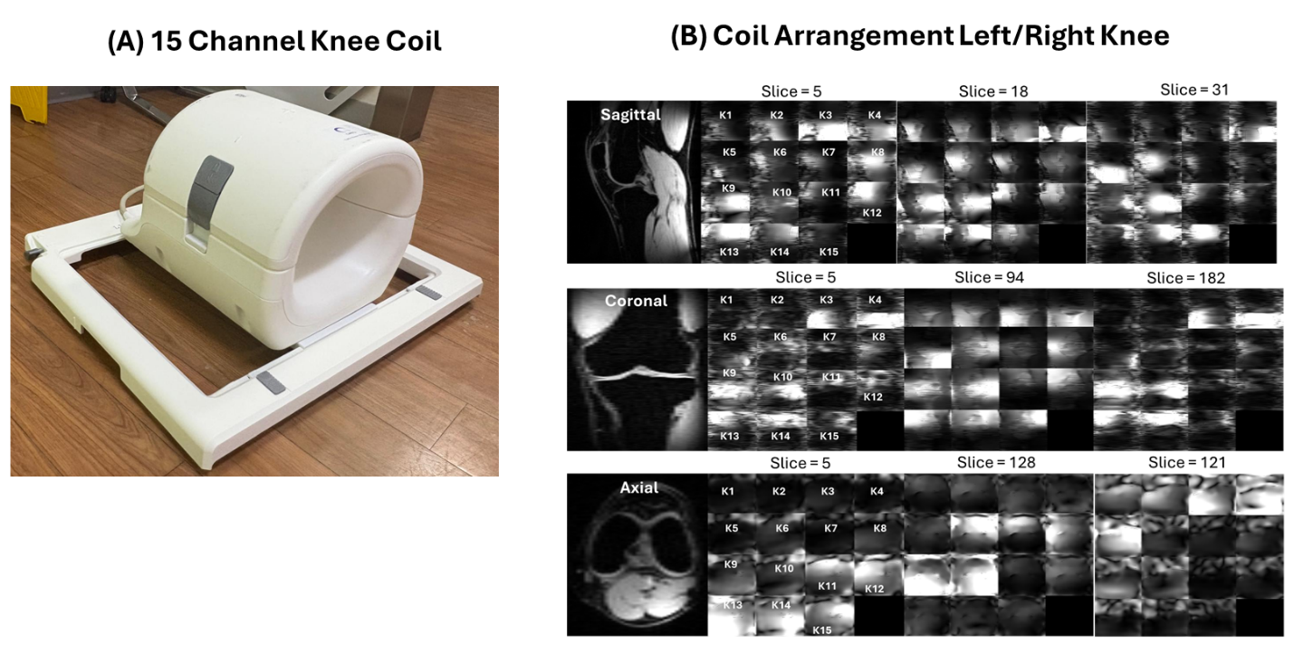
Figure S3: (A) Fifteen-channel knee coil from QED. (B) Example T_{1ρ}-weighted image and the corresponding coil sensitivity maps for coil elements K1–K15, shown in axial, sagittal, and coronal orientations.

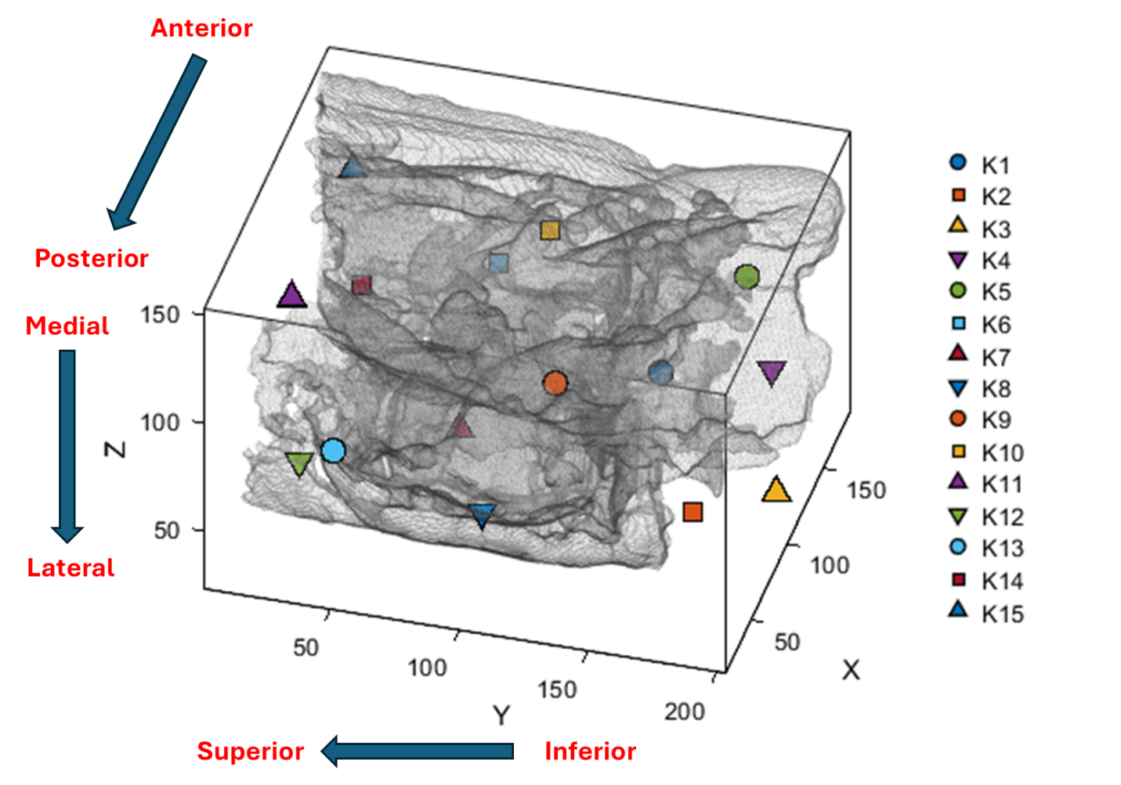
Figure S4: Three-dimensional rendering of the knee joint illustrating the spatial distribution of coil elements (K1–K15). The semi-transparent grayscale volume represents the knee anatomy, while colored markers indicate the positions of individual coil elements. Labeled axes denote anatomical orientation: anterior–posterior, medial–lateral, and superior–inferior. The coil elements span multiple joint compartments, enabling region-specific analysis of neuronal firing across the entire knee volume.

