7.0 Appendix

7.1 Class Distribution Tables
Table 32: Class Distribution between Left and Right BI-RADS
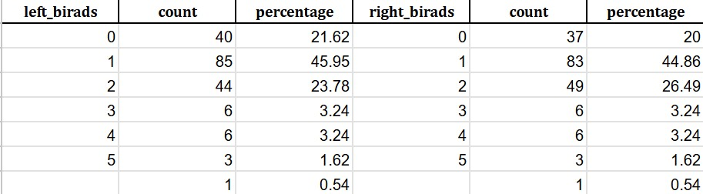

Table 33: Class Distribution for ACR
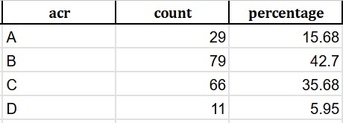

Table 34: Class Distribution for HKA
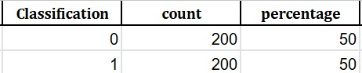

Table 35: Class Distribution for Brain MR
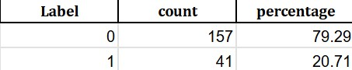

7.2 P-Values Table
Table 36: P-Value Results of Council vs MedGemma, Qwen vs MedGemma, and Qwen vs Council
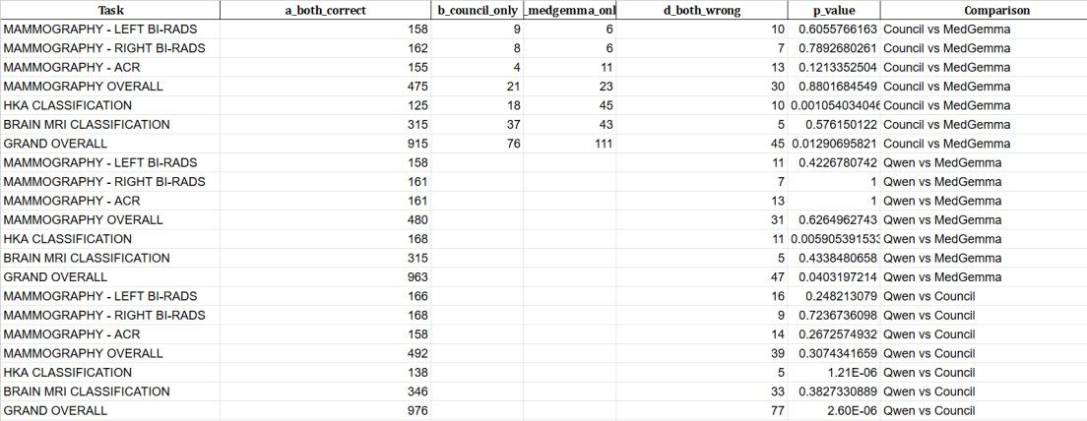

7.3 Confusion Matrices :
Fig 2 : LFM Left BI-RADS Confusion Matrix 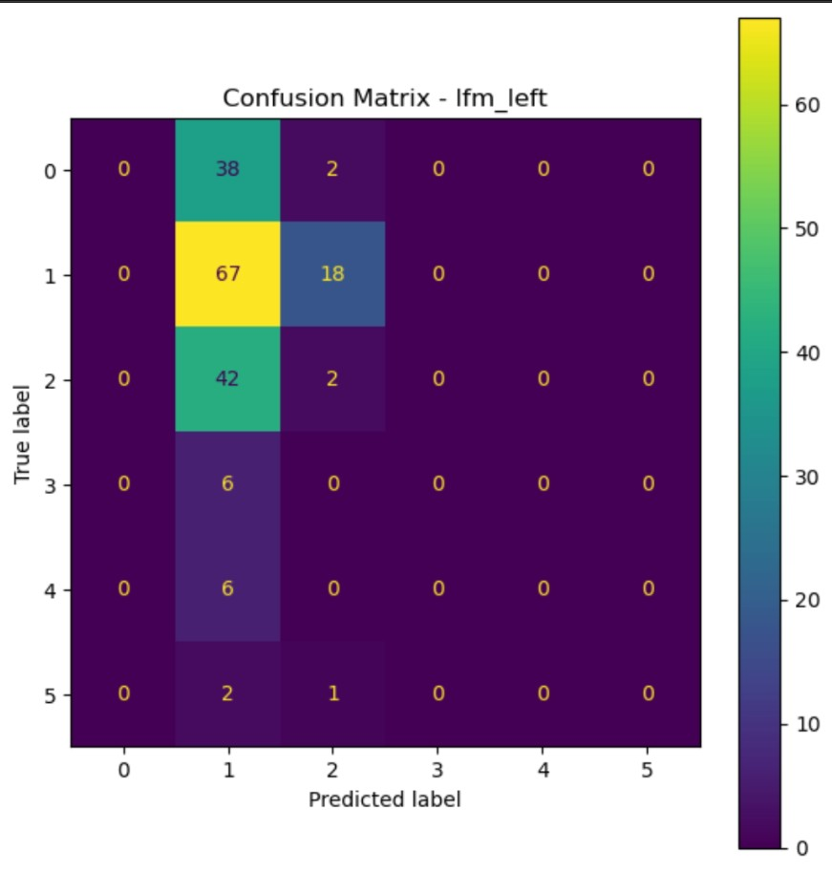

Fig 3 : Phi Left BI-RADS Confusion Matrix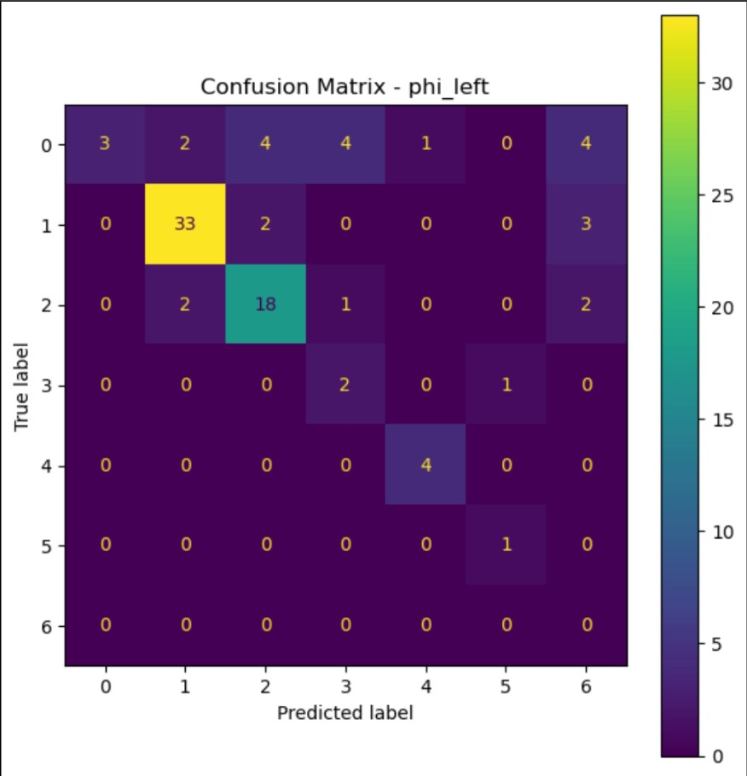

Fig 4 : Qwen Left BI-RADS Confusion Matrix

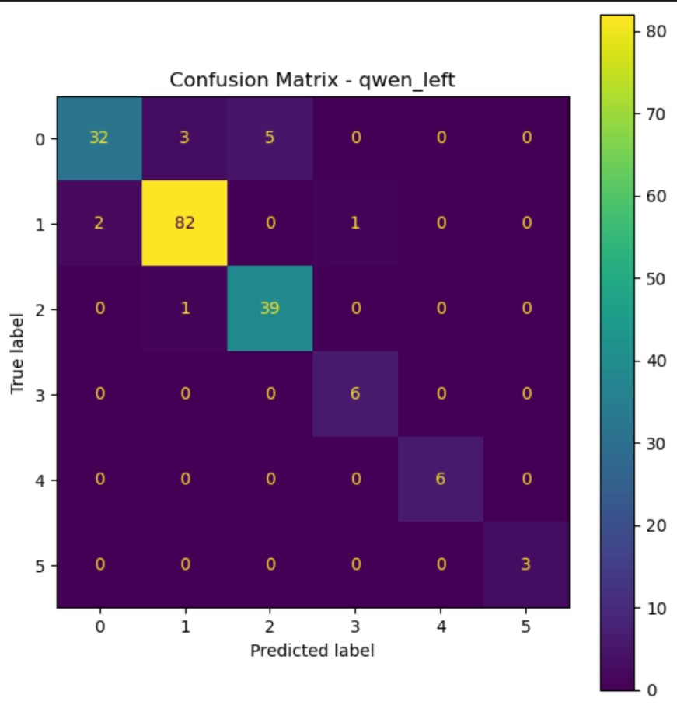

Fig 5 : LLaMa Left BI-RADS Confusion Matrix
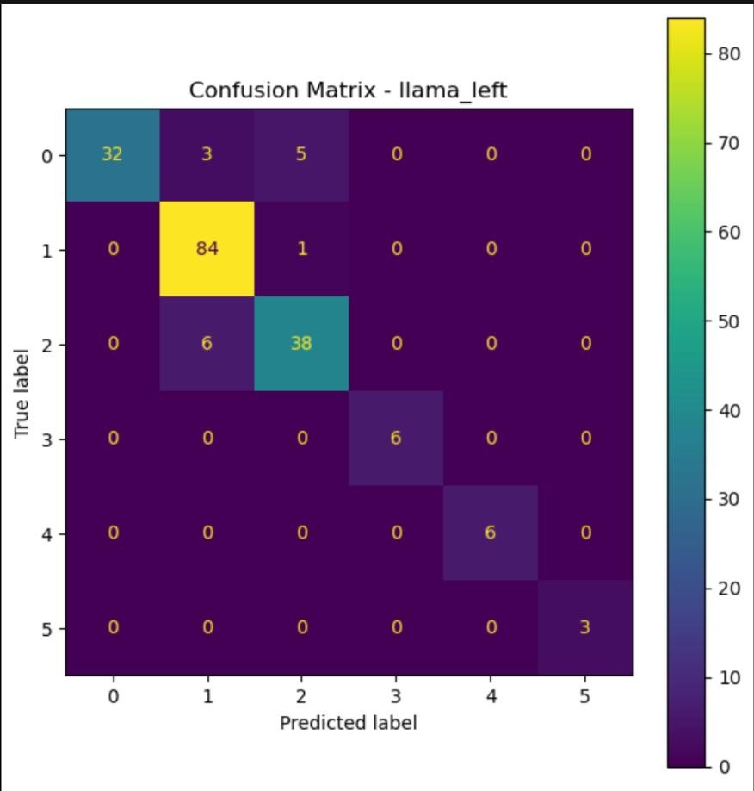

Fig 6 : MedGemma Left BI-RADS Confusion Matrix
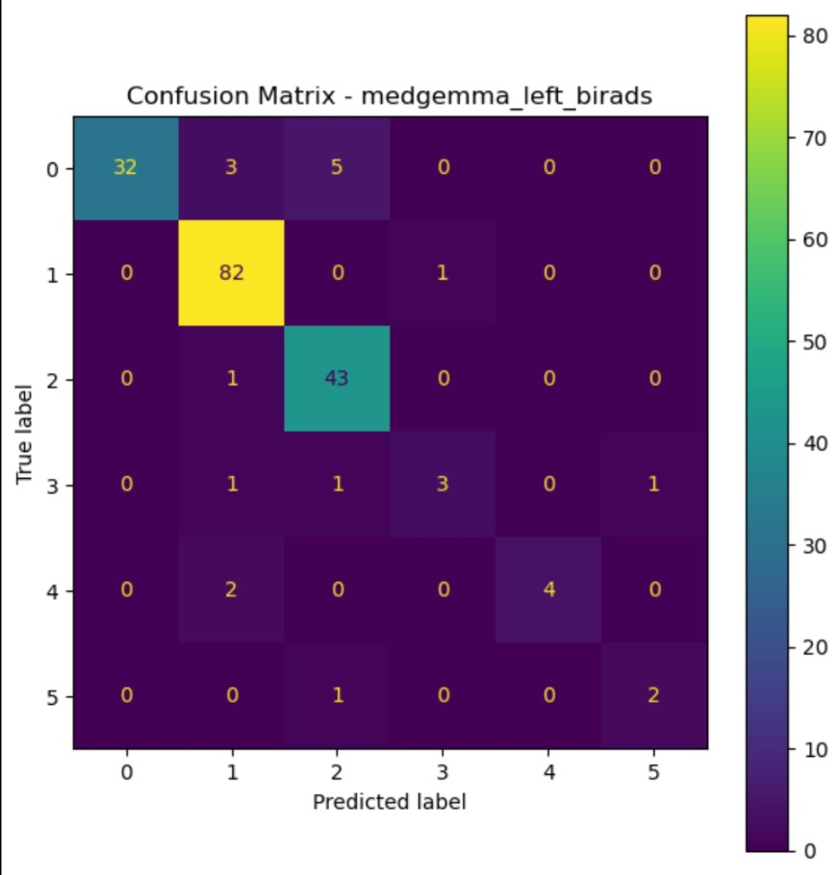

Fig 7 : LFM Right BI-RADS Confusion Matrix
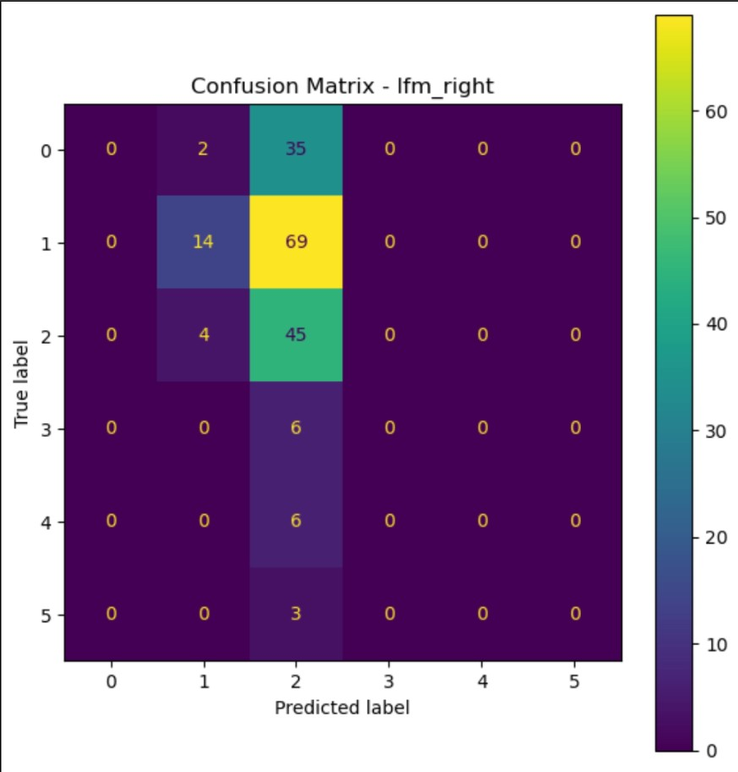
Fig 8 : Phi Right BI-RADS Confusion Matrix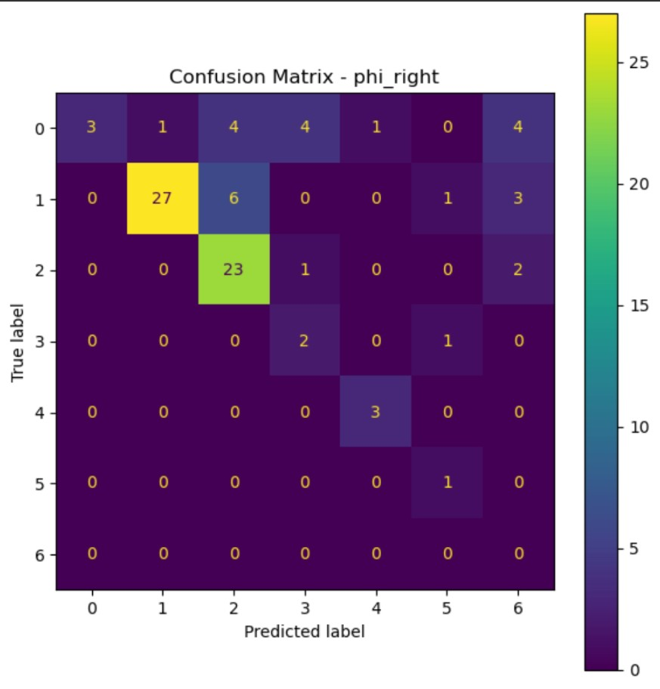

Fig 9 : Qwen Right BI-RADS Confusion Matrix
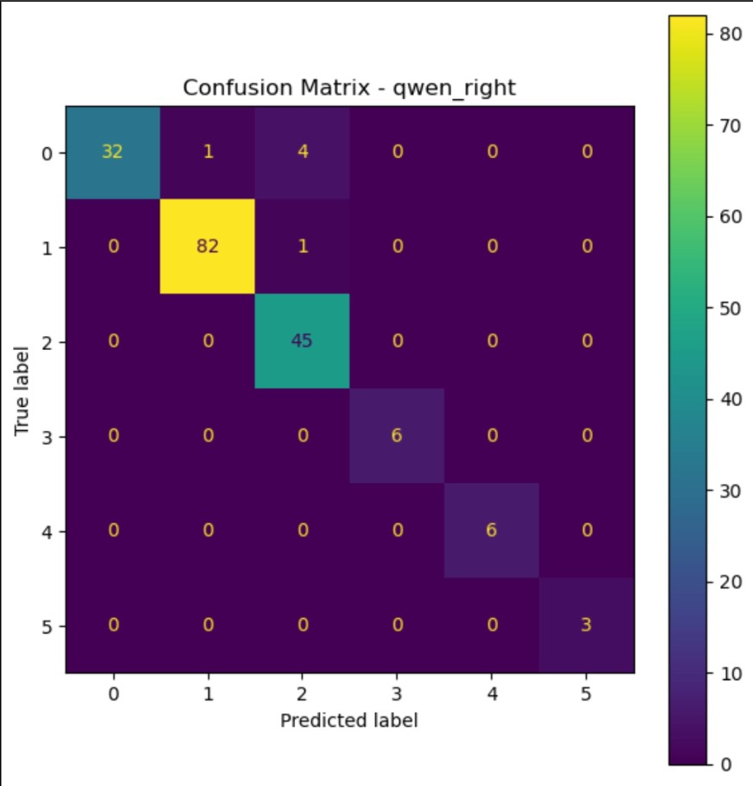

Fig 10 : LLaMa Right BI-RADS Confusion Matrix
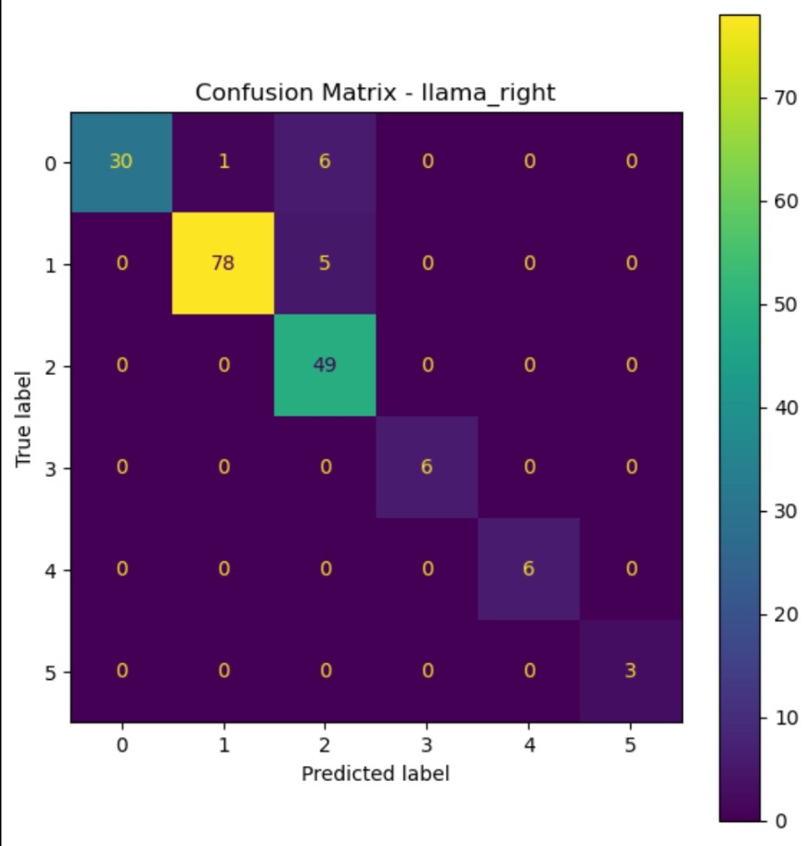

Fig 11 : MedGemma Right BI-RADS Confusion Matrix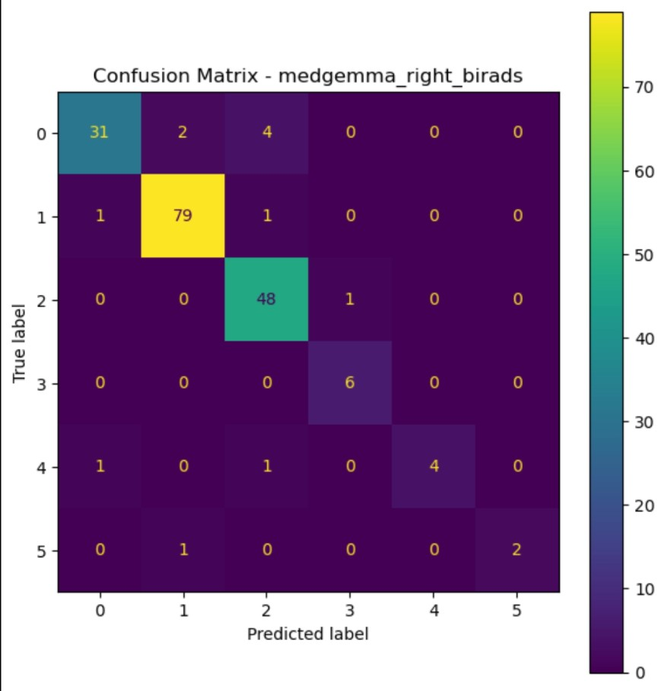

Fig 12 : LFM ACR Confusion Matrix
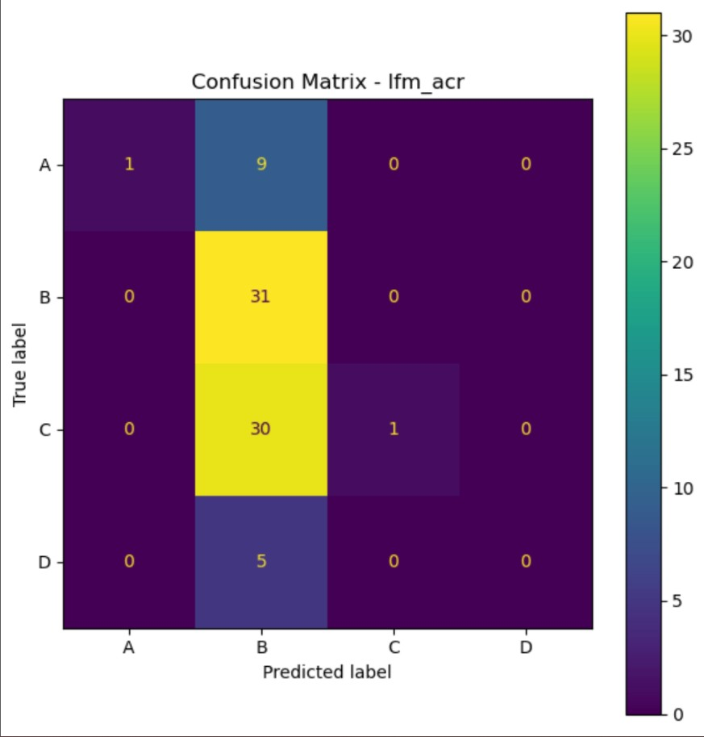
Fig 13 : Phi ACR Confusion Matrix 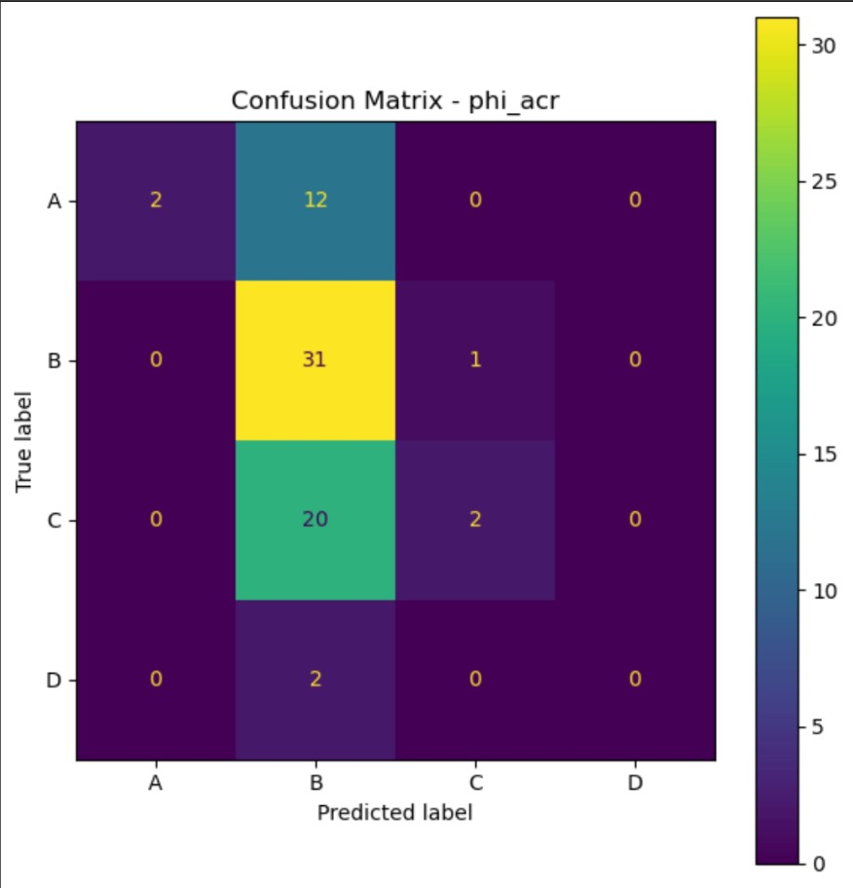

Fig 14 : Qwen ACR Confusion Matrix
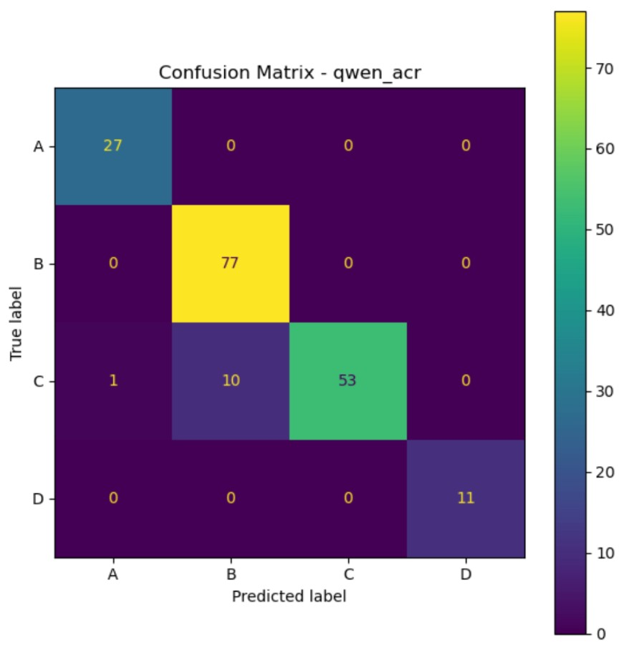

Fig 15 : LLaMa ACR Confusion Matrix 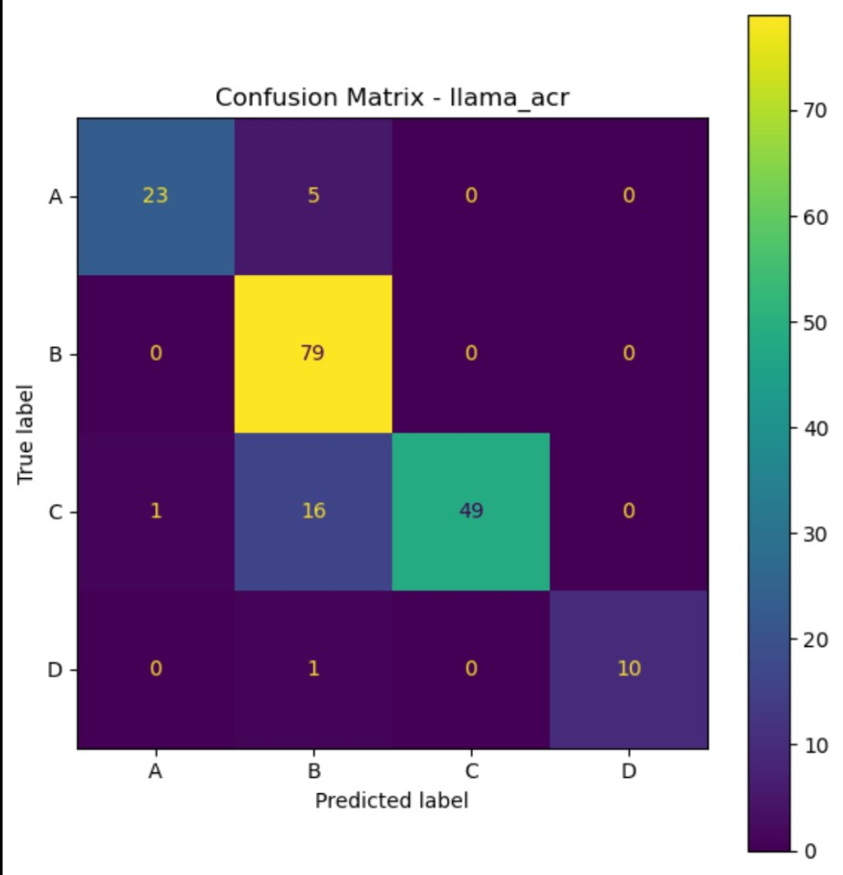

Fig 16 : MedGemma ACR Confusion Matrix
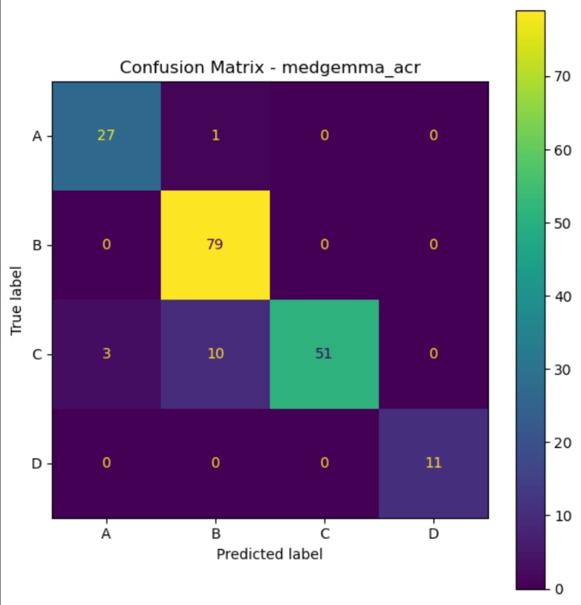

Fig 17 : LFM HKA Confusion Matrix
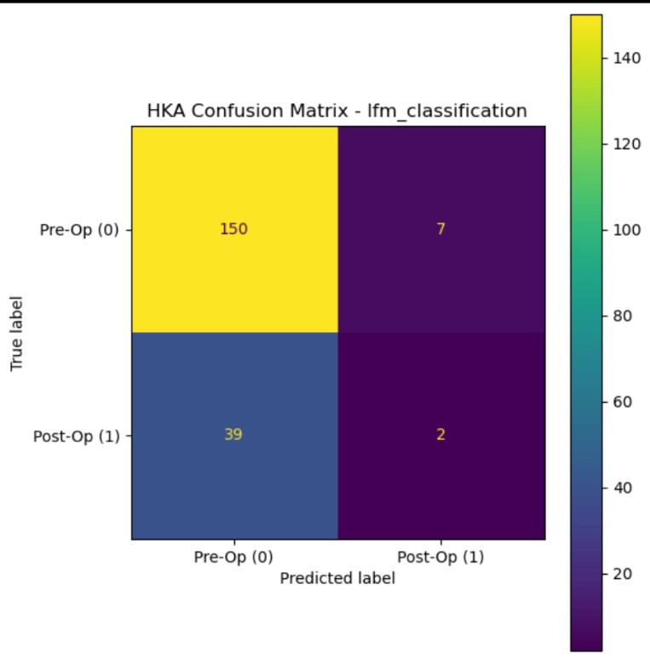
Fig 18 : Phi HKA Confusion Matrix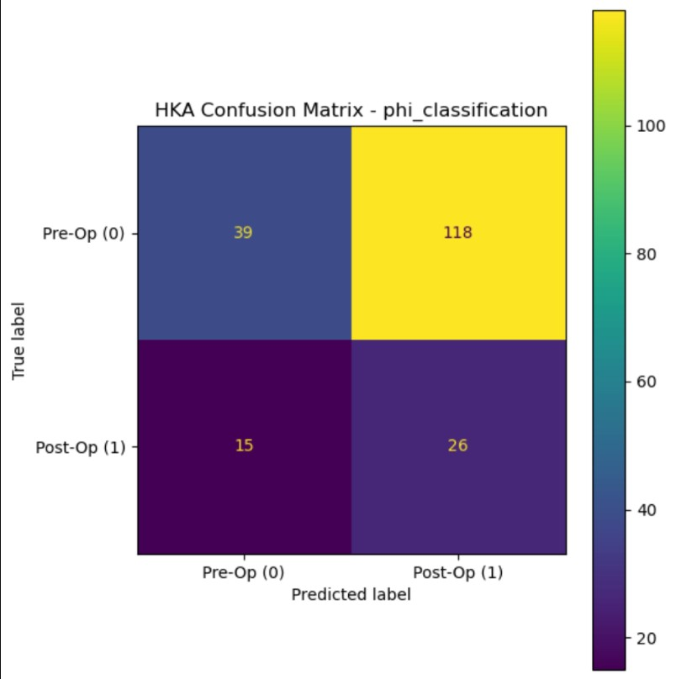
Fig 19 : Qwen HKA Confusion Matrix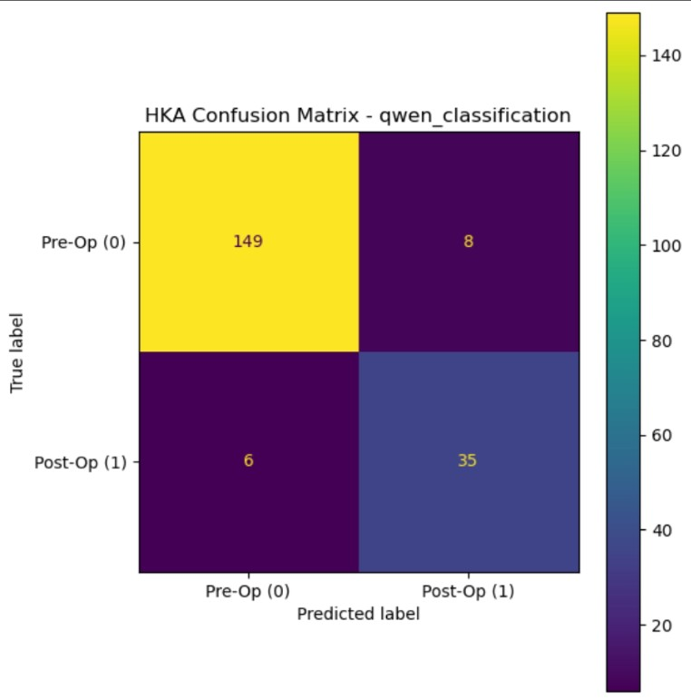

Fig 20 : LLaMa HKA Confusion Matrix
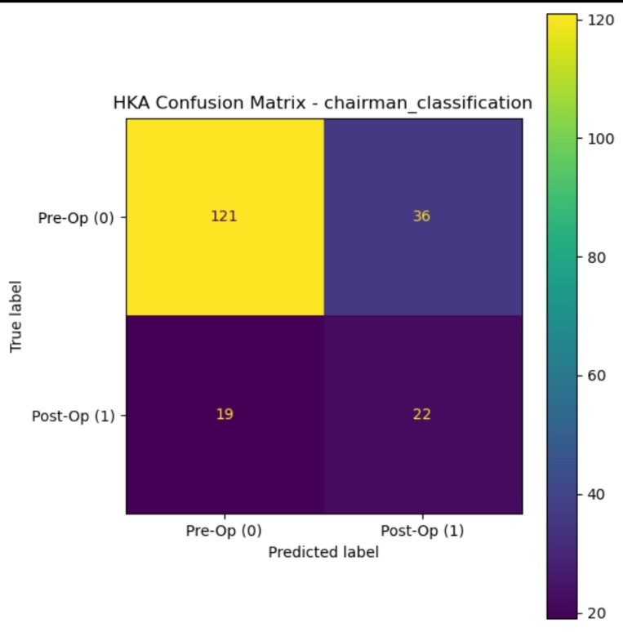

Fig 21 : MedGemma HKA Confusion Matrix
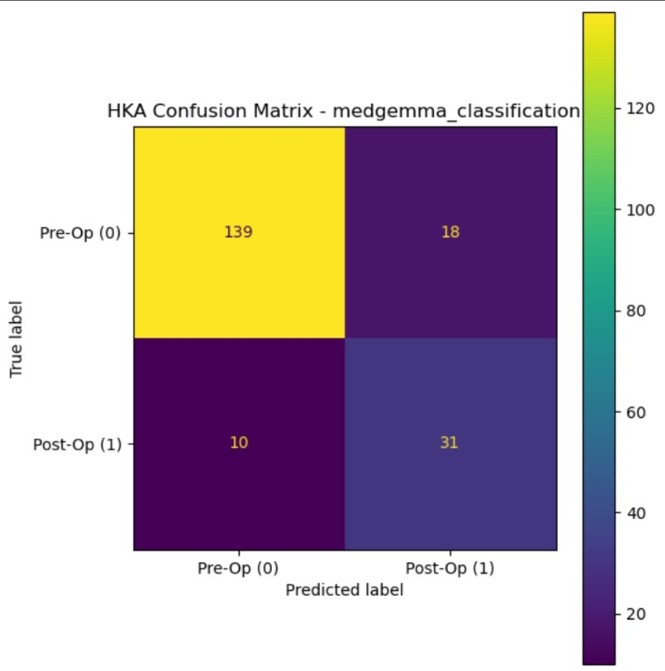

Fig 22: LFM Brain MR Confusion Matrix
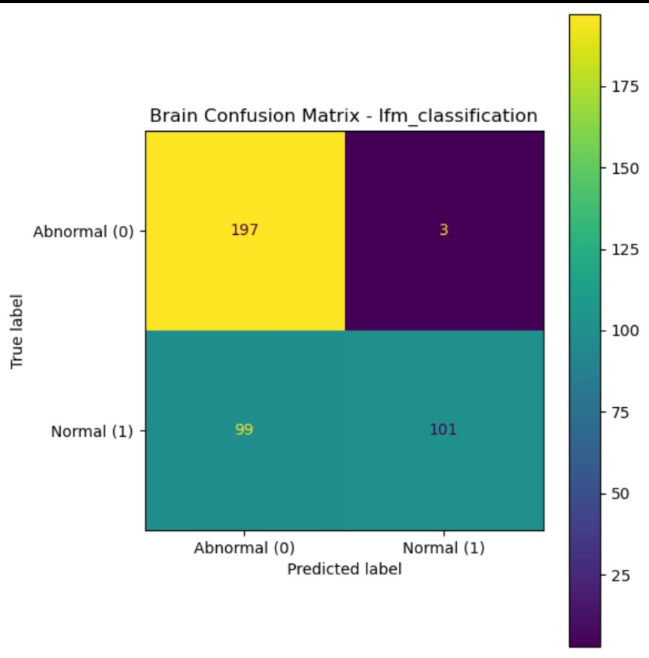

Fig 23 : Phi Brain MR Confusion Matrix
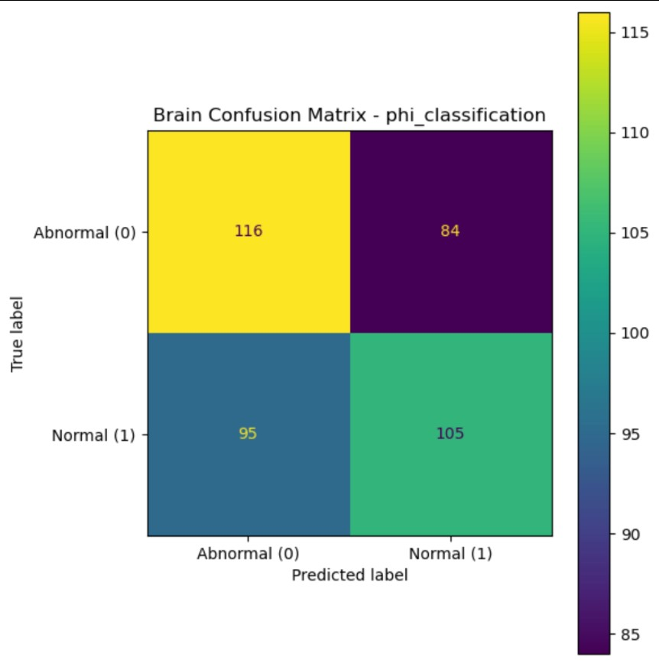

Fig 24 : Qwen Brain MR Confusion Matrix
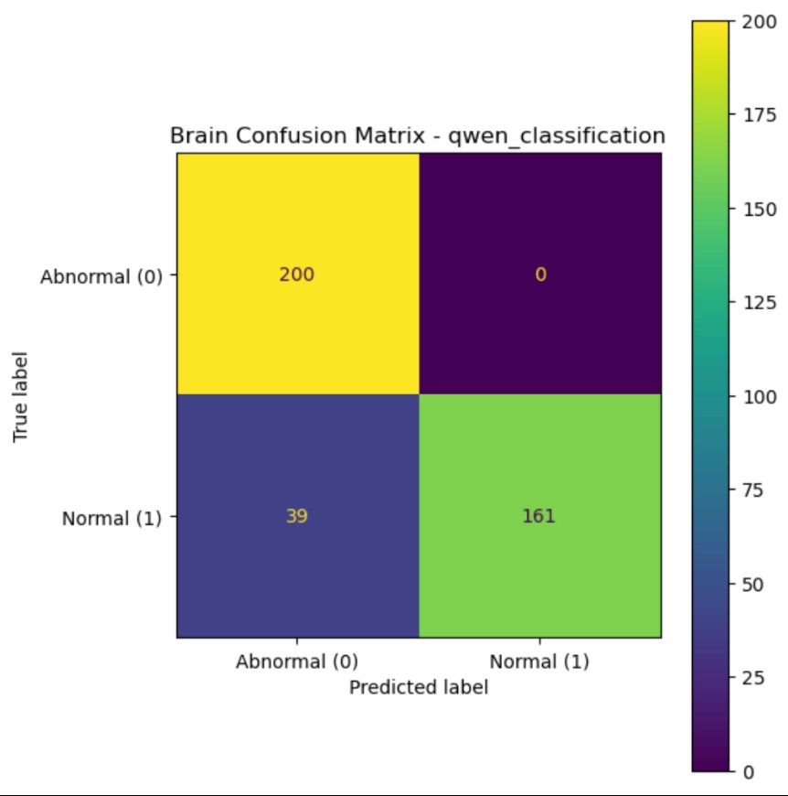

Fig 25 : LLaMa Brain MR Confusion Matrix
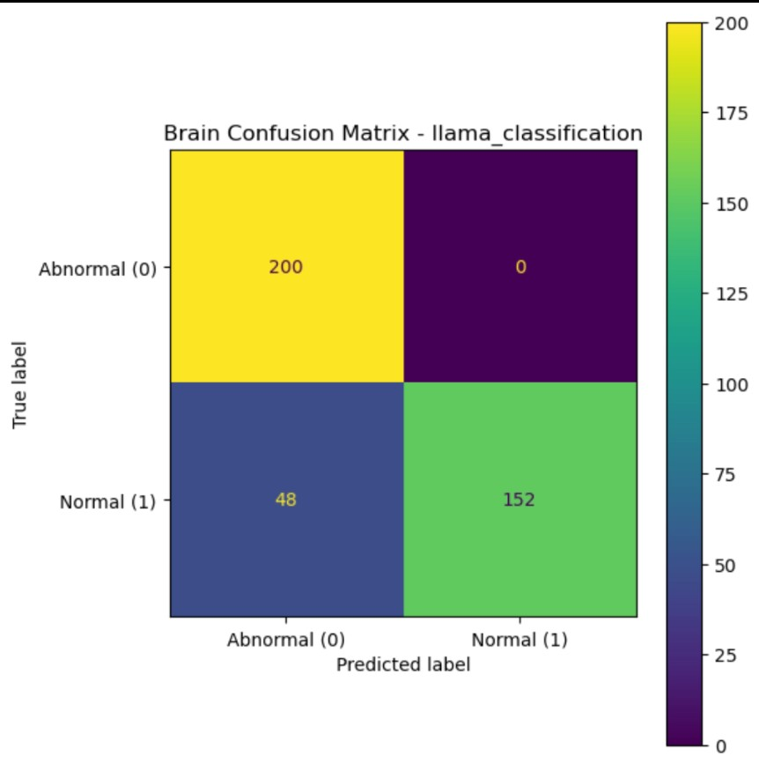

Fig 26 : MedGemma Brain MR Confusion Matrix
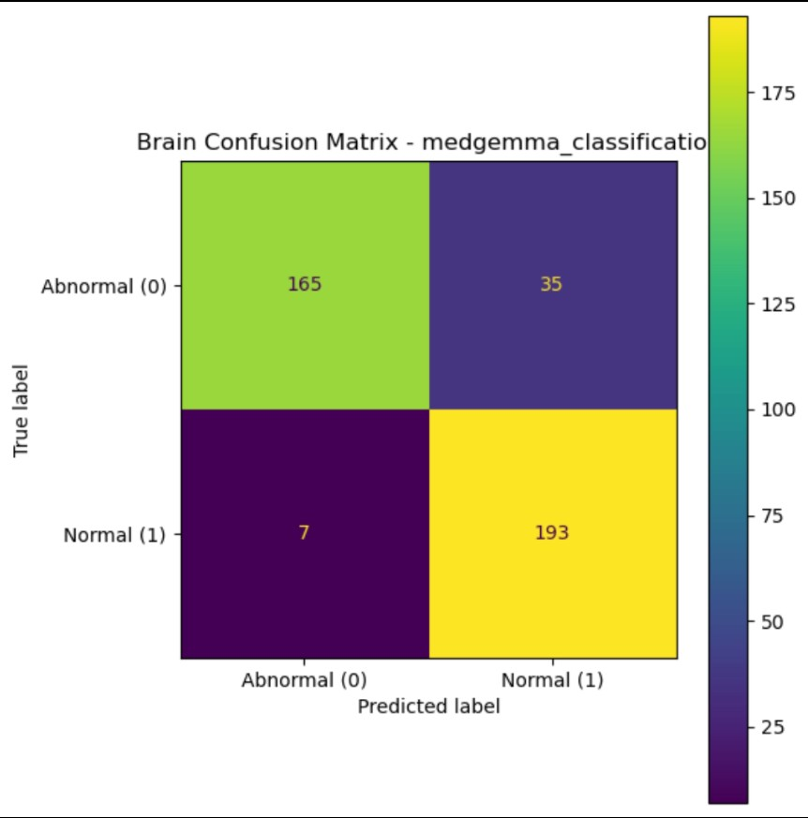

7.4 Prompts
The following are the exact prompts used for the LLM Council.
Mammography:
You are a medical JSON extraction engine.

TASK:
Extract:
- left_birads
- right_birads
- acr

STRICT RULES:
- Output ONLY valid JSON
- No markdown
- No explanation
- No reasoning
- No Python
- No comments
- Start with {{
- End with }}
- BI-RADS must be integer 0-6
- Score of 0 is VALID - If only one BI-RADS score exists, apply it to BOTH left and right
- Missing values = null

VALID FORMAT:
{{
"left_birads": 1,
"right_birads": 2,
"acr": "B"
}}

REPORT:
{user_query}

HKA:
You are a binary classifier.
Classify this hka report.

Output:
0 = pre-operative
1 = post-operative

Post-operative indicators include:
- total knee replacement
- TKR
- arthroplasty
- prosthesis
- implant
- revision surgery

If there is no indication of the report being post-operative, it is then pre-operative.
Classify accordingly.

Return ONLY:
0 or 1 DO NOT RETURN ANY TEXT.
DO NOT THINK EXCESSIVELY.
DO NOT OVER-THINK.
YOU ARE ONLY TO RETURN 0 OR 1 AS A RESULT, NOTHING ELSE.

Report:
{user_query}

Brain MR:
You are a binary classifier.

Task:
Classify the MRI brain report.

0 = abnormal
1 = normal

Rules:
- Any pathology, lesion, infarct, hemorrhage, tumor, mass, edema, atrophy, hydrocephalus, demyelination, or abnormal finding = 0
- Clinically normal MRI brain = 1
- If the impression contains any abnormal diagnosis = 0

Return exactly one integer.

Valid outputs: 0 or 1

Do NOT explain.
Do NOT think aloud or think excessively.
Do NOT output JSON.
Return ONLY the classification value.

Report:
{user_query}

Classification:

The following are the exact prompts used for MedGemma.
Mammography:
You are a medical imaging classifier.

Task:
Extract structured mammography findings.

Return ONLY JSON:

{{
"left_birads": integer,
"right_birads": integer,
"acr": "A|B|C|D"
}}

Rules:
- No explanation
- No markdown
- No text outside JSON

Report:
{report}

HKA:
You are a binary classifier.

0 = pre-operative
1 = post-operative

Return ONLY JSON:
{{"classification": 0 or 1}}

Rules:
- No explanation
- No text outside JSON

Report:
{report}

Brain MR:
You are a binary classifier for brain MRI.

0 = abnormal
1 = normal

Return ONLY JSON:
{{"classification": 0 or 1}}

Rules:
- No explanation
- No extra text

Report:
{report}

The following are the exact prompts used for the LLaMa 3.1 8B Ablation Test.

Mammography:
You are a medical imaging classifier.

Task:
Extract structured mammography findings.

Return ONLY JSON:

{{
"left_birads": integer,
"right_birads": integer,
"acr": "A|B|C|D"
}}

Rules:

- No explanation
- No markdown
- No text outside JSON

Report:
{report}

HKA:
You are a binary classifier.

0 = pre-operative
1 = post-operative

Return ONLY JSON:
{{"classification": 0 or 1}}

Rules:

- No explanation
- No text outside JSON

Report:
{report}

Brain MR:
You are a binary classifier for brain MRI.

0 = abnormal
1 = normal

Return ONLY JSON:
{{"classification": 0 or 1}}

Rules:

- No explanation
- No extra text

Report:
{report}

7.5 Scripts Used
Due to the large amount of code used in the experiment for the tables, experimental trials and graphs, a GitHub repository was created where all the scripts, tables and graphs can be viewed with ease.
All files containing the reports used were removed as requested by Max Healthcare Saket in line with the ethical commitments of this project.
Please access through this link:
https://github.com/Vihaan-Mathur-04/Vihaan-Mathur-LLM-Council-Repository

