Supplementary Information
Wafer-scale integration of atomically thin metal oxide in memtransistor arrays for artificial neural networks

Honghong Li^{1#}, Yukang Chen^{1#}, Tao Liu^{2#*}, Zhou Xin¹, Yufeng Ning¹, Tianqi Zhang³, Shengyao Chen³, Yujie Zheng^{4*}, Zhongchang Wang^{3*}, Du Xiang^{1,3*}

Affiliations
¹State Key Laboratory of Integrated Chips and Systems, Frontier Institute of Chip and System, Fudan University, Shanghai, China
²Shanghai Frontiers Science Research Base of Intelligent Optoelectronics and Perception, Institute of Optoelectronics and Department of Materials Science, Fudan University, Shanghai, China
³School of Materials and Energy, Southwest University, Chongqing, China
⁴National Innovation Center for Industry-Education Integration of Energy Storage Technology, MOE Key Laboratory of Low-grade Energy Utilization Technologies and Systems, CQU-NUS Renewable Energy Materials & Devices Joint Laboratory, School of Energy & Power Engineering, Chongqing University, Chongqing 400044, China

#These authors contributed equally to this work
*Author to whom correspondence should be addressed. Electronic mail: liu_tao@fudan.edu.cn (T. L.); zhengyujie@cqu.edu.cn (Y. Z.); zhongchangwang@buaa.edu.cn (Z. W.); xiang_du@fudan.edu.cn (D. X.)
Supplementary Figure 1. Roughness of the as-synthesized SnO film. (a) Schematic of SnO film on a 2-inch SiO₂/Si wafer. The three rectangles indicate the regions for AFM roughness measurement. (b–d) Surface roughness of the SnO film at different regions. The surface roughness is highly uniform across the wafer, with a low average value between 0.5 nm to 0.77 nm.

Supplementary Figure 2. XRD spectra of the 2D SnO film. XRD characterization was performed to examine the crystal structure of the 2D SnO film. The diffraction peaks can be indexed to a tetragonal SnO phase with the space group P4/nmm (JCPDS No. 01-078-1913), without detectable impurity peaks. Specifically, the peaks located at 17.8° and 36.6° can be assigned to the (110) and (200) planes of SnO, respectively, which are consistent with the lattice planes observed in the HRTEM image shown in Figure 1e. The sharp diffraction features further indicate good crystallinity and high phase purity of the film.

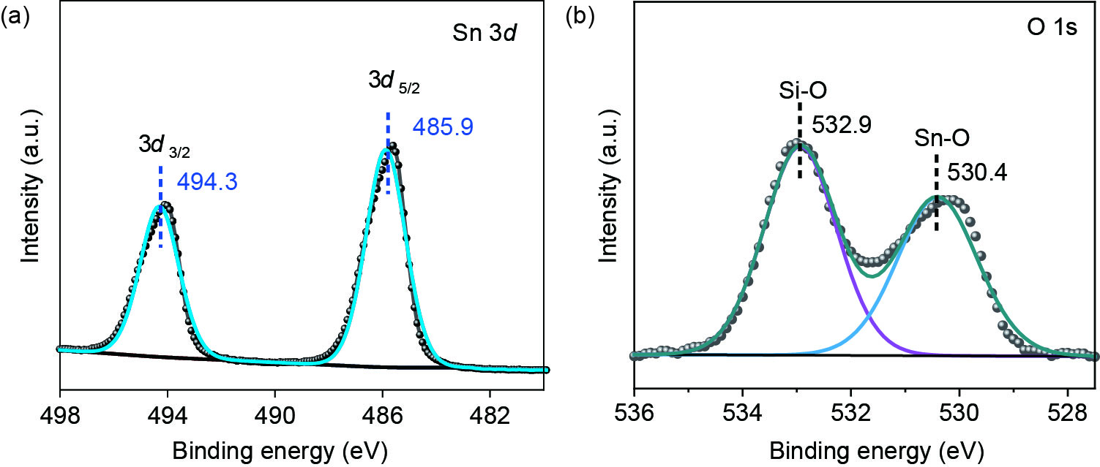

Supplementary Figure 3. XPS spectra of the 2D SnO film. XPS spectra of the (a) Sn 3d and (b) O 1s core levels. XPS measurements were carried out to investigate the chemical composition and valence states of the as-prepared SnO film. The Sn 3d_{3/2} and Sn 3d_{5/2} peaks located at 494.3 eV and 485.9 eV belong to SnO, confirming the formation of stannous oxide rather than SnO₂. Additionally, there is no Sn metal related peaks observed in the XPS spectra, indicating the negligible Sn residue on the sample surface. The two deconvoluted peaks located at 530.4 and 532.9 eV in the O 1s core level can be assigned to lattice oxygen (O²⁻) in SnO and SiO₂, respectively.

Supplementary Figure 4. Wafer-scale patterning of SnO channels. (a) Optical image of 1024 channels selected from one single block circled in the photograph. (b) Photograph of the SnO crossbar arrays isolated in 48 blocks.

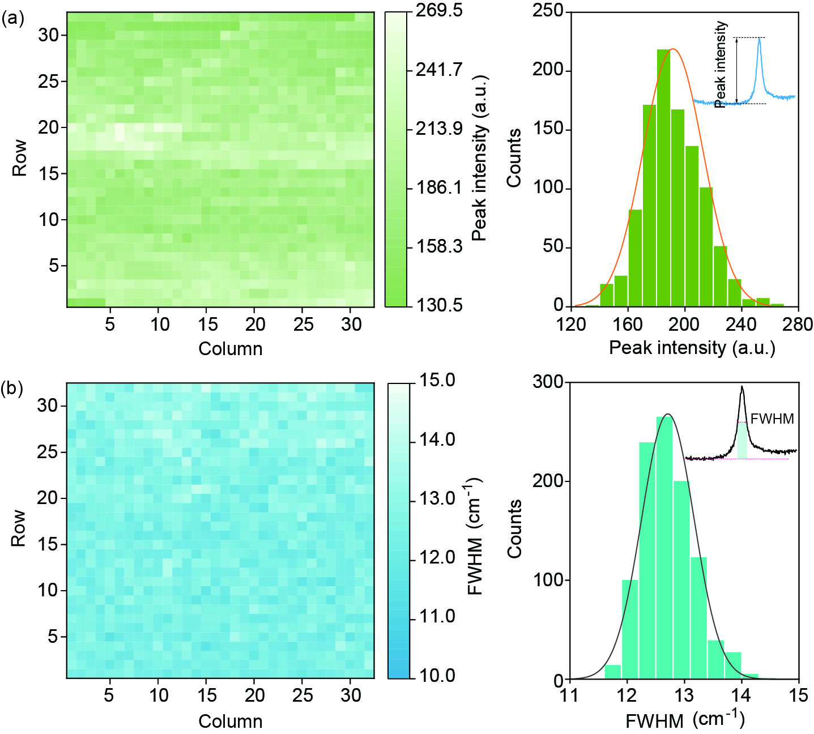
Supplementary Figure 5. Statistics of the Raman spectra. Statistical results of the (a) intensities and (b) FWHMs of the A_{1g} characteristic peak extracted from the SnO Raman spectra. The intensity and FWHM of the A_{1g} characteristic peaks were extracted from Figure 1g for Gaussian statistical analysis, which further validates the high quality and uniformity of the as-synthesized SnO film.

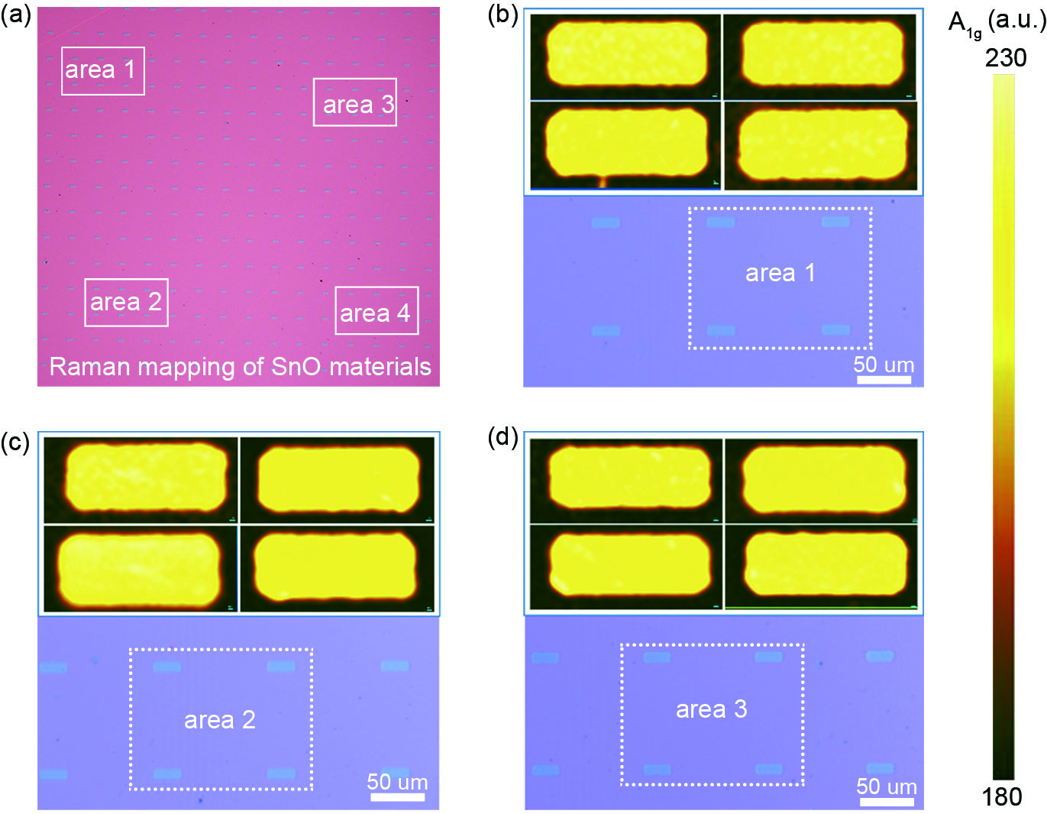
Supplementary Figure 6. Raman mapping of the SnO channels. (a) Optical image of the isolated SnO channels. (b–d) Raman mapping of the SnO channels selected from the different regions marked by the white boxes shown in the optical image. The SnO channels in different regions exhibit intense and uniform Raman signals, in good agreement with the results shown in the main text.

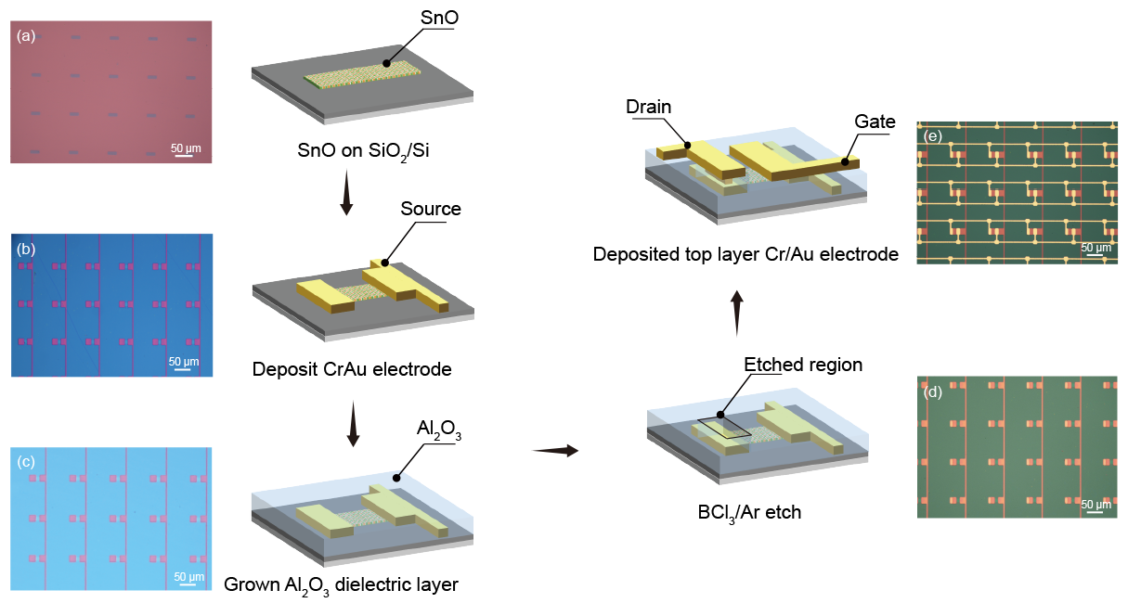
Supplementary Figure 7. Fabrication flow chart of the SnO crossbar arrays. (a) SnO film preparation and RIE etching. (b) Contact-metal deposition (5/15 nm Cr/Au). (c) Dielectric deposition by ALD (30 nm). (d) Via etching. (e) Top-metal deposition (5/50 nm Cr/Au).

Supplementary Figure 8. Spatial mapping (left) and statistical histogram (right) of the SS. The SS mapping shows a uniform color distribution, indicating the excellent device-to-device uniformity across the array. The histogram in the right side illustrate the highly concentrated Gaussian distribution of the SS, where the variability is determined to be 5.3%.

Supplementary Figure 9. Total density of states (TDOS) of (a) SnO and (b) am-Al₂O₃ calculated using the HSE06 functional.

Supplementary Figure 10. Structural models and formation energies for Sn substitution at fourfold-, fivefold-, and sixfold-coordinated Al sites in an am-Al₂O₃ unit cell. Red, blue, and purple spheres denote O, Al, and Sn atoms, respectively.
The formation energy of Sn substitution at different Al coordination sites was calculated by:
where E_{tot} (Sn_{Al}) and E_{tot} (pristine) are the total energies of the Sn-substituted and pristine am-Al₂O₃ supercells, respectively. E_{Al} and E_{Sn} were defined as the total energy of metal divided by the number of atoms in bulk.

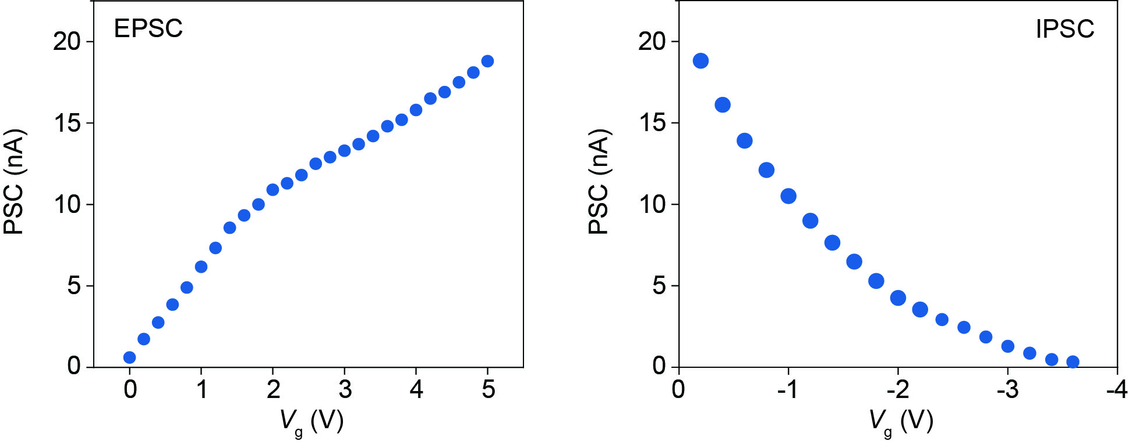
Supplementary Figure 11. Synaptic behavior modulated by the gate terminal. The positive and negative V_{g} induce the potentiation and depression plasticity in the SnO synaptic device, respectively. With gradually increasing the V_{g} from 0 V to 5 V, the PSC is enhanced from 0.6 nA to 18.8 nA. Similarly, the PSC decreases to its initial value as V_{g} decreases from −0.2 V to −3.6 V.

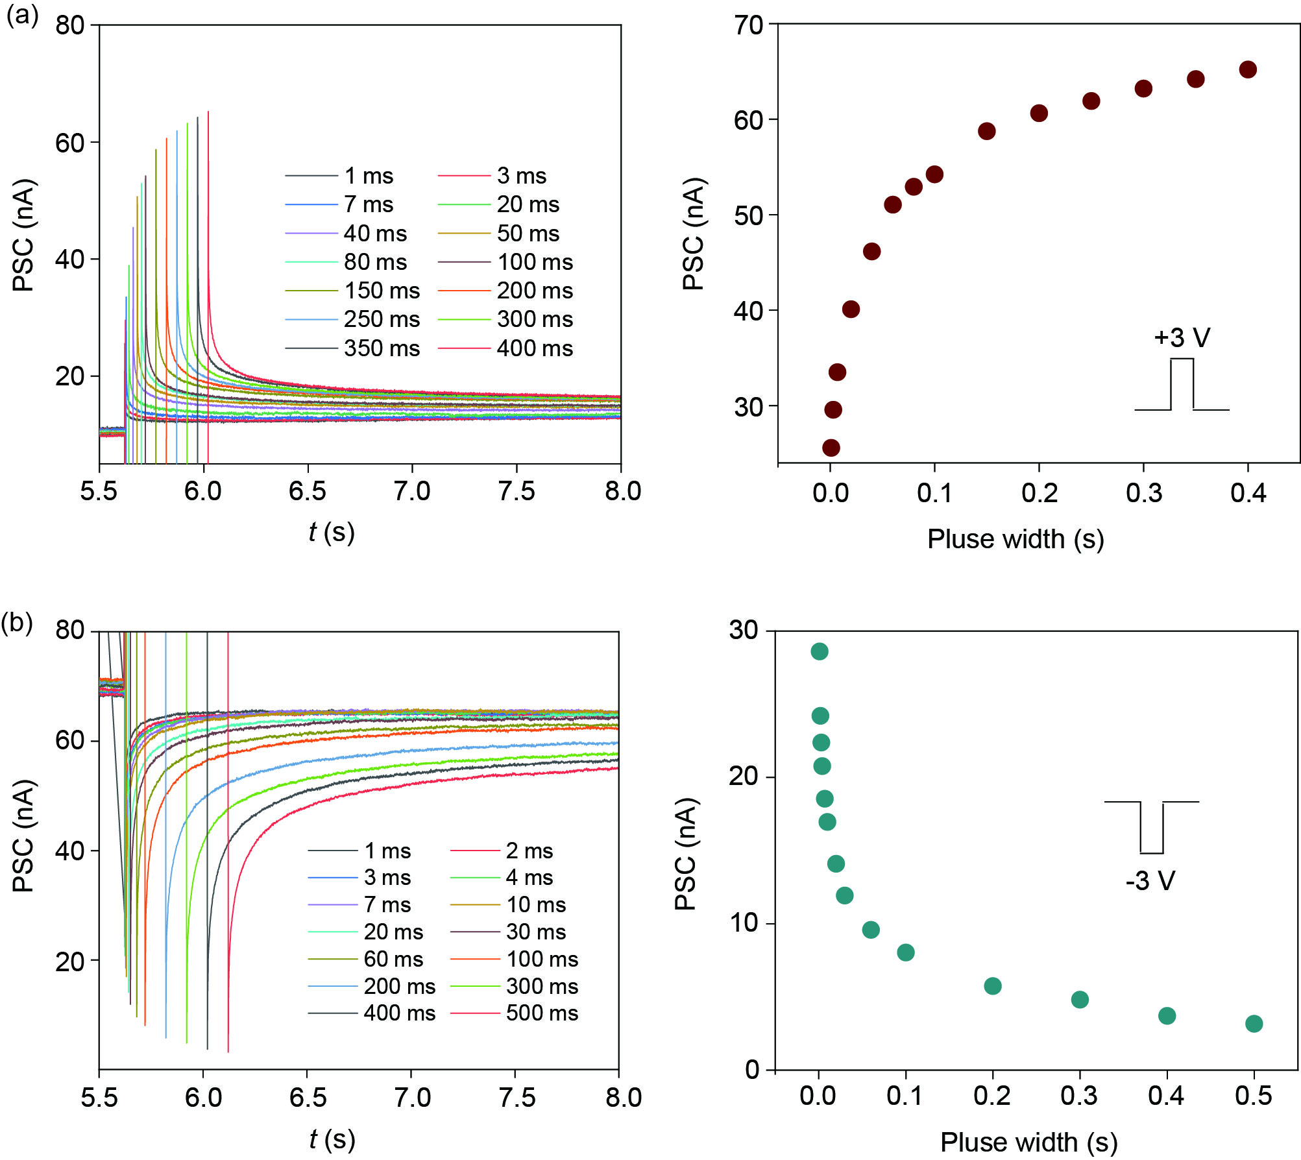
Supplementary Figure 12. PSC modulated by pulse width. (a) EPSC and (b) IPSC measured under different pulse widths. The pulse amplitudes are fixed at +3 V and −3 V, respectively. With increasing the pulse width from 1 ms to 400 ms, the EPSC demonstrates a rapid enhancement at the beginning, followed by a gradual saturation at around 65.2 nA. Similarly, the IPSC declines dramatically under the negative V_{g} pulses, and then progressively stabilizes at around 3.2 nA when the pulse width increases from 1 ms to 500 ms.

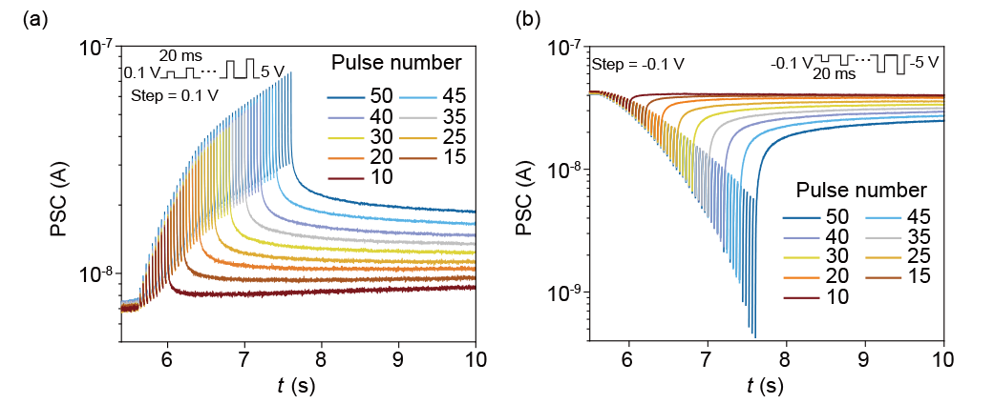
Supplementary Figure 13. PSC modulated by pulse number. The evolution of PSC under successive stimulation of the (a) positive and (b) negative gate spikes, respectively. With increasing the pulse number from 10 to 50, the EPSC is gradually enhanced from 8.66 nA to 19.10 nA. Similarly, the IPSC decreases from 40.30 nA to 24.13 nA as the pulse number increases from 10 to 50.

Supplementary Figure 14. The P−D curves of 150 randomly selected devices in the crossbar array.
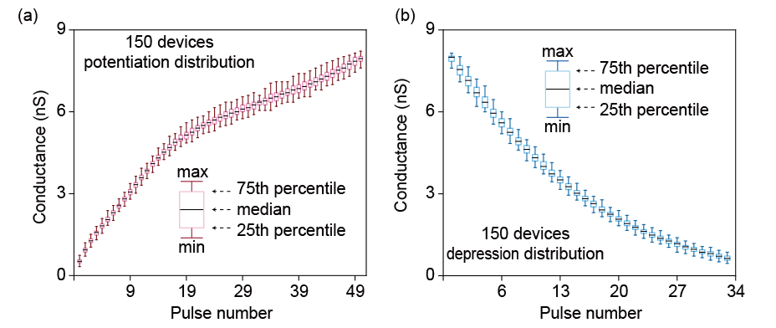
Supplementary Figure 15. Device-to-Device variation in box plot. Device-to-Device variation of (a) the LTP and (b) LTD processes. The stochastic fluctuations at each conductance level are investigated to qualitatively visualize the device-to-device variation in both the LTP and LTD processes. The clustered conductance distributions with small variation at each state indicate the excellent device-to-device uniformity.

Supplementary Figure 16. Potentiation and depression characteristics of the SnO synapse under consecutive training pulses. The P−D curve consists of 50 potentiation pulses and 32 depression pulses.
To quantify the deviation of the P−D curve from ideal linear weight updating, a parameter A is introduced to evaluate the linearity of the LTP and LTD processes. The P−D curve is fitted by the equations as follows:
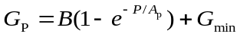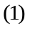
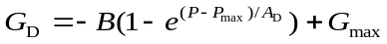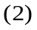
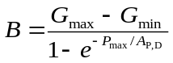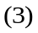
where G_{P} and G_{D} are the conductance for LTP and LTD, respectively. P is the pulse number. G_{max} and G_{min} represent the maximum and minimum conductance, respectively. P_{max} is the maximum number of pulses required to reach G_{max}. By fitting the P−D curve, the parameters A_{P} and A_{D} are determined to be 2.2897 and 2.4225, respectively.

Supplementary Figure 17. Statistics of parameter A. Histograms for the (a) A_{P} and (b) A_{D} distributions of the 150 synaptic devices. To comprehensively evaluate the device-to-device variation of the SnO crossbar array, the parameters A_{P} and A_{D} of the 150 randomly selected devices are extracted using the equation shown above. The statistics of A_{P} and A_{D} demonstrate typical Gaussian distributions, in which the variabilities are determined to be 7.48% and 2.96%, respectively.

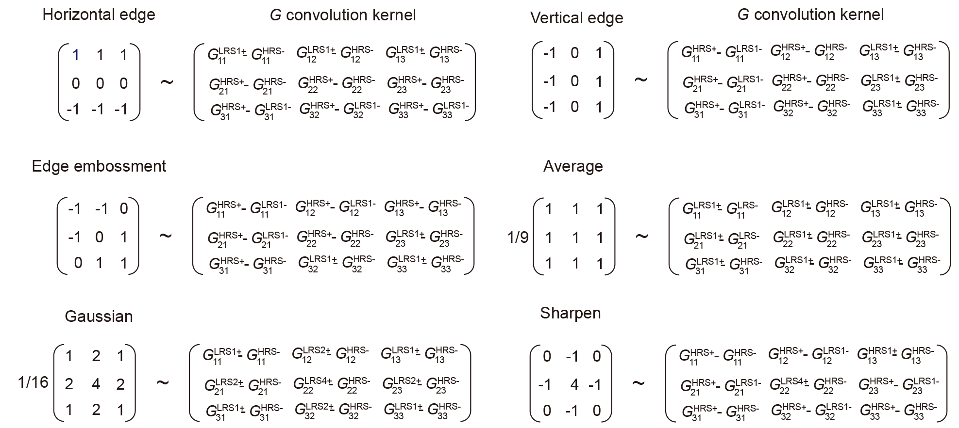

Supplementary Figure 18. Construction of convolution kernels based on the experimental conductance measured in the SnO synaptic array.
It is noted that two different synapses with two distinct conductance states (HRS and LRS) are used as the differential pair to represent the positive and negative weights for kernel construction. Thus, the −1/+1 weight value can be mapped using HRS and LRS with the specific definition that G^{HRS} − G^{LRS1}, G^{HRS} − G^{LRS2}, G^{HRS} − G^{LRS3}, or G^{HRS} − G^{LRS4} ~ −1, and G^{LRS1} − G^{HRS}, G^{LRS2} − G^{HRS}, G^{LRS3} − G^{HRS}, or G^{LRS4} − G^{HRS} ~ +1. Therefore, the crossbar arrays can be used to construct the target 3×3 G convolution kernel. When constructing the G convolution kernel, we extracted the conductance values from the conductance map based on the position of the memory units and their resistance states (HRS, LRS1, LRS2, LRS3, and LRS4). In other words, the G convolution kernel is determined by the conductance of the devices in the crossbar array. The process of converting image intensity to voltage, performing convolution operations between the voltage matrix and the G convolution kernel, and converting the convolution results back to pixels was implemented through software code. Any of the four LRS states (LRS1, LRS2, LRS3, and LRS4) can be combined with the HRS state to construct the convolution kernels, enabling image processing such as averaging and embossing.

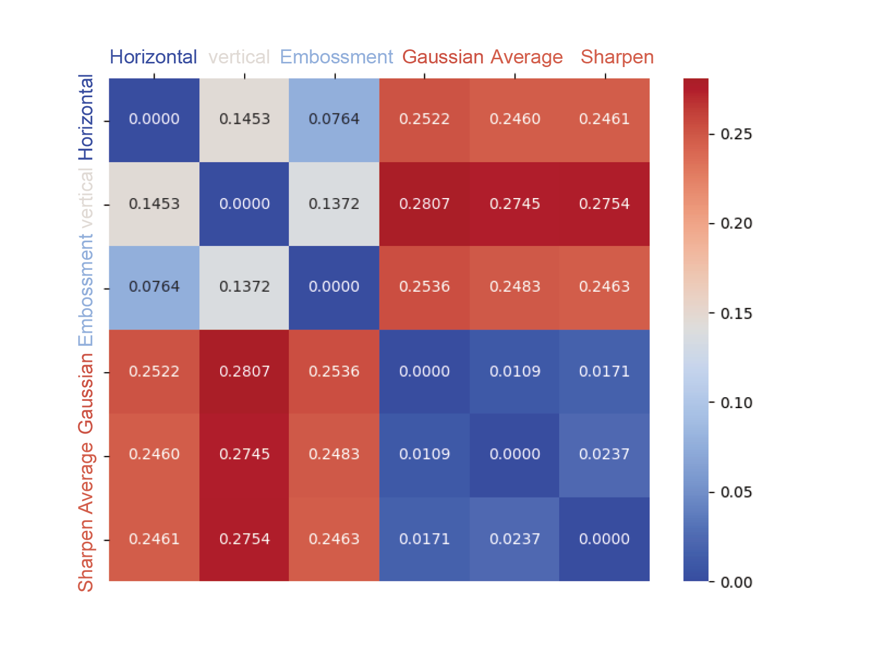
Supplementary Figure 19. LPIPS matrix of the hardware- and software-processed results under different convolution kernels. LPIPS is employed as the index to evaluate the image similarity based on deep learning. Different from traditional error-based evaluation methods, LPIPS uses a trained neural network model to learn the perceptual correlation of image content, so as to provide an image quality evaluation method that aligns well with human visual perception. It is noted that the six different convolution kernels demonstrate significant perceptual differences from each other (0.07−0.28), validating their capability to extract the differentiated features. In contrast, the LPIPS under the same convolution kernel remains below 0.05, suggesting the high perceptual consistency of the two different processing images.

Supplementary Figure 20. Pixel distributions for the hardware- and software-processed images under six different convolution kernels.

Supplementary Figure 21. Restoration for three image patterns. (a) Visualization of the restoration results and (b) the corresponding SSIM processed by the HNN network for three different image patterns.
SSIM is an objective metric for measuring the similarity between two images regarding to their structure, luminance, and contrast. In contrast to the traditional metrics such as MSE and PSNR, SSIM emphasizes perceptual quality by evaluating the degree of similarity between two images based on the sensitivity of the human visual system to structural information. As shown in Supplementary Fig. 21, the random noise intensity is set at seven different levels of 0, 6%, 12%, 18%, 24%, 30%, and 35%. Each column presents the noisy input image on the left and its corresponding restoration result on the right. Notably, even under random noise perturbations of varying intensities, the network successfully restores all three image patterns (SSIM = 100%), demonstrating the robust multi-pattern associative memory functionality of the SnO based HNN network.

Supplementary Figure 22. Restoration for four image patterns. Visualization of the restoration results for four different image patterns processed by the HNN network under random noise intensities of 6%, 18%, and 30%.

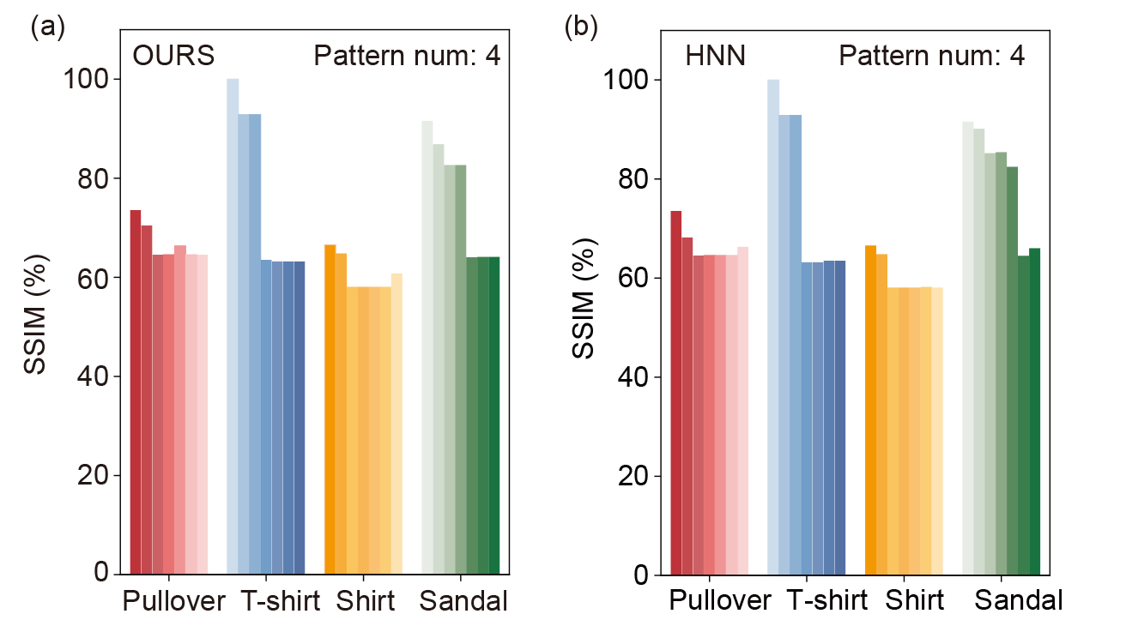
Supplementary Figure 23. Comparison between hardware- and software-processed results. SSIM distributions of the (a) hardware- and (b) software-processed images at different noise intensities, respectively. The image pattern number is fixed at four.

To evaluate the impact of memory load on network performance, we compared the SSIM results of the HNNs based on hardware devices and software simulation using four image patterns from the Fashion-MNIST dataset (Pullover, T-shirt, Shirt, and Sandal). As shown in Supplementary Fig. 23, the bars with the same color family represent the restoration results for the same images. Each color family contains seven different bars corresponding to seven noise intensities of 0, 6%, 12%, 18%, 24%, 30%, and 35%. With increasing the noise intensity, the SSIM exhibit a gradual degradation, followed by saturation in image restoration for both the hardware and software conditions. In such a case, the increase in inter-pattern interference reduces the reconstruction accuracy, which is a typical HNN characteristic when the memory load approaches the storage capacity limit.

Supplementary Figure 24. Restoration for five image patterns. (a) Visualization of the restoration results and (b) the corresponding SSIM for five different image patterns processed by the HNN network. The random noise intensity is set at seven different levels: 0, 6%, 12%, 18%, 24%, 30%, and 35%. The memory load is further increased to five image patterns, where the SSIM can still be maintained above 50% as the network approaches its storage capacity limit, indicating the preserved image restoration capability.

Supplementary Figure 25. Comparison of the image restoration results based on the HNNs constructed by using the SnO, RRAM, and PCM devices under random noise intensities of 6%, 18%, and 30%.

Supplementary Figure 26. Parameter fitting of the SnO transistor in both the (a) low and (b) high resistance states.
We compared the image restoration performance of HNNs constructed using three different types of memory devices including SnO transistors, RRAM, and PCM. For HNN construction, representative device characteristics measured within a given testing period were selected and fitted for each device type. The fitting operation was performed using an exponential function: 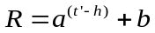. To improve numerical stability and accelerate convergence during the fitting process, the time variable was normalized in scale, expressed as 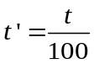, and the fitting parameters (a, b, h) were extracted based on the normalized time variable. Through fitting the testing duration of the LRS (HRS) for the SnO transistor, the fitting parameters a, b, and h are determined to be 0.76 (0.83), 1.45×10⁻⁸ (1.08×10⁻⁸), and −74.08 (−112.51), respectively. It is noted that the retention data for the RRAM device is extracted from a conventional TiN/HfO_{x}/TiN structure reported previously. The PCM data was obtained from the AIHWKit repository on GitHub (aihwkit/docs/source/pcm_inference.rst).

Supplementary Table 1. Performance evaluation for perceptual image similarity by using LPIPS metric.
Item  Kernel | horizontal | vertical | embossment | average | gaussian | sharpen
LPIPS value  (software Vs hardware) | 0.0024 | 0.0055 | 0.0030 | 0.0141 | 0.0031 | 0.0397
Result description | Almost lossless | Almost lossless | Almost lossless | Almost lossless | Almost lossless | Almost lossless

Supplementary Table 2. The structural parameters of SnO and am-Al₂O₃.
System |  | Lattice parameters |  |  |  |  |  | Number of atoms / cells | Density  (g/cm³)
 |  | a | b | c | α | β | γ | Number of atoms / cells | Density  (g/cm³)
tetra-  SnO | Unit cell | 3.80 | 3.80 | 4.97 | 90.0° | 90.0° | 90.0° | 4 | 6.23
tetra-  SnO | Supercell | 11.40 | 11.40 | 9.94 | 90.0° | 90.0° | 90.0° | 72 | 6.23
am-  Al₂O₃ | Supercell | 11.40 | 11.40 | 9.76 | 90.0° | 90.0° | 90.0° | 120 | 3.20

