Title Page
Manuscript category: ORIGINAL ARTICLE
Manuscript title: Anti-gastric cancer effect of purified Omphalia lapidescens protein via regulating the JAK/STAT3 signaling pathway
Running title: Effect of pPeOp on gastric cancer cells

Authors information:
Wenjun Xu¹⁺, Zhongxia Lu^{1,3+}, Man Hei Cheung²⁺, Yuqin Xu¹, Meiai Lin¹, Chun Liang^{2,5*}, Jianshu Lou^{4*}, Yitao Chen^{1,2*}

¹ College of Life Science, Zhejiang Chinese Medical University, Hangzhou, China;
² Division of Life Science, Center for Cancer Research and State Key Lab for Molecular Neural Science, The Hong Kong University of Science and Technology, Hong Kong, China;
³ School of Medicine and Pharmacy, Ocean University of China, QingDao, China;
⁴ Key Laboratory of Elemene Class Anti-cancer Chinese Medicine of Zhejiang Province, Holistic Integrative Pharmacy Institutes, School of medicine, Hangzhou Normal University, Hangzhou, China;
⁵ EnKang Pharmaceuticals (Guangzhou), Ltd., Guangzhou, China.
⁺Contributed equally.
*These authors are co-corresponding author.
Yitao Chen will handle the production process.

Correspondence to: Professor Yitao Chen, College of Life Science, Zhejiang Chinese Medical University, Hangzhou, China. Email address: cytworld@163.com.

Author: Wenjun Xu
Affiliations: College of Life Science, Zhejiang Chinese Medical University, Hangzhou 310053, China.
Address: No. 548 Binwen Road, Binjiang District, Zhejiang Chinese Medical University, Hangzhou 310053, China.
Tel: +86-15988828396; Fax: +86-571-86613600.
E-mail: 15988828396@163.com

Author: Zhongxia Lu
Affiliations: College of Life Science, Zhejiang Chinese Medical University, Hangzhou 310053, China.
School of Medicine and Pharmacy, Ocean University of China, QingDao 266003, China
Address: No. 548 Binwen Road, Binjiang District, Zhejiang Chinese Medical University, Hangzhou 310053, China.
Tel: +86-18158507989; Fax: +86-571-86613600.
E-mail: 18158507989@163.com

Author: Man Hei Cheung
Affiliations: Division of Life Science, Center for Cancer Research and State Key Lab for Molecular Neural Science, Hong Kong University of Science and Technology, Hong Kong, China
Address: The Hong Kong University of Science and Technology Clear Water Bay, Kowloon, Hong Kong, China
Fax: +86-571-86613600.
E-mail: mhcheungac@connect.ust.hk

Author: Yuqin Xu
Affiliations: College of Life Science, Zhejiang Chinese Medical University, Hangzhou 310053, China.
Address: No. 548 Binwen Road, Binjiang District, Zhejiang Chinese Medical University, Hangzhou 310053, China.
Tel: +86-15757303616; Fax: +86-571-86613600.
E-mail: 15757303616@163.com

Author: Meiai Lin
Affiliations: The Second Clinical Medical College, Zhejiang Chinese Medical University, Hangzhou 310053, China
Address: No. 548 Binwen Road, Binjiang District, Zhejiang Chinese Medical University, Hangzhou 310053, China.
Tel: +86-15868866086; Fax: +86-571-86613600.
E-mail: lma@zcmu.edu.cn

*Corresponding authors: Chun Liang
Affiliations: Division of Life Science, Center for Cancer Research and State Key Lab for Molecular Neural Science, Hong Kong University of Science and Technology, Hong Kong, China.
Intelgen (Hong Kong-Guangzhou-Foshan) Limited, China.
Address: The Hong Kong University of Science and Technology Clear Water Bay, Kowloon, Hong Kong, China.
E-mail addresses: bccliang@ust.hk

*Corresponding author: Jianshu Lou
Affiliations: Holistic Integrative Pharmacy Institutes, School of medicine, Hangzhou Normal University, Hangzhou 311121, China.
Key Laboratory of Elemene Class Anti-cancer Chinese Medicine of Zhejiang Province, Holistic Integrative Pharmacy Institutes, School of medicine, Hangzhou Normal University
Address: No. 2318 Yuhangtang Road, Yuhang District, Hangzhou city, Hangzhou Normal University, China.
Tel: +86-571-86633051; Fax: +86-571-86613600.
E-mail: jlouab@connect.ust.hk

*Corresponding author: Yitao Chen
Affiliations: College of Life Science, Zhejiang Chinese Medical University, Hangzhou 310053, China.
Division of Life Science, Center for Cancer Research and State Key Lab for Molecular Neural Science, Hong Kong University of Science and Technology, Hong Kong, China.
Address: No. 548 Binwen Road, Binjiang District, Zhejiang Chinese Medical University, Hangzhou 310053, China.
Tel: +86-571-86633051; Fax: +86-571-86613600.
E-mail: cytworld@163.com

⁺ These authors contributed equally to this work.
*These authors are co-corresponding author.
Yitao Chen will handle the production process.

The original figures of western blot

- Full-length blots of Figure 2a, p-STAT3 of MC-4.
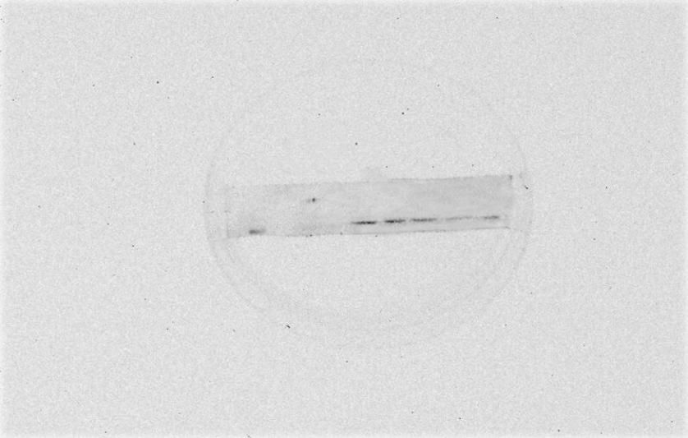
Figure 2a: p-STAT3

Figure 2a PVP (90 µg/ml) and pPeOp (30, 60, 90 µg/ml) were used to treat MC-4 gastric cancer cells for 24 h, respectively. p-STAT3 protein expression, then, was detected by western blotting.

- Full-length blots of Figure 2a, GAPDH of MC-4.
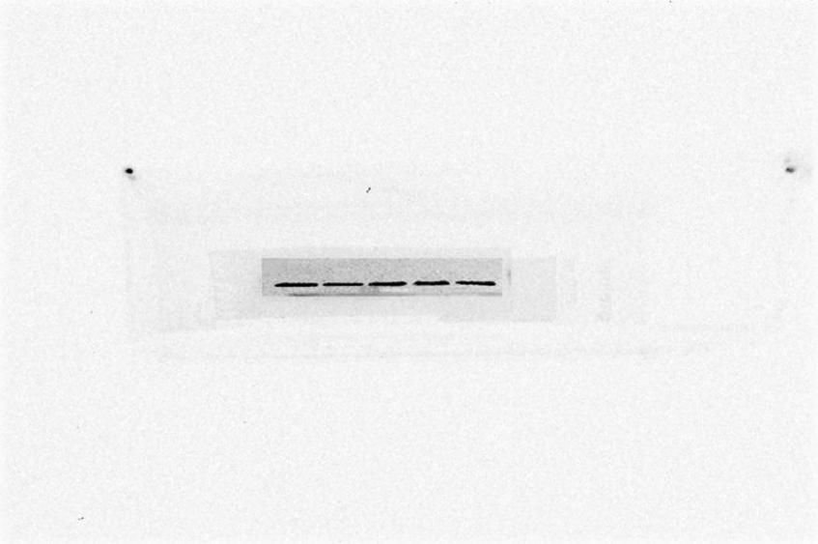
Figure 2a: GAPDH

Figure 2a PVP (90 µg/ml) and pPeOp (30, 60, 90 µg/ml) were used to treat MC-4 gastric cancer cells for 24 h, respectively. GAPDH protein expression, then, was detected by western blotting.

- Full-length blots of Figure 5a, JAK1.

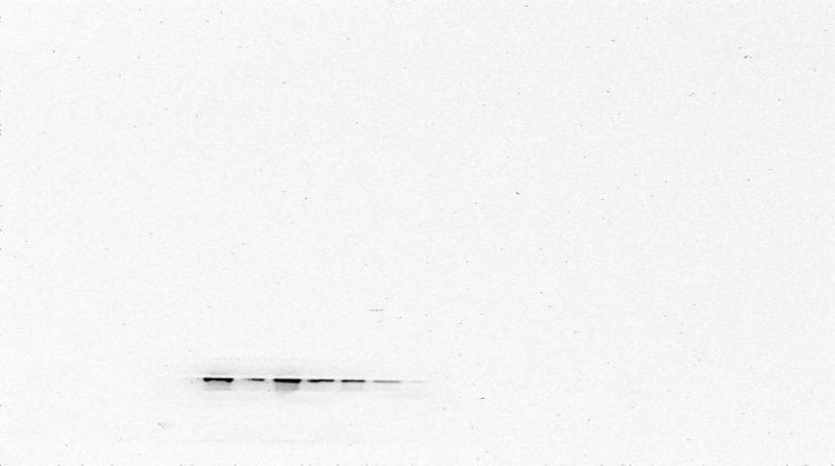
Figure 5a: JAK1
Figure 5a Effect of pPeOp on the JAK/STAT3 signaling pathway in gastric cancer cells. MC-4 gastric cancer cells were treated with pPeOp (60 µg/ml) in the absence or presence of NSC74859 (100 ng/ml) or IL-6 (100 ng/ml) for 24 h. Western blotting was used for detecting the protein expression levels of JAK1.

- Full-length blots of Figure 5a, JAK2.
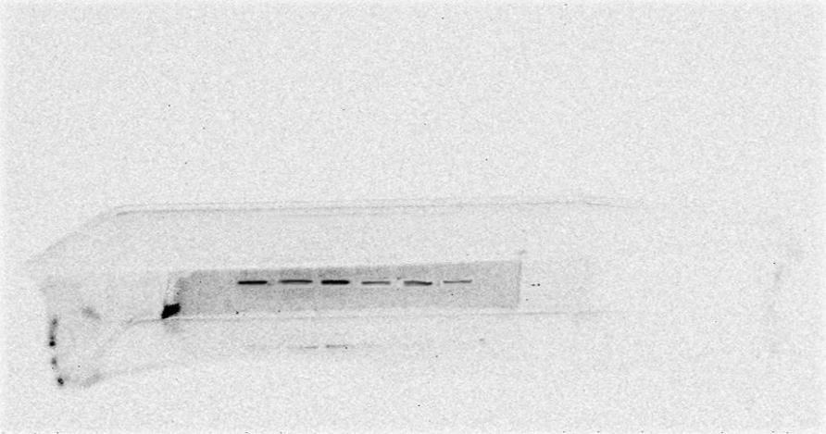
Figure 5a: JAK2
Figure 5a Effect of pPeOp on the JAK/STAT3 signaling pathway in gastric cancer cells. MC-4 gastric cancer cells were treated with pPeOp (60 µg/ml) in the absence or presence of NSC74859 (100 ng/ml) or IL-6 (100 ng/ml) for 24 h. Western blotting was used for detecting the protein expression levels of JAK2.

- Full-length blots of Figure 5a, p-STAT3.
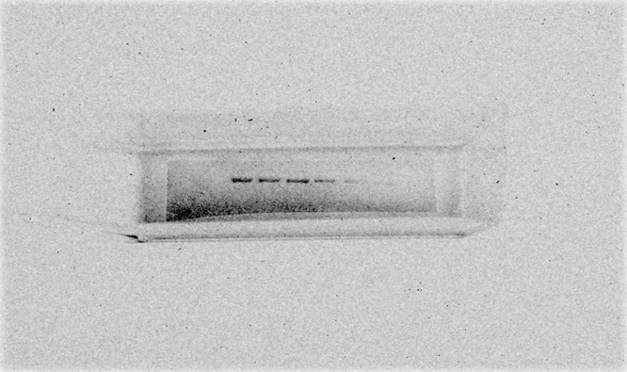
Figure 5a: p-STAT3
Figure 5a Effect of pPeOp on the JAK/STAT3 signaling pathway in gastric cancer cells. MC-4 gastric cancer cells were treated with pPeOp (60 µg/ml) in the absence or presence of NSC74859 (100 ng/ml) or IL-6 (100 ng/ml) for 24 h. Western blotting was used for detecting the protein expression levels of p-STAT3.

- Full-length blots of Figure 5a, STAT3.
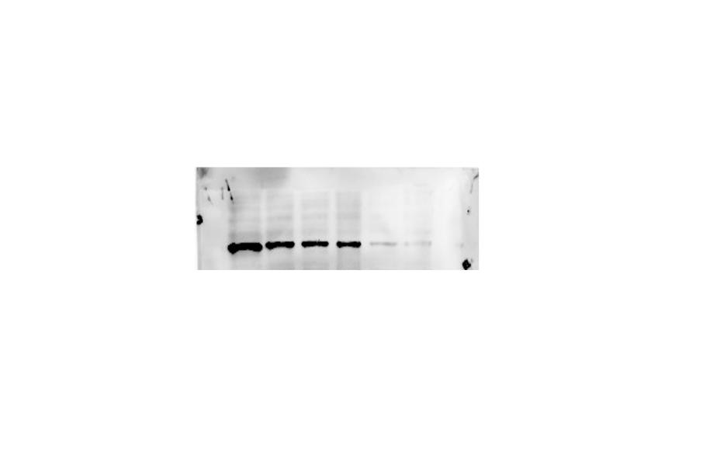
Figure 5a: STAT3
Figure 5a Effect of pPeOp on the JAK/STAT3 signaling pathway in gastric cancer cells. MC-4 gastric cancer cells were treated with pPeOp (60 µg/ml) in the absence or presence of NSC74859 (100 ng/ml) or IL-6 (100 ng/ml) for 24 h. Western blotting was used for detecting the protein expression levels of STAT3.

- Full-length blots of Figure 5a, SOCS1.
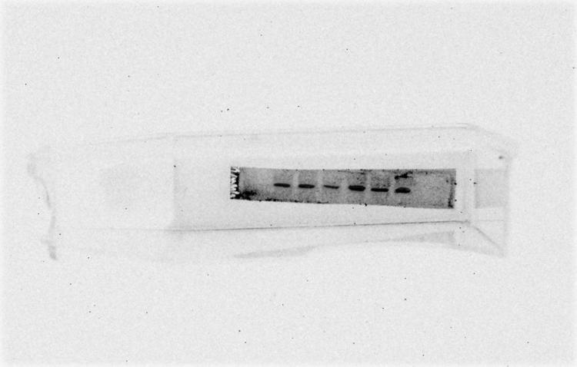
Figure 5a: SOCS1

Figure 5a Effect of pPeOp on the JAK/STAT3 signaling pathway in gastric cancer cells. MC-4 gastric cancer cells were treated with pPeOp (60 µg/ml) in the absence or presence of NSC74859 (100 ng/ml) or IL-6 (100 ng/ml) for 24 h. Western blotting was used for detecting the protein expression levels of SOCS1.

- Full-length blots of Figure 5a, SOCS3.
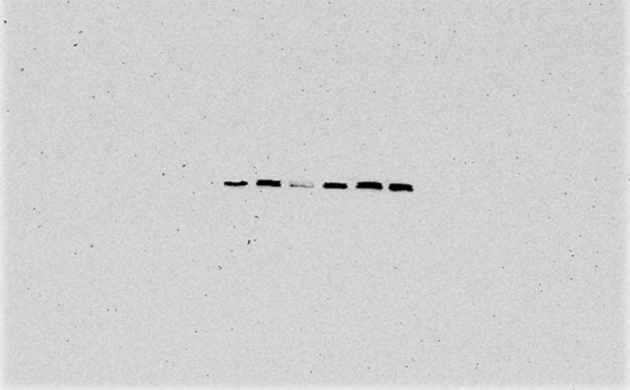
Figure 5a: SOCS3
Figure 5a Effect of pPeOp on the JAK/STAT3 signaling pathway in gastric cancer cells. MC-4 gastric cancer cells were treated with pPeOp (60 µg/ml) in the absence or presence of NSC74859 (100 ng/ml) or IL-6 (100 ng/ml) for 24 h. Western blotting was used for detecting the protein expression levels of SOCS3.

- Full-length blots of Figure 5a, GAPDH.
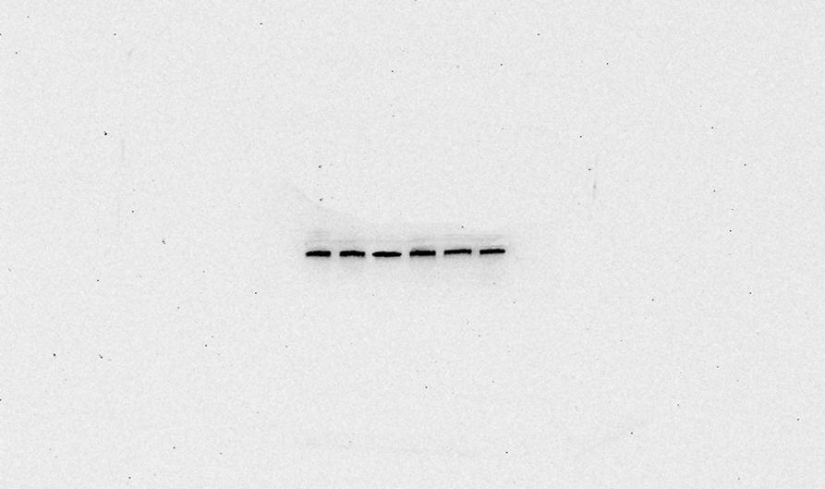
Figure 5a: GAPDH
Figure 5a Effect of pPeOp on the JAK/STAT3 signaling pathway in gastric cancer cells. MC-4 gastric cancer cells were treated with pPeOp (60 µg/ml) in the absence or presence of NSC74859 (100 ng/ml) or IL-6 (100 ng/ml) for 24 h. Western blotting was used for detecting the protein expression levels of GAPDH.

- Full-length blots of Figure 6b, STAT3.
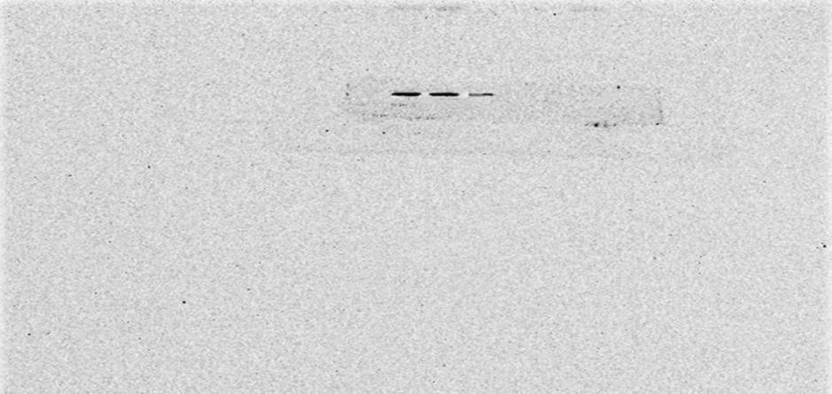
Figure 6b: STAT3
Figure 6b MC-4 gastric cancer cells were transfected by lentivirus. STAT3 protein expression was detected by western blotting.

- Full-length blots of Figure 6b, GAPDH.
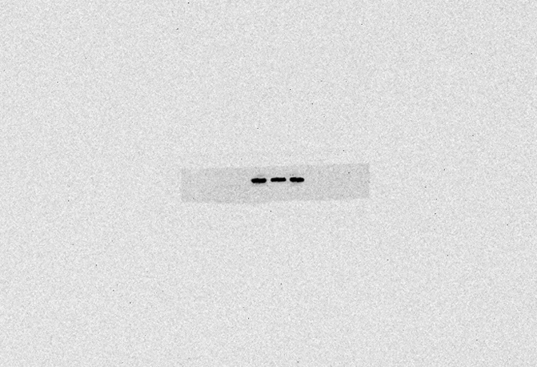
Figure 6b: GAPDH
Figure 6b MC-4 gastric cancer cells were transfected by lentivirus. GAPDH protein expression was detected by western blotting.

