Self-Supervised Representation Learning from Ventilator Waveforms: A Pilot Feasibility Study
Seibi Kobara, Md Hassanuzzaman, Vijay Krishnamoorthy, Tetsu Onuma, Mihai V. Podgoreanu, Krista L. Haines, Suresh M. Agarwal, and Rishikesan Kamaleswaran
Online Supplement

Related work

Ventilator waveform analysis and patient–ventilator interaction
Mechanical ventilation waveforms have been utilized to identify respiratory events and patient–ventilator interactions, such as patient-ventilator asynchronies (PVAs). Early studies demonstrated that the feasibility of applying deep learning to ventilator waveforms using architectures such as a two-layer long short-term memory neural network (LSTM)¹, a one-dimensional convolutional neural network (1D-CNN)², and a recurrent neural network (RNN)³. These approaches primarily focused on detecting predefined PVA events, including double trigger and ineffective inspiratory efforts. In most studies, individual respiratory cycles were first segmented from continuous waveform recordings and subsequently used as inputs for supervised model training.

Subsequent work expanded waveform-based analysis to additional respiratory monitoring tasks. Bakkes et al. developed an automated framework for detecting the starts and ends of breathing cycles, and algorithmically determined PVAs using a modified U-Net CNN⁴. PVADet introduces a deep learning framework capable of detecting PVAs across several ventilation modes, including PCV, PS, volume-control ventilation (VCV), and synchronized intermittent mandatory ventilation (SIMV)⁵.

Beyond asynchrony detection, deep learning has also been applied to identify other respiratory events. These include automated detection of air trapping from ventilator waveforms⁶ and real-time detection of respiratory circuit events such as fluid accumulation and circuit leakage using ventilator displays as an image input⁷.

Collectively, these studies demonstrate that ventilator waveforms contain rich information regarding respiratory physiology and patient-ventilator interactions. However, most existing approaches are designed for narrowly defined prediction tasks, rely on task-specific annotations, and frequently require respiratory-cycle segmentation before model development.

Ventilator mode prediction from waveform data
Mechanical ventilation waveforms reflect respiratory responses under different ventilator settings, including volume-controlled ventilation (VCV), pressure-controlled ventilation (PCV), pressure support ventilation (PS), and continuous positive airway pressure (CPAP). Ventilator settings influence airway pressure, flow, and volume waveforms through differences in target airway pressure, inspiratory flow patterns, cycling criteria, and tidal volume delivery. Consequently, waveform morphology contains information regarding ventilator mode and ventilator configuration.

Previous studies have leveraged this information to develop machine learning approaches for ventilator mode prediction⁸. In particular, engineered waveform features such as inspiratory flow slope variance, pressure variance, inspiratory time variability, and plateau pressure characteristics have been used to distinguish ventilator modes. These handcrafted features were subsequently used to train supervised machine learning models capable of accurately classifying common ventilator modes. While effective, these approaches rely heavily on expert feature engineering and are designed for a single downstream task, limiting their generalizability to broader respiratory monitoring applications.

Representation learning and foundation models for physiological signals
Recent advances in self-supervised learning have demonstrated the value of learning transferable representations directly from large-scale biomedical data, enabling robust downstream prediction without extensive manual annotation^{9,10}. Furthermore, these advances have led to the development of general-purpose time-series foundation models (TSFMs), which are pretrained on large and heterogenous collections of time-series data and adapted to diverse downstream tasks, including representation learning and forecasting^{11,12}.

Among these, MOMENT was pretrained on 13 million unique time series and 1.23 billion timestamps and demonstrated robust forecasting performances across heterogeneous domains, including weather, epidemiology, and transportation¹¹. Chronos-2 is an encoder-only transformer architecture that employs time and group attention mechanisms to perform time-series forecasting, trained on 1.1 million unique datasets¹². Chronos-2 achieved substantial improvement over existing TSFMs in the energy domain (e.g., electricity demand, price, solar power generation with weather) and retail domain waveforms (e.g., store sales).

Within mechanical ventilation, unsupervised machine learning approaches have been applied to pressure and flow waveforms to identify recurring respiratory patterns, demonstrating the feasibility of clustering from ventilator-derived signals¹³. However, despite the continuous generation of high-frequency ventilator waveform data in critical care, representation learning for mechanical ventilation remains underexplored. Furthermore, ventilator waveforms, including pressure and flow waves, reflect respiratory mechanisms, ventilator control strategies, and patient-ventilator interactions. These physiologic signals may exhibit domain-specific temporal structures that differ fundamentally from the heterogeneous time-series datasets used to develop existing TSFMs. This motivates the development of a respiratory foundation model capable of capturing latent respiratory state while supporting multiple downstream tasks.

Supplementary methods

Data preprocessing
Patients were randomly assigned to training (n = 100), validation (n = 15), and test (n = 30) cohorts at the patient level to ensure that waveform segments from the same patient did not appear in multiple datasets. Airway pressure and flow waveforms were standardized using the mean and standard deviation estimated from the training cohort. The same normalization parameters were subsequently applied to the validation and test cohorts to prevent information leakage.

Encoder architecture
VentWaveT was implemented as a masked waveform reconstruction model consisting of a one-dimensional convolutional patch embedding layer, convolutional positional encoding, Transformer encoder blocks, and a linear reconstruction decoder. Each input waveform segment consisted of two channels corresponding to airway pressure and flow.

For a waveform segment of length (T), the input tensor had dimensions (B $×$ T $×$ 2), where (B) denotes batch size. Each segment was divided into non-overlapping temporal patches using a one-dimensional convolutional layer with kernel size 25 and stride 25. This patch embedding layer mapped each pressure–flow patch of 25 time points into a 128-dimensional latent token. Thus, for an input segment of 750 time points, the patch embedding produced 30 tokens, each with 128 features.

To incorporate local positional information, we applied convolutional positional encoding to the token sequence using a one-dimensional convolution (kernel size = 3) with a residual connection. This enabled the model to capture local temporal relationships between neighboring waveform patches while preserving the 128-dimensional token representation.

The contextual encoder consisted of four Transformer encoder layers with embedding dimension 128, four attention heads, Gaussian Error Linear Unit (GELU) activation, and dropout of 0.1. The Transformer encoder preserved the token dimensionality while allowing each waveform token to incorporate information from other patches within the segment through self-attention.

Masked waveform reconstruction
VentWaveT was pretrained using a self-supervised masked reconstruction objective. During each training iteration, 30% of waveform tokens were randomly selected and replaced with a learnable mask token. The masked token sequence was then passed through convolutional positional encoding and the Transformer encoder. A linear decoder mapped each contextualized 128-dimensional token back to the original waveform patch dimension of 50 values, corresponding to 25 time points across two channels. Reconstructed patches were reshaped to recover the full pressure–flow waveform segment.

The reconstruction loss was computed only over masked regions. Specifically, the token-level mask was expanded to the original time dimension, and mean squared error was calculated between the reconstructed and original pressure–flow values at masked time points. If no tokens were masked in a batch, the loss was computed over the full waveform segment.

Embedding extraction
After pretraining, the encoder was frozen and used to generate waveform embeddings for downstream analyses. For each input waveform segment or breath, pressure and flow signals were passed through the convolutional patch embedding layer, convolutional positional encoding, and Transformer encoder without masking. The resulting contextualized token representations were averaged across the token dimension to obtain a single 128-dimensional embedding for each waveform segment. These frozen embeddings were subsequently used for downstream ventilator mode classification and respiratory physiology prediction.

Training procedure
The model was trained using the AdamW optimizer with a learning rate of 0.001 and weight decay of 0.001. Training was performed with mini-batches of 64 waveform segments. Gradient norms were clipped at 1.0 to improve training stability. During model development, the training and validation cohorts were used to monitor the masked reconstruction loss (mean squared error) and determine the optimal number of training epochs. After selecting the final training configuration, the model was pretrained using the combined training and validation cohorts. The independent test cohort was reserved exclusively for downstream evaluation. All models were implemented in PyTorch¹⁴ and trained on CUDA-enabled NVIDIA graphics processing units.

Visual inspection of pretrained embeddings
To qualitatively assess the organization of the learned respiratory representations, pretrained embeddings were projected into two dimensions using Uniform Manifold Approximation and Projection (UMAP). Prior to UMAP, principal component analysis (PCA) was performed, and the first 30 principal components were retained to reduce dimensionality while preserving the local neighborhood structure of the latent space. Breaths were colored according to ventilator mode to visualize local neighborhood structure and representative waveform morphology. To characterize the waveform features contributing to the learned latent representation, we computed input gradients of the embedding dimensions with respect to the pressure and flow waveforms. For ventilator mode classification, embeddings were standardized using the training-set mean and standard deviation before fitting the L2-regularized multinomial logistic regression model. For each ventilator mode, the embedding dimensions with the largest ten positive coefficients from the multinomial logistic regression model were selected, and their gradients were averaged to generate embedding-feature attribution maps. These maps were aimed to identify waveform regions contributing to the construction of the latent features most informative for ventilator mode classification.

Models in ablation experiments
To assess whether nonlinear readout was necessary to extract information from the pretrained embeddings, classification performance using multinomial logistic regression was compared with that of a shallow multilayer perceptron (MLP) and an extreme gradient boosting (XGBoost) model. The MLP consisted of an input layer, a single hidden layer with 64 neurons, ReLU activation, and a dropout rate of 0.2, followed by an output layer. The XGBoost classifier was constructed using 200 decision trees with a maximum tree depth of three. All models were trained and evaluated using the same pretrained embeddings.

Benchmarking against general-purpose time-series foundation models
To evaluate the quality of the VentWaveT-derived embeddings, breath-level ventilation mode classification performance was compared with two state-of-the-art general-purpose time-series foundation models (TSFMs), MOMENT¹¹ and Chronos-2¹².
MOMENT was installed using the official Python package (pip). The pretrained embedding model, specifying "embedding", was used to extract representations from pressure and flow waveforms of 750 time points for both training and test datasets. The resulting embeddings were averaged across channels and tokens to obtain a single feature vector for each breath.

Chronos-2 was installed from the official Python package. Embeddings were extracted using the "embed" attribute. Similar to MOMENT, the encoder output embeddings were averaged across channels and tokens.
Because the dimensionality of the extracted embeddings differed from that of VentWaveT, principal component analysis (PCA) was applied using only the training dataset to reduce the feature dimensionality to match the VentWaveT latent representation. The fitted PCA transformation was applied to the independent test dataset.

The resulting feature vectors were used to train a multinomial logistic regression model on the training dataset. Classification performance was evaluated on the independent test dataset using accuracy, F1 score, recall, precision, and specificity. Performance metrics and paired differences between VentWaveT and each TSFM were estimated using 1,000 patient-level bootstrap resampling.

Sample size experiments
As part of this pilot feasibility study, we investigated the minimum sample size required to support effective representation learning from ventilator waveform data. Test sets were held constant while the number of patients available for pretraining was varied. Models were pretrained using 20, 40, 60, 80, and 100 patients and subsequently evaluated using the reconstruction loss based on the true pressure and flow waveform values and reconstructed values. To quantify variability arising from patient selection, each sample-size condition was repeated across 50 random seeds, and performance distributions were summarized using bootstrap confidence intervals. We additionally evaluated the full sample of 115 patients across 50 random seeds to quantify variability due to model initialization.

Decoder architecture
The VentWaveT decoder was designed to reconstruct paired pressure and flow waveforms from a single global respiratory embedding. For each breath, the decoder received a 128-dimensional latent representation and generated a two-channel waveform containing 750 time points per channel.

The global embedding was first expanded into a sequence of temporal tokens using a two-layer multilayer perceptron. Specifically, the 128-dimensional embedding was projected to 256 dimensions, followed by a Gaussian error linear unit activation and layer normalization, and subsequently projected to $30×128$ dimensions. The expanded representation was reshaped into 30 temporal tokens, each with an embedding dimension of 128. The number of tokens corresponded to dividing the 750-point waveform into non-overlapping patches of 25 time points. Token-wise layer normalization was applied after reshaping.

A learnable absolute positional embedding with dimensions $30×128$ was added to the token sequence to encode patch order. The position-aware tokens were then processed by four stacked transformer encoder layers. Each layer used four attention heads, a feed-forward dimension of 512, Gaussian error linear unit activation, and dropout of 0.1. Although implemented using transformer encoder layers, this module functioned as the temporal reconstruction component of the decoder by modeling dependencies among the generated waveform patches. A final layer-normalization operation was applied to the transformer outputs.

Each reconstructed token was mapped through a linear projection from 128 dimensions to 50 values, corresponding to 25 time points for each of the two waveform channels. The projected outputs were reshaped and concatenated across the 30 patches to produce pressure and flow sequences of length 750. Finally, a channel-wise one-dimensional convolution with kernel size 5 and padding of 2 was applied independently to pressure and flow as a boundary-smoothing operation. The decoder output therefore had dimensions $750×2$ for each breath.

Decoder performance evaluation
To evaluate reconstruction performance, we first generated 100 randomly shifted waveform segments for each breath from unseen test patients and extracted respiratory embeddings using the pretrained encoder. The embeddings were subsequently decoded into ventilator waveforms using the trained decoder. The reconstructed waveforms were compared with their corresponding original, non-shifted waveforms. Reconstruction performance was evaluated using the Pearson correlation coefficient and root mean squared error (RMSE), with uncertainty estimated by patient-level block bootstrap resampling. Because the distributions of the Pearson correlation coefficient and RMSE were non-normal (Supplementary Figure E6), reconstruction performance is reported as the median with corresponding 95% confidence intervals.

Supplementary results

Model learning curve
We first used the training and validation cohorts to determine the optimal number of pretraining epochs. VentWaveT was pretrained using a self-supervised masked reconstruction objective with a masking ratio of 30%. The reconstruction loss was quantified using mean squared error (MSE). Training and validation MSE decreased steadily throughout training, and the validation loss reached a plateau at approximately 30 epochs (Supplementary Figure E7-A). Based on this observation, the final encoder was pretrained for 30 epochs using the combined training and validation cohorts. During this final training stage, the reconstruction loss decreased smoothly and converged to a stable plateau (Supplementary Figure E7-B).

To reconstruct ventilator waveforms from respiratory embeddings, we subsequently trained the transformer-based decoder using the frozen pretrained encoder. As with encoder pretraining, the training and validation cohorts were initially used to determine the optimal number of training epochs based on the reconstruction MSE. Both training and validation losses decreased steadily and converged after approximately 30 epochs (Supplementary Figure E7-C). The final decoder was then trained using the combined training and validation cohorts, during which the reconstruction loss again decreased smoothly and reached a stable plateau (Supplementary Figure E7-D).

Sample size experiments
We further evaluated the sample size required to train a latent representation model for ventilator waveform data by varying the number of patients used during pretraining from 20 to 115 (Supplementary Figure E8). Increasing sample size was associated with progressive reductions in reconstruction loss, particularly between 20 and 80 patients. The reconstruction loss plateaued beyond approximately 80 patients.

References
- Zhang Lingwei, Mao Kedong, Duan Kailiang, et al. Detection of Patient-Ventilator Asynchrony from Mechanical Ventilation Waveforms Using a Two-Layer Long Short-Term Memory Neural Network Computers in Biology and Medicine.2020;120:103721.
- Pan Qing, Zhang Lingwei, Jia Mengzhe, et al. An Interpretable 1D Convolutional Neural Network for Detecting Patient-Ventilator Asynchrony in Mechanical Ventilation Computer Methods and Programs in Biomedicine. 2021;204:106057.
- Van De Kamp Lars, Reinders Joey, Hunnekens Bram, Oomen Tom, Van De Wouw Nathan. Automatic Patient-Ventilator Asynchrony Detection Framework Using Objective Asynchrony Definitions IFAC Journal of Systems and Control. 2024;27:100236.
- Bakkes Tom, Van Diepen Anouk, De Bie Ashley, et al. Automated Detection and Classification of Patient–Ventilator Asynchrony by Means of Machine Learning and Simulated Data Computer Methods and Programs in Biomedicine. 2023;230:107333.
- Su Longxiang, Li Yan, Lan Yunping, et al. PVADet: Fast Patient-Ventilator Asynchrony Detection on Waveforms Journal of Clinical Monitoring and Computing. 2026;40:113–127.
- Zhang Chengxuan, Gu Lifeng, Shen Weimin, et al. Automated Detection of Air Trapping from Mechanical Ventilation Waveform through Interpretable Dual-Channel 1D Convolutional Neural Network Physiological Measurement. 2025;46:075001.
- He Qian, Pan Tingting, Hou Haiyang, et al. Real-Time Detection of Respiratory Circuit Events in Mechanical Ventilation Using Deep Learning npj Digital Medicine. 2025;8:626.
- Rehm Gregory B. , Kuhn Brooks T. , Nguyen Jimmy , Anderson Nicholas R. , Chuah Chen-Nee , Adams Jason Y. . Improving Mechanical Ventilator Clinical Decision Support Systems with a Machine Learning Classifier for Determining Ventilator Mode in Studies in Health Technology and InformaticsIOS Press 2019.
- Zhu Xiangqian, Shi Mengnan, Yu Xuexin, et al. Self-Supervised Inter–Intra Period- Aware ECG Representation Learning for Detecting Atrial Fibrillation Biomedical Signal Processing and Control. 2025;100:106939.
- Dalla-Torre Hugo, Gonzalez Liam, Mendoza-Revilla Javier, et al. Nucleotide Transformer: Building and Evaluating Robust Foundation Models for Human Genomics. Nature Methods. 2025;22:287–297.
- Goswami Mononito, Szafer Konrad, Choudhry Arjun, Cai Yifu, Li Shuo, Dubrawski Artur. MOMENT: A Family of Open Time-series Foundation Models 2024.
- Ansari Abdul Fatir, Shchur Oleksandr, K ¨ uken Jaris, et al. Chronos-2: From Univariate to Universal Forecasting 2025.
- De Almeida Ricardo Gaudio, Motta-Ribeiro G., Giannella-Neto A., Carvalho A. R. S., Camilo L. M., Nadal J.. Extraction of Patterns of Mechanical Ventilation Waveforms Using Unsupervised Neural Network: A Preliminary Study in XXIX Brazilian Congress on Biomedical Engineering - Volume 3: Biomedical Informatics, and Biomedical Signal and Image Processing (Soares Alcimar Barbosa, Leoni Renata Ferranti, Cardoso George Cunha. , eds.);127:897–904Cham: Springer Nature Switzerland 2025.
- Paszke Adam, Gross Sam, Massa Francisco, et al. PyTorch: An Imperative Style, High-Performance Deep Learning Library. in NeurIPS (Wallach Hanna M., Larochelle Hugo, Beygelzimer Alina, Buc Florence, Fox Emily B., Garnett Roman. , eds.):8024-8035 2019.

Table E1. Number of breaths and total ventilation hours across available ventilation modes in the dataset. Ventilation mode information was available for 133 of the 145 patients in the dataset.
 | Ventilation mode
 | CPAP | PS | PCV | PAV | VCV
Patient, n | 32 | 65 | 41 | 26 | 32
Waveform, n | 18,661 | 98,323 | 79,045 | 40,999 | 49,780
Total length, hours | 13.68 | 78.36 | 64.31 | 30.29 | 34.52
Abbreviations: CPAP, Continuous positive airway pressure; PS, pressure support ventilation; PCV, pressure-controlled ventilation; PAV, proportional-assist ventilation; VCV, volume-controlled ventilation.

Table E2: Paired differences in mode classification performance metrics based on patient-level bootstrap resampling between VentWaveT and general-purpose time-series foundation models
Paired differences | VentWaveT - MOMENT | VentWaveT - Chronos-2
Accuracy, mean [95%CI] | -0.020 [-0.056, 0.013] | 0.001 [-0.041, 0.064]
F1, mean [95%CI] | -0.067 [-0.243, 0.043] | -0.001 [-0.206, 0.221]
Recall, mean [95%CI] | -0.048 [-0.264, 0.182] | 0.012 [-0.247, 0.407]
Precision, mean [95%CI] | -0.063 [-0.248, 0.055] | -0.013 [-0.204, 0.124]
Specificity, mean [95%CI] | -0.011 [-0.056, 0.040] | 0.006 [-0.049, 0.102]
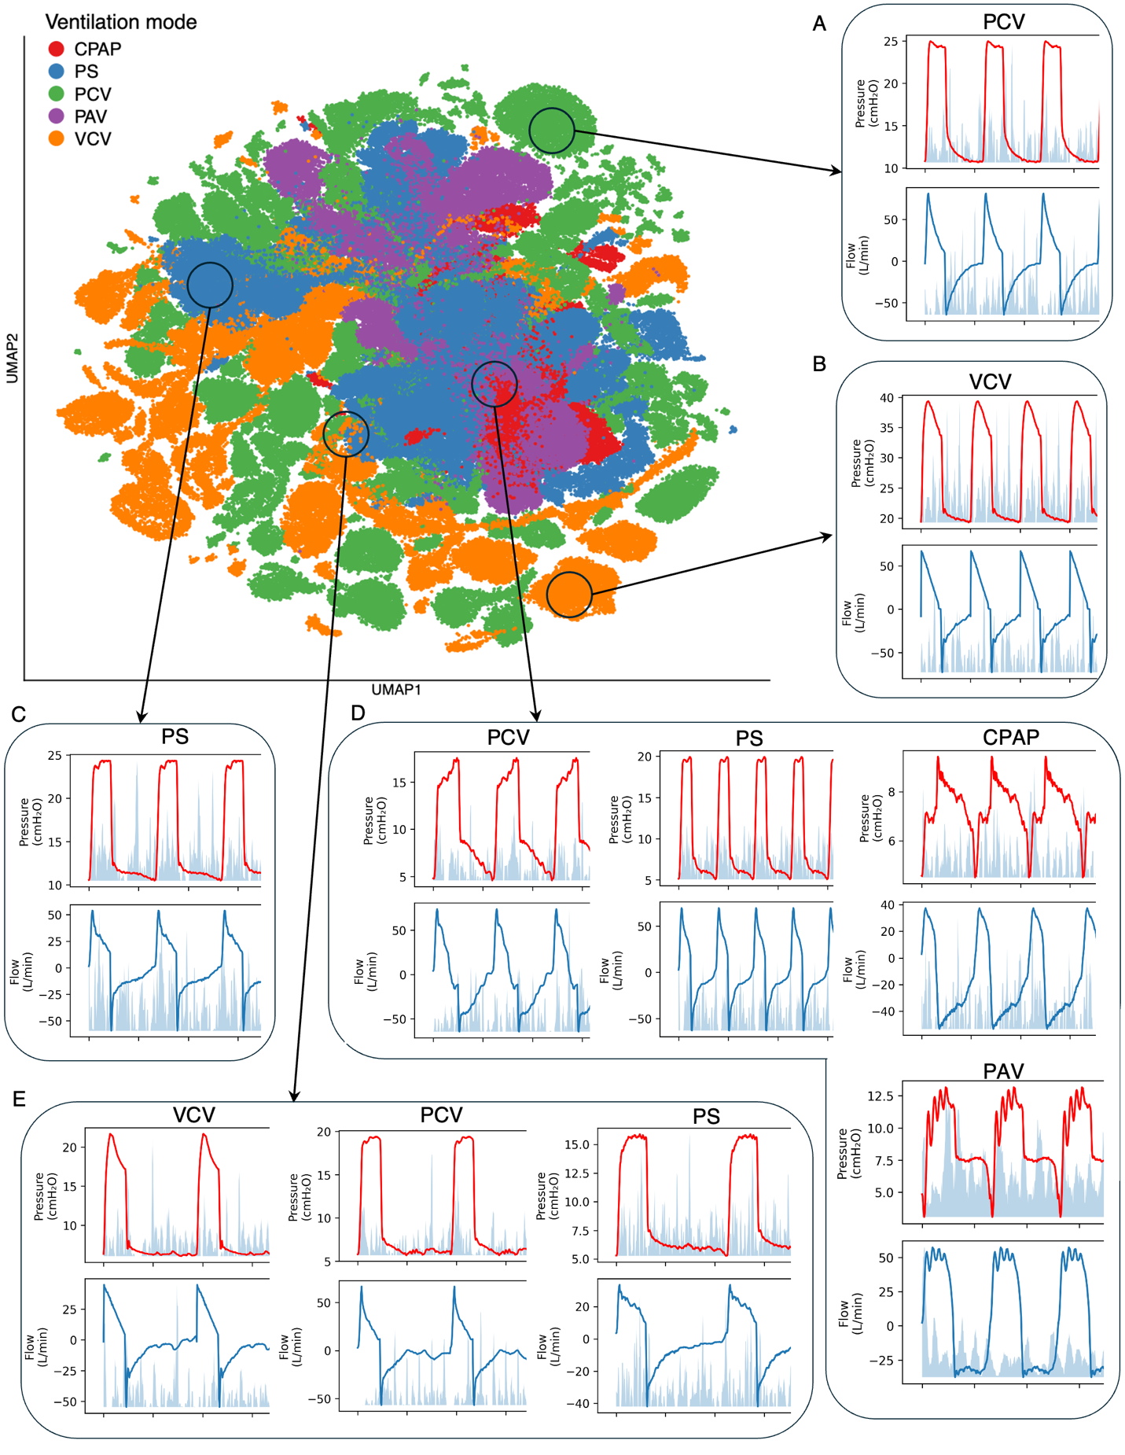

Figure E1. UMAP projection of VentWaveT embeddings and embedding-feature attribution maps. Pretrained VentWaveT embeddings were projected into UMAP space and colored by ventilator mode. Illustrative breaths from distinct mode-enriched regions were visualized for pressure-controlled ventilation (A), volume-controlled ventilation (B), and pressure-support ventilation (C). Illustrative breaths from regions exhibiting partial overlap among ventilation modes were visualized (D and E). The ten embedding dimensions with the largest positive coefficients in the multinomial logistic regression model were identified. Gradients of these embedding dimensions for each input breath-level pressure and flow waveform were averaged and overlaid onto the corresponding representative breath waveforms. Peaks in the attribution maps indicate waveform segments that contributed most strongly to the construction of embedding dimensions that were most informative for ventilator mode classification.

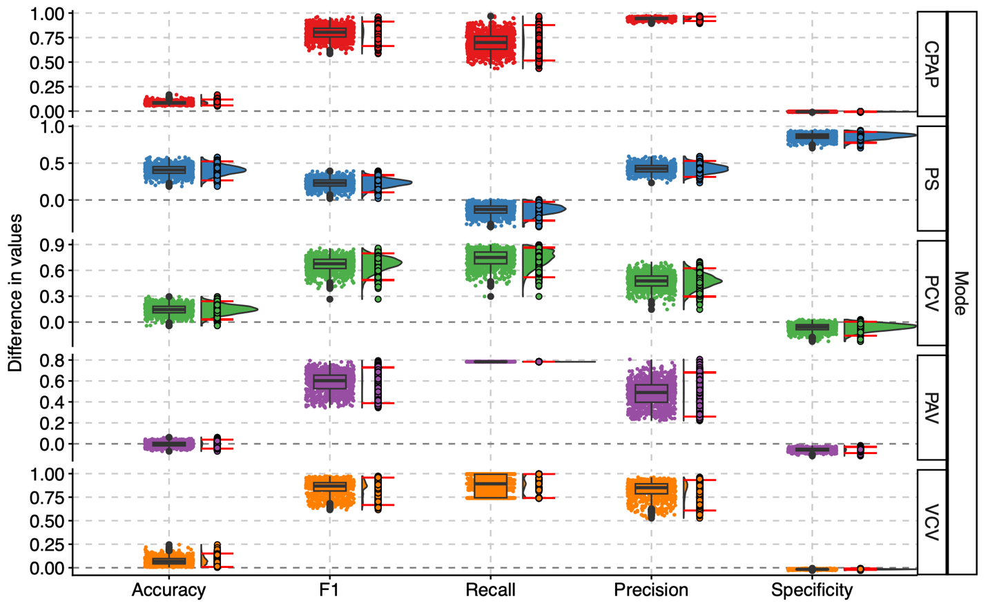

Figure E2. Ablation analysis of ventilator mode classification. Classification performance of pretrained VentWaveT embeddings compared with random embeddings generated from feature-wise Gaussian distributions parameterized by the means and standard deviations of the pretrained latent representations. For each bootstrap resample, performance metrics were calculated for both pretrained and random embeddings, and paired differences were computed within the same resample. Distributions of paired performance differences are shown across 1,000 patient-level bootstrap resamples and are summarized by means with 95% confidence intervals, medians, and interquartile ranges.
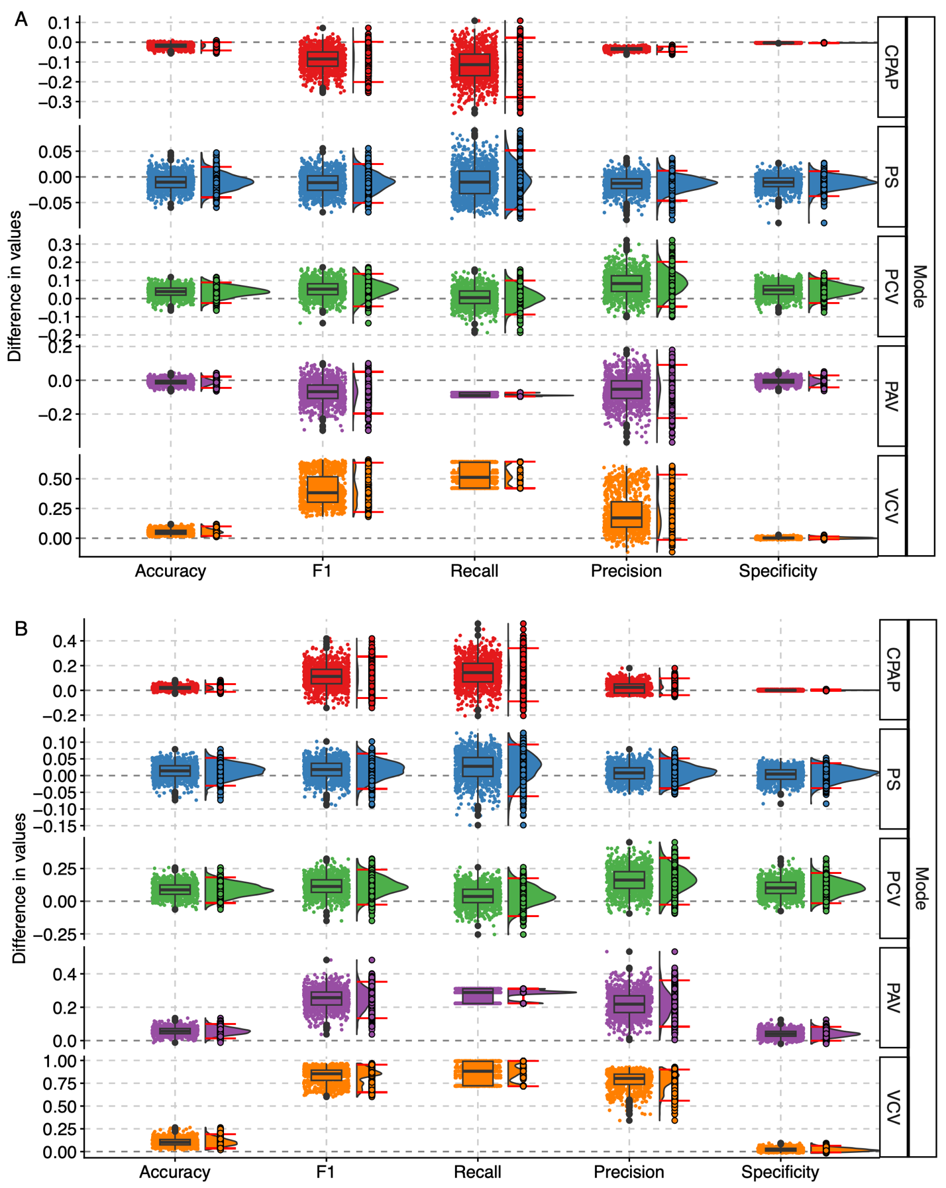

Figure E3. Ablation analysis of ventilator mode classification using linear and nonlinear readout models. Classification performance of pretrained VentWaveT embeddings using multinomial logistic regression was compared with a shallow multilayer perceptron (MLP; A) and extreme gradient boosting (XGBoost; B). Performance differences were estimated using 1,000 patient-level bootstrap resamples. Within each bootstrap resample, paired differences in performance metrics between multinomial logistic regression and the comparison model were computed. Distributions of paired performance differences are summarized by the mean with 95% confidence intervals, together with the median and interquartile range.

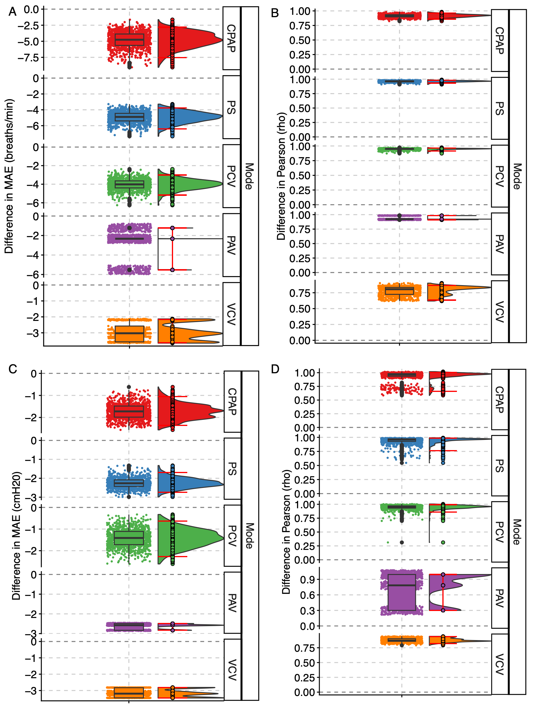
Figure E4. Ablation analysis of ventilator and respiratory characteristic prediction. Comparison of pretrained VentWaveT embeddings and random embeddings for prediction of respiratory rate (RR) and positive end-expiratory pressure (PEEP). For each bootstrap resample, performance metrics were calculated for both pretrained and random embeddings, and paired differences were computed within the same resample. Distributions of paired performance differences are shown across 1,000 patient-level bootstrap resamples and are summarized by means with 95% confidence intervals, medians, and interquartile ranges. (A) Difference in MAE for RR prediction. (B) Difference in Pearson correlation coefficient ($ρ$) for RR prediction. (C) Difference in MAE for PEEP prediction. (D) Difference in Pearson correlation coefficient ($ρ$) for PEEP prediction.

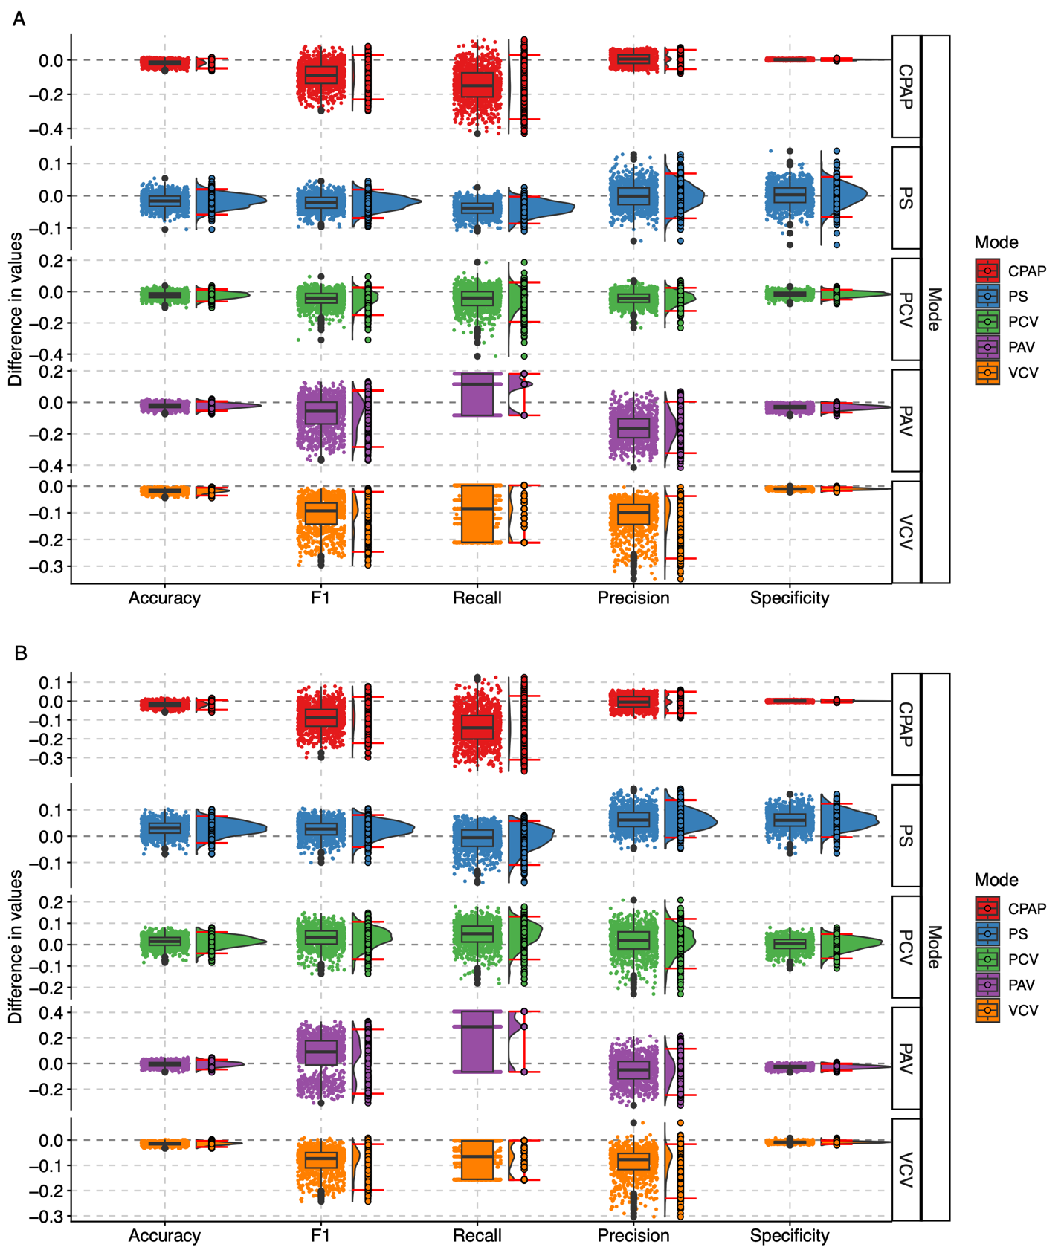

Figure E5. Benchmarking ventilator mode classification against general-purpose time-series foundation models. Classification performance of VentWaveT was compared with two state-of-the-art general-purpose time-series foundation models using multinomial logistic regression. Performance differences were estimated using 1,000 patient-level bootstrap resamples. Within each bootstrap resample, paired differences in performance metrics between VentWaveT and counterparts were computed. Distributions of paired performance differences are summarized by the mean with 95% confidence intervals, together with the median and interquartile range. (A) Performance differences between VentWaveT and MOMENT. (B) Performance differences between VentWaveT and Chronos-2.

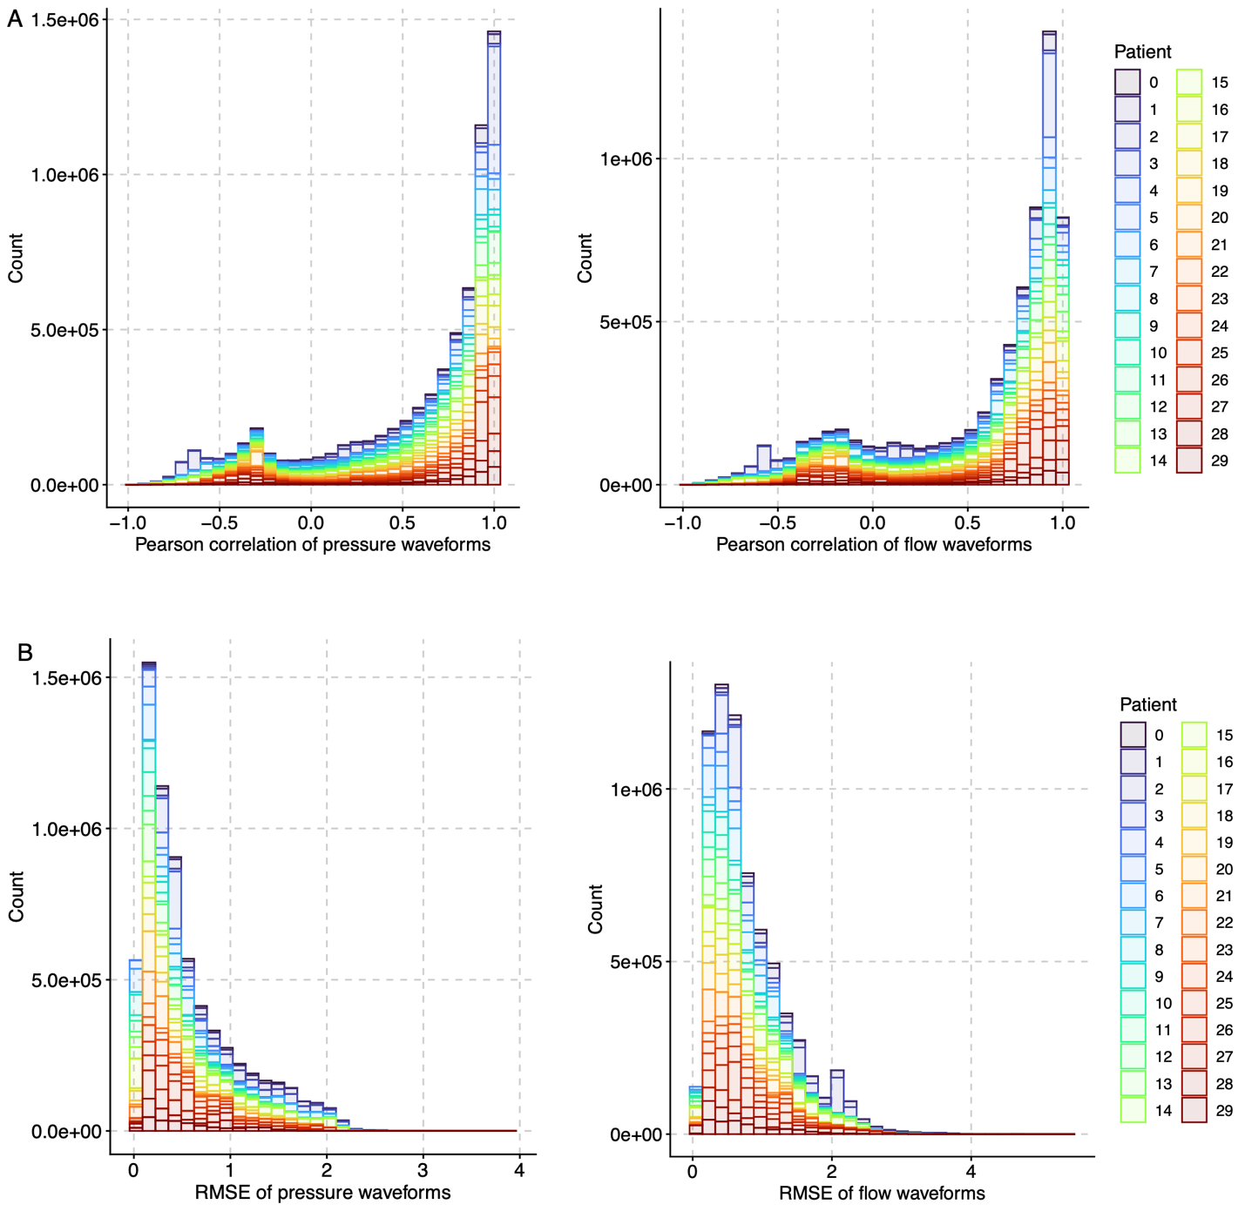

Figure E6. Histogram of decoder reconstruction performance metrics. Decoder reconstruction performance was evaluated using the Pearson correlation coefficient and root mean squared error (RMSE) between 100 randomly shifted reconstructed waveform segments from unseen held-out patients and their corresponding original waveforms. (A) Pearson correlation coefficient for pressure waveforms. (B) Pearson correlation coefficient for flow waveforms. (C) RMSE for pressure waveforms. (D) RMSE for flow waveforms.

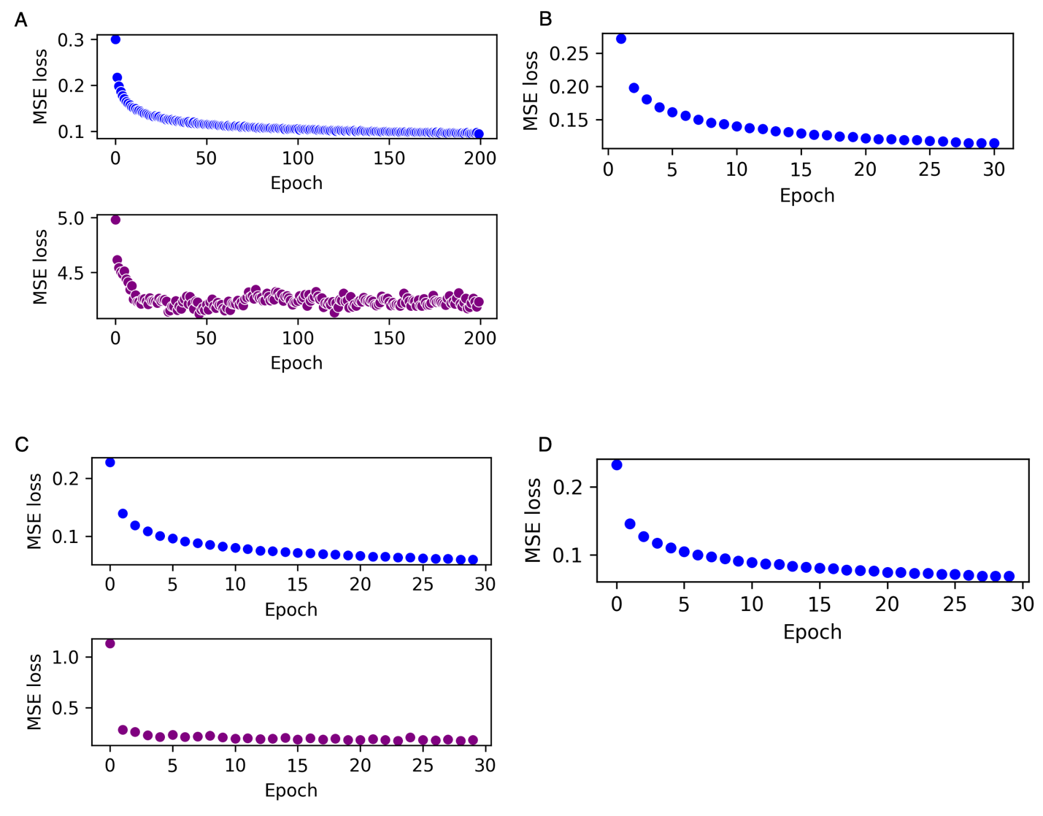
Figure E7. Mean squared error reconstruction loss during VentWaveT training (A) Training (top) and validation (bottom) MSE reconstruction loss during encoder training. The reconstruction loss was averaged across each training epoch. (B) After epoch selection, the training and validation sets were combined to train the final VentWaveT encoder. The panel shows the MSE reconstruction loss during this final training stage. (C) Training (top) and validation (bottom) MSE reconstruction loss during decoder training. (D) The panel shows the MSE reconstruction loss during the decoder training stage using the combined training and validation sets.

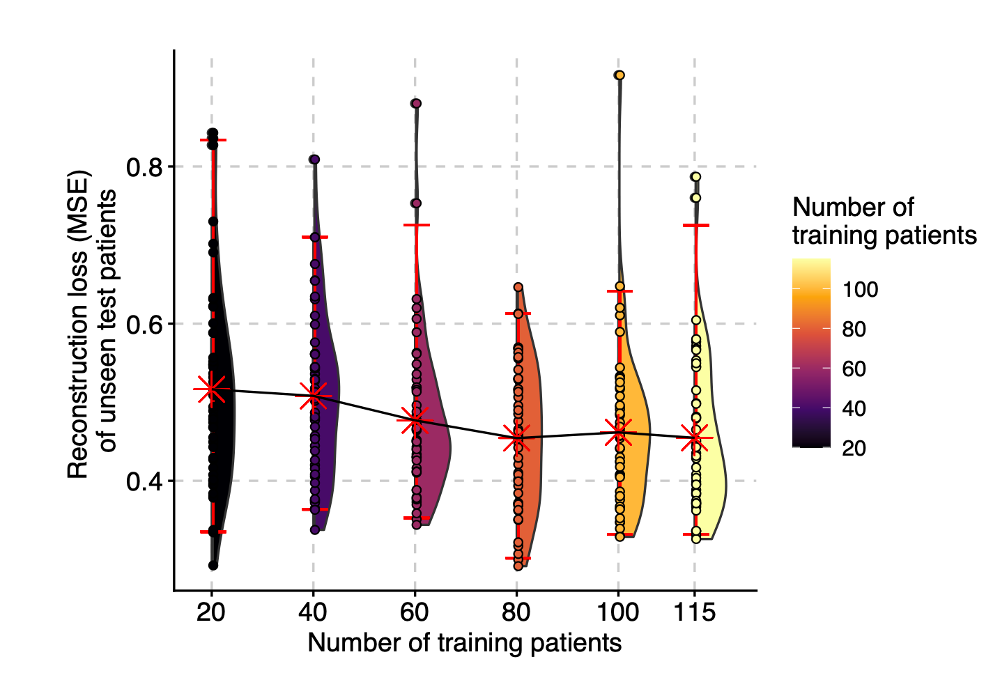

Figure E8. Sample-size analysis for self-supervised pretraining. Reconstruction loss on previously unseen patients while varying the number of patients included during pretraining. Models were pretrained using 20, 40, 60, 80, 100, and 115 patients. Each sample-size condition was repeated across 50 random patient selections and model initializations to assess variability in reconstruction performance.

