Habitat Radiomics-Based Stacking Ensemble Model for Predicting Disease-Free Survival in Early-Stage Cervical Cancer

ELECTRONIC SUPPLEMENTARY MATERIAL

Supplementary Figures：

Figure S1. Heatmap of selected predictive features associated with Recurrence/Metastasis in Cervical Cancer.
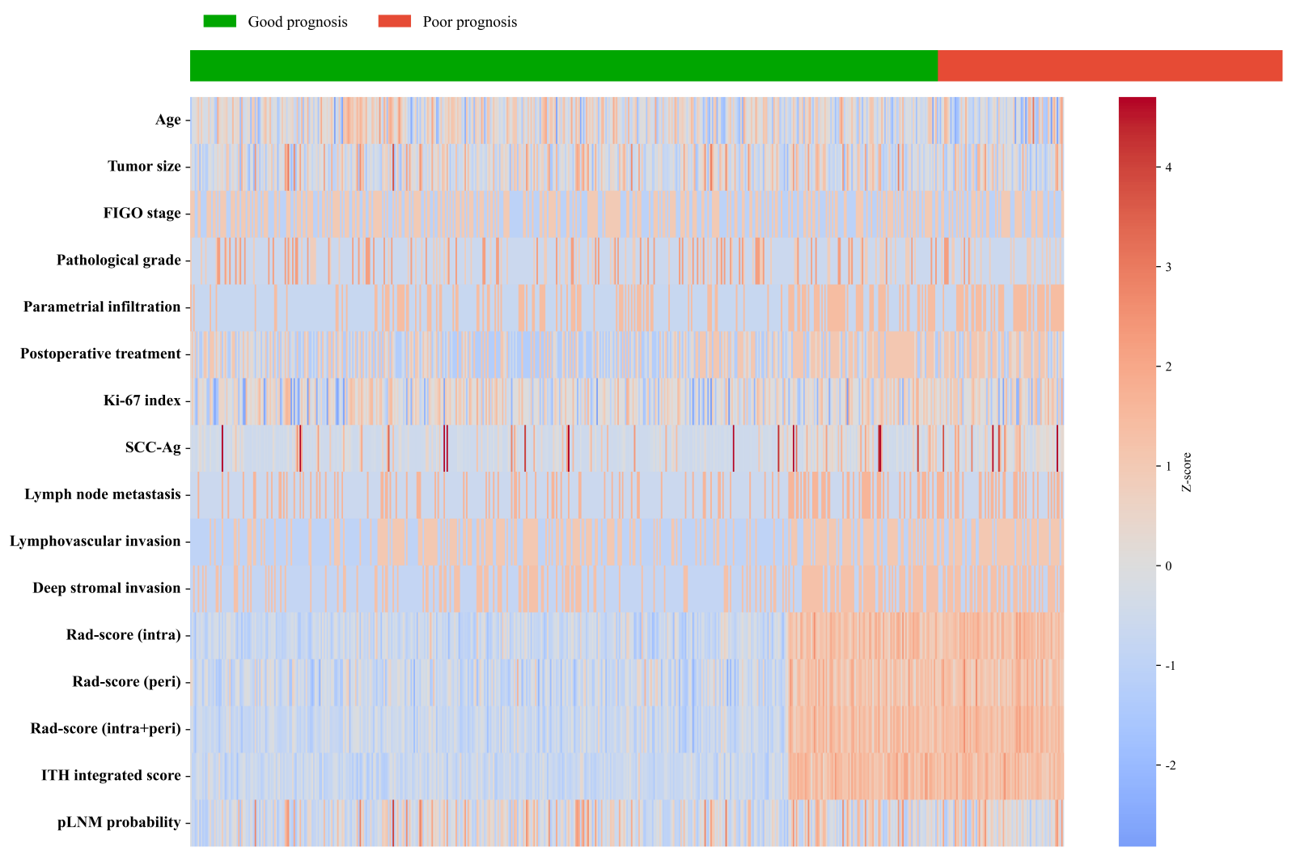

Figure S2. Pearson correlation heatmap between clinicopathological features and radiomics scores.

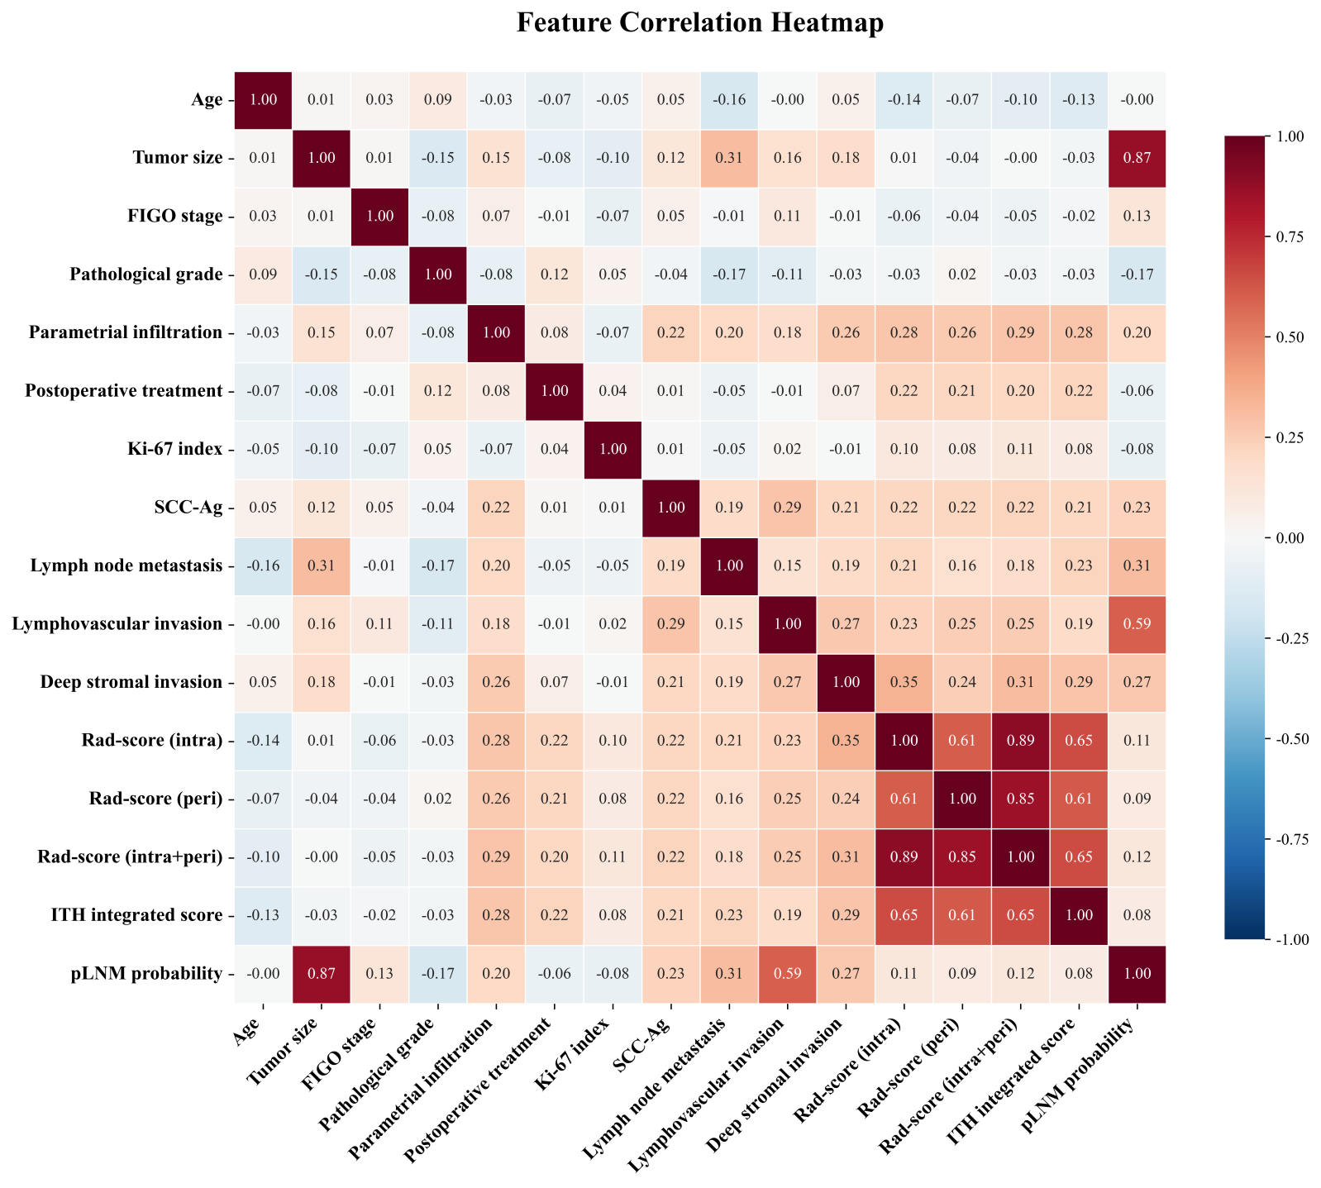

Figure S3. Forest plot of clinicopathological features and habitat radiomics scores associated with disease-free survival.
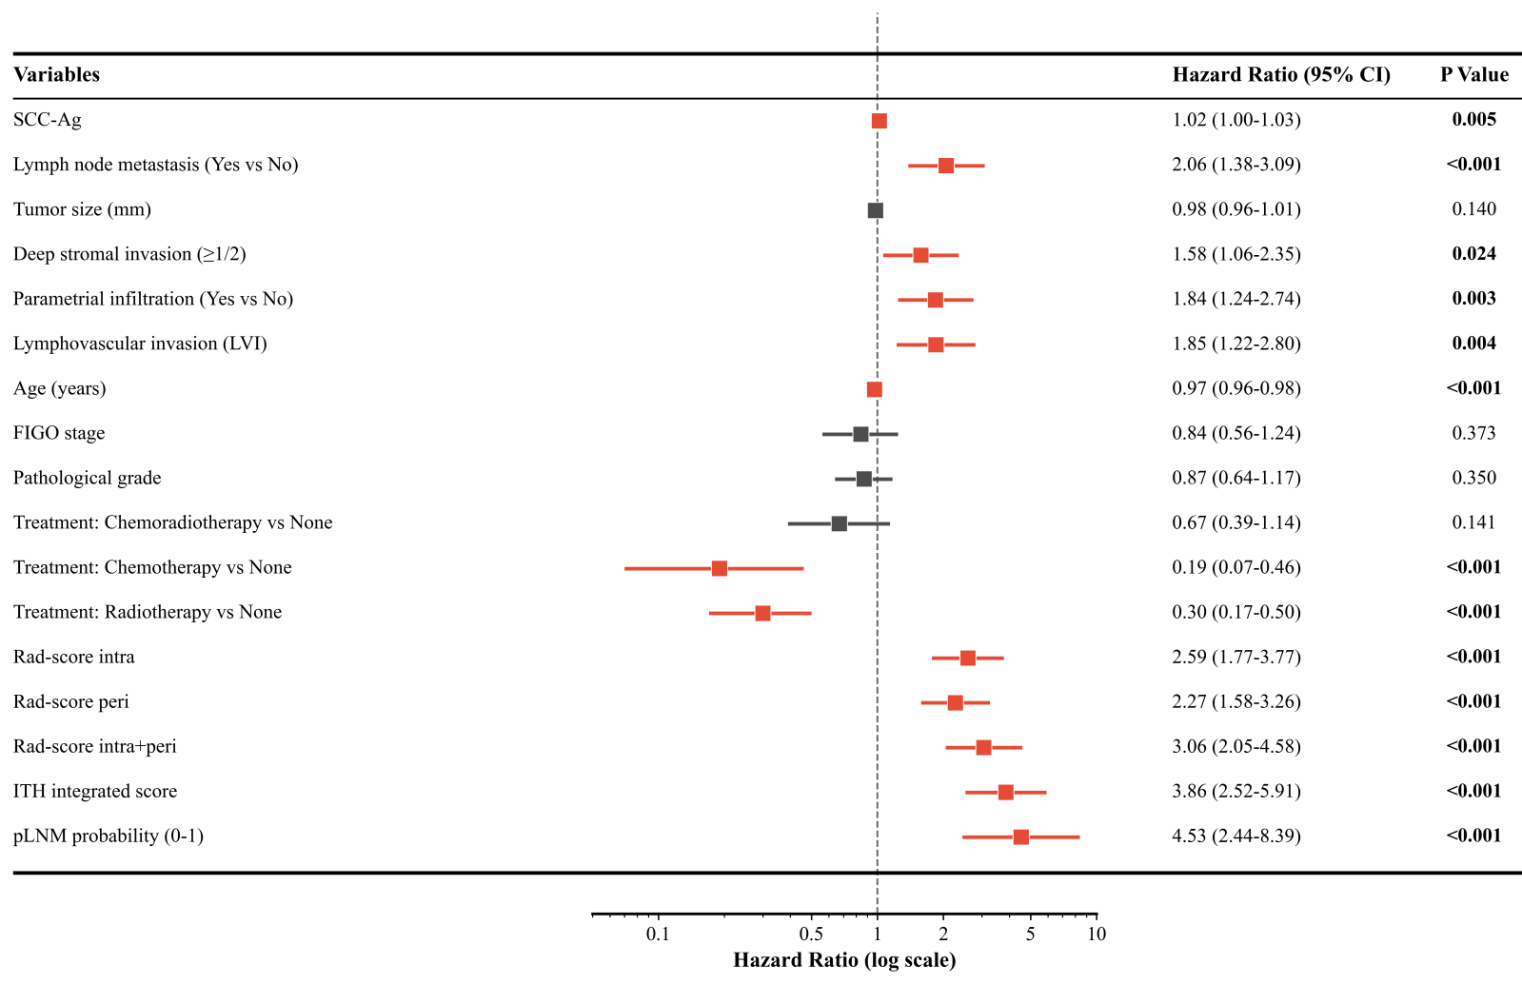
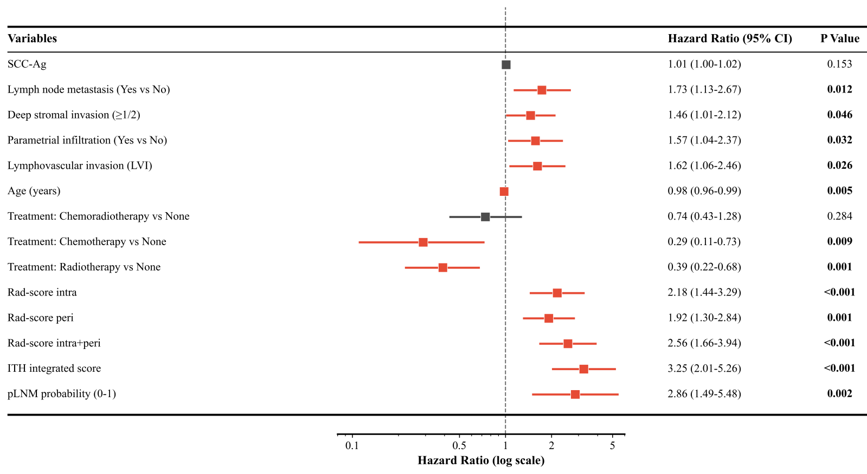

Figure S4. (A) Venn diagram showing the overlap between the 10 radiomic features selected in the LNM prediction model and the 9 features selected in the prognostic Cox model. The intersection (8 features) represents a shared radiomic phenotype associated with both nodal metastasis and recurrence. (B) Clustermap visualizing the expression patterns of the 8 core radiomic features shared between the LNM prediction model and the prognostic model.

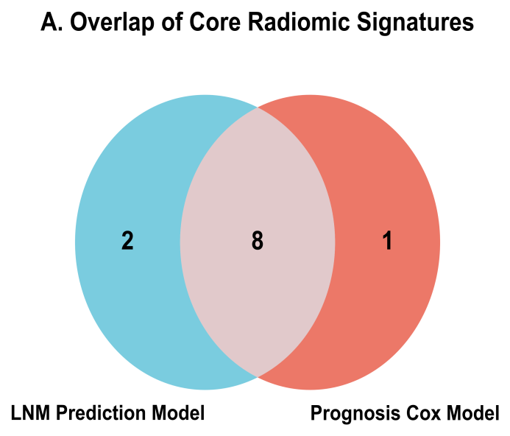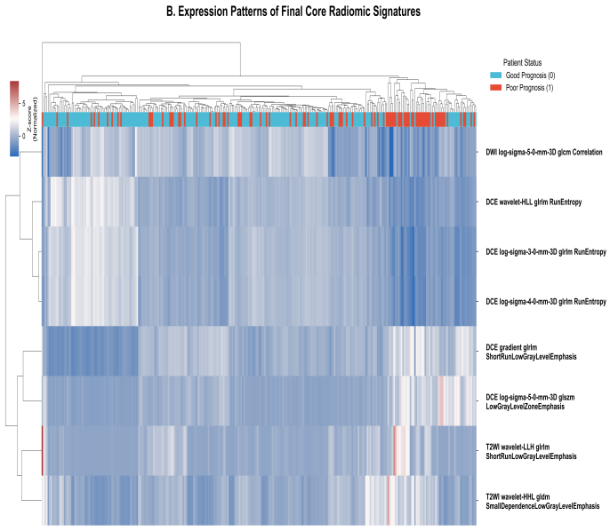

Figure S5. Radar plots across the three cohorts.
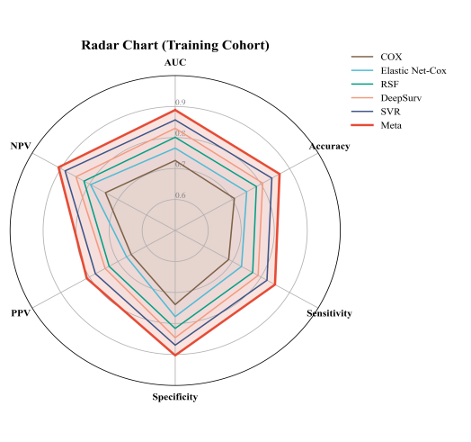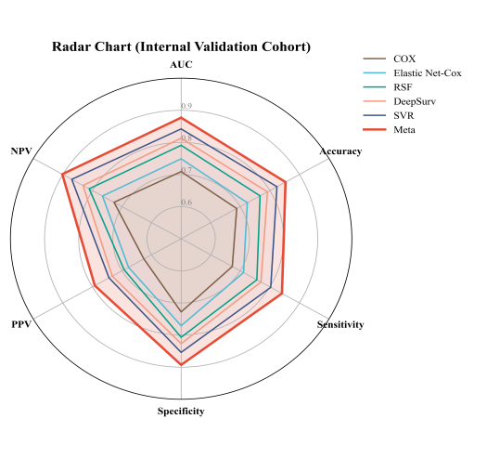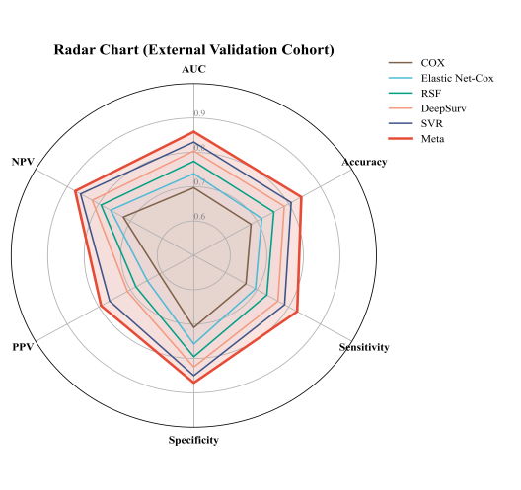

Figure S6. DeLong test results comparing Meta-model with 5 base learns.
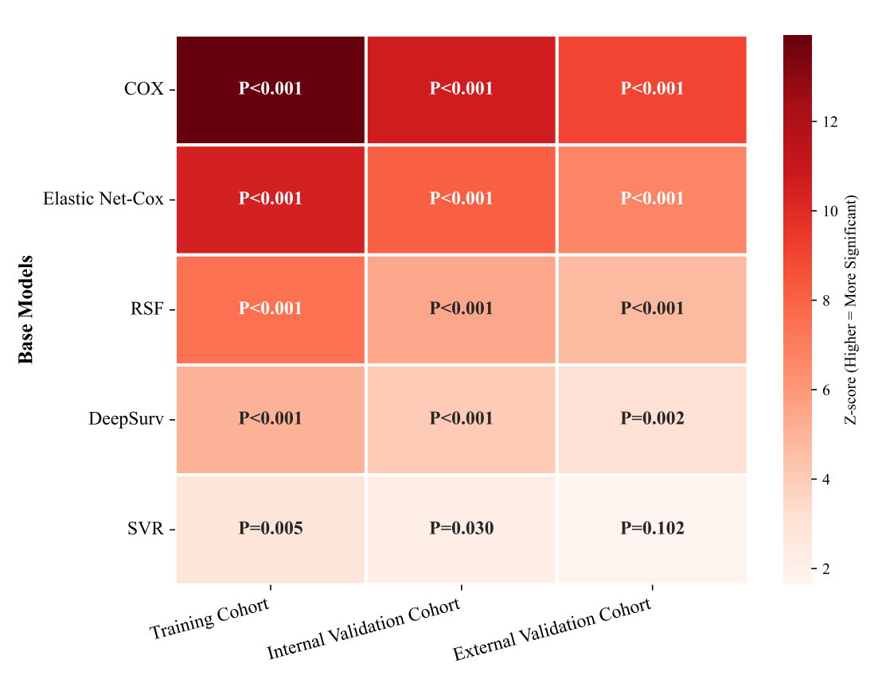

Figure S7. Incremental predictive value of the Meta-Model over other stacking models assessed by Net Reclassification Index (NRI) and Integrated Discrimination Improvement (IDI).
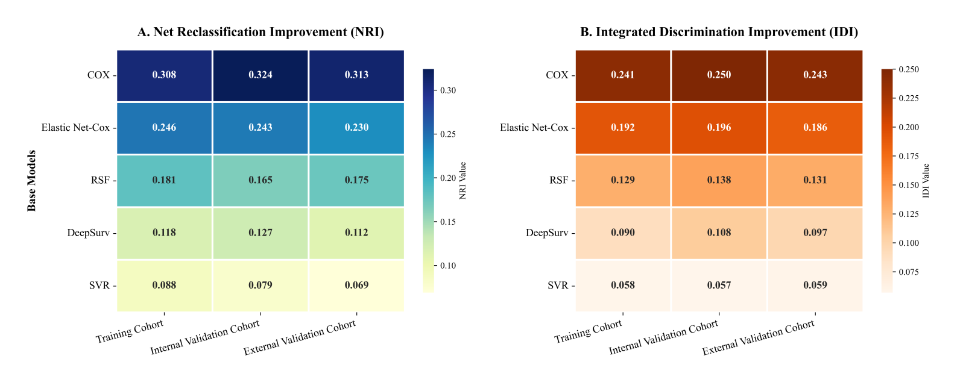

Figure S8. DFS stratified by pLNM (cutoff: 0.29) in pathologically node‑negative patients. High pLNM was associated with significantly shorter DFS (log‑rank P < 0.001). Tick marks indicate censored data.
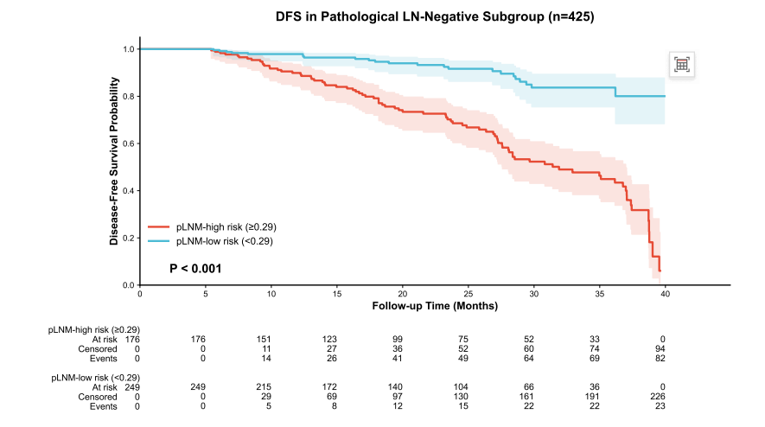

Supplementary Tables：

Table S1. The Optimal Features for the Model Construction.

Radiomic Signature | Feature Name | Sequence | Coefficient / Weight)
Intratumoral Rad-score ( n=7) | wavelet-HLL_glrlm_RunEntropy | DCE | -0.0786
 | log-sigma-3-0-mm-3D_glrlm_RunEntropy | DCE | -0.0051
 | log-sigma-5-0-mm-3D_glcm_Correlation | DWI | -0.008
 | original_shape_LeastAxisLength | DCE | 0.0142
 | original_shape_MajorAxisLength | DCE | -0.0215
 | original_shape_Maximum2DDiameterColumn | DCE | 0.0093
 | wavelet-LHL_glcm_Idmn | T2WI | -0.0154
Peritumoral Rad-score ( n=8) | gradient_glrlm_ShortRunLowGrayLevelEmphasis | DCE | 0.005
 | log-sigma-4-0-mm-3D_glrlm_RunEntropy | DCE | -0.0428
 | log-sigma-5-0-mm-3D_glszm_LowGrayLevelZoneEmphasis | DCE | 0.0074
 | wavelet-LLH_glrlm_ShortRunLowGrayLevelEmphasis | T2WI | 0.0222
 | wavelet-HHL_gldm_SmallDependenceLowGrayLevelEmphasis | T2WI | 0.0193
 | original_shape_Maximum2DDiameterRow | DCE | -0.0177
 | original_shape_Maximum2DDiameterSlice | DCE | 0.0116
 | original_shape_MeshVolume | DCE | 0.0301
Intra+Peri Fusion Score ( n=11) | wavelet-HLL_glrlm_RunEntropy | DCE | -0.0786
 | gradient_glrlm_ShortRunLowGrayLevelEmphasis | DCE | 0.005
 | log-sigma-3-0-mm-3D_glrlm_RunEntropy | DCE | -0.0051
 | log-sigma-4-0-mm-3D_glrlm_RunEntropy | DCE | -0.0428
 | log-sigma-5-0-mm-3D_glszm_LowGrayLevelZoneEmphasis | DCE | 0.0074
 | log-sigma-5-0-mm-3D_glcm_Correlation | DWI | -0.008
 | wavelet-LLH_glrlm_ShortRunLowGrayLevelEmphasis | T2WI | 0.0222
 | wavelet-HHL_gldm_SmallDependenceLowGrayLevelEmphasis | T2WI | 0.0193
 | original_shape_Elongation | DCE | 0.0125
 | original_shape_Flatness | DCE | -0.0083
 | original_shape_SurfaceVolumeRatio | T2WI | 0.021
ITH Integrated Score ( n=8) | logarithm_firstorder_10Percentile | DCE | -0.0412
 | logarithm_firstorder_90Percentile | DCE | 0.0387
 | logarithm_firstorder_Energy | DCE | 0.0295
 | logarithm_firstorder_Entropy | DCE | -0.0551
 | logarithm_firstorder_InterquartileRange | DCE | 0.0173
 | logarithm_firstorder_Kurtosis | DCE | -0.0204
 | wavelet-HLL_glrlm_RunEntropy | DCE | -0.0786
 | log-sigma-4-0-mm-3D_glrlm_RunEntropy | DCE | -0.0428

Table S2. Comparison of clinicopathological and radiomics features between Recurrence/Metastasis and Disease-Free Groups.
Variables | Disease-free survival (n=198) | Recurrence/Metastasis (n=95) | P value
Follow-up time (months), median [IQR] | 50.00 [48.00, 52.00] | 18.00 [12.50, 24.00] | <0.001
Age (years), median [IQR] | 56.50 [50.25, 65.00] | 50.00 [43.00, 55.00] | <0.001
Maximum diameter (mm), median [IQR] | 28.47 [22.11, 35.24] | 26.44 [20.73, 32.99] | 0.083
Delivery times, n (%) |  |  | 0.620
<3 | 323 (55.4%) | 162 (55.3%)
≥3 | 260 (44.6%) | 131 (44.7%)
Ki67, median [IQR] | 60.00 [51.25, 80.00] | 60.00 [60.00, 77.50] | 0.429
SCC-Ag, median [IQR] | 1.90 [1.10, 5.17] | 6.90 [1.21, 9.20] | 0.002
MSI, median [IQR] | 1.40 [1.17, 1.63] | 1.37 [1.19, 1.56] | 0.363
SER, median [IQR] | 1.21 [0.97, 1.32] | 1.12 [0.93, 1.31] | 0.435
ADCmean, median [IQR] | 1.11 [0.97, 1.32] | 1.07 [0.91, 1.30] | 0.382
ADCmin, median [IQR] | 0.87 [0.73, 1.12] | 0.90 [0.74, 1.14] | 0.627
Lymph node metastasis, n (%)
No | 154 (77.8%) | 55 (57.9%) | <0.001
Yes | 44 (22.2%) | 40 (42.1%)
Postoperative treatment, n (%)
Radiotherapy | 77 (38.9%) | 16 (16.8%) | <0.001
Chemotherapy | 36 (18.2%) | 4 (4.2%)
Chemoradiotherapy | 32 (16.2%) | 17 (17.9%)
None | 53 (26.8%) | 58 (61.1%)
Menopause, n (%)
No | 60 (30.3%) | 61 (64.2%) | <0.001
Yes | 138 (69.7%) | 34 (35.8%)
Smoke history, n (%)
No | 150 (75.8%) | 68 (71.6%) | 0.532
Yes | 48 (24.2%) | 27 (28.4%)
HPV status, n (%)
Negative | 25 (12.6%) | 13 (13.7%) | 0.947
Positive | 173 (87.4%) | 82 (86.3%)
FIGO stage, n (%)
I | 85 (42.9%) | 47 (49.5%) | 0.353
II | 113 (57.1%) | 48 (50.5%)
Pathological type, n (%)
Squamous carcinoma | 169 (85.4%) | 73 (76.8%) | 0.289
Adenocarcinoma | 18 (9.1%) | 15 (15.8%)
Adenosquamous carcinoma | 9 (4.5%) | 5 (5.3%)
Others | 2 (1.0%) | 2 (2.1%)
Pathological grade, n (%)
G1 | 144 (72.7%) | 68 (71.6%) | 0.053
G2 | 27 (13.6%) | 21 (22.1%)
G3 | 27 (13.6%) | 6 (6.3%)
1/2 Stromal infiltration, n (%)
No | 118 (59.6%) | 43 (45.3%) | 0.029
Yes | 80 (40.4%) | 52 (54.7%)
Parametrial infiltration, n (%)
No | 133 (67.2%) | 48 (50.5%) | 0.009
Yes | 65 (32.8%) | 47 (49.5%)
LVI (Lymphovascular invasion), n (%)
No | 100 (50.5%) | 32 (33.7%) | 0.010
Yes | 98 (49.5%) | 63 (66.3%)
Rad-score_intra, median [IQR] | 0.52 (0.25, 0.76) | 1.05 (0.75, 1.35) | <0.001
Rad-score_peri, median [IQR] | 0.45 (0.21, 0.68) | 0.82 (0.55, 1.15) | <0.001
Rad-score_intra+peri, median [IQR] | 0.95 (0.51, 1.35) | 1.88 (1.42, 2.45) | <0.001
ITH_integrated_score, median [IQR] | 1.20 (0.85, 1.65) | 3.45 (2.80, 4.15) | <0.001
pLNM, median [IQR] | 0.44 [0.44, 0.45] | 0.45 [0.44, 0.71] | <0.001

Table S3. Incremental predictive value of the Meta model over each base model assessed by NRI and IDI.
Base model | Training  cohort |  |  |  | Internal validation  cohort |  |  |  | External validation  cohort
Base model | NRI  (95% CI) | P value | IDI  (95% CI) | P value | NRI  (95% CI) | P value | IDI  (95% CI) | P value | NRI  (95% CI) | P value | IDI  (95% CI) | P value
Cox  model | 0.308 (0.253-  0.365) | <0.001 | 0.241 (0.204-  0.273) | <0.001 | 0.324 (0.272-  0.373) | <0.001 | 0.250 (0.204-0.286) | <0.001 | 0.313 (0.269-0.372) | <0.001 | 0.243 (0.201-0.280) | <0.001
RSF model | 0.181 (0.127-0.231) | <0.001 | 0.129 (0.093-0.168) | <0.001 | 0.165 (0.118-0.219) | <0.001 | 0.138 (0.103-0.187) | <0.001 | 0.175 (0.117-0.217) | <0.001 | 0.131 (0.092-0.173) | <0.001
Elastic Net-Cox | 0.246 (0.199-0.289) | <0.001 | 0.192 (0.157-0.222) | <0.001 | 0.243 (0.191-0.297) | <0.001 | 0.196 (0.156-0.244) | <0.001 | 0.230 (0.172-0.289) | <0.001 | 0.186 (0.146-0.223) | <0.001
DeepSurv model | 0.118 (0.074-0.163) | <0.001 | 0.090 (0.042-0.131) | <0.001 | 0.127 (0.083-0.178) | <0.001 | 0.108 (0.060-0.141) | <0.001 | 0.112 (0.058-0.167) | <0.001 | 0.097 (0.047-0.138) | <0.001
SVR model | 0.088 (0.030-0.137) | 0.024 | 0.058 (0.025-0.101) | 0.024 | 0.079 (0.026-0.126) | 0.013 | 0.057 (0.021-0.094) | 0.013 | 0.069 (0.017-0.114) | 0.037 | 0.059 (0.023-0.097) | 0.037

Table S4. Time-dependent AUC of the five base models and Meta model across the three cohorts.

Cohort | Time point | COX | RSF | Elastic Net-Cox | DeepSurv | SVR | Meta
Tra | 12 months | 0.745 (0.703-0.792) | 0.828 (0.791-0.870) | 0.789 (0.754-0.836) | 0.856 (0.818-0.891) | 0.877 (0.831-0.919) | 0.915 (0.872-0.954)
Tra | 24 months | 0.733 (0.697-0.773) | 0.811 (0.773-0.846) | 0.776 (0.732-0.819) | 0.839 (0.801-0.874) | 0.866 (0.828-0.914) | 0.902 (0.856-0.938)
Tra | 36 months | 0.726 (0.685-0.767) | 0.801 (0.762-0.838) | 0.766 (0.727-0.813) | 0.830 (0.795-0.866) | 0.857 (0.815-0.892) | 0.889 (0.846-0.926)
Int-Val | 12 months | 0.733 (0.691-0.775) | 0.813 (0.766-0.855) | 0.774 (0.729-0.821) | 0.840 (0.799-0.886) | 0.865 (0.822-0.903) | 0.901 (0.858-0.944)
Int-Val | 24 months | 0.718 (0.672-0.755) | 0.803 (0.758-0.843) | 0.766 (0.726-0.804) | 0.825 (0.781-0.863) | 0.851 (0.808-0.893) | 0.888 (0.848-0.929)
Int-Val | 36 months | 0.709 (0.664-0.746) | 0.791 (0.754-0.830) | 0.749 (0.709-0.796) | 0.813 (0.775-0.852) | 0.842 (0.802-0.884) | 0.877 (0.839-0.922)
Ext-Val | 12 months | 0.721 (0.683-0.766) | 0.802 (0.766-0.842) | 0.761 (0.720-0.802) | 0.825 (0.778-0.863) | 0.850 (0.807-0.895) | 0.887 (0.845-0.930)
Ext-Val | 24 months | 0.705 (0.658-0.743) | 0.786 (0.742-0.832) | 0.748 (0.704-0.788) | 0.814 (0.769-0.859) | 0.842 (0.803-0.880) | 0.875 (0.828-0.920)
Ext-Val | 36 months | 0.697 (0.657-0.742) | 0.774 (0.729-0.810) | 0.738 (0.701-0.785) | 0.804 (0.765-0.840) | 0.830 (0.788-0.875) | 0.860 (0.820-0.906)

