Fig. S1
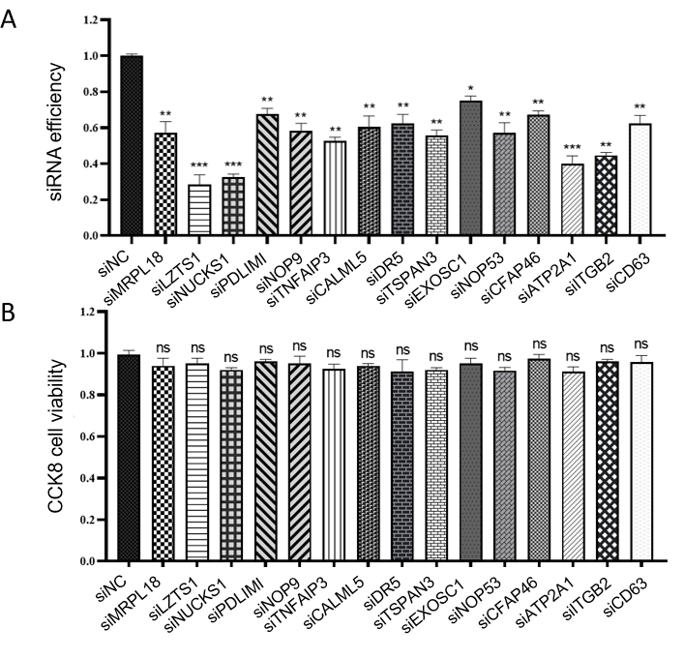
LEGENDS
Figure S1A. The siRNA efficiency of targeted genes for effect of viral mRNA assay
Vero cells were transfected with siRNA targeting indicated genes for 36 h, and cells were infected with HSV-1/COS at an MOI of 0.1 at 37℃ for 2 h. After 24 h, the cells were harvested, and the efficiency of siRNA was analyzed using RT-qPCR.

Figure S1B. The cell viability of targeted genes for effect of viral mRNA assay
Vero cells were transfected with siRNA targeting indicated genes for 36 h, and the cell viability was analyzed using CCK-8 kit.

Fig. S2
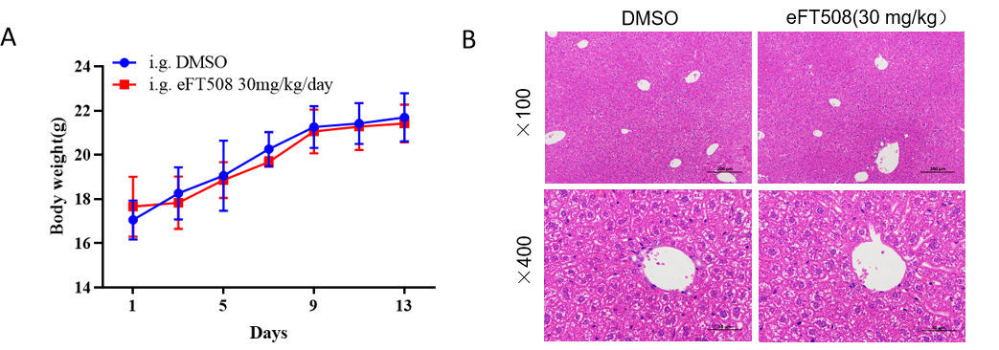
LEGENDS
Figure S2. Toxicity analysis of eFT508 in mice.
eFT508 was administered by oral gavage for 5 consecutive days in a regimen of a single daily dose of 30 mg/kg. Four-week-old SPF BALB/c mice were randomly divided into 2 groups (n = 6, the control group, and the eFT508 group, with equal numbers of males and females). Changes in the body weights of the mice were recorded at regular intervals daily (S2A). They were humanely slaughtered at a given time, and the lung and liver were obtained, tissue morphological changes and inflammatory infiltration were surveyed by H&E Staining (S2B).

