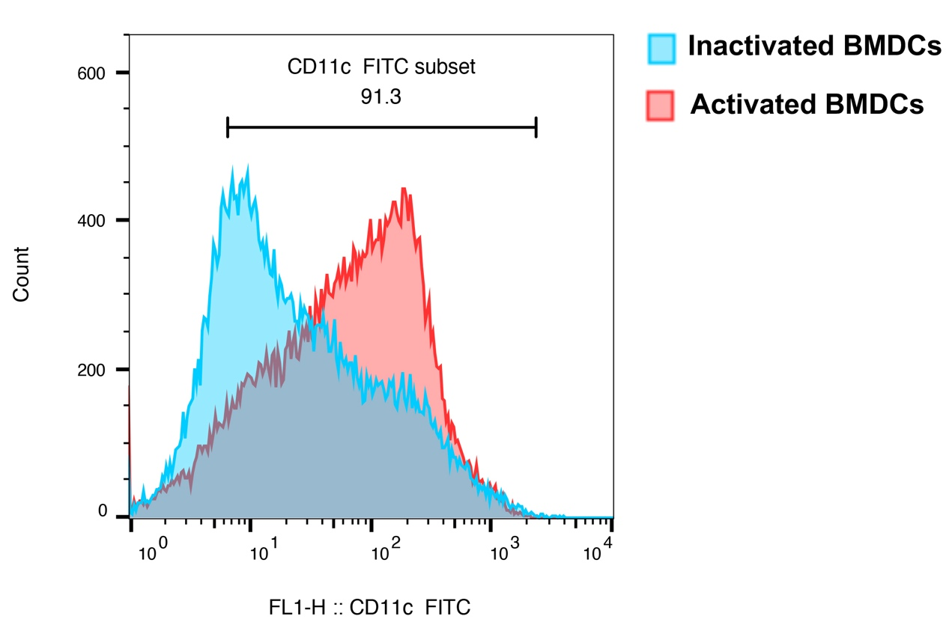
Figure S1. The specific marker of BMDCs. Generation of BMDCs from the bone marrow precursors after 6 d culture with 10 ng/ml GM-CSF and 10 ng/ml IL-4. CD11c⁺ cells were detected by FACS. More than 90% of the suspension cells expressed CD11c.

