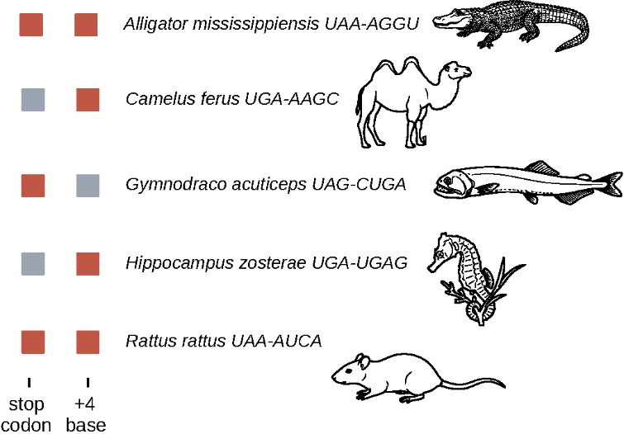
Figure S1: Species Lacking UGA-C context out of 697 species (A2)
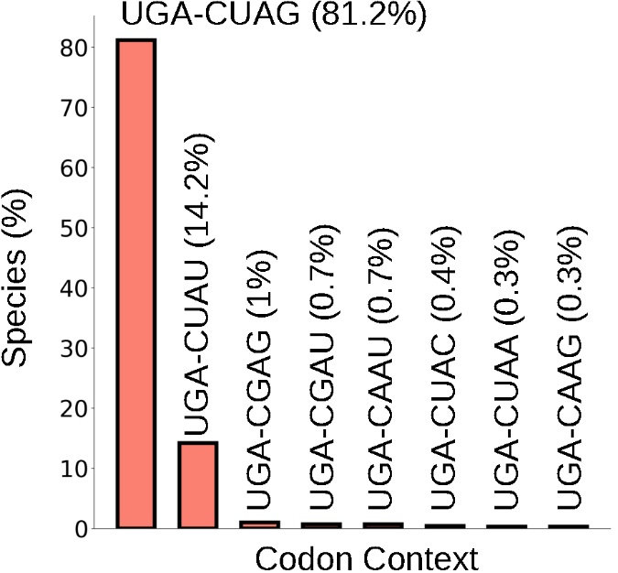
Fig S2: Different readthrough codon context appearing in the dataset
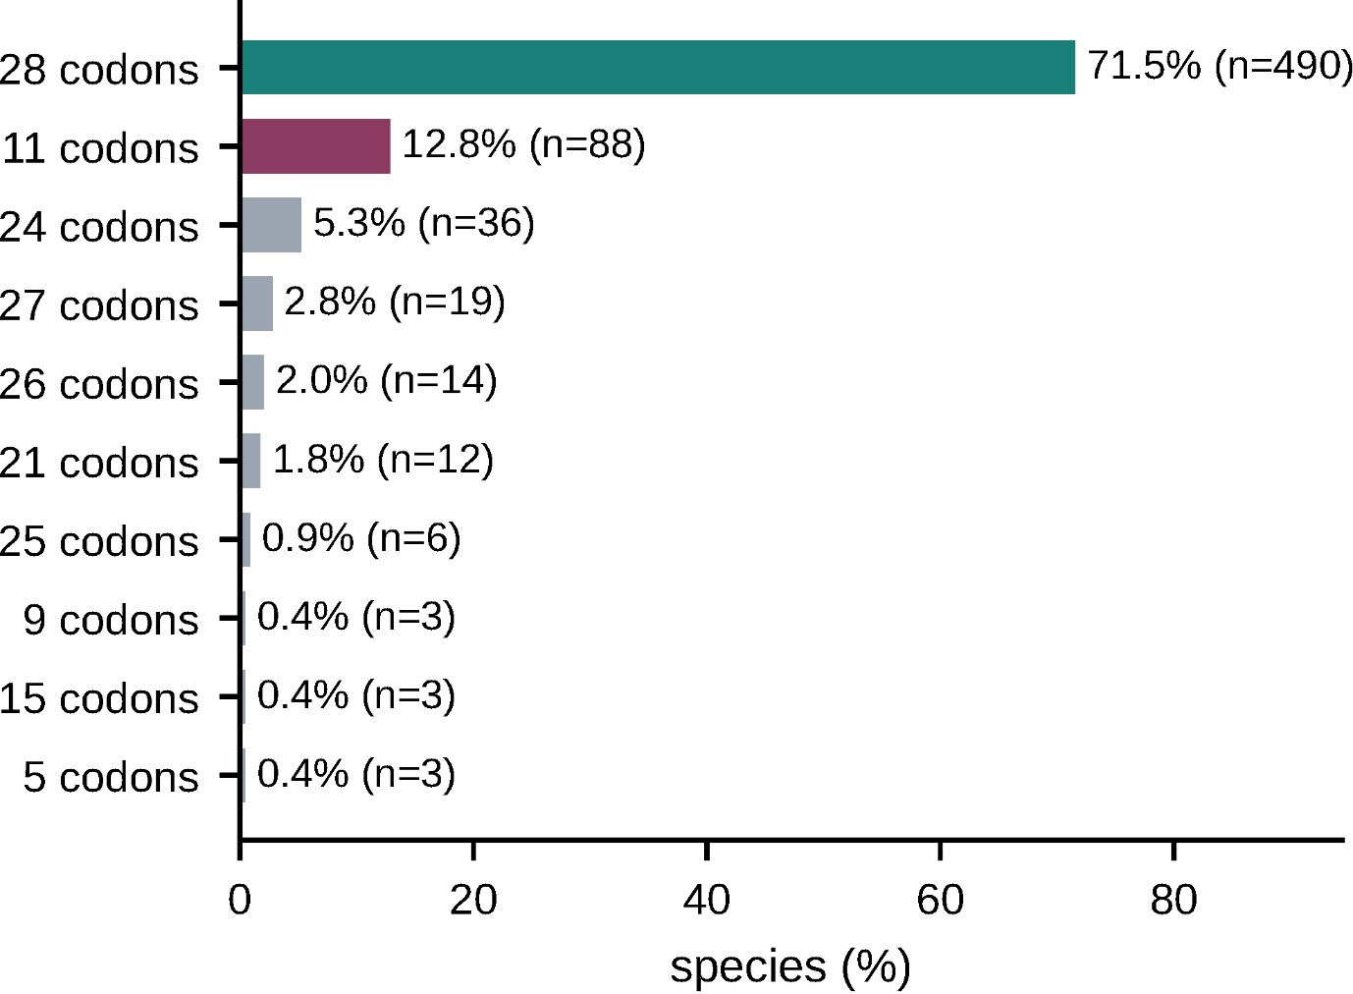
Fig. S3: Codon distribution across the A4 set analysed with majority of species having 28 codons and then 11 codons.
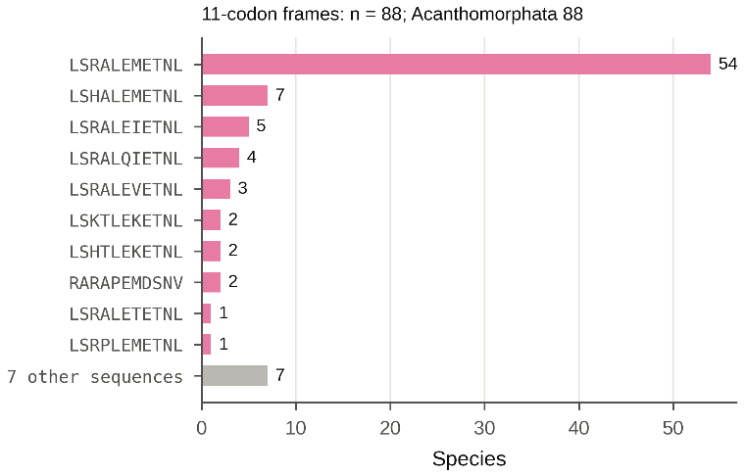
Figure S4: Distribution of the 11-codon frames among the acanthomorph fishes. ETNL is the most common C-terminal sequence with the N-terminal being highly variable
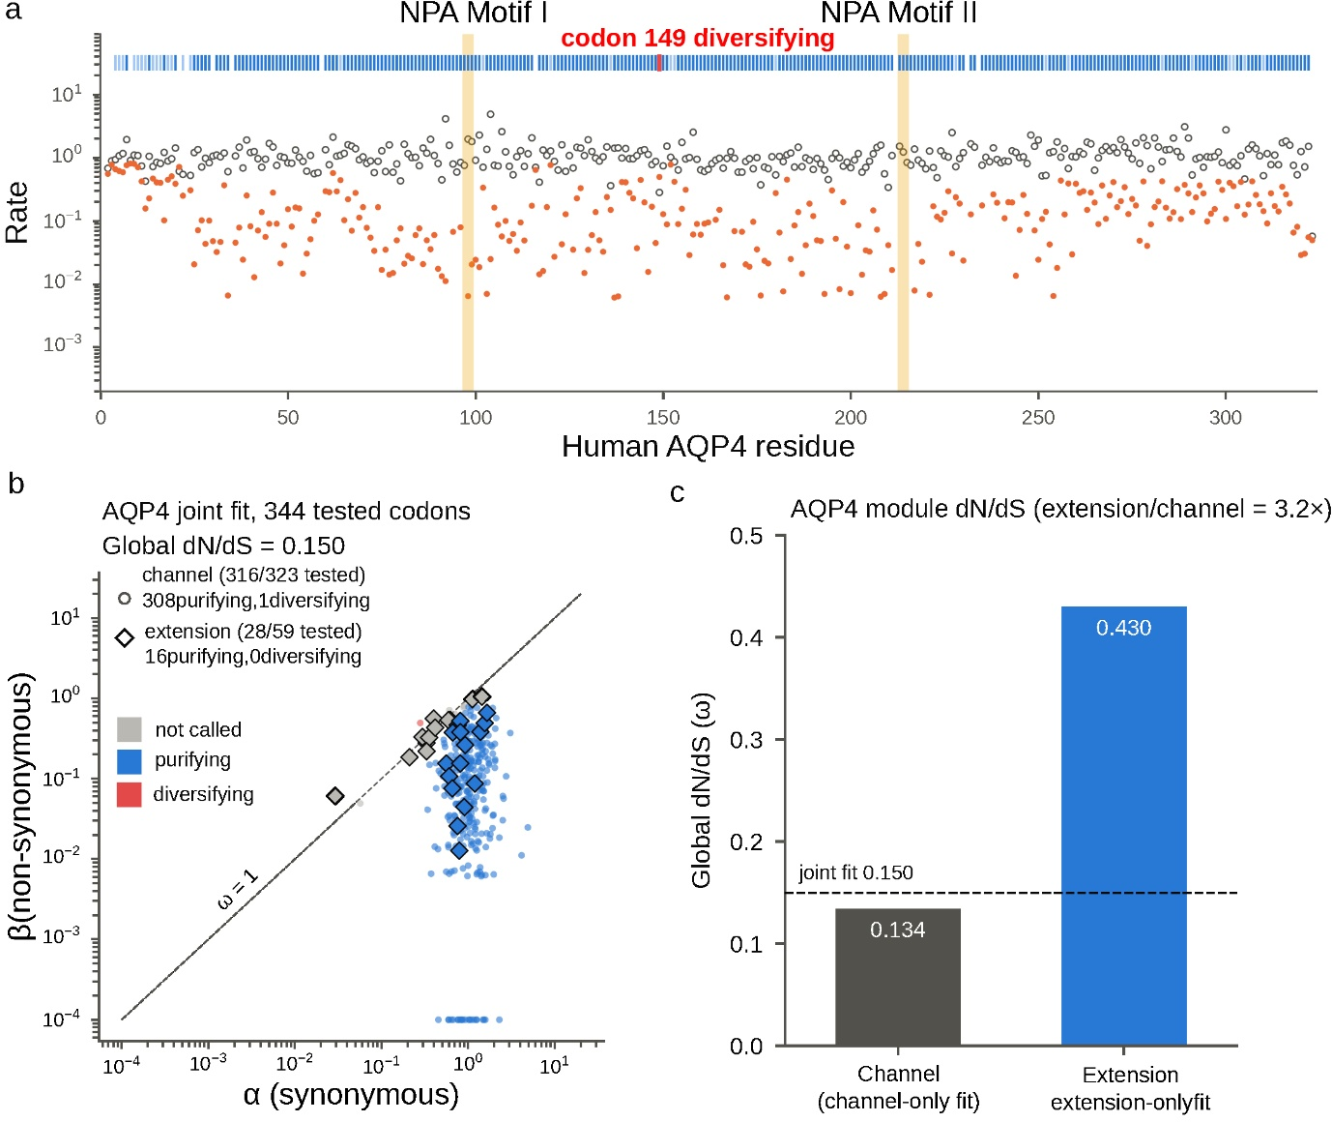
Figure S5: Selection on the AQP4 channel domain and module specific dN/dS (a) Site wise synonymous (α, open circles) and non-synonymous (β, file=filled orange circles) rates across the 323 channel codons, from the joint channel + extension FEL fit. Ticks above the plot marks the selection status at each site (blue: purifying (q≤0.20), red: diversifying). The two NPA motifs are shaded. Codon 149 is labelled as the single site identified as diversifying. (b) β against α for all 344 tested codons of the same fit. Circles represent channel codons; diamonds represent extension codons. Colour gives the call (blue: purifying, red: diversifying and grey: not called). The diagonal is ω=1. Points below it has β<α. The global dN/dS of the joint fit are 0.150. (c) Global dN/dS from separate fits to each module. 0.134 for the channel alone and 0.430 for extension alone. Extension is 3.2-fold less constrained than channel. The dashed line is the global dN/dS joint fit (0.150).
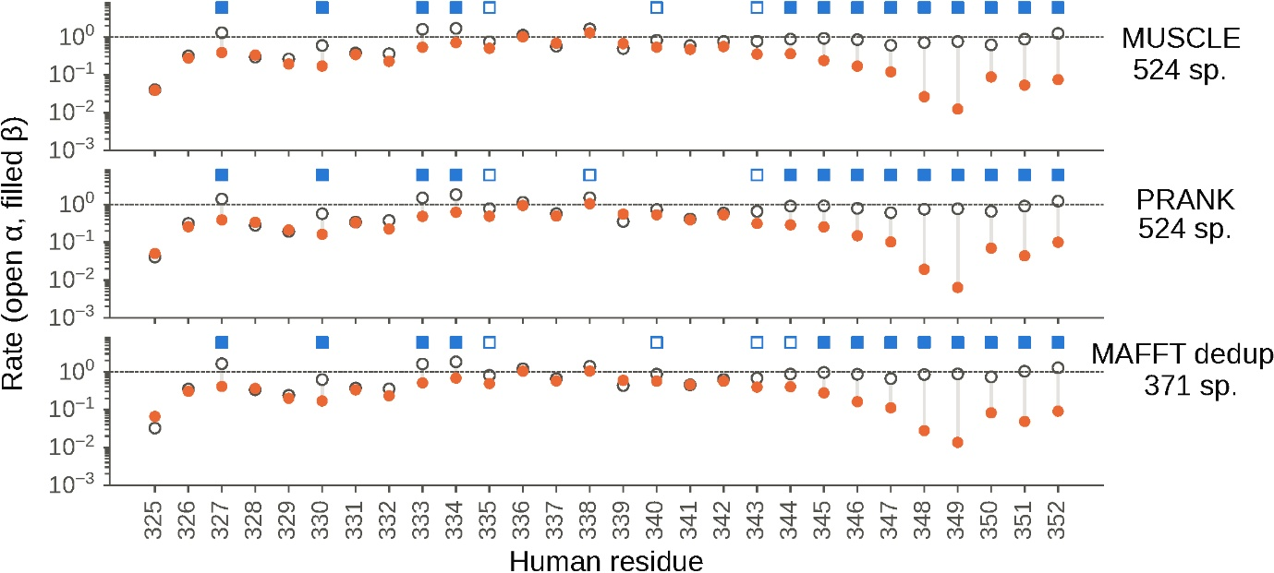
Figure S6: Site-wise rates are insensitive to alignment methods and to sequence redundancy. The analysis of Fig. 3a repeated with three alternative inputs. The MUSCLE alignment (524 species), the PRANK alignment (524 species) and the MAFFT alignment after removing the 153 species carrying duplicate extension sequences (371 species). Symbols as in Fig. 3a: open circles, synonymous rate α, filled orange circles, non-synonymous rate (β), vertical lines join the pair at each site, the dashed line is the gene-wide mean synonymous rate. Square above each panel marks sites under purifying selection: open (q≤0.20), filled (q≤0.20 and Bonferroni significant).
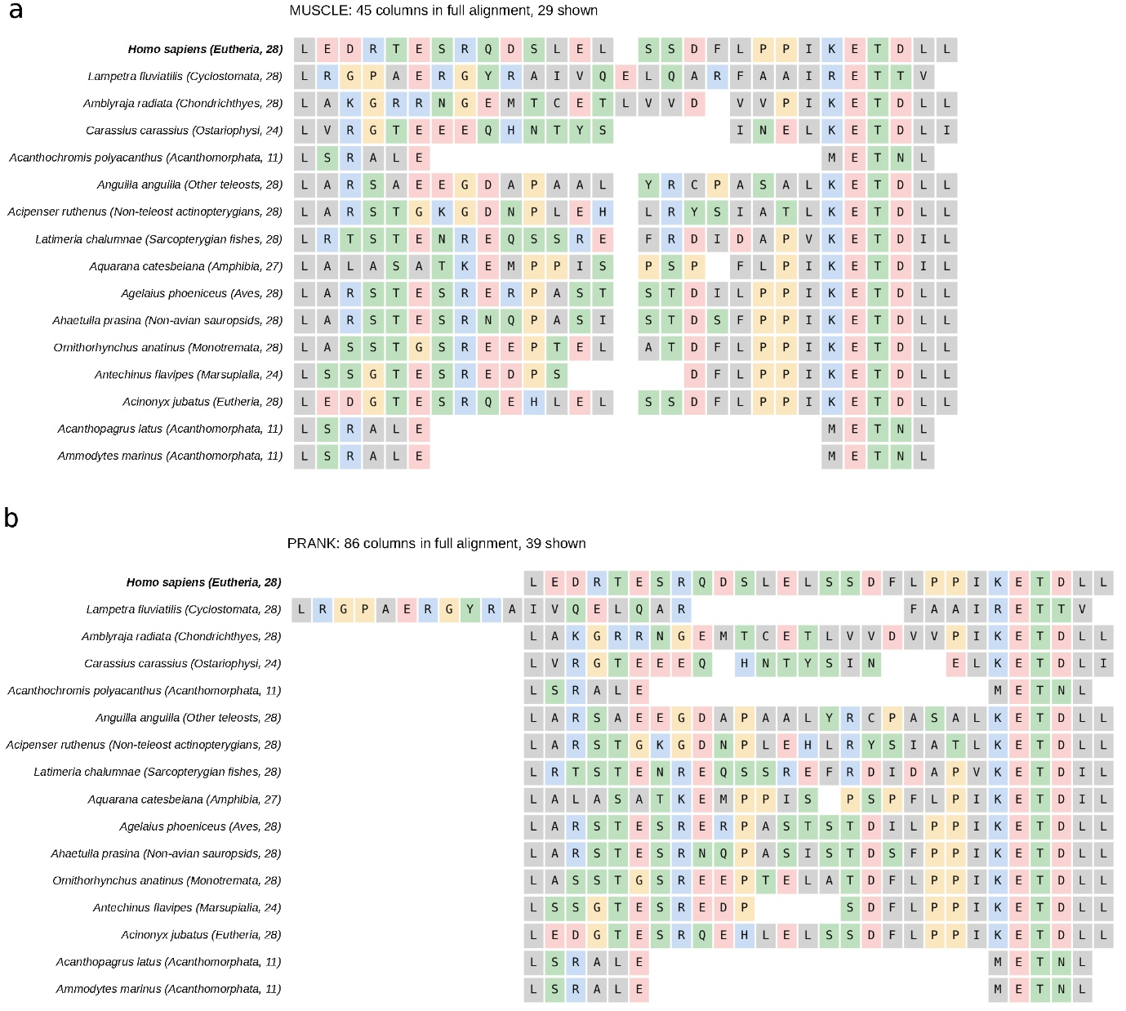
Figure S7: Extension alignments differ between methods, principally how insertions are handled. Amino acid alignments of the extension for 16 species one or more per taxonomic group under (a) MUSCLE and (b) PRANK. The human sequence is shown first and in bold. The taxonomic group and the species’ own extension length in residues are given in parentheses. Residues are coloured by physicochemical class: acidic (D, E) red; basic (K, R, H) blue; hydrophobic (A, V, L, I, M, F, W, C) grey; polar (S, T, N, Q, Y) green; P and G yellow.

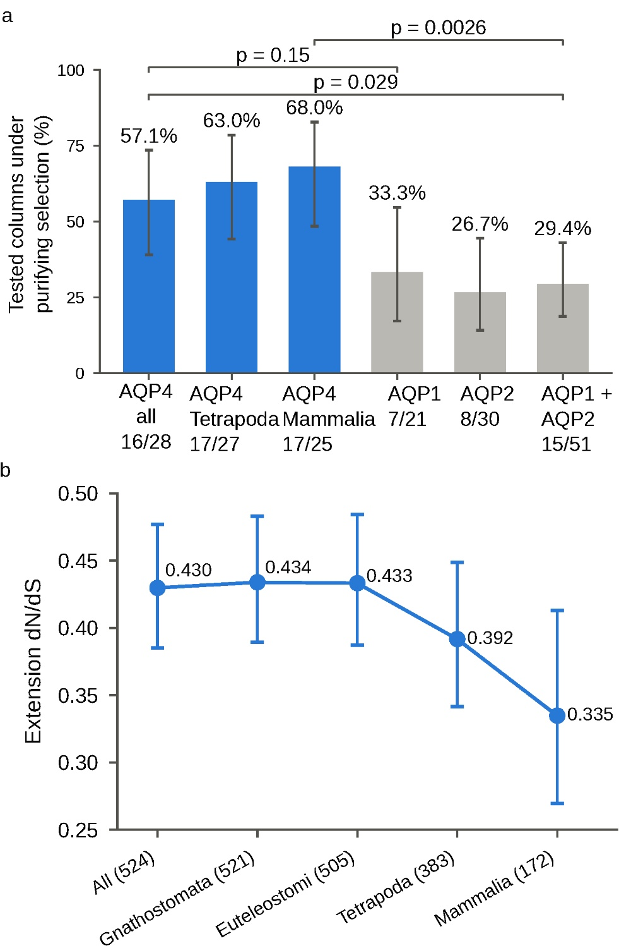
Figure S8: Purifying selection and extension dN/dS across nested taxonomic subsets. (a) Each bar shows the percentage of tested downstream-frame columns under purifying selection (q≤0.20). AQP4 (blue) is shown for the full selection set (524 species), Tetrapoda (383 species) and Mammalia (172 species), which match the depth of the paralogues sets. AQP1 and AQP2 (grey) lack the UGA-C context in every sampled species, so their downstream frames act as untranslated controls. Counts below each bar are columns under purifying selection over the tested columns. Each bar are Wilson 95% confidence intervals and bracket give two-sided Fisher’s exact p-values. (b) Global dN/dS from extension-only fits to progressively shallower subsets of the species set. The species count is provided in the parentheses. Vertical bars are the profile likelihood 95% confidence intervals, obtained by fixing dN/dS and re-optimising all other parameters. The subsets are nested, so the estimates are not independent.
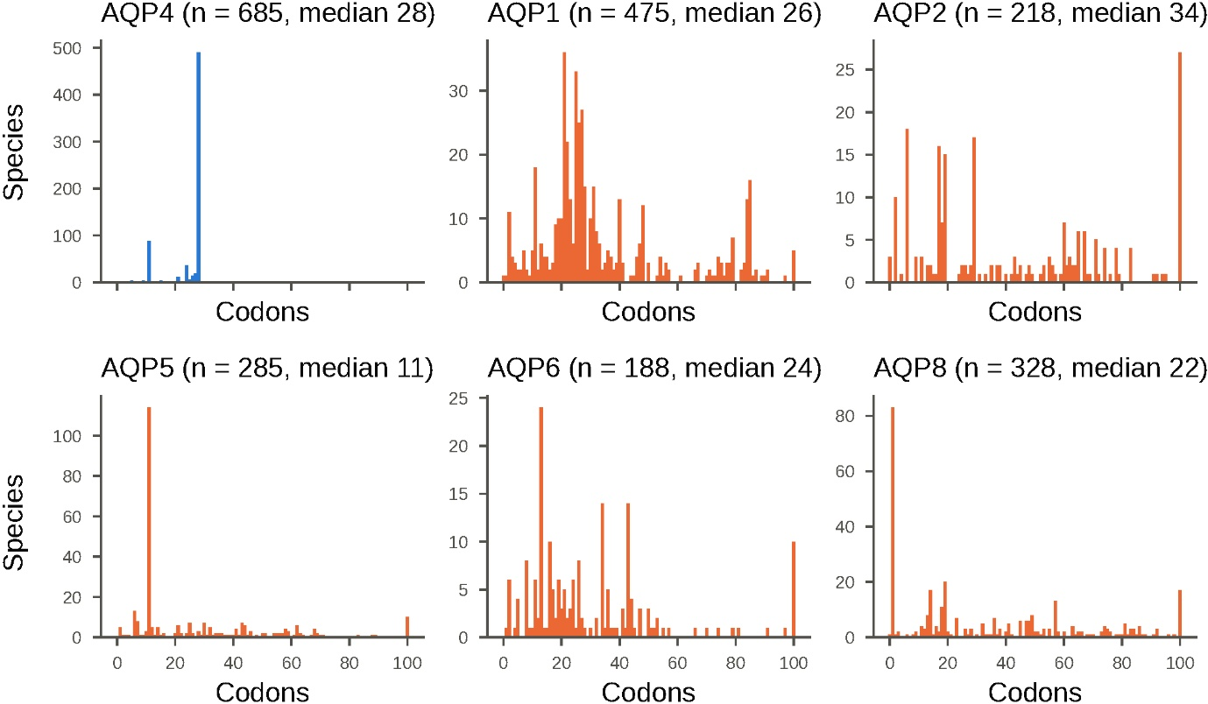
Figure S9: Length distribution of the downstream reading frame in aquaporins. Number of species against the length in codons of the reading frame beginning immediately after the canonical stop codon, for each gene.

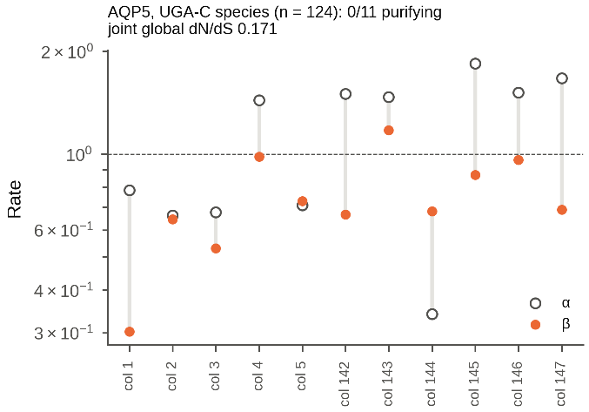
Figure S10: FEL on AQP5 readthrough extension limited to species that carry UGA-C.

