Appendix A: Calculation methods of pollution load emission
(1) Industrial source
There were 2899 industrial enterprises discharging wastewater in Dianchi Lake Basin, including 247 critical industrial enterprises (Fig. 1). The industry can be divided into seven main types: manufacturing chemical raw materials and chemical products, equipment manufacturing, pharmaceutical manufacturing, agricultural and sideline products processing, food manufacturing, non-ferrous metal smelting, and rolling processing. In 2018, COD_{Cr}, NH₃-N, TN, and TP emissions from industrial sources in Dianchi Lake Basin were 1397.58 t, 87.11 t, 111.66 t, and 14.35 t, respectively.
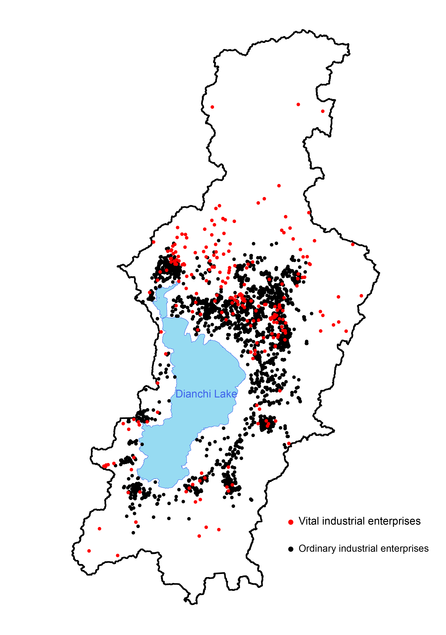
Fig. 1 Distribution of industrial enterprises in Dianchi Lake Basin. Red dots represent the vital industrial enterprises, and black dots represent the ordinary industrial enterprises
(2) Urban domestic sewage and pollutant
Urban domestic pollution includes sewage pollution and other pollutants directly discharging from urban residents' daily lives. Firstly, the average concentration of domestic sewage was calculated by the monitoring results of sewage outfall into the river and the investigation results of centralized pollution control facilities, using equation 1.
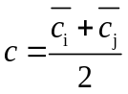 (Equation 1)
Where, c is the average concentration of urban domestic sewage, mg / L; c_{i} is the average concentration at the inlet of urban sewage treatment plant, mg / L; c_{j} is the average concentration at the sewage outlet into the river, mg / L.
Kunming is a general city of grade six. According to the Manual on Production and Discharge coefficient of domestic pollution sources in the Second National Census of Pollution Sources, the average concentration of urban domestic source water pollutants was listed in Table 2.
Table 2 Average concentration of urban domestic source water pollutants
Type | COD  (mg/L) | NH₃-N  (mg/L) | TN  (mg/L) | TP  (mg/L)
City | 330 | 32.8 | 43.2 | 4.20
County | 295 | 29.6 | 39.0 | 3.80
Town | 315 | 31.4 | 41.6 | 4.04
The production of urban domestic sewage and pollutants was calculated using per capita daily domestic water consumption, pollution reduction coefficient, and average concentration of domestic sewage by equations 2 - 3.
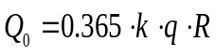 (Equation 2)
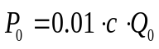 (Equation 3)
Where, Q₀ is the output of urban domestic sewage, ×10⁴ m³; k is the urban domestic sewage conversion coefficient, taken as 0.85; q is daily domestic water consumption per capita, L; R is the number of permanent residents in cities and towns (shown in Fig. 3), ×10⁴ p; P₀ is the amount of urban domestic source water pollutants, t; C is the average concentration of urban domestic sewage, mg / L.
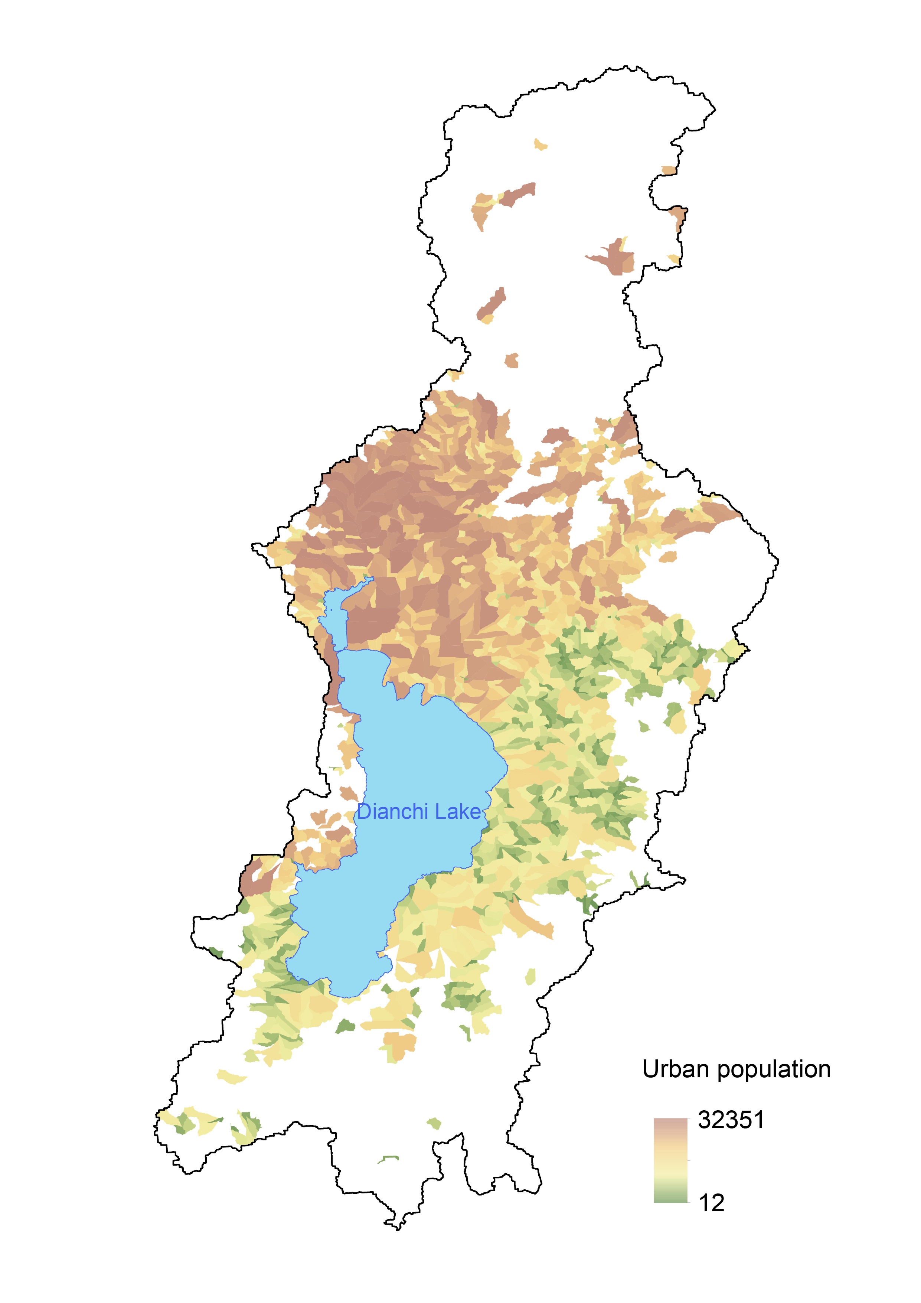
Fig. 4 distribution of urban population in the basin
The urban domestic sewage and pollutant discharge can be obtained by deducting the water pollutants disposal by urban sewage treatment plants and industrial centralized sewage treatment plants, calculated by Equation 4 - 5.
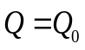 (Equation 4)
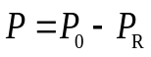 (Equation 5)
Where, Q is the urban domestic sewage discharge, ×10⁴ m³. Q₀ is the output of urban domestic sewage, ×10⁴ m³. P is the discharge of pollutants from urban domestic source water, t. P₀ is the amount of urban domestic source water pollutants, t. P_{R} is the removal amount of domestic sewage pollutants in the sewage treatment plant, t.
We collected the annual monitoring data of eight urban water purification plants and two county sewage treatment plants in the basin in 2018 and identified the service scope of urban sewage treatment plants. The average concentration of sewage at the sewage outlet into the river adopted the value specified in the Coefficient Manual. The average concentration of urban domestic sewage pollutants in the service area of the water purification plant (sewage treatment plant) in the basin was calculated, listed in table 3.
Table 3 Average concentration of pollutants in urban domestic sewage
Sewage treatment plants | COD  （mg/L） | NH₃-N  （mg/L） | TN  （mg/L） | TP  （mg/L）
First sewage treatment plants | 412.04 | 29.16 | 39.27 | 6.02
Second sewage treatment plants | 311.88 | 33.40 | 37.68 | 3.66
Third sewage treatment plants | 334.96 | 32.50 | 37.84 | 3.65
Fourth sewage treatment plants | 317.67 | 35.80 | 42.13 | 4.49
Fifth sewage treatment plants | 331.50 | 32.73 | 39.92 | 4.47
Sixth sewage treatment plants | 318.38 | 32.84 | 41.51 | 5.15
Seventh and eighth sewage treatment plants | 319.25 | 27.95 | 43.16 | 7.18
Chenggong sewage treatment plants | 287.58 | 28.63 | 43.20 | 4.20
Jinning sewage treatment plants | 247.50 | 28.74 | 43.20 | 4.20
According to Kunming Water Resources Bulletin 2018, the per capita domestic water consumption of urban residents in Kunming (excluding urban public water consumption) was 136 L/d, and that of rural residents was 100 L/d. According to the Coefficient Manual, the value range of urban per capita daily domestic water consumption is 89 - 435 L/d, and the value range of county per capita daily domestic water consumption is 68 - 285 L/d. The coefficient obtained from actual monitoring and collection (the value in table 3) is within the value range, which can be used to calculate the production of urban domestic sewage. The amount of pollutants COD_{Cr}, NH₃-N, TN, and TP from urban domestic sources were 122033.45 t, 14634.19 t, 24406.62 t, and 1851.89 t, respectively.
(3) Tertiary industry
A web crawler written in Python based on Baidu map API was used to fetch the geography information of all tertiary industries within the towns in the basin. There were 33741 tertiary industry enterprises in Dianchi Lake Basin (shown in Fig. 4). According to the industry classification, the number of catering enterprises accounts for 50.85% of the total tertiary industry enterprises in Dianchi Lake Basin, followed by the accommodation service industry, beauty salon industry, medical care service industry, bathing industry, photography and printing industry, automobile maintenance industry and washing and dyeing industry.
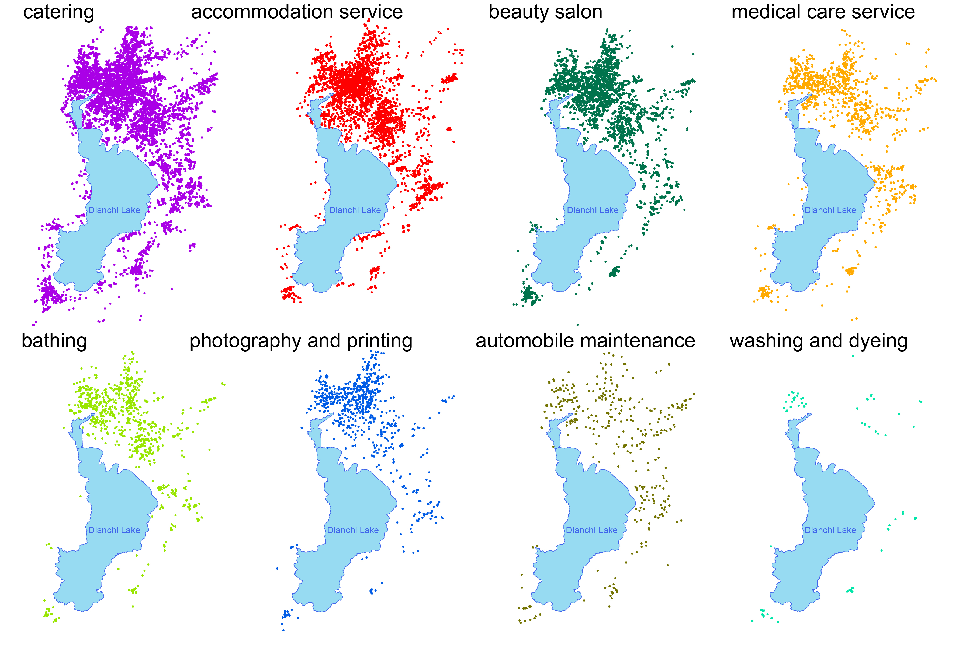
Fig. 5 Distribution of tertiary industry enterprises in Dianchi Lake Basin
We investigated the pollution load from the tertiary industry in 17 sub-basins and counted the number of different enterprises. The coefficient calculated by regression analysis was used as the pollution producing coefficient of enterprises in the corresponding industry, listed in table 4.
Table 4 pollution producing coefficient of enterprises
Industry | COD  （t/one） | NH₃-N  （kg/one） | TN  （kg/one） | TP  （kg/one）
catering | 0.90 | 6.18 | 33.80 | 2.63
accommodation service | 0.13 | 2.36 | 12.90 | 1.92
beauty salon | 0.28 | 2.67 | 14.58 | 1.60
medical care service | 2.25 | 39.89 | 218.19 | 32.53
bathing | 0.28 | 2.67 | 14.58 | 1.60
photography and printin | 0.28 | 2.67 | 14.58 | 1.60
automobile maintenance | 0.28 | 2.67 | 14.58 | 1.60
washing and dyeing | 0.28 | 2.67 | 14.58 | 1.60
In 2018, the output of COD_{Cr}, NH₃-N, TN, and TP of tertiary industry in Dianchi Lake Basin was 27928.46 t, 270.13 t, 1490.33 t, and 164.89 t, respectively.
(4) Urban runoff
The urban non-point source pollution load from urban runoff in Dianchi Lake Basin was calculated using the event mean concentration (EMC) values of runoff pollutants of different underlying surface types and the urban roads and buildings obtained by remote sensing image interpretation. Urban non-point source pollutants mainly come from the scouring of rainwater on the sediments on the underlying impervious surface of the city and the bare ground without vegetation cover. The urban non-point source pollution load can be estimated according to Equation 6.
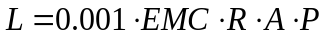 (Equation 6)
Where, EMC is the event mean concentration of rainfall, mg/L. R is the annual runoff coefficient, the rainfall-runoff coefficient of hardened roof and pavement in Kunming, taken as 0.8. P is the annual average rainfall, mm. A is the catchment area, km².
We sampled three distinct underlying surfaces (roads, roofs, and courtyards) in Kunming City in the early, middle, and late stages of rainfall and recorded the intensity of the whole rainfall with a rain gauge. The average event mean concentration (EMC) values of runoff pollutants from different underlying surfaces in Dianchi Lake Basin were obtained, as shown in Fig. 6.
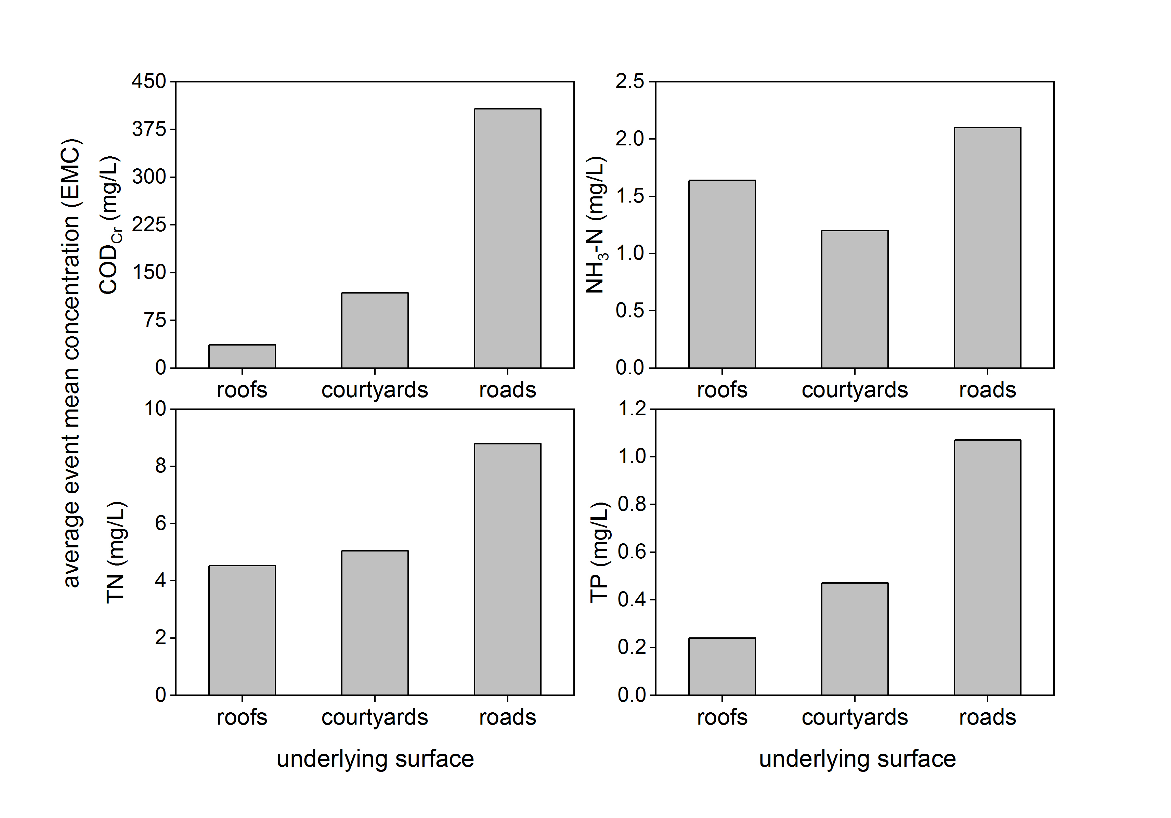
Fig. 7 The EMC of rainfall-runoff pollutants from the different underlying surfaces in Dianchi Lake Basin. The underlying surfaces included roads, roofs, and courtyards. The concentration of COD_{Cr}, NH₃-N, TN, and TP was tested in the whole rainfall
The urban roads and buildings in the basin were interpreted using the object-oriented method from Rapid-eye remote sensing images. The results were shown in Fig. 5.
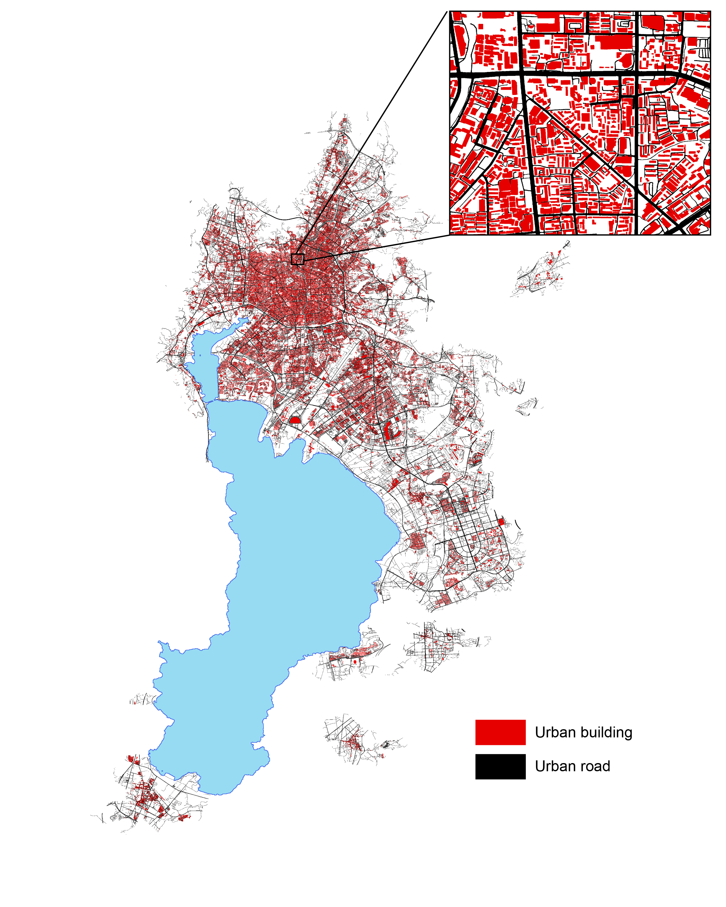
Fig. 6 Urban roads and buildings
The urban non-point source pollutant load in Dianchi Lake Basin was calculated according to the urban roads and buildings derived from the EMC values of runoff pollutants of different underlying surfaces in Dianchi Lake Basin. In 2018, the load generation of pollutants COD_{Cr}, NH₃-N, TN, and TP from urban non-point sources were 38093.95 t, 439.87 t, 3817.35 t, and 135.42 t, respectively.
(5) Agricultural runoff
The export coefficient model was used to calculate the pollutant load of agricultural runoff, as Equation 7.
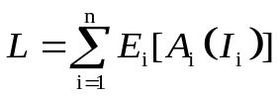 (Equation 7)
Where, L is the loss of nutrients, t/a. E_{i} is the export coefficient of the ith nutrient source, t/(km2·a). A_{i} is the area of land-use type, km². I_{i} is the nutrient export of the .ith nutrient source, t.
Values of the export coefficient referred to published papers. The export coefficients suitable for COD, NH₃-N, TN, and TP in Dianchi Lake Basin were selected by considering the location of the study area and the year in which the study was carried out.
Table 1 Pollutant export coefficient of land use in Dianchi Lake Basin
Land use | COD_{Cr}  t/(km²·a) | NH₃-N  t/(km²·a) | TN  t/(km²·a) | TP  t/(km²·a)
Dryland | 7.966 | 0.115 | 1.921 | 0.079
Paddy fields | 7.429 | 0.124 | 2.625 | 1.820
Orchard land | 5.674 | 0.103 | 1.234 | 0.098
Forest | 1.120 | 0.154 | 0.238 | 0.015
Grassland | 1.088 | 0.154 | 0.600 | 0.165
Unused land | 0.800 | 0.28 | 1.490 | 0.051
According to the distribution of paddy fields, drylands, irrigated fields, orchards, tea gardens, and other gardens in the basin (Fig. 7) and pollutant export coefficient (Table 1), the pollutant loads of COD_{Cr}, NH₃-N, TN, and TP produced from agricultural runoff in 2018 were 5786.34 t, 833.96 t, 1938.05 t, and 402.05 t respectively.
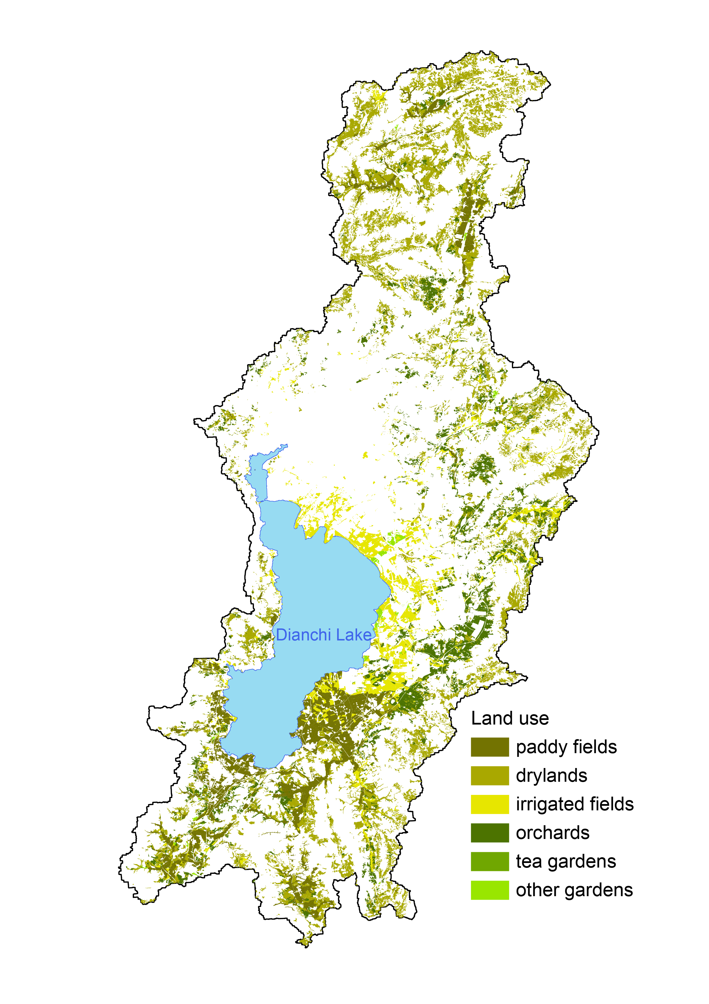
Fig. 8 Distribution of cultivated land and garden land in the basin. The categories included paddy fields, irrigated fields, dryland, orchard land, tea garden, and other gardens.
(6) Livestock and poultry breeding
The pollutant load of livestock and poultry breeding was calculated according to the export coefficient (Table 2). In 2018, the load of pollutant COD_{Cr}, NH₃-N, TN, and TP from livestock and poultry breeding was 12518.44 t, 650.40 t, 3880.87 t, and 782.75 t.
Table 2 Pollutant export coefficient of livestock and poultry breeding in Dianchi Lake Basin
Types | COD_{Cr}  kg/(one·a) | NH₃-N  kg/(one·a) | TN  kg/(one·a) | TP  kg/(one·a)
Pig | 72.661 | 1.230 | 3.553 | 0.871
Cattle | 226.300 | 12.48 | 10.210 | 0.587
Mutton sheep | 4.400 | 0.570 | 0.400 | 0.054
Poultry | 7.483 | 0.101 | 0.046 | 0.005
(7) Rural domestic discharge
The pollutants from rural domestic sources were calculated using the rural domestic sewage and pollutants generation coefficient (Table 3). In 2018, the generation of COD_{Cr}, NH₃-N, TN, and TP pollutant load of rural domestic sources were 5693.62 t, 958.20 t, 1528.10 t, and 83.48 t.
Table 3 Generation and discharge coefficient of domestic sewage and pollutants of village residents
Pollutants | Domestic sewage  L/(p·d) | COD_{Cr}  g/(p·d) | NH₃-N  g/(p·d) | TN  g/(p·d)
Coefficients | 22.2 | 20.3 | 0.1 | 0.47
(8) Soil erosion
According to the distribution of forest and grassland (Fig. 8) and the export coefficient (Table 1), the pollutant loads of COD_{Cr}, NH₃-N, TN, and TP export from water and soil loss in 2018 were 1309.03 t, 169.91 t, 266.17 t, and 26.10 t, respectively.
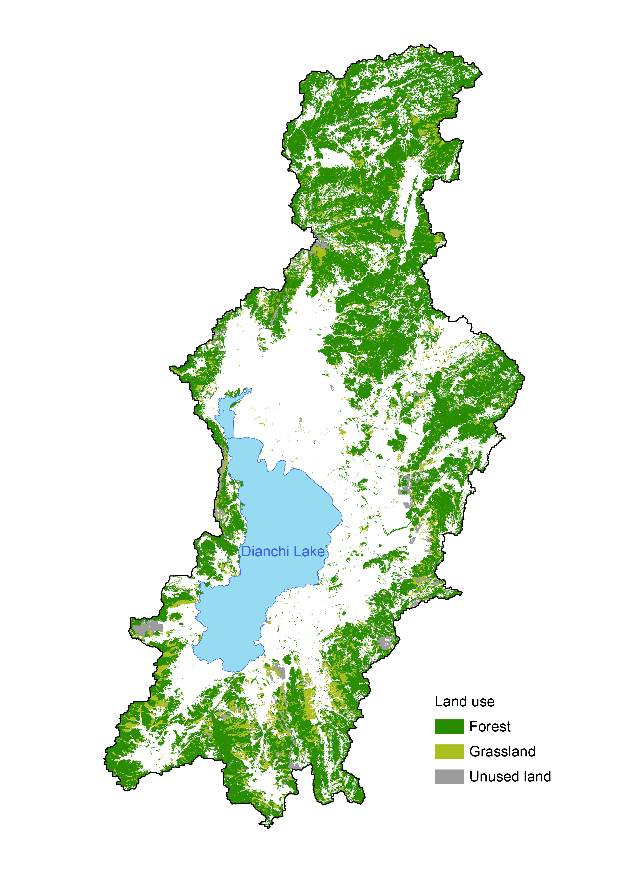
Fig. 9 Distribution of forest and grassland in Dianchi Lake Basin

