Appendix 1
Supplementary Material

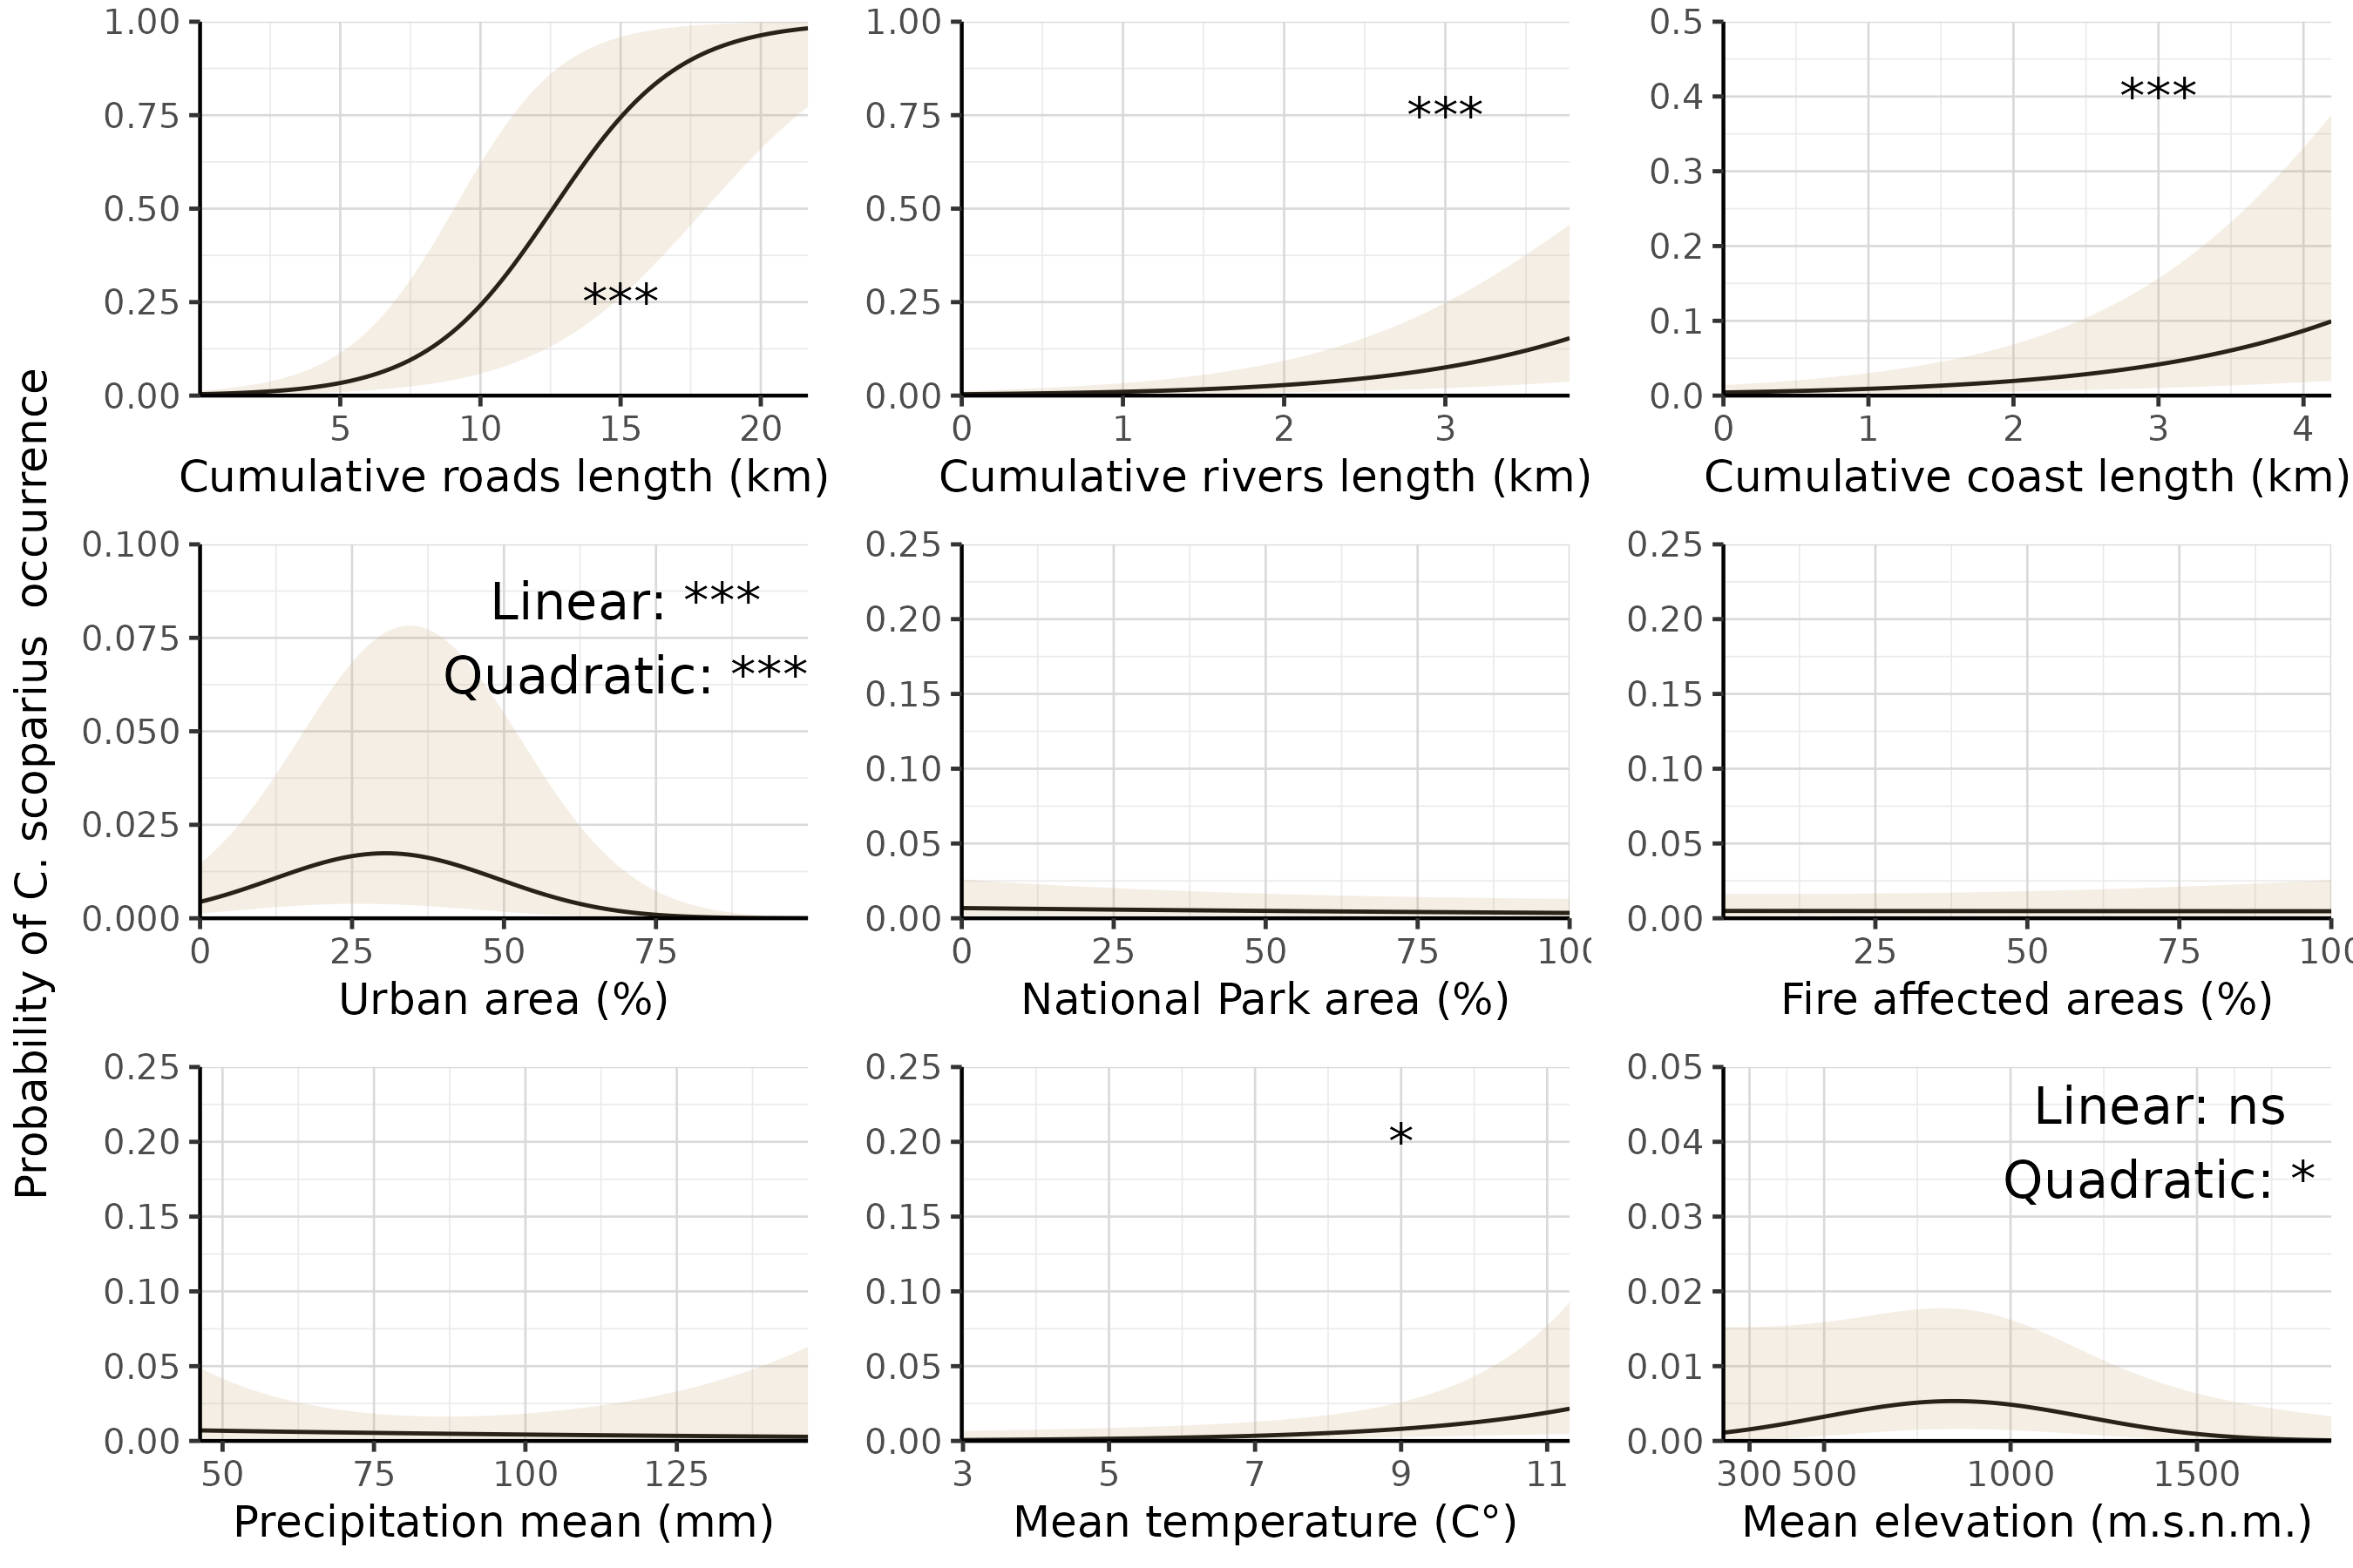
Figure S1 Marginal effects of model parameters on the probability of C. scoparius occurrence in a 1km² cell. All parameters are shown and keeping all other variables constant at their average. Lines and color envelopes indicate the mean and its corresponding 95 % CI. Note: The model was fitted using all occurrence records but only a representative subset of available control cells. Therefore, the predicted probabilities should not be interpreted as estimates of the true occurrence probability in the landscape. However, the shape and direction of the relationships between predictors and occurrence are not affected by this sampling design.

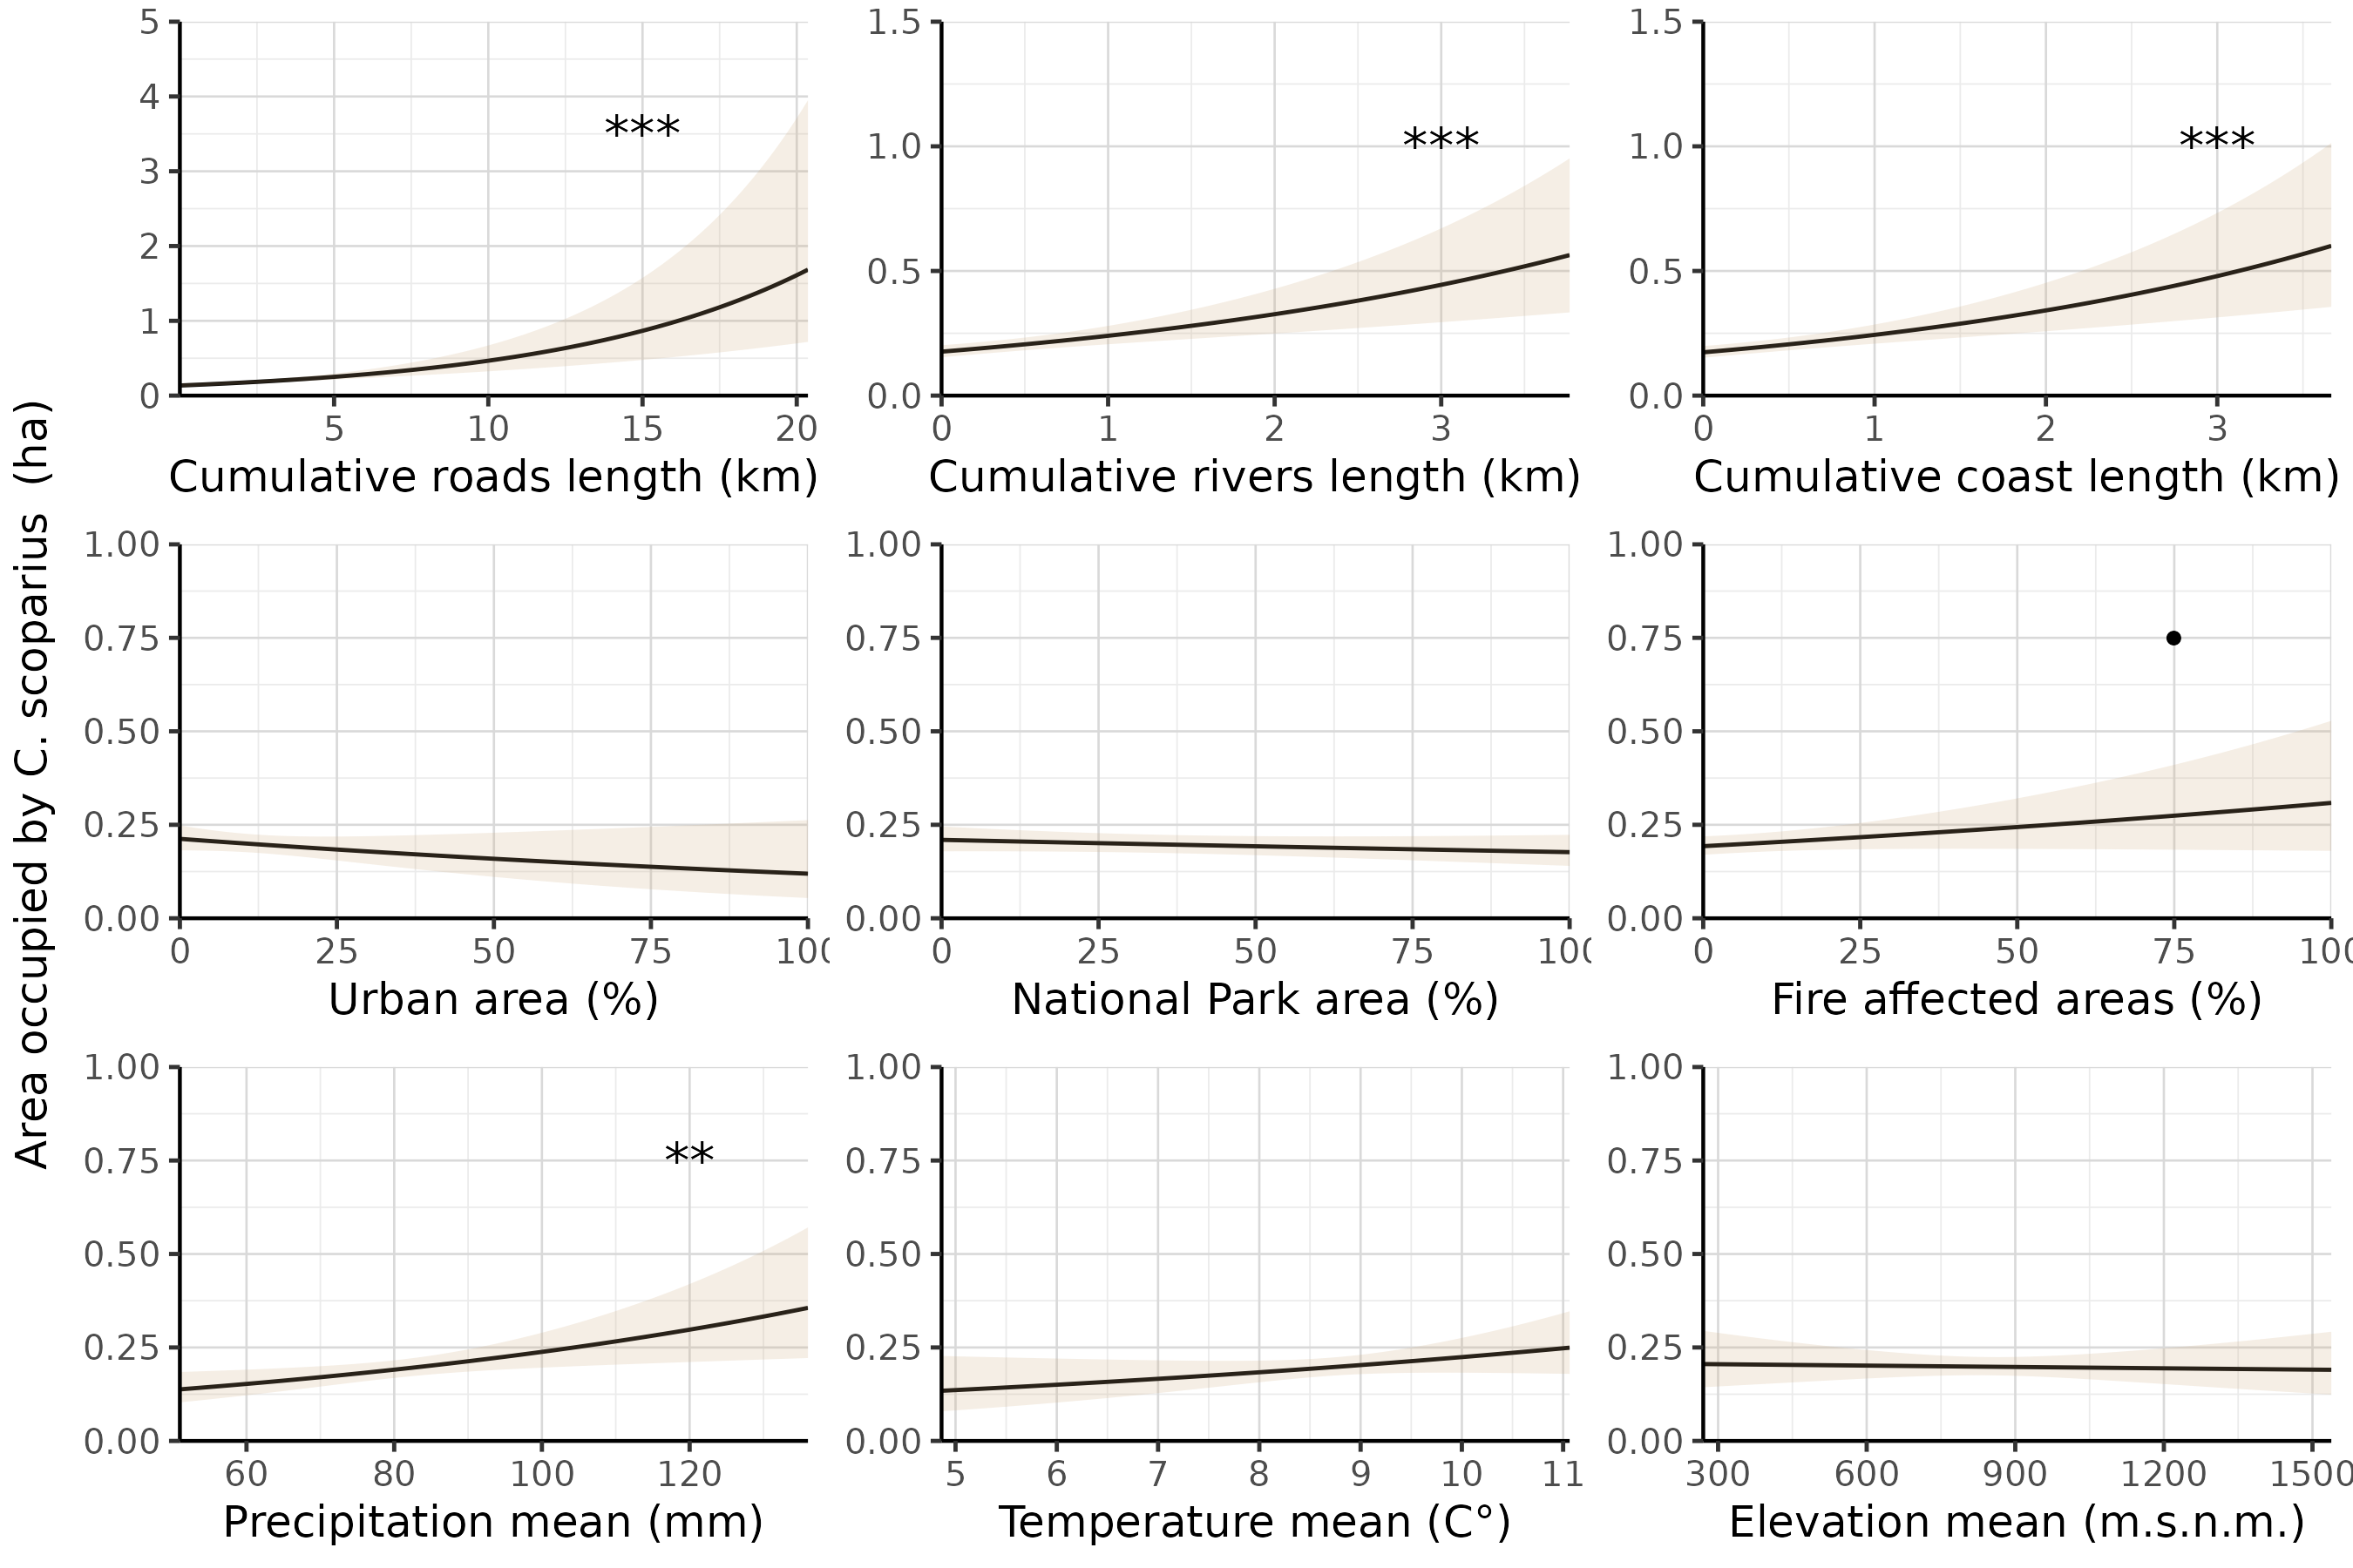
Figure S2. Marginal effects of model parameters of C. scoparius invaded area in a 1km² cell. All parameters are shown and keeping all other variables constant at their average. In all cases lines and color envelopes indicate the mean and its corresponding 95 % CI. The statistical significance is indicated (•p ≈ 0.051, *p < 0.05, ** p < 0.01, *** p < 0.001).

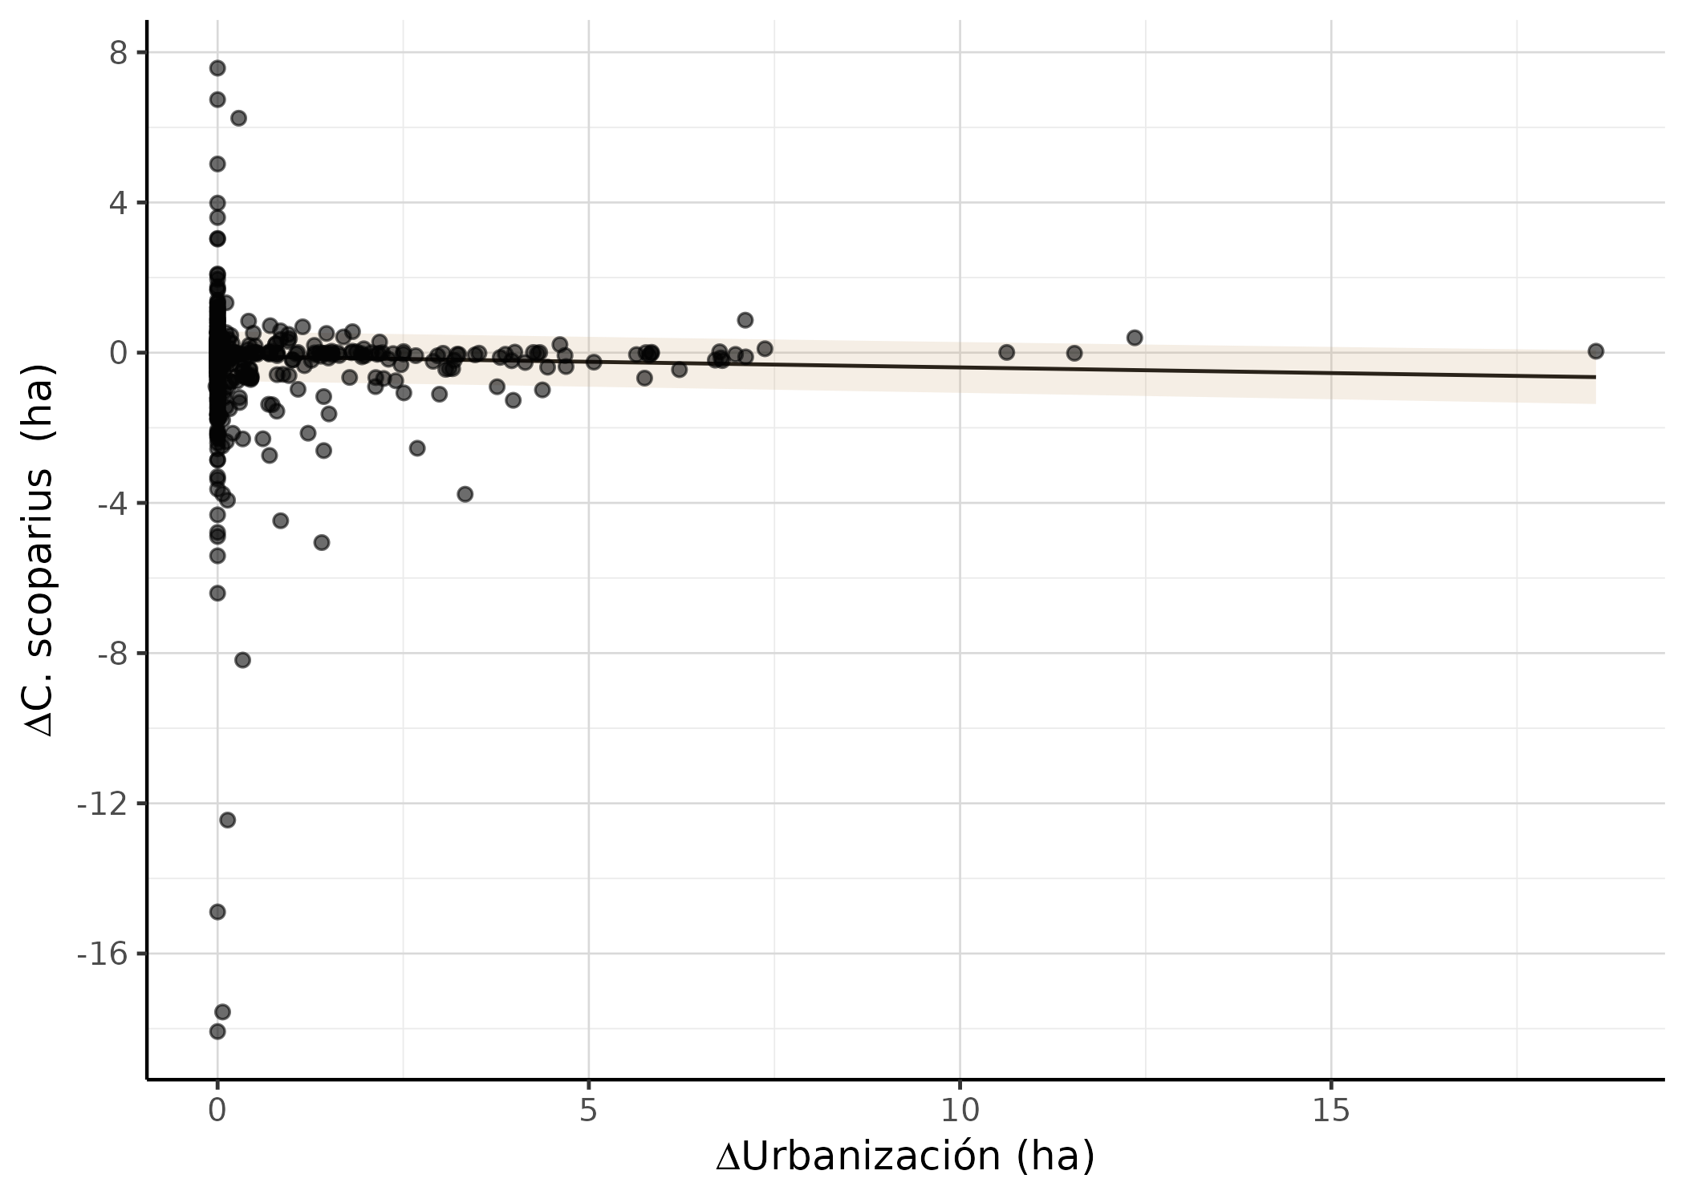

Figure S3 C. scoparius invaded area change, average last three years minus average first three years sampled, in function of urban area change of the same years within 1km² grid cells across the study area. The line and envelope indicate the estimated mean of the invaded area change with its corresponding 95 % CI, and the points show the observed data for each 1km² grid cell.
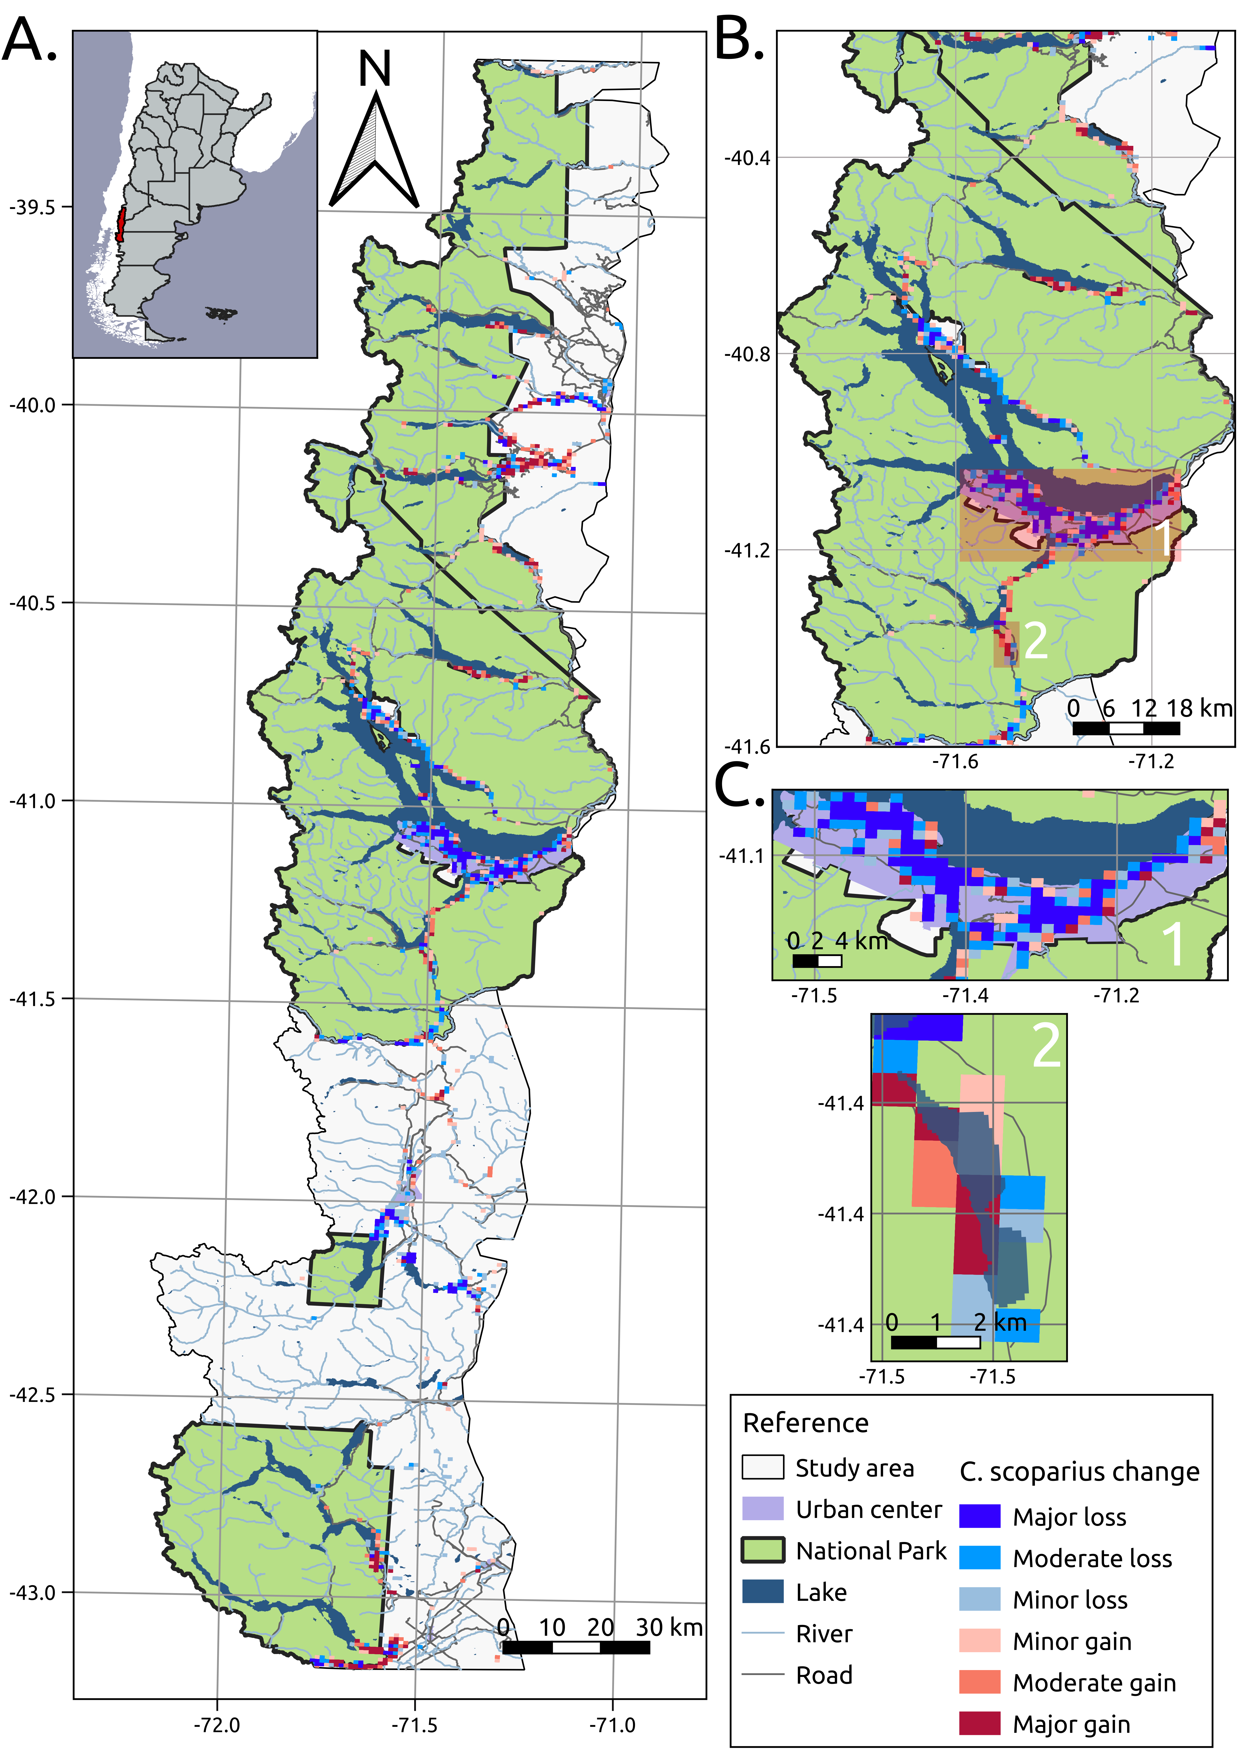

Figure S4. A. Change in C. scoparius invasion area within 1km² grid cells across the study area for the average of the three last years that included urban change data available (2022, 2023, 2024) minus the average of the three first years sampled (2017, 2018, 2019). B. Detail of Nahuel Huapi National Park showing two subareas: (1) the urban area of San Carlos de Bariloche and (2) a non-urbanized area surrounding Lake Guillelmo.

