Online Resource 1
Predictive accuracy without physical validity: structural channel corruption in industrial gas-turbine field data
Journal: Journal of Intelligent Information Systems
Montaser Saeed¹*, Saad Adam²
¹ Department of Aeronautical Engineering, Bright Star University, El Brega, Libya
² Department of Mechanical Engineering, Faculty of Engineering, Tobruk University, Tobruk, Libya
*Corresponding author: montaser.saeed@bsu.edu.ly
Contents
- Section S1. Verification of the reconstruction
- Table S1. Reconstruction rules and gross plausibility bounds
- Table S2. Block-corruption metrics in the pre-specified benchmark
- Table S3. Secondary point-corruption scenarios
- Table S4. Post hoc benchmark sensitivity analyses
- Figures S1–S8
- Supplementary Protocol. Pre-specified benchmark protocol
- Section S2. Reproducibility package

Section S1. Verification of the reconstruction
This section summarises the checks on the direction and completeness of the T₁/start-count correction (rule R01) referred to in Section 2.4 of the main text. All checks use the source records and the cumulative counters only; none uses the regression model, so the physical plausibility of the fitted sensitivities is not used as evidence that the reconstruction is correct. Counts refer to the study period (3,067 hourly records) unless stated otherwise.
S1.1 Orientation and completeness of R01
R01 was applied to 2,520 records in total: 2,508 fall within the study period and 12 fall outside the study period (rule R03). In the study period, 2,501 records met both conditions of the classification rule (start-count position below 100 and T₁ position above 100); the remaining 7 were assigned from other rows in the same worksheet because one member was missing or malformed (Section 3.1). Before correction, the T₁ row held values above 100 in 2,508 study-period records and the start-count row held values below 100 in 2,501. After correction, no reconstructed T₁ value exceeds 100 and no start-count value is below 100: reconstructed T₁ spans 20.3–36.2 °C (n = 3,000) and the start count spans 925–1,250 (n = 2,915). Because the two numerical domains do not overlap, the orientation of every transposed record is determined without ambiguity.
S1.2 Monotonicity of the reconstructed start count
A start counter can only increase. As recorded, the start-count row decreased at 1,312 of 3,006 consecutive readings, because transposed rows inserted temperature values into the series. After R01 and before R06, 20 decreases remained (17 by more than one unit). Rule R06 excluded 96 start-count readings that lay outside the longest monotonic, clock-rate-admissible sequence; after R06, 4 decreases remained, none by more than one unit, and the series rose from 925 to 1,250. Monotonicity after R06 is partly a consequence of the rule itself; the informative quantities are the small number of readings R06 had to exclude and the near-monotonic series obtained after R01 alone.
S1.3 Consistency of the cumulative operating counters
Turbine hours should equal the sum of gas- and liquid-fuel-fired hours plus a constant. As recorded, H_{T} − H_{G} − H_{L} had a standard deviation of 2,751 h, with 86 readings more than 5 h from the median, because of mistyped counter values. R06 excluded 58 turbine-hour, 43 gas-fuel-hour, and 26 liquid-fuel-hour readings in the study period. Afterwards, the identity had a median of 45 h and a standard deviation of 1.6 h (range 43–58 h; n = 2,897; Fig. S4). These counters fix the chronology of the worksheets, including the date correction under R02, on which the assignment of records to hours depends.
S1.4 Consistency with the separately recorded ceiling temperature
Ceiling (enclosure) temperature responds to the same ambient conditions as T₁ but is recorded in a different row of the worksheet. Its Pearson correlation with the published T₁ column was 0.36 (n = 3,007) and with the reconstructed T₁ 0.78 (n = 2,997). Ceiling temperature exceeded reconstructed T₁ in 2,995 of 2,997 records, by a mean of 17.3 °C (s.d. 2.4 °C); in the complete-case stable sample used in Section 3.5 (n = 1,460) the correlation was 0.82 and the mean offset 17.6 °C (Fig. S3).
S1.5 Limitations of these checks
The checks establish the orientation and completeness of the transposition correction, not the accuracy of individual values. They cannot detect values that are wrong but numerically plausible; Fig. S5 shows stable-hour observations that are inconsistent with the load–ambient relation yet lie inside the plausibility bounds, and these were retained. Ceiling temperature is not a measurement of T₁; agreement with it indicates consistency, not validation. The same channel is used in the main text as a substitute in the controlled experiments, which address a different question (the effect of substitution by a correlated, offset channel). Values excluded under R05–R07 were not imputed, so the reconstructed dataset contains gaps rather than estimated values.

Table S1. Reconstruction rules and gross plausibility bounds
Table S1A. Source-audit rules. Probable values recorded under R05–R07 are informational and were not inserted into the reconstructed dataset.
Rule | Name | Definition | Class | Treatment
R01 | Channel transposition | Rows "Start count" and "Compressor inlet air temp. (T₁)" exchanged in the source sheet. Row is transposed when start-count slot < 100 and T₁ slot > 100; ambiguous rows (one slot missing or mistyped) take the layout of the other rows of the same sheet. | Deterministic | Applied
R02 | Mis-dated worksheet | Sheet name encodes a date inconsistent with its Date cell and with the cumulative counters of neighbouring sheets; date corrected to the one confirmed by the counters. | Deterministic | Applied
R03 | Out-of-period worksheet | Sheet dated after the study period filed among study-period sheets. | Deterministic | Kept, flagged outside study period
R04 | Empty worksheet | Sheet template with no time header or values. | Deterministic | Documented only
R05 | Non-numeric cell | Operational notes moved to the event-text field; malformed numbers (e.g. "0..94") excluded, with a repaired Probable Value. | Excluded | Probable values not applied
R06 | Counter inconsistency | Cumulative counter reading outside the longest sequence of readings that never decreases by more than 1 unit and advances no faster than the clock (hours counters: elapsed hours + 1; start count: max(3, elapsed hours/2)); sequence found by dynamic programming. | Excluded | Interpolated Probable_Value not applied
R07 | Physical bounds | Value outside the gross bounds listed in Table S1B. If exactly one decimal shift (/10, /100, /1000, x10) lands inside the 1-99 % range of the channel, it is reported as Probable Value. | Excluded | Probable values not applied
R08 | T₅ cross-channel | While running (P > 200 kW), a T₅ thermocouple more than 100 °C from the median of the six. | Flag | Value kept

Table S1B. Gross physical-plausibility bounds used by R07 (inclusive). The bounds are deliberately wide: they admit shutdown values and reject only values that cannot be physical for this 5.68-MW, 11-kV, 50-Hz unit. Variable names are as written in the source worksheets.
Variable | Lower | Upper | Variable | Lower | Upper
Compressor-inlet air temperature T₁ (°C) | 10 | 50 | Generator excitation current (A) | 0 | 20
Ceiling temperature (°C) | 15 | 80 | Instrument Air Pressure (barg) | 0 | 12
Compressor T₅ average (°C) | 0 | 800 | Gas Fuel Control Temperature (°C) | 5 | 80
Turbine Exhaust temperature T₇ (Average) (°C) | 0 | 750 | Enclosure Main Filter DP (mbard) | -1 | 5
Compressor outlet air pressure (PCD) (barg) | 0 | 15 | Turbine air inlet filter DP (mbard) [A] | 0 | 5
Lube oil pressure (mbarg) | 0 | 15 | Turbine air inlet filter DP (mbard) [B] | 0 | 5
Lube oil temperature (°C) | 0 | 110 | Turbine Air Inlet Pre Filter DP (mbard) | 0 | 5
Gearbox Acceleration Vibration (g ms) | 0 | 50 | Turbine Air Inlet PrePre Filter DP (mbard) | 0 | 5
Generator DE bearing temperature (°C) | 0 | 120 | Turbine temperature T₅ #1 (°C) | 0 | 800
Generator NDE bearing temperature (°C) | 0 | 120 | Turbine temperature T₅ #2 (°C) | 0 | 800
Gas fuel flow (kg/h) | 0 | 2500 | Turbine temperature T₅ #3 (°C) | 0 | 800
Gas fuel pressure 1 (barg) | 0 | 40 | Turbine temperature T₅ #4 (°C) | 0 | 800
Liquid fuel flow (kg/min) | 0 | 40 | Turbine temperature T₅ #5 (°C) | 0 | 800
Liquid fuel inlet pressure (barg) | 0 | 30 | Turbine temperature T₅ #6 (°C) | 0 | 800
Voltage (Vac) | 0 | 13000 | Turbine vibration 1 X (µm pp) | 0 | 200
Current A (A) | 0 | 500 | Turbine vibration 1 Y (µm pp) | 0 | 200
Current B (A) | 0 | 500 | Turbine vibration 2 X (µm pp) | 0 | 200
Current C (A) | 0 | 500 | Turbine vibration 2 Y (µm pp) | 0 | 200
Real power (kW) | 0 | 6500 | Turbine vibration 3 X (µm pp) | 0 | 200
Apparent power (kVA) | 0 | 8000 | Turbine vibration 3 Y (µm pp) | 0 | 200
Reactive power (kVAR) | 0 | 6000 | Generator L1 winding temperature (°C) | 0 | 155
Power factor | 0 | 1 | Generator L2 winding temperature (°C) | 0 | 155
Frequency (Hz) | 0 | 55 | Generator L3 winding temperature (°C) | 0 | 155

Table S2. Block-corruption metrics in the pre-specified benchmark
Table S2. Detection delay, detected-block fraction, and channel localisation for the block pattern (contiguous 25% of the evaluation half), with the clean-data false-positive rate (FPR) for comparison. Values are medians over the five swap pairs of the scenario-level medians over five seeds. Localisation was specified for the physics–chronology detector only.
Method | Reference | Delay (rows) | Fraction of block detected | Localisation | Clean-data FPR
Physics–chronology | A | 0 | 1.000 | 1.000 | 0.683
 | B | 0 | 1.000 | 1.000 | 0.520
Isolation Forest | A | 20 | 0.036 | – | 0.036
 | B | 13 | 0.116 | – | 0.096
Range/IQR | A | 0 | 1.000 | – | 0.425
 | B | 0 | 0.959 | – | 0.472
Robust z | A | 0 | 1.000 | – | 0.982
 | B | 0 | 0.983 | – | 0.634
Robust Mahalanobis | A | 0 | 1.000 | – | 1.000
 | B | 0 | 1.000 | – | 0.997
Methods with zero delay and complete block detection also had high clean-data false-positive rates, so these metrics are informative only together with the false-positive rate.
Table S3. Secondary point-corruption scenarios
Table S3. Median recall over five seeds for point corruption of 1% of evaluation rows (spike: multiplication by U(3, 10); decimal shift: ×10 or ×0.1) in one randomly chosen channel, with the clean-data false-positive rate. Each seed corrupted 2 rows in Reference A and 11 rows in Reference B, so recall is estimated from very few rows.
Method | Recall, spike (A / B) | Recall, decimal shift (A / B) | Clean-data FPR (A / B)
Physics–chronology | 1.000 / 0.909 | 1.000 / 1.000 | 0.683 / 0.520
Isolation Forest | 0.000 / 0.091 | 0.000 / 0.091 | 0.036 / 0.096
Range/IQR | 1.000 / 1.000 | 1.000 / 1.000 | 0.425 / 0.472
Robust z | 1.000 / 1.000 | 1.000 / 1.000 | 0.982 / 0.634
Robust Mahalanobis | 1.000 / 1.000 | 1.000 / 1.000 | 1.000 / 0.997
Superiority of the physics–chronology detector was not required in these scenarios (Supplementary Protocol).
Table S4. Post hoc benchmark sensitivity analyses
Table S4A. Post hoc variants of the four statistical detectors (not part of the pre-specified protocol). V1 excludes the four cumulative counters unless they form part of the swapped pair; V2 fits and evaluates each detector on the two swapped channels only and therefore assumes knowledge of which channels were exchanged. Clean-data FPR is the median over the five pair-specific channel sets; median recall is over the 20 swap scenarios of each reference set; the last column counts scenarios (of 40) with recall ≥ 0.90 and FPR ≤ 0.05, using medians over five seeds.
Variant | Detector | Clean-data FPR (A / B) | Median recall (A / B) | Scenarios meeting both thresholds
V1: without counters | Isolation Forest | 0.045 / 0.082 | 0.034 / 0.092 | 0/40
 | Range/IQR | 0.081 / 0.472 | 1.000 / 0.884 | 2/40
 | Robust z | 0.964 / 0.575 | 1.000 / 0.952 | 0/40
 | Robust Mahalanobis | 0.995 / 0.952 | 1.000 / 1.000 | 0/40
V2: swapped pair only | Isolation Forest | 0.072 / 0.082 | 0.975 / 1.000 | 2/40
 | Range/IQR | 0.009 / 0.003 | 1.000 / 0.831 | 17/40
 | Robust z | 0.068 / 0.101 | 1.000 / 0.905 | 12/40
 | Robust Mahalanobis | 0.127 / 0.263 | 1.000 / 1.000 | 5/40

Table S4B. Variant V2: number of scenarios (of 8 per pair: four patterns × two references) meeting both thresholds, by swapped pair.
Detector | T₁ ↔ start count | T₁ ↔ ceiling temperature | Gas-fuel flow ↔ average T₅ | T₅#2 ↔ T₅#5 | DE ↔ NDE bearing temperature | Total (of 40)
Isolation Forest | 1 | 1 | 0 | 0 | 0 | 2
Range/IQR | 5 | 8 | 4 | 0 | 0 | 17
Robust z | 1 | 4 | 7 | 0 | 0 | 12
Robust Mahalanobis | 0 | 1 | 0 | 0 | 4 | 5
Successes were confined to pairs whose channels occupy distinct numerical ranges, except for robust Mahalanobis on the DE ↔ NDE pair; no variant detected the exchange of two T₅ thermocouples.

Figures S1–S8
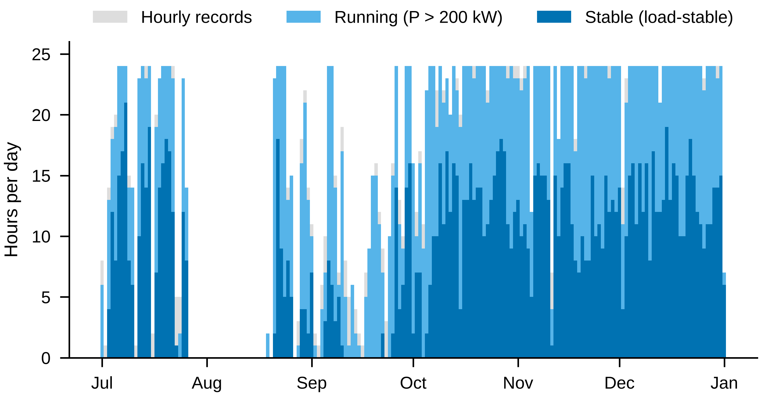
Fig. S1. Daily availability of hourly records, running hours (P > 200 kW), and load-stable hours over the study period.
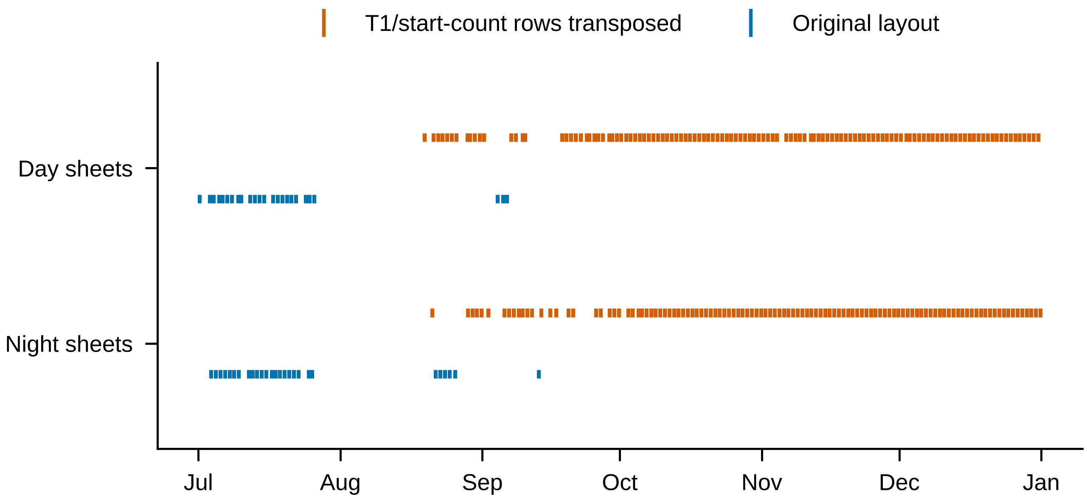
Fig. S2. Layout of the T₁/start-count rows in each shift worksheet containing data in either row. Transposition was intermittent at the worksheet level rather than a single continuous period.
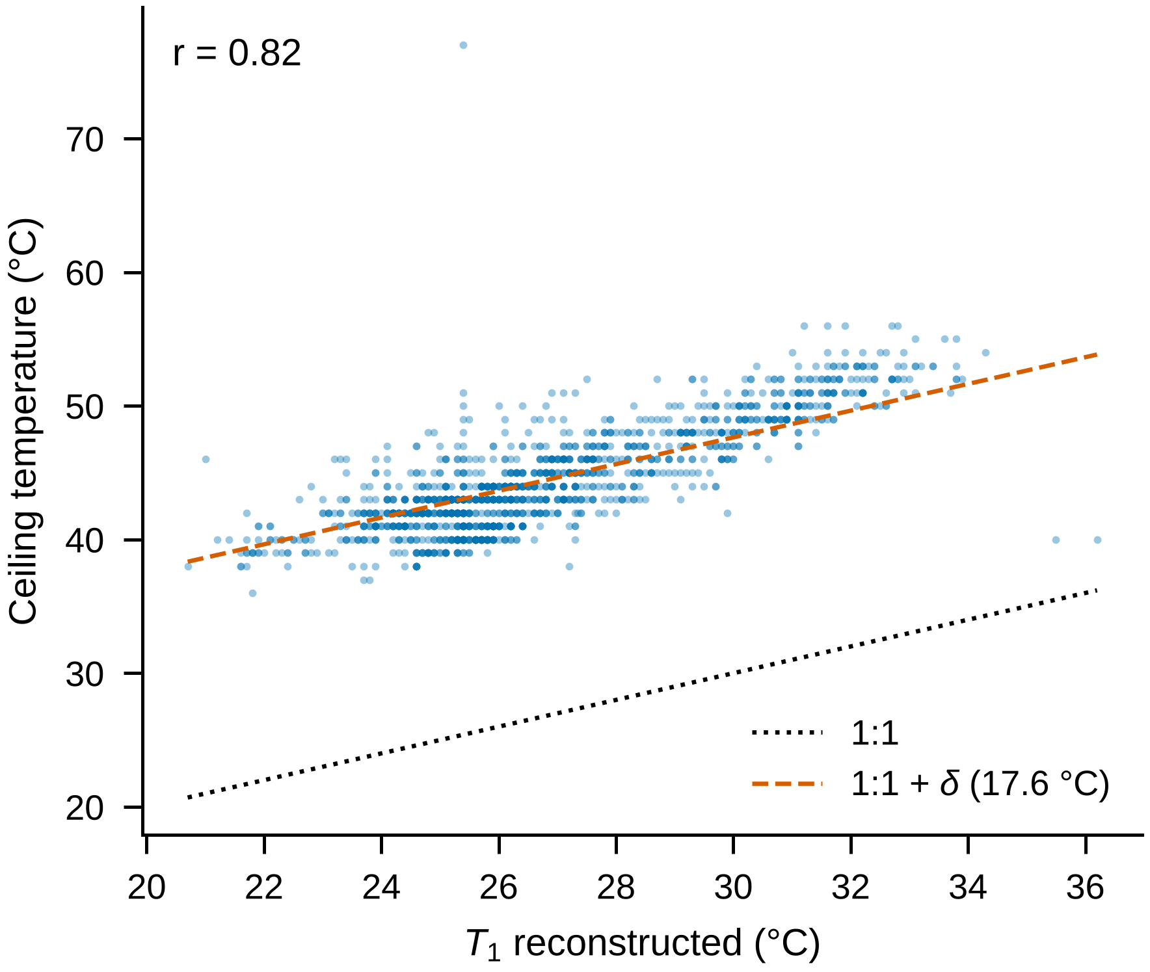
Fig. S3. Reconstructed T₁ versus ceiling (enclosure) temperature in the complete-case stable sample (n = 1,460; r = 0.82)—dotted line: 1:1; dashed line: 1:1 plus the mean offset δ = 17.6 °C.
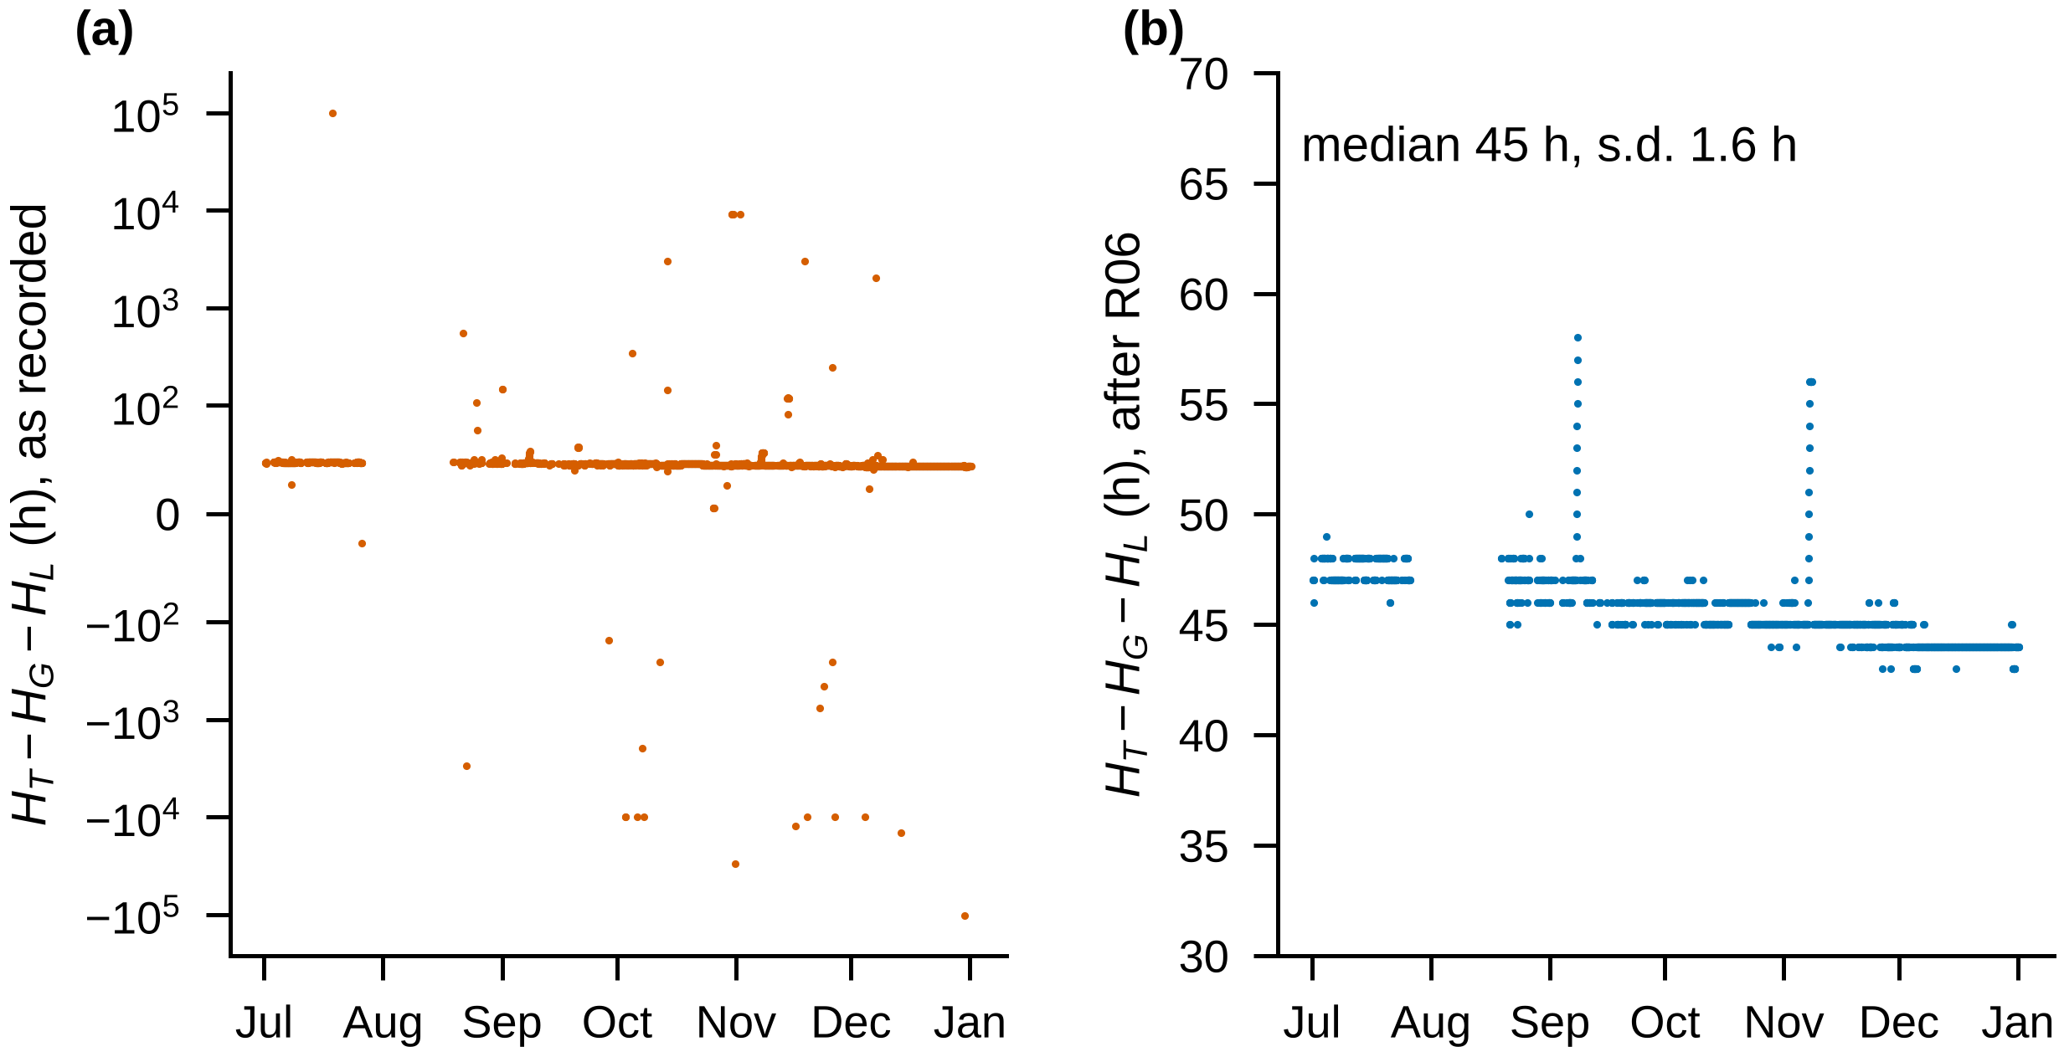
Fig. S4. Counter identity H_{T} − H_{G} − H_{L} (turbine hours minus gas- and liquid-fuel-fired hours). (a) As recorded (symmetric-log scale). (b) After rule R06 (median 45 h, s.d. 1.6 h). Short residual excursions and a slow drift of about 3 h remain and are reported rather than corrected.
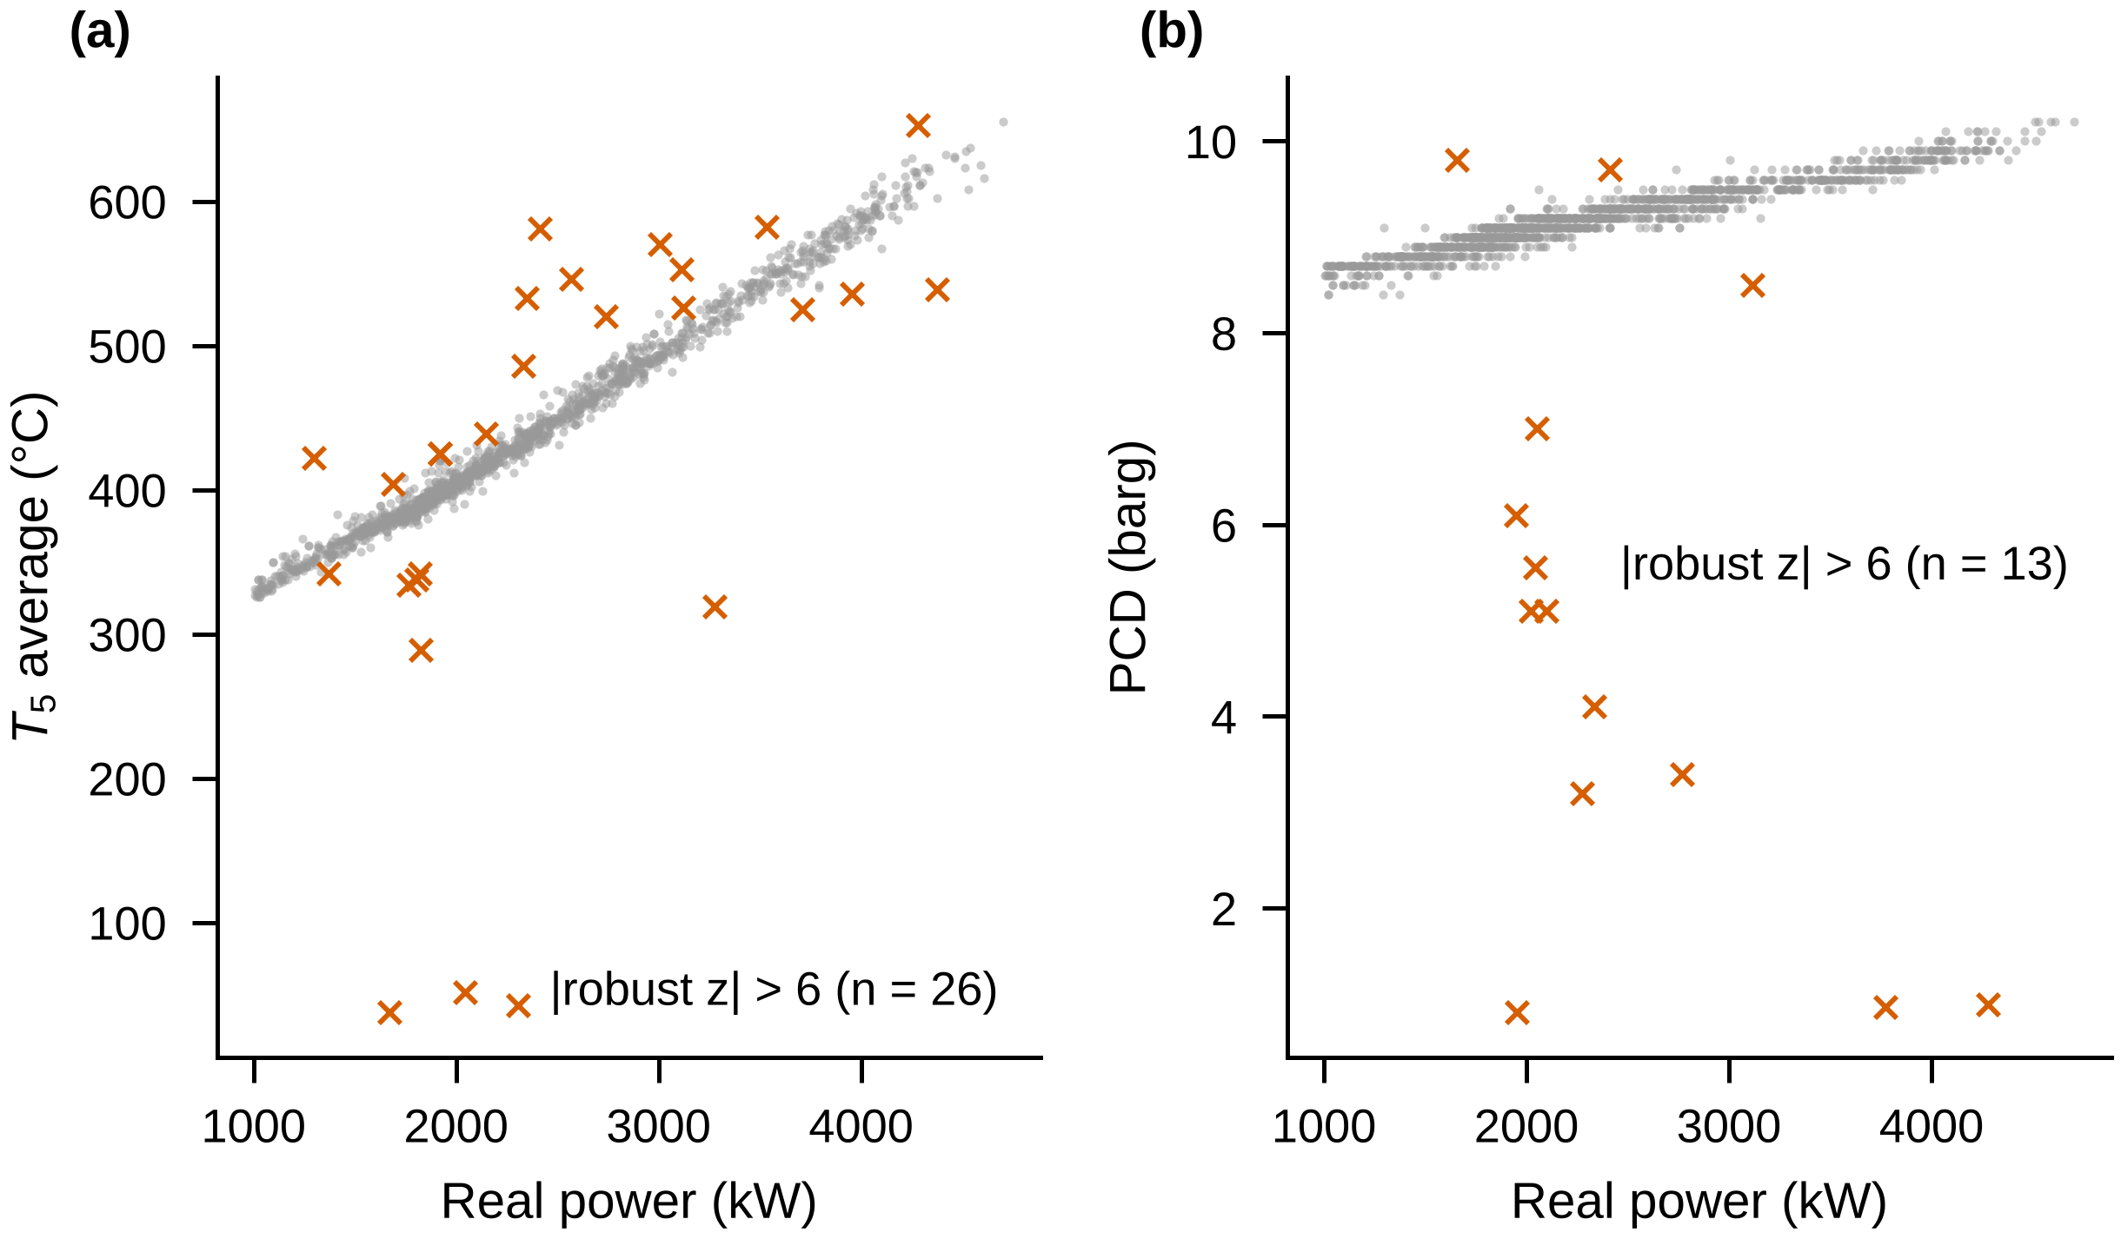
Fig. S5. Stable-hour observations inconsistent with the load–ambient relation Y = f(P, P², T₁) (|robust z| > 6): (a) average T₅ (n = 26); (b) compressor discharge pressure (n = 13). Some are physically implausible for loads above 1.5 MW (T₅ ≈ 40 °C, PCD ≈ 1 barg) yet lie inside the gross plausibility bounds; others may be genuine transients. We retained them, so the reconstructed dataset is not error-free.
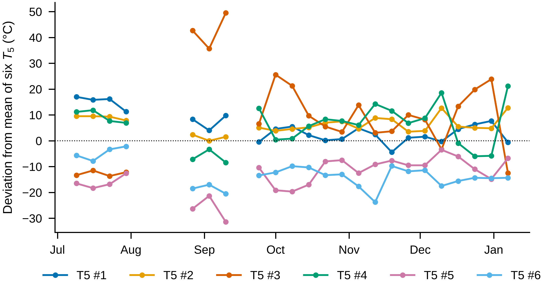
Fig. S6. Weekly median deviation of each of the six T₅ thermocouples from their mean in stable hours. Thermocouple #3 shows a transient departure of +35 to +50 °C in late August–September.
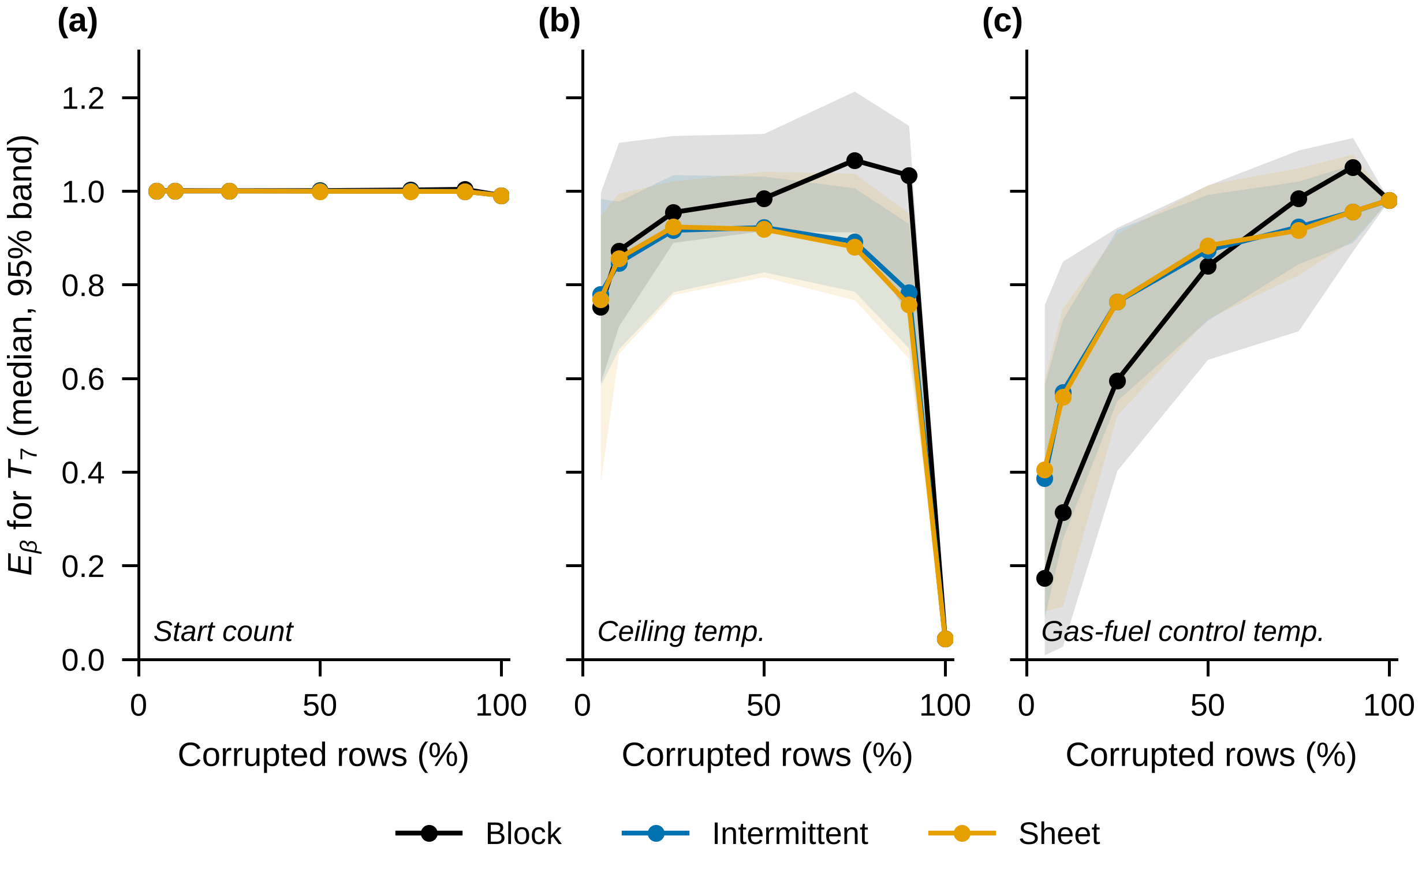
Fig. S7. Controlled substitutions. Effect of the corruption pattern (block, intermittent, whole worksheets) on E_{β} for T₇, for each substitute channel (median and 95% band of 200 replications).
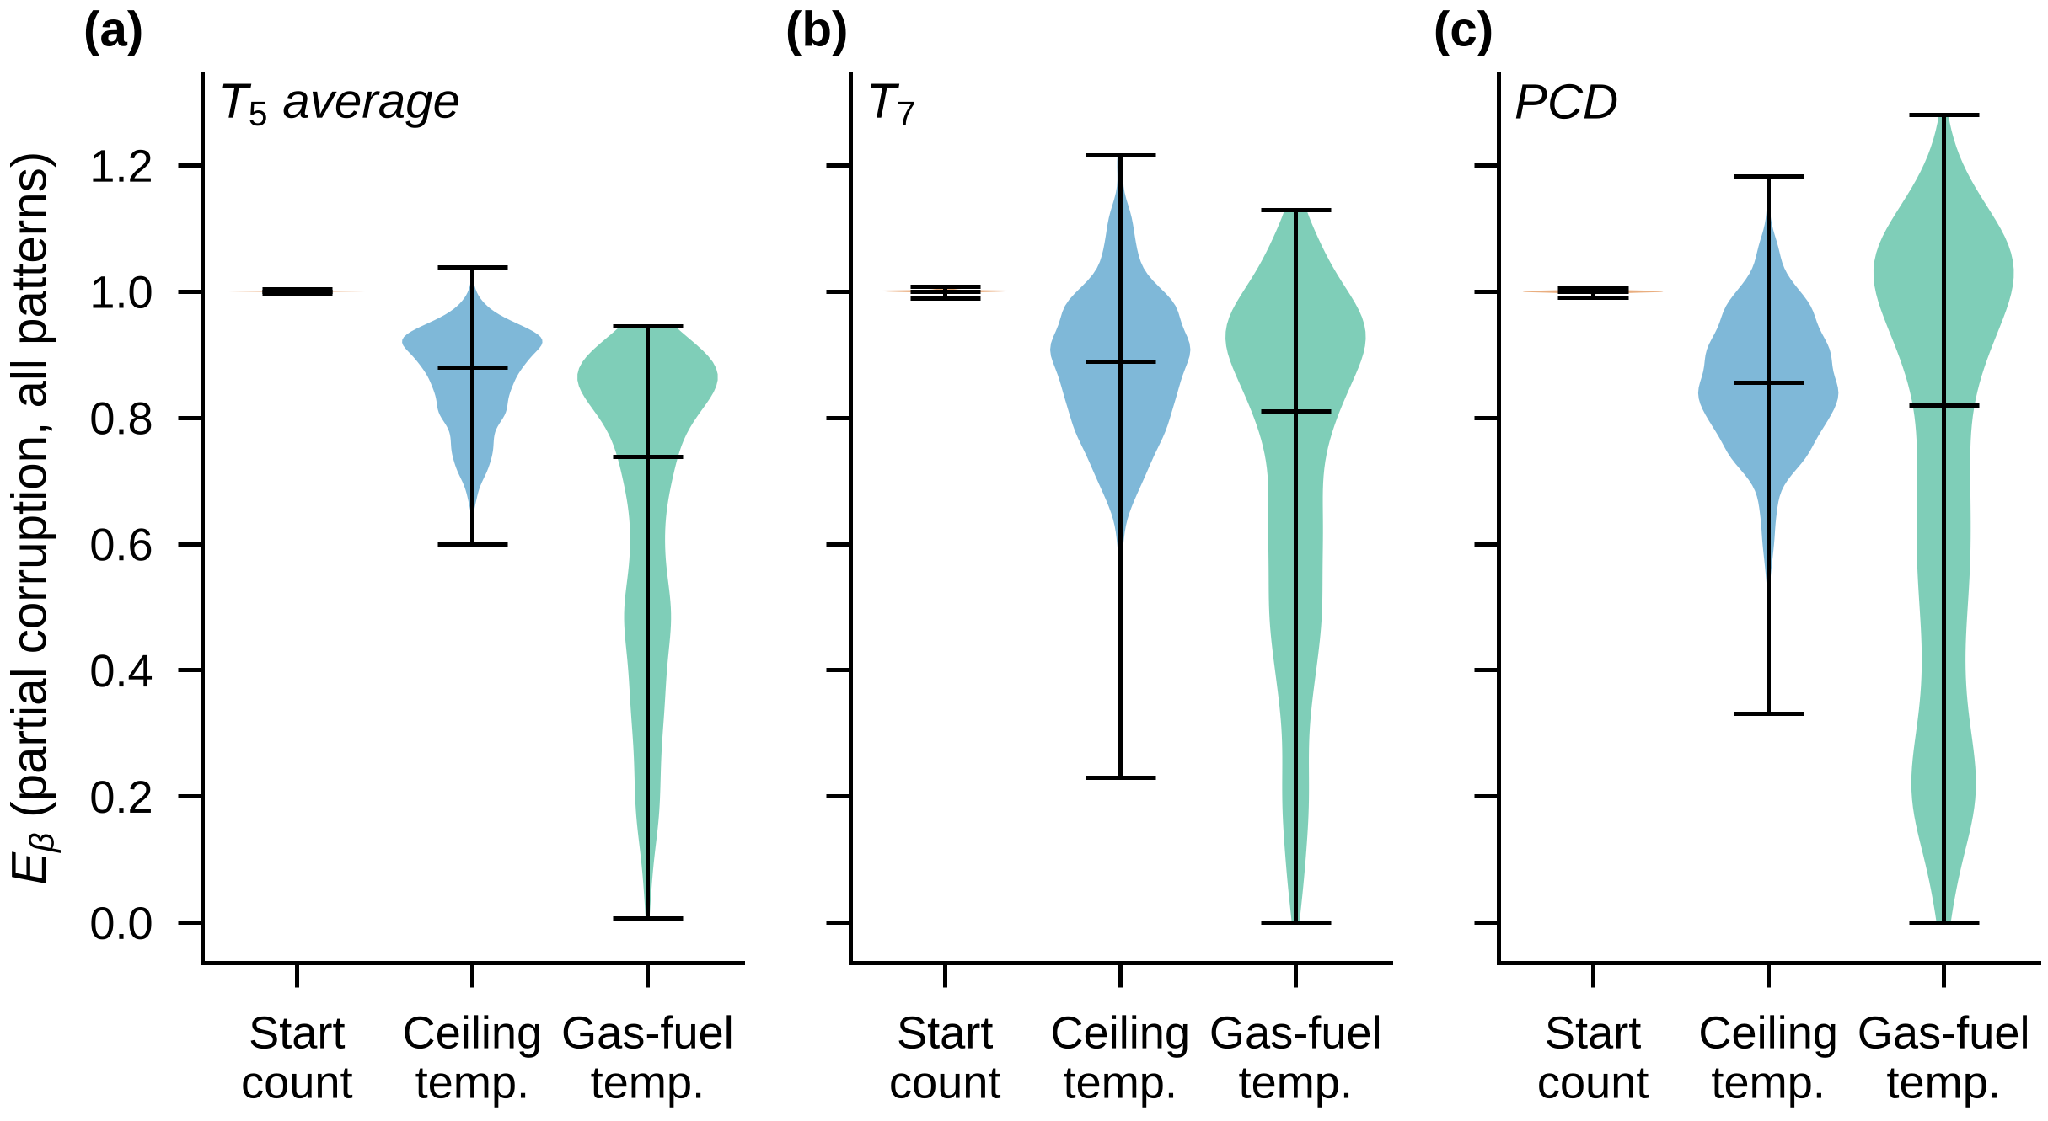
Fig. S8. Controlled substitutions. Distribution of E_{β} under partial substitution (5–90%, all patterns) by substitute channel, for (a) T₅, (b) T₇, and (c) compressor discharge pressure.

Supplementary Protocol. Pre-specified benchmark protocol
The following is a condensed and reorganised presentation of the benchmark protocol frozen on 29 September 2026, before the benchmark code was executed (benchmark_preregistration.md). The protocol was not deposited in an externally time-stamped registry and is therefore described as pre-specified, rather than preregistered. “Framework” refers to the physics–chronology detector, “Master v1.0” to the reconstructed dataset, and “Experiment II” to the smaller pre-specified substitution experiment (Section 2.6). The verbatim protocol file is included in Online Resource 2.
P1. Data and reference populations
The benchmark used Master v1.0 (GT568 Master Reconstructed; 3,079 records). Two reference populations were selected from running, gas-fuel observations within the July-December 2017 study period.
Reference A (pristine; approximately 441 observations) included only records with Quality Flag = OK, indicating that no reconstruction or exclusion rule had been triggered.
Reference B (reconstructed; approximately 2,351 observations) included Reference A records and those corrected deterministically under R01 or R02, excluding any records affected by R05–R08.
Reference A covered July–September 2017, whereas Reference B covered July December 2017. Each population was divided chronologically into equal calibration and evaluation halves. We calibrated detectors on the first half and injected known channel swaps only into the second half. Injection labels were not provided to the detectors.
The same channels were evaluated by all methods: T₁, ceiling temperature, average T₅, T₅ thermocouples #1–#6, T₇, compressor discharge pressure (PCD), gas-fuel flow, real/apparent/reactive power, power factor, voltage, phase currents A–C, generator drive-end (DE) and non-drive-end (NDE) bearing temperatures, generator winding temperatures L1–L3, lubricating-oil temperature and pressure, gearbox vibration, six turbine vibration channels, inlet-filter differential pressure [A], turbine/gas/liquid operating hours, and start count.
P2. Physics–chronology detector
The proposed framework combined three types of constraints, with thresholds fixed before execution.
Physical plausibility: Gross channel bounds from the Bounds sheet of Master v1.0 (rule R07).
Counter consistency: The longest monotonic, clock-rate-admissible counter sequence (R06), together with the turbine-hour identity:
$$H_{T}-H_{G}-H_{L}=constant,$$
with a robust-z threshold greater than 6 for violations of the identity.
Analytical redundancy: Relations between operational channels, with coefficients estimated by ordinary least squares (OLS) on the calibration half. The relations were:
$$S≈\sqrt{3} V\overline{I}, \\ P≈S PF, \\ Q≈\sqrt{S^{2}-P^{2}}, \\ I_{k}≈mean⁡\left(I_{\text{other two phases}}\right), \\ W_{k}≈mean⁡\left(W_{\text{other two windings}}\right). \\ T_{5,i}-mean⁡\left(T_{5,j≠i}\right)≈a+bP, i=1,…,6, \\ T_{5,avg}≈a+b mean⁡\left(T_{5,1} , … , T_{5,6}\right), \\ T_{7}≈a+bT_{5,avg}, \\ F_{g}≈a+bP+cP^{2}, \\ PCD≈a+bP+cP^{2}+dT_{1}, \\ T_{1}≈a+bT_{ceiling}, \\ T_{DE}≈a+bT_{NDE}.$$
Each relation predicted one target channel. We normalised its residual using the calibration median and median absolute deviation (MAD).
A relation was considered violated when either the absolute normalised residual exceeded 6 at an individual row or its centred five-row rolling median exceeded 3. We flagged a row if any constraint was violated; we recorded the target of the violated relation as the localised channel.
P3. Statistical baseline detectors
Four conventional detectors were evaluated using the same channels and row-level alarm aggregation:
Detector | Fixed specification
Range/IQR | Outside the calibration interval defined by the first and third quartiles ± three interquartile ranges
Robust z-score | Absolute median-centred deviation divided by $1.4826×MAD$ greater than 3.5
Isolation Forest | 200 trees; random seed 0; standardised, median-imputed channels; 99th percentile of calibration anomaly scores
Robust Mahalanobis | Minimum Covariance Determinant (MCD), random seed 0, on standardised channels; chi-square threshold at probability $0.999$ with $d$ dimensions
A row was flagged whenever any evaluated channel triggered an alarm.
P4. Corruption scenarios
Five channel-swap pairs were defined:
Pair | Exchanged channels | Intended difficulty
P1 | T₁ ↔ start count | Easy; observed error
P2 | T₁ ↔ ceiling temperature | Medium; values within bounds
P3 | Gas-fuel flow ↔ average T₅ | Medium; values within bounds
P4 | T₅ thermocouple #2 ↔ #5 | Hard; same numerical range
P5 | Generator DE ↔ NDE bearing temperatures | Hard; approximately 3 °C apart
Four temporal patterns were used: (i) a contiguous block covering 25% of evaluation observations; (ii) intermittent runs of 1–12 rows with approximately 30% coverage; (iii) whole 12-hour shift worksheets, covering approximately 40% of worksheets; and (iv) replay of the observed R01 corruption mask, mapped by relative position onto the evaluation half.
The design comprised 5 channel pairs × 4 patterns × 2 reference populations = 40 swap scenarios, each evaluated with five random seeds.
Two secondary point-corruption scenarios were also specified, both affecting 1% of evaluation rows in one randomly selected channel: multiplicative spikes with a factor drawn uniformly from 3 to 10, and decimal shifts by multiplication or division by 10. These scenarios were expected to favour statistical baseline detectors.
P5. Metrics and success criteria
Row-level metrics included recall, false-positive rate (FPR), precision, F1-score, detection delay from the onset of a corrupted block to the first alarm, and the fraction of the corrupted block detected. For the physics–chronology framework, localisation measured the proportion of detected corrupted rows with at least one swapped channel identified.
The primary criterion (H2) required the physics–chronology framework to achieve both recall ≥ 0.90 and FPR ≤ 0.05 in at least 21 of the 40 swap scenarios, using scenario-level medians across five seeds.
The secondary criterion required at least one baseline to have recall below 0.60 or substantially greater detection delay in those scenarios. Superiority of the framework on point spikes or decimal shifts was not required.
If the primary criterion failed, we would report the failure and withdraw the claim of a generally effective screening framework.
P6. Experiment II: Consequences of missed corruption
The evaluation half of Reference B was used to compare clean and corrupted regressions. T₁ was replaced by either start count or ceiling temperature in one contiguous block covering 10%, 25%, 50%, 75%, or 100% of the observations, with five random seeds per configuration.
The model used real power, squared real power, and T₁ to predict average T₅ and T₇. Changes in model fit and the relative error in the T₁ coefficient were reported using $ΔR^{2}$ and $E_{β}$, respectively.
Section S2. Reproducibility package
The reproducibility package contains the analysis scripts, reconstructed dataset, cell-level correction log, pre-specified protocol, and a ledger linking reported numerical results to their generating output files. The three source workbooks remain available through Mendeley Data (DOI: 10.17632/6w3vy3ybhg.3) and are not redistributed. The run_all.sh script reproduces the analyses, with random generators seeded.
Step | Script | Purpose
01 | 01 build master.py | Parse 317 worksheets, reconstruct timestamps, apply R01–R08, and generate the dataset and correction log
01b | 01b write workbook.py | Export the audited Excel workbook, including data, logs, events, rules, bounds, and raw values
02 | 02 published verification.py | Verify published correlations and compare source worksheets with Compiled Raw
03 | 03 three analysts.py | Compare Strategies A/B/C using OLS, day-block bootstrap, post hoc Huber regression, and incremental R²
04 | 04 robustness.py | Evaluate nine stability definitions, models M1–M3, and leave-one-month-out analyses
05 | 05 benchmark.py | Execute the pre-specified screening benchmark and smaller substitution experiment
06 | 06 substitution experiment.py | Run 37,800 exploratory controlled substitutions
07 | 07_eiv derivation.py | Compare the parameter-free errors-in-variables derivation with simulation
08 | 08 independent rerun.py | Independently reimplement Step 06 using Frisch-Waugh partialling and a different random seed
09 | 09 provenance audit.py | Trace reconstructed values to source cells, independently reparse with pandas, and verify worksheet dates
10 | 10 make figures.py | Generate Figures 1–8 and S1–S8
11 | 11 manuscripts numbers.py | Generate the ledger of manuscript numerical results
12 | 12 posthoc reviewer checks.py | Run post hoc cross-validation, time-trend checks, stratified error analyses, and benchmark variants V1/V2 (with bench sens.py)
SHA-256 checksum of GT568 Master Reconstructed.csv:

