Supplementary Materials

- Methods

- Results

- Table S1 – Sociodemographic characteristics associated with retention at 14-23 years

- Table S2 – Sociodemographic characteristics associated with retention at 18-28 years

- Table S3 – Regression analysis of predictors associated with response at 14-23 years

- Table S4 – Regression analysis of predictors associated with response at 18-28 years

- Table S5 - Operationalization of clinical validators by age of assessment

- Table S6 – Confirmatory Factor Analysis Models for depressive symptoms using sMFQ

- Table S7 - Standardized centrality indices for sMFQ network analysis

- Table S8 - Full regression analysis: clinical groups associated with clinical validators at 14-23 years (cross-sectional) and 18-28 years (longitudinal)

- Table S9 - Regression analysis: clinical groups associated with Any Suicide Attempt or Self-harm at 14-23 years

- Table S10 - Regression analysis: clinical groups associated with Any Suicide Attempt at 18-28 years

- Table S11 - Regression analysis: clinical groups associated with Any Psychiatric Inpatient Admission at 14-23 years

- Table S12 - Regression analysis: clinical groups associated with Any Psychiatric Inpatient Admission at 18-28 years

- Table S13 - Regression analysis: clinical groups associated with Lifetime Substance Use at 14-23 years

- Table S14 - Regression analysis: clinical groups associated with ASSIST Any Moderate/High Risk for Substance Use at 18-28 years

- Table S15 - Regression analysis: clinical groups associated with NEET at 14-23 years

- Table S16 - Regression analysis: clinical groups associated with NEET at 18-28 years

- Table S17 - Regression analysis: clinical groups associated with Conviction at 14-23 years

- Figure S1 – Bootstrapped confidence intervals for edge-weights for sMFQ network analysis

- Figure S2 – Bootstrapped difference test between edge-weights for sMFQ network analysis

- Figure S3 – Bootstrapped difference test between node strength for sMFQ network analysis

- Figure S4 - Average correlations between centrality indices of networks with reduced sample sizes and the original sample

Methods

Loneliness
We first estimated a confirmatory factor model for the sMFQ (see Confirmatory Factor Analysis section below), which yielded a threshold of 0.5 standard deviation (SD) above the mean for item 10 ("I felt lonely"). Response options for this item were scored 0 ("Never"), 1 ("Sometimes"), and 2 ("True"); the 0.5 SD threshold fell between scores 1 and 2. Accordingly, participants scoring 2 ("True") on this item were classified as positive for loneliness in the regression analyses reported below.

Covariates
We adjusted the analysis for the following possible confounding variables: age, sex (male as reference), race/ethnicity categorized as white or non-white (black, mixed and indigenous), study site (Porto Alegre as reference), social isolation and social class as classified by the Brazilian Association of Research Companies (ABEP). Social isolation was measured according to the item “I have at least one good friend” of the Strengths and Difficulties Questionnaire (SDQ). It was considered negative if the answer was “Not True” in a 3-item likert scale (0 = “Not True; 1 = Somewhat True; 2 = Certainly True) and otherwise true. The ABEP is a parent-reported asset-based assessment that also includes parental education and sanitation to classify subjects belonging to the A (highest) to E (lowest and reference category) socioeconomic class.

Oversampling and inverse probability weights
The BHRCS used an oversampling procedure, as described in Salum et al., 2025. A sampling weight was generated to account for this high-risk stratification, which fully accounted for the oversampling procedure (Martel et al., 2017). In a previous analysis of the BHRCS, baseline maternal education and study site predicted response at follow-up (Ziebold et al., 2023). Furthermore, participants who had a mental health diagnosis at baseline and those with maternal mental health problems presented a higher proportion of missing data at follow-up. Therefore, we used these four variables to compute inverse probability weight (IPW) to address sample attrition in all regression analysis (Seaman and White, 2013). For the present study, this procedure was applied separately for retention at 14-23 and 18-28 years. Sampling weight and IPW were multiplied, and weights for the few cases (n = 36) were trimmed for the 1st and 99th percentile. The resulting weights were used throughout the analyses to minimize bias associated with oversampling high-risk procedures and missing data at follow-up, so the sample is closer to the general population at baseline.

Clinical Validators
Life-threatening outcomes
Lifetime suicide attempts were assessed at 18-28 years using the Brazilian Portuguese version of the Columbia-Suicide Severity Rating Scale (C-SSRS) (Posner et al., 2011). Participants were initially asked “Have you ever made a suicide attempt?” and, if endorsed, completed additional questions regarding the characteristics of the behavior and the presence of suicidal intent. Responses were classified according to C-SSRS criteria, with suicide attempts defined as self-injurious acts accompanied by at least some degree of suicidal intent. At 14-23 years, suicidality was assessed using a self-report item from the Brazilian Portuguese version of the Development and Well-Being Assessment (DAWBA) (Goodman et al., 2000), which asked whether participants “Have you ever tried to hurt yourself or kill yourself?”. This item was administered only to participants who endorsed previous screening questions indicating depressive symptoms. Responses at both waves were coded dichotomously (yes/no).
Psychiatric inpatient admission was assessed at 14-23 and 18-28 years using cohort-specific questions from the BHRCS protocol. Participants were asked whether they had been admitted to a hospital or clinic for emotional or behavioral problems during the previous three years. At 14-23 years, information was obtained from parents for participants younger than 18 years and from self-report for those aged 18 years or older; at 18-28 years, information was obtained through self-report. Responses were coded dichotomously (yes/no).
Death from any cause was assessed at 14-23 and 18-28 years through parent reports collected as part of the BHRCS protocol and coded dichotomously (yes/no).
Poor life-chances outcomes

Criminal conviction was considered positive when participants or their parents/caregivers endorsed any of the following at 14-23 or 18-28 years: receiving assistance from an assisted freedom program, staying overnight in a socio-educational center for adolescents, or having been convicted of a crime.
Substance use risk at 18-28 years was assessed using the Alcohol, Smoking and Substance Involvement Screening Test (ASSIST) (WHO ASSIST Working Group, 2002; Humeniuk et al., 2008). The ASSIST evaluates substance use involvement across multiple classes of psychoactive substances. A dichotomous indicator of substance-related risk was created, coding participants as positive if they presented moderate or high risk for at least one substance category, including tobacco, alcohol, cannabis, cocaine, amphetamine-type stimulants, inhalants, sedatives, hallucinogens, opioids, or other substances (Henrique et al., 2004). Moderate/high risk was defined according to established ASSIST cut-offs (scores ≥11 for alcohol and ≥4 for all other substances) (Henrique et al., 2004). At 14-23 years, substance use risk was defined as the presence of at least one of the following: high-risk alcohol use, assessed with the Alcohol Use Disorders Identification Test Consumption (AUDIT-C, score ≥5) (Bush et al., 1998) or any self-reported use of tobacco or illicit substances during the previous 12 months, assessed through a confidential substance use assessment included in the BHRCS protocol.
Not being in education, employment, or training (NEET) status at 14-23 and 18-28 years (Yes/No) was inquired to participants as a part of the BHRCS protocol.

Well-being
Mental well-being was assessed using the Short Warwick–Edinburgh Mental Well-being Scale (SWEMWBS), a 7-item instrument derived from the original 14-item Warwick–Edinburgh Mental Well-being Scale (WEMWBS) (Stewart-Brown et al., 2009; Tennant et al., 2007). The SWEMWBS includes items that primarily reflect psychological functioning rather than affective states (Stewart-Brown et al., 2009). Participants were asked to rate their experiences over the previous two weeks using a five-point Likert scale (1 = none of the time, 2 = rarely, 3 = some of the time, 4 = often, 5 = all of the time), with higher scores indicating greater mental well-being. The Brazilian Portuguese version, based on the validated translation and cultural adaptation of the WEMWBS, was used (Santos et al., 2015). SWEMWBS raw scores were transformed into metric scores using the conversion table recommended by the scale developers (Stewart-Brown et al., 2009).

Statistical analysis
Confirmatory Factor Analysis
The “I felt lonely” sMFQ item was dichotomized using a CFA threshold value of 0.5. The analysis was implemented with Weighted Least Square Mean and Variance (WLSMV) as the estimation method. Model goodness of fit was evaluated using chi-square fit statistics, root-mean-square error of approximation (RMSEA), comparative fit index (CFI), and Tucker-Lewis index (TLI). A nonsignificant chi-square, RMSEA equal or below .06 and CFI and TLI above .95 indicate a good fit (Brown, 2015). In order to assess the reliability of the factors, we considered Lucke’s omega (ω; Lucke, 2005), a model-based reliability estimate, being analogous to alpha coefficient but appropriate for congeneric tests (varying factor loadings); Values of ω may vary between 0 and 1, where higher scores indicate greater reliability; a value of 1 indicates that the instrument’s sum score measures the target construct with perfect accuracy.

Results
Loneliness as part of the depression construct and clinical operationalization
The unidimensional structure of sMFQ showed an ω reliability of 0.935, indicating strong unidimensionality. The item “I felt lonely” had a factor loading of 0.916, the second higher among tested depression symptoms. Given the established threshold of 0.5, loneliness was identified as a clinical indicator only when the corresponding item received a score of 2 (i.e., “True”). Therefore, those participants with scores 0 or 1 were considered not lonely and those who scored 2 were considered positive for loneliness, as a clinical indicator for the regression analysis reported below. Accordingly, participants scoring 2 ("True") on this item were classified as positive for loneliness in the regression analyses reported below.

References

Brown, T.A., 2015. Confirmatory factor analysis for applied research, 2nd ed., Confirmatory factor analysis for applied research, 2nd ed. The Guilford Press, New York, NY, US.
Bush, K., Kivlahan, D.R., McDonell, M.B., Fihn, S.D., Bradley, K.A., 1998. The AUDIT alcohol consumption questions (AUDIT-C): an effective brief screening test for problem drinking. Ambulatory Care Quality Improvement Project (ACQUIP). Alcohol Use Disorders Identification Test. Arch Intern Med 158, 1789–1795.
Goodman, R., Ford, T., Richards, H., Gatward, R., & Meltzer, H. (2000). The Development and Well-Being Assessment: description and initial validation of an integrated assessment of child and adolescent psychopathology. Journal of Child Psychology and Psychiatry, and Allied Disciplines, 41(5), 645–655. https://doi.org/10.1017/s0021963099005909
Gratz, K.L., 2001. Measurement of Deliberate Self-Harm: Preliminary Data on the Deliberate Self-Harm Inventory. J. Psychopathol. Behav. Assess. 23, 253–263. https://doi.org/10.1023/A:1012779403943
Lucke, J.F., 2005. The α and the ω of Congeneric Test Theory: An Extension of Reliability and Internal Consistency to Heterogeneous Tests. Applied Psychological Measurement 29, 65–81. https://doi.org/10.1177/0146621604270882
Martel, M.M., Pan, P.M., Hoffmann, M.S., Gadelha, A., do Rosário, M.C., Mari, J.J., Manfro, G.G., Miguel, E.C., Paus, T., Bressan, R.A., Rohde, L.A., Salum, G.A., 2017. A general psychopathology factor (P factor) in children: Structural model analysis and external validation through familial risk and child global executive function. J Abnorm Psychol 126, 137–148.
Posner, K., Brown, G. K., Stanley, B., et al. (2011). The Columbia-Suicide Severity Rating Scale: Initial validity and internal consistency findings from three multisite studies with adolescents and adults. American Journal of Psychiatry, 168(12), 1266–1277. https://doi.org/10.1176/appi.ajp.2011.10111704
Salum, G.A., Gadelha, A., Pan, P.M., Moriyama, T.S., Graeff-Martins, A.S., Tamanaha, A.C., Alvarenga, P., Valle Krieger, F., Fleitlich-Bilyk, B., Jackowski, A., Sato, J.R., Brietzke, E., Polanczyk, G.V., Brentani, H., de Jesus Mari, J., Do Rosário, M.C., Manfro, G.G., Bressan, R.A., Mercadante, M.T., Miguel, E.C., Rohde, L.A., 2015. High risk cohort study for psychiatric disorders in childhood: rationale, design, methods and preliminary results. Int J Methods Psychiatr Res 24, 58–73.
Santos, J.J.A.D., Costa, T.A.D., Guilherme, J.H., Silva, W.C.D., Abentroth, L.R.L., Krebs, J.A., Sotoriva, P., 2015. Adaptation and cross-cultural validation of the Brazilian version of the Warwick-Edinburgh mental well-being scale. Rev. Assoc. Médica Bras. 61, 209–214. https://doi.org/10.1590/1806-9282.61.03.209
Seaman, S.R., White, I.R., 2013. Review of inverse probability weighting for dealing with missing data. Stat Methods Med Res 22, 278–295.
Stewart-Brown, S., Tennant, A., Tennant, R., Platt, S., Parkinson, J., Weich, S., 2009. Internal construct validity of the Warwick-Edinburgh Mental Well-being Scale (WEMWBS): a Rasch analysis using data from the Scottish Health Education Population Survey. Health Qual. Life Outcomes 7, 15. https://doi.org/10.1186/1477-7525-7-15
Tennant, R., Hiller, L., Fishwick, R., Platt, S., Joseph, S., Weich, S., Parkinson, J., Secker, J., Stewart-Brown, S., 2007. The Warwick-Edinburgh Mental Well-being Scale (WEMWBS): development and UK validation. Health Qual Life Outcomes 5, 63.
World Health Organization ASSIST Working Group. (2002). The Alcohol, Smoking and Substance Involvement Screening Test (ASSIST): Development, reliability and feasibility. Addiction, 97(9), 1183–1194. https://doi.org/10.1046/j.1360-0443.2002.00185.x
World Health Organization. (2024). International Classification of Diseases for Mortality and Morbidity Statistics (11th Revision). https://icd.who.int/browse/2024-01/mms/en
Humeniuk, R., Ali, R., Babor, T. F., Farrell, M., Formigoni, M. L., Jittiwutikarn, J., … Simon, S. (2008). Validation of the Alcohol, Smoking and Substance Involvement Screening Test (ASSIST). Addiction, 103(6), 1039–1047. https://doi.org/10.1111/j.1360-0443.2007.02114.x
Ziebold, C., Evans-Lacko, S., Andrade, M.C.R., Hoffmann, M., Fonseca, L., Barbosa, M., Pan, P.M., Miguel, E., Bressan, R., Rohde, L.A., Salum, G., Schafer, J., de Jesus Mari, J., Gadelha, A., 2023. Childhood poverty and mental health disorders in early adulthood: evidence from a Brazilian cohort study. Eur Child Adolesc Psychiatry 32, 903–914.

Table S1 – Sociodemographic characteristics associated with retention at 14-23 years
 |  | Missing at follow-up
Characteristic |  | No, N = 1,905 | Yes, N = 606 |  | p-value
Age (years) at Domicile Evaluation |  | 10.22 (8.73, 11.69) | 10.01 (8.58, 11.39) |  | 0.031
Gender |  |  |  |  | 0.300
Female |  | 872 (46%) | 264 (44%)
Male |  | 1,033 (54%) | 342 (56%)
IQ |  | 99 (89, 110) | 101 (91, 109) |  | 0.300
Missing |  | 191 | 79
ABEP: Socioeconomic status score |  | 18.0 (15.0, 21.0) | 18.0 (15.0, 21.0) |  | 0.400
ABEP: Socioeconomic status stratified |  |  |  |  | 0.800
Class A/B |  | 220 (12%) | 75 (12%)
Class C |  | 1,357 (71%) | 431 (71%)
Class D/E |  | 328 (17%) | 100 (17%)
Selection |  |  |  |  | 0.500
Community |  | 734 (39%) | 224 (37%)
High risk |  | 1,171 (61%) | 382 (63%)
Maternal education |  |  |  |  | <0.001
No/incomplete primary |  | 429 (23%) | 178 (30%)
Complete primary |  | 640 (34%) | 217 (36%)
Complete secondary |  | 744 (39%) | 190 (32%)
Complete tertiary |  | 73 (3.9%) | 12 (2.0%)
Missing |  | 19 | 9
Race/Ethnicity |  |  |  |  | 0.300
Asian |  | 4 (0.2%) | 1 (0.2%)
Black |  | 208 (11%) | 56 (9.3%)
Mixed |  | 517 (27%) | 189 (31%)
Native |  | 9 (0.5%) | 2 (0.3%)
White |  | 1,162 (61%) | 357 (59%)
Missing |  | 5.000 | 1.000
Site |  |  |  |  | <0.001
RS |  | 1,002 (53%) | 253 (42%)
SP |  | 903 (47%) | 353 (58%)
Any mental health diagnoses: Self |  | 523 (27%) | 129 (21%) |  | 0.003
Broad fear |  |  |  |  | 0.011
Fear |  | 176 (9.2%) | 36 (5.9%)
No Fear |  | 1,729 (91%) | 570 (94%)
Any mental health diagnoses: Mother |  | 584 (31%) | 157 (26%) |  | 0.026
Note: Median (IQR); n (%); Wilcoxon rank sum test; Pearson's Chi-squared test; Fisher's exact test

Table S2 – Sociodemographic characteristics associated with retention at 18-28 years
 |  | Missing at follow-up
Characteristic |  | No, N = 2,052 | Yes, N = 459 |  | p-value
Age (years) at Domicile Evaluation |  | 10.19 (8.67, 11.69) | 10.06 (8.72, 11.38) |  | 0.03
Gender |  |  |  |  | <0.001
Female |  | 982 (48%) | 154 (34%)
Male |  | 1,070 (52%) | 305 (66%)
IQ |  | 99 (90, 110) | 99 (87, 108) |  | 0.038
Missing |  | 202 | 68
ABEP: Socioeconomic status score |  | 18.0 (15.0, 21.0) | 18.0 (15.0, 21.0) |  | 0.074
ABEP: Socioeconomic status stratified |  |  |  |  | 0.2
Class A/B |  | 357 (19%) | 71 (16%)
Class C |  | 1,340 (70%) | 300 (69%)
Class D/E |  | 231 (12%) | 64 (15%)
Missing |  | 124 | 24
Selection |  |  |  |  | 0.8
Community |  | 785 (38%) | 173 (38%)
High risk |  | 1,267 (62%) | 286 (62%)
Maternal education |  |  |  |  | <0.001
No/incomplete primary |  | 462 (23%) | 145 (32%)
Complete primary |  | 694 (34%) | 163 (36%)
Complete secondary |  | 803 (39%) | 131 (29%)
Complete tertiary |  | 74 (3.6%) | 11 (2.4%)
Missing |  | 19 | 9
Race/Ethnicity |  |  |  |  | 0.8
Asian |  | 5 (0.2%) | 0 (0%)
Black |  | 220 (11%) | 44 (9.6%)
Mixed |  | 570 (28%) | 136 (30%)
Native |  | 9 (0.5%) | 2 (0.4%)
White |  | 1,242 (61%) | 277 (60%)
Missing |  | 6 | 0
Site |  |  |  |  | <0.001
RS |  | 1,065 (52%) | 190 (41%)
SP |  | 987 (48%) | 269 (59%)
Any mental health diagnoses: Self |  | 558 (27%) | 94 (20%) |  | 0.003
Broad fear |  |  |  |  | <0.001
Fear |  | 191 (9.3%) | 21 (4.6%)
No Fear |  | 1,861 (91%) | 438 (95%)
Any mental health diagnoses: Mother |  | 620 (30%) | 121 (26%) |  | 0.1
Note: Median (IQR); n (%); Wilcoxon rank sum test; Pearson's Chi-squared test; Fisher's exact test

Table S3 – Regression analysis of predictors associated with response at 14-23 years
 | Response at follow-up
Variable | OR | 95% CI | p
Predictors
Age (years) at domicile evaluation | 1.051 | 1.000, 1.104 | 0.051
Study site: São Paulo | 0.638 | 0.524, 0.776 | <0.001
Maternal education | 1.379 | 1.225, 1.553 | <0.001
Any mental health diagnoses: Self | 1.237 | 0.982, 1.564 | 0.073
Any mental health diagnoses: Mother | 1.088 | 0.875, 1.358 | 0.450
Observations | 2,511
Pseudo R² | 0.023
Note: OR, odds ratio; CI, confidence interval;

Table S4 – Regression analysis of predictors associated with response at 18-28 years
 | Response at follow-up
Variable | OR | 95% CI | p
Predictors
Age (years) at domicile evaluation | 1.029 | 0.974, 1.087 | 0,312
Study site: São Paulo | 0.629 | 0.506, 0.782 | <0.001
Maternal education | 1.434 | 1.266, 1.625 | <0.001
Any mental health diagnoses: Self | 1.294 | 1.000, 1.688 | 0.053
Any mental health diagnoses: Mother | 1.029 | 0.808, 1.315 | 0.82
Observations | 2,511
Pseudo R² | 0.022
Note: OR, odds ratio; CI, confidence interval;

Table S5 - Operationalization of clinical validators by age of assessment

Validator | Variable | 14-23 years | 18-28 years
Life-threatening events | Suicide attempt | DAWBA item: "Have you ever tried to hurt yourself or kill yourself?" Administered only to participants who endorsed prior depressive-symptom screening items. Yes/No. | Columbia-Suicide Severity Rating Scale (C-SSRS; Posner et al., 2011). Initial screening item ("Have you ever made a suicide attempt?"), followed by additional questions on behavior characteristics and suicidal intent if endorsed. Classified per C-SSRS criteria (self-injurious act with at least some suicidal intent). Yes/No.
 | Psychiatric inpatient admission | Cohort-specific BHRCS item: hospital/clinic admission for emotional or behavioral problems in the previous 3 years. Reported by parents (participants <18 years) or self-report (participants ≥18 years). Yes/No. | Same cohort-specific BHRCS item. Self-report only. Yes/No.
 | Death (any cause) | Parent report, BHRCS protocol. Yes/No. | Parent report, BHRCS protocol. Yes/No.
Poor life chances | Criminal conviction | Endorsement (self- or parent/caregiver-report) of any of: assistance from an assisted freedom program; overnight stay in a socio-educational center for adolescents; or criminal conviction. | Same criteria as at 14-23 years.
 | Substance use risk | Presence of at least one of: high-risk alcohol use (AUDIT-C ≥5; Bush et al., 1998) or self-reported use of tobacco or illicit substances in the previous 12 months, via a confidential BHRCS substance-use protocol. | Alcohol, Smoking and Substance Involvement Screening Test (ASSIST; WHO ASSIST Working Group, 2002; Humeniuk et al., 2008). Positive if moderate/high risk for ≥1 of: tobacco, alcohol, cannabis, cocaine, amphetamine-type stimulants, inhalants, sedatives, hallucinogens, opioids, or other substances. Cut-offs: ≥11 (alcohol), ≥4 (other substances) (Henrique et al., 2004).
 | NEET status | Self-reported, BHRCS protocol. Yes/No. | Self-reported, BHRCS protocol. Yes/No.
Well-being | Well-being | Short Warwick-Edinburgh Mental Well-being Scale (SWEMWBS; Tennant et al., 2007). | Short Warwick-Edinburgh Mental Well-being Scale (SWEMWBS; Tennant et al., 2007).
Note: BHRCS = Brazilian High-Risk Cohort Study; DAWBA = Development and Well-Being Assessment; C-SSRS = Columbia-Suicide Severity Rating Scale; AUDIT-C = Alcohol Use Disorders Identification Test – Consumption; ASSIST = Alcohol, Smoking and Substance Involvement Screening Test; NEET = not in education, employment, or training; SWEMWBS = Short Warwick-Edinburgh Mental Well-being Scale

Table S6 - Confirmatory Factor Analysis Models for depressive symptoms using sMFQ
 | Factor loadings (λ) |  | Thresholds
Items |  |  | T1 | T2
I felt miserable or unhappy. | 0.842 |  | 0.305 | 1.294
I didn’t enjoy anything at all. | 0.757 |  | 0.802 | 1.707
I felt so tired I just sat around and did nothing. | 0.720 |  | 0.236 | 1.114
I was very restless. | 0.422 |  | 0.107 | 1.143
I felt I was no good anymore. | 0.920 |  | 0.825 | 1.484
I cried a lot. | 0.834 |  | 0.563 | 1.231
I found it hard to think properly or concentrate. | 0.712 |  | 0.191 | 1.243
I hated myself. | 0.915 |  | 0.881 | 1.558
I was a bad person. | 0.904 |  | 0.866 | 1.607
I felt lonely. | 0.916 |  | 0.424 | 1.230
I thought nobody really loved me. | 0.894 |  | 0.824 | 1.499
I thought I could never be as good as other kids. | 0.852 |  | 0.481 | 1.371
I did everything wrong. | 0.879 |  | 0.756 | 1.526
Model fit (scaled)
SRMR | 0.032
RMSEA | 0.018
RMSEA 90% CI | 0.010, 0.025
CFI | 0.999
TLI | 0.999
Reliability
ω (Lucke) | 0.935
Note: SRMR: Standardized root mean square residuals; RMSEA, Root Mean Square Error of Approximation; CFI, Comparative Fit Index; TLI, Tucker-Lewis Index.

Table S7 – Standardized centrality indices for sMFQ network analysis
Node | Expected Influence |  | Strength |  | Closeness |  | Betweenness
1. I felt miserable or unhappy | 0.300 |  | 0.215 |  | 1.334 |  | 1.564
2. I didn’t enjoy anything at all | -0.912 |  | -1.087 |  | -0.389 |  | -0.024
3. I felt so tired I just sat around and did nothing | -0.890 |  | -1.063 |  | -0.780 |  | -0.660
4. I was very restless | -2.433 |  | -2.021 |  | -2.216 |  | -1.295
5. I felt I was no good anymore | 1.143 |  | 1.120 |  | 0.520 |  | 0.293
6. I cried a lot | 0.129 |  | 0.032 |  | -0.149 |  | -1.295
7. I found it hard to think properly or concentrate | -0.369 |  | -0.504 |  | -0.876 |  | 0.929
8. I hated myself | 0.660 |  | 1.299 |  | 0.450 |  | -0.024
9. I was a bad person | 0.130 |  | 0.032 |  | -0.629 |  | -0.977
10. I felt lonely | 1.378 |  | 1.372 |  | 1.195 |  | 1.564
11. I thought nobody really loved me | 0.442 |  | 0.367 |  | 0.890 |  | 0.611
12. I thought I could never be as good as other kids | -0.157 |  | -0.276 |  | -0.155 |  | -0.977
13. I did everything wrong | 0.579 |  | 0.514 |  | 0.803 |  | 0.293

Table S8 - Full regression analysis: clinical groups associated with clinical validators at 14-23 years (cross-sectional) and 18-28 years (longitudinal)
 | Any Life-threatening Validator |  |  |  | Any Poor Life Chances Validator |  |  |  | Well-being Score*
Predictor | OR | 95% CI | p |  | OR | 95% CI | p |  | B | 95% CI | p
14-23 years
Neither MDD nor lonely (vs MDD without loneliness) | 0.331 | 0.243, 0.452 | <0.001 |  | 0.246 | 0.125, 0.438 | <0.001 |  | 2.461 | 1.726, 3.196 | <0.001
Loneliness without MDD (vs MDD without loneliness) | 2.057 | 1.333, 3.188 | 0.001 |  | 0.913 | 0.386, 2.141 | 0.833 |  | -0.003 | -1.065, 1.059 | 0.995
MDD with lonely (vs MDD without loneliness) | 3.963 | 2.571, 6.177 | <0.001 |  | 2.047 | 0.803, 5.481 | 0.138 |  | -2.100 | -3.096, -1.104 | <0.001
Age (years) at domicile evaluation | 1.007 | 0.961, 1.054 | 0.782 |  | 1.672 | 1.572, 1.781 | <0.001 |  | 0.051 | -0.042, 0.143 | 0.284
Socioeconomic status (class C vs D/E) | 0.530 | 0.410, 0.686 | <0.001 |  | 1.421 | 1.041, 1.923 | 0.025 |  | 0.526 | -0.026, 1.078 | 0.062
Socioeconomic status (class A/B vs D/E) | 0.639 | 0.474, 0.862 | 0.003 |  | 1.227 | 0.869, 1.723 | 0.241 |  | 0.965 | 0.336, 1.594 | 0.003
Sex: Male | 0.543 | 0.450, 0.654 | <0.001 |  | 0.902 | 0.739, 1.099 | 0.305 |  | 0.596 | 0.225, 0.966 | 0.002
Study site: São Paulo | 0.841 | 0.698, 1.014 | 0.070 |  | 0.690 | 0.565, 0.842 | <0.001 |  | -0.229 | -0.597, 0.140 | 0.224
Race/ethnicity: White | 0.933 | 0.771, 1.129 | 0.474 |  | 1.442 | 1.184, 1.757 | <0.001 |  | -0.373 | -0.748, 0.002 | 0.051
Social isolation | 1.382 | 1.046, 1.815 | 0.021 |  | 0.845 | 0.614, 1.176 | 0.309 |  | -1.304 | -1.887, -0.720 | <0.001
Observations | 1,150 |  |  |  | 1,150 |  |  |  | 1,150
Pseudo R² / R² | 0.177 |  |  |  | 0.151 |  |  |  | 0.197
18-28 years
Neither MDD nor lonely (vs MDD without loneliness) | 0.283 | 0.165, 0.493 | <0.001 |  | 0.758 | 0.469, 1.232 | 0.261 |  | 0.791 | 0.138, 1.443 | 0.018
Loneliness without MDD (vs MDD without loneliness) | 0.931 | 0.411, 2.067 | 0.861 |  | 0.943 | 0.453, 1.955 | 0.875 |  | -0.812 | -1.800, 0.175 | 0.107
MDD with loneliness (vs MDD without loneliness) | 1.419 | 0.678, 2.984 | 0.353 |  | 1.666 | 0.831, 3.372 | 0.152 |  | -1.477 | -2.420, -0.534 | 0.002
Age (years) at domicile evaluation | 1.107 | 1.006, 1.219 | 0.038 |  | 1.023 | 0.955, 1.095 | 0.522 |  | -0.017 | -0.108, 0.074 | 0.715
Socioeconomic status (class C vs D/E) | 1.611 | 0.917, 2.960 | 0.109 |  | 1.049 | 0.711, 1.556 | 0.809 |  | 0.335 | -0.188, 0.857 | 0.209
Socioeconomic status (class A/B vs D/E) | 2.562 | 1.349, 5.031 | 0.005 |  | 0.845 | 0.536, 1.334 | 0.469 |  | 0.176 | -0.430, 0.782 | 0.569
Sex: Male | 0.337 | 0.223, 0.502 | <0.001 |  | 1.778 | 1.359, 2.333 | <0.001 |  | 1.192 | 0.833, 1.551 | <0.001
Study site: São Paulo | 0.786 | 0.538, 1.153 | 0.216 |  | 0.921 | 0.703, 1.209 | 0.553 |  | 0.380 | 0.017, 0.743 | 0.040
Race/ethnicity: White | 0.806 | 0.547, 1.189 | 0.275 |  | 1.113 | 0.850, 1.459 | 0.438 |  | -0.063 | -0.424, 0.299 | 0.734
Social isolation | 1.180 | 0.664, 2.022 | 0.558 |  | 1.035 | 0.677, 1.571 | 0.873 |  | -0.933 | -1.494, -0.371 | 0.001
Observations | 1,010 |  |  |  | 1,004 |  |  |  | 1,011
Pseudo R² / R² | 0.123 |  |  |  | 0.024 |  |  |  | 0.125
Note: MDD, Major depressive disorder; OR, odds ratio; CI, confidence interval. *Well-being scores (SWEMWBS raw scores) were transformed into metric scores using the conversion table recommended by the scale developers (Stewart-Brown et al., 2009)

Table S9 - Regression analysis: clinical groups associated with Any Suicide Attempt or Self-harm at 14-23 years
 | Any Suicide Attempt or Self-harm (14-23 years)
Variable | OR | 95% CI | p
Predictors
Neither depressed nor lonely | 0.323 | 0.237. 0.441 | <0.001
Not depressed but lonely | 2.053 | 1.330. 3.184 | 0.001
Depressed and lonely | 3.901 | 2.530. 6.081 | <0.001
Age (years) at domicile evaluation | 0.999 | 0.953. 1.047 | 0.96
Socioeconomic status (class C vs D/E) | 0.523 | 0.404. 0.677 | <0.001
Socioeconomic status (class A/B vs D/E) | 0.625 | 0.463. 0.844 | 0.002
Gender: Male | 0.524 | 0.434. 0.633 | <0.001
Study site: São Paulo | 0.865 | 0.717. 1.043 | 0.129
Race/ethnicity: White | 0.912 | 0.754. 1.105 | 0.348
Social isolation | 1.32 | 0.995. 1.738 | 0.051
Observations | 1,150
Pseudo R² | 0.181
Note: OR, odds ratio; CI, confidence interval;

Table S10 - Regression analysis: clinical groups associated with Any Suicide Attempt at 18-28 years
 | Any Suicide Attempt (18-28 years)
Variable | OR | 95% CI | p
Predictors
Neither depressed nor lonely | 0.272 | 0.155. 0.485 | <0.001
Not depressed but lonely | 0.993 | 0.434. 2.230 | 0.986
Depressed and lonely | 1.483 | 0.699. 3.165 | 0.305
Age (years) at domicile evaluation | 1.068 | 0.966. 1.181 | 0.197
Socioeconomic status (class C vs D/E) | 1.667 | 0.929. 3.148 | 0.099
Socioeconomic status (class A/B vs D/E) | 2.339 | 1.190. 4.760 | 0.016
Gender: Male | 0.314 | 0.201. 0.480 | <0.001
Study site: São Paulo | 0.788 | 0.528. 1.179 | 0.243
Race/ethnicity: White | 0.731 | 0.487. 1.097 | 0.129
Social isolation | 1.23 | 0.673. 2.155 | 0.484
Observations | 1,009
Pseudo R² | 0.126
Note: OR, odds ratio; CI, confidence interval;

Table S11 - Regression analysis: clinical groups associated with Any Psychiatric Inpatient Admission at 14-23 years
 | Any Psychiatric Inpatient Admission (14-23 years)
Variable | OR | 95% CI | p
Predictors
Neither depressed nor lonely | 0.285 | 0.130. 0.669 | 0.002
Not depressed but lonely | 0.762 | 0.195. 2.476 | 0.667
Depressed and lonely | 0.563 | 0.140. 1.868 | 0.373
Age (years) at domicile evaluation | 1.611 | 1.349. 1.957 | <0.001
Socioeconomic status (class C vs D/E) | 0.901 | 0.371. 2.444 | 0.825
Socioeconomic status (class A/B vs D/E) | 1.526 | 0.543. 4.578 | 0.431
Gender: Male | 0.516 | 0.241. 1.049 | 0.075
Study site: São Paulo | 0.115 | 0.030. 0.316 | <0.001
Race/ethnicity: White | 0.82 | 0.403. 1.735 | 0.591
Social isolation | 0.791 | 0.228. 2.084 | 0.67
Observations | 1,150
Pseudo R² | 0.039
Note: OR, odds ratio; CI, confidence interval;

Table S12 - Regression analysis: clinical groups associated with Any Psychiatric Inpatient Admission at 18-28 years
 | Any Psychiatric Inpatient Admission (18-28 years)
Variable | OR | 95% CI | p
Predictors
Neither depressed nor lonely | 0.372 | 0.124. 1.326 | 0.095
Not depressed but lonely | 0.705 | 0.073. 4.069 | 0.716
Depressed and lonely | 4.135 | 1.209. 16.154 | 0.029
Age (years) at domicile evaluation | 1.215 | 0.983. 1.512 | 0.075
Socioeconomic status (class C vs D/E) | 1.802 | 0.560. 7.857 | 0.369
Socioeconomic status (class A/B vs D/E) | 2.543 | 0.647. 12.383 | 0.202
Gender: Male | 0.644 | 0.256. 1.531 | 0.329
Study site: São Paulo | 0.41 | 0.165. 0.963 | 0.045
Race/ethnicity: White | 1.271 | 0.532. 3.303 | 0.602
Social isolation | 1.347 | 0.372. 3.824 | 0.608
Observations | 1,007
Pseudo R² | 0.065
Note: OR, odds ratio; CI, confidence interval;

Table S13 - Regression analysis: clinical groups associated with Lifetime Substance Use at 14-23 years
 | Lifetime Substance Use (14-23 years)
Variable | OR | 95% CI | p
Predictors
Neither depressed nor lonely | 0.324 | 0.178. 0.549 | <0.001
Not depressed but lonely | 1.218 | 0.545. 2.757 | 0.631
Depressed and lonely | 2.746 | 1.135. 7.134 | 0.029
Age (years) at domicile evaluation | 1.666 | 1.568. 1.775 | <0.001
Socioeconomic status (class C vs D/E) | 1.482 | 1.091. 1.998 | 0.011
Socioeconomic status (class A/B vs D/E) | 1.311 | 0.933. 1.834 | 0.116
Gender: Male | 0.891 | 0.731. 1.084 | 0.249
Study site: São Paulo | 0.689 | 0.565. 0.840 | <0.001
Race/ethnicity: White | 1.388 | 1.141. 1.689 | 0.001
Social isolation | 0.864 | 0.629. 1.202 | 0.376
Observations | 1,150
Pseudo R² | 0.148
Note: OR, odds ratio; CI, confidence interval;

Table S14 - Regression analysis: clinical groups associated with ASSIST Any Moderate/High Risk for Substance Use at 18-28 years
 | Moderate/High Risk for Substance Use (18-28 years)
Variable | OR | 95% CI | p
Predictors
Neither depressed nor lonely | 0.542 | 0.325. 0.918 | 0.02
Not depressed but lonely | 1.053 | 0.484. 2.273 | 0.895
Depressed and lonely | 1.815 | 0.879. 3.769 | 0.108
Age (years) at domicile evaluation | 0.986 | 0.912. 1.064 | 0.712
Socioeconomic status (class C vs D/E) | 1.776 | 1.104. 2.951 | 0.022
Socioeconomic status (class A/B vs D/E) | 1.793 | 1.049. 3.136 | 0.036
Gender: Male | 2.433 | 1.791. 3.325 | <0.001
Study site: São Paulo | 0.985 | 0.728. 1.336 | 0.922
Race/ethnicity: White | 1.024 | 0.758. 1.386 | 0.88
Social isolation | 0.95 | 0.576. 1.526 | 0.836
Observations | 1,003
Pseudo R² | 0.05
Note: OR, odds ratio; CI, confidence interval;

Table S15 - Regression analysis: clinical groups associated with NEET at 14-23 years
 | NEET (14-23 years)
Variable | OR | 95% CI | p
Predictors
Neither depressed nor lonely | 0.663 | 0.460. 0.968 | 0.03
Not depressed but lonely | 0.714 | 0.392. 1.272 | 0.26
Depressed and lonely | 0.329 | 0.175. 0.598 | <0.001
Age (years) at domicile evaluation | 1.492 | 1.411. 1.579 | <0.001
Socioeconomic status (class C vs D/E) | 0.61 | 0.461. 0.811 | <0.001
Socioeconomic status (class A/B vs D/E) | 0.475 | 0.335. 0.672 | <0.001
Gender: Male | 1.292 | 1.043. 1.604 | 0.02
Study site: São Paulo | 1.143 | 0.920. 1.422 | 0.229
Race/ethnicity: White | 0.961 | 0.774. 1.196 | 0.724
Social isolation | 1.112 | 0.806. 1.514 | 0.508
Observations | 1,150
Pseudo R² | 0.082
Note: OR, odds ratio; CI, confidence interval;

Table S16 - Regression analysis: clinical groups associated with NEET at 18-28 years
 | NEET (18-28 years)
Variable | OR | 95% CI | p
Predictors
Neither depressed nor lonely | 1.359 | 0.711. 2.840 | 0.38
Not depressed but lonely | 0.729 | 0.218. 2.175 | 0.583
Depressed and lonely | 0.992 | 0.367. 2.633 | 0.987
Age (years) at domicile evaluation | 1.041 | 0.952. 1.138 | 0.38
Socioeconomic status (class C vs D/E) | 0.546 | 0.353. 0.855 | 0.007
Socioeconomic status (class A/B vs D/E) | 0.265 | 0.142. 0.484 | <0.001
Gender: Male | 0.843 | 0.592. 1.199 | 0.343
Study site: São Paulo | 0.993 | 0.696. 1.424 | 0.97
Race/ethnicity: White | 0.973 | 0.685. 1.388 | 0.878
Social isolation | 1.086 | 0.625. 1.814 | 0.759
Observations | 1,012
Pseudo R² | 0.023
Note: OR, odds ratio; CI, confidence interval;

Table S17 - Regression analysis: clinical groups associated with Conviction at 14-23 years
 | Conviction (14-23 years)
Variable | OR | 95% CI | p
Predictors
Neither depressed nor lonely | 0.663 | 0.460. 0.968 | 0.03
Not depressed but lonely | 0.714 | 0.392. 1.272 | 0.26
Depressed and lonely | 0.329 | 0.175. 0.598 | <0.001
Age (years) at domicile evaluation | 1.492 | 1.411. 1.579 | <0.001
Socioeconomic status (class C vs D/E) | 0.61 | 0.461. 0.811 | <0.001
Socioeconomic status (class A/B vs D/E) | 0.475 | 0.335. 0.672 | <0.001
Gender: Male | 1.292 | 1.043. 1.604 | 0.02
Study site: São Paulo | 1.143 | 0.920. 1.422 | 0.229
Race/ethnicity: White | 0.961 | 0.774. 1.196 | 0.724
Social isolation | 1.112 | 0.806. 1.514 | 0.508
Observations | 1,150
Pseudo R² | 0.082
Note: OR, odds ratio; CI, confidence interval;

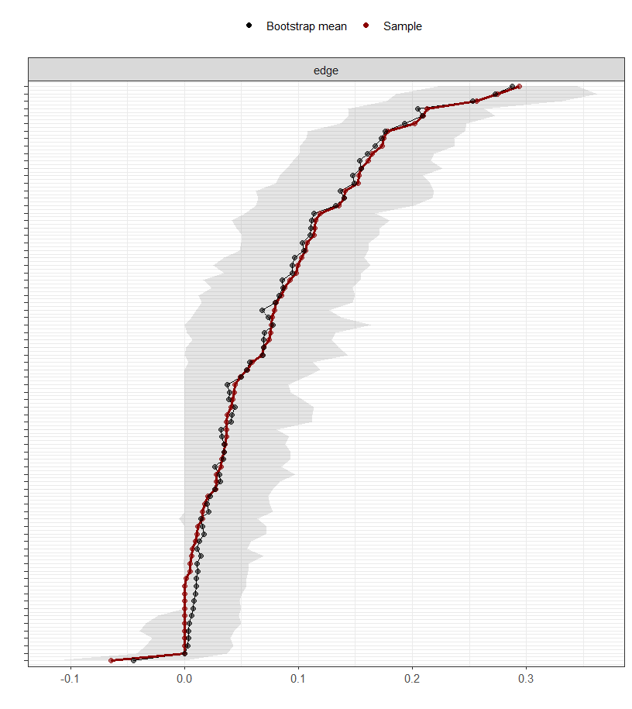

Figure S1 – Bootstrapped confidence intervals for edge-weights for sMFQ network analysis.

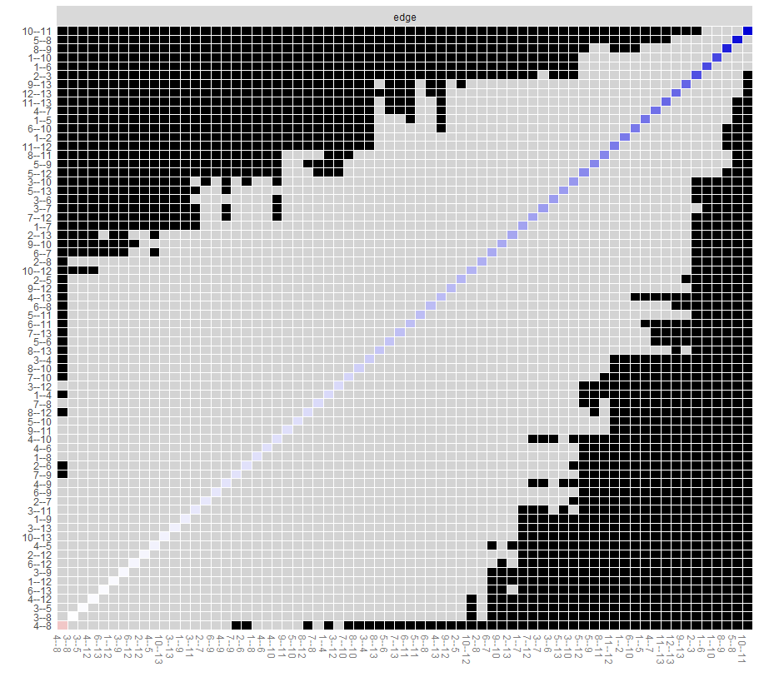

Figure S2 – Bootstrapped difference test between edge-weights for sMFQ network analysis.

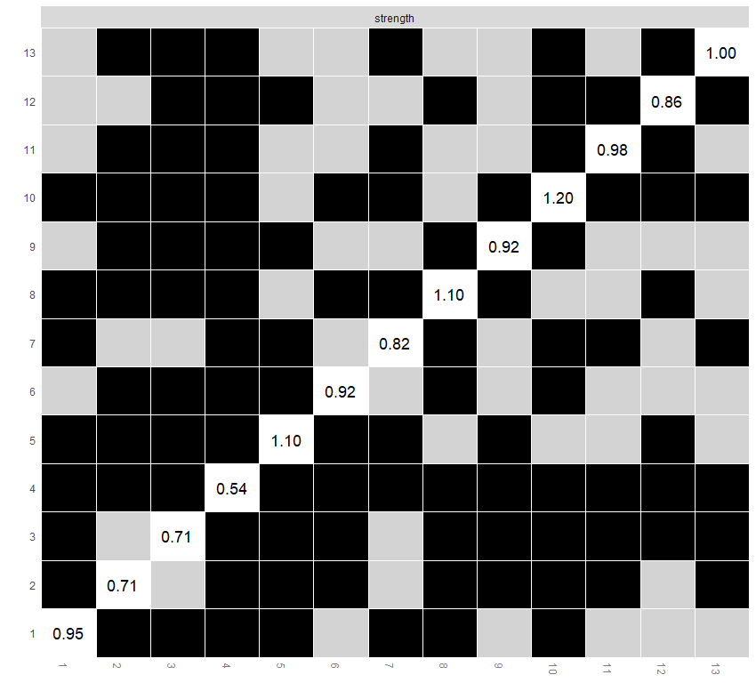

Figure S3 – Bootstrapped difference test between node strength for sMFQ network analysis.
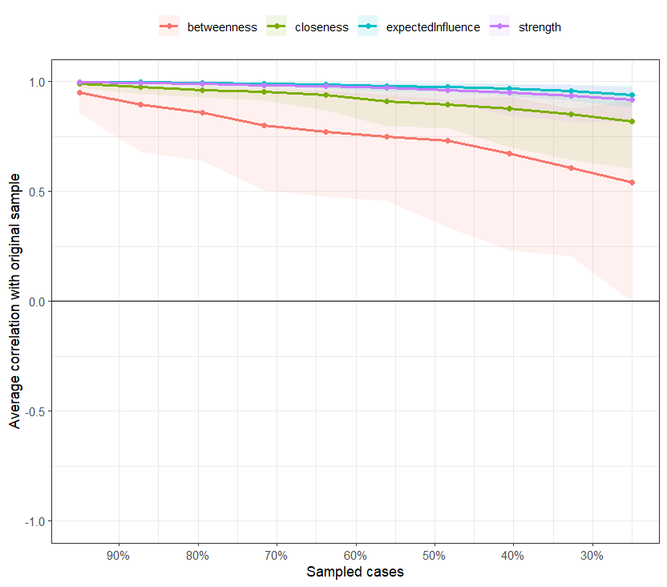

Figure S4 - Average correlations between centrality indices of networks with reduced sample sizes and the original sample.

