Supplementary Material
Supplementary Table S1. How cancer types were matched for the signature (Aim 2) and DNA openness (Aim 3) analyses.
TCGA code | Signature file label | Tumors with signatures (n) | Tissue used (Aim 3)
BRCA | Breast-cancer | 930 | breast epithelium
OV | Ovary-AdenoCa | 385 | ovary
PRAD | Prost-AdenoCa | 484 | prostate gland
STAD | Stomach-AdenoCa | 401 | stomach
LUAD | Lung-AdenoCa | 528 | lung
LUSC | Lung-SCC | 427 | lung
BLCA | Transitional-cell-carcinoma | 389 | mucosa of urinary bladder
PAAD | Panc-AdenoCa | 174 | pancreas
LIHC | Liver-HCC | 311 | liver
COAD | ColoRect-AdenoCa | 496 | sigmoid colon
UCEC | Uterus-AdenoCa | 474 | uterus
CESC | Cervix-CA | 271 | uterus (approximation)
THCA | Thy-AdenoCa | 478 | thyroid gland
KIRC | Kidney-RCC | 334 | kidney
SKCM | Skin-Melanoma | 412 | foreskin keratinocyte (stand-in)
GBM | CNS-GBM | 362 | posterior cingulate cortex (stand-in)
LGG | not available | — | posterior cingulate cortex (stand-in)
SARC | Sarcoma | 208 | psoas muscle (stand-in)
PCPG | Pheochromocytoma | 182 | body of pancreas (placeholder; see Limitations)

Supplementary Table S2. Main (Reactome) pathway lists used for Aim 3.
Gene(s) | Reactome gene set | Genes
ATM, CHEK2 | REACTOME_DNA_REPAIR | 332
BRCA1, BRCA2, PALB2 | REACTOME_HDR_THROUGH_HOMOLOGOUS_RECOMBINATION_HRR | 70
BRIP1 | REACTOME_FANCONI_ANEMIA_PATHWAY | 39
BUB1B, GJB2 | REACTOME_DISEASES_OF_DNA_REPAIR (not specific) | 51
NF1 | REACTOME_RAS_SIGNALING_DOWNSTREAM_OF_NF1_LOSS_OF_FUNCTION_VARIANTS | 7
PMS2 | REACTOME_MISMATCH_REPAIR | 15
VHL | REACTOME_TP53_REGULATES_TRANSCRIPTION_OF_DNA_REPAIR_GENES (not specific) | 62

Supplementary Table S3. Number of tumors with the gene broken, for each Phase 2 gene–cancer pair.
Gene | Truncating mutations (main) | Truncating + missense (sensitivity)
ATM | BRCA 10, PRAD 4, STAD 19, LUAD 17, BLCA 18, PAAD 3, LGG 0, SKCM 2, LUSC 6 | BRCA 25, PRAD 16, STAD 42, LUAD 40, BLCA 52, PAAD 7, LGG 2, SKCM 4, LUSC 28
BRCA1 | OV 16, BRCA 12, UCEC 13, CESC 2, PRAD 0, STAD 1 | OV 17, BRCA 24, UCEC 47, CESC 13, PRAD 1, STAD 13
BRCA2 | OV 7, BRCA 10, PAAD 2, SKCM 1, STAD 18, THCA 0, LUSC 6, SARC 2 | OV 13, BRCA 27, PAAD 2, SKCM 5, STAD 38, THCA 0, LUSC 32, SARC 4
BRIP1 | BRCA 1, LGG 0, OV 0, STAD 1 | BRCA 10, LGG 0, OV 4, STAD 7
BUB1B | GBM 1, LUSC 1 | GBM 1, LUSC 6
CHEK2 | BLCA 2, BRCA 2, LUAD 0, SKCM 0 | BLCA 9, BRCA 9, LUAD 8, SKCM 2
GJB2 | LUAD 0, LIHC 0, STAD 0 | LUAD 1, LIHC 1, STAD 0
NF1 | PCPG 0, SARC 6 | PCPG 0, SARC 8
PALB2 | STAD 8, BRCA 1, COAD 2 | STAD 12, BRCA 7, COAD 10
PMS2 | PRAD 0, UCEC 12 | PRAD 1, UCEC 35
VHL | PCPG 0, KIRC 105 | PCPG 0, KIRC 167

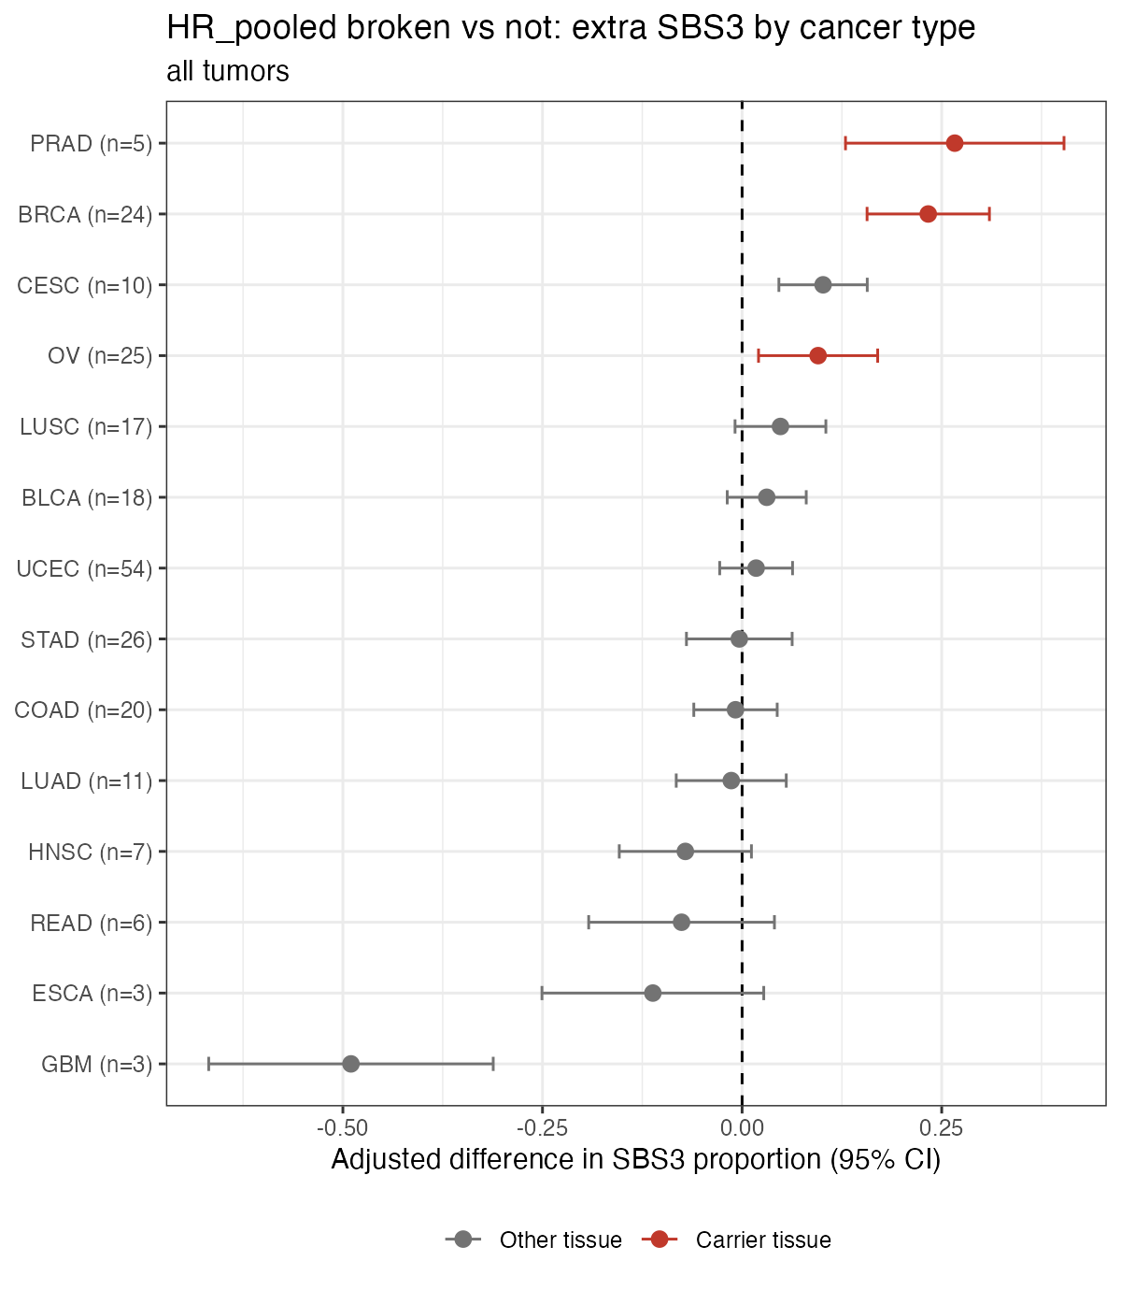
Supplementary Figure S1. Same as Figure 5, but including hypermutated tumors. The large negative glioblastoma (GBM) estimate comes from three hypermutated tumors and disappears when they are removed (see Section 3.7).
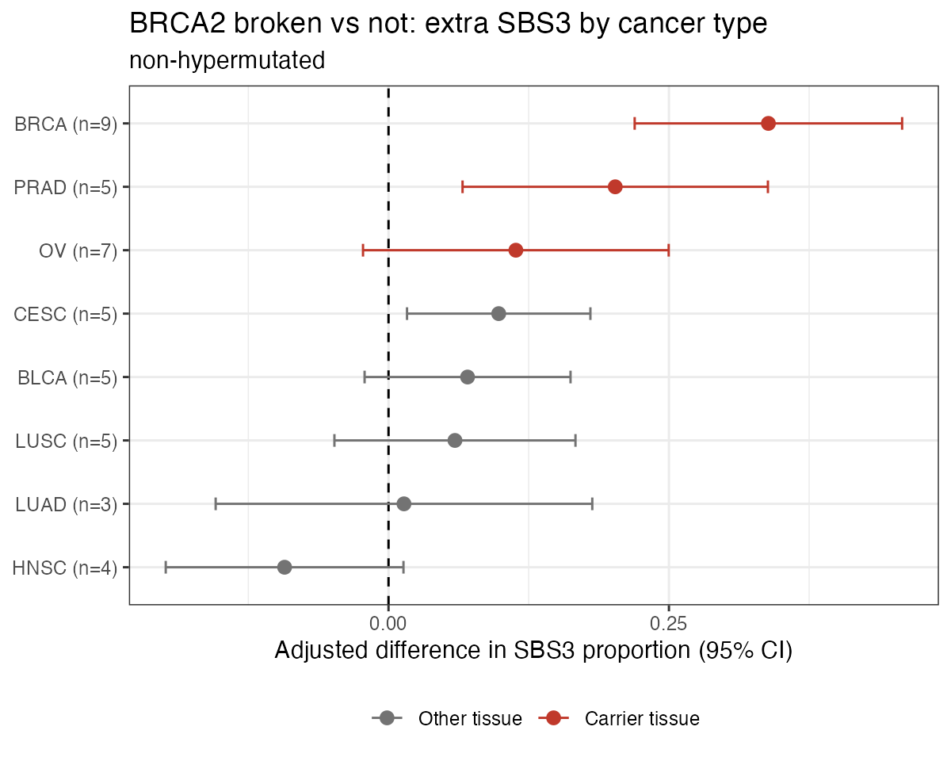
Supplementary Figure S2. Extra SBS3 in tumors with a truncating BRCA2 mutation, by cancer type (hypermutated tumors removed). Red marks the carrier tissues.
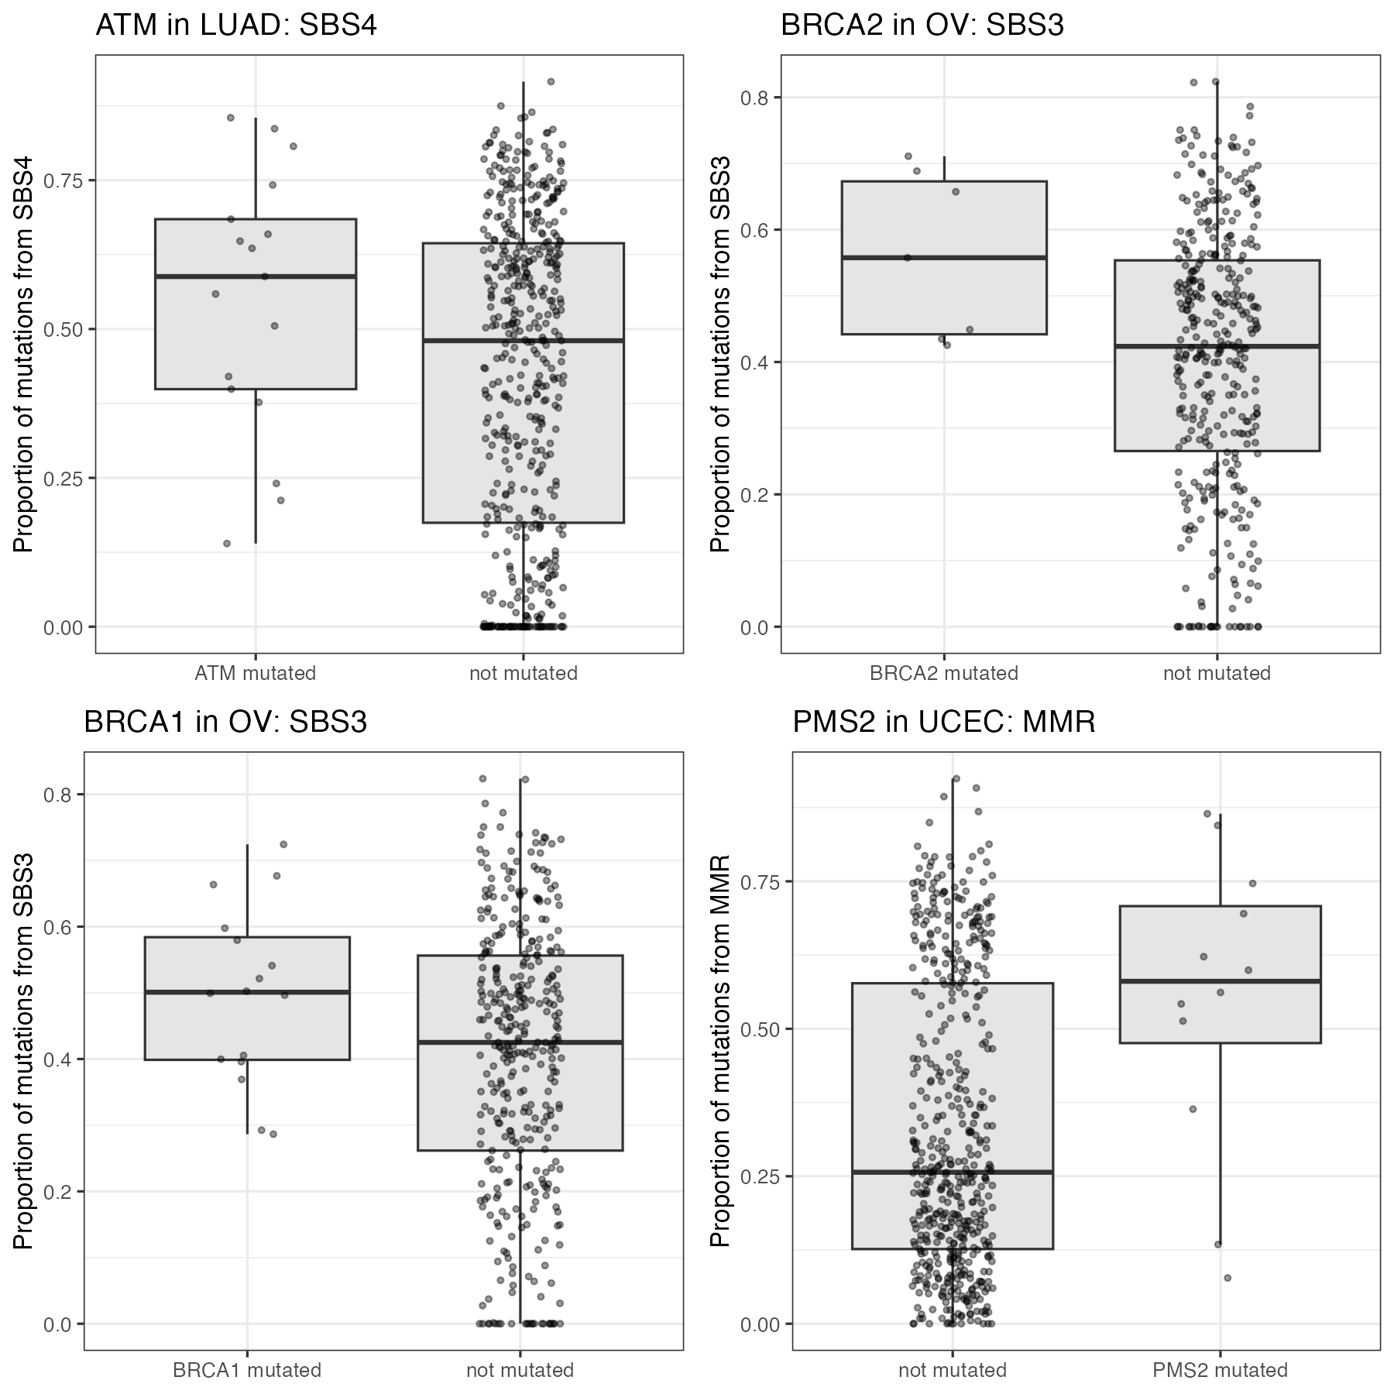
Supplementary Figure S3. Other predictions that could be tested. Top left: ATM and smoking (SBS4) in lung adenocarcinoma. Top right: BRCA2 and SBS3 in ovarian cancer. Bottom left: BRCA1 and SBS3 in ovarian cancer. Bottom right: PMS2 and mismatch-repair damage in endometrial cancer. Each dot is one tumor.

