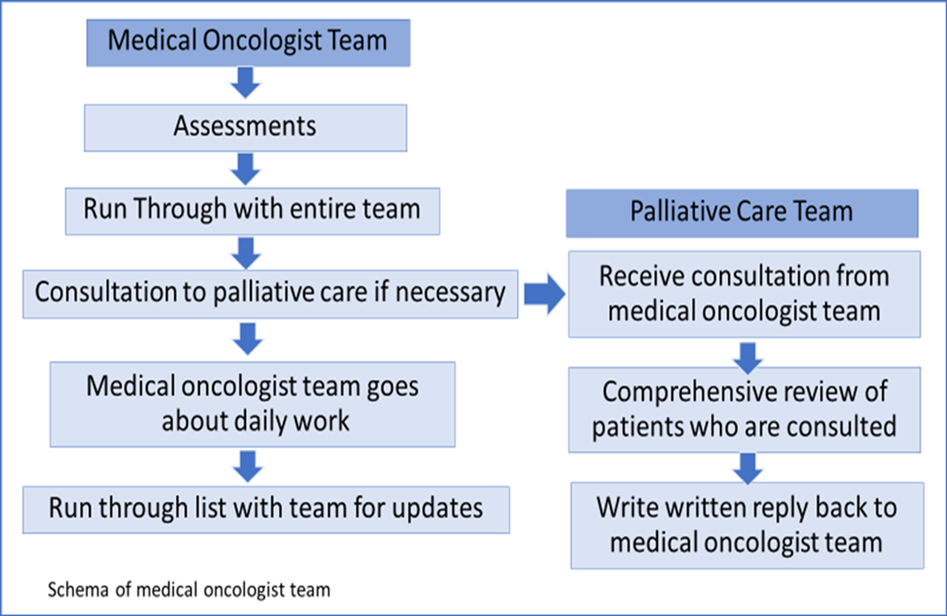
Supplementary Figure 1. Schema for palliative care in clinical practice by medical oncologists.

Supplementary Figure 2. Comparison of the difference in median of Thai-Functional Assessment of Cancer Therapy-General (Thai FACT-G) scale from day 1 to day 7 of hospitalization between Professional Collaborative Team group and Medical Oncologist group.
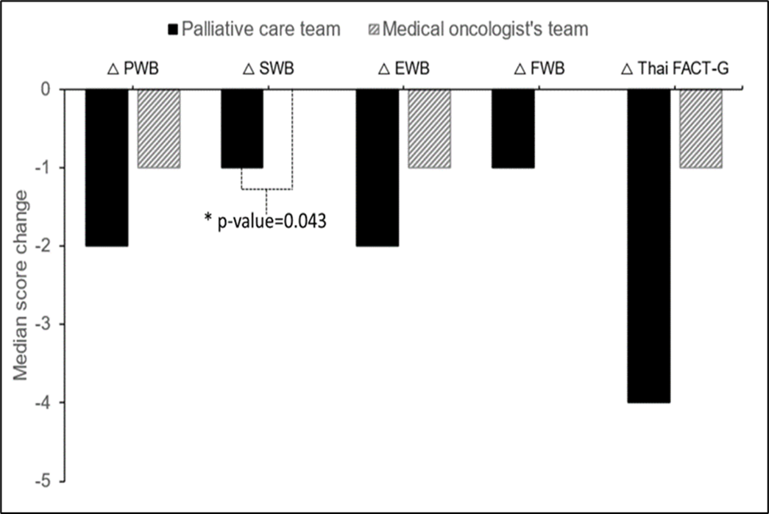

Supplementary Table 1. Comparison of the difference in median of Thai-Hospital Anxiety and Depression Scale (Thai-HADS) from day 1 to day 7 of hospitalization between Professional Collaborative Team group and Medical Oncologist group

 | Professional Collaborative Team (n=61) | Medical Oncologists Team(n=61) | p-value
 | n (%) | n (%)
△ Anxiety
median (min - Max) | 0 (-7 - 13) | 0 (-8 - 9) | 0.393‡
△ Depression
median (min - max) | 1 (-5 - 14) | 1 (-7 - 10) | 0.622‡
‡Mann-Whitney U test
Significant if p<0.05

Supplementary Table 2. Thai-Functional Assessment of Cancer Therapy- General (Thai FACT-G) scale at baseline
 | Professional Collaborative Team (n=61) | Medical Oncologists (n=61) | p-value
 | median (min - max) | median (min - max)
Physical Well-Being | 16 (5 - 27) | 16 (7 - 27) | 0.967
Social Well-being | 18 (0 - 28) | 18 (7 - 28) | 0.681
Emotional Well -being | 17 (1 - 24) | 16 (3 - 24) | 0.665
Functional Well-being | 14 (2 - 28) | 13 (4 - 23) | 0.451
Thai FACT-G | 66 (30 - 100) | 60 (31 - 95) | 0.552
Mann-Whitney U test
Significant if p<0.05

Supplementary Table 3. Thai-Functional Assessment of Cancer Therapy-General (Thai FACT-G) scale at day 1 and day 7 of hospitalization on each group
 | Day 1 | Day 7 | p-value
 | median (min - max) | median (min - max)
Interprofessional collaborative Team
Physical Well-being | 16 (5 - 27) | 19 (5 - 27) | 0.001
Social Well-being | 18 (0 - 28) | 21 (6 - 28) | 0.052
Emotional Well -being | 17 (1 - 24) | 19 (7 - 24) | 0.001
Functional Well-being | 14 (2 - 28) | 17 (3 - 28) | 0.009
Thai FACT-G | 66 (30 - 100) | 74 (36 - 100) | 0.002
Medical Oncologists
Physical Well-being | 16 (7 - 27) | 16 (7 - 27) | 0.020
Social Well-being | 18 (7 - 28) | 19 (5 - 28) | 0.320
Emotional Well -being | 16 (3 - 24) | 17 (3 - 24) | 0.045
Functional Well-being | 13 (4 - 23) | 13 (3 - 27) | 0.393
Thai FACT-G | 60 (31 - 95) | 66 (41 - 99) | 0.106
Wilcoxon Signed Ranks test
Significant if p<0.05

Supplementary Table 4. Comparison of the difference in median of
scale from day 1 to day 7 of hospitalization between Professional Collaborative Team group and Medical Oncologist group

 | Professional Collaborative Team, | Medical Oncologists, | p-value
 | median (min - max) | median (min - max)
△ Physical Well-being | -2 (-17 - 10) | -1 (-17 - 8) | 0.283
△ Social Well-being | -1 (-19 - 11) | 0 (-9 - 15) | 0.043
△ Emotional Well-being | -2 (-14 - 8) | -1 (-11 - 9) | 0.181
△ Functional Well-being | -1 (-17 - 11) | 0 (-22 - 10) | 0.120
△ Thai FACT-G | -4 (-50 - 23) | -1 (-44 - 26) | 0.134
Mann-Whitney U test
Significant if p<0.05

Supplementary Table 5. Re-admission events (rate) at 7 days, and 30 days after hospital discharge, duration of hospitalization, and discharge status between two groups.
 | Professional Collaborative Team (n=61) | Medical Oncologists (n=61) | Total | p-value
 | n (%) | n (%) | n(%)
Re-Admission 7 days After Discharge |  |  |  | 0.013
yes | 3 (4.92) | 12 (19.67) | 15 (12.2)
no | 58 (95.08) | 49 (80.33) | 107 (87.8)
Re-admission 30 day After Discharge |  |  |  | 0.348
yes | 20 (32.79) | 25 (40.98) | 45(36.8)
no | 41 (67.21) | 36 (59.02) | 77(63.2)
Status at 30 days |  |  |  | 0.142
alive | 48 (78.69) | 54 (88.52) | 102(83.6)
death | 13 (21.31) | 7 (11.48) | 20(16.4)
Duration of Admission
Median (Min - Max) | 14 (7 - 127) | 11 (7 - 45) |  | 0.012‡
Type of Discharge |  |  |  | 1.000†
Death During Admission | 8 (13.11) | 7 (11.48) | 15(12.3)
Stay at Home | 53 (86.89) | 53 (86.89) | 106(86.8)
Admission other Hospital | - | 1 (1.64) | 1(0.9)
Chi-Square test
Significant if p<0.05

