Supporting Information (SI) for:

Material diets for Climate-Neutral Buildings
Olga Beatrice Carcassi¹, Guillaume Habert^{2*}, Laura Elisabetta Malighetti¹, Francesco Pittau^{1,2}

* Corresponding author: Institute of Construction & Infrastructure Management, Chair of Sustainable Construction, ETH Zurich, Stefano-​Franscini-Platz 5, 8093 Zurich, Switzerland
, mail: habert@ibi.baug.ethz.ch, phone: +41 44 633 0560
¹ Department of Architecture, Built environment and Construction engineering (ABC), Politecnico di Milano, Via G. Ponzio 31, 20133 Milan, Italy
² Institute of Construction & Infrastructure Management, Chair of Sustainable Construction, ETH Zurich, Stefano-​Franscini-Platz 5, 8093 Zurich, Switzerland

Contents:

- Extended Methods
- Extended Results
- References
- Annex

Extended Methods

Geometric parameters for the Building Typologies

The TABULA/Episcope database ⁴² contains the main base information about the composition of the reference residential buildings which are representative of the stocks across 21 European Countries, where more than 2700 buildings are analyzed and collected (see “Extended data 1: 2008_Building typology statistics_Tabula Episcope.xlsx”).
From the excel file “tabula calculator.xlsx, the data that have been taken into account are:
- A_C_Storey = single conditioned storey surface [m²],
- N_Storey_effective_envelope = number of conditioned storeys [-],
- A_Esto, _W all_ExtAir = exterior Wall surface [m²],
- A_Estim_Window = window surface [m²].

Further simplifications are made in the definition of the geometric configurations. More precisely, the single area for every floor is kept the same for each storey. All the data of the different BT collected from TABULA/Episcope database are normalized according to the Reference Energy Surface (RES). RES is the total surface of the conditioned building, which in this case is the single conditioned storey surface multiplied by the number of conditioned storeys.

Supplementary Figures and Tables

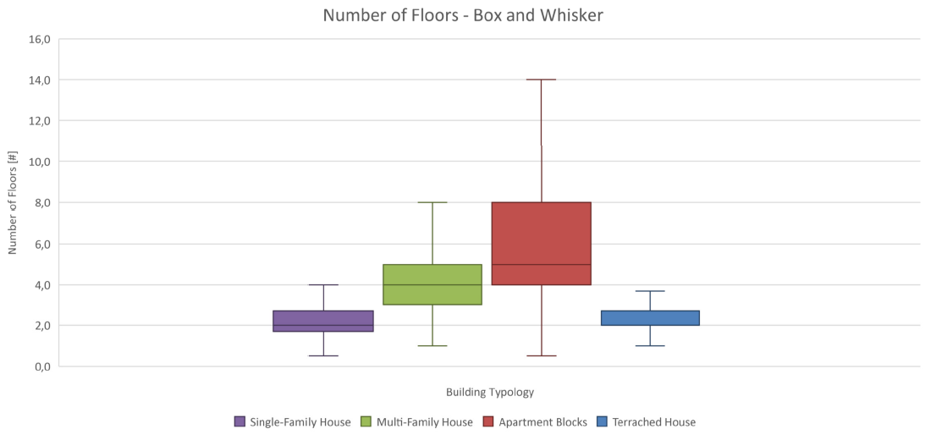
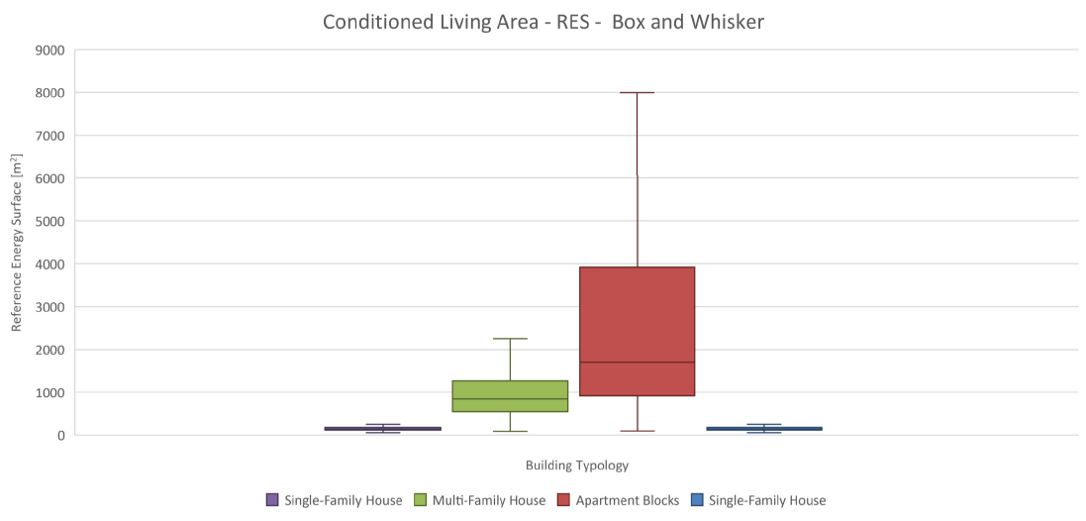
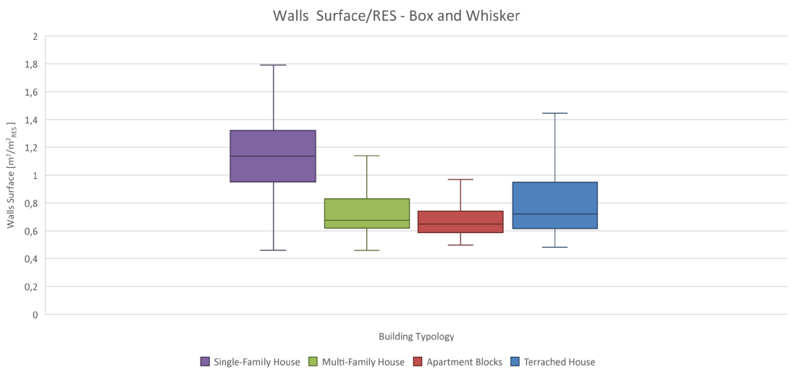
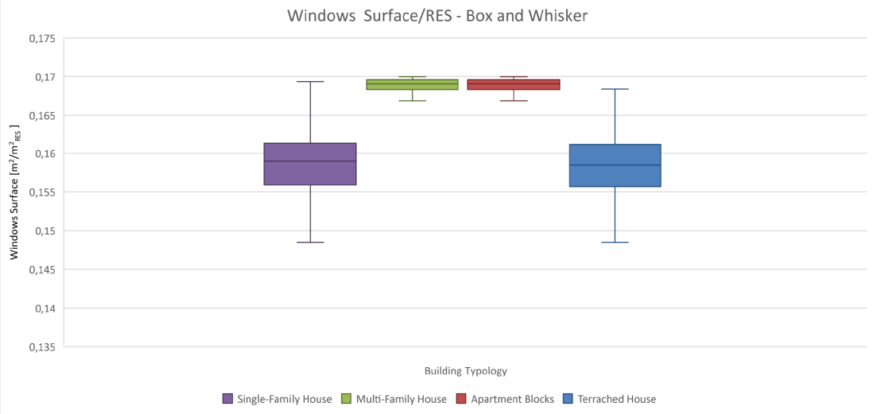

Figure S 1: Box and whisker statistical representations for the geometrical parameters extracted from the Tabula/Episcope Database. Top left: wall surface normalized according to the RES. Top right: number of conditioned storeys. Bottom left: window surface normalized according to the RES. Bottom left: conditioned living area, or RES

 |  |  |   SF H | 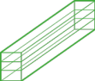  MFH | 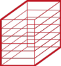  AB | 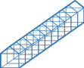  TH
Building Geometry from TABULA/Episcope | UP Whisker | RES [m²] (reference for normalization) | 255 | 2250 | 7997 | 297
Building Geometry from TABULA/Episcope | UP Whisker | Number of conditioned storeys | 4 | 8 | 14 | 4
Building Geometry from TABULA/Episcope | UP Whisker | Roof area = basement= area single floor [m²/ m²_{RES}] | 0,25 | 0,13 | 0,07 | 0,25
Building Geometry from TABULA/Episcope | UP Whisker | Exterior Wall area [m²/ m² _{RES}] | 1,79 | 1,14 | 0,97 | 1,45
Building Geometry from TABULA/Episcope | UP Whisker | Window area [m²/ m² _{RES}] | 0,17 | 0,17 | 0,17 | 0,17
Building Geometry from TABULA/Episcope | LOW Whisker | RES [m²] (reference for normalization) | 53 | 86 | 93 | 60
Building Geometry from TABULA/Episcope | LOW Whisker | Number of conditioned storeys | 1 | 1 | 1 | 1
Building Geometry from TABULA/Episcope | LOW Whisker | Roof area = basement= area single floor [m²/ m²_{RES}] | 1,00 | 1,00 | 1,00 | 1,00
Building Geometry from TABULA/Episcope | LOW Whisker | Exterior Wall area [m²/ m² _{RES}] | 0,46 | 0,46 | 0,5 | 0,48
Building Geometry from TABULA/Episcope | LOW Whisker | Window area [m²/ m² _{RES}] | 0,15 | 0,16 | 0,17 | 0,15
Building Geometry from TABULA/Episcope | MEDIAN | RES [m²] (reference for normalization) | 145 | 842 | 1702 | 136,7
Building Geometry from TABULA/Episcope | MEDIAN | Number of conditioned storeys | 2 | 4 | 5 | 2
Building Geometry from TABULA/Episcope | MEDIAN | Roof area = basement= area single floor [m²/ m²_{RES}] | 0,50 | 0,25 | 0,20 | 0,50
Building Geometry from TABULA/Episcope | MEDIAN | Exterior Wall area [m²/ m² _{RES}] | 1,13 | 0,68 | 0,65 | 0,72
Building Geometry from TABULA/Episcope | MEDIAN | Window area [m²/ m² _{RES}] | 0,16 | 0,17 | 0,17 | 0,16
Table S 1 – Summary of the statistical geometrical values extracted from TABULA/Episcope database and elaborated in “Extended data 1: 2008_Building typology statistics_Tabula Episcope.xlsx”

Structural mass incidence

Supplementary Figures and Tables

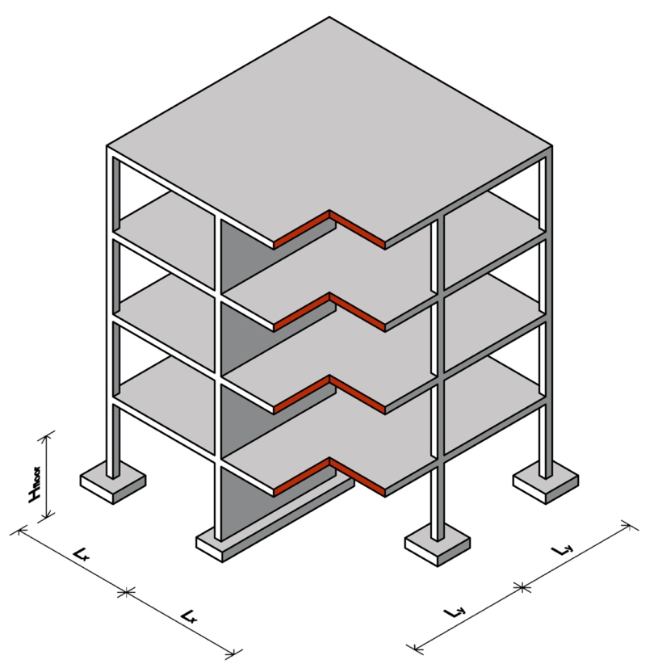
Figure S 2- Modular structure. In particular: Lx = Ly = 5m; H floor= 3,2 m

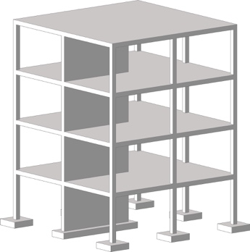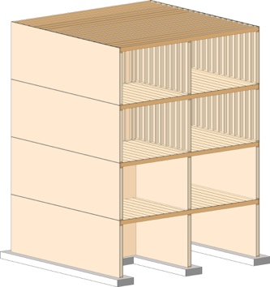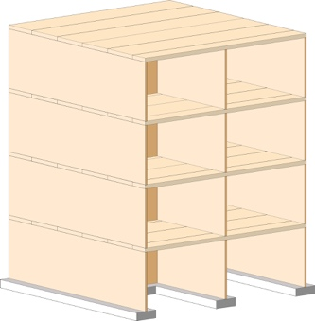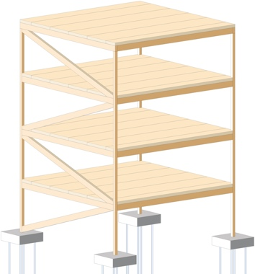

Figure S 3 - Structure schemes and related material diets. From the left: reinforce concrete (RC) omnivore diet; platform timber frame (PTF) vegetarian diet; cross laminated bamboo (CLB) vegan diet; post and beams (PB) vegan and vegetarian diet

Output of the structural parametric models
The output of the static parametrization is the amount of materials used for each material diet structure expressed in m³ normalized according to the gross area by varying the number of storeys (Figure S 4-8). Since for the rest of the materials we normalize for the RES resulting from the geometric configurations, we assume that the structural normalization is equal to the normalization to the RES. Therefore, for have integrity and correspondence with the unit of measurement, we also express the structural incidence per m²RES.
For each geometric configuration, we extract the value corresponding the number of storey for each material diet to be used as the structural volumetric incidence. To obtain the mass incidence, we divide these values for the related material density.

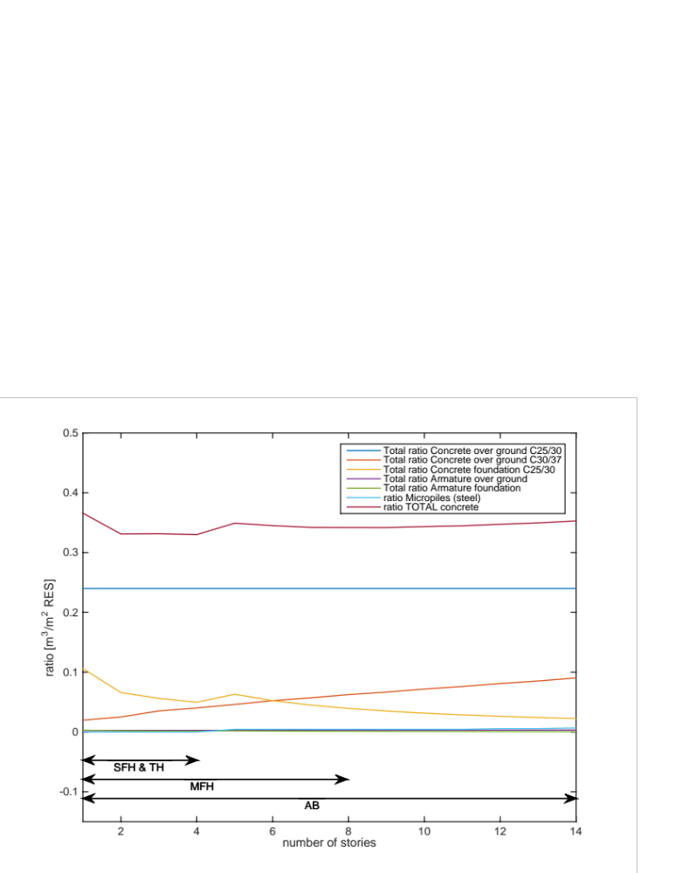
Figure S 4 – Mineral diet, structural scheme RC – reinforced concrete
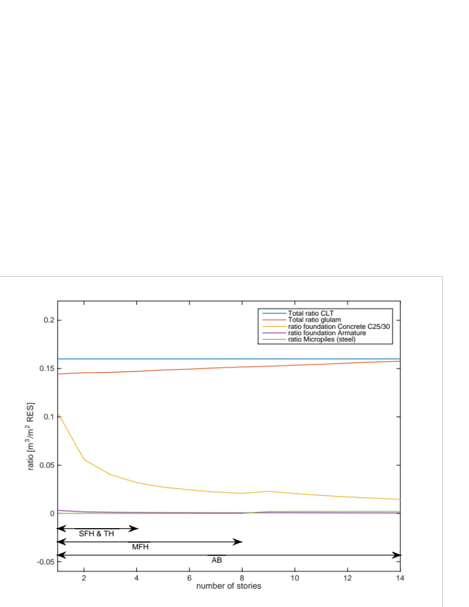
Figure S 5 – Woody diet, structural scheme BP – posts and beams (more that 10 storeys)
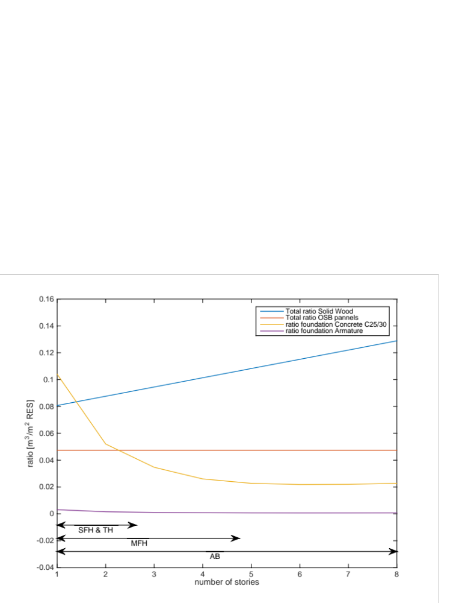
Figure S 6 – Woody diet, structural scheme PTF - platform timber frame (max 10 storeys)

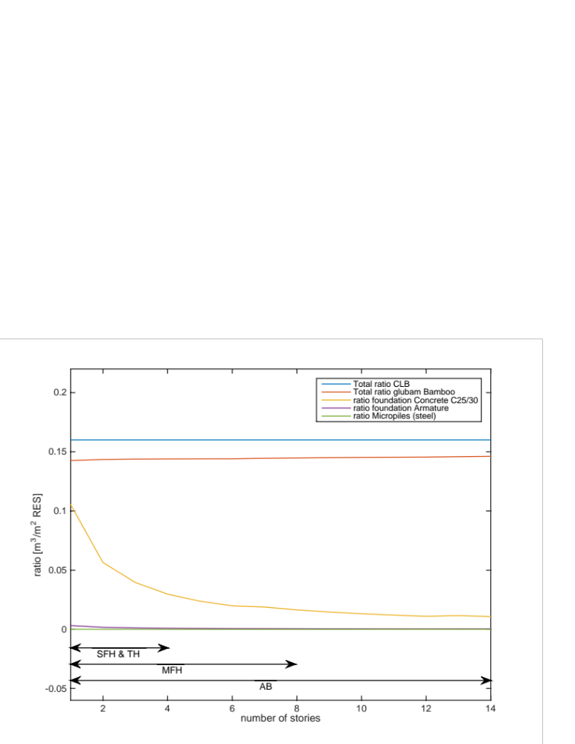
Figure S 7 – Herbaceous diet, structural scheme BP – posts and beams (more than 10 storeys)
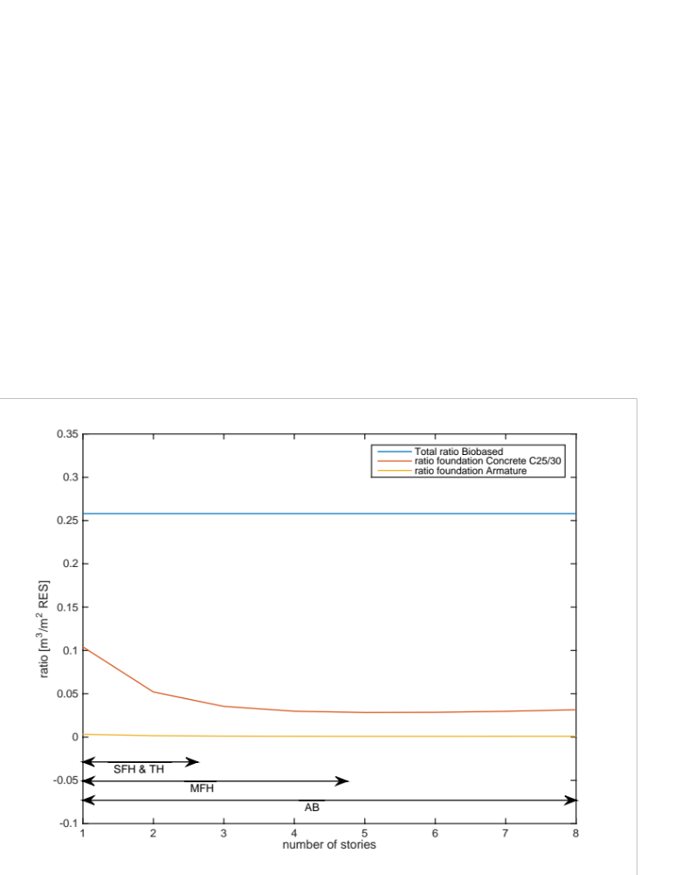
Figure S 8 – Herbaceous diet, structural scheme CLB – cross laminated bamboo (max 10 storeys))

Construction materials and Net-GWP computation

Materials | Density | Carbon content | Biomass content | Carbon storage | Storage-Uptake | GWP_{100y} =  Emissions | GWP_{Bio} | Uptake | Net-GWP | Net-GWP | GWP Ref.
Family | [kg/m³] | [%] | [%] | kgCO₂/kg | kgCO₂/kg | [kg CO_{2e}/kg] | [kg CO_{2e}/kgCO₂] | [kg CO_{2e}/  kg] | [kg CO_{2e}/kg] | [kg CO_{2e}/m³]
Concrete C30/37 | 2300 | 0% | 0% | 0,00 | 0,00 | 0,099 | 0,00 | 0,00 | 0,10 | 227,70 | KBOB
Concrete C25/30 | 2300 | 0% | 0% | 0,00 | 0,00 | 0,074 | 0,00 | 0,00 | 0,07 | 170,20 | KBOB + Ecoivent
Concrete deep foundations | 2325 | 0% | 0% | 0,00 | 0,00 | 0,117 | 0,00 | 0,00 | 0,12 | 272,03 | KBOB
Steel (reinforcement) | 7850 | 0% | 0% | 0,00 | 0,00 | 0,682 | 0,00 | 0,00 | 0,68 | 5353,7 | KBOB
Waterproof membrane | 1000 | 0% | 0% | 0,00 | 0,00 | 2,52 | 0,00 | 0,00 | 2,52 | 2520,0 | KBOB
Mineral plaster | 1100 | 0% | 0% | 0,00 | 0,00 | 0,147 | 0,00 | 0,00 | 0,15 | 161,70 | KBOB
Gypsum plasterboard | 850 | 0% | 0% | 0,00 | 0,00 | 0,293 | 0,00 | 0,00 | 0,29 | 249,05 | KBOB
Ceramic tiles (0,009 m thickness) | 2000 | 0% | 0% | 0,00 | 0,00 | 0,778 | 0,00 | 0,00 | 0,78 | 1555,6 | KBOB
Clay plaster | 1800 | 0% | 0% | 0,00 | 0,00 | 0,023 | 0,00 | 0,00 | 0,02 | 41,40 | KBOB
Wood Window Frame, thickness 80mm | 1002,5 | 0% | 0% | 0,00 | 0,00 |  | 0,00 | 0,00 | 1,60 | 1600,0 | KBOB
Wood-Aluminium Window Frame, thickness 80 mm | 1042,5 | 0% | 0% | 0,00 | 0,00 |  | 0,00 | 0,00 | 2,60 | 2712,5 | KBOB
PVC Window Frame, thickness 80mm | 1181,2 | 0% | 0% | 0,00 | 0,00 |  | 0,00 | 0,00 | 3,02 | 3562,5 | KBOB
Insulated Triple Glazing, Thickness 40 mm | 30 | 0% | 0% | 0,00 | 0,00 |  | 0,00 | 0,00 | 55,7 | 1670,0 | KBOB
Solid wood (softwood) | 485 | 50% | 100% | -1,84 | -1,65 | 0,087 | -0,10 | -0,18 | -0,10 | -46,80 | KBOB
Solid wood (hardwood) | 705 | 50% | 100% | -1,84 | -1,65 | 0,068 | -0,10 | -0,18 | -0,12 | -81,43 | KBOB
Glulam | 470 | 50% | 99% | -1,82 | -1,63 | 0,397 | -0,10 | -0,18 | 0,22 | 101,21 | KBOB
OSB | 605 | 50% | 98% | -1,80 | -1,62 | 0,614 | -0,10 | -0,18 | 0,43 | 262,67 | KBOB
Cross Laminated Timber | 500 | 50% | 98% | -1,80 | -1,62 | 1,17 | -0,10 | -0,18 | 0,99 | 495,09 | KBOB
Wood Fibres Board | 140 | 50% | 100% | -1,84 | -1,65 | 0,404 | -0,10 | -0,18 | 0,22 | 30,87 | KBOB
Cellulose fibres | 60 | 45% | 88% | -1,45 | -1,31 | 0,203 | -0,10 | -0,15 | 0,06 | 3,46 | KBOB
Cross Laminated Bamboo (CLB) | 700 | 54% | 98% | -1,94 | -1,01 | 1,076 | -0,48 | -0,93 | 0,14 | 100,63 | ﻿¹ + KBOB
Glue Laminated Bamboo (GLB) | 700 | 54% | 98% | -1,94 | -1,01 | 1,227 | -0,48 | -0,93 | 0,29 | 206,33 | ﻿¹ + KBOB
Bamboo Flooring | 700 | 54% | 100% | -1,98 | -1,03 | 0,92 | -0,48 | -0,95 | -0,03 | -21,88 | ﻿¹ + KBOB
Bamboo Cladding | 1150 | 54% | 93% | -1,84 | -0,96 | 1,202 | -0,48 | -0,88 | 0,32 | 364,92 | ﻿¹ + KBOB
Straw | 100 | 40% | 100% | -1,47 | -0,73 | 0,09 | -0,50 | -0,73 | -0,64 | -64,40 | KBOB
Hempcrete | 600 | 45% | 44% | -0,72 | -0,36 | 0,277 | -0,50 | -0,36 | -0,08 | -49,32 | ﻿² + KBOB + ³
Hemp fibre | 82 | 45% | 64% | -1,06 | -0,53 | 0,137 | -0,50 | -0,53 | -0,39 | -32,11 | ﻿⁴
Reed | 150 | 47% | 100% | -1,72 | -0,86 | 0,09 | -0,50 | -0,86 | -0,77 | -115,9 | Assumed equal to Straw
Kenaf | 40 | 40% | 85% | -1,25 | -0,62 | 2,09 | -0,50 | -0,62 | 1,46 | 58,47 | ⁴ + ﻿⁵
Sea grass | 100 | 21% | 100% | -0,77 | -0,39 | 0 | -0,50 | -0,39 | -0,39 | -38,54 | Assumed
Meadow grass | 40 | 46% | 70% | -1,19 | -0,59 | 0,882 | -0,50 | -0,59 | 0,29 | 11,49 | ⁶
Posidonia Oceanica | 75 | 21% | 100% | -0,77 | -0,39 | 0 | -0,50 | -0,39 | -0,39 | -28,90 | Assumed
Cotton (stalks) | 450 | 40% | 90% | -1,32 | -0,66 | 0,34 | -0,50 | -0,66 | -0,32 | -144,3 | ^{7,8}
Mycelium | 552 | 21% | 100% | -0,77 | -0,39 | 0,4 | -0,50 | -0,39 | 0,01 | 8,09 | Assumed equal cotton
Cork | 120 | 60% | 50% | -1,10 | -0,59 | 0,81 | -0,46 | -0,51 | 0,30 | 36,14 | ⁴ +﻿ ⁹
Coconut fibres | 100 | 50% | 100% | -1,84 | -0,92 | 1,2 | -0,50 | -0,92 | 0,28 | 28,25 | Assumed
Sheep wool | 20 | 50% | 85% | -1,56 | -0,78 | 1,92 | -0,50 | -0,78 | 1,14 | 22,74 | ⁴
Rice Husk | 170 | 48% | 98% | -1,73 | -0,86 | 1,11 | -0,50 | -0,86 | 0,25 | 41,79 | ¹⁰
Flax boards | 30 | 40% | 75% | -1,10 | -0,55 | 1,87 | -0,50 | -0,55 | 1,32 | 39,59 | ¹¹

Table S 2 – Properties of construction materials used. Highlighted in yellow, the values used

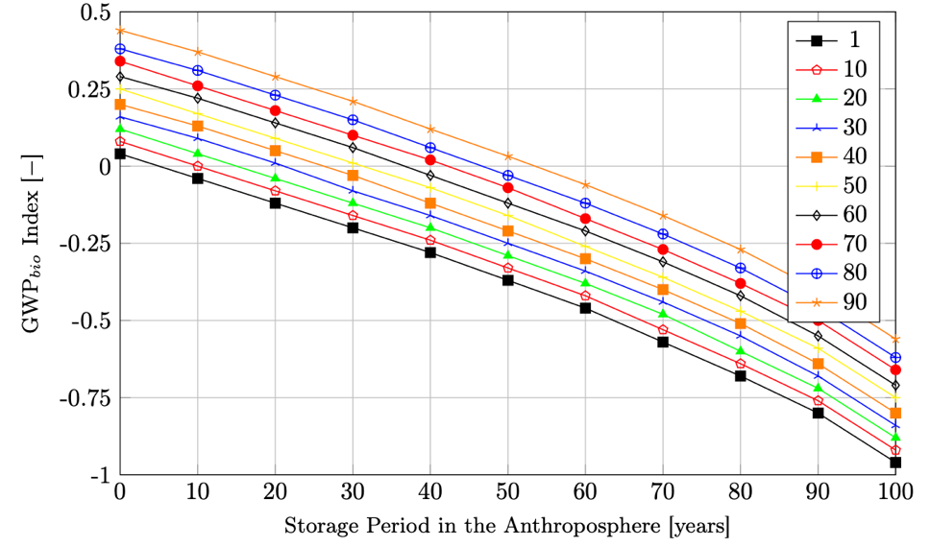
Figure S 9 – Each color refers to the rotation period of the different biomass with time horizon 100 years. Source: Guest et al ¹²

U-value Calculation

The general formula for calculating the U-Value is:

$$U \left[\frac{W}{m^{2} K}\right]=\frac{1 }{R_{t} \left[\frac{m^{2} K}{W}\right]}$$
Where:
U = Thermal Transmittance
R_{t} = Total Thermal Resistance of the element composed of layers, obtained according to:

$$R_{t} = R_{si}+ R_{1}+R_{2}+…+R_{n}+R_{se}$$
Where:
R_{si} = Interior Surface Thermal Resistance, here assumed as 8 W/(m²K)
R_{se} = Exterior Surface Thermal Resistance, here assumed as 25 W/(m²K)

R₁, R₂, R₃, R_{n} = Thermal Resistance of each layer, which is obtained according to:

$$R_{n} \left[\frac{m^{2} K}{W}\right]=\frac{D [m] }{λ\left[\frac{ W}{K m}\right]}$$
Where:
D = Material Thickness (m)
λ = Thermal Conductivity of the Material (W/ K·m) (according to each material).

In particular:
- Mineral plaster (0,02 m thickness) : 0,08 W/(m K)¹³
- Solid Wood (0,02 m thickness) : 0,12 W/(m K) ¹³
- Plasterboards (0,0125 m thickness) : 0,21 W/(m K) ¹³
- Clay Panels (0,02 m thickness) : 0,47 W/(m K) ¹³
- Bamboo cladding (0,02 m thickness) : 0,34 W/(m K) ¹⁴
- Cotton stalks (varying thickness) : 0,082 W/(m K) ⁴
- Hemp fibers (varying thickness) : 0,039 W/(m K) ⁴
- Straw (varying thickness) : 0,043 W/(m K) ¹³

Extended Results

Figure S 10 – Representation of the material diets’ emissions to counterbalance for the three geometrical configurations and the four BT
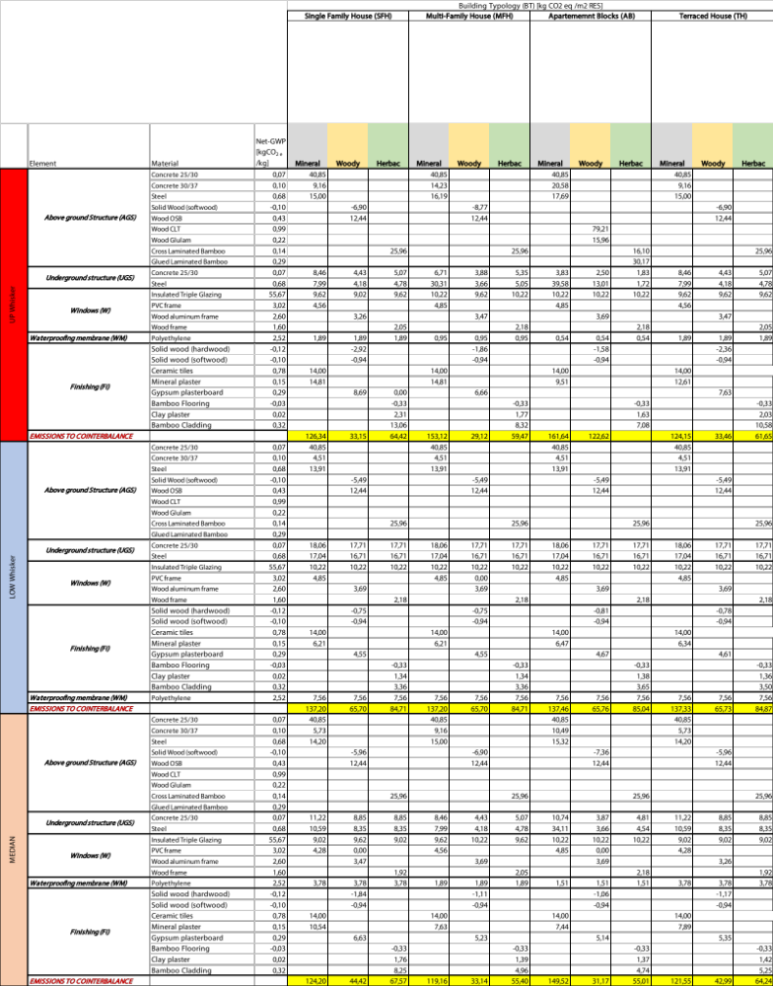
Table S 3 – Material diets’ emissions to counterbalance for the three geometrical configurations and the four BT

 |  |  | Mineral |  |  | Woody |  |  | Herbac
 |  |  | Climate Positive [m³/m²_{RES}] | Climate Negative [m³/m²_{RES}] | Ratio | Climate Positive [m³/m²_{RES}] | Climate Negative [m³/m²_{RES}] | Ratio | Climate Positive [m³/m²_{RES}] | Climate Negative [m³/m²_{RES}] | Ratio
Max Cotton stalks | SFH | UP Whisker | 0,44 | 0,88 | 0,51 | 0,12 | 0,39 | 0,30 | 0,39 | 0,46 | 0,84
Max Cotton stalks | SFH | LOW Whisker | 0,43 | 0,95 | 0,45 | 0,18 | 0,57 | 0,32 | 0,42 | 0,60 | 0,69
Max Cotton stalks | SFH | MEDIAN | 0,42 | 0,86 | 0,49 | 0,16 | 0,44 | 0,37 | 0,38 | 0,48 | 0,80
Max Cotton stalks | MFH | UP Whisker | 0,46 | 1,06 | 0,43 | 0,11 | 0,37 | 0,28 | 0,36 | 0,43 | 0,85
Max Cotton stalks | MFH | LOW Whisker | 0,43 | 0,95 | 0,45 | 0,18 | 0,57 | 0,32 | 0,42 | 0,40 | 1,05
Max Cotton stalks | MFH | MEDIAN | 0,40 | 0,83 | 0,48 | 0,10 | 0,36 | 0,27 | 0,34 | 0,40 | 0,86
Max Cotton stalks | AB | UP Whisker | 0,44 | 1,12 | 0,39 | 0,37 | 0,89 | 0,41 | 0,38 | 0,51 | 0,76
Max Cotton stalks | AB | LOW Whisker | 0,43 | 0,95 | 0,45 | 0,18 | 0,55 | 0,34 | 0,42 | 0,60 | 0,69
Max Cotton stalks | AB | MEDIAN | 0,42 | 1,04 | 0,41 | 0,10 | 0,36 | 0,28 | 0,34 | 0,40 | 0,86
Max Cotton stalks | TH | UP Whisker | 0,43 | 0,86 | 0,50 | 0,11 | 0,38 | 0,29 | 0,37 | 0,44 | 0,85
Max Cotton stalks | TH | LOW Whisker | 0,43 | 0,46 | 0,94 | 0,18 | 0,57 | 0,32 | 0,42 | 0,60 | 0,69
Max Cotton stalks | TH | MEDIAN | 0,40 | 0,84 | 0,48 | 0,13 | 0,42 | 0,31 | 0,37 | 0,46 | 0,80
Min Hemp fibre | SFH | UP Whisker | 0,44 | 3,93 | 0,11 | 0,12 | 1,19 | 0,10 | 0,39 | 2,02 | 0,19
Min Hemp fibre | SFH | LOW Whisker | 0,43 | 4,27 | 0,10 | 0,18 | 2,16 | 0,09 | 0,42 | 2,65 | 0,16
Min Hemp fibre | SFH | MEDIAN | 0,42 | 3,87 | 0,11 | 0,16 | 1,51 | 0,11 | 0,38 | 2,12 | 0,18
Min Hemp fibre | MFH | UP Whisker | 0,46 | 4,77 | 0,10 | 0,11 | 1,08 | 0,10 | 0,36 | 1,87 | 0,19
Min Hemp fibre | MFH | LOW Whisker | 0,43 | 4,27 | 0,10 | 0,18 | 2,16 | 0,09 | 0,42 | 2,65 | 0,16
Min Hemp fibre | MFH | MEDIAN | 0,40 | 3,71 | 0,11 | 0,10 | 1,17 | 0,09 | 0,34 | 1,74 | 0,20
Min Hemp fibre | AB | UP Whisker | 0,44 | 5,03 | 0,09 | 0,37 | 3,86 | 0,10 | 0,38 | 2,23 | 0,17
Min Hemp fibre | AB | LOW Whisker | 0,43 | 4,28 | 0,10 | 0,18 | 2,14 | 0,09 | 0,42 | 2,66 | 0,16
Min Hemp fibre | AB | MEDIAN | 0,42 | 4,66 | 0,09 | 0,10 | 1,11 | 0,09 | 0,34 | 1,73 | 0,20
Min Hemp fibre | TH | UP Whisker | 0,43 | 3,87 | 0,11 | 0,11 | 1,19 | 0,09 | 0,37 | 1,93 | 0,19
Min Hemp fibre | TH | LOW Whisker | 0,43 | 2,05 | 0,21 | 0,18 | 2,16 | 0,09 | 0,42 | 2,66 | 0,16
Min Hemp fibre | TH | MEDIAN | 0,40 | 3,79 | 0,11 | 0,13 | 1,46 | 0,09 | 0,37 | 2,02 | 0,18
Med Straw | SFH | UP Whisker | 0,44 | 1,96 | 0,23 | 0,12 | 0,67 | 0,17 | 0,39 | 1,02 | 0,38
Med Straw | SFH | LOW Whisker | 0,43 | 2,13 | 0,20 | 0,18 | 1,13 | 0,16 | 0,42 | 1,33 | 0,31
Med Straw | SFH | MEDIAN | 0,42 | 1,93 | 0,22 | 0,16 | 0,82 | 0,20 | 0,38 | 1,06 | 0,36
Med Straw | MFH | UP Whisker | 0,46 | 2,38 | 0,19 | 0,11 | 0,62 | 0,17 | 0,36 | 0,94 | 0,39
Med Straw | MFH | LOW Whisker | 0,43 | 2,13 | 0,20 | 0,18 | 1,13 | 0,16 | 0,42 | 1,33 | 0,31
Med Straw | MFH | MEDIAN | 0,40 | 1,85 | 0,22 | 0,10 | 0,65 | 0,15 | 0,34 | 0,88 | 0,39
Med Straw | AB | UP Whisker | 0,44 | 2,51 | 0,17 | 0,37 | 1,94 | 0,19 | 0,38 | 1,12 | 0,34
Med Straw | AB | LOW Whisker | 0,43 | 2,13 | 0,20 | 0,18 | 1,11 | 0,17 | 0,42 | 1,34 | 0,31
Med Straw | AB | MEDIAN | 0,42 | 2,32 | 0,18 | 0,10 | 0,63 | 0,16 | 0,34 | 0,87 | 0,39
Med Straw | TH | UP Whisker | 0,43 | 1,93 | 0,22 | 0,11 | 0,67 | 0,17 | 0,37 | 0,97 | 0,39
Med Straw | TH | LOW Whisker | 0,43 | 1,02 | 0,42 | 0,18 | 1,13 | 0,16 | 0,42 | 1,33 | 0,31
Med Straw | TH | MEDIAN | 0,40 | 1,89 | 0,21 | 0,13 | 0,79 | 0,17 | 0,37 | 1,01 | 0,36

Table S 4 – Ratios among Climate Positive and Climate Negative materials

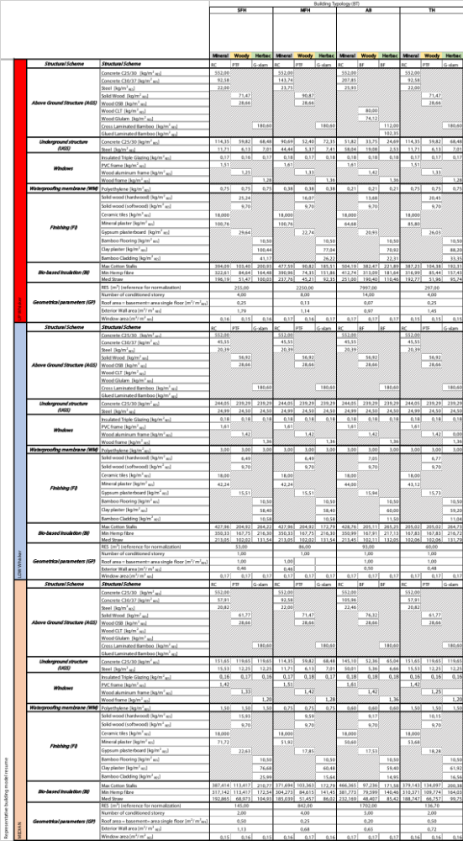

Table S 5 – Final geometrical building configurations resumé showing the geometrical values and the material quantity used

References
1. Vogtländer, J. G. & van der Lugt, P. The Environmental Impact of Industrial Bamboo Products: Life cycle assessment and carbon sequestration. (2015). doi:10.13140/RG.2.2.20797.46560
2. Arrigoni, A. et al. Life cycle assessment of natural building materials: the role of carbonation, mixture components and transport in the environmental impacts of hempcrete blocks. J. Clean. Prod. 149, 1051–1061 (2017).
3. Pittau, F., Krause, F., Lumia, G. & Habert, G. Fast-growing bio-based materials as an opportunity for storing carbon in exterior walls. Build. Environ. 129, 117–129 (2018).
4. Schiavoni, S., D’Alessandro, F., Bianchi, F. & Asdrubali, F. Insulation materials for the building sector: A review and comparative analysis. Renew. Sustain. Energy Rev. 62, 988–1011 (2016).
5. Ardente, F., Beccali, M., Cellura, M. & Mistretta, M. Building energy performance: A LCA case study of kenaf-fibres insulation board. Energy Build. 40, 1–10 (2008).
6. Gramitherm® IP & Technology. Gramitherm. (2020). Available at: http://gramitherm.ch/. (Accessed: 10th May 2020)
7. Cavac Biomatériaux. Fiche De Declaration Environnementale Et Sanitaire Du Produit: Isolant Biofib Trio. (2018).
8. Zhou, X. yan, Zheng, F., Li, H. guan & Lu, C. long. An environment-friendly thermal insulation material from cotton stalk fibers. Energy Build. 42, 1070–1074 (2010).
9. Gil, L., Marreiros, N. & Cortiço, P. Insulation corkboard carbon content and CO2 equivalent. Ciência e Tecnol. dos Mater. 23, 42–43 (2011).
10. Buratti, C., Belloni, E., Lascaro, E., Merli, F. & Ricciardi, P. Rice husk panels for building applications: Thermal, acoustic and environmental characterization and comparison with other innovative recycled waste materials. Constr. Build. Mater. 171, 338–349 (2018).
11. Schmidt, A. C., Jensen, A. A., Clausen, A. U., Kamstrup, O. & Postlethwaite, D. A Comparative Life Cycle Assessment of Building Insulation Products made of Stone Wool, Paper Wool and Flax Part 2: Comparative Assessment. Int. J. Life Cycle Assess. 9, 122–129 (2004).
12. Guest, G., Cherubini, F. & Strømman, A. H. Global Warming Potential of Carbon Dioxide Emissions from Biomass Stored in the Anthroposphere and Used for Bioenergy at End of Life. J. Ind. Ecol. 17, 20–30 (2013).
13. Eidgenossenschaft, S. KBOB - Koordinationskonferenz der Bau- und Liegenschaftsorgane der öffentlichen Bauherren. (2016). Available at: https://www.kbob.admin.ch/kbob/de/home.html. (Accessed: 20th March 2020)
14. Vogtländer, J. G. & van der Lugt, P. The Environmental Impact of Industrial Bamboo Products: Life cycle assessment and carbon sequestration. Technical report No.35. (2015). doi:10.13140/RG.2.2.20797.46560

Annex

Annex A: MATLAB Script

%% Master Project FS2020: Which Materials Diet for Climate Neutral Buildings?
% Title: Which Materials Diet for Climate Neutral Buildings?
% Author: Lolli Marco
% lollim@student.ethz.ch
%
% Supervision: Dr. Francesco Pittau
% Olga Beatrice Carcassi
%
% Date: Spring Semester - 2020
% fsklajf:
% Description: This Script analyses the required materials volumes in a given structure to withstand vertical loads.
% It is subdivided in 4 sub-scripts, one for each different structural scheme and different material.
% Horizontal and vertical elements are proven, as well as the foundation of the generated building.
% The code iterative generates a building with a given number of stories
% and proofs at each step the statically required dimensions of the structural elements.
% By adding these together at each iteration step, plots are generated showing the materials volumes
% required at each story height and for each different structural material scheme.
%% ------------- BEGIN CODE --------------
%% SCHEME 1 : In-situ cast concrete columns and wall supporting a reinforcing concrete plate
maxstories = 14;
volumeslab_concrete_tot = zeros(maxstories,1);
volumeslab_armature_tot = zeros(maxstories,1);
k_c_found = zeros(maxstories,1);
A_co = zeros(maxstories,1);
V_co = zeros(maxstories,1);
volumecolumns_concrete = zeros(maxstories,1);
volumewalls_concrete = zeros(maxstories,1);
volumecolumns_armature = zeros(maxstories,1);
volumewalls_armature = zeros(maxstories,1);
volumevertical_concrete = zeros(maxstories,1);
volumevertical_armature = zeros(maxstories,1);
volumecolumns_concrete_tot = zeros(maxstories,1);
volumewalls_concrete_tot = zeros(maxstories,1);
volumecolumns_armature_tot = zeros(maxstories,1);
volumewalls_armature_tot = zeros(maxstories,1);
volumevertical_concrete_tot = zeros(maxstories,1);
volumevertical_armature_tot = zeros(maxstories,1);
volumefoundation_concrete = zeros(maxstories,1);
volumefoundation_armature = zeros(maxstories,1);
nr_micropiles_tot = zeros(maxstories,1);
volumemicropiles = zeros(maxstories,1);
volume_armature_overground_tot = zeros(maxstories,1);
usageratio_overground_C2530 = zeros(maxstories,1);
usageratio_overground_C3037 = zeros(maxstories,1);
usageratio_foundation = zeros(maxstories,1);
usageratio_armature_overground_tot = zeros(maxstories,1);
usageratio_armature_underground_tot = zeros(maxstories,1);
usageratio_micropiles = zeros(maxstories,1);
usageratio_concrete_tot = zeros(maxstories,1);
usageratio_impact_concrete = zeros(maxstories,1);
usageratio_impact_steel = zeros(maxstories,1);
usageratio_impact_tot = zeros(maxstories,1);
for n_st_o=1:maxstories
%% Building Geometry
H_st=2.7;%Intern Height of story
L=10;
B=10;
H=n_st_o*(H_st+0.5);%30cm of suspended ceiling and 40cm/2 of Floor Beams height
s1=5;% s1 => s2 , as the static verifications are apported on the length of s1
s2=5;%spacing of intern walls
usage_resid=0;
usage_office=1;

%Display Variables
geometryvar_names = {'n_st_o' 'stories';
'H_st' 'm';
'L' 'm';
'B' 'm';
'H' 'm';
's1' 'm';
's2' 'm';
'usage_resid' '(1=100%)';
'usage_office' '(1=100%)'};
geometryvar_values = [n_st_o,H_st,L,B,H,s1,s2,...
usage_resid,usage_office];
disp(char(' '))
disp(char(' '))
disp(char(' '))
disp(char({'Building Geometry';''}))

for i = 1:size(geometryvar_names,1)
disp([char(geometryvar_names(i,1)),' = ', num2str(geometryvar_values(i)),' ', char(geometryvar_names(i,2))])
end
%% Slab
%Material Properties
sortofmaterialslab='concrete';
strengthclassslab='C25/30';
if strcmp(strengthclassslab,'C25/30')
f_c_d=16.5;%connect this value to the material with if function.
else%C30/37
f_c_d=20;
end
f_s_d=435;

%Bending Resistence verification
%Profile
h_sl=0.01;%ev. minimal thickness of ceiling
P_sl=0.01;%armature content for 4 layers of ?10@150 and 3 strongband over rows of columns of 1mx?16@150mm
p_sl_o=P_sl*1/4;%upper layer around 1/4 of total armature (4 layers and 3 strongbands)
p_sl_u=P_sl*1/5;%lower layer equal upper -> plastification possible
a_s_o=h_sl*p_sl_o*10^6;%in mm^2/m'
a_s_u=h_sl*p_sl_u*10^6;%in mm^2/m'

%Loads
g_0k_sl=25;
g_Ak_sl=1;%Assumption of 100kg/m^2
q_Nk_S=2.5;
q_Nk_resid=2;
q_Nk_office=3;
q_k_sl=h_sl*g_0k_sl+g_Ak_sl+max(q_Nk_S,q_Nk_resid*usage_resid+q_Nk_office*usage_office);%kN/m'
q_d_sl=1.35*(h_sl*g_0k_sl+g_Ak_sl)+1.5*max(q_Nk_S,q_Nk_resid*usage_resid+q_Nk_office*usage_office);%kN/m'
%Strongbands (sb)
%a_sb=1;%1m width strongband
%q_k_sl_sb=q_k_sl/2*s1/(2*a_sb);
%q_d_sl_sb=q_d_sl/2*s1/(2*a_sb);
%Total
%q_k_sl_tot=q_k_sl+q_k_sl_sb;
%q_d_sl_tot=q_d_sl+q_d_sl_sb;
m_d_sl_o=q_d_sl*s1^2/12;%upper layer
m_d_sl_u=q_d_sl*s1^2/24;%lower layer

%Bending resistence (SIA 265,(14))
m_rd_sl_o=a_s_o*f_s_d*(0.9*h_sl*1000-a_s_o*f_s_d/(2*f_c_d*1000))/10^6;%in kNm/m'
m_rd_sl_u=a_s_u*f_s_d*(0.9*h_sl*1000-a_s_u*f_s_d/(2*f_c_d*1000))/10^6;%in kNm/m'

%Display Variables
%slabvar_names = {'f_c_d' 'N/mm^2';'f_s_d' 'N/mm^2';'h_sl' 'm';'P_sl' '-';'p_sl_o' '-';'p_sl_u' '-';'a_s_o' 'mm^2/m';'a_s_u' 'mm^2/m';'g_0k_sl' 'kN/m^3';'g_Ak_sl' 'kN/m^2';'q_Nk_S' 'kN/mm^2';'q_Nk_resid' 'kN/m^2';'q_Nk_office' 'kN/m^2';'q_k_sl' 'kN/m^2';'q_d_sl' 'kN/m^2';'a_sb' 'm';'q_k_sl_sb' 'kN/m^2';'q_d_sl_sb' 'kN/m^2';'q_k_sl_tot' 'kN/m^2';'q_d_sl_tot' 'kN/m^2';'m_d_sl_o' 'kNm/m (must be < m_rd_sl_o)';'m_d_sl_u' 'kNm/m (must be < m_rd_sl_u)';'m_rd_sl_o' 'kNm/m';'m_rd_sl_u' 'kNm/m'};
%slabvar_values = [f_c_d,f_s_d,h_sl,P_sl,p_sl_o,p_sl_u,a_s_o,a_s_u,g_0k_sl,g_Ak_sl,q_Nk_S,q_Nk_resid,q_Nk_office,q_k_sl,q_d_sl,a_sb,q_k_sl_sb,q_d_sl_sb,q_k_sl_tot,q_d_sl_tot,m_d_sl_o,m_d_sl_u,m_rd_sl_o,m_rd_sl_u];

%disp(char(' '))
%disp(char(' '))
%disp('Slab verification')
%disp(['Material:',' ',char(sortofmaterialslab)])
%disp(['Strength Class:',' ',char(strengthclassslab)])
%disp(char({'';'';'Start Bending Values Slabs';''}))

%for i = 1:size(slabvar_names,1)
%disp([char(slabvar_names(i,1)),' = ', num2str(slabvar_values(i)),' ', char(slabvar_names(i,2))])
%end
%disp(char(' '))
%disp([char('h_sl'),' = ', num2str(h_sl),' ', char('m')])
%disp([char('Armature content'),' = ', num2str(P_sl),' ', char('-')])
%disp(char(' '))

while (m_d_sl_o > m_rd_sl_o) || (m_d_sl_u > m_rd_sl_u)
%Bending Resistence verification
%Profile
h_sl=h_sl + 0.01;%ev. minimal thickness of ceiling
a_s_o=h_sl*p_sl_o*10^6;%in mm^2/m'
a_s_u=h_sl*p_sl_u*10^6;%in mm^2/m'

%Loads
g_0k_sl=25;
g_Ak_sl=1;%Assumption of 100kg/m^2
q_Nk_S=2.5;
q_Nk_resid=2;
q_Nk_office=3;
q_k_sl=h_sl*g_0k_sl+g_Ak_sl+max(q_Nk_S,q_Nk_resid*usage_resid+q_Nk_office*usage_office);%kN/m'
q_d_sl=1.35*(h_sl*g_0k_sl+g_Ak_sl)+1.5*max(q_Nk_S,q_Nk_resid*usage_resid+q_Nk_office*usage_office);%kN/m'
%Strongbands (sb)
%a_sb=1;%1m width strongband
%q_k_sl_sb=q_k_sl/2*s1/(2*a_sb);
%q_d_sl_sb=q_d_sl/2*s1/(2*a_sb);
%Total
%q_k_sl_tot=q_k_sl+q_k_sl_sb;
%q_d_sl_tot=q_d_sl+q_d_sl_sb;
m_d_sl_o=q_d_sl*s1^2/12;%upper layer
m_d_sl_u=q_d_sl*s1^2/24;%lower layer

%Bending resistence (SIA 265,(14))
m_rd_sl_o=a_s_o*f_s_d*(0.9*h_sl*1000-a_s_o*f_s_d/(2*f_c_d*1000))/10^6;%in kNm/m'
m_rd_sl_u=a_s_u*f_s_d*(0.9*h_sl*1000-a_s_u*f_s_d/(2*f_c_d*1000))/10^6;%in kNm/m'
end

%Display Variables
%slabvar_names = {'f_c_d' 'N/mm^2';'f_s_d' 'N/mm^2';'h_sl' 'm';'P_sl' '-';'p_sl_o' '-';'p_sl_u' '-';'a_s_o' 'mm^2/m';'a_s_u' 'mm^2/m';'g_0k_sl' 'kN/m^3';'g_Ak_sl' 'kN/m^2';'q_Nk_S' 'kN/mm^2';'q_Nk_resid' 'kN/m^2';'q_Nk_office' 'kN/m^2';'q_k_sl' 'kN/m^2';'q_d_sl' 'kN/m^2';'a_sb' 'm';'q_k_sl_sb' 'kN/m^2';'q_d_sl_sb' 'kN/m^2';'q_k_sl_tot' 'kN/m^2';'q_d_sl_tot' 'kN/m^2';'m_d_sl_o' 'kNm/m (must be < m_rd_sl_o)';'m_d_sl_u' 'kNm/m (must be < m_rd_sl_u)';'m_rd_sl_o' 'kNm/m';'m_rd_sl_u' 'kNm/m'};
%slabvar_values = [f_c_d,f_s_d,h_sl,P_sl,p_sl_o,p_sl_u,a_s_o,a_s_u,g_0k_sl,g_Ak_sl,q_Nk_S,q_Nk_resid,q_Nk_office,q_k_sl,q_d_sl,a_sb,q_k_sl_sb,q_d_sl_sb,q_k_sl_tot,q_d_sl_tot,m_d_sl_o,m_d_sl_u,m_rd_sl_o,m_rd_sl_u];

%disp(char({'';'';'Final Bending Values Slabs';''}))

%for i = 1:size(slabvar_names,1)
%disp([char(slabvar_names(i,1)),' = ', num2str(slabvar_values(i)),' ', char(slabvar_names(i,2))])
%end
%disp(char(' '))
%disp([char('h_sl'),' = ', num2str(h_sl),' ', char('m')])
%disp([char('Armature content'),' = ', num2str(P_sl),' ', char('-')])
%disp(char(' '))

%Deflection verification
%h_sl taken from bending resistence verification,ev. further reduced if deflection is determinating
%Material Properties
if strcmp(strengthclassslab,'C25/30')
E_c_m=32000;%connect this value to the material with if function.
f_ctm=2.6;
else%C30/37
E_c_m=33600;
f_ctm=2.9;
end

%Profile
W_sl=h_sl^2/6*1;%in m^3/m
k_t=1/(1+0.5*h_sl/3);
f_ctd=k_t*f_ctm;
m_r_crack_sl=W_sl*f_ctd*1000;%in kNm/m'

I_sl=h_sl^3/12*1;%in m^4/m
phi_creep=2;%assumed
if m_r_crack_sl > m_d_sl_u
f_creep=1+phi_creep;%uncracked concrete
else
f_creep=(1-20*p_sl_u)/(10*p_sl_o^0.7)*(0.75+0.1*phi_creep)*(1/0.9)^3;%cracked concrete
end

%Loads (SIA 260,A,tab.2)
psi_1=0.5;%frequent
psi_2=0.3;%quasi-permanent
%rare
q_k_sl_rare=h_sl*g_0k_sl+g_Ak_sl+...
max(q_Nk_S,q_Nk_resid*usage_resid+q_Nk_office*usage_office);%only one payload acting
%frequent
q_k_sl_fr=h_sl*g_0k_sl+g_Ak_sl+...
psi_1*max(q_Nk_S,q_Nk_resid*usage_resid+q_Nk_office*usage_office);%only one payload acting
%quasi-permanent
q_k_sl_qp=h_sl*g_0k_sl+g_Ak_sl+...
psi_2*max(q_Nk_S,q_Nk_resid*usage_resid+q_Nk_office*usage_office);%only one payload acting

%Deflections (SIA 260,A,tab.3)
%rare
w_sl_rare=5/384*q_k_sl_rare*s1^4/(E_c_m*I_sl)*f_creep*1.5;%2-field carrier and 2D deflection
w_sl_lim_rare=s1/0.500;
%frequent
w_sl_fr=5/384*q_k_sl_fr*s1^4/(E_c_m*I_sl)*f_creep*1.5;%2-field carrier and 2D deflection
w_sl_lim_fr=s1/0.350;
%quasi-permanent
w_sl_qp=5/384*q_k_sl_qp*s1^4/(E_c_m*I_sl)*f_creep*1.5;%2-field carrier and 2D deflection
w_sl_lim_qp=s1/0.300;

%Display Variables
%slabvar_names2 = {'E_c_m' 'kN/mm^2';'f_ctm' 'N/mm^2';'h_sl' 'm';'W_sl' 'm^3/m`';'k_t' '-';'f_ctd' 'N/mm^2';'m_r_crack_sl' 'kNm/m`';'I_sl' 'm^4/m`';'phi_creep' '-';'f_creep' '- (1+phi for uncracked concrete)';'psi_1' '-';'psi_2' '-';'q_k_sl_rare' 'kN/m^2';'q_k_sl_fr' 'kN/m^2';'q_k_sl_qp' 'kN/m^2';'w_sl_rare' 'mm (must be < w_sl_lim_rare)';'w_sl_lim_rare' 'mm';'w_sl_fr' 'mm (must be < w_sl_lim_fr)';'w_sl_lim_fr' 'mm';'w_sl_qp' 'mm (must be < w_sl_lim_qp)';'w_sl_lim_qp' 'mm'};
%slabvar_values2 = [E_c_m,f_ctm,h_sl,W_sl,k_t,f_ctd,m_r_crack_sl,I_sl,phi_creep,f_creep,psi_1,psi_2,q_k_sl_rare,q_k_sl_fr,q_k_sl_qp,w_sl_rare,w_sl_lim_rare,w_sl_fr,w_sl_lim_fr,w_sl_qp,w_sl_lim_qp];

%disp(char({'';'';'Start Deflection Values Slabs';''}))

%for i = 1:size(slabvar_names2,1)
%disp([char(slabvar_names2(i,1)),' = ', num2str(slabvar_values2(i)),' ', char(slabvar_names2(i,2))])
%end
%disp(char(' '))
%disp([char('h_sl'),' = ', num2str(h_sl),' ', char('m')])
%disp([char('Armature content'),' = ', num2str(P_sl),' ', char('-')])
%disp(char(' '))

while (w_sl_rare > w_sl_lim_rare)||(w_sl_fr > w_sl_lim_fr)||(w_sl_qp > w_sl_lim_qp)
%Profile
h_sl = h_sl + 0.01;
W_sl=h_sl^2/6*1;%in m^3/m
k_t=1/(1+0.5*h_sl/3);
f_ctd=k_t*f_ctm;
m_r_crack_sl=W_sl*f_ctd*1000;%in kNm/m'

I_sl=h_sl^3/12*1;%in m^4/m
phi_creep=2;%assumed
if m_r_crack_sl > m_d_sl_u
f_creep=1+phi_creep;%uncracked concrete
else
f_creep=(1-20*p_sl_u)/(10*p_sl_o^0.7)*(0.75+0.1*phi_creep)*(1/0.9)^3;%cracked concrete
end

%Loads (SIA 260,A,tab.2)
psi_1=0.5;%frequent
psi_2=0.3;%quasi-permanent
%rare
q_k_sl_rare=h_sl*g_0k_sl+g_Ak_sl+...
max(q_Nk_S,q_Nk_resid*usage_resid+q_Nk_office*usage_office);%only one payload acting
%frequent
q_k_sl_fr=h_sl*g_0k_sl+g_Ak_sl+...
psi_1*max(q_Nk_S,q_Nk_resid*usage_resid+q_Nk_office*usage_office);%only one payload acting
%quasi-permanent
q_k_sl_qp=h_sl*g_0k_sl+g_Ak_sl+...
psi_2*max(q_Nk_S,q_Nk_resid*usage_resid+q_Nk_office*usage_office);%only one payload acting

%Deflections (SIA 260,A,tab.3)
%rare
w_sl_rare=5/384*q_k_sl_rare*s1^4/(E_c_m*I_sl)*f_creep*1.5;%2-field carrier and 2D deflection
w_sl_lim_rare=s1/0.500;
%frequent
w_sl_fr=5/384*q_k_sl_fr*s1^4/(E_c_m*I_sl)*f_creep*1.5;%2-field carrier and 2D deflection
w_sl_lim_fr=s1/0.350;
%quasi-permanent
w_sl_qp=5/384*q_k_sl_qp*s1^4/(E_c_m*I_sl)*f_creep*1.5;%2-field carrier and 2D deflection
w_sl_lim_qp=s1/0.300;
end

%Display Variables
%slabvar_names2 = {'E_c_m' 'kN/mm^2';'f_ctm' 'N/mm^2';'h_sl' 'm';'W_sl' 'm^3/m`';'k_t' '-';'f_ctd' 'N/mm^2';'m_r_crack_sl' 'kNm/m`';'I_sl' 'm^4/m`';'phi_creep' '-';'f_creep' '- (1+phi for uncracked concrete)';'psi_1' '-';'psi_2' '-';'q_k_sl_rare' 'kN/m^2';'q_k_sl_fr' 'kN/m^2';'q_k_sl_qp' 'kN/m^2';'w_sl_rare' 'mm (must be < w_sl_lim_rare)';'w_sl_lim_rare' 'mm';'w_sl_fr' 'mm (must be < w_sl_lim_fr)';'w_sl_lim_fr' 'mm';'w_sl_qp' 'mm (must be < w_sl_lim_qp)';'w_sl_lim_qp' 'mm'};
%slabvar_values2 = [E_c_m,f_ctm,h_sl,W_sl,k_t,f_ctd,m_r_crack_sl,I_sl,phi_creep,f_creep,psi_1,psi_2,q_k_sl_rare,q_k_sl_fr,q_k_sl_qp,w_sl_rare,w_sl_lim_rare,w_sl_fr,w_sl_lim_fr,w_sl_qp,w_sl_lim_qp];

%disp(char({'';'';'Final Deflection Values Slabs';''}))

%for i = 1:size(slabvar_names2,1)
%disp([char(slabvar_names2(i,1)),' = ', num2str(slabvar_values2(i)),' ', char(slabvar_names2(i,2))])
%end
%disp(char(' '))
%disp([char('h_sl'),' = ', num2str(h_sl),' ', char('m')])
%disp([char('Armature content'),' = ', num2str(P_sl),' ', char('-')])
%disp(char(' '))

%Volumes
%1 Story
volumeslab_concrete=h_sl*B*L;
volumeslab_armature=volumeslab_concrete*P_sl;
%n Stories
volumeslab_concrete_tot(n_st_o)=volumeslab_concrete*n_st_o;
volumeslab_armature_tot(n_st_o)=volumeslab_armature*n_st_o;

% %Display Volumes
% volumeslabvar_names = {'Volume slabs' 'm^3 each story';
% 'Volume armature' 'm^3 each story';
% 'Total Volume slabs' 'm^3 over whole building';
% 'Total Volume armature' 'm^3 over whole building'};
% volumeslabvar_values = [volumeslab_concrete,volumeslab_armature,...
% volumeslab_concrete_tot(n_st_o),volumeslab_armature_tot(n_st_o)];
%
%disp(char({'';'Total Volumes Slabs';''}))

%for i = 1:size(volumeslabvar_names,1)
%disp([char(volumeslabvar_names(i,1)),' = ', num2str(volumeslabvar_values(i)),' ', char(volumeslabvar_names(i,2))])
%end
%disp(char(' '))
%% Columns
%Material Properties
sortofmaterialcolumn='concrete';
strengthclasscolumn='C30/37';
if strcmp(strengthclasscolumn,'C30/37')
f_c_d=20;%connect this value to the material with if function.
else%C25/30
f_c_d=16.5;
end

%Profile
P_co=0.01;%armature content
h_co=0.01;%ev. minimal profile height
b_co=h_co;%quadratic profils
L_co=H_st+h_sl/2+0.3;%30cm of suspended ceiling
A_co(n_st_o)=b_co*h_co;
V_co(n_st_o)=A_co(n_st_o)*L_co;

%Loads
g_0k_co=25;%25kN/m^3
g_Ak_co=1;%Assumption 100kg/m^2 walls aruond columns
N_k_co=(n_st_o-1)*(s1*s2*(h_sl*g_0k_sl+g_Ak_sl)+...
(s1+s2)*L_co*g_Ak_co)+sum(V_co(1:n_st_o))*g_0k_co+...%Assumptions for an intern column with intern Walls over it.
s1*s2*(q_Nk_S+(n_st_o-1)*(q_Nk_resid*usage_resid+q_Nk_office*usage_office));
N_d_co=1.35*((n_st_o-1)*(s1*s2*(h_sl*g_0k_sl+g_Ak_sl)+...
(s1+s2)*L_co*g_Ak_co)+sum(V_co(1:n_st_o))*g_0k_co)+...%Assumptions for an intern column with intern Walls over it.
1.5*(s1*s2*(q_Nk_S+(n_st_o-1)*(q_Nk_resid*usage_resid+q_Nk_office*usage_office)));

%Compression
sigma_c_d=N_d_co/A_co(n_st_o)/1000;%brought to N/mm^2

%Display Variables
%columnsvar_names = {'f_c_d' 'N/mm^2';'h_co' 'm';'b_co' 'm';'L_co' 'm';'A_co' 'm^2';'g_0k_co' 'kN/m^3';'g_Ak_co' 'kN/m^2';'N_k_co' 'kN';'N_d_co' 'kN';'sigma_c_d' 'N/mm^2 (must be < f_c_0_d)';'f_c_d' 'N/mm^2'};
%columnsvar_values = [f_c_d,h_co,b_co,L_co,A_co(n_st_o),g_0k_co,g_Ak_co,N_k_co,N_d_co,sigma_c_d,f_c_d];

%disp(char(' '))
%disp(char(' '))
%disp('Columns verification')
%disp(['Material:',' ',char(sortofmaterialcolumn)])
%disp(['Strength Class:',' ',char(strengthclasscolumn)])
%disp(char({'';'';'Start Values Columns';''}))

%for i = 1:size(columnsvar_names,1)
%disp([char(columnsvar_names(i,1)),' = ', num2str(columnsvar_values(i)),' ', char(columnsvar_names(i,2))])
%end
%disp(char(' '))
%disp([char('h_co'),' = ', num2str(h_co),' ', char('m')])
%disp([char('b_co'),' = ', num2str(b_co),' ', char('m')])
%disp([char('Armature content'),' = ', num2str(P_co),' ', char('-')])
%disp(char(' '))

while sigma_c_d > f_c_d
%Profile
h_co=h_co + 0.05;
b_co=h_co;%quadratic profils
L_co=H_st+h_sl/2+0.3;%30cm of suspended ceiling
A_co(n_st_o)=b_co*h_co;
V_co(n_st_o)=A_co(n_st_o)*L_co;

%Loads
g_0k_co=25;%5kN/m^3
g_Ak_co=1;%Assumption 100kg/m^2 walls aruond columns
N_k_co=(n_st_o-1)*(s1*s2*(h_sl*g_0k_sl+g_Ak_sl)+...
(s1+s2)*L_co*g_Ak_co)+sum(V_co(1:n_st_o))*g_0k_co+...%Assumptions for an intern column with intern Walls over it.
s1*s2*(q_Nk_S+(n_st_o-1)*(q_Nk_resid*usage_resid+q_Nk_office*usage_office));
N_d_co=1.35*((n_st_o-1)*(s1*s2*(h_sl*g_0k_sl+g_Ak_sl)+...
(s1+s2)*L_co*g_Ak_co)+sum(V_co(1:n_st_o))*g_0k_co)+...%Assumptions for an intern column with intern Walls over it.
1.5*(s1*s2*(q_Nk_S+(n_st_o-1)*(q_Nk_resid*usage_resid+q_Nk_office*usage_office)));

%Compression
sigma_c_d=N_d_co/A_co(n_st_o)/1000;%brought to N/mm^2
end

%Display Variables
%columnsvar_names = {'f_c_d' 'N/mm^2';'h_co' 'm';'b_co' 'm';'L_co' 'm';'A_co' 'm^2';'g_0k_co' 'kN/m^3';'g_Ak_co' 'kN/m^2';'N_k_co' 'kN';'N_d_co' 'kN';'sigma_c_d' 'N/mm^2 (must be < f_c_0_d)';'f_c_d' 'N/mm^2'};
%columnsvar_values = [f_c_d,h_co,b_co,L_co,A_co(n_st_o),g_0k_co,g_Ak_co,N_k_co,N_d_co,sigma_c_d,f_c_d];

%disp(char({'';'';'Final Values Columns';''}))

%for i = 1:size(columnsvar_names,1)
%disp([char(columnsvar_names(i,1)),' = ', num2str(columnsvar_values(i)),' ', char(columnsvar_names(i,2))])
%end
%disp(char(' '))
%disp([char('h_co'),' = ', num2str(h_co),' ', char('m')])
%disp([char('b_co'),' = ', num2str(b_co),' ', char('m')])
%disp([char('Armature content'),' = ', num2str(P_co),' ', char('-')])
%disp(char(' '))

%Volumes
%1 Story
nrcolumns=7;
nrwalls=1;
%n Stories
Nrcolumns=nrcolumns*n_st_o;
Nrwalls=nrwalls*n_st_o;
%1 Story
volumecolumns_concrete(n_st_o)=b_co*h_co*L_co*nrcolumns;
volumewalls_concrete(n_st_o)=5*h_co*L_co*nrwalls;%5m long walls, with the same width as the columns
volumecolumns_armature(n_st_o)=volumecolumns_concrete(n_st_o)*P_co;
volumewalls_armature(n_st_o)=volumewalls_concrete(n_st_o)*P_co;
volumevertical_concrete(n_st_o)=volumecolumns_concrete(n_st_o)+volumewalls_concrete(n_st_o);
volumevertical_armature(n_st_o)=volumecolumns_armature(n_st_o)+volumewalls_armature(n_st_o);
%n Stories
volumecolumns_concrete_tot(n_st_o)=sum(volumecolumns_concrete(1:n_st_o));
volumewalls_concrete_tot(n_st_o)=sum(volumewalls_concrete(1:n_st_o));
volumecolumns_armature_tot(n_st_o)=sum(volumecolumns_armature(1:n_st_o));
volumewalls_armature_tot(n_st_o)=sum(volumewalls_armature(1:n_st_o));
volumevertical_concrete_tot(n_st_o)=sum(volumevertical_concrete(1:n_st_o));
volumevertical_armature_tot(n_st_o)=sum(volumevertical_armature(1:n_st_o));

% %Display Volumes
% volumecolumnsvar_names = {'Nr. columns' 'each story';
% 'Nr. walls' 'each story';
% 'Nr. columns' 'over whole building';
% 'Nr. walls' 'over whole building';
% 'Volume concrete' 'm^3 this story';
% 'Volume armature' 'm^3 this story';
% 'Total Volume concrete' 'm^3 over whole building';
% 'Total Volume armature' 'm^3 over whole building'};
% volumecolumnsvar_values = [nrcolumns,nrwalls,Nrcolumns,Nrwalls,...
% volumevertical_concrete(n_st_o),volumevertical_armature(n_st_o),...
% volumevertical_concrete_tot(n_st_o),volumevertical_armature_tot(n_st_o)];

%disp(char({'';'Total Nr. and Volume of Columns';''}))

%for i = 1:size(volumecolumnsvar_names,1)
%disp([char(volumecolumnsvar_names(i,1)),' = ', num2str(volumecolumnsvar_values(i)),' ', char(volumecolumnsvar_names(i,2))])
%end
%disp(char(' '))
%% Foundation
%Material Properties
%Ground
sigma_bd=700;%in kN/m^2;for C_c = 30%, compression ground
%Concrete
sortofmaterialfoundation='concrete';
strengthclassfoundation='C25/30';
if strcmp(strengthclassfoundation,'C25/30')
f_cd=16.5;%connect this value to the material with if function.
else%C30/37
f_cd=20;
end

%Profile
%b_co and h_co of cross-section known
P_found=0.03;%armature content
t_plate_concrete=0.1;%10cm of concrete for closing of flat foundation for isolation
t_found=t_plate_concrete;%total thickness under columns
s_found=h_co+2*t_found;%Force propagation 1:1
f_found=s_found;%width of local foundation, f_found > s_found

%Compression
%Ground
sigma_b_d=N_d_co/(f_found*f_found);%in kN/m^2, concentrated foundation for fxf
%sigma_bd must be greater than sigma_b_d
%this should get the help of the plate compression, else the foundation has
%to get ways to big

%Concrete
%sigma_c_d=N_d_co/A_co/1000; must be smaller sigma_c_Rd
%SIA262,4.2.1.10 with 1:2 compression propagation resistence
k_c_found(n_st_o)=1/sqrt((h_co*b_co)/((h_co+t_found)*(b_co+t_found)));
if k_c_found(n_st_o) > 3
disp(char(''))
disp(char('k_c_found > 3 (SIA 262,(32))'));%if k_c_found > 3, the compression of the concrete is too high -> either bigger foundation or more columns, for less compression
break;
end
sigma_c_Rd=k_c_found(n_st_o)*f_cd;%k_c_found contains distribution of force

%Display Variables
%foundationvar_names = {'sigma_bd' 'kN/m^2';'f_cd' 'N/mm^2'; 'b_co' 'm'; 'h_co' 'm';'A_co' 'm^2';'t_plate_concrete' 'm';'t_found' 'm';'s_found' 'm';'f_found' 'm';'N_d_co' 'kN'; 'sigma_b_d' 'kN/m` (must be < sigma_bd)'; 'sigma_bd' 'kN/m`';'k_c_found' '-'; 'sigma_c_d' 'N/mm^2 (must be < sigma_c_Rd)';'sigma_c_Rd' 'N/mm^2'};
%foundationvar_values = [sigma_bd,f_cd,b_co,h_co,A_co(n_st_o),t_plate_concrete,t_found,s_found,f_found,N_d_co,sigma_b_d,sigma_bd,k_c_found,sigma_c_d,sigma_c_Rd];

%disp(char(' '))
%disp(char(' '))
%disp('Foundation verification')
%disp(['Material:',' ','Concrete'])
%disp(['Strength Class:',' ',char(strengthclassfoundation)])
%disp(char({'';'';'Start Values Foundation';''}))

%for i = 1:size(foundationvar_names,1)
%disp([char(foundationvar_names(i,1)),' = ', num2str(foundationvar_values(i)),' ', char(foundationvar_names(i,2))])
%end
%disp(char(' '))
%disp([char('h_co'),' = ', num2str(h_co),' ', char('m')])
%disp([char('b_co'),' = ', num2str(b_co),' ', char('m')])
%disp([char('t_plate_concrete'),' = ', num2str(t_plate_concrete),' ', char('m')])
%disp([char('t_found'),' = ', num2str(t_found),' ', char('m')])
%disp([char('s_found'),' = ', num2str(s_found),' ', char('m')])
%disp([char('f_found'),' = ', num2str(f_found),' ', char('m')])
%disp([char('Armature content'),' = ', num2str(P_found),' ', char('-')])
%disp(char(' '))

%Micropiles eventually
l_micropiles=0.5*H;%approximation of half of building height
d_micropiles=0.100;
t_micropiles=0.010;
nr_micropiles=0;
N_Rd_micropiles=l_micropiles*d_micropiles*pi*sigma_bd*nr_micropiles;

while sigma_c_d > sigma_c_Rd || sigma_b_d > sigma_bd
if (t_found < 0.6) && (f_found < 2.0)
%Profile
%b_co and h_co of cross-section known
t_found=t_found + 0.01;%total thickness under columns
s_found=h_co+2*t_found;%Force propagation 1:1
f_found=s_found;%width of local foundation, f_found > s_found

%Compression
%Ground
sigma_b_d=N_d_co/(f_found*f_found);%in kN/m^2, concentrated foundation for fxf
%sigma_bd must be greater than sigma_b_d
%this should get the help of the plate compression, else the foundation has
%to get ways to big

%Concrete
%sigma_c_d=N_d_co/A_co/1000; must be smaller sigma_c_Rd
%SIA262,4.2.1.10 with 1:2 compression propagation resistence
k_c_found(n_st_o)=1/sqrt((h_co*b_co)/((h_co+t_found)*(b_co+t_found)));
if k_c_found(n_st_o) > 3
disp(char(''))
disp(char('k_c_found > 3 (SIA 262,(32))'));%if k_c_found > 3, the compression of the concrete is too high -> either bigger foundation or more columns, for less compression
break;
end
sigma_c_Rd=k_c_found(n_st_o)*f_cd;%k_c_found contains distribution of force
else
%Profile
%b_co and h_co of cross-section known
t_found=min(0.6,(2-h_co)/2);%t_founs so, that s_found doesn't get bigger than 2m
s_found=h_co+2*t_found;%Force propagation 1:1
f_found=2;%2m x 2m foundation foot enabling enough place for micropiles

%Compression
%Ground
nr_micropiles=max(nr_micropiles+1,4);%4 minimal amount of micropiles because of the high costs of work
N_Rd_micropiles=l_micropiles*d_micropiles*pi*sigma_bd*0.1*nr_micropiles;%tau = 10% of sigma
N_d_b_d=max(0,N_d_co - N_Rd_micropiles);
sigma_b_d=N_d_b_d/(f_found*f_found);%in kN/m^2, concentrated foundation for fxf
%sigma_bd must be greater than sigma_b_d
%this should get the help of the plate compression, else the foundation has
%to get ways to big

%Concrete
%sigma_c_d=N_d_co/A_co/1000; must be smaller sigma_c_Rd
%SIA262,4.2.1.10 with 1:2 compression propagation resistence
k_c_found(n_st_o)=1/sqrt((h_co*b_co)/((h_co+t_found)*(b_co+t_found)));
if k_c_found(n_st_o) > 3
disp(char(''))
disp(char('k_c_found > 3 (SIA 262,(32))'));%if k_c_found > 3, the compression of the concrete is too high -> either bigger foundation or more columns, for less compression
break;
end
sigma_c_Rd=k_c_found(n_st_o)*f_cd;%k_c_found contains distribution of force
end
end
nr_micropiles_tot(n_st_o)=nr_micropiles*9;%7columns and 1 wall like 9 columns

%Display Variables
%foundationvar_names = {'sigma_bd' 'kN/m^2';'f_cd' 'N/mm^2'; 'b_co' 'm'; 'h_co' 'm';'A_co' 'm^2';'t_plate_concrete' 'm';'t_found' 'm';'s_found' 'm';'f_found' 'm';'N_d_co' 'kN'; 'sigma_b_d' 'kN/m` (must be < sigma_bd)'; 'sigma_bd' 'kN/m`';'k_c_found' '-'; 'sigma_c_d' 'N/mm^2 (must be < sigma_c_Rd)';'sigma_c_Rd' 'N/mm^2'};
%foundationvar_values = [sigma_bd,f_cd,b_co,h_co,A_co(n_st_o),t_plate_concrete,t_found,s_found,f_found,N_d_co,sigma_b_d,sigma_bd,k_c_found,sigma_c_d,sigma_c_Rd];

%disp(char({'';'';'Final Values Foundation';''}))

%for i = 1:size(foundationvar_names,1)
%disp([char(foundationvar_names(i,1)),' = ', num2str(foundationvar_values(i)),' ', char(foundationvar_names(i,2))])
%end
%disp(char(' '))
%disp([char('h_co'),' = ', num2str(h_co),' ', char('m')])
%disp([char('t_plate_concrete'),' = ', num2str(t_plate_concrete),' ', char('m')])
%disp([char('t_found'),' = ', num2str(t_found),' ', char('m')])
%disp([char('s_found'),' = ', num2str(s_found),' ', char('m')])
%disp([char('f_found'),' = ', num2str(f_found),' ', char('m')])
%disp([char('Armature content'),' = ', num2str(P_found),' ', char('-')])
%disp(char(' '))

%Volumes
volumeplate=t_plate_concrete*(B+2*(s_found/2-h_co/2))*(L+2*(s_found/2-h_co/2));
volumeconcentratedfoundation=(t_found-t_plate_concrete)*f_found*f_found*nrcolumns;%under columns
volumeribbonfoundation=(t_found-t_plate_concrete)*f_found*5;%ribbon foundation under wall
volumefoundation_concrete(n_st_o)=volumeplate + volumeconcentratedfoundation + volumeribbonfoundation;
volumefoundation_armature(n_st_o)=volumefoundation_concrete(n_st_o)*P_found;
volumemicropiles(n_st_o)=l_micropiles*(d_micropiles^2-t_micropiles^2)*pi/4*nr_micropiles_tot(n_st_o);

%Display Volumes
%disp([char('Volume plate'),' = ', num2str(volumeplate),' ', char('m^3')])
%disp([char('Volume concentrated foundation'),' = ', num2str(volumeconcentratedfoundation),' ', char('m^3')])
%disp([char('Volume ribbon foundation'),' = ', num2str(volumeribbonfoundation),' ', char('m^3')])
%disp([char('Tot. Volume foundation'),' = ', num2str(volumefoundation_concrete(n_st_o)),' ', char('m^3')])
%disp([char('Tot. Volume armature'),' = ', num2str(volumefoundation_armature(n_st_o)),' ', char('m^3')])
%disp(char(' '))
%% Summary
%Display Variables
disp(char(' '))
disp(char(' '))
disp(char('Summary of Values'))
disp(char(' '))
disp(char('SCHEME 1 : In-situ cast concrete columns and wall supporting a reinforcing concrete plate'))
disp([char('Nr. stories'),' = ', num2str(n_st_o)])
disp(char(' '))
disp(char('Slab'))
disp([char('Material'),': ', num2str(sortofmaterialslab),', ', num2str(strengthclassslab)])
slab_names = {'h_sl' 'm';'Armature content' '-';'Total Volume concrete' 'm^3 in whole building';'Total Volume armature' 'm^3 in whole building'};
slab_values = [h_sl,P_sl,volumeslab_concrete_tot(n_st_o),volumeslab_armature_tot(n_st_o)];
% for i = 1:size(slab_values,2)
% disp([char(slab_names(i,1)),' = ', num2str(slab_values(i)),' ', char(slab_names(i,2))])
% end
for i = 1:size(slab_values,2)%only values output
disp(num2str(slab_values(i)))
end
disp(char(' '))
disp(char('Columns'))
disp([char('Material'),': ', num2str(sortofmaterialcolumn),', ', num2str(strengthclasscolumn)])
columns_names = {'b_co' 'm';'h_co' 'm';'Armature content' '-';'Total Volume concrete' 'm^3 in whole building';'Total Volume armature' 'm^3 in whole building'};
columns_values = [b_co,h_co,P_co,volumevertical_concrete_tot(n_st_o),volumevertical_armature_tot(n_st_o)];
% for i = 1:size(columns_values,2)
% disp([char(columns_names(i,1)),' = ', num2str(columns_values(i)),' ', char(columns_names(i,2))])
% end
for i = 1:size(columns_values,2)%only values output
disp(num2str(columns_values(i)))
end
disp(char(' '))
disp(char('Foundation'))
disp([char('Material'),': ', 'Concrete' ,', ', num2str(strengthclassfoundation)])
foundation_names = {'t_plate_concrete' 'm';'t_found' 'm';'s_found' 'm';'f_found' 'm'; 'Armature content' '-'; 'Volume plate' 'm^3';'Volume concentrated foundation' 'm^3';'Volume ribbon foundation' 'm^3';'Tot. Volume foundation' 'm^3';'Tot. Volume armature' 'm^3'; 'Tot Number Micropiles (steel)' 'm^3';'Tot. Volume Micropiles (steel)' 'm^3'};
foundation_values = [t_plate_concrete,t_found,s_found,f_found,P_found,volumeplate,volumeconcentratedfoundation,volumeribbonfoundation,volumefoundation_concrete(n_st_o),volumefoundation_armature(n_st_o),nr_micropiles_tot(n_st_o),volumemicropiles(n_st_o)];
% for i = 1:size(foundation_values,2)
% disp([char(foundation_names(i,1)),' = ', num2str(foundation_values(i)),' ', char(foundation_names(i,2))])
% end
for i = 1:size(foundation_values,2)%only values output
disp(num2str(foundation_values(i)))
end
disp(char(' '))
disp(char(' '))
disp(char('TOTAL Materials'))
volume_armature_overground_tot(n_st_o)=volumeslab_armature_tot(n_st_o)+volumevertical_armature_tot(n_st_o);
TOTAL_names = {'Tot. Volume Concrete over ground C25/30' 'm^3';'Tot. Volume Concrete over ground C30/37' 'm^3';'Tot. Volume Concrete foundation C25/30' 'm^3';'Tot. Volume Armature over ground' 'm^3';'Tot. Volume Armature foundation' 'm^3';'Tot. Volume Micropiles (steel)' 'm^3'};
TOTAL_values = [volumeslab_concrete_tot(n_st_o),volumevertical_concrete_tot(n_st_o),volumefoundation_concrete(n_st_o),volume_armature_overground_tot(n_st_o),volumefoundation_armature(n_st_o),volumemicropiles(n_st_o)];
% for i = 1:size(TOTAL_values,2)
% disp([char(TOTAL_names(i,1)),' = ', num2str(TOTAL_values(i)),' ', char(TOTAL_names(i,2))])
% end
for i = 1:size(TOTAL_values,2)%only values output
disp(num2str(TOTAL_values(i)))
end
disp(char(' '))
usageratio_overground_C2530(n_st_o) = volumeslab_concrete_tot(n_st_o)/(B*L*n_st_o);
usageratio_overground_C3037(n_st_o) = volumevertical_concrete_tot(n_st_o)/(B*L*n_st_o);
usageratio_foundation(n_st_o) = volumefoundation_concrete(n_st_o)/(B*L*n_st_o);
usageratio_armature_overground_tot(n_st_o)=volume_armature_overground_tot(n_st_o)/(B*L*n_st_o);
usageratio_armature_underground_tot(n_st_o)=volumefoundation_armature(n_st_o)/(B*L*n_st_o);
usageratio_micropiles(n_st_o)=volumemicropiles(n_st_o)/(B*L*n_st_o);
usageratio_concrete_tot(n_st_o)=usageratio_overground_C2530(n_st_o)+usageratio_overground_C3037(n_st_o)+usageratio_foundation(n_st_o);
usage_names = {'Usage ratio Concrete over ground C25/30' 'm^3/m^2 RES';'Usage ratio over ground Concrete C30/37' 'm^3/m^2 RES';'Usage ratio Concrete foundation C25/30' 'm^3/m^2 RES';'Usage ratio Armature over ground' 'm^3/m^2 RES';'Usage ratio Armature foundation' 'm^3/m^2 RES';'Usage ratio Micropiles (steel)' 'm^3/m^2 RES'};
usage_values = [usageratio_overground_C2530(n_st_o),usageratio_overground_C3037(n_st_o),usageratio_foundation(n_st_o),usageratio_armature_overground_tot(n_st_o),usageratio_armature_underground_tot(n_st_o),usageratio_micropiles(n_st_o)];
% for i = 1:size(usage_values,2)
% disp([char(usage_names(i,1)),' = ', num2str(usage_values(i)),' ', char(usage_names(i,2))])
% end
for i = 1:size(usage_values,2)%only values output
disp(num2str(usage_values(i)))
end

usageratio_impact_concrete(n_st_o)=227.70*usageratio_overground_C3037(n_st_o)+170.2*(usageratio_overground_C2530(n_st_o)+usageratio_foundation(n_st_o));
usageratio_impact_steel(n_st_o)=5353.7*(usageratio_armature_overground_tot(n_st_o)+usageratio_armature_underground_tot(n_st_o)+usageratio_micropiles(n_st_o));
usageratio_impact_tot(n_st_o)=usageratio_impact_concrete(n_st_o)+usageratio_impact_steel(n_st_o);
end
figure(11);
plot(1:maxstories,volumeslab_concrete_tot)
hold on;
plot(1:maxstories,volumeslab_armature_tot)
plot(1:maxstories,volumevertical_concrete_tot)
plot(1:maxstories,volumevertical_armature_tot)
plot(1:maxstories,volumefoundation_concrete)
plot(1:maxstories,volumefoundation_armature)
plot(1:maxstories,volumemicropiles)
legend('slabs concrete','slabs armature','columns concrete',...
'columns armature','foundation concrete','foundation armature','Volume Micropiles (steel)')
xlabel('number of stories')
ylabel('volume [m^3]')
xlim([1 14])
ylim([-100 350])
annotation('doublearrow',[0.13,0.31],[0.24,0.24])
annotation('textbox',[0.17,0.24,0.1,0],'string','SFH & TH')
annotation('doublearrow',[0.13,0.545],[0.2,0.2])
annotation('textbox',[0.29,0.2,0.05,0],'string','MFH')
annotation('doublearrow',[0.13,0.905],[0.16,0.16])
annotation('textbox',[0.47,0.16,0.04,0],'string','AB')
hold off;
saveas(gcf,'images/Matlab plots/11_omnivore_totvolumes_all','epsc')
figure(12);
plot(1:maxstories,volumeslab_concrete_tot)
hold on;
plot(1:maxstories,volumevertical_concrete_tot)
plot(1:maxstories,volumefoundation_concrete)
plot(1:maxstories,volume_armature_overground_tot)
plot(1:maxstories,volumefoundation_armature)
plot(1:maxstories,volumemicropiles)
legend('Total volume Concrete over ground C25/30','Total volume Concrete over ground C30/37','Total volume Concrete foundation','Total volume Armature over ground','Total volume Armature foundation','Volume Micropiles (steel)')
xlabel('number of stories')
ylabel('volume [m^3]')
xlim([1 14])
ylim([-100 350])
annotation('doublearrow',[0.13,0.31],[0.24,0.24])
annotation('textbox',[0.17,0.24,0.1,0],'string','SFH & TH')
annotation('doublearrow',[0.13,0.545],[0.2,0.2])
annotation('textbox',[0.29,0.2,0.05,0],'string','MFH')
annotation('doublearrow',[0.13,0.905],[0.16,0.16])
annotation('textbox',[0.47,0.16,0.04,0],'string','AB')
hold off;
saveas(gcf,'images/Matlab plots/12_omnivore_totvolumes_summary','epsc')
figure(13);
plot(1:maxstories,usageratio_overground_C2530)
hold on;
plot(1:maxstories,usageratio_overground_C3037)
plot(1:maxstories,usageratio_foundation)
plot(1:maxstories,usageratio_armature_overground_tot)
plot(1:maxstories,usageratio_armature_underground_tot)
plot(1:maxstories,usageratio_micropiles)
plot(1:maxstories,usageratio_concrete_tot)
legend('Total ratio Concrete over ground C25/30','Total ratio Concrete over ground C30/37','Total ratio Concrete foundation C25/30','Total ratio Armature over ground','Total ratio Armature foundation','ratio Micropiles (steel)','ratio TOTAL concrete')
xlabel('number of stories')
ylabel('ratio [m^3/m^2 RES]')
xlim([1 14])
ylim([-0.15 0.5])
annotation('doublearrow',[0.13,0.31],[0.24,0.24])
annotation('textbox',[0.17,0.24,0.1,0],'string','SFH & TH')
annotation('doublearrow',[0.13,0.545],[0.2,0.2])
annotation('textbox',[0.29,0.2,0.05,0],'string','MFH')
annotation('doublearrow',[0.13,0.905],[0.16,0.16])
annotation('textbox',[0.47,0.16,0.04,0],'string','AB')
hold off;
saveas(gcf,'images/Matlab plots/13_omnivore_RES','epsc')
figure(14);
plot(1:maxstories,usageratio_impact_concrete)
hold on;
plot(1:maxstories,usageratio_impact_steel)
plot(1:maxstories,usageratio_impact_tot)
legend('ratio concrete impact','ratio steel impact','ratio total building impact')
xlabel('number of stories')
ylabel('ratio impact [kg CO_2 / m^2 RES]')
xlim([1 14])
ylim([-10 150])
annotation('doublearrow',[0.13,0.31],[0.24,0.24])
annotation('textbox',[0.17,0.24,0.1,0],'string','SFH & TH')
annotation('doublearrow',[0.13,0.545],[0.2,0.2])
annotation('textbox',[0.29,0.2,0.05,0],'string','MFH')
annotation('doublearrow',[0.13,0.905],[0.16,0.16])
annotation('textbox',[0.47,0.16,0.04,0],'string','AB')
hold off;
saveas(gcf,'images/Matlab plots/14_omnivore_CO2impact','epsc')
%% SCHEMA 2 : Platform timber frame prefab load-bearing walls and beams
maxstories = 8;
k_c_found = zeros(maxstories,1);
volumebeams_tot = zeros(maxstories,1);
volumepavement = zeros(maxstories,1);
volumehorizontal = zeros(maxstories,1);
volumecolumns = zeros(maxstories,1);
volumesupports = zeros(maxstories,1);
volumevertical = zeros(maxstories,1);
volumepannels = zeros(maxstories,1);
volume_solidwood_tot = zeros(maxstories,1);
volumefoundation_concrete = zeros(maxstories,1);
volumefoundation_armature = zeros(maxstories,1);
usageratio_pannels = zeros(maxstories,1);
usageratio_solidwood_tot = zeros(maxstories,1);
usageratio_foundation_concrete = zeros(maxstories,1);
usageratio_foundation_armature = zeros(maxstories,1);
usageratio_impact_solid = zeros(maxstories,1);
usageratio_impact_OSB = zeros(maxstories,1);
usageratio_impact_concrete = zeros(maxstories,1);
usageratio_impact_steel = zeros(maxstories,1);
usageratio_impact_tot = zeros(maxstories,1);
for n_st_o=1:maxstories
%% Building Geometry
H_st=2.7;%Intern Height of story
L=10;
B=10;
H=n_st_o*(H_st+0.5);%30cm of suspended ceiling and 40cm/2 of Floor Beams height
s1=5;% s1 => s2 , as the static verifications are apported on the length of s1
s2=0.625;%spacing of little columns
usage_resid=1;
usage_office=0;

%Display Variables
geometryvar_names = {'n_st_o' 'stories';
'H_st' 'm';
'L' 'm';
'B' 'm';
'H' 'm';
's1' 'm';
's2' 'm';
'usage_resid' '(1=100%)';
'usage_office' '(1=100%)'};
geometryvar_values = [n_st_o,H_st,L,B,H,s1,s2,...
usage_resid,usage_office];

disp(char(' '))
disp(char(' '))
disp(char(' '))
disp(char({'Building Geometry';''}))

for i = 1:size(geometryvar_names,1)
disp([char(geometryvar_names(i,1)),' = ', num2str(geometryvar_values(i)),' ', char(geometryvar_names(i,2))])
end
%% Beams
%Material Properties
sortofmaterialbeam='solid';%solid or glulam wood, concrete in a second moment
strengthclassbeam='C24';
if strcmp(sortofmaterialbeam,'solid')%Solid C24
f_m_d=14;%connect this value to the material with if function.
else%Glulam GL24h
f_m_d=16;
end

%Bending Resistence verification
%Profile
b_be=0.06;
h_be=0.01;%ev. minimal thickness of ceiling
A_be=b_be*h_be;
W_be=b_be*h_be^2/6;

%Loads
g_0k_be=5;
g_Ak_be=1;%Assumption of 100kg/m^2
q_Nk_S=2.5;
q_Nk_resid=2;
q_Nk_office=3;
q_k_be_s1=A_be*g_0k_be+s2*(g_Ak_be+max(q_Nk_S,q_Nk_resid*usage_resid+q_Nk_office*usage_office));
q_k_be_s2=A_be*g_0k_be+s1*(g_Ak_be+max(q_Nk_S,q_Nk_resid*usage_resid+q_Nk_office*usage_office));
q_d_be_s1=1.35*(A_be*g_0k_be+s2*g_Ak_be)+1.5*s2*max(q_Nk_S,q_Nk_resid*usage_resid+q_Nk_office*usage_office);
q_d_be_s2=1.35*(A_be*g_0k_be+s1*g_Ak_be)+1.5*s1*max(q_Nk_S,q_Nk_resid*usage_resid+q_Nk_office*usage_office);
m_d_be_s1=q_d_be_s1*s1^2/8;
m_d_be_s2=q_d_be_s2*s2^2/8;

%Bending resistence (SIA 265,(14))
sigma_m_d_be_s1=m_d_be_s1/W_be/1000;%brought to N/mm^2
sigma_m_d_be_s2=m_d_be_s2/W_be/1000;%brought to N/mm^2

%Display Variables
%beamsvar_names = {'f_m_d' 'N/mm^2';'b_be' 'm';'h_be' 'm';'A_be' 'm^2';'W_be' 'm^3';'g_0k_be' 'kN/mm^3';'g_Ak_be' 'kN/mm^2'; 'q_Nk_S' 'kN/mm^2';'q_Nk_resid' 'kN/mm^2';'q_Nk_office' 'kN/mm^2';'q_k_be_s1' 'kN/m';'q_k_be_s2' 'kN/m';'q_d_be_s1' 'kN/m';'q_d_be_s2' 'kN/m';'m_d_be_s1' 'kNm';'m_d_be_s2' 'kNm';'sigma_m_d_be_s1' 'N/mm^2 (must be < f_m_d)'; 'sigma_m_d_be_s2' 'N/mm^2 (must be < f_m_d)';'f_m_d' 'N/mm^2'};
%beamsvar_values = [f_m_d,b_be,h_be,A_be,W_be,g_0k_be,g_Ak_be,q_Nk_S,q_Nk_resid,q_Nk_office,q_k_be_s1,q_k_be_s2,q_d_be_s1,q_d_be_s2,m_d_be_s1,m_d_be_s2,sigma_m_d_be_s1,sigma_m_d_be_s2,f_m_d];

%disp(char(' '))
%disp(char(' '))
%disp('Beams verification')
%disp(['Material:',' ',char(sortofmaterialbeam)])
%disp(['Strength Class:',' ',char(strengthclassbeam)])
%disp(char({'';'';'Start Bending Values Beams';''}))

%for i = 1:size(beamsvar_names,1)
%disp([char(beamsvar_names(i,1)),' = ', num2str(beamsvar_values(i)),' ', char(beamsvar_names(i,2))])
%end
%disp(char(' '))
%disp([char('b_be'),' = ', num2str(b_be),' ', char('m')])
%disp([char('h_be'),' = ', num2str(h_be),' ', char('m')])
%disp(char(' '))

while sigma_m_d_be_s1 > f_m_d
h_be = h_be + 0.01;
A_be=b_be*h_be;
W_be=b_be*h_be^2/6;

%Loads (own Weight could be neglected for static)
g_0k_be=5;
g_Ak_be=1;%Assumption of 100kg/m^2
q_Nk_S=2.5;
q_Nk_resid=2;
q_Nk_office=3;
q_k_be_s1=A_be*g_0k_be+s2*(g_Ak_be+max(q_Nk_S,q_Nk_resid*usage_resid+q_Nk_office*usage_office));
q_k_be_s2=A_be*g_0k_be+s1*(g_Ak_be+max(q_Nk_S,q_Nk_resid*usage_resid+q_Nk_office*usage_office));
q_d_be_s1=1.35*(A_be*g_0k_be+s2*g_Ak_be)+1.5*s2*max(q_Nk_S,q_Nk_resid*usage_resid+q_Nk_office*usage_office);
q_d_be_s2=1.35*(A_be*g_0k_be+s1*g_Ak_be)+1.5*s1*max(q_Nk_S,q_Nk_resid*usage_resid+q_Nk_office*usage_office);
m_d_be_s1=q_d_be_s1*s1^2/8;
m_d_be_s2=q_d_be_s2*s2^2/8;

%Bending resistence (SIA 265,(14))
sigma_m_d_be_s1=m_d_be_s1/W_be/1000;%brought to N/mm^2
sigma_m_d_be_s2=m_d_be_s2/W_be/1000;%brought to N/mm^2
end

%Display Variables
%beamsvar_names = {'f_m_d' 'N/mm^2';'b_be' 'm';'h_be' 'm';'A_be' 'm^2';'W_be' 'm^3';'g_0k_be' 'kN/mm^3';'g_Ak_be' 'kN/mm^2'; 'q_Nk_S' 'kN/mm^2';'q_Nk_resid' 'kN/mm^2';'q_Nk_office' 'kN/mm^2';'q_k_be_s1' 'kN/m';'q_k_be_s2' 'kN/m';'q_d_be_s1' 'kN/m';'q_d_be_s2' 'kN/m';'m_d_be_s1' 'kNm';'m_d_be_s2' 'kNm';'sigma_m_d_be_s1' 'N/mm^2 (must be < f_m_d)'; 'sigma_m_d_be_s2' 'N/mm^2 (must be < f_m_d)';'f_m_d' 'N/mm^2'};
%beamsvar_values = [f_m_d,b_be,h_be,A_be,W_be,g_0k_be,g_Ak_be,q_Nk_S,q_Nk_resid,q_Nk_office,q_k_be_s1,q_k_be_s2,q_d_be_s1,q_d_be_s2,m_d_be_s1,m_d_be_s2,sigma_m_d_be_s1,sigma_m_d_be_s2,f_m_d];

%disp(char({'';'';'Final Bending Values Beams';''}))

%for i = 1:size(beamsvar_names,1)
%disp([char(beamsvar_names(i,1)),' = ', num2str(beamsvar_values(i)),' ', char(beamsvar_names(i,2))])
%end
%disp(char(' '))
%disp([char('b_be'),' = ', num2str(b_be),' ', char('m')])
%disp([char('h_be'),' = ', num2str(h_be),' ', char('m')])
%disp(char(' '))

%Deflection verification
%h_be taken from bending resistence verification,ev. further reduced if deflection is determinating
%Material Properties
if strcmp(sortofmaterialbeam,'solid')%Solid C24
E_0_m=11000;%connect this value to the material with if function.
phi=0.6;%humidity class 1
E_0_phi=E_0_m/(1+phi);
else%Glulam GL24h (exact the same as solid wood, but this is a preparation for concrete programming)
E_0_m=11000;
phi=0.6;%humidity class 1
E_0_phi=E_0_m/(1+phi);
end

%Profile
A_be=b_be*h_be;
I_be=b_be*h_be^3/12;%in m^4

%Loads (SIA 260,A,tab.2)
psi_1=0.5;%frequent
psi_2=0.3;%quasi-permanent
%rare
q_k_be_s1_rare=A_be*g_0k_be+s2*(g_Ak_be+...
max(q_Nk_S,q_Nk_resid*usage_resid+q_Nk_office*usage_office));%only one payload acting
q_k_be_s2_rare=A_be*g_0k_be+s1*(g_Ak_be+...
max(q_Nk_S,q_Nk_resid*usage_resid+q_Nk_office*usage_office));
%frequent
q_k_be_s1_fr=A_be*g_0k_be+s2*(g_Ak_be+...
psi_1*max(q_Nk_S,q_Nk_resid*usage_resid+q_Nk_office*usage_office));%only one payload acting
q_k_be_s2_fr=A_be*g_0k_be+s1*(g_Ak_be+...
psi_1*max(q_Nk_S,q_Nk_resid*usage_resid+q_Nk_office*usage_office));
%quasi-permanent
q_k_be_s1_qp=A_be*g_0k_be+s2*(g_Ak_be+...
psi_2*max(q_Nk_S,q_Nk_resid*usage_resid+q_Nk_office*usage_office));%only one payload acting
q_k_be_s2_qp=A_be*g_0k_be+s1*(g_Ak_be+...
psi_2*max(q_Nk_S,q_Nk_resid*usage_resid+q_Nk_office*usage_office));

%Deflections (SIA 260,A,tab.3)
%rare
w_be_s1_rare=5/384*q_k_be_s1_rare*s1^4/(E_0_phi*I_be);
w_be_s2_rare=5/384*q_k_be_s2_rare*s2^4/(E_0_phi*I_be);
w_be_s1_lim_rare=s1/0.500;
w_be_s2_lim_rare=s2/0.500;
%frequent
w_be_s1_fr=5/384*q_k_be_s1_fr*s1^4/(E_0_phi*I_be);
w_be_s2_fr=5/384*q_k_be_s2_fr*s2^4/(E_0_phi*I_be);
w_be_s1_lim_fr=s1/0.350;
w_be_s2_lim_fr=s2/0.350;
%quasi-permanent
w_be_s1_qp=5/384*q_k_be_s1_qp*s1^4/(E_0_phi*I_be);
w_be_s2_qp=5/384*q_k_be_s2_qp*s2^4/(E_0_phi*I_be);
w_be_s1_lim_qp=s1/0.300;
w_be_s2_lim_qp=s2/0.300;

%Display Variables
%beamsvar_names2 = {'E_0_m' 'N/mm^2';'phi' '-';'E_0_phi' 'N/mm^2';'b_be' 'm';'h_be' 'm';'I_be' 'm^4';'g_0k_be' 'N/mm^2';'g_Ak_be' 'N/mm^2';'q_Nk_S' 'N/mm^2';'q_Nk_resid' 'N/mm^2';'q_Nk_office' 'N/mm^2';'psi_1' '-';'psi_2' '-';'q_k_be_s1_rare' 'kN/m';'q_k_be_s2_rare' 'kN/m';'q_k_be_s1_fr' 'kN/m';'q_k_be_s2_fr' 'kN/m';'q_k_be_s1_qp' 'kN/m';'q_k_be_s2_qp' 'kN/m';'w_be_s1_rare' 'mm (must be < w_be_s1_lim_rare)';'w_be_s2_rare' 'mm (must be < w_be_s2_lim_rare)';'w_be_s1_lim_rare' 'mm';'w_be_s2_lim_rare' 'mm';'w_be_s1_fr' 'mm (must be < w_be_s1_lim_fr)';'w_be_s2_fr' 'mm (must be < w_be_s2_lim_fr)';'w_be_s1_lim_fr' 'mm';'w_be_s2_lim_fr' 'mm';'w_be_s1_qp' 'mm (must be < w_be_s1_lim_qp)';'w_be_s2_qp' 'mm (must be < w_be_s1_lim_qp)';'w_be_s1_lim_qp' 'mm';'w_be_s2_lim_qp' 'mm'};
%beamsvar_values2 = [E_0_m,phi,E_0_phi,b_be,h_be,I_be,g_0k_be,g_Ak_be,q_Nk_S,q_Nk_resid,q_Nk_office,psi_1,psi_2,q_k_be_s1_rare,q_k_be_s2_rare,q_k_be_s1_fr,q_k_be_s2_fr,q_k_be_s1_qp,q_k_be_s2_qp,w_be_s1_rare,w_be_s2_rare,w_be_s1_lim_rare,w_be_s2_lim_rare,w_be_s1_fr,w_be_s2_fr,w_be_s1_lim_fr,w_be_s2_lim_fr,w_be_s1_qp,w_be_s2_qp,w_be_s1_lim_qp,w_be_s2_lim_qp];

%disp(char({'';'';'Start Deflection Values Beams';''}))

%for i = 1:size(beamsvar_names2,1)
%disp([char(beamsvar_names2(i,1)),' = ', num2str(beamsvar_values2(i)),' ', char(beamsvar_names2(i,2))])
%end
%disp(char(' '))
%disp([char('b_be'),' = ', num2str(b_be),' ', char('m')])
%disp([char('h_be'),' = ', num2str(h_be),' ', char('m')])
%disp(char(' '))

while (w_be_s1_rare > w_be_s1_lim_rare)||...
(w_be_s1_fr > w_be_s1_lim_fr)||(w_be_s1_qp > w_be_s1_lim_qp)
%Profile
h_be = h_be + 0.01;
A_be=b_be*h_be;
I_be=b_be*h_be^3/12;%in m^4

%Loads (SIA 260,A,tab.2)
psi_1=0.5;%frequent
psi_2=0.3;%quasi-permanent
%rare
q_k_be_s1_rare=A_be*g_0k_be+s2*(g_Ak_be+...
max(q_Nk_S,q_Nk_resid*usage_resid+q_Nk_office*usage_office));%only one payload acting
q_k_be_s2_rare=A_be*g_0k_be+s1*(g_Ak_be+...
max(q_Nk_S,q_Nk_resid*usage_resid+q_Nk_office*usage_office));
%frequent
q_k_be_s1_fr=A_be*g_0k_be+s2*(g_Ak_be+...
psi_1*max(q_Nk_S,q_Nk_resid*usage_resid+q_Nk_office*usage_office));%only one payload acting
q_k_be_s2_fr=A_be*g_0k_be+s1*(g_Ak_be+...
psi_1*max(q_Nk_S,q_Nk_resid*usage_resid+q_Nk_office*usage_office));
%quasi-permanent
q_k_be_s1_qp=A_be*g_0k_be+s2*(g_Ak_be+...
psi_2*max(q_Nk_S,q_Nk_resid*usage_resid+q_Nk_office*usage_office));%only one payload acting
q_k_be_s2_qp=A_be*g_0k_be+s1*(g_Ak_be+...
psi_2*max(q_Nk_S,q_Nk_resid*usage_resid+q_Nk_office*usage_office));

%Deflections (SIA 260,A,tab.3)
%rare
w_be_s1_rare=5/384*q_k_be_s1_rare*s1^4/(E_0_phi*I_be);
w_be_s2_rare=5/384*q_k_be_s2_rare*s2^4/(E_0_phi*I_be);
w_be_s1_lim_rare=s1/0.500;
w_be_s2_lim_rare=s2/0.500;
%frequent
w_be_s1_fr=5/384*q_k_be_s1_fr*s1^4/(E_0_phi*I_be);
w_be_s2_fr=5/384*q_k_be_s2_fr*s2^4/(E_0_phi*I_be);
w_be_s1_lim_fr=s1/0.350;
w_be_s2_lim_fr=s2/0.350;
%quasi-permanent
w_be_s1_qp=5/384*q_k_be_s1_qp*s1^4/(E_0_phi*I_be);
w_be_s2_qp=5/384*q_k_be_s2_qp*s2^4/(E_0_phi*I_be);
w_be_s1_lim_qp=s1/0.300;
w_be_s2_lim_qp=s2/0.300;
end

%Display Variables
%beamsvar_names2 = {'E_0_m' 'N/mm^2';'phi' '-';'E_0_phi' 'N/mm^2';'b_be' 'm';'h_be' 'm';'I_be' 'm^4';'g_0k_be' 'N/mm^2';'g_Ak_be' 'N/mm^2';'q_Nk_S' 'N/mm^2';'q_Nk_resid' 'N/mm^2';'q_Nk_office' 'N/mm^2';'psi_1' '-';'psi_2' '-';'q_k_be_s1_rare' 'kN/m';'q_k_be_s2_rare' 'kN/m';'q_k_be_s1_fr' 'kN/m';'q_k_be_s2_fr' 'kN/m';'q_k_be_s1_qp' 'kN/m';'q_k_be_s2_qp' 'kN/m';'w_be_s1_rare' 'mm (must be < w_be_s1_lim_rare)';'w_be_s2_rare' 'mm (must be < w_be_s2_lim_rare)';'w_be_s1_lim_rare' 'mm';'w_be_s2_lim_rare' 'mm';'w_be_s1_fr' 'mm (must be < w_be_s1_lim_fr)';'w_be_s2_fr' 'mm (must be < w_be_s2_lim_fr)';'w_be_s1_lim_fr' 'mm';'w_be_s2_lim_fr' 'mm';'w_be_s1_qp' 'mm (must be < w_be_s1_lim_qp)';'w_be_s2_qp' 'mm (must be < w_be_s1_lim_qp)';'w_be_s1_lim_qp' 'mm';'w_be_s2_lim_qp' 'mm'};
%beamsvar_values2 = [E_0_m,phi,E_0_phi,b_be,h_be,I_be,g_0k_be,g_Ak_be,q_Nk_S,q_Nk_resid,q_Nk_office,psi_1,psi_2,q_k_be_s1_rare,q_k_be_s2_rare,q_k_be_s1_fr,q_k_be_s2_fr,q_k_be_s1_qp,q_k_be_s2_qp,w_be_s1_rare,w_be_s2_rare,w_be_s1_lim_rare,w_be_s2_lim_rare,w_be_s1_fr,w_be_s2_fr,w_be_s1_lim_fr,w_be_s2_lim_fr,w_be_s1_qp,w_be_s2_qp,w_be_s1_lim_qp,w_be_s2_lim_qp];

%disp(char({'';'';'Final Deflection Values Beams';''}))

%for i = 1:size(beamsvar_names2,1)
%disp([char(beamsvar_names2(i,1)),' = ', num2str(beamsvar_values2(i)),' ', char(beamsvar_names2(i,2))])
%end
%disp(char(' '))
%disp([char('b_be'),' = ', num2str(b_be),' ', char('m')])
%disp([char('h_be'),' = ', num2str(h_be),' ', char('m')])
%disp(char(' '))

%Volumes
%1 Story
nrbeams_s1=min(L,B)/s1*(max(L,B)/s2+1);
%if s2 too small, beams only in one directions and hence the beams of length s2 should be ignored
nrbeams_s2=max(L,B)/s2*(min(L,B)/s1+1);%2 outside for attachment insulation and 1 for every middle support to close spaces between walls.
%n Stories
Nrbeams_s1=nrbeams_s1*n_st_o;
Nrbeams_s2=nrbeams_s2*n_st_o;

volumebeams_s1=b_be*h_be*Nrbeams_s1*s1;
volumebeams_s2=b_be*h_be*Nrbeams_s2*s2;
volumebeams_tot(n_st_o)=volumebeams_s1+volumebeams_s2;
volumepavement(n_st_o)=B*L*0.02*n_st_o;%2cm of pavement
volumehorizontal(n_st_o)=volumebeams_tot(n_st_o)+volumepavement(n_st_o);

%Display Volumes
%volumebeamsvar_names = {'nrbeams_s1' 'each story';'nrbeams_s2' 'each story';'Nrbeams_s1' 'over whole building';'Nrbeams_s2' 'over whole building';'Volume beams s1' 'm^3';'Volume beams s2' 'm^3';'Total Volume beams' 'm^3'};
%volumebeamsvar_values = [nrbeams_s1,nrbeams_s2,Nrbeams_s1,Nrbeams_s2,volumebeams_s1,volumebeams_s2,volumebeams_tot(n_st_o)];

%disp(char({'';'Total Nr. and Volume Beams';''}))

%for i = 1:size(volumebeamsvar_names,1)
%disp([char(volumebeamsvar_names(i,1)),' = ', num2str(volumebeamsvar_values(i)),' ', char(volumebeamsvar_names(i,2))])
%end
%disp(char(' '))
%% Columns
%Material Properties
sortofmaterialcolumn='solid';%solid or glulam wood,concrete in a second moment
strengthclasscolumn='C24';
if strcmp(sortofmaterialcolumn,'solid')%Solid C24
f_c_0_d=12;%connect this value to the material with if function.
else%Glulam GL24h
f_c_0_d=14.5;
end

%Profile
b_co=0.06;%ev. dynamic profile dependent from maxstories
h_co=0.01;%ev. minimal profile height
L_co=3.2;%3.2m approximately of static length of columns
A_co=b_co*h_co;
V_co=A_co*L_co;
I_y_co=b_co*h_co^3/12;
I_z_co=h_co*b_co^3/12;
i_y_co=sqrt(I_y_co/A_co);
i_z_co=sqrt(I_z_co/A_co);

%Loads (own Weight could be neglected for static)
g_0k_co=5;%5kN/m^3
g_Ak_co=1;%Assumption 100kg/m^2
N_k_co_s1=(n_st_o-1)*((s1+s2)*A_be*g_0k_be+s1*s2*g_Ak_be+...
V_co*g_0k_co+(s1+s2)*L_co*g_Ak_co)+...%Assumptions for an intern column with intern Walls over it.
s1*s2*(q_Nk_S+(n_st_o-1)*(q_Nk_resid*usage_resid+q_Nk_office*usage_office));
N_k_co_s2=N_k_co_s1;
N_d_co_s1=1.35*((n_st_o-1)*((s1+s2)*A_be*g_0k_be+s1*s2*g_Ak_be+...
V_co*g_0k_co+(s1+s2)*L_co*g_Ak_co))+...%Assumptions for an intern column with intern Walls over it.
1.5*(s1*s2*(q_Nk_S+(n_st_o-1)*(q_Nk_resid*usage_resid+q_Nk_office*usage_office)));
N_d_co_s2=N_d_co_s1;

%Compression & Buckling (SIA 265,(10)/(29))
bucklingfactor_y=1.0;%Pin supported
bucklingfactor_z=0.0;%Buckling restrained by OSB pannels along the wall
L_k_y_co=bucklingfactor_y*L_co;
L_k_z_co=bucklingfactor_z*L_co;
lambda_y=L_k_y_co/i_y_co;
lambda_z=L_k_z_co/i_z_co;
lambda=max(lambda_y,lambda_z);
if strcmp(sortofmaterialcolumn,'solid')
lambda_rel=lambda/(18*pi);
betha_c=0.2;
else
lambda_rel=lambda/(20*pi);
betha_c=0.1;
end
if lambda_rel < 0.3%control of minimal Slenderness
buckling='lambda_rel < 0.3 -> no buckling';
else
buckling='buckling to proof ';
end
k=0.5*(1+betha_c*(lambda_rel-0.3)+lambda_rel^2);
k_c=1/(k+sqrt(k^2-lambda_rel^2));
if k_c > 1
disp(char(''))
disp(char('k_c > 1 -> no buckling'));
break;
end
sigma_c_0_k=N_k_co_s1/A_co/1000;%brought to N/mm^2
sigma_c_0_d=N_d_co_s1/A_co/1000;%brought to N/mm^2

%Display Variables
%columnsvar_names = {'f_c_0_d' 'N/mm^2';'b_co' 'm';'h_co' 'm';'L_co' 'm';'A_co' 'm^2';'V_co' 'm^3';'I_y_co' 'm^4';'I_z_co' 'm^4';'i_y_co' 'm';'i_z_co' 'm';'g_0k_co' 'kN/m^3';'g_Ak_co' 'kN/m^2';'N_k_co_s1' 'kN';'N_k_co_s2' 'kN';'N_d_co_s1' 'kN';'N_d_co_s2' 'kN';'bucklingfactor_y' '-';'bucklingfactor_z' '-';'L_k_y_co' 'm';'L_k_z_co' 'm';'lambda_y' '-';'lambda_z' '-';'lambda' '-';'lambda_rel' '-';'betha_c=0.2' '-';'k' '-';'k_c' '-';'sigma_c_0_d' 'N/mm^2 (must be < f_c_0_d)';'sigma_c_0_k' 'N/mm^2 (must be < k_c*f_c_0_d)';'f_c_0_d' 'N/mm^2';'k_c*f_c_0_d' 'N/mm^2'};
%columnsvar_values = [f_c_0_d,b_co,h_co,L_co,A_co,V_co,I_y_co,I_z_co,i_y_co,i_z_co,g_0k_co,g_Ak_co,N_k_co_s1,N_k_co_s2,N_d_co_s1,N_d_co_s2,bucklingfactor_y,bucklingfactor_z,L_k_y_co,L_k_z_co,lambda_y,lambda_z,lambda,lambda_rel,betha_c,k,k_c,sigma_c_0_d,sigma_c_0_k,f_c_0_d,k_c*f_c_0_d];

%disp(char(' '))
%disp(char(' '))
%disp('Columns verification')
%disp(['Material:',' ',char(sortofmaterialcolumn)])
%disp(['Strength Class:',' ',char(strengthclasscolumn)])
%disp(char({'';'';'Start Values Columns';''}))

%for i = 1:size(columnsvar_names,1)
%disp([char(columnsvar_names(i,1)),' = ', num2str(columnsvar_values(i)),' ', char(columnsvar_names(i,2))])
%end
%disp(char(' '))
%disp(char(buckling))
%disp(char(' '))
%disp([char('b_co'),' = ', num2str(b_co),' ', char('m')])
%disp([char('h_co'),' = ', num2str(h_co),' ', char('m')])
%disp(char(' '))

while sigma_c_0_d > k_c*f_c_0_d
h_co = h_co + 0.05;
L_co=H_st+h_be/2+0.3;
A_co=b_co*h_co;
V_co=A_co*L_co;
I_y_co=b_co*h_co^3/12;
I_z_co=h_co*b_co^3/12;
i_y_co=sqrt(I_y_co/A_co);
i_z_co=sqrt(I_z_co/A_co);

%Loads (own Weight could be neglected for static)
g_0k_co=5;
g_Ak_co=1;%Assumption 100kg/m^2
N_k_co_s1=(n_st_o-1)*((s1+s2)*A_be*g_0k_be+s1*s2*g_Ak_be+...
V_co*g_0k_co+(s1+s2)*L_co*g_Ak_co)+...%Assumptions for an intern column with intern Walls over it.
s1*s2*(q_Nk_S+(n_st_o-1)*(q_Nk_resid*usage_resid+q_Nk_office*usage_office));
N_k_co_s2=N_k_co_s1;
N_d_co_s1=1.35*((n_st_o-1)*((s1+s2)*A_be*g_0k_be+s1*s2*g_Ak_be+...
V_co*g_0k_co+(s1+s2)*L_co*g_Ak_co))+...%Assumptions for an intern column with intern Walls over it.
1.5*(s1*s2*(q_Nk_S+(n_st_o-1)*(q_Nk_resid*usage_resid+q_Nk_office*usage_office)));
N_d_co_s2=N_d_co_s1;

%Compression & Buckling (SIA 265,(10)/(29))
bucklingfactor_y=1.0;%Pin supported
bucklingfactor_z=0.0;%Buckling restrained by OSB pannels along the wall
L_k_y_co=bucklingfactor_y*L_co;
L_k_z_co=bucklingfactor_z*L_co;
lambda_y=L_k_y_co/i_y_co;
lambda_z=L_k_z_co/i_z_co;
lambda=max(lambda_y,lambda_z);
if strcmp(sortofmaterialcolumn,'solid')
lambda_rel=lambda/(18*pi);
betha_c=0.2;
else
lambda_rel=lambda/(20*pi);
betha_c=0.1;
end
if lambda_rel < 0.3%control of minimal Slenderness
buckling='lambda_rel < 0.3 -> no buckling';
else
buckling='buckling to proof ';
end
k=0.5*(1+betha_c*(lambda_rel-0.3)+lambda_rel^2);
k_c=1/(k+sqrt(k^2-lambda_rel^2));
if k_c > 1
disp(char(''))
disp(char('k_c > 1 -> no buckling'));
break;
end
sigma_c_0_k=N_k_co_s1/A_co/1000;%brought to N/mm^2
sigma_c_0_d=N_d_co_s1/A_co/1000;%brought to N/mm^2
end

%Display Variables
%columnsvar_names = {'f_c_0_d' 'N/mm^2';'b_co' 'm';'h_co' 'm';'L_co' 'm';'A_co' 'm^2';'V_co' 'm^3';'I_y_co' 'm^4';'I_z_co' 'm^4';'i_y_co' 'm';'i_z_co' 'm';'g_0k_co' 'kN/m^3';'g_Ak_co' 'kN/m^2';'N_k_co_s1' 'kN';'N_k_co_s2' 'kN';'N_d_co_s1' 'kN';'N_d_co_s2' 'kN';'bucklingfactor_y' '-';'bucklingfactor_z' '-';'L_k_y_co' 'm';'L_k_z_co' 'm';'lambda_y' '-';'lambda_z' '-';'lambda' '-';'lambda_rel' '-';'betha_c=0.2' '-';'k' '-';'k_c' '-';'sigma_c_0_d' 'N/mm^2 (must be < f_c_0_d)';'sigma_c_0_k' 'N/mm^2 (must be < k_c*f_c_0_d)';'f_c_0_d' 'N/mm^2';'k_c*f_c_0_d' 'N/mm^2'};
%columnsvar_values = [f_c_0_d,b_co,h_co,L_co,A_co,V_co,I_y_co,I_z_co,i_y_co,i_z_co,g_0k_co,g_Ak_co,N_k_co_s1,N_k_co_s2,N_d_co_s1,N_d_co_s2,bucklingfactor_y,bucklingfactor_z,L_k_y_co,L_k_z_co,lambda_y,lambda_z,lambda,lambda_rel,betha_c,k,k_c,sigma_c_0_d,sigma_c_0_k,f_c_0_d,k_c*f_c_0_d];

%disp(char({'';'';'Final Values Columns';''}))

%for i = 1:size(columnsvar_names,1)
%disp([char(columnsvar_names(i,1)),' = ', num2str(columnsvar_values(i)),' ', char(columnsvar_names(i,2))])
%end
%disp(char(' '))
%disp(char(buckling))
%disp(char(' '))
%disp([char('b_co'),' = ', num2str(b_co),' ', char('m')])
%disp([char('h_co'),' = ', num2str(h_co),' ', char('m')])
%disp(char(' '))

%Volumes
%Extern walls and structural intern walls too.
%Intern walls assumed to be spaced with s1
%1 Story
nrcolumns=(min(L,B)/s1+1)*(max(L,B)/s2+1)+5/s2;%3 main walls and one 5m-long intern wall
%n Stories
Nrcolumns=nrcolumns*n_st_o;

volumecolumns(n_st_o)=b_co*h_co*H_st*Nrcolumns;%geometrical height column is intern storey height
volumesupports(n_st_o)=2*0.06*h_co*(max(B,L)*(min(B,L)/s1+1)+min(B,L)/2)*n_st_o;%2 rows of supports over whole lenght of 3 main walls and of half of the width intern wall
volumevertical(n_st_o)=volumecolumns(n_st_o)+volumesupports(n_st_o);
volumepannels(n_st_o)=2*0.024*(H_st+2*0.06)*(max(B,L)*(min(B,L)/s1+1)+min(B,L)/2)*n_st_o;%2 shear pannels of thickness 24mm on whole lenght of walls

%Display Volumes
%volumecolumnsvar_names = {'nrcolumns' 'each story';'Nr. columns' 'over whole building';'Total Volume columns' 'm^3'};
%volumecolumnsvar_values = [nrcolumns,Nrcolumns,volumecolumns(n_st_o)];

%disp(char({'';'Total Nr. and Volume of Columns';''}))

%for i = 1:size(volumecolumnsvar_names,1)
%disp([char(volumecolumnsvar_names(i,1)),' = ', num2str(volumecolumnsvar_values(i)),' ', char(volumecolumnsvar_names(i,2))])
%end
%disp(char(' '))
%% Foundation
%Material Properties
%Ground
sigma_bd=300;%in kN/m^2;
%Concrete
sortofmaterialfoundation='concrete';
strengthclassfoundation='C25/30';
if strcmp(strengthclassfoundation,'C25/30')
f_cd=16.5;%connect this value to the material with if function.
else%C30/37
f_cd=20;
end

%Profile
%b_co and h_co of cross-section known
P_found=0.03;%armature content
t_plate=0.1;%10cm of concrete for closing of flat foundation for isolation
t_found=t_plate;%total thickness under columns
s_found=h_co+2*t_found;%Force propagation 1:1
f_found=s_found;%width of local foundation, f_found > s_found

%Compression
%Ground
sigma_b_d=N_d_co_s1/(f_found*1);%in kN/m^2, ribbon foundation for 1m length
%sigma_bd ? sigma_b_d

%Concrete
%sigma_c_0_d=N_d_co_s1/A_co/1000; ? sigma_c_Rd
%SIA262,4.2.1.10 with 1:2 compression propagation resistence
k_c_found(n_st_o)=1/sqrt((h_co*b_co)/((h_co+t_found)*(b_co+t_found)));
if k_c_found(n_st_o) > 3
disp(char(''))
disp(char('k_c_found > 3 (SIA 262,(32))'));%if k_c_found > 3, the compression of the concrete is too high -> either bigger foundation or more columns, for less compression
break;
end
sigma_c_Rd=k_c_found(n_st_o)*f_cd;%k_c_found contains distribution of force

%Display Variables
% foundationvar_names = {'sigma_bd' 'kN/m^2';'f_cd' 'N/mm^2';'b_co' 'm';'h_co' 'm';'A_co' 'm^2';'t_plate' 'm';'t_found' 'm';'s_found' 'm';'f_found' 'm';'N_d_co_s1' 'kN';'sigma_b_d' 'kN/m` (must be < sigma_bd)';'sigma_bd' 'kN/m`';'k_c_found' '-';'sigma_c_0_d' 'N/mm^2 (must be < sigma_c_Rd)';'sigma_c_Rd' 'N/mm^2'};
% foundationvar_values = [sigma_bd,f_cd,b_co,h_co,A_co,t_plate,t_found,s_found,f_found,N_d_co_s1,sigma_b_d,sigma_bd,k_c_found,sigma_c_0_d,sigma_c_Rd];
%
% disp(char(' '))
% disp(char(' '))
% disp('Foundation verification')
% disp(['Material:',' ','Concrete'])
% disp(['Strength Class:',' ',char(strengthclassfoundation)])
% disp(char({'';'';'Start Values Foundation';''}))
%
% for i = 1:size(foundationvar_names,1)
% disp([char(foundationvar_names(i,1)),' = ', num2str(foundationvar_values(i)),' ', char(foundationvar_names(i,2))])
% end
% disp(char(' '))
% disp([char('h_co'),' = ', num2str(h_co),' ', char('m')])
% disp([char('t_plate'),' = ', num2str(t_plate),' ', char('m')])
% disp([char('t_found'),' = ', num2str(t_found),' ', char('m')])
% disp([char('s_found'),' = ', num2str(s_found),' ', char('m')])
% disp([char('f_found'),' = ', num2str(f_found),' ', char('m')])
% disp(char(' '))

while sigma_c_0_d > sigma_c_Rd || sigma_b_d > sigma_bd
%Profile
%b_co and h_co of cross-section known
t_found=t_found + 0.01;%total thickness under columns
s_found=h_co+2*t_found;%Force propagation 1:1
f_found=s_found;%width of local foundation, f_found > s_found

%Compression
%Ground
sigma_b_d=N_d_co_s1/(f_found*1);%in kN/m^2, ribbon foundation for 1m length
%sigma_bd ? sigma_b_d

%Concrete
%sigma_c_0_d=N_d_co_s1/A_co/1000; ? sigma_c_Rd
%SIA262,4.2.1.10 with 1:2 compression propagation resistence
k_c_found(n_st_o)=1/sqrt((h_co*b_co)/((h_co+t_found)*(b_co+t_found)));
if k_c_found(n_st_o) > 3
disp(char(''))
disp(char('k_c_found > 3 (SIA 262,(32))'));%if k_c_found > 3, the compression of the concrete is too high -> either bigger foundation or more columns, for less compression
break;
end
sigma_c_Rd=k_c_found(n_st_o)*f_cd;%k_c_found contains distribution of force
end

%Display Variables
% foundationvar_names = {'sigma_bd' 'kN/m^2';'f_cd' 'N/mm^2';'b_co' 'm';'h_co' 'm';'A_co' 'm^2';'t_plate' 'm';'t_found' 'm';'s_found' 'm';'f_found' 'm';'N_d_co_s1' 'kN';'sigma_b_d' 'kN/m` (must be < sigma_bd)';'sigma_bd' 'kN/m`';'k_c_found' '-';'sigma_c_0_d' 'N/mm^2 (must be < sigma_c_Rd)';'sigma_c_Rd' 'N/mm^2'};
% foundationvar_values = [sigma_bd,f_cd,b_co,h_co,A_co,t_plate,t_found,s_found,f_found,N_d_co_s1,sigma_b_d,sigma_bd,k_c_found,sigma_c_0_d,sigma_c_Rd];
%
% disp(char({'';'';'Final Values Foundation';''}))
%
% for i = 1:size(foundationvar_names,1)
% disp([char(foundationvar_names(i,1)),' = ', num2str(foundationvar_values(i)),' ', char(foundationvar_names(i,2))])
% end
% disp(char(' '))
% disp([char('h_co'),' = ', num2str(h_co),' ', char('m')])
% disp([char('t_plate'),' = ', num2str(t_plate),' ', char('m')])
% disp([char('t_found'),' = ', num2str(t_found),' ', char('m')])
% disp([char('s_found'),' = ', num2str(s_found),' ', char('m')])
% disp([char('f_found'),' = ', num2str(f_found),' ', char('m')])
% disp(char(' '))

%Volumes
volumeplate=t_plate*(B+2*(s_found/2-h_co/2))*(L+2*(s_found/2-h_co/2));
volumeribbon=(t_found-t_plate)*f_found*(2*min(B,L)+max(B,L)*(min(B,L)/s1+1));
volumefoundation_concrete(n_st_o)=volumeplate + volumeribbon;
volumefoundation_armature(n_st_o)=volumefoundation_concrete(n_st_o)*P_found;

% Display Volumes
% disp([char('Volume plate'),' = ', num2str(volumeplate),' ', char('m^3')])
% disp([char('Volume ribbon'),' = ', num2str(volumeribbon),' ', char('m^3')])
% disp([char('Tot. Volume foundation'),' = ', num2str(volumefoundation_concrete(n_st_o)),' ', char('m^3')])
% disp([char('Tot. Volume armature'),' = ', num2str(volumefoundation_armature(n_st_o)),' ', char('m^3')])
% disp(char(' '))
%% Summary
disp(char(' '))
disp(char(' '))
disp(char('Summary of Values'))
disp(char(' '))
disp(char('SCHEMA 2 : Platform timber frame prefab load-bearing walls and beams'))
disp([char('Nr. stories'),' = ', num2str(n_st_o)])
disp(char(' '))
disp(char('Beams'))
disp([char('Material'),': ', num2str(sortofmaterialbeam),', ', num2str(strengthclassbeam)])
beams_names = {'b_be' 'm';'h_be' 'm';'Total Volume' 'm^3'};
beams_values = [b_be,h_be,volumehorizontal(n_st_o)];
% for i = 1:size(beams_values,2)
% disp([char(beams_names(i,1)),' = ', num2str(beams_values(i)),' ', char(beams_names(i,2))])
% end
for i = 1:size(beams_values,2)%only values output
disp(num2str(beams_values(i)))
end
disp(char(' '))
disp(char('Columns'))
disp([char('Material'),': ', num2str(sortofmaterialcolumn),', ', num2str(strengthclasscolumn)])
columns_names = {'b_co' 'm';'h_co' 'm';'Total Volume' 'm^3'};
columns_values = [b_co,h_co,volumevertical(n_st_o)];
% for i = 1:size(columns_values,2)
% disp([char(columns_names(i,1)),' = ', num2str(columns_values(i)),' ', char(columns_names(i,2))])
% end
for i = 1:size(columns_values,2)%only values output
disp(num2str(columns_values(i)))
end
disp([char('Material'),': ', 'OSB'])
disp(num2str(volumepannels(n_st_o)))
disp(char(' '))
disp(char('Foundation'))
disp([char('Material'),': ', 'Concrete' ,', ', num2str(strengthclassfoundation)])
foundation_names = {'t_plate' 'm';'t_found' 'm';'s_found' 'm';'f_found' 'm'; 'Armature content' '-'; 'Volume plate' 'm^3';'Volume ribbon foundation' 'm^3';'Tot. Volume foundation' 'm^3';'Tot. Volume armature' 'm^3'};
foundation_values = [t_plate,t_found,s_found,f_found,P_found,volumeplate,volumeribbon,volumefoundation_concrete(n_st_o),volumefoundation_armature(n_st_o)];
% for i = 1:size(foundation_values,2)
% disp([char(foundation_names(i,1)),' = ', num2str(foundation_values(i)),' ', char(foundation_names(i,2))])
% end
for i = 1:size(foundation_values,2)%only values output
disp(num2str(foundation_values(i)))
end
disp(char(' '))
disp(char(' '))
disp(char(' '))
disp(char(' '))
disp(char('TOTAL Materials'))
volume_solidwood_tot(n_st_o)=volumehorizontal(n_st_o)+volumevertical(n_st_o);
TOTAL_names = {'Tot. Volume Solid Wood' 'm^3';'Tot. Volume OSB' 'm^3';'Tot. Volume Concrete C25/30' 'm^3';'Tot. Volume Armature' 'm^3'};
TOTAL_values = [volume_solidwood_tot(n_st_o),volumepannels(n_st_o),volumefoundation_concrete(n_st_o),volumefoundation_armature(n_st_o)];
% for i = 1:size(TOTAL_values,2)
% disp([char(TOTAL_names(i,1)),' = ', num2str(TOTAL_values(i)),' ', char(TOTAL_names(i,2))])
% end
for i = 1:size(TOTAL_values,2)%only values output
disp(num2str(TOTAL_values(i)))
end
disp(char(' '))
disp(char(' '))
usageratio_solidwood_tot(n_st_o)=volume_solidwood_tot(n_st_o)/(B*L*n_st_o);
usageratio_pannels(n_st_o)=volumepannels(n_st_o)/(B*L*n_st_o);
usageratio_foundation_concrete(n_st_o)=volumefoundation_concrete(n_st_o)/(B*L*n_st_o);
usageratio_foundation_armature(n_st_o)=volumefoundation_armature(n_st_o)/(B*L*n_st_o);
usage_names = {'Usage ratio Solid Wood' 'm^3/m^2 RES';'Usage ratio OSB' 'm^3/m^2 RES';'Usage ratio Concrete C25/30' 'm^3/m^2 RES';'Usage Armature' 'm^3/m^2 RES'};
usage_values = [usageratio_solidwood_tot(n_st_o),usageratio_pannels(n_st_o),usageratio_foundation_concrete(n_st_o),usageratio_foundation_armature(n_st_o)];
% for i = 1:size(usage_values,2)
% disp([char(usage_names(i,1)),' = ', num2str(usage_values(i)),' ', char(usage_names(i,2))])
% end
for i = 1:size(usage_values,2)%only values output
disp(num2str(usage_values(i)))
end

usageratio_impact_solid(n_st_o)=-46.8*usageratio_solidwood_tot(n_st_o);
usageratio_impact_OSB(n_st_o)=262.67*usageratio_pannels(n_st_o);
usageratio_impact_concrete(n_st_o)=227.70*usageratio_foundation_concrete(n_st_o);
usageratio_impact_steel(n_st_o)=5353.7*usageratio_foundation_armature(n_st_o);
usageratio_impact_tot(n_st_o)=usageratio_impact_solid(n_st_o)+usageratio_impact_OSB(n_st_o)+usageratio_impact_concrete(n_st_o)+usageratio_impact_steel(n_st_o);
end
figure(21);
plot(1:maxstories,volumebeams_tot)
hold on;
plot(1:maxstories,volumepavement)
plot(1:maxstories,volumehorizontal)
plot(1:maxstories,volumecolumns)
plot(1:maxstories,volumesupports)
plot(1:maxstories,volumevertical)
plot(1:maxstories,volumepannels)
plot(1:maxstories,volume_solidwood_tot)
plot(1:maxstories,volumefoundation_concrete)
plot(1:maxstories,volumefoundation_armature)
legend('beams','pavement','Solid Wood horizontal','columns','wall supports','Solid Wood vertical','OSB pannels','TOTAL Solid Wood','foundation Concrete C25/30','foundation Armature')
xlabel('number of stories')
ylabel('volume [m^3]')
xlim([1 8])
ylim([-40 140])
annotation('doublearrow',[0.13,0.31],[0.24,0.24])
annotation('textbox',[0.17,0.24,0.1,0],'string','SFH & TH')
annotation('doublearrow',[0.13,0.545],[0.2,0.2])
annotation('textbox',[0.29,0.2,0.05,0],'string','MFH')
annotation('doublearrow',[0.13,0.905],[0.16,0.16])
annotation('textbox',[0.47,0.16,0.04,0],'string','AB')
hold off;
saveas(gcf,'images/Matlab plots/21_vegetarian_totvolumes_all','epsc')
figure(22);
plot(1:maxstories,volumepannels)
hold on;
plot(1:maxstories,volume_solidwood_tot)
plot(1:maxstories,volumefoundation_concrete)
plot(1:maxstories,volumefoundation_armature)
legend('OSB pannels','TOTAL Solid Wood','foundation Concrete C25/30','foundation Armature')
xlabel('number of stories')
ylabel('volume [m^3]')
xlim([1 8])
ylim([-40 140])
annotation('doublearrow',[0.13,0.31],[0.24,0.24])
annotation('textbox',[0.17,0.24,0.1,0],'string','SFH & TH')
annotation('doublearrow',[0.13,0.545],[0.2,0.2])
annotation('textbox',[0.29,0.2,0.05,0],'string','MFH')
annotation('doublearrow',[0.13,0.905],[0.16,0.16])
annotation('textbox',[0.47,0.16,0.04,0],'string','AB')
hold off;
saveas(gcf,'images/Matlab plots/22_vegetarian_totvolumes_summary','epsc')
figure(23);
plot(1:maxstories,usageratio_solidwood_tot)
hold on;
plot(1:maxstories,usageratio_pannels)
plot(1:maxstories,usageratio_foundation_concrete)
plot(1:maxstories,usageratio_foundation_armature)
legend('Total ratio Solid Wood','Total ratio OSB pannels','ratio foundation Concrete C25/30','ratio foundation Armature')
xlabel('number of stories')
ylabel('ratio [m^3/m^2 RES]')
xlim([1 8])
ylim([-0.04 .16])
annotation('doublearrow',[0.13,0.31],[0.24,0.24])
annotation('textbox',[0.17,0.24,0.1,0],'string','SFH & TH')
annotation('doublearrow',[0.13,0.545],[0.2,0.2])
annotation('textbox',[0.29,0.2,0.05,0],'string','MFH')
annotation('doublearrow',[0.13,0.905],[0.16,0.16])
annotation('textbox',[0.47,0.16,0.04,0],'string','AB')
hold off;
saveas(gcf,'images/Matlab plots/23_vegetarian_RES','epsc')
figure(24);
plot(1:maxstories,usageratio_impact_solid)
hold on;
plot(1:maxstories,usageratio_impact_OSB)
plot(1:maxstories,usageratio_impact_concrete)
plot(1:maxstories,usageratio_impact_steel)
plot(1:maxstories,usageratio_impact_tot)
legend('ratio solid impact','ratio OSB impacts','ratio concrete impact','ratio steel impact','ratio total building impact')
xlabel('number of stories')
ylabel('ratio impact [kg CO_2 / m^2 RES]')
xlim([1 8])
ylim([-30 50])
annotation('doublearrow',[0.13,0.31],[0.24,0.24])
annotation('textbox',[0.17,0.24,0.1,0],'string','SFH & TH')
annotation('doublearrow',[0.13,0.545],[0.2,0.2])
annotation('textbox',[0.29,0.2,0.05,0],'string','MFH')
annotation('doublearrow',[0.13,0.905],[0.16,0.16])
annotation('textbox',[0.47,0.16,0.04,0],'string','AB')
hold off;
saveas(gcf,'images/Matlab plots/24_vegetarian_CO2impact','epsc')
%% SCHEME 3 : Cross-laminated bamboo (CLB) load-bearing walls and floor panels
maxstories = 8;
k_c_found = zeros(maxstories,1);
volumeslabs = zeros(maxstories,1);
volumewalls = zeros(maxstories,1);
volumefoundation_concrete = zeros(maxstories,1);
volumefoundation_armature = zeros(maxstories,1);
volume_Biobased_tot = zeros(maxstories,1);
usageratio_Biobased_tot = zeros(maxstories,1);
usageratio_foundation_concrete = zeros(maxstories,1);
usageratio_foundation_armature = zeros(maxstories,1);
usageratio_impact_gxlam = zeros(maxstories,1);
usageratio_impact_concrete = zeros(maxstories,1);
usageratio_impact_steel = zeros(maxstories,1);
usageratio_impact_tot = zeros(maxstories,1);
for n_st_o=1:maxstories
%% Building Geometry
H_st=2.7;%Intern Height of story
L=10;
B=10;
H=n_st_o*(H_st+0.5);%30cm of suspended ceiling and 40cm/2 of Floor Beams height
s1=5;% s1 => s2 , as the static verifications are apported on the length of s1
s2=5;%spacing of intern walls
usage_resid=0;
usage_office=1;

%Display Variables
geometryvar_names = {'n_st_o' 'stories';
'H_st' 'm';
'L' 'm';
'B' 'm';
'H' 'm';
's1' 'm';
's2' 'm';
'usage_resid' '(1=100%)';
'usage_office' '(1=100%)'};
geometryvar_values = [n_st_o,H_st,L,B,H,s1,s2,...
usage_resid,usage_office];
disp(char(' '))
disp(char(' '))
disp(char(' '))
disp(char({'Building Geometry';''}))

for i = 1:size(geometryvar_names,1)
disp([char(geometryvar_names(i,1)),' = ', num2str(geometryvar_values(i)),' ', char(geometryvar_names(i,2))])
end
%% Slab
%Material Properties
sortofmaterialslab='CLB';%Cross-laminated Bamboo or Timber or solid wood
strengthclassslab='C24';%important only for timber
if strcmp(sortofmaterialslab,'CLB')
f_m_k=80;
f_m_d=f_m_k/1.5;%=53.33
f_v_k=4;
f_v_d=f_v_k/1.5;%=2.33
elseif strcmp(sortofmaterialslab,'CLT')%CLT C24
f_m_k=24;
f_m_d=f_m_k/1.5;%=16,reduced by k_mod=1, humidity class 1
f_v_k=1.8;
f_v_d=f_v_k/1.5;%=1.2, k_mod=1, humidity class 1
else%Solid C24
f_m_d=14;%=f_m_k/1.7, because of natural material and not engineered
f_v_d=1.5;
end
E_0_m=11000;%approximately equal for all materials
G_R=50;

%Bending Resistence verification
%Profile
b=1;%for 1m plate
d_long=0.04;
d_trans=0.02;
h_sl=3*d_long+2*d_trans;%calculation for a 5-layer CLT plate
A = zeros(3,1);
I = zeros(3,1);
a = zeros(3,1);
gamma = zeros(3,1);
I_steiner = zeros(3,1);
for i=1:3
A(i)=b*d_long;
I(i)=b*d_long^3/12;
a(i)=d_long+d_trans;
gamma(i)=1/(1+(pi^2*E_0_m*A(i))/(G_R*b/d_long*s1^2));
I_steiner(i)=A(i)*a(i)^2*gamma(i);
end
A(2)=b*d_long;
I(2)=b*d_long^3/12;
a(2)=0;
gamma(2)=1;
I_steiner(2)=0;
A_tot=sum(A(1:3))+2*b*d_trans;
I_tot_eff=sum(I(1:3)+I_steiner(1:3));
W_tot_eff=I_tot_eff/(h_sl/2);
S_eff=b*(gamma(3)*d_long*a(3)+d_long/2*d_long/4);

%Loads
g_0k_sl=5;
g_Ak_sl=1;%Assumption of 100kg/m^2
q_Nk_S=2.5;
q_Nk_resid=2;
q_Nk_office=3;
q_k_sl_s1=A_tot*g_0k_sl+1*(g_Ak_sl+max(q_Nk_S,q_Nk_resid*usage_resid+q_Nk_office*usage_office));
q_d_sl_s1=1.35*(A_tot*g_0k_sl+1*g_Ak_sl)+1.5*1*max(q_Nk_S,q_Nk_resid*usage_resid+q_Nk_office*usage_office);
m_d_sl_s1=q_d_sl_s1*s1^2/8;
v_d_sl_s1=q_d_sl_s1*s1/2;

%Bending resistence (SIA 265,(14))
sigma_m_d_sl_s1=m_d_sl_s1/W_tot_eff/1000;%brought to N/mm^2
exploit_bending=sigma_m_d_sl_s1/f_m_d;

%Shear resistence
tau_d_sl_s1=v_d_sl_s1*S_eff/(I_tot_eff*b)/1000;%brought to N/mm^2
exploit_shear=tau_d_sl_s1/f_v_d;

%Deflection verification
%Material Properties
phi=0.6;%humidity class 1
E_0_phi=E_0_m/(1+phi);

%Loads (SIA 260,A,tab.2)
psi_1=0.5;%frequent
psi_2=0.3;%quasi-permanent
%rare
q_k_sl_s1_rare=A_tot*g_0k_sl+1*(g_Ak_sl+...
max(q_Nk_S,q_Nk_resid*usage_resid+q_Nk_office*usage_office));%only one payload acting
%frequent
q_k_sl_s1_fr=A_tot*g_0k_sl+1*(g_Ak_sl+...
psi_1*max(q_Nk_S,q_Nk_resid*usage_resid+q_Nk_office*usage_office));%only one payload acting
%quasi-permanent
q_k_sl_s1_qp=A_tot*g_0k_sl+1*(g_Ak_sl+...
psi_2*max(q_Nk_S,q_Nk_resid*usage_resid+q_Nk_office*usage_office));%only one payload acting

%Deflections (SIA 260,A,tab.3)
%rare
w_sl_s1_rare=1/192*q_k_sl_s1_rare*s1^4/(E_0_phi*I_tot_eff);%2-field carrier
w_sl_s1_lim_rare=s1/0.500;
exploit_defl_rare=w_sl_s1_rare/w_sl_s1_lim_rare;
%frequent
w_sl_s1_fr=1/192*q_k_sl_s1_fr*s1^4/(E_0_phi*I_tot_eff);%2-field carrier
w_sl_s1_lim_fr=s1/0.350;
exploit_defl_fr=w_sl_s1_fr/w_sl_s1_lim_fr;
%quasi-permanent
w_sl_s1_qp=1/192*q_k_sl_s1_qp*s1^4/(E_0_phi*I_tot_eff);%2-field carrier
w_sl_s1_lim_qp=s1/0.300;
exploit_defl_qp=w_sl_s1_qp/w_sl_s1_lim_qp;

%Exploit of geometry
maxexploitslabs_value=max([exploit_bending,exploit_shear,exploit_defl_rare,exploit_defl_fr,exploit_defl_qp]);
if maxexploitslabs_value == exploit_bending
maxexploitslabs_name = 'Bending';
elseif maxexploitslabs_value == exploit_shear
maxexploitslabs_name = 'Shear';
elseif maxexploitslabs_value == exploit_defl_rare
maxexploitslabs_name = 'Deflection rare loading';
elseif maxexploitslabs_value == exploit_defl_fr
maxexploitslabs_name = 'Deflection frequen loading';
else
maxexploitslabs_name = 'Deflection quasi-permanent loading';
end

%Volumes
volumeslabs(n_st_o)=B*L*h_sl*n_st_o;
%% Walls
%Material Properties
sortofmaterialwall='CLB';%Cross-laminated Bamboo or Timber or solid wood
strengthclasswall='C24';%important only for timber
if strcmp(sortofmaterialwall,'CLB')
f_c_0_d=63;
elseif strcmp(sortofmaterialwall,'CLT')%CLT C24
f_c_0_d=14.5;%k_mod=1, humidity class 1
else%Solid C24
f_c_0_d=12;
end

%Profile
b=1;%for 1m plate
d_long=0.02;
d_trans=0.02;
h_co=3*d_long+2*d_trans;%calculation for a 5-layer CLT plate
L_co=2.8;%static & geometrical length of wall
A = zeros(3,1);
I = zeros(3,1);
a = zeros(3,1);
gamma = zeros(3,1);
I_steiner = zeros(3,1);
for i=1:3
A(i)=b*d_long;
I(i)=b*d_long^3/12;
a(i)=d_long+d_trans;
gamma(i)=1/(1+(pi^2*E_0_m*A(i))/(G_R*b/d_long*L_co^2));
I_steiner(i)=A(i)*a(i)^2*gamma(i);
end
A(2)=b*d_long;
I(2)=b*d_long^3/12;
a(2)=0;
gamma(2)=1;
I_steiner(2)=0;
A_tot=sum(A(1:3))+2*b*d_trans;
A_tot_eff=sum(A(1:3));%only long. cross-section
I_tot_eff=sum(I(1:3)+I_steiner(1:3));
i_y_co=sqrt(I_tot_eff/A_tot_eff);

%Loads (own Weight could be neglected for static)
g_0k_co=2.35;%kN/m
n_k_co_s1=(n_st_o-1)*(s1*(h_sl*g_0k_sl+g_Ak_sl))+g_0k_co+...%self-load of wall acting on it
s1*(q_Nk_S+(n_st_o-1)*(q_Nk_resid*usage_resid+q_Nk_office*usage_office));
n_d_co_s1=1.35*((n_st_o-1)*(s1*(h_sl*g_0k_sl+g_Ak_sl))+g_0k_co)+...
1.5*(s1*(q_Nk_S+(n_st_o-1)*(q_Nk_resid*usage_resid+q_Nk_office*usage_office)));

%Compression & Buckling (SIA 265,(10)/(29))
bucklingfactor_y=1.0;%Pin supported
L_k_y_co=bucklingfactor_y*L_co;
lambda_y=L_k_y_co/i_y_co;
if (strcmp(sortofmaterialwall,'CLB')) || (strcmp(sortofmaterialwall,'CLT'))
lambda_rel=lambda_y/(20*pi);
betha_c=0.1;
else%solid
lambda_rel=lambda_y/(18*pi);
betha_c=0.2;
end
if lambda_rel < 0.3%control of minimal Slenderness
buckling='lambda_rel < 0.3 -> no buckling';
else
buckling='buckling to proof ';
end
k=0.5*(1+betha_c*(lambda_rel-0.3)+lambda_rel^2);
k_c=1/(k+sqrt(k^2-lambda_rel^2));
if k_c > 1
disp(char(''))
disp(char('k_c > 1 -> no buckling'));
break;
end
sigma_c_0_k=n_k_co_s1/A_tot_eff/1000;%brought to N/mm^2
sigma_c_0_d=n_d_co_s1/A_tot_eff/1000;%brought to N/mm^2
exploit_compression=sigma_c_0_d/f_c_0_d;
exploit_buckling=sigma_c_0_d/(k_c*f_c_0_d);

%Exploit of geometry
maxexploitwalls_value=max([exploit_compression,exploit_buckling]);%this part has no sense, of course buckling is allways determinant
if maxexploitwalls_value == exploit_compression
maxexploitwalls_name = 'Compression';
else
maxexploitwalls_name = 'Buckling';
end

%Volumes
volumewalls(n_st_o)=L_co*h_co*(max(B,L)*(min(B,L)/s1+1)+min(B,L)/2)*n_st_o;%3 long walls and 1 intern 5m-long wall
%% Foundation
%Material Properties
%Ground
sigma_bd=300;%in kN/m^2;
%Concrete
sortofmaterialfoundation='concrete';
strengthclassfoundation='C25/30';
if strcmp(strengthclassfoundation,'C25/30')
f_cd=16.5;%connect this value to the material with if function.
else%C30/37
f_cd=20;
end

%Profile
%b_co and h_co of cross-section known
P_found=0.03;%armature content
t_plate=0.1;%10cm of concrete for closing of flat foundation for isolation
t_found=t_plate;%total thickness under columns
s_found=h_co+2*t_found;%Force propagation 1:1
f_found=s_found;%width of local foundation, f_found > s_found

%Compression
%Ground
sigma_b_d=n_d_co_s1/(f_found*1);%in kN/m^2, ribbon foundation for 1m length
%sigma_bd ? sigma_b_d

%Concrete
%sigma_c_0_d=N_d_co_s1/A_co/1000; ? sigma_c_Rd
%SIA262,4.2.1.10 with 1:2 compression propagation resistence
k_c_found(n_st_o)=1/sqrt((h_co*b)/((h_co+t_found)*(b+t_found)));
if k_c_found(n_st_o) > 3
disp(char('k_c_found > 3 (SIA 262,(32))'));%if k_c_found > 3, the compression of the concrete is too high -> either bigger foundation or more columns, for less compression
break;
end
sigma_c_Rd=k_c_found(n_st_o)*f_cd;%k_c_found contains distribution of force

while sigma_c_0_d > sigma_c_Rd || sigma_b_d > sigma_bd
%Profile
%b_co and h_co of cross-section known
t_found=t_found + 0.01;%total thickness under columns
s_found=h_co+2*t_found;%Force propagation 1:1
f_found=s_found;%width of local foundation, f_found > s_found

%Compression
%Ground
sigma_b_d=n_d_co_s1/(f_found*1);%in kN/m^2, ribbon foundation for 1m length
%sigma_bd ? sigma_b_d

%Concrete
%sigma_c_0_d=N_d_co_s1/A_co/1000; ? sigma_c_Rd
%SIA262,4.2.1.10 with 1:2 compression propagation resistence
k_c_found(n_st_o)=1/sqrt((h_co*b)/((h_co+t_found)*(b+t_found)));
if k_c_found(n_st_o) > 3
disp(char(''))
disp(char('k_c_found > 3 (SIA 262,(32))'));%if k_c_found > 3, the compression of the concrete is too high -> either bigger foundation or more columns, for less compression
break;
end
sigma_c_Rd=k_c_found(n_st_o)*f_cd;%k_c_found contains distribution of force
end

%Volumes
volumeplate=t_plate*(B+2*(s_found/2-h_co/2))*(L+2*(s_found/2-h_co/2));
volumeribbon=(t_found-t_plate)*f_found*(2*min(B,L)+max(B,L)*(min(B,L)/s1+1));
volumefoundation_concrete(n_st_o)=volumeplate + volumeribbon;
volumefoundation_armature(n_st_o)=volumefoundation_concrete(n_st_o)*P_found;
%% Summary
disp(char(' '))
disp(char(' '))
disp(char('Summary of Values'))
disp(char(' '))
disp(char('SCHEME 3 : Cross-laminated bamboo (CLB) load-bearing walls and floor panels'))
disp([char('Nr. stories'),' = ', num2str(n_st_o)])
disp(char(' '))
disp(char('Slabs'))
if strcmp(sortofmaterialslab,'CLB')
disp([char('Material'),': ', num2str(sortofmaterialslab)])
else
disp([char('Material'),': ', num2str(sortofmaterialslab),', ', num2str(strengthclassslab)])
end
slab_names = {'b' 'm';'h_sl' 'm';'Total Volume' 'm^3'};
slab_values = [b,h_sl,volumeslabs(n_st_o)];
% for i = 1:size(slab_values,2)
% disp([char(slab_names(i,1)),' = ', num2str(slab_values(i)),' ', char(slab_names(i,2))])
% end
for i = 1:size(slab_values,2)%only values output
disp(num2str(slab_values(i)))
end
disp([char('Max exploit'),': ', char(maxexploitslabs_name),' = ', num2str(maxexploitslabs_value)])
disp(char(' '))
disp(char(' '))
disp(char(' '))
disp(char(' '))
disp(char(' '))
disp(char(' '))
disp(char(' '))
disp(char('Walls'))
if strcmp(sortofmaterialwall,'CLB')
disp([char('Material'),': ', num2str(sortofmaterialwall)])
else
disp([char('Material'),': ', num2str(sortofmaterialwall),', ', num2str(strengthclasswall)])
end
walls_names = {'b' 'm';'h_co' 'm';'Total Volume' 'm^3'};
walls_values = [b,h_co,volumewalls(n_st_o)];
% for i = 1:size(walls_values,2)
% disp([char(walls_names(i,1)),' = ', num2str(walls_values(i)),' ', char(walls_names(i,2))])
% end
for i = 1:size(walls_values,2)%only values output
disp(num2str(walls_values(i)))
end
disp([char('Max exploit'),': ', char(maxexploitwalls_name),' = ', num2str(maxexploitwalls_value)])
disp(char(' '))
disp(char(' '))
disp(char('Foundation'))
disp([char('Material'),': ', 'Concrete' ,', ', num2str(strengthclassfoundation)])
foundation_names = {'t_plate' 'm';'t_found' 'm';'s_found' 'm';'f_found' 'm'; 'Armature content' '-'; 'Volume plate' 'm^3';'Volume ribbon foundation' 'm^3';'Tot. Volume foundation' 'm^3';'Tot. Volume armature' 'm^3'};
foundation_values = [t_plate,t_found,s_found,f_found,P_found,volumeplate,volumeribbon,volumefoundation_concrete(n_st_o),volumefoundation_armature(n_st_o)];
% for i = 1:size(foundation_values,2)
% disp([char(foundation_names(i,1)),' = ', num2str(foundation_values(i)),' ', char(foundation_names(i,2))])
% end
for i = 1:size(foundation_values,2)%only values output
disp(num2str(foundation_values(i)))
end
disp(char(' '))
disp(char(' '))
disp(char(' '))
disp(char(' '))
disp(char('TOTAL Materials'))
disp(char(' '))
volume_Biobased_tot(n_st_o)=volumeslabs(n_st_o)+volumewalls(n_st_o);
% if strcmp(sortofmaterialslab,'CLB')
% disp([char('Tot. Volume CLB in building'),' = ', num2str(volume_Biobased_tot(n_st_o)),' ', char('m^3')])
% else
% disp([char('Tot. Volume CLT in building'),' = ', num2str(volume_Biobased_tot(n_st_o)),' ', char('m^3')])
% end
TOTAL_names = {'Tot. Volume Biobased' 'm^3';'Tot. Volume foundation C25/30' 'm^3';'Tot. Volume Armature' 'm^3'};
TOTAL_values = [volume_Biobased_tot(n_st_o),volumefoundation_concrete(n_st_o),volumefoundation_armature(n_st_o)];
% for i = 1:size(TOTAL_values,2)
% disp([char(TOTAL_names(i,1)),' = ', num2str(TOTAL_values(i)),' ', char(TOTAL_names(i,2))])
% end
for i = 1:size(TOTAL_values,2)%only values output
disp(num2str(TOTAL_values(i)))
end
disp(char(' '))
disp(char(' '))
disp(char(' '))
usageratio_Biobased_tot(n_st_o)=volume_Biobased_tot(n_st_o)/(B*L*n_st_o);
% if strcmp(sortofmaterialslab,'CLB')
% disp([char('Usage ratio CLB'),' = ', num2str(usageratio_Biobased_tot(n_st_o)),' ', char('m^3/m^2 RES')])
% else
% disp([char('Usage ratio CLT'),' = ', num2str(usageratio_Biobased_tot(n_st_o)),' ', char('m^3/m^2 RES')])
% end
usageratio_foundation_concrete(n_st_o)=volumefoundation_concrete(n_st_o)/(B*L*n_st_o);
usageratio_foundation_armature(n_st_o)=volumefoundation_armature(n_st_o)/(B*L*n_st_o);
usage_names = {'Usage ratio Biobased' 'm^3/m^2 RES';'Usage ratio Concrete C25/30' 'm^3/m^2 RES';'Usage Armature' 'm^3/m^2 RES'};
usage_values = [usageratio_Biobased_tot(n_st_o),usageratio_foundation_concrete(n_st_o),usageratio_foundation_armature(n_st_o)];
% for i = 1:size(usage_values,2)
% disp([char(usage_names(i,1)),' = ', num2str(usage_values(i)),' ', char(usage_names(i,2))])
% end
for i = 1:size(usage_values,2)%only values output
disp(num2str(usage_values(i)))
end

usageratio_impact_gxlam(n_st_o)=167.47*usageratio_Biobased_tot(n_st_o);%CLB)
usageratio_impact_concrete(n_st_o)=227.70*usageratio_foundation_concrete(n_st_o);%C25/30
usageratio_impact_steel(n_st_o)=5353.7*usageratio_foundation_armature(n_st_o);
usageratio_impact_tot(n_st_o)=usageratio_impact_gxlam(n_st_o)+usageratio_impact_concrete(n_st_o)+usageratio_impact_steel(n_st_o);
end
figure(31);
plot(1:maxstories,volumeslabs)
hold on;
plot(1:maxstories,volumewalls)
plot(1:maxstories,volume_Biobased_tot)
plot(1:maxstories,volumefoundation_concrete)
plot(1:maxstories,volumefoundation_armature)
legend('slabs','walls','Biobased total','foundation Concrete C25/30','foundation Armature')
xlabel('number of stories')
ylabel('volume [m^3]')
xlim([1 8])
ylim([-100 250])
annotation('doublearrow',[0.13,0.31],[0.24,0.24])
annotation('textbox',[0.17,0.24,0.1,0],'string','SFH & TH')
annotation('doublearrow',[0.13,0.545],[0.2,0.2])
annotation('textbox',[0.29,0.2,0.05,0],'string','MFH')
annotation('doublearrow',[0.13,0.905],[0.16,0.16])
annotation('textbox',[0.47,0.16,0.04,0],'string','AB')
hold off;
saveas(gcf,'images/Matlab plots/31_vegan_totvolumes_all','epsc')
figure(32);
plot(1:maxstories,volume_Biobased_tot)
hold on;
plot(1:maxstories,volumefoundation_concrete)
plot(1:maxstories,volumefoundation_armature)
legend('Biobased total','foundation Concrete C25/30','foundation Armature')
xlabel('number of stories')
ylabel('volume [m^3]')
xlim([1 8])
ylim([-100 250])
annotation('doublearrow',[0.13,0.31],[0.24,0.24])
annotation('textbox',[0.17,0.24,0.1,0],'string','SFH & TH')
annotation('doublearrow',[0.13,0.545],[0.2,0.2])
annotation('textbox',[0.29,0.2,0.05,0],'string','MFH')
annotation('doublearrow',[0.13,0.905],[0.16,0.16])
annotation('textbox',[0.47,0.16,0.04,0],'string','AB')
hold off;
saveas(gcf,'images/Matlab plots/32_vegan_totvolumes_summary','epsc')
figure(33);
plot(1:maxstories,usageratio_Biobased_tot)
hold on;
plot(1:maxstories,usageratio_foundation_concrete)
plot(1:maxstories,usageratio_foundation_armature)
legend('Total ratio Biobased ','ratio foundation Concrete C25/30','ratio foundation Armature')
xlabel('number of stories')
ylabel('ratio [m^3/m^2 RES]')
xlim([1 8])
ylim([-0.1 0.35])
annotation('doublearrow',[0.13,0.31],[0.24,0.24])
annotation('textbox',[0.17,0.24,0.1,0],'string','SFH & TH')
annotation('doublearrow',[0.13,0.545],[0.2,0.2])
annotation('textbox',[0.29,0.2,0.05,0],'string','MFH')
annotation('doublearrow',[0.13,0.905],[0.16,0.16])
annotation('textbox',[0.47,0.16,0.04,0],'string','AB')
hold off;
saveas(gcf,'images/Matlab plots/33_vegan_RES','epsc')
figure(34);
plot(1:maxstories,usageratio_impact_gxlam)
hold on;
plot(1:maxstories,usageratio_impact_concrete)
plot(1:maxstories,usageratio_impact_steel)
plot(1:maxstories,usageratio_impact_tot)
legend('ratio CLB impact','ratio concrete impact','ratio steel impact','ratio total building impact')
xlabel('number of stories')
ylabel('ratio impact [kg CO_2 / m^2 RES]')
xlim([1 8])
ylim([-20 90])
annotation('doublearrow',[0.13,0.31],[0.24,0.24])
annotation('textbox',[0.17,0.24,0.1,0],'string','SFH & TH')
annotation('doublearrow',[0.13,0.545],[0.2,0.2])
annotation('textbox',[0.29,0.2,0.05,0],'string','MFH')
annotation('doublearrow',[0.13,0.905],[0.16,0.16])
annotation('textbox',[0.47,0.16,0.04,0],'string','AB')
hold off;
saveas(gcf,'images/Matlab plots/34_vegan_CO2impact','epsc')
%% SCHEME 4 : Post and beams timber or bamboo frame with diagonal bracing and CLT or CLB floor panels
maxstories = 14;
volumeslabs = zeros(maxstories,1);
volumebeams_tot = zeros(maxstories,1);
k_c_found = zeros(maxstories,1);
A_co = zeros(maxstories,1);
V_co = zeros(maxstories,1);
N_d_co = zeros(maxstories,1);
volumecolumns = zeros(maxstories,1);
volumediagonal = zeros(maxstories,1);
volumevertical = zeros(maxstories,1);
volumecolumns_tot = zeros(maxstories,1);
volumediagonal_tot = zeros(maxstories,1);
volumevertical_tot = zeros(maxstories,1);
volumefoundation_concrete = zeros(maxstories,1);
volumefoundation_armature = zeros(maxstories,1);
nr_micropiles_tot = zeros(maxstories,1);
volumemicropiles = zeros(maxstories,1);
volume_Biobased_beamsandverticals_tot = zeros(maxstories,1);
usageratio_slab_tot = zeros(maxstories,1);
usageratio_Biobased_beamsandverticals_tot = zeros(maxstories,1);
usageratio_concrete_tot = zeros(maxstories,1);
usageratio_armature_tot = zeros(maxstories,1);
usageratio_micropiles = zeros(maxstories,1);
usageratio_impact_slab = zeros(maxstories,1);
usageratio_impact_Biobased_beamsandverticals = zeros(maxstories,1);
usageratio_impact_concrete = zeros(maxstories,1);
usageratio_impact_steel = zeros(maxstories,1);
usageratio_impact_tot = zeros(maxstories,1);
for n_st_o=1:maxstories
%% Building Geometry
H_st=2.7;%Intern Height of story
L=10;
B=10;
H=n_st_o*(H_st+0.5);%30cm of suspended ceiling and 40cm/2 of Floor Beams height
s1=10;% s1 => s2 , as the static verifications are apported on the length of s1
s2=10;%spacing of intern walls
usage_resid=0;
usage_office=1;

%Display Variables
geometryvar_names = {'n_st_o' 'stories';
'H_st' 'm';
'L' 'm';
'B' 'm';
'H' 'm';
's1' 'm';
's2' 'm';
'usage_resid' '(1=100%)';
'usage_office' '(1=100%)'};
geometryvar_values = [n_st_o,H_st,L,B,H,s1,s2,...
usage_resid,usage_office];
disp(char(' '))
disp(char(' '))
disp(char(' '))
disp(char({'Building Geometry';''}))

for i = 1:size(geometryvar_names,1)
disp([char(geometryvar_names(i,1)),' = ', num2str(geometryvar_values(i)),' ', char(geometryvar_names(i,2))])
end
%% Slab
%Material Properties
sortofmaterialslab='CLT';%Cross-laminated Bamboo or Timber or solid wood
strengthclassslab='C24';%important only for timber
if strcmp(sortofmaterialslab,'CLB')
f_m_k=80;
f_m_d=f_m_k/1.5;%=53.33
f_v_k=4;
f_v_d=f_v_k/1.5;%=2.33
elseif strcmp(sortofmaterialslab,'CLT')%CLT C24
f_m_k=24;
f_m_d=f_m_k/1.5;%=12.8,reduced by k_mod=1, humidity class 1
f_v_k=1.8;
f_v_d=f_v_k/1.5;%=1.2, k_mod=1, humidity class 1
else%Solid C24
f_m_d=14;%=f_m_k/1.7, because of natural material and not engineered
f_v_d=1.5;
end
E_0_m=11000;%approximately equal for all materials
G_R=50;

%Bending Resistence verification
%Profile
b=1;%for 1m plate
d_long=0.04;
d_trans=0.02;
h_sl=3*d_long+2*d_trans;%calculation for a 5-layer CLT plate
A = zeros(1,3);
I = zeros(1,3);
a = zeros(1,3);
gamma = zeros(1,3);
I_steiner = zeros(1,3);
for i=1:3
A(i)=b*d_long;
I(i)=b*d_long^3/12;
a(i)=d_long+d_trans;
gamma(i)=1/(1+(pi^2*E_0_m*A(i))/(G_R*b/d_long*s1^2));
I_steiner(i)=A(i)*a(i)^2*gamma(i);
end
A(2)=b*d_long;
I(2)=b*d_long^3/12;
a(2)=0;
gamma(2)=1;
I_steiner(2)=0;
A_tot=b*h_sl;
I_tot_eff=sum(I(1:3)+I_steiner(1:3));
W_tot_eff=I_tot_eff/(h_sl/2);
S_eff=b*(gamma(3)*d_long*a(3)+d_long/2*d_long/4);

%Loads
g_0k_sl=5;
g_Ak_sl=1;%Assumption of 100kg/m^2
q_Nk_S=2.5;
q_Nk_resid=2;
q_Nk_office=3;
q_k_sl_s1=A_tot*g_0k_sl+1*(g_Ak_sl+max(q_Nk_S,q_Nk_resid*usage_resid+q_Nk_office*usage_office));
q_d_sl_s1=1.35*(A_tot*g_0k_sl+1*g_Ak_sl)+1.5*1*max(q_Nk_S,q_Nk_resid*usage_resid+q_Nk_office*usage_office);
m_d_sl_s1=q_d_sl_s1*(s1/2)^2/8;%Beams are with half of the columns spacing
v_d_sl_s1=q_d_sl_s1*s1/4;%Beams are with half of the columns spacing

%Bending resistence (SIA 265,(14))
sigma_m_d_sl_s1=m_d_sl_s1/W_tot_eff/1000;%brought to N/mm^2
exploit_bending_sl=sigma_m_d_sl_s1/f_m_d;

%Shear resistence
tau_d_sl_s1=v_d_sl_s1*S_eff/(I_tot_eff*b)/1000;%brought to N/mm^2
exploit_shear_sl=tau_d_sl_s1/f_v_d;

%Deflection verification
%Material Properties
phi=0.6;%humidity class 1
E_0_phi=E_0_m/(1+phi);

%Loads (SIA 260,A,tab.2)
psi_1=0.5;%frequent
psi_2=0.3;%quasi-permanent
%rare
q_k_sl_s1_rare=A_tot*g_0k_sl+1*(g_Ak_sl+...
max(q_Nk_S,q_Nk_resid*usage_resid+q_Nk_office*usage_office));%only one payload acting
%frequent
q_k_sl_s1_fr=A_tot*g_0k_sl+1*(g_Ak_sl+...
psi_1*max(q_Nk_S,q_Nk_resid*usage_resid+q_Nk_office*usage_office));%only one payload acting
%quasi-permanent
q_k_sl_s1_qp=A_tot*g_0k_sl+1*(g_Ak_sl+...
psi_2*max(q_Nk_S,q_Nk_resid*usage_resid+q_Nk_office*usage_office));%only one payload acting

%Deflections (SIA 260,A,tab.3)
%rare
w_sl_s1_rare=1/192*q_k_sl_s1_rare*(s1/2)^4/(E_0_phi*I_tot_eff);%2-field carrier
w_sl_s1_lim_rare=(s1/2)/0.500;
exploit_defl_rare_sl=w_sl_s1_rare/w_sl_s1_lim_rare;
%frequent
w_sl_s1_fr=1/192*q_k_sl_s1_fr*(s1/2)^4/(E_0_phi*I_tot_eff);%2-field carrier
w_sl_s1_lim_fr=(s1/2)/0.350;
exploit_defl_fr_sl=w_sl_s1_fr/w_sl_s1_lim_fr;
%quasi-permanent
w_sl_s1_qp=1/192*q_k_sl_s1_qp*(s1/2)^4/(E_0_phi*I_tot_eff);%2-field carrier
w_sl_s1_lim_qp=(s1/2)/0.300;
exploit_defl_qp_sl=w_sl_s1_qp/w_sl_s1_lim_qp;

%Exploit of geometry
maxexploitslabs_value=max([exploit_bending_sl,exploit_shear_sl,exploit_defl_rare_sl,exploit_defl_fr_sl,exploit_defl_qp_sl]);
if maxexploitslabs_value == exploit_bending_sl
maxexploitslabs_name = 'Bending';
elseif maxexploitslabs_value == exploit_shear_sl
maxexploitslabs_name = 'Shear';
elseif maxexploitslabs_value == exploit_defl_rare_sl
maxexploitslabs_name = 'Deflection rare loading';
elseif maxexploitslabs_value == exploit_defl_fr_sl
maxexploitslabs_name = 'Deflection frequen loading';
else
maxexploitslabs_name = 'Deflection quasi-permanent loading';
end

%Volumes
volumeslabs(n_st_o)=B*L*h_sl*n_st_o;
%% Beams
%Material Properties
sortofmaterialbeam='glulam';%solid or glulam wood, or glued bamboo (glubam)
strengthclassbeam='C24';%important only for timber
if strcmp(sortofmaterialbeam,'glubam Bamboo')%Bamboo
f_m_k=80;%equal to CLB
f_m_d=f_m_k/1.5;%=53.33
elseif strcmp(sortofmaterialbeam,'glulam')%Glulam GL24h
f_m_d=16;
else%Solid C24
f_m_d=14;%=f_m_k/1.7, because of natural material and not engineered
end
E_0_m=11000;%approximately equal for all materials

%Bending Resistence verification
%Profile
b_be=0.3;
h_be=0.01;%ev. minimal thickness of ceiling
A_be=b_be*h_be;
W_be=b_be*h_be^2/6;

%Loads
g_0k_be=5;
g_Ak_be=1;%Assumption of 100kg/m^2
q_Nk_S=2.5;
q_Nk_resid=2;
q_Nk_office=3;
q_k_be_s2=A_be*g_0k_be+s1/2*(g_Ak_be+max(q_Nk_S,q_Nk_resid*usage_resid+q_Nk_office*usage_office));%Beams are with half of the columns spacing
q_k_be_s1=A_be*g_0k_be;
Q_k_be_s1=q_k_be_s2*s2/2;%two big beams as supports
q_d_be_s2=1.35*(A_be*g_0k_be+s1/2*g_Ak_be)+1.5*s1/2*max(q_Nk_S,q_Nk_resid*usage_resid+q_Nk_office*usage_office);%Beams are with half of the columns spacing
q_d_be_s1=1.35*A_be*g_0k_be;
Q_d_be_s1=1.35*q_k_be_s2*s2/2;
m_d_be_s2=q_d_be_s2*s2^2/8;%pin supported by the perpendicular oriented two beams
m_d_be_s1=q_d_be_s1*s1^2/8+Q_d_be_s1*s1/4;%pin supported by the columns

%Bending resistence (SIA 265,(14))
sigma_m_d_be_s1=m_d_be_s1/W_be/1000;%brought to N/mm^2
sigma_m_d_be_s2=m_d_be_s2/W_be/1000;%brought to N/mm^2

%Display Variables
%beamsvar_names = {'f_m_d' 'N/mm^2';'b_be' 'm';'h_be' 'm';'A_be' 'm^2';'W_be' 'm^3';'g_0k_be' 'kN/mm^3';'g_Ak_be' 'kN/mm^2'; 'q_Nk_S' 'kN/mm^2';'q_Nk_resid' 'kN/mm^2';'q_Nk_office' 'kN/mm^2';'q_k_be_s1' 'kN/m';'q_k_be_s2' 'kN/m';'q_d_be_s1' 'kN/m';'q_d_be_s2' 'kN/m';'m_d_be_s1' 'kNm';'m_d_be_s2' 'kNm';'sigma_m_d_be_s1' 'N/mm^2 (must be < f_m_d)'; 'sigma_m_d_be_s2' 'N/mm^2 (must be < f_m_d)';'f_m_d' 'N/mm^2'};
%beamsvar_values = [f_m_d,b_be,h_be,A_be,W_be,g_0k_be,g_Ak_be,q_Nk_S,q_Nk_resid,q_Nk_office,q_k_be_s1,q_k_be_s2,q_d_be_s1,q_d_be_s2,m_d_be_s1,m_d_be_s2,sigma_m_d_be_s1,sigma_m_d_be_s2,f_m_d];

%disp(char(' '))
%disp(char(' '))
%disp('Beams verification')
%disp(['Material:',' ',char(sortofmaterialbeam)])
%disp(['Strength Class:',' ',char(strengthclassbeam)])
%disp(char({'';'';'Start Bending Values Beams';''}))

%for i = 1:size(beamsvar_names,1)
%disp([char(beamsvar_names(i,1)),' = ', num2str(beamsvar_values(i)),' ', char(beamsvar_names(i,2))])
%end
%disp(char(' '))
%disp([char('b_be'),' = ', num2str(b_be),' ', char('m')])
%disp([char('h_be'),' = ', num2str(h_be),' ', char('m')])
%disp(char(' '))

while (sigma_m_d_be_s1 > f_m_d) || (sigma_m_d_be_s2 > f_m_d)
h_be = h_be + 0.01;
A_be=b_be*h_be;
W_be=b_be*h_be^2/6;

%Loads (own Weight could be neglected for static)
g_0k_be=5;
g_Ak_be=1;%Assumption of 100kg/m^2
q_Nk_S=2.5;
q_Nk_resid=2;
q_Nk_office=3;
q_k_be_s2=A_be*g_0k_be+s1/2*(g_Ak_be+max(q_Nk_S,q_Nk_resid*usage_resid+q_Nk_office*usage_office));%Beams are with half of the columns spacing
q_k_be_s1=A_be*g_0k_be;
Q_k_be_s1=q_k_be_s2*s2/2;%two big beams as supports
q_d_be_s2=1.35*(A_be*g_0k_be+s1/2*g_Ak_be)+1.5*s1/2*max(q_Nk_S,q_Nk_resid*usage_resid+q_Nk_office*usage_office);%Beams are with half of the columns spacing
q_d_be_s1=1.35*A_be*g_0k_be;
Q_d_be_s1=1.35*q_k_be_s2*s2/2;
m_d_be_s2=q_d_be_s2*s2^2/8;%pin supported by the perpendicular oriented two beams
m_d_be_s1=q_d_be_s1*s1^2/8+Q_d_be_s1*s1/4;%pin supported by the columns

%Bending resistence (SIA 265,(14))
sigma_m_d_be_s1=m_d_be_s1/W_be/1000;%brought to N/mm^2
sigma_m_d_be_s2=m_d_be_s2/W_be/1000;%brought to N/mm^2
end

%Display Variables
%beamsvar_names = {'f_m_d' 'N/mm^2';'b_be' 'm';'h_be' 'm';'A_be' 'm^2';'W_be' 'm^3';'g_0k_be' 'kN/mm^3';'g_Ak_be' 'kN/mm^2'; 'q_Nk_S' 'kN/mm^2';'q_Nk_resid' 'kN/mm^2';'q_Nk_office' 'kN/mm^2';'q_k_be_s1' 'kN/m';'q_k_be_s2' 'kN/m';'q_d_be_s1' 'kN/m';'q_d_be_s2' 'kN/m';'m_d_be_s1' 'kNm';'m_d_be_s2' 'kNm';'sigma_m_d_be_s1' 'N/mm^2 (must be < f_m_d)'; 'sigma_m_d_be_s2' 'N/mm^2 (must be < f_m_d)';'f_m_d' 'N/mm^2'};
%beamsvar_values = [f_m_d,b_be,h_be,A_be,W_be,g_0k_be,g_Ak_be,q_Nk_S,q_Nk_resid,q_Nk_office,q_k_be_s1,q_k_be_s2,q_d_be_s1,q_d_be_s2,m_d_be_s1,m_d_be_s2,sigma_m_d_be_s1,sigma_m_d_be_s2,f_m_d];

%disp(char({'';'';'Final Bending Values Beams';''}))

%for i = 1:size(beamsvar_names,1)
%disp([char(beamsvar_names(i,1)),' = ', num2str(beamsvar_values(i)),' ', char(beamsvar_names(i,2))])
%end
%disp(char(' '))
%disp([char('b_be'),' = ', num2str(b_be),' ', char('m')])
%disp([char('h_be'),' = ', num2str(h_be),' ', char('m')])
%disp(char(' '))

%Deflection verification
%Material Properties
phi=0.6;%humidity class 1
E_0_phi=E_0_m/(1+phi);

%Profile
I_be=b_be*h_be^3/12;%in m^4

%Loads (SIA 260,A,tab.2)
psi_1=0.5;%frequent
psi_2=0.3;%quasi-permanent
%rare
q_k_be_s2_rare=A_be*g_0k_be+s1/2*(g_Ak_be+...
max(q_Nk_S,q_Nk_resid*usage_resid+q_Nk_office*usage_office));%Beams are with half of the columns spacing
q_k_be_s1_rare=A_be*g_0k_be;
Q_k_be_s1_rare=q_k_be_s2_rare*s2/2;%two big beams as supports

%frequent
q_k_be_s2_fr=A_be*g_0k_be+s1/2*(g_Ak_be+...
psi_1*max(q_Nk_S,q_Nk_resid*usage_resid+q_Nk_office*usage_office));
q_k_be_s1_fr=A_be*g_0k_be;
Q_k_be_s1_fr=q_k_be_s2_fr*s2/2;%two big beams as supports

%quasi-permanent
q_k_be_s2_qp=A_be*g_0k_be+s1/2*(g_Ak_be+...
psi_2*max(q_Nk_S,q_Nk_resid*usage_resid+q_Nk_office*usage_office));
q_k_be_s1_qp=A_be*g_0k_be;
Q_k_be_s1_qp=q_k_be_s2_qp*s2/2;%two big beams as supports

%Deflections (SIA 260,A,tab.3)
%rare
w_be_s2_rare=5/384*q_k_be_s2_rare*s2^4/(E_0_phi*I_be);
w_be_s1_rare=(5/384*q_k_be_s1_rare*s1+1/48*Q_k_be_s1_rare)*s1^3/(E_0_phi*I_be);
w_be_s2_lim_rare=s2/0.500;
w_be_s1_lim_rare=s1/0.500;
exploit_defl_s2_rare_be=w_be_s2_rare/w_be_s2_lim_rare;
exploit_defl_s1_rare_be=w_be_s1_rare/w_be_s1_lim_rare;
%frequent
w_be_s2_fr=5/384*q_k_be_s2_fr*s2^4/(E_0_phi*I_be);
w_be_s1_fr=(5/384*q_k_be_s1_fr*s1+1/48*Q_k_be_s1_fr)*s1^3/(E_0_phi*I_be);
w_be_s2_lim_fr=s2/0.350;
w_be_s1_lim_fr=s1/0.350;
exploit_defl_s2_fr_be=w_be_s2_fr/w_be_s2_lim_fr;
exploit_defl_s1_fr_be=w_be_s1_fr/w_be_s1_lim_fr;
%quasi-permanent
w_be_s2_qp=5/384*q_k_be_s2_qp*s2^4/(E_0_phi*I_be);
w_be_s1_qp=(5/384*q_k_be_s1_qp*s1+1/48*Q_k_be_s1_qp)*s1^3/(E_0_phi*I_be);
w_be_s2_lim_qp=s2/0.300;
w_be_s1_lim_qp=s1/0.300;

%Display Variables
%beamsvar_names2 = {'E_0_m' 'N/mm^2';'phi' '-';'E_0_phi' 'N/mm^2';'b_be' 'm';'h_be' 'm';'I_be' 'm^4';'g_0k_be' 'N/mm^2';'g_Ak_be' 'N/mm^2';'q_Nk_S' 'N/mm^2';'q_Nk_resid' 'N/mm^2';'q_Nk_office' 'N/mm^2';'psi_1' '-';'psi_2' '-';'q_k_be_s1_rare' 'kN/m';'q_k_be_s2_rare' 'kN/m';'q_k_be_s1_fr' 'kN/m';'q_k_be_s2_fr' 'kN/m';'q_k_be_s1_qp' 'kN/m';'q_k_be_s2_qp' 'kN/m';'w_be_s1_rare' 'mm (must be < w_be_s1_lim_rare)';'w_be_s2_rare' 'mm (must be < w_be_s2_lim_rare)';'w_be_s1_lim_rare' 'mm';'w_be_s2_lim_rare' 'mm';'w_be_s1_fr' 'mm (must be < w_be_s1_lim_fr)';'w_be_s2_fr' 'mm (must be < w_be_s2_lim_fr)';'w_be_s1_lim_fr' 'mm';'w_be_s2_lim_fr' 'mm';'w_be_s1_qp' 'mm (must be < w_be_s1_lim_qp)';'w_be_s2_qp' 'mm (must be < w_be_s1_lim_qp)';'w_be_s1_lim_qp' 'mm';'w_be_s2_lim_qp' 'mm'};
%beamsvar_values2 = [E_0_m,phi,E_0_phi,b_be,h_be,I_be,g_0k_be,g_Ak_be,q_Nk_S,q_Nk_resid,q_Nk_office,psi_1,psi_2,q_k_be_s1_rare,q_k_be_s2_rare,q_k_be_s1_fr,q_k_be_s2_fr,q_k_be_s1_qp,q_k_be_s2_qp,w_be_s1_rare,w_be_s2_rare,w_be_s1_lim_rare,w_be_s2_lim_rare,w_be_s1_fr,w_be_s2_fr,w_be_s1_lim_fr,w_be_s2_lim_fr,w_be_s1_qp,w_be_s2_qp,w_be_s1_lim_qp,w_be_s2_lim_qp];

%disp(char({'';'';'Start Deflection Values Beams';''}))

%for i = 1:size(beamsvar_names2,1)
%disp([char(beamsvar_names2(i,1)),' = ', num2str(beamsvar_values2(i)),' ', char(beamsvar_names2(i,2))])
%end
%disp(char(' '))
%disp([char('b_be'),' = ', num2str(b_be),' ', char('m')])
%disp([char('h_be'),' = ', num2str(h_be),' ', char('m')])
%disp(char(' '))

while (w_be_s1_rare > w_be_s1_lim_rare)||(w_be_s1_fr > w_be_s1_lim_fr)||(w_be_s1_qp > w_be_s1_lim_qp)||...
(w_be_s2_rare > w_be_s2_lim_rare)||(w_be_s2_fr > w_be_s2_lim_fr)||(w_be_s2_qp > w_be_s2_lim_qp)
%Profile
h_be = h_be + 0.01;
A_be=b_be*h_be;
I_be=b_be*h_be^3/12;%in m^4

%Loads (SIA 260,A,tab.2)
psi_1=0.5;%frequent
psi_2=0.3;%quasi-permanent
%rare
q_k_be_s2_rare=A_be*g_0k_be+s1/2*(g_Ak_be+...
max(q_Nk_S,q_Nk_resid*usage_resid+q_Nk_office*usage_office));%Beams are with half of the columns spacing
q_k_be_s1_rare=A_be*g_0k_be;
Q_k_be_s1_rare=q_k_be_s2_rare*s2/2;%two big beams as supports

%frequent
q_k_be_s2_fr=A_be*g_0k_be+s1/2*(g_Ak_be+...
psi_1*max(q_Nk_S,q_Nk_resid*usage_resid+q_Nk_office*usage_office));
q_k_be_s1_fr=A_be*g_0k_be;
Q_k_be_s1_fr=q_k_be_s2_fr*s2/2;%two big beams as supports

%quasi-permanent
q_k_be_s2_qp=A_be*g_0k_be+s1/2*(g_Ak_be+...
psi_2*max(q_Nk_S,q_Nk_resid*usage_resid+q_Nk_office*usage_office));
q_k_be_s1_qp=A_be*g_0k_be;
Q_k_be_s1_qp=q_k_be_s2_qp*s2/2;%two big beams as supports

%Deflections (SIA 260,A,tab.3)
%rare
w_be_s2_rare=5/384*q_k_be_s2_rare*s2^4/(E_0_phi*I_be);
w_be_s1_rare=(5/384*q_k_be_s1_rare*s1+1/48*Q_k_be_s1_rare)*s1^3/(E_0_phi*I_be);
w_be_s2_lim_rare=s2/0.500;
w_be_s1_lim_rare=s1/0.500;
%frequent
w_be_s2_fr=5/384*q_k_be_s2_fr*s2^4/(E_0_phi*I_be);
w_be_s1_fr=(5/384*q_k_be_s1_fr*s1+1/48*Q_k_be_s1_fr)*s1^3/(E_0_phi*I_be);
w_be_s2_lim_fr=s2/0.350;
w_be_s1_lim_fr=s1/0.350;
%quasi-permanent
w_be_s2_qp=5/384*q_k_be_s2_qp*s2^4/(E_0_phi*I_be);
w_be_s1_qp=(5/384*q_k_be_s1_qp*s1+1/48*Q_k_be_s1_qp)*s1^3/(E_0_phi*I_be);
w_be_s2_lim_qp=s2/0.300;
w_be_s1_lim_qp=s1/0.300;
end

%Display Variables
%beamsvar_names2 = {'E_0_m' 'N/mm^2';'phi' '-';'E_0_phi' 'N/mm^2';'b_be' 'm';'h_be' 'm';'I_be' 'm^4';'g_0k_be' 'N/mm^2';'g_Ak_be' 'N/mm^2';'q_Nk_S' 'N/mm^2';'q_Nk_resid' 'N/mm^2';'q_Nk_office' 'N/mm^2';'psi_1' '-';'psi_2' '-';'q_k_be_s1_rare' 'kN/m';'q_k_be_s2_rare' 'kN/m';'q_k_be_s1_fr' 'kN/m';'q_k_be_s2_fr' 'kN/m';'q_k_be_s1_qp' 'kN/m';'q_k_be_s2_qp' 'kN/m';'w_be_s1_rare' 'mm (must be < w_be_s1_lim_rare)';'w_be_s2_rare' 'mm (must be < w_be_s2_lim_rare)';'w_be_s1_lim_rare' 'mm';'w_be_s2_lim_rare' 'mm';'w_be_s1_fr' 'mm (must be < w_be_s1_lim_fr)';'w_be_s2_fr' 'mm (must be < w_be_s2_lim_fr)';'w_be_s1_lim_fr' 'mm';'w_be_s2_lim_fr' 'mm';'w_be_s1_qp' 'mm (must be < w_be_s1_lim_qp)';'w_be_s2_qp' 'mm (must be < w_be_s1_lim_qp)';'w_be_s1_lim_qp' 'mm';'w_be_s2_lim_qp' 'mm'};
%beamsvar_values2 = [E_0_m,phi,E_0_phi,b_be,h_be,I_be,g_0k_be,g_Ak_be,q_Nk_S,q_Nk_resid,q_Nk_office,psi_1,psi_2,q_k_be_s1_rare,q_k_be_s2_rare,q_k_be_s1_fr,q_k_be_s2_fr,q_k_be_s1_qp,q_k_be_s2_qp,w_be_s1_rare,w_be_s2_rare,w_be_s1_lim_rare,w_be_s2_lim_rare,w_be_s1_fr,w_be_s2_fr,w_be_s1_lim_fr,w_be_s2_lim_fr,w_be_s1_qp,w_be_s2_qp,w_be_s1_lim_qp,w_be_s2_lim_qp];

%disp(char({'';'';'Final Deflection Values Beams';''}))

%for i = 1:size(beamsvar_names2,1)
%disp([char(beamsvar_names2(i,1)),' = ', num2str(beamsvar_values2(i)),' ', char(beamsvar_names2(i,2))])
%end
%disp(char(' '))
%disp([char('b_be'),' = ', num2str(b_be),' ', char('m')])
%disp([char('h_be'),' = ', num2str(h_be),' ', char('m')])
%disp(char(' '))

%Volumes
%1 Story
nrbeams_s1=min(L,B)/s1*(max(L,B)/s2+1);
nrbeams_s2=max(L,B)/s2*(min(L,B)/(s1/2)+1);%1 every half span of columns.
%n Stories
Nrbeams_s1=nrbeams_s1*n_st_o;
Nrbeams_s2=nrbeams_s2*n_st_o;

volumebeams_s1=b_be*h_be*Nrbeams_s1*s1;
volumebeams_s2=b_be*h_be*Nrbeams_s2*s2;
volumebeams_tot(n_st_o)=volumebeams_s1+volumebeams_s2;

%Display Volumes
%volumebeamsvar_names = {'nrbeams_s1' 'each story';'nrbeams_s2' 'each story';'Nrbeams_s1' 'over whole building';'Nrbeams_s2' 'over whole building';'Volume beams s1' 'm^3';'Volume beams s2' 'm^3';'Total Volume beams' 'm^3'};
%volumebeamsvar_values = [nrbeams_s1,nrbeams_s2,Nrbeams_s1,Nrbeams_s2,volumebeams_s1,volumebeams_s2,volumebeams_tot(n_st_o)];

%disp(char({'';'Total Nr. and Volume Beams';''}))

%for i = 1:size(volumebeamsvar_names,1)
%disp([char(volumebeamsvar_names(i,1)),' = ', num2str(volumebeamsvar_values(i)),' ', char(volumebeamsvar_names(i,2))])
%end
%disp(char(' '))
%% Columns
%Material Properties
sortofmaterialcolumn='glulam';%solid or glulam wood, or glued bamboo (glubam)
strengthclasscolumn='C24';%important only for timber
if strcmp(sortofmaterialcolumn,'glubam Bamboo')%Bamboo
f_c_0_d=63;
%f_c_90_d=f_c_0_d/10;%assumption of factor 10 for engineered bamboo
elseif strcmp(sortofmaterialcolumn,'glulam')%Glulam GL24h
f_c_0_d=14.5;%k_mod=1, humidity class 1
%f_c_90_d=1.9;%this value is determinant, as the columns can buckle in both directions
else%Solid C24
f_c_0_d=12;
end

%Profile
h_co=0.01;%ev. minimal profile height
b_co=h_co;%quadratic profils
L_co=3.2;%3.2m approximately of static length of columns, one part is in the beam fixment
A_co(n_st_o)=b_co*h_co;
V_co(n_st_o)=A_co(n_st_o)*L_co;%for the loads
I_y_co=b_co*h_co^3/12;
I_z_co=h_co*b_co^3/12;
i_y_co=sqrt(I_y_co/A_co(n_st_o));
i_z_co=sqrt(I_z_co/A_co(n_st_o));

%Loads (own Weight could be neglected for static)
g_0k_co=5;%5kN/m^3
g_Ak_co=1;%Assumption 100kg/m^2
N_k_co=(n_st_o-1)*(q_k_be_s2*s2/4+q_k_be_s1*s1/2+Q_k_be_s1/2)+sum(V_co(1:n_st_o))*g_0k_co+B*L*q_Nk_S/4;%extern beams have only half total load, snow load applies on all 4 columns.
N_d_co(n_st_o)=1.35*((n_st_o-1)*(q_d_be_s2*s2/4+q_d_be_s1*s1/2+Q_d_be_s1/2)+sum(V_co(1:n_st_o))*g_0k_co)+1.5*B*L*q_Nk_S/4;

%Compression & Buckling (SIA 265,(10)/(29))
bucklingfactor_y=1.0;%Pin supported
bucklingfactor_z=1.0;
L_k_y_co=bucklingfactor_y*L_co;
L_k_z_co=bucklingfactor_z*L_co;
lambda_y=L_k_y_co/i_y_co;
lambda_z=L_k_z_co/i_z_co;
if strcmp(sortofmaterialcolumn,'solid')
lambda_rel_y=lambda_y/(18*pi);
lambda_rel_z=lambda_z/(18*pi);
betha_c=0.2;
else%engineered materials
lambda_rel_y=lambda_y/(20*pi);
lambda_rel_z=lambda_z/(20*pi);
betha_c=0.1;
end
if (lambda_rel_y < 0.3) || (lambda_rel_z < 0.3) %control of minimal Slenderness
buckling='lambda_rel < 0.3 -> no buckling';
else
buckling='buckling to proof ';
end
k_y=0.5*(1+betha_c*(lambda_rel_y-0.3)+lambda_rel_y^2);
k_z=0.5*(1+betha_c*(lambda_rel_z-0.3)+lambda_rel_z^2);
k_c_y=1/(k_y+sqrt(k_y^2-lambda_rel_y^2));
if k_c_y > 1
disp(char(''))
disp(char('k_c_y > 1 -> no buckling'));
break;
end
k_c_z=1/(k_z+sqrt(k_z^2-lambda_rel_z^2));
if k_c_z > 1
disp(char(''))
disp(char('k_c_z > 1 -> no buckling'));
break;
end
sigma_c_0_k=N_k_co/A_co(n_st_o)/1000;%brought to N/mm^2
%sigma_c_90_k=sigma_c_0_k;
sigma_c_0_d=N_d_co(n_st_o)/A_co(n_st_o)/1000;%brought to N/mm^2
%sigma_c_90_d=sigma_c_0_d;

% %Display Variables
% columnsvar_names = {'f_c_0_d' 'N/mm^2';'b_co' 'm';'h_co' 'm';'L_co' 'm';'A_co' 'm^2';'V_co' 'm^3';'I_y_co' 'm^4';'I_z_co' 'm^4';'i_y_co' 'm';'i_z_co' 'm';'g_0k_co' 'kN/m^3';'g_Ak_co' 'kN/m^2';'N_k_co' 'kN';'N_d_co' 'kN';'bucklingfactor_y' '-';'bucklingfactor_z' '-';'L_k_y_co' 'm';'L_k_z_co' 'm';'lambda_y' '-';'lambda_z' '-';'lambda_rel_y' '-';'lambda_rel_z' '-';'betha_c=0.2' '-';'k_y' '-';'k_z' '-';'k_c_y' '-';'k_c_z' '-';'sigma_c_0_k' 'N/mm^2 (must be < k_c*f_c_0_d)';'sigma_c_0_d' 'N/mm^2 (must be < f_c_0_d)';'f_c_0_d' 'N/mm^2';'k_c_y*f_c_0_d' 'N/mm^2';'k_c_z*f_c_0_d' 'N/mm^2'};
% columnsvar_values = [f_c_0_d,b_co,h_co,L_co,A_co(n_st_o),V_co(n_st_o),I_y_co,I_z_co,i_y_co,i_z_co,g_0k_co,g_Ak_co,N_k_co,N_d_co,bucklingfactor_y,bucklingfactor_z,L_k_y_co,L_k_z_co,lambda_y,lambda_z,lambda_rel_y,lambda_rel_z,betha_c,k_y,k_z,k_c_y,k_c_z,sigma_c_0_k,sigma_c_0_d,f_c_0_d,k_c_y*f_c_0_d,k_c_z*f_c_0_d];
%
% disp(char(' '))
% disp(char(' '))
% disp('Columns verification')
% disp(['Material:',' ',char(sortofmaterialcolumn)])
% disp(['Strength Class:',' ',char(strengthclasscolumn)])
% disp(char({'';'';'Start Values Columns';''}))
%
% for i = 1:size(columnsvar_names,1)
% disp([char(columnsvar_names(i,1)),' = ', num2str(columnsvar_values(i)),' ', char(columnsvar_names(i,2))])
% end
% disp(char(' '))
% disp(char(buckling))
% disp(char(' '))
% disp([char('b_co'),' = ', num2str(b_co),' ', char('m')])
% disp([char('h_co'),' = ', num2str(h_co),' ', char('m')])
% disp(char(' '))

while (sigma_c_0_d > k_c_y*f_c_0_d) || (sigma_c_0_d > k_c_z*f_c_0_d)

h_co = h_co + 0.05;
b_co=h_co;%quadratic profils
L_co=3.2;%3.2m approximately of static length of columns
A_co(n_st_o)=b_co*h_co;
V_co(n_st_o)=A_co(n_st_o)*L_co;
I_y_co=b_co*h_co^3/12;
I_z_co=h_co*b_co^3/12;
i_y_co=sqrt(I_y_co/A_co(n_st_o));
i_z_co=sqrt(I_z_co/A_co(n_st_o));

%Loads (own Weight could be neglected for static)
g_0k_co=5;%5kN/m^3
g_Ak_co=1;%Assumption 100kg/m^2
N_k_co=(n_st_o-1)*(q_k_be_s2*s2/4+q_k_be_s1*s1/2+Q_k_be_s1/2)+sum(V_co(1:n_st_o))*g_0k_co+B*L*q_Nk_S/4;%extern beams have only half total load, snow load applies on all 4 columns.
N_d_co(n_st_o)=1.35*((n_st_o-1)*(q_d_be_s2*s2/4+q_d_be_s1*s1/2+Q_d_be_s1/2)+sum(V_co(1:n_st_o))*g_0k_co)+1.5*B*L*q_Nk_S/4;

%Compression & Buckling (SIA 265,(10)/(29))
bucklingfactor_y=1.0;%Pin supported
bucklingfactor_z=1.0;
L_k_y_co=bucklingfactor_y*L_co;
L_k_z_co=bucklingfactor_z*L_co;
lambda_y=L_k_y_co/i_y_co;
lambda_z=L_k_z_co/i_z_co;
if strcmp(sortofmaterialcolumn,'solid')
lambda_rel_y=lambda_y/(18*pi);
lambda_rel_z=lambda_z/(18*pi);
betha_c=0.2;
else%engineered materials
lambda_rel_y=lambda_y/(20*pi);
lambda_rel_z=lambda_z/(20*pi);
betha_c=0.1;
end
if (lambda_rel_y < 0.3) || (lambda_rel_z < 0.3) %control of minimal Slenderness
buckling='lambda_rel < 0.3 -> no buckling';
else
buckling='buckling to proof ';
end
k_y=0.5*(1+betha_c*(lambda_rel_y-0.3)+lambda_rel_y^2);
k_z=0.5*(1+betha_c*(lambda_rel_z-0.3)+lambda_rel_z^2);
k_c_y=1/(k_y+sqrt(k_y^2-lambda_rel_y^2));
if k_c_y > 1
disp(char(''))
disp(char('k_c_y > 1 -> no buckling'));
break;
end
k_c_z=1/(k_z+sqrt(k_z^2-lambda_rel_z^2));
if k_c_z > 1
disp(char(''))
disp(char('k_c_z > 1 -> no buckling'));
break;
end
sigma_c_0_k=N_k_co/A_co(n_st_o)/1000;%brought to N/mm^2
%sigma_c_90_k=sigma_c_0_k;
sigma_c_0_d=N_d_co(n_st_o)/A_co(n_st_o)/1000;%brought to N/mm^2
%sigma_c_90_d=sigma_c_0_d;
end

% %Display Variables
% columnsvar_names = {'f_c_0_d' 'N/mm^2';'b_co' 'm';'h_co' 'm';'L_co' 'm';'A_co' 'm^2';'V_co' 'm^3';'I_y_co' 'm^4';'I_z_co' 'm^4';'i_y_co' 'm';'i_z_co' 'm';'g_0k_co' 'kN/m^3';'g_Ak_co' 'kN/m^2';'N_k_co' 'kN';'N_d_co' 'kN';'bucklingfactor_y' '-';'bucklingfactor_z' '-';'L_k_y_co' 'm';'L_k_z_co' 'm';'lambda_y' '-';'lambda_z' '-';'lambda_rel_y' '-';'lambda_rel_z' '-';'betha_c=0.2' '-';'k_y' '-';'k_z' '-';'k_c_y' '-';'k_c_z' '-';'sigma_c_0_k' 'N/mm^2 (must be < k_c*f_c_0_d)';'sigma_c_0_d' 'N/mm^2 (must be < f_c_0_d)';'f_c_0_d' 'N/mm^2';'k_c_y*f_c_0_d' 'N/mm^2';'k_c_z*f_c_0_d' 'N/mm^2'};
% columnsvar_values = [f_c_0_d,b_co,h_co,L_co,A_co(n_st_o),V_co(n_st_o),I_y_co,I_z_co,i_y_co,i_z_co,g_0k_co,g_Ak_co,N_k_co,N_d_co,bucklingfactor_y,bucklingfactor_z,L_k_y_co,L_k_z_co,lambda_y,lambda_z,lambda_rel_y,lambda_rel_z,betha_c,k_y,k_z,k_c_y,k_c_z,sigma_c_0_k,sigma_c_0_d,f_c_0_d,k_c_y*f_c_0_d,k_c_z*f_c_0_d];
%
%
% disp(char({'';'';'Final Values Columns';''}))
%
% for i = 1:size(columnsvar_names,1)
% disp([char(columnsvar_names(i,1)),' = ', num2str(columnsvar_values(i)),' ', char(columnsvar_names(i,2))])
% end
% disp(char(' '))
% disp(char(buckling))
% disp(char(' '))
% disp([char('b_co'),' = ', num2str(b_co),' ', char('m')])
% disp([char('h_co'),' = ', num2str(h_co),' ', char('m')])
% disp(char(' '))

%Volumes
%Extern walls and structural intern walls too.
%Intern walls assumed to be spaced with s1
%1 Story
nrcolumns=(min(L,B)/s1+1)*(max(L,B)/s2+1);%4 columns
%n Stories
Nrcolumns=nrcolumns*n_st_o;
%1 Story
volumecolumns(n_st_o)=b_co*h_co*H_st*nrcolumns;%geometrical height column is intern storey height
volumediagonal(n_st_o)=b_co*h_co*H_st;%1 diagonal for wind loads
volumevertical(n_st_o)=volumecolumns(n_st_o)+volumediagonal(n_st_o);
%n Stories
volumecolumns_tot(n_st_o)=sum(volumecolumns(1:n_st_o));
volumediagonal_tot(n_st_o)=sum(volumediagonal(1:n_st_o));
volumevertical_tot(n_st_o)=volumecolumns_tot(n_st_o)+volumediagonal_tot(n_st_o);

% % Display Volumes
% volumecolumnsvar_names = {'nrcolumns' 'each story';'Nr. columns' 'over whole building';'Total Volume vertical' 'm^3'};
% volumecolumnsvar_values = [nrcolumns,Nrcolumns,volumevertical_tot(n_st_o)];
%
% disp(char({'';'Total Nr. and Volume of Columns';''}))
%
% for i = 1:size(volumecolumnsvar_names,1)
% disp([char(volumecolumnsvar_names(i,1)),' = ', num2str(volumecolumnsvar_values(i)),' ', char(volumecolumnsvar_names(i,2))])
% end
% disp(char(' '))
%% Foundation
%Material Properties
%Ground
sigma_bd=700;%in kN/m^2;for C_c = 30%, compression ground
%Concrete
sortofmaterialfoundation='concrete';
strengthclassfoundation='C25/30';
if strcmp(strengthclassfoundation,'C25/30')
f_cd=16.5;%connect this value to the material with if function.
else%C30/37
f_cd=20;
end

%Profile
%b_co and h_co of cross-section known
P_found=0.03;%armature content
t_plate_concrete=0.1;%10cm of concrete for closing of flat foundation for isolation
t_found=t_plate_concrete;%total thickness under columns
s_found=h_co+2*t_found;%Force propagation 1:1
f_found=s_found;%width of local foundation, f_found > s_found

%Compression
%Ground
sigma_b_d=N_d_co(n_st_o)/(f_found*f_found);%in kN/m^2, concentrated foundation for fxf
%sigma_bd must be greater than sigma_b_d
%this should get the help of the plate compression, else the foundation has
%to get ways to big

%Concrete
%sigma_c_d=N_d_co/A_co/1000; must be smaller sigma_c_Rd
%SIA262,4.2.1.10 with 1:2 compression propagation resistence
k_c_found(n_st_o)=1/sqrt((h_co*b_co)/((h_co+t_found)*(b_co+t_found)));
if k_c_found(n_st_o) > 3
disp(char(''))
disp(char('k_c_found > 3 (SIA 262,(32))'));%if k_c_found > 3, the compression of the concrete is too high -> either bigger foundation or more columns, for less compression
break;
end
sigma_c_Rd=k_c_found(n_st_o)*f_cd;%k_c_found contains distribution of force

%Display Variables
%foundationvar_names = {'sigma_bd' 'kN/m^2';'f_cd' 'N/mm^2'; 'b_co' 'm'; 'h_co' 'm';'A_co' 'm^2';'t_plate_concrete' 'm';'t_found' 'm';'s_found' 'm';'f_found' 'm';'N_d_co' 'kN'; 'sigma_b_d' 'kN/m` (must be < sigma_bd)'; 'sigma_bd' 'kN/m`';'k_c_found' '-'; 'sigma_c_d' 'N/mm^2 (must be < sigma_c_Rd)';'sigma_c_Rd' 'N/mm^2'};
%foundationvar_values = [sigma_bd,f_cd,b_co,h_co,A_co(n_st_o),t_plate_concrete,t_found,s_found,f_found,N_d_co,sigma_b_d,sigma_bd,k_c_found,sigma_c_d,sigma_c_Rd];

%disp(char(' '))
%disp(char(' '))
%disp('Foundation verification')
%disp(['Material:',' ','Concrete'])
%disp(['Strength Class:',' ',char(strengthclassfoundation)])
%disp(char({'';'';'Start Values Foundation';''}))

%for i = 1:size(foundationvar_names,1)
%disp([char(foundationvar_names(i,1)),' = ', num2str(foundationvar_values(i)),' ', char(foundationvar_names(i,2))])
%end
%disp(char(' '))
%disp([char('h_co'),' = ', num2str(h_co),' ', char('m')])
%disp([char('b_co'),' = ', num2str(b_co),' ', char('m')])
%disp([char('t_plate_concrete'),' = ', num2str(t_plate_concrete),' ', char('m')])
%disp([char('t_found'),' = ', num2str(t_found),' ', char('m')])
%disp([char('s_found'),' = ', num2str(s_found),' ', char('m')])
%disp([char('f_found'),' = ', num2str(f_found),' ', char('m')])
%disp([char('Armature content'),' = ', num2str(P_found),' ', char('-')])
%disp(char(' '))

%Micropiles eventually
l_micropiles=0.5*H;%approximation of half of building height
d_micropiles=0.100;
t_micropiles=0.010;
nr_micropiles=0;
N_Rd_micropiles=l_micropiles*d_micropiles*pi*sigma_bd*nr_micropiles;

while sigma_c_0_d > sigma_c_Rd || sigma_b_d > sigma_bd
if (t_found < 0.6) && (f_found < 2.0)
%Profile
%b_co and h_co of cross-section known
t_found=t_found + 0.01;%total thickness under columns
s_found=h_co+2*t_found;%Force propagation 1:1
f_found=s_found;%width of local foundation, f_found > s_found

%Compression
%Ground
sigma_b_d=N_d_co(n_st_o)/(f_found*f_found);%in kN/m^2, concentrated foundation for fxf
%sigma_bd must be greater than sigma_b_d
%this should get the help of the plate compression, else the foundation has
%to get ways to big

%Concrete
%sigma_c_d=N_d_co/A_co/1000; must be smaller sigma_c_Rd
%SIA262,4.2.1.10 with 1:2 compression propagation resistence
k_c_found(n_st_o)=1/sqrt((h_co*b_co)/((h_co+t_found)*(b_co+t_found)));
if k_c_found(n_st_o) > 3
disp(char(''))
disp(char('k_c_found > 3 (SIA 262,(32))'));%if k_c_found > 3, the compression of the concrete is too high -> either bigger foundation or more columns, for less compression
break;
end
sigma_c_Rd=k_c_found(n_st_o)*f_cd;%k_c_found contains distribution of force
else
%Profile
%b_co and h_co of cross-section known
t_found=min(0.6,(2-h_co)/2);%t_founs so, that s_found doesn't get bigger than 2m
s_found=h_co+2*t_found;%Force propagation 1:1
f_found=2;%2m x 2m foundation foot enabling enough place for micropiles

%Compression
%Ground
nr_micropiles=max(nr_micropiles+1,4);%4 minimal amount of micropiles because of the high costs of work
N_Rd_micropiles=l_micropiles*d_micropiles*pi*sigma_bd*0.1*nr_micropiles;%tau = 10% of sigma
N_d_b_d=max(0,N_d_co(n_st_o) - N_Rd_micropiles);
sigma_b_d=N_d_b_d/(f_found*f_found);%in kN/m^2, concentrated foundation for fxf
%sigma_bd must be greater than sigma_b_d
%this should get the help of the plate compression, else the foundation has
%to get ways to big

%Concrete
%sigma_c_d=N_d_co/A_co/1000; must be smaller sigma_c_Rd
%SIA262,4.2.1.10 with 1:2 compression propagation resistence
k_c_found(n_st_o)=1/sqrt((h_co*b_co)/((h_co+t_found)*(b_co+t_found)));
if k_c_found(n_st_o) > 3
disp(char(''))
disp(char('k_c_found > 3 (SIA 262,(32))'));%if k_c_found > 3, the compression of the concrete is too high -> either bigger foundation or more columns, for less compression
break;
end
sigma_c_Rd=k_c_found(n_st_o)*f_cd;%k_c_found contains distribution of force
end
end
nr_micropiles_tot(n_st_o)=nr_micropiles*4;%4columns

%Display Variables
%foundationvar_names = {'sigma_bd' 'kN/m^2';'f_cd' 'N/mm^2'; 'b_co' 'm'; 'h_co' 'm';'A_co' 'm^2';'t_plate_concrete' 'm';'t_found' 'm';'s_found' 'm';'f_found' 'm';'N_d_co' 'kN'; 'sigma_b_d' 'kN/m` (must be < sigma_bd)'; 'sigma_bd' 'kN/m`';'k_c_found' '-'; 'sigma_c_d' 'N/mm^2 (must be < sigma_c_Rd)';'sigma_c_Rd' 'N/mm^2'};
%foundationvar_values = [sigma_bd,f_cd,b_co,h_co,A_co(n_st_o),t_plate_concrete,t_found,s_found,f_found,N_d_co,sigma_b_d,sigma_bd,k_c_found,sigma_c_d,sigma_c_Rd];

%disp(char({'';'';'Final Values Foundation';''}))

%for i = 1:size(foundationvar_names,1)
%disp([char(foundationvar_names(i,1)),' = ', num2str(foundationvar_values(i)),' ', char(foundationvar_names(i,2))])
%end
%disp(char(' '))
%disp([char('h_co'),' = ', num2str(h_co),' ', char('m')])
%disp([char('t_plate_concrete'),' = ', num2str(t_plate_concrete),' ', char('m')])
%disp([char('t_found'),' = ', num2str(t_found),' ', char('m')])
%disp([char('s_found'),' = ', num2str(s_found),' ', char('m')])
%disp([char('f_found'),' = ', num2str(f_found),' ', char('m')])
%disp([char('Armature content'),' = ', num2str(P_found),' ', char('-')])
%disp(char(' '))

%Volumes
volumeplate=t_plate_concrete*(B+2*(s_found/2-h_co/2))*(L+2*(s_found/2-h_co/2));
volumeconcentratedfoundation=(t_found-t_plate_concrete)*f_found*f_found*nrcolumns;%under columns
volumefoundation_concrete(n_st_o)=volumeplate + volumeconcentratedfoundation;
volumefoundation_armature(n_st_o)=volumefoundation_concrete(n_st_o)*P_found;
volumemicropiles(n_st_o)=l_micropiles*(d_micropiles^2-t_micropiles^2)*pi/4*nr_micropiles_tot(n_st_o);

%Display Volumes
%disp([char('Volume plate'),' = ', num2str(volumeplate),' ', char('m^3')])
%disp([char('Volume concentrated foundation'),' = ', num2str(volumeconcentratedfoundation),' ', char('m^3')])
%disp([char('Volume ribbon foundation'),' = ', num2str(volumeribbonfoundation),' ', char('m^3')])
%disp([char('Tot. Volume foundation'),' = ', num2str(volumefoundation_concrete(n_st_o)),' ', char('m^3')])
%disp([char('Tot. Volume armature'),' = ', num2str(volumefoundation_armature(n_st_o)),' ', char('m^3')])
%disp(char(' '))
%% Summary
disp(char(' '))
disp(char(' '))
disp(char('Summary of Values'))
disp(char(' '))
disp(char('SCHEME 4 : Post and beams timber or bamboo frame with diagonal bracing and CLT or CLB floor panels'))
disp([char('Nr. stories'),' = ', num2str(n_st_o)])
disp(char(' '))
disp(char('Slabs'))
if strcmp(sortofmaterialslab,'CLB')
disp([char('Material'),': ', num2str(sortofmaterialslab)])
else
disp([char('Material'),': ', num2str(sortofmaterialslab),', ', num2str(strengthclassslab)])
end
slab_names = {'b' 'm';'h_sl' 'm';'Total Volume' 'm^3'};
slab_values = [b,h_sl,volumeslabs(n_st_o)];
% for i = 1:size(slab_values,2)
% disp([char(slab_names(i,1)),' = ', num2str(slab_values(i)),' ', char(slab_names(i,2))])
% end
for i = 1:size(slab_values,2)%only values output
disp(num2str(slab_values(i)))
end
disp([char('Max exploit'),': ', char(maxexploitslabs_name),' = ', num2str(maxexploitslabs_value)])
disp(char(' '))
disp(char('Beams'))
if strcmp(sortofmaterialbeam,'glubam Bamboo')
disp([char('Material'),': ', num2str(sortofmaterialbeam)])
else
disp([char('Material'),': ', num2str(sortofmaterialbeam),', ', num2str(strengthclassbeam)])
end
beams_names = {'b_be' 'm';'h_be' 'm';'Total Volume' 'm^3'};
beams_values = [b_be,h_be,volumebeams_tot(n_st_o)];
% for i = 1:size(beams_values,2)
% disp([char(beams_names(i,1)),' = ', num2str(beams_values(i)),' ', char(beams_names(i,2))])
% end
for i = 1:size(beams_values,2)%only values output
disp(num2str(beams_values(i)))
end
disp(char(' '))
disp(char('Columns & Wind diagonal'))
if strcmp(sortofmaterialcolumn,'glubam Bamboo')
disp([char('Material'),': ', num2str(sortofmaterialcolumn)])
else
disp([char('Material'),': ', num2str(sortofmaterialcolumn),', ', num2str(strengthclasscolumn)])
end
columns_names = {'h_co' 'm';'b_co' 'm';'Total Volume' 'm^3'};
columns_values = [h_co,b_co,volumevertical_tot(n_st_o)];
% for i = 1:size(columns_values,2)
% disp([char(columns_names(i,1)),' = ', num2str(columns_values(i)),' ', char(columns_names(i,2))])
% end
for i = 1:size(columns_values,2)%only values output
disp(num2str(columns_values(i)))
end
disp(char(' '))
disp(char(' '))
disp(char(' '))
disp(char('Foundation'))
disp([char('Material'),': ', 'Concrete' ,', ', num2str(strengthclassfoundation)])
foundation_names = {'t_plate_concrete' 'm';'t_found' 'm';'s_found' 'm';'f_found' 'm'; 'Armature content' '-'; 'Volume plate' 'm^3';'Volume concentrated foundation' 'm^3';'Volume ribbon foundation' 'm^3';'Tot. Volume armature' 'm^3'; 'Tot Number Micropiles (steel)' 'm^3';'Tot. Volume Micropiles (steel)' 'm^3'};
foundation_values = [t_plate_concrete,t_found,s_found,f_found,P_found,volumeplate,volumeconcentratedfoundation,volumefoundation_concrete(n_st_o),volumefoundation_armature(n_st_o),nr_micropiles_tot(n_st_o),volumemicropiles(n_st_o)];
% for i = 1:size(foundation_values,2)
% disp([char(foundation_names(i,1)),' = ', num2str(foundation_values(i)),' ', char(foundation_names(i,2))])
% end
for i = 1:size(foundation_values,2)%only values output
disp(num2str(foundation_values(i)))
end
disp(char(' '))
disp(char(' '))

disp(char('TOTAL Materials'))
volume_Biobased_beamsandverticals_tot(n_st_o)=volumebeams_tot(n_st_o)+volumevertical_tot(n_st_o);
% if strcmp(sortofmaterialslab,'CLB')
% disp([char('Tot. Volume CLB in building'),' = ', num2str(volumeslabs(n_st_o)),' ', char('m^3')])
% else
% disp([char('Tot. Volume CLT in building'),' = ', num2str(volumeslabs(n_st_o)),' ', char('m^3')])
% end
% if strcmp(sortofmaterialbeam,'glubam Bamboo')
% disp([char('Tot. Volume Glubam Bamboo in building'),' = ', num2str(volume_Biobased_beamsandverticals_tot(n_st_o)),' ', char('m^3')])
% else
% disp([char('Tot. Volume Glulam in building'),' = ', num2str(volume_Biobased_beamsandverticals_tot(n_st_o)),' ', char('m^3')])
% end
TOTAL_names = {'Tot. Volume Biobased slabs' 'm^3';'Tot. Volume Biobased beams and verticals' 'm^3';'Tot. Volume Concrete C25/30' 'm^3';'Tot. Volume Armature' 'm^3';'Tot. Volume Micropiles (steel)' 'm^3'};
TOTAL_values = [volumeslabs(n_st_o),volume_Biobased_beamsandverticals_tot(n_st_o),volumefoundation_concrete(n_st_o),volumefoundation_armature(n_st_o),volumemicropiles(n_st_o)];
% for i = 1:size(TOTAL_values,2)
% disp([char(TOTAL_names(i,1)),' = ', num2str(TOTAL_values(i)),' ', char(TOTAL_names(i,2))])
% end
for i = 1:size(TOTAL_values,2)%only values output
disp(num2str(TOTAL_values(i)))
end
disp(char(' '))
usageratio_slab_tot(n_st_o)=volumeslabs(n_st_o)/(B*L*n_st_o);
usageratio_Biobased_beamsandverticals_tot(n_st_o)=volume_Biobased_beamsandverticals_tot(n_st_o)/(B*L*n_st_o);
usageratio_concrete_tot(n_st_o)=volumefoundation_concrete(n_st_o)/(B*L*n_st_o);
usageratio_armature_tot(n_st_o)=volumefoundation_armature(n_st_o)/(B*L*n_st_o);
usageratio_micropiles(n_st_o)=volumemicropiles(n_st_o)/(B*L*n_st_o);
% if strcmp(sortofmaterialslab,'CLB')
% disp([char('Usage ratio CLB'),' = ', num2str(usageratio_slab_tot(n_st_o)),' ', char('m^3/m^2 RES')])
% else
% disp([char('Usage ratio CLT'),' = ', num2str(usageratio_slab_tot(n_st_o)),' ', char('m^3/m^2 RES')])
% end
% if strcmp(sortofmaterialbeam,'glubam Bamboo')
% disp([char('Usage ratio Glubam Bamboo'),' = ', num2str(usageratio_Biobased_beamsandverticals_tot(n_st_o)),' ', char('m^3/m^2 RES')])
% else
% disp([char('Usage ratio Glulam'),' = ', num2str(usageratio_Biobased_beamsandverticals_tot(n_st_o)),' ', char('m^3/m^2 RES')])
% end
usage_names = {'Usage ratio Biobased slabs' 'm^3/m^2 RES';'Usage ratio Biobased beams and verticals' 'm^3/m^2 RES';'Usage ratio Concrete C25/30' 'm^3/m^2 RES';'Usage ratio Armature' 'm^3/m^2 RES';'Usage ratio Micropiles (steel)' 'm^3/m^2 RES'};
usage_values = [usageratio_slab_tot(n_st_o),usageratio_Biobased_beamsandverticals_tot(n_st_o),usageratio_concrete_tot(n_st_o),usageratio_armature_tot(n_st_o),usageratio_micropiles(n_st_o)];
% for i = 1:size(usage_values,2)
% disp([char(usage_names(i,1)),' = ', num2str(usage_values(i)),' ', char(usage_names(i,2))])
% end
for i = 1:size(usage_values,2)%only values output
disp(num2str(usage_values(i)))
end

if strcmp(sortofmaterialslab,'CLB')
usageratio_impact_slab(n_st_o)=167.47*usageratio_slab_tot(n_st_o);%CLB
else
usageratio_impact_slab(n_st_o)=495.09*usageratio_slab_tot(n_st_o);%CLT
end
if strcmp(sortofmaterialcolumn,'glubam Bamboo')%assumption columns and beams same material
usageratio_impact_Biobased_beamsandverticals(n_st_o)=273.17*usageratio_Biobased_beamsandverticals_tot(n_st_o);%glubam Bamboo
else
usageratio_impact_Biobased_beamsandverticals(n_st_o)=101.21*usageratio_Biobased_beamsandverticals_tot(n_st_o);%glulam
end
usageratio_impact_concrete(n_st_o)=170.2*usageratio_concrete_tot(n_st_o);%C25/30
usageratio_impact_steel(n_st_o)=5353.7*(usageratio_armature_tot(n_st_o)+usageratio_micropiles(n_st_o));
usageratio_impact_tot(n_st_o)= usageratio_impact_slab(n_st_o)+usageratio_impact_Biobased_beamsandverticals(n_st_o)+usageratio_impact_concrete(n_st_o)+usageratio_impact_steel(n_st_o);

if strcmp(sortofmaterialslab,'CLB')
diet='vegan';
else
diet='vegetarian';
end
end
figure(41);
plot(1:maxstories,volumeslabs)
hold on;
plot(1:maxstories,volumebeams_tot)
plot(1:maxstories,volumecolumns_tot)
plot(1:maxstories,volumediagonal_tot)
plot(1:maxstories,volume_Biobased_beamsandverticals_tot)
plot(1:maxstories,volumefoundation_concrete)
plot(1:maxstories,volumefoundation_armature)
plot(1:maxstories,volumemicropiles)
legend(['slabs',' ', num2str(sortofmaterialslab)],['beams',' ', num2str(sortofmaterialbeam)],['columns',' ', num2str(sortofmaterialcolumn)],['diagonal',' ', num2str(sortofmaterialbeam)],['TOTAL',' ', num2str(sortofmaterialbeam)],'foundation Concrete C25/30','foundation Armature','Volume Micropiles (steel)')
xlabel('number of stories')
ylabel('volume [m^3]')
xlim([1 14])
ylim([-100 300])
annotation('doublearrow',[0.13,0.31],[0.24,0.24])
annotation('textbox',[0.17,0.24,0.1,0],'string','SFH & TH')
annotation('doublearrow',[0.13,0.545],[0.2,0.2])
annotation('textbox',[0.29,0.2,0.05,0],'string','MFH')
annotation('doublearrow',[0.13,0.905],[0.16,0.16])
annotation('textbox',[0.47,0.16,0.04,0],'string','AB')
hold off;
saveas(gcf,['images/Matlab plots/41_',diet,'_totvolumes_all'],'epsc')
figure(42);
plot(1:maxstories,volumeslabs)
hold on;
plot(1:maxstories,volume_Biobased_beamsandverticals_tot)
plot(1:maxstories,volumefoundation_concrete)
plot(1:maxstories,volumefoundation_armature)
plot(1:maxstories,volumemicropiles)
legend(['slabs',' ', num2str(sortofmaterialslab)],['Total',' ', num2str(sortofmaterialbeam)],'foundation Concrete C25/30','foundation Armature','Volume Micropiles (steel)')
xlabel('number of stories')
ylabel('volume [m^3]')
xlim([1 14])
ylim([-100 300])
annotation('doublearrow',[0.13,0.31],[0.24,0.24])
annotation('textbox',[0.17,0.24,0.1,0],'string','SFH & TH')
annotation('doublearrow',[0.13,0.545],[0.2,0.2])
annotation('textbox',[0.29,0.2,0.05,0],'string','MFH')
annotation('doublearrow',[0.13,0.905],[0.16,0.16])
annotation('textbox',[0.47,0.16,0.04,0],'string','AB')
hold off;
saveas(gcf,['images/Matlab plots/42_',diet,'_totvolumes_summary'],'epsc')
figure(43);
plot(1:maxstories,usageratio_slab_tot)
hold on;
plot(1:maxstories,usageratio_Biobased_beamsandverticals_tot)
plot(1:maxstories,usageratio_concrete_tot)
plot(1:maxstories,usageratio_armature_tot)
plot(1:maxstories,usageratio_micropiles)
legend(['Total ratio',' ', num2str(sortofmaterialslab)],['Total ratio',' ', num2str(sortofmaterialbeam)],'ratio foundation Concrete C25/30','ratio foundation Armature','ratio Micropiles (steel)')
xlabel('number of stories')
ylabel('ratio [m^3/m^2 RES]')
xlim([1 14])
ylim([-0.060 0.22])
annotation('doublearrow',[0.13,0.31],[0.24,0.24])
annotation('textbox',[0.17,0.24,0.1,0],'string','SFH & TH')
annotation('doublearrow',[0.13,0.545],[0.2,0.2])
annotation('textbox',[0.29,0.2,0.05,0],'string','MFH')
annotation('doublearrow',[0.13,0.905],[0.16,0.16])
annotation('textbox',[0.47,0.16,0.04,0],'string','AB')
hold off;
saveas(gcf,['images/Matlab plots/43_',diet,'_RES'],'epsc')
figure(44);
plot(1:maxstories,usageratio_impact_slab)
hold on;
plot(1:maxstories,usageratio_impact_Biobased_beamsandverticals)
plot(1:maxstories,usageratio_impact_concrete)
plot(1:maxstories,usageratio_impact_steel)
plot(1:maxstories,usageratio_impact_tot)
legend(['ratio',' ', num2str(sortofmaterialslab),' ', 'impact'],['ratio',' ', num2str(sortofmaterialbeam),' ', 'impact'],'ratio concrete impact','ratio steel impact','ratio total building impact')
xlabel('number of stories')
ylabel('ratio impact [kg CO_2 / m^2 RES]')
xlim([1 14])
ylim([-40 150])
annotation('doublearrow',[0.13,0.31],[0.24,0.24])
annotation('textbox',[0.17,0.24,0.1,0],'string','SFH & TH')
annotation('doublearrow',[0.13,0.545],[0.2,0.2])
annotation('textbox',[0.29,0.2,0.05,0],'string','MFH')
annotation('doublearrow',[0.13,0.905],[0.16,0.16])
annotation('textbox',[0.47,0.16,0.04,0],'string','AB')
hold off;
saveas(gcf,['images/Matlab plots/44_',diet,'_CO2impact'],'epsc')
%% ------------- END CODE --------------

