Supplementary Information
Seven anthropometric indices of adiposity and incident cardiovascular disease in China and England
JunCong Mao, Yunfei Hong, Shujing Yang & Yerui Cai
Corresponding author: Yerui Cai, Department of Cardiology, The Third People's Hospital of Yunnan Province, Kunming 650011, Yunnan, China. E-mail: 18787091820@163.com

Supplementary Tables
- Table S1. Proportional-hazards assumption tests (Schoenfeld residuals) for all M4 Cox models. Note (v3): the exposure term satisfied the PH assumption for every index (all exposure-term P>0.05); the significant GLOBAL test in all models is attributable to time-varying effects of covariates (age, sex, smoking, hypertension diagnosis), not of the adiposity exposures. The main text reports exposure-term P values.
- Table S2. Tertile hazard ratios for stroke (models M1–M4).
- Table S3. Tertile hazard ratios for heart disease (models M1–M4).
- Table S4. Two-piece linear spline threshold analysis (per-SD HRs below/above the curve nadir), combined cohort and by country. Nadirs fall at or below the extreme lower edge of each distribution (at or below about the 0.5th percentile), so below-nadir estimates are statistically unstable, are not interpretable as protective, and are shown as NA where no observations fall below the nadir.
- Table S5. Calibration of the combined XGBoost model by predicted-risk decile, per test cohort (predicted mean 7-year risk versus Kaplan-Meier 7-year risk). Note (v3): in England the lowest deciles are overestimated two- to four-fold (decile 1: predicted 14.3% vs observed 3.5%) and the observed curve is non-monotonic in the middle deciles (decile 7 observed risk 13.3% < decile 6, 18.4%); see main text for the full calibration description.
- Table S6. Variable dictionary and missingness table for the analytic dataset.
- Table S7. Single-mediator proportions mediated for BMI and WC (SBP, DBP, diabetes, hypertension diagnosis), combined cohort and by country. These proportions are non-additive because the mediators are strongly mutually correlated, and several exceed 100%; the joint proportions in Table 4 (main text) are the interpretable quantities.
- Table S8. Quantitative calibration of the combined XGBoost model by country (7-year window): calibration slope and intercept with 95% CIs, Brier score, and decision-curve summary (threshold range of model superiority and net benefit at a 10% threshold). Calibration slopes above 1 (China 1.39; England 1.82) confirm the decile-pattern overprediction at low predicted risks described in Table S5 and the main text.
- Table S9. Incremental value of adiposity indices for 7-year CVD: nested Cox models (base conventional-risk model vs base + all seven indices, or base + WWI and WC), with ΔC-index (bootstrap 95% CI), category-free NRI and IDI, pooled across imputations.
- Table S10. Time-varying-coefficient sensitivity analysis of the M4 Cox models: per-SD exposure HRs with and without linear time-varying coefficients for age, sex, smoking and hypertension diagnosis. All seven indices remained directionally consistent with essentially unchanged effect sizes, supporting the interpretation that the significant global Schoenfeld tests (Table S1) reflect covariate rather than exposure non-proportionality.
- Table S11. Mixture analysis (quantile g-computation), competing-risk (Fine–Gray) and absolute time-loss (RMTL) analyses.
- Table S12. Joint mediation of the BMI–CVD and WC–CVD associations by blood pressure and cardiometabolic disease (Cox product method, MICE pooled).
- Table S13. Sensitivity analyses, subgroup interactions and machine-learning external validation.
- Table S14a. Time-dependent AUC (timeROC, inverse-probability-of-censoring weighting; 500 bootstrap replications) of the combined-cohort XGBoost model, by country.
- Table S14b. Risk-stratified Kaplan–Meier analysis by predicted-risk tertile (combined-cohort model).
- Table S14c. Calibration of the combined-cohort model by predicted-risk decile (predicted 7-year risk vs observed Kaplan–Meier risk).
Supplementary Figures
- Figure S1. Subgroup forest plot of the BMI per-SD association (M4 adjustment) with interaction P values.
- Figure S2. SHAP dependence plots of the two leading adiposity predictors (WWI, WC), by country, for comparison with the RCS dose–response curves.
- Figure S3. Decision-curve analysis of the combined XGBoost model for 7-year CVD risk, by country (China: model superior across 5–60% thresholds; England: 6–49%; net benefit at a 10% threshold 0.100 and 0.046, respectively).
- Figure S4. Risk-stratified Kaplan–Meier curves. Seven-year CVD-free survival by predicted-risk tertile in China (A) and England (B); numbers at risk shown below each panel. Corresponding hazard ratios in Supplementary Table S14b.
- Figure S5. Calibration curves. Predicted versus observed (Kaplan–Meier) 7-year CVD risk by decile in China (A) and England (B), with bootstrap 95% confidence bands and the diagonal line of perfect calibration. Corresponding numerical values in Supplementary Table S14c.
- Figure S6. Survival decision-curve analysis. Censored (survival) net benefit of the combined-cohort model versus treat-all and treat-none strategies across threshold probabilities in China (A) and England (B). This estimand differs from the binary 7-year decision-curve analysis in Supplementary Figure S3 (e.g., England net benefit at 10% threshold 0.065 here vs 0.046 in Figure S3); both estimands support model net benefit across clinically relevant thresholds.
Notes
- Single-mediator proportions (Supplementary Table S7) are non-additive because the four mediators are strongly correlated; the joint proportion mediated (Table 4, main text) is the interpretable quantity.
- qgcomp was implemented via quantile-scored joint Cox models (the qgcomp R package is not required for this estimator); the joint effect is exp(sum of component log-HRs) with Rubin's-rule variance for the linear combination.
- Fine–Gray models used survival::finegray() inverse-probability-weighted start–stop data with cluster-robust variance, pooled across imputations.
- Machine-learning analyses used the first imputed dataset (imp1); all regression-based analyses used all five imputations.
- Provenance note: Tables S8–S10 and Figure S3 were computed on a validated reconstruction of the analytic dataset (fidelity gate passed against all frozen main-text tables); all main-text frozen numbers are unchanged, and the C-indexes reported in Table S8 (0.689/0.723) are reconstruction-panel values for the combined model on imp1, given there only as context—the authoritative combined-model C-indexes remain 0.656 (China) and 0.701 (England) in the main text.
- Dataset note: Table S14a–c and Figures S4–S6 were computed on the rebuilt analysis panel (single imputation set, v2; n = 13,837: China 10,083, England 3,754; 7-year incident CVD 2,435), consistent with the precedent in the Supplementary Table S8 notes. Combined-model C-index on this dataset: China 0.675; England 0.709. Point estimates may differ slightly from the frozen main-text values, which remain authoritative.
- Estimand note: the survival decision-curve analysis (Figure S6; underlying values in tableS14d_km_dca.csv) censors at death and weights by the Kaplan–Meier censoring distribution; it is not directly comparable with the binary 7-year decision-curve analysis (Supplementary Figure S3). Similarly, observed risks in Supplementary Table S14c are Kaplan–Meier estimates and differ in estimand from the binary-window proportions in Supplementary Table S5.
- Time-dependent AUCs at 1 and 7 years are not estimable (almost no events within year 1; the Kaplan–Meier estimator reaches its variance boundary at the 7-year administrative censoring point); the China 2-year AUC carries a very wide confidence interval owing to early-time variance inflation of the IPCW estimator.

Supplementary Table S11. Mixture analysis (quantile g-computation), competing-risk (Fine–Gray) and absolute time-loss (RMTL) analyses.
Panel / component | HR or RMTL (95% CI / range) | Weight or detail
A. Quantile g-computation (mixture BMI+WC+WHtR+SBP+DBP, M3-adjusted)
BMI | 1.148 per +1 quantile | 29.7% weight
WC | 1.158 per +1 quantile | 31.5% weight
WHtR | 1.019 per +1 quantile | 4% weight
SBP | 1.131 per +1 quantile | 26.5% weight
DBP | 1.039 per +1 quantile | 8.3% weight
JOINT (all +1 quantile) | 1.593 per +1 quantile | 100% weight
B. Fine-Gray competing-risk analysis (per-SD, M4-adjusted)
Index | Cox HR (95% CI) | SHR (95% CI)
BMI | 1.167 (1.122-1.214) | 1.171 (1.127-1.217)
WC | 1.199 (1.15-1.25) | 1.203 (1.151-1.258)
WHtR | 1.162 (1.117-1.209) | 1.165 (1.117-1.215)
ABSI | 1.042 (1.001-1.084) | 1.041 (0.999-1.084)
WWI | 1.076 (1.033-1.121) | 1.076 (1.03-1.124)
BRI | 1.166 (1.124-1.21) | 1.169 (1.126-1.213)
Conicity index | 1.161 (1.114-1.21) | 1.164 (1.113-1.217)
BMI tertile T3 vs T1 (SHR) | 1.496 (1.348-1.66)
C. Restricted mean time lost to CVD by year 7 (RMTL, years)
Combined T1 | 0.287 | n=5267; CVD 806; death 485
Combined T2 | 0.308 | n=5243; CVD 998; death 302
Combined T3 | 0.419 | n=5278; CVD 1365; death 302
China T1 | 0.283 | n=4725; CVD 710; death 409
China T2 | 0.304 | n=3703; CVD 651; death 178
China T3 | 0.476 | n=2129; CVD 526; death 73
England T1 | 0.328 | n=542; CVD 96; death 76
England T2 | 0.32 | n=1540; CVD 347; death 124
England T3 | 0.378 | n=3149; CVD 839; death 229
Combined T2_minus_T1 | +0.021 years vs T1 | bootstrap 95% CI -0.011-0.059
Combined T3_minus_T1 | +0.132 years vs T1 | bootstrap 95% CI 0.096-0.173

Supplementary Table S12. Joint mediation of the BMI–CVD and WC–CVD associations by blood pressure and cardiometabolic disease (Cox product method, MICE pooled).
Exposure | Group | Effect (95% CI) | Joint proportion mediated
Joint mediation by SBP, DBP, diabetes and hypertension (M3-adjusted); single-mediator proportions are non-additive and are therefore reported in Supplementary Table S7
BMI | Combined | total HR 1.342 (1.278-1.41); direct HR 1.22 (1.16-1.284) | 32.4%
BMI | China | total HR 1.35 (1.273-1.433); direct HR 1.195 (1.124-1.272) | 40.6%
BMI | England | total HR 1.234 (1.13-1.348); direct HR 1.176 (1.075-1.288) | 22.7%
WC | Combined | total HR 1.332 (1.271-1.395); direct HR 1.222 (1.164-1.283) | 30%
WC | China | total HR 1.357 (1.282-1.437); direct HR 1.216 (1.145-1.291) | 35.9%
WC | England | total HR 1.176 (1.081-1.28); direct HR 1.122 (1.03-1.223) | 29%

Supplementary Table S13. Sensitivity analyses, subgroup interactions and machine-learning external validation.
Scenario / subgroup / model | Indicator | HR (95% CI) / C-index | P / detail
A. Sensitivity analyses (per-SD M4 unless stated)
S1_landmark_2yr | BMI | 1.165 (1.115-1.217) | <0.001
S1_landmark_2yr | WC | 1.19 (1.136-1.246) | <0.001
S1_landmark_2yr | WHtR | 1.156 (1.106-1.208) | <0.001
S1_landmark_2yr | ABSI | 1.033 (0.988-1.08) | 0.147
S1_landmark_2yr | WWI | 1.069 (1.021-1.119) | 0.004
S1_landmark_2yr | BRI | 1.164 (1.118-1.213) | <0.001
S1_landmark_2yr | CI | 1.154 (1.102-1.208) | <0.001
S3_complete_case | BMI | 1.175 (1.127-1.225) | <0.001
S3_complete_case | WC | 1.249 (1.192-1.309) | <0.001
S3_complete_case | WHtR | 1.2 (1.147-1.255) | <0.001
S3_complete_case | ABSI | 1.077 (1.022-1.136) | 0.006
S3_complete_case | WWI | 1.124 (1.067-1.185) | <0.001
S3_complete_case | BRI | 1.171 (1.126-1.218) | <0.001
S3_complete_case | CI | 1.214 (1.157-1.273) | <0.001
S5_exclude_WC_lt50 | BMI | 1.17 (1.125-1.217) | <0.001
S5_exclude_WC_lt50 | WC | 1.239 (1.185-1.294) | <0.001
S5_exclude_WC_lt50 | WHtR | 1.194 (1.145-1.246) | <0.001
S5_exclude_WC_lt50 | ABSI | 1.071 (1.018-1.126) | 0.008
S5_exclude_WC_lt50 | WWI | 1.119 (1.065-1.175) | <0.001
S5_exclude_WC_lt50 | BRI | 1.166 (1.124-1.209) | <0.001
S5_exclude_WC_lt50 | CI | 1.209 (1.156-1.264) | <0.001
S6_equal_country_weight | BMI | 1.158 (1.11-1.207) | <0.001
S6_equal_country_weight | WC | 1.193 (1.14-1.249) | <0.001
S6_equal_country_weight | WHtR | 1.161 (1.112-1.212) | <0.001
S6_equal_country_weight | ABSI | 1.043 (0.998-1.09) | 0.063
S6_equal_country_weight | WWI | 1.083 (1.034-1.134) | <0.001
S6_equal_country_weight | BRI | 1.155 (1.111-1.201) | <0.001
S6_equal_country_weight | CI | 1.164 (1.112-1.219) | <0.001
S4a_BMI_China_cut_24_28 | BMI_overweight | 1.29 (1.182-1.409) | <0.001
S4a_BMI_China_cut_24_28 | BMI_obese | 1.481 (1.337-1.64) | <0.001
S4b_BMI_WHO_cut_25_30 | BMI_overweight | 1.29 (1.186-1.404) | <0.001
S4b_BMI_WHO_cut_25_30 | BMI_obese | 1.443 (1.286-1.619) | <0.001
B. Subgroup analysis (BMI per-SD, M4)
Age >=65y | BMI | 1.117 (1.049-1.19) | P-int 0.503
Female | BMI | 1.137 (1.081-1.195) | P-int 0.00000441
Ever smoker | BMI | 1.165 (1.102-1.231) | P-int 0.257
Ever drinker | BMI | 1.184 (1.124-1.247) | P-int 0.407
Diabetes | BMI | 1.138 (0.982-1.318) | P-int 0.35
Hypertension | BMI | 1.127 (1.062-1.196) | P-int 0.00211
C. XGBoost 7-year CVD prediction (external validation)
China -> England |  | C-index 0.623; AUC 0.629 | Brier 0.1367; n=3754
England -> China |  | C-index 0.618; AUC 0.623 | Brier 0.1525; n=10084
Combined -> China |  | C-index 0.656; AUC 0.665 | Brier 0.1456; n=10084
Combined -> England |  | C-index 0.701; AUC 0.712 | Brier 0.1231; n=3754
D. Incremental value of adiposity indices for 7-year CVD (nested Cox models, MICE pooled)
Base model (conventional risk factors) | 7 adiposity indices / WWI+WC | C-index 0.631 | reference
Base + 7 adiposity indices |  | 0.641 (ΔC +0.010, 95%CI 0.008-0.014) | NRI 0.070 (0.029-0.107); IDI 0.005 (0.001-0.008)
Base + WWI and WC |  | 0.639 (ΔC +0.008, 95%CI 0.006-0.012) | NRI 0.060 (0.031-0.096); IDI 0.005 (0.001-0.007)

Supplementary Table S14a. Time-dependent AUC (timeROC, inverse-probability-of-censoring weighting; 500 bootstrap replications) of the combined-cohort XGBoost model, by country.
Cohort | Years | AUC (95% CI)
China | 2 | 0.942 (0.871–0.985)
China | 3 | 0.685 (0.654–0.712)
China | 5 | 0.680 (0.661–0.697)
England | 2 | 0.698 (0.633–0.760)
England | 3 | 0.744 (0.709–0.780)
England | 5 | 0.739 (0.712–0.765)

Supplementary Table S14b. Risk-stratified Kaplan–Meier analysis by predicted-risk tertile (combined-cohort model).
Cohort | Tertile | n | Events | HR vs low (95% CI) | Log-rank P
China | Low | 3,361 | 321 | 1 (reference) | <1×10⁻¹²⁰
China | Intermediate | 3,361 | 499 | 1.602 (1.392–1.843)
China | High | 3,361 | 1,037 | 3.676 (3.243–4.166)
England | Low | 1,252 | 67 | 1 (reference) | <1×10⁻⁷⁰
England | Intermediate | 1,251 | 169 | 2.656 (2.002–3.525)
England | High | 1,251 | 342 | 5.863 (4.512–7.618)

Supplementary Table S14c. Calibration of the combined-cohort model by predicted-risk decile (predicted 7-year risk vs observed Kaplan–Meier risk).
Cohort | Decile | n | Predicted | Observed (95% CI)
China | 1 | 1,009 | 0.089 | 0.050 (0.049–0.050)
China | 2 | 1,008 | 0.108 | 0.089 (0.088–0.091)
China | 3 | 1,008 | 0.122 | 0.130 (0.127–0.133)
China | 4 | 1,008 | 0.134 | 0.137 (0.134–0.140)
China | 5 | 1,009 | 0.147 | 0.136 (0.133–0.139)
China | 6 | 1,008 | 0.164 | 0.158 (0.154–0.161)
China | 7 | 1,008 | 0.183 | 0.185 (0.180–0.189)
China | 8 | 1,008 | 0.205 | 0.255 (0.248–0.262)
China | 9 | 1,008 | 0.252 | 0.290 (0.282–0.298)
China | 10 | 1,009 | 0.337 | 0.413 (0.401–0.426)
England | 1 | 376 | 0.095 | 0.029 (0.029–0.030)
England | 2 | 375 | 0.116 | 0.053 (0.052–0.055)
England | 3 | 375 | 0.133 | 0.072 (0.070–0.074)
England | 4 | 376 | 0.150 | 0.080 (0.078–0.082)
England | 5 | 375 | 0.168 | 0.139 (0.134–0.144)
England | 6 | 375 | 0.184 | 0.139 (0.134–0.144)
England | 7 | 376 | 0.202 | 0.181 (0.174–0.188)
England | 8 | 375 | 0.229 | 0.189 (0.182–0.197)
England | 9 | 375 | 0.273 | 0.251 (0.240–0.262)
England | 10 | 376 | 0.343 | 0.407 (0.387–0.427)

Supplementary Figure S1.
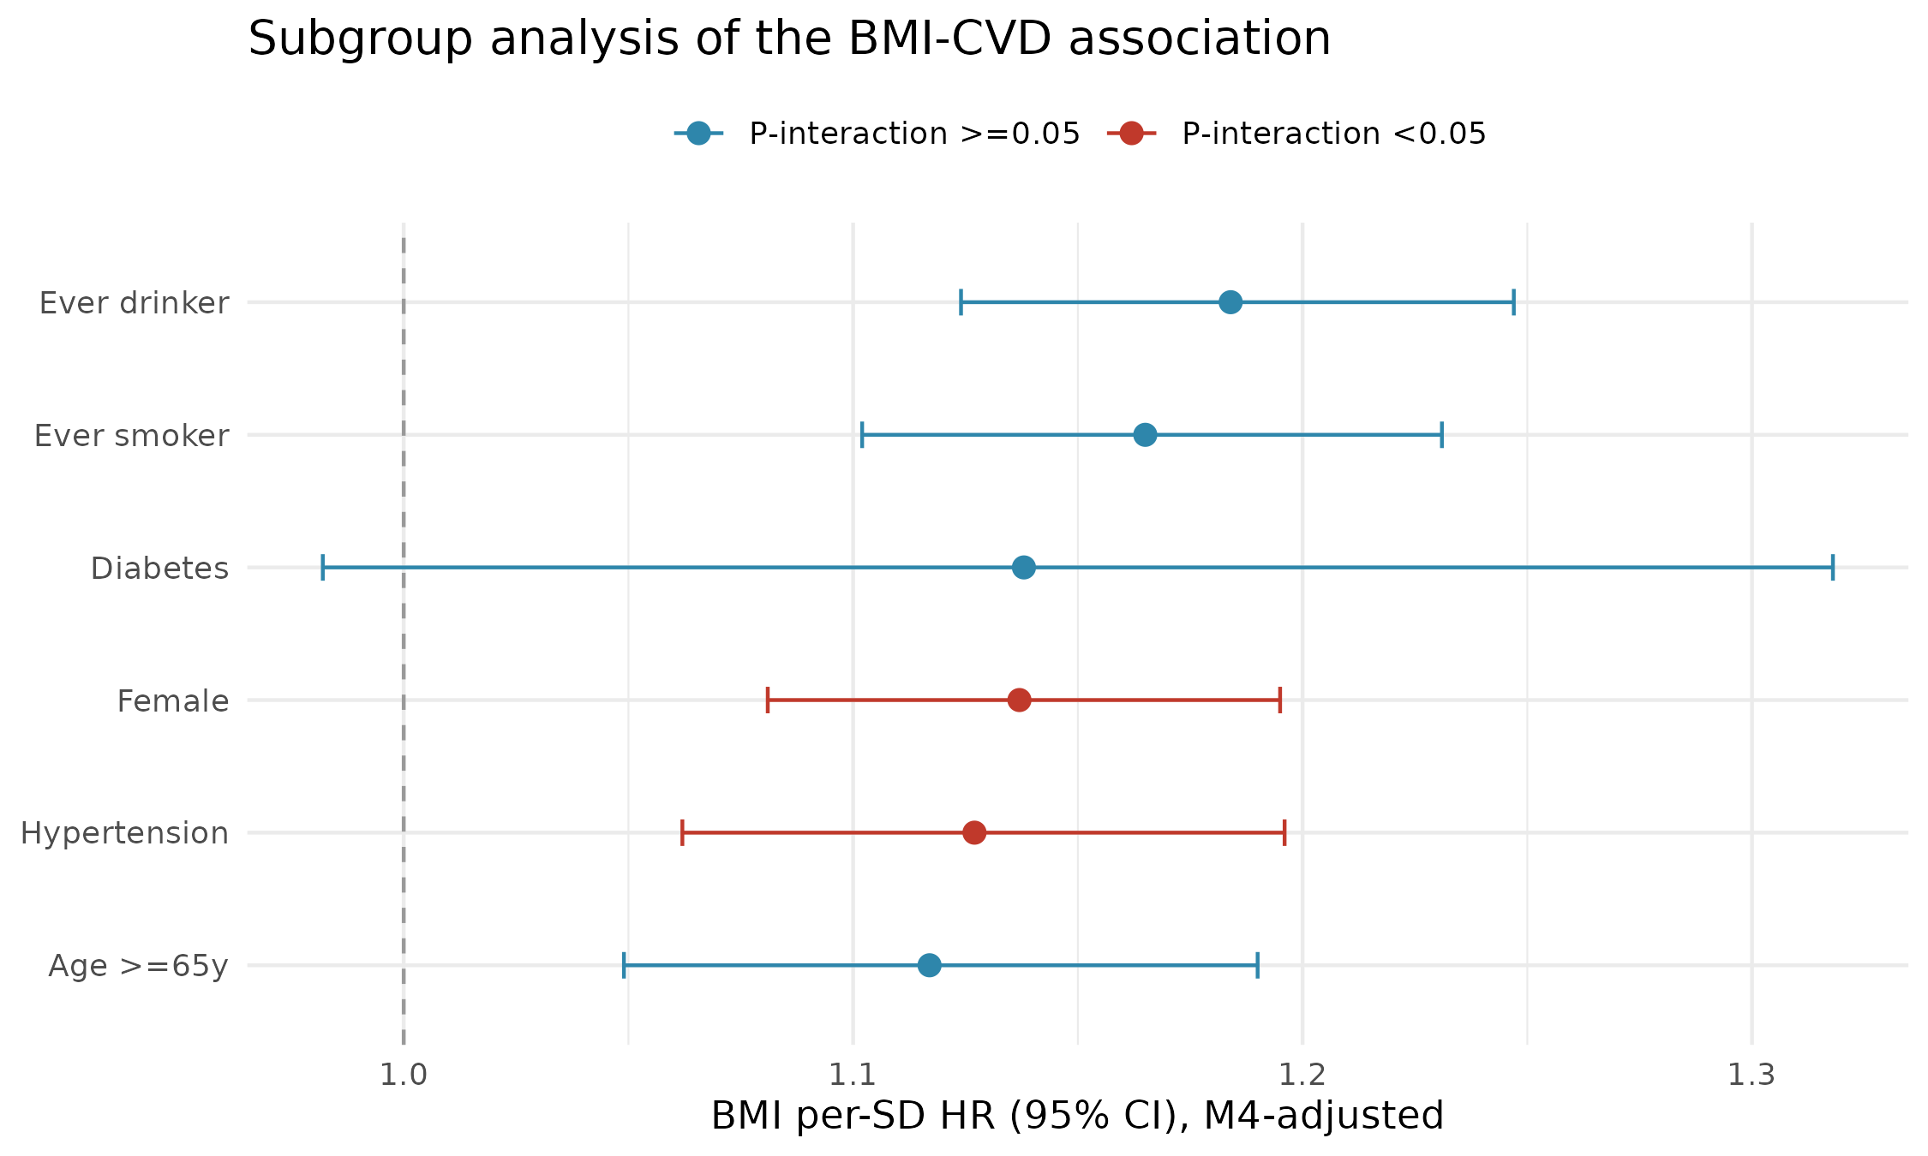
Subgroup forest plot of the BMI per-SD association (M4 adjustment) with interaction P values.

Supplementary Figure S2.
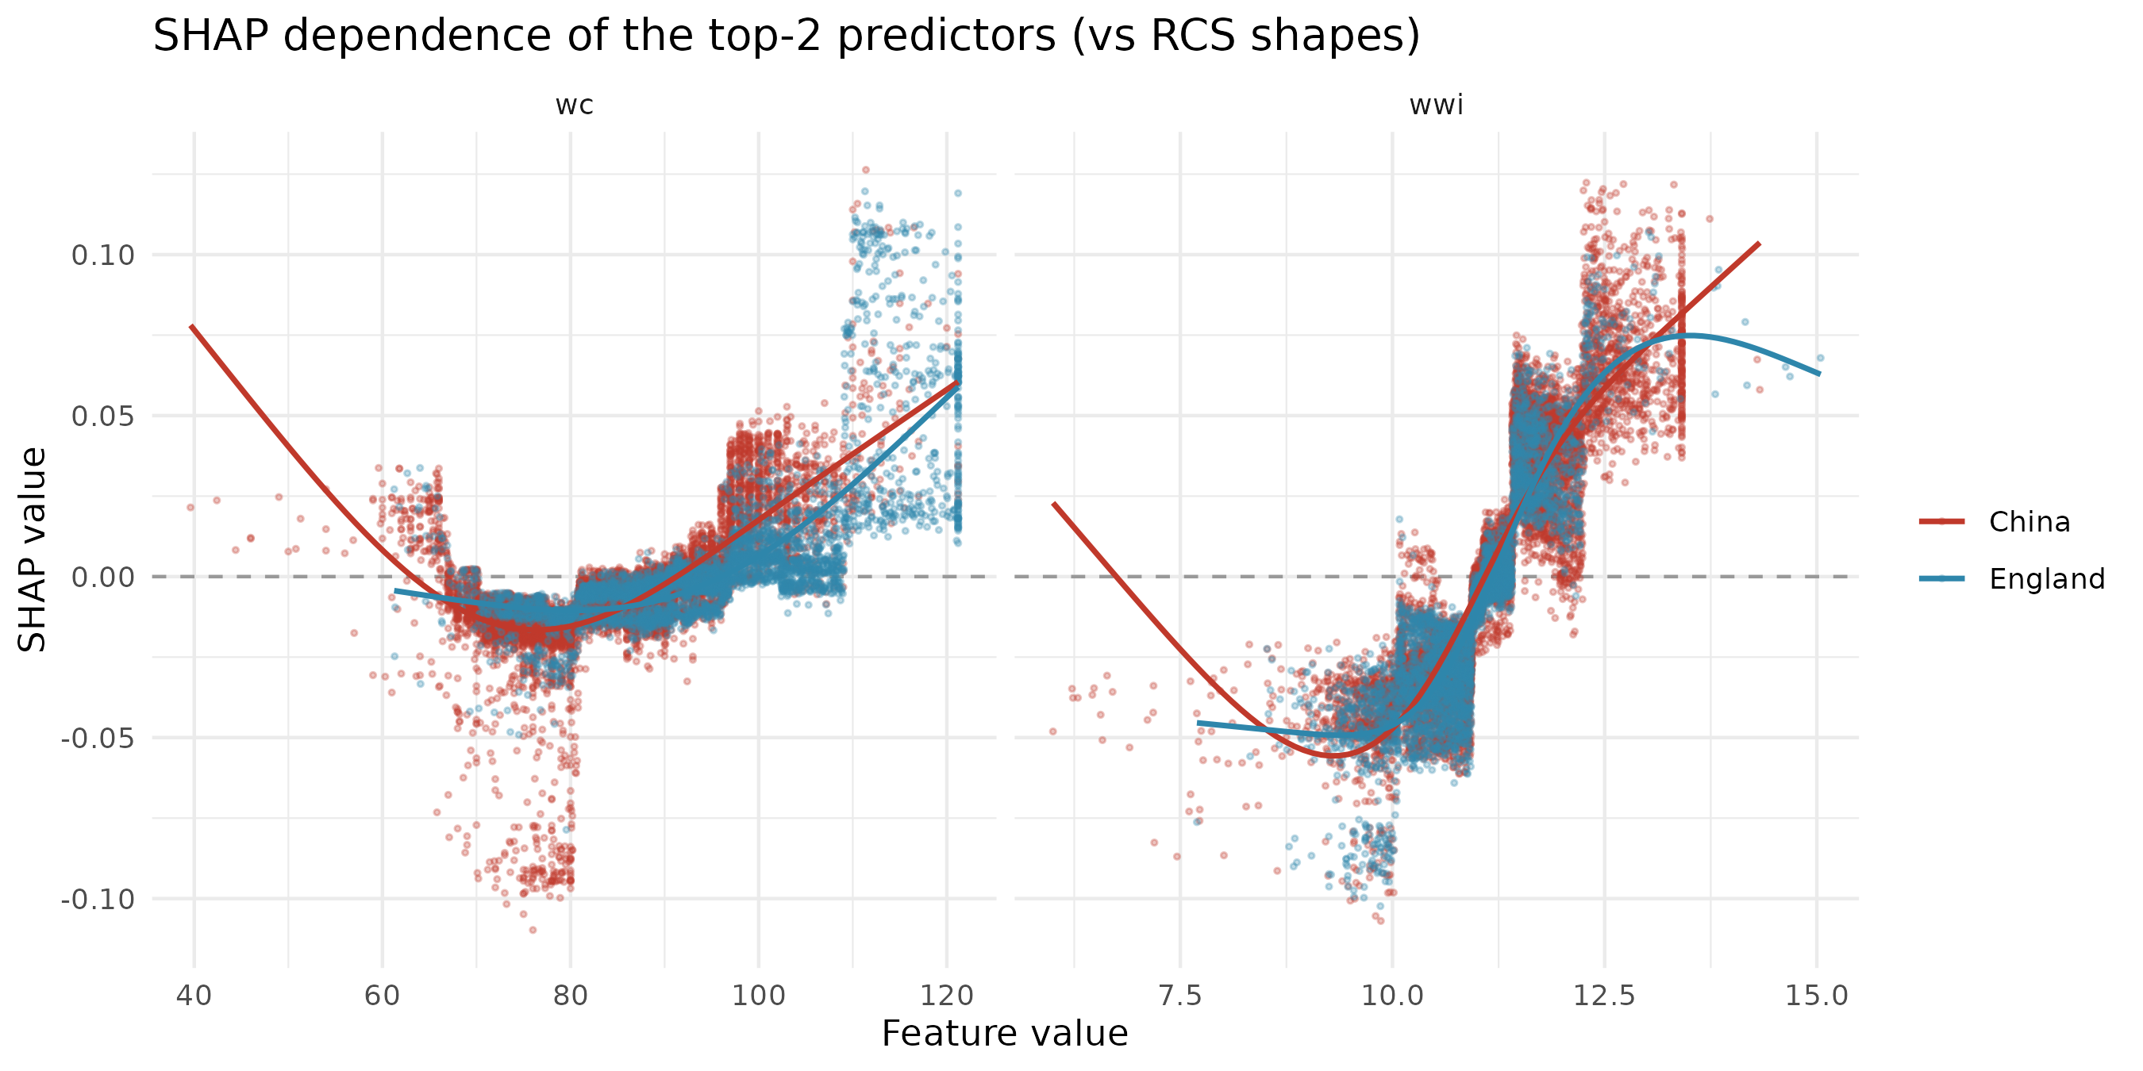
SHAP dependence plots of the two leading adiposity predictors (WWI, WC), by country, for comparison with the RCS dose–response curves.

Supplementary Figure S3.
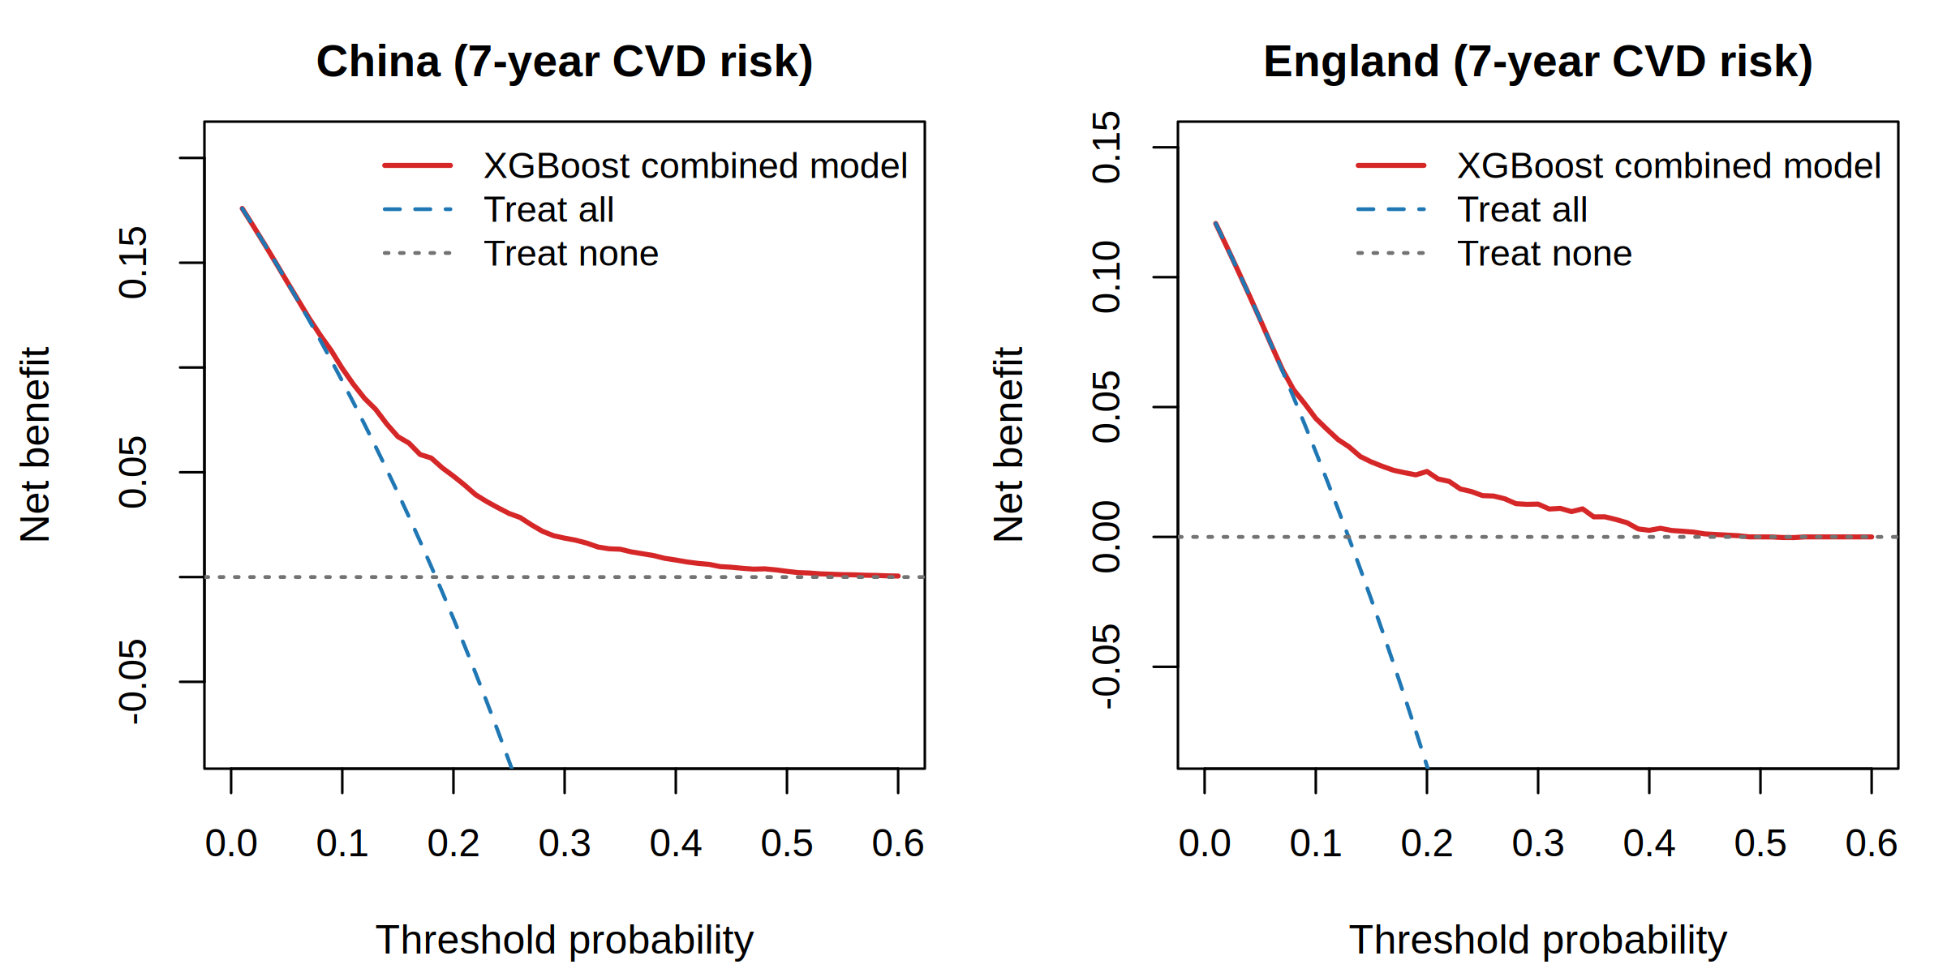
Decision-curve analysis of the combined XGBoost model for 7-year CVD risk, by country (China: model superior across 5–60% thresholds; England: 6–49%; net benefit at a 10% threshold 0.100 and 0.046, respectively).

Supplementary Figure S4.
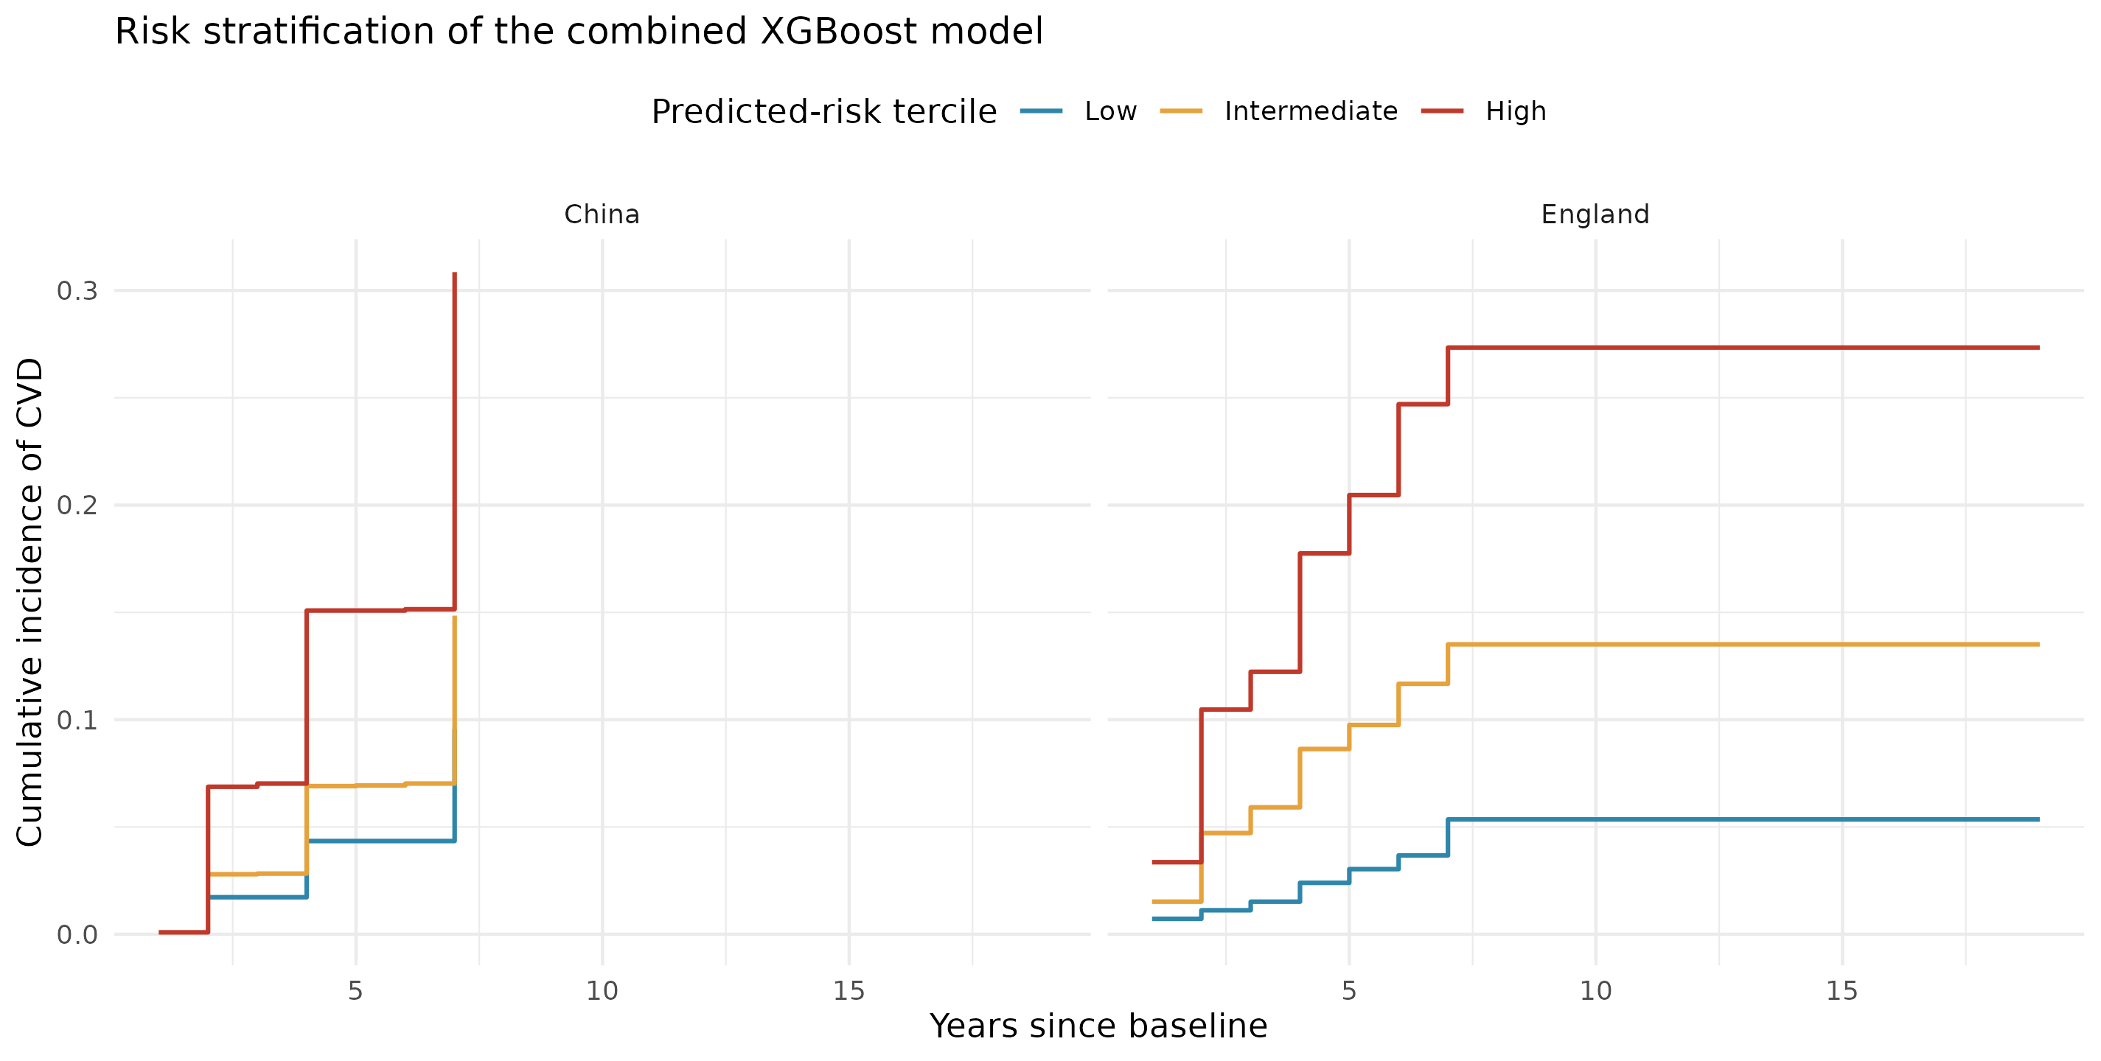
Risk-stratified Kaplan–Meier curves. Seven-year CVD-free survival by predicted-risk tertile in China (A) and England (B); numbers at risk shown below each panel. Corresponding hazard ratios in Supplementary Table S14b.

Supplementary Figure S5.
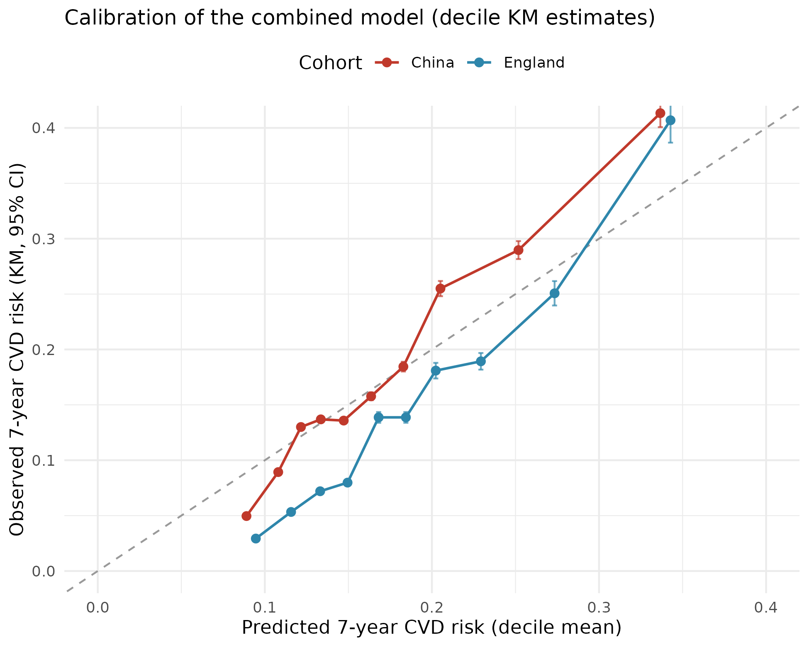
Calibration curves. Predicted versus observed (Kaplan–Meier) 7-year CVD risk by decile in China (A) and England (B), with bootstrap 95% confidence bands and the diagonal line of perfect calibration. Corresponding numerical values in Supplementary Table S14c.

Supplementary Figure S6.
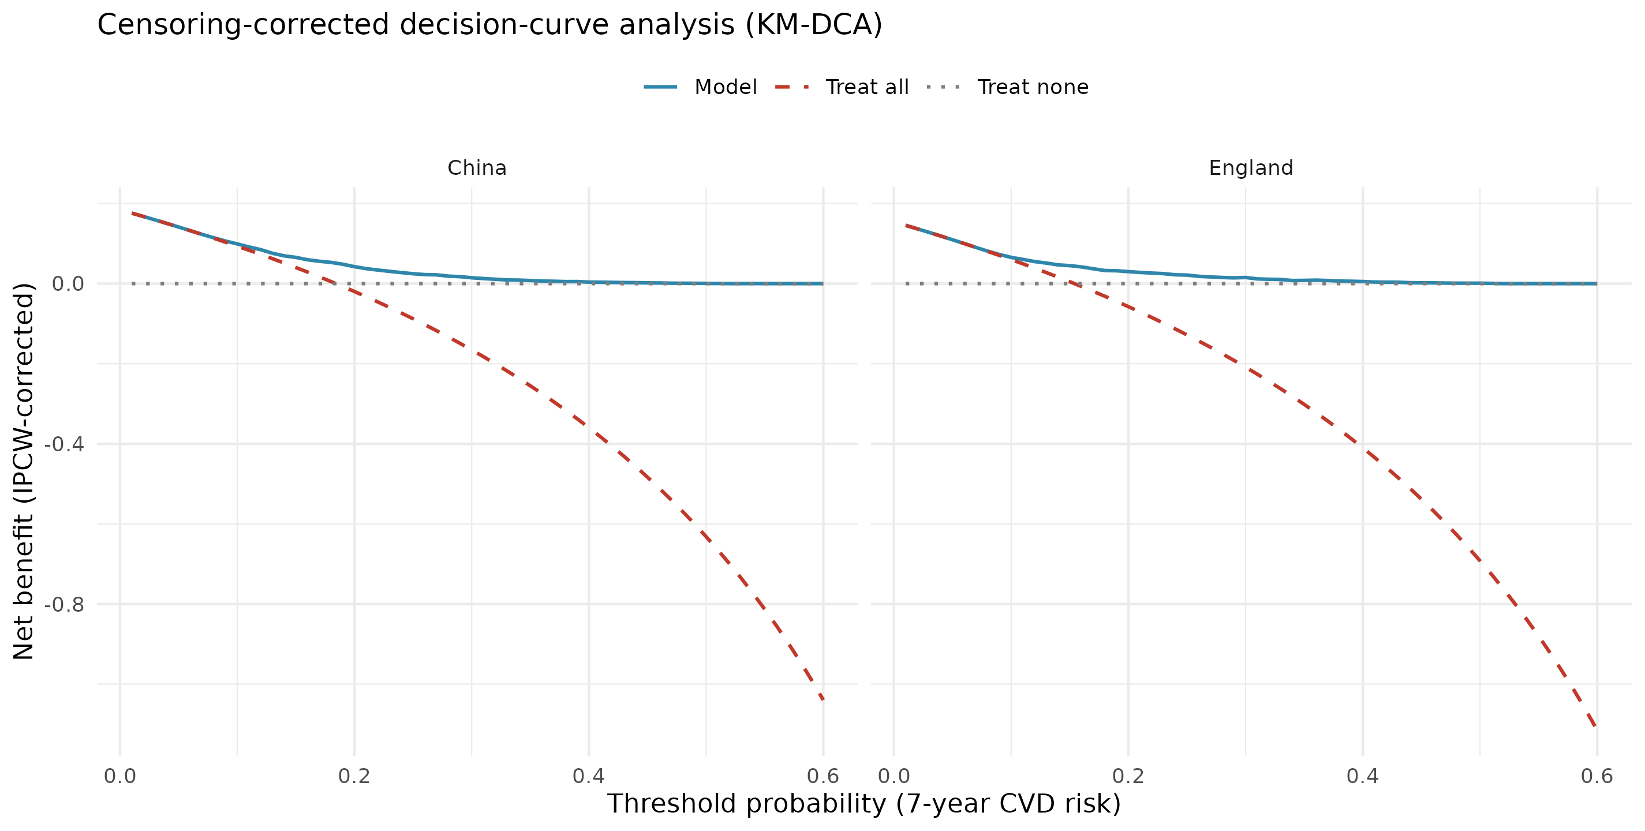
Survival decision-curve analysis. Censored (survival) net benefit of the combined-cohort model versus treat-all and treat-none strategies across threshold probabilities in China (A) and England (B). This estimand differs from the binary 7-year decision-curve analysis in Supplementary Figure S3 (e.g., England net benefit at 10% threshold 0.065 here vs 0.046 in Figure S3); both estimands support model net benefit across clinically relevant thresholds.

