Supplementary Information
Geomechanical Stability Assessment of Underground Chalk Heritage Galleries Based on TLS-Derived 3D Geometry and Numerical Modelling
Mateusz Blajer ^{1,}*, Wioletta Podwyszyńska-Sałosz ² and Krzysztof Tajduś ³
¹ AGH University of Krakow, Poland; blajer@agh.edu.pl
² Budimex S.A., Poland
³ AGH University of Krakow, Poland; ktajdus@agh.edu.pl
* Correspondence: blajer@agh.edu.pl; Tel.: +48126172168

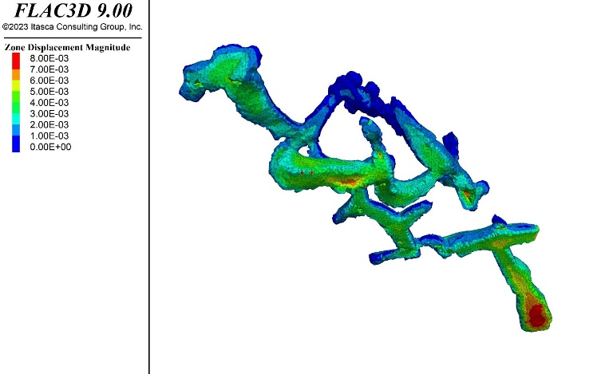  (a) | 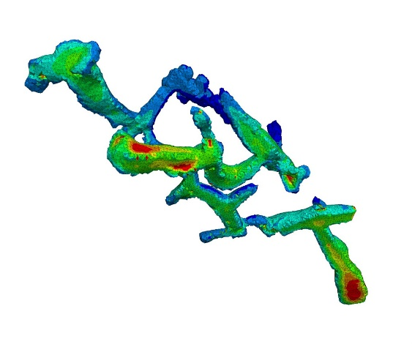  (b)
Supplementary Figure S1. Total displacements in the analysed chambers [m]: (a) λ̄ = 0.8; (b) λ̄ = 1.2—Stage 4 (view from the “Bieluch” Chamber towards the excavation floor)
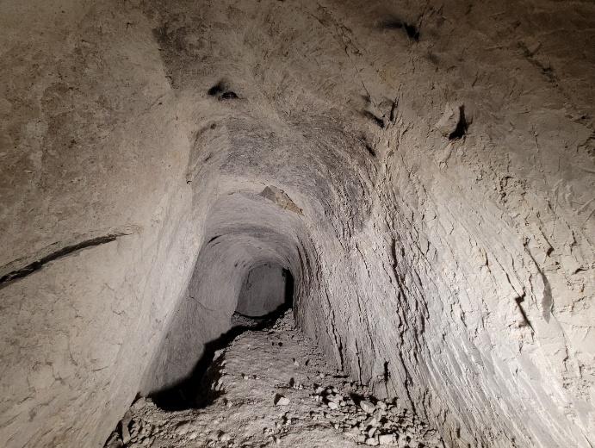  (a) | 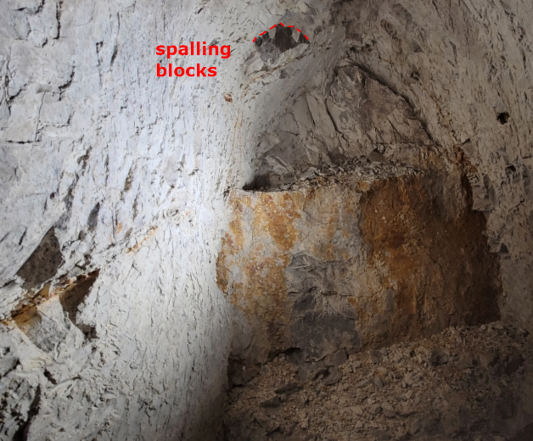  (b)
Supplementary Figure S2. Condition of the analysed chambers: (a) elliptical roof profile and irregular excavation floor; (b) detached and spalling rock blocks, with visible inclusions and heterogeneities within the rock mass.

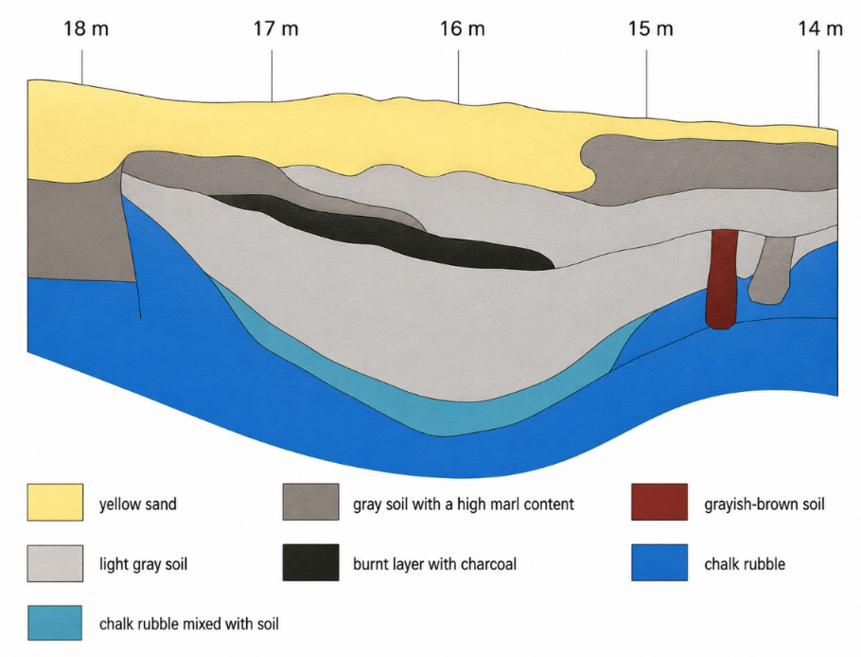
Supplementary Figure S3. Geological profile of the central area of Chełm [1]
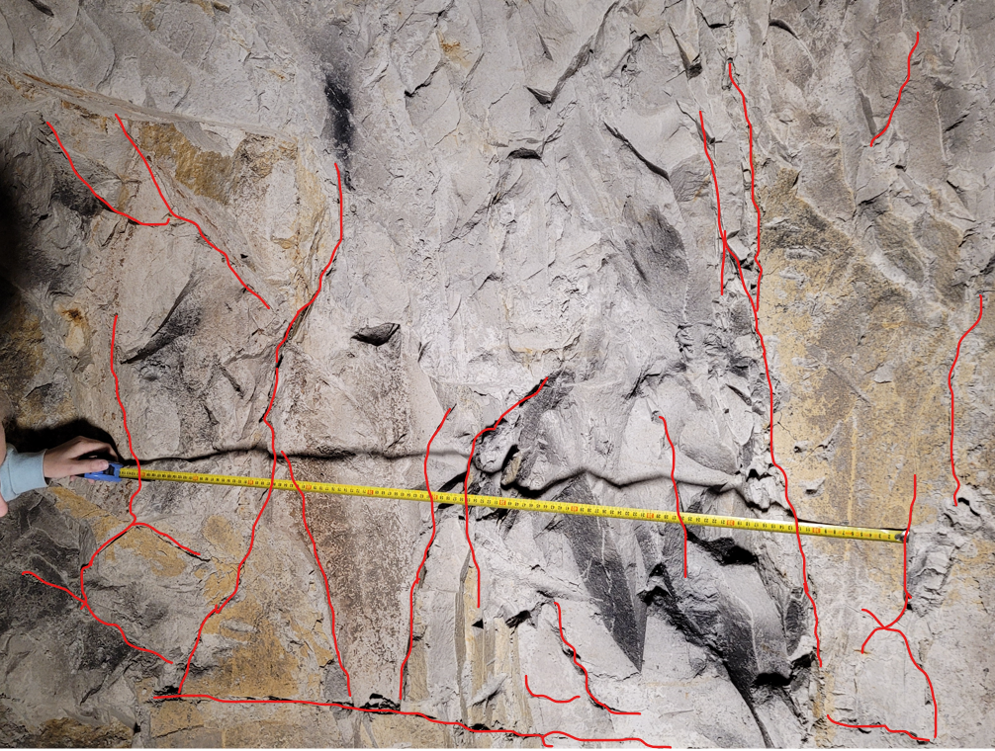
Supplementary Figure S4. Discontinuity pattern within the assessed section of the rock mass

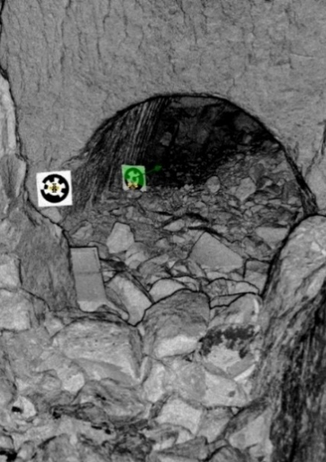
Supplementary Figure S5. Point cloud generated from terrestrial laser scanning data
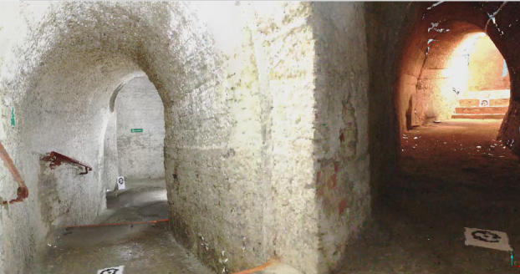
Supplementary Figure S6. Visualisation of the underground interior generated from terrestrial laser scanning data

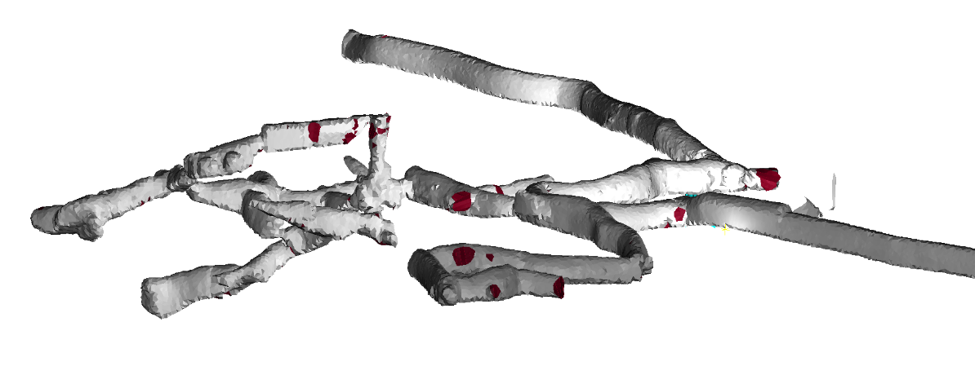
Supplementary Figure S7. CAD model of a section of the Chełm Chalk Tunnels
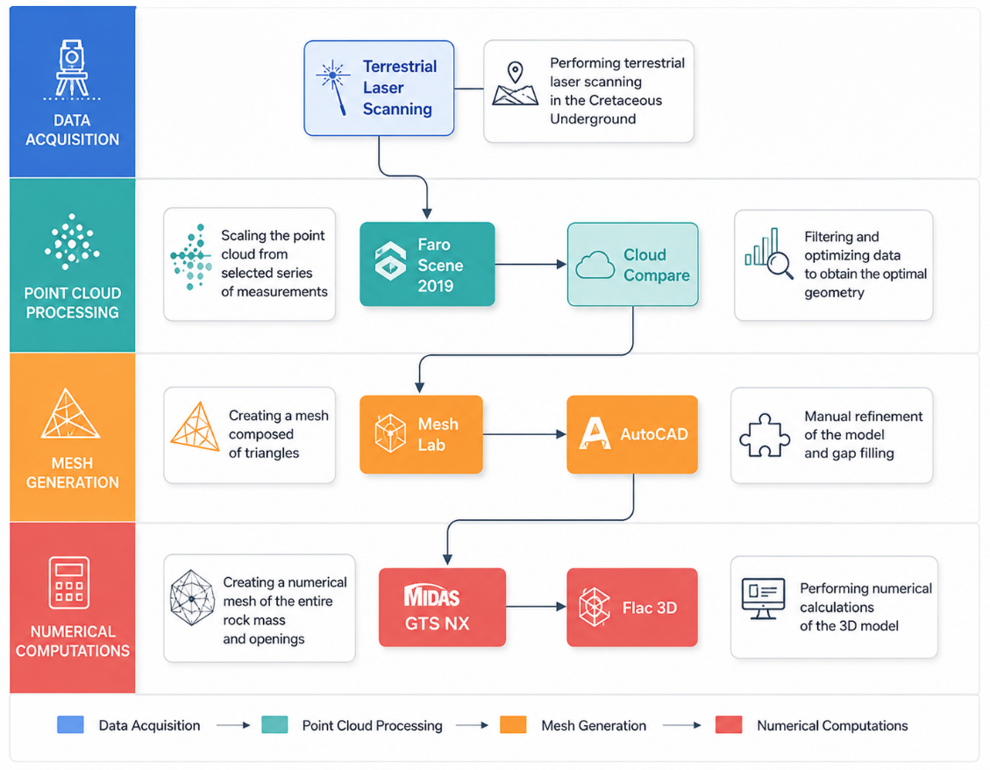
Supplementary Figure S8. Numerical model development workflow

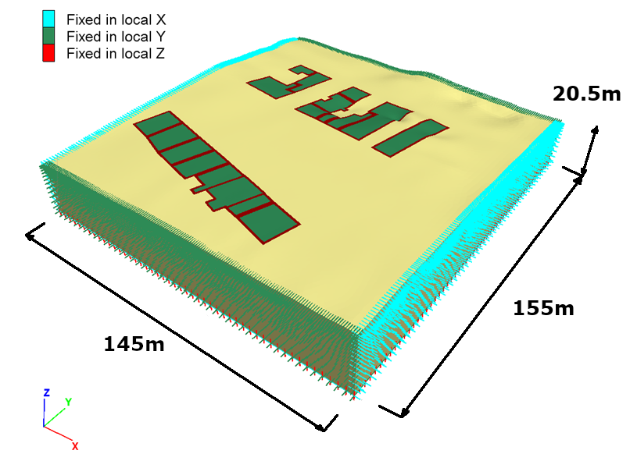
Supplementary Figure S9. Model geometry and displacement boundary conditions in FLAC3D
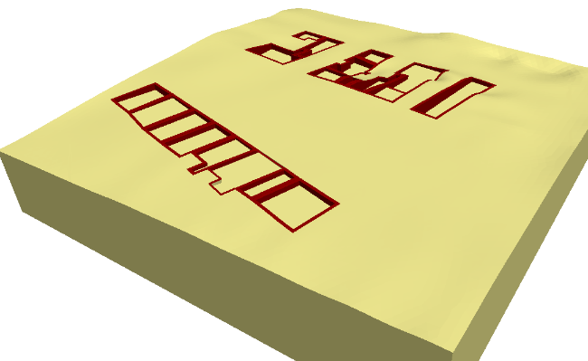 (a) | 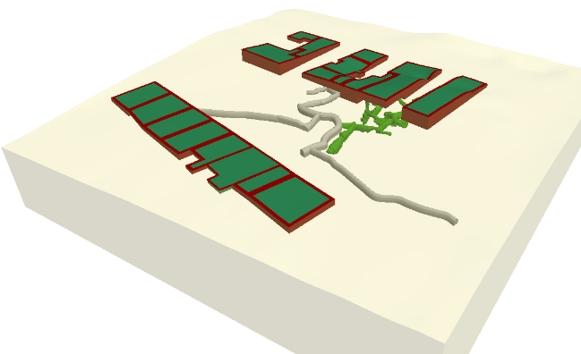  (b)
Supplementary Figure S10. FLAC3D model geometry: (a) view of the building foundations; (b) layout of the underground workings

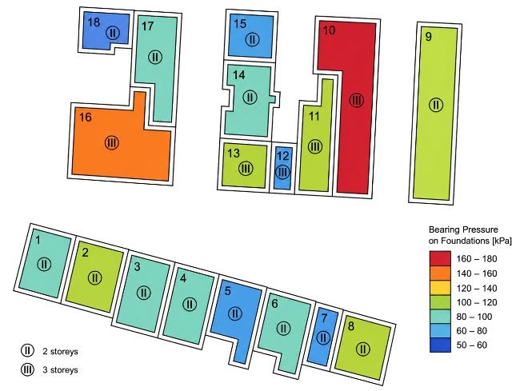  (a) | 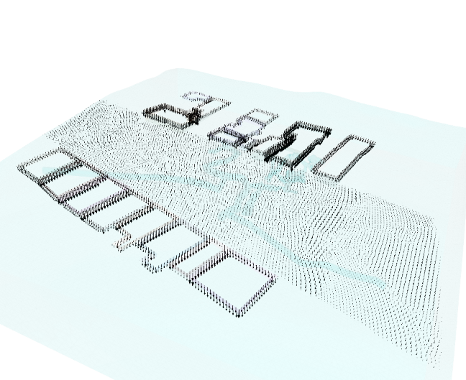  (b)
Supplementary Figure S11. Estimated loads exerted by the tenement buildings on the market square
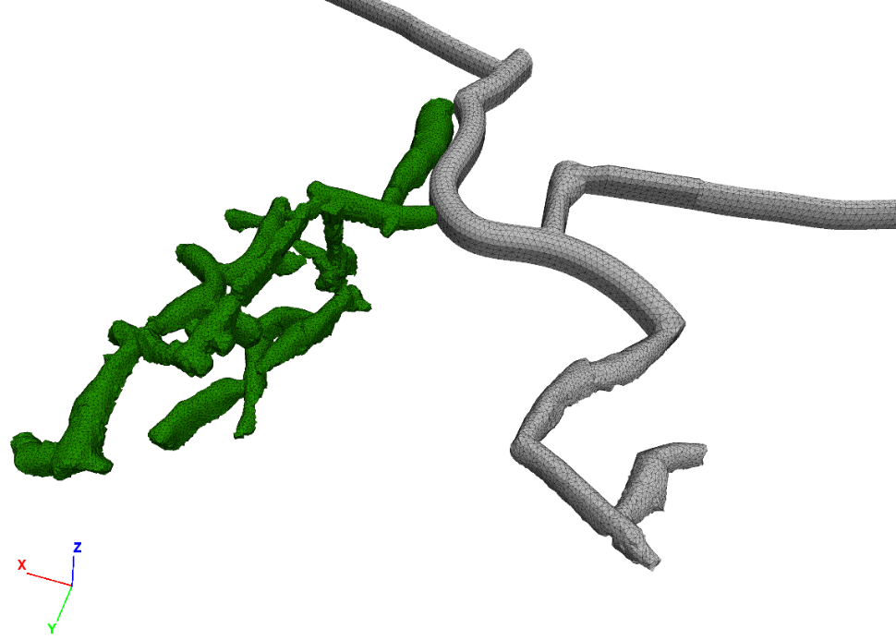
Supplementary Figure S12. Layout of the underground workings in MIDAS GTS NX (green—area analysed)

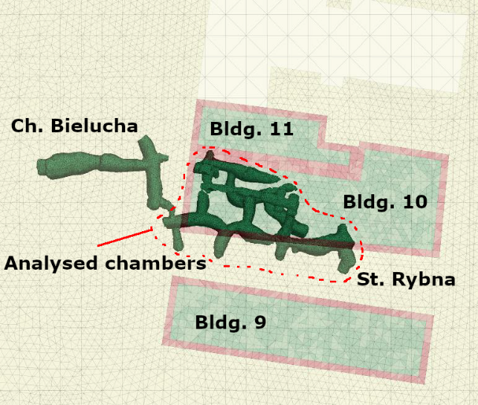  (a) | 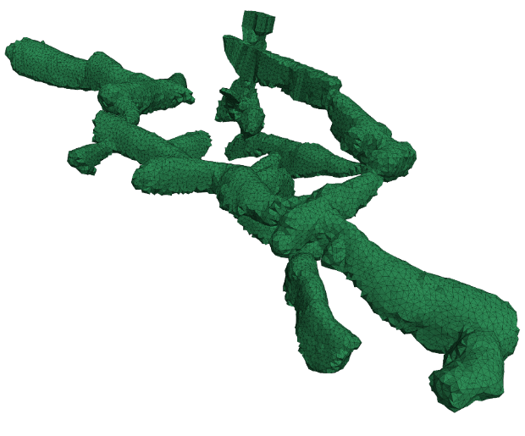  (b)
Supplementary Figure S13. Set of chambers subjected to stability analysis in FLAC3D 9.0: (a) location of the analysed area; (b) three-dimensional view of the chamber layout
Supplementary References
1. Mikoś, T., Chmura, J. & Tajduś, A. Górniczo-Geotechniczne Metody Adaptacji i Rekonstrukcji Zabytkowych Podziemi (Wydawnictwa AGH, 2014).

Supplementary Table S1. Specimen dimensions and mass: series 1 and 2.
Sample | h₁  (mm) | h₂  (mm) | h₃  (mm) | D₁  (mm) | D₂  (mm) | D₃  (mm) | Mass  (g) | Mean h  (mm) | Mean D  (mm)
1.1 | 74.13 | 73.96 | 73.98 | 37.97 | 37.96 | 37.55 | 161.89 | 74.02 | 37.83
1.2 | 74.65 | 74.77 | 74.60 | 37.91 | 37.85 | 37.88 | 166.79 | 74.67 | 37.88
1.3 | 74.67 | 74.68 | 74.60 | 37.92 | 37.88 | 37.85 | 164.22 | 74.65 | 37.88
1.4 | 74.75 | 74.88 | 74.78 | 37.93 | 37.91 | 37.85 | 166.41 | 74.80 | 37.90
1.5 | 74.73 | 74.95 | 74.73 | 37.85 | 37.87 | 37.91 | 164.77 | 74.80 | 37.88
1.6 | 74.80 | 74.76 | 74.77 | 37.84 | 37.87 | 37.98 | 164.46 | 74.78 | 37.90
1.7 | 74.88 | 74.76 | 74.75 | 37.87 | 37.81 | 37.93 | 164.91 | 74.80 | 37.87
1.8 | 37.36 | 37.49 | 37.38 | 37.90 | 37.93 | 37.87 | 82.90 | 37.41 | 37.90
1.9 | 37.55 | 37.68 | 37.60 | 37.83 | 37.92 | 37.84 | 83.76 | 37.61 | 37.86
1.10 | 37.50 | 37.57 | 37.54 | 37.94 | 37.90 | 37.86 | 82.40 | 37.54 | 37.90
1.11 | 37.16 | 36.92 | 36.91 | 38.19 | 37.93 | 37.96 | 81.06 | 37.00 | 38.03
2.1 | 74.91 | 74.82 | 74.84 | 37.51 | 37.84 | 37.90 | 164.23 | 74.86 | 37.75
2.2 | 74.74 | 74.77 | 74.79 | 37.82 | 37.93 | 37.91 | 163.76 | 74.77 | 37.89
2.3 | 75.08 | 74.84 | 74.95 | 37.84 | 37.78 | 37.75 | 163.45 | 74.96 | 37.79
2.4 | 74.69 | 74.64 | 74.79 | 37.86 | 37.76 | 37.88 | 163.75 | 74.71 | 37.83
2.5 | 74.77 | 74.75 | 74.67 | 37.91 | 37.86 | 37.87 | 162.93 | 74.73 | 37.88
2.6 | 74.77 | 74.84 | 75.02 | 37.87 | 37.94 | 37.95 | 162.48 | 74.88 | 37.92
2.7 | 37.14 | 36.98 | 37.11 | 38.22 | 37.93 | 37.94 | 81.56 | 37.08 | 38.03
2.8 | 36.75 | 36.67 | 36.74 | 37.96 | 37.95 | 37.75 | 80.63 | 36.72 | 37.89
2.9 | 36.61 | 36.64 | 36.87 | 37.70 | 37.62 | 37.67 | 78.10 | 36.71 | 37.66

Supplementary Table S2. Specimen dimensions and mass: series 3.
Sample | h₁  (mm) | h₂  (mm) | h₃  (mm) | D₁  (mm) | D₂  (mm) | D₃  (mm) | Mass  (g) | Mean h  (mm) | Mean D  (mm)
3.1 | 74.69 | 74.56 | 74.65 | 37.99 | 37.89 | 38.11 | 164.11 | 74.63 | 38.00
3.2 | 74.87 | 74.86 | 74.98 | 38.03 | 38.00 | 38.06 | 164.78 | 74.90 | 38.03
3.3 | 74.87 | 74.96 | 74.91 | 38.00 | 38.02 | 38.11 | 166.27 | 74.91 | 38.04
3.4 | 74.89 | 74.15 | 75.24 | 37.96 | 38.00 | 37.69 | 164.16 | 74.76 | 37.88
3.5 | 74.93 | 74.92 | 74.89 | 37.93 | 37.98 | 37.38 | 164.75 | 74.91 | 37.76
3.6 | 74.96 | 74.88 | 74.90 | 38.21 | 37.94 | 37.95 | 165.19 | 74.91 | 38.03
3.7 | 74.75 | 74.77 | 74.69 | 37.96 | 37.98 | 37.95 | 166.51 | 74.74 | 37.96
3.8 | 74.76 | 74.90 | 74.78 | 37.95 | 37.94 | 37.94 | 164.62 | 74.81 | 37.94
3.9 | 74.05 | 74.01 | 73.75 | 37.95 | 38.00 | 37.97 | 162.53 | 73.94 | 37.97
3.10 | 74.71 | 74.42 | 74.79 | 37.99 | 38.01 | 38.02 | 164.47 | 74.64 | 38.01
3.11 | 74.88 | 74.88 | 74.95 | 37.73 | 37.92 | 37.97 | 160.64 | 74.90 | 37.87
3.12 | 74.92 | 74.67 | 75.13 | 38.01 | 37.95 | 37.97 | 165.61 | 74.91 | 37.98
3.13 | 74.95 | 74.81 | 74.93 | 37.93 | 37.98 | 37.94 | 165.80 | 74.90 | 37.95
3.14 | 74.96 | 74.91 | 75.05 | 37.97 | 37.92 | 37.85 | 164.45 | 74.97 | 37.91
3.15 | 74.18 | 74.43 | 74.25 | 37.91 | 37.92 | 39.98 | 164.24 | 74.29 | 38.60
3.16 | 36.61 | 37.12 | 36.95 | 37.96 | 38.00 | 37.96 | 81.19 | 36.89 | 37.97
3.17 | 36.71 | 36.26 | 36.92 | 38.01 | 38.03 | 38.01 | 81.21 | 36.63 | 38.02
3.18 | 36.42 | 36.60 | 37.00 | 37.98 | 37.95 | 37.97 | 80.08 | 36.67 | 37.97
3.19 | 36.77 | 36.85 | 36.96 | 37.95 | 37.82 | 38.01 | 79.75 | 36.86 | 37.93
3.20 | 36.92 | 37.13 | 36.91 | 37.95 | 38.01 | 37.93 | 80.70 | 36.99 | 37.96
3.21 | — | — | — | — | — | — | 464.00 | — | —

Supplementary Table S3. Specimen dimensions and mass: series 4, specimens 4.1–4.20.
Sample | h₁  (mm) | h₂  (mm) | h₃  (mm) | D₁  (mm) | D₂  (mm) | D₃  (mm) | Mass  (g) | Mean h  (mm) | Mean D  (mm)
4.1 | 74.87 | 74.91 | 74.74 | 37.92 | 37.96 | 38.03 | 163.22 | 74.84 | 37.97
4.2 | 74.65 | 74.70 | 74.93 | 37.97 | 37.91 | 37.90 | 163.88 | 74.76 | 37.93
4.3 | 74.83 | 74.98 | 74.92 | 37.87 | 37.93 | 37.99 | 164.12 | 74.91 | 37.93
4.4 | 74.98 | 74.91 | 74.99 | 38.03 | 37.98 | 37.99 | 165.87 | 74.96 | 38.00
4.5 | 74.76 | 74.86 | 74.80 | 37.95 | 37.65 | 37.88 | 164.65 | 74.81 | 37.83
4.6 | 75.06 | 74.86 | 74.99 | 37.97 | 37.96 | 37.77 | 163.74 | 74.97 | 37.90
4.7 | 75.01 | 74.86 | 74.68 | 37.97 | 37.90 | 37.94 | 163.45 | 74.85 | 37.94
4.8 | 36.85 | 37.00 | 36.97 | 37.90 | 37.56 | 37.78 | 81.27 | 36.94 | 37.75
4.9 | 36.97 | 36.95 | 37.09 | 37.94 | 37.90 | 37.93 | 81.38 | 37.00 | 37.92
4.10 | 36.69 | 36.95 | 36.87 | 37.89 | 37.92 | 37.91 | 80.63 | 36.84 | 37.91
4.11 | 36.63 | 36.46 | 36.55 | 37.95 | 37.91 | 37.95 | 80.52 | 36.55 | 37.94
4.12 | 36.95 | 37.07 | 37.04 | 37.79 | 37.96 | 37.89 | 81.48 | 37.02 | 37.88
4.13 | 36.33 | 36.51 | 36.76 | 37.87 | 37.85 | 37.82 | 79.65 | 36.53 | 37.85
4.14 | 37.49 | 37.25 | 36.83 | 37.61 | 37.96 | 37.94 | 81.59 | 37.19 | 37.84
4.15 | 37.20 | 36.93 | 36.86 | 37.93 | 37.84 | 38.06 | 81.00 | 37.00 | 37.94
4.16 | 36.94 | 37.20 | 36.70 | 37.87 | 37.95 | 37.95 | 80.97 | 36.95 | 37.92
4.17 | 36.63 | 36.42 | 36.54 | 37.95 | 37.96 | 37.98 | 80.42 | 36.53 | 37.96
4.18 | 36.89 | 36.95 | 36.94 | 37.75 | 37.92 | 37.93 | 80.35 | 36.93 | 37.87
4.19 | 36.90 | 36.81 | 36.88 | 37.31 | 37.62 | 37.83 | 80.10 | 36.86 | 37.59
4.20 | 36.88 | 36.96 | 37.11 | 37.85 | 37.91 | 37.75 | 80.61 | 36.98 | 37.84

Supplementary Table S4. Specimen dimensions and mass: series 4, specimens 4.21–4.40.
Sample | h₁  (mm) | h₂  (mm) | h₃  (mm) | D₁  (mm) | D₂  (mm) | D₃  (mm) | Mass  (g) | Mean h  (mm) | Mean D  (mm)
4.21 | 36.86 | 36.65 | 36.70 | 37.96 | 37.96 | 38.02 | 81.26 | 36.74 | 37.98
4.22 | 36.46 | 36.40 | 36.93 | 38.02 | 37.91 | 37.80 | 79.97 | 36.60 | 37.91
4.23 | — | — | — | — | — | — | 255.11 | — | —
4.24 | 74.62 | 75.59 | 74.78 | 37.03 | 37.98 | 37.92 | 164.51 | 75.00 | 37.64
4.25 | 74.50 | 74.48 | 75.08 | 37.97 | 38.02 | 37.99 | 163.56 | 74.69 | 37.99
4.26 | 75.00 | 74.83 | 75.16 | 37.92 | 37.95 | 37.91 | 164.94 | 75.00 | 37.93
4.27 | 74.86 | 74.84 | 75.08 | 37.88 | 37.90 | 37.86 | 165.00 | 74.93 | 37.88
4.28 | 74.44 | 74.29 | 74.11 | 37.96 | 37.97 | 37.95 | 162.99 | 74.28 | 37.96
4.29 | 75.19 | 74.96 | 74.99 | 37.81 | 37.90 | 37.82 | 164.31 | 75.05 | 37.84
4.30 | 75.30 | 74.88 | 74.71 | 38.00 | 38.01 | 37.92 | 163.51 | 74.96 | 37.98
4.31 | 74.99 | 75.14 | 75.64 | 38.01 | 38.09 | 37.94 | 165.01 | 75.26 | 38.01
4.32 | 74.95 | 74.78 | 74.77 | 37.92 | 37.95 | 37.96 | 164.26 | 74.83 | 37.94
4.33 | 75.23 | 75.34 | 74.99 | 37.97 | 37.94 | 37.91 | 164.29 | 75.19 | 37.94
4.34 | 74.80 | 75.16 | 74.83 | 37.95 | 37.99 | 37.73 | 165.34 | 74.93 | 37.89
4.35 | 74.77 | 74.85 | 74.99 | 38.02 | 37.99 | 38.00 | 164.28 | 74.87 | 38.00
4.36 | 75.22 | 75.05 | 75.03 | 38.02 | 37.91 | 37.77 | 164.34 | 75.10 | 37.90
4.37 | 74.95 | 74.91 | 74.90 | 37.96 | 37.99 | 37.93 | 166.19 | 74.92 | 37.96
4.38 | 74.82 | 75.21 | 75.15 | 37.95 | 37.95 | 37.80 | 163.62 | 75.06 | 37.90
4.39 | 75.20 | 75.30 | 75.04 | 37.91 | 37.81 | 37.85 | 164.47 | 75.18 | 37.86
4.40 | 75.40 | 74.98 | 75.08 | 37.94 | 37.95 | 37.98 | 165.30 | 75.15 | 37.96

Supplementary Table S5. Natural moisture content and uniaxial compressive strength.
Specimen | Natural moisture content, wₙ (%) | Compressive strength, Rc (kPa)
1.1 | 27.85 | 3182.41
1.2 | 28.14 | 2899.83
1.3 | 27.65 | 2810.21
2.1 | 27.36 | 1855.72
2.2 | 26.99 | 2225.16
3.1 | 27.31 | 1729.98
3.2 | 28.09 | 1557.35
4.5 | 28.23 | 2148.60
4.6 | 28.30 | 2053.80
4.28 | 27.59 | 1751.30
4.29 | 25.56 | 1467.84
4.31 | 27.25 | 1891.78
4.34 | 27.70 | 2377.70
4.35 | 26.68 | 1678.84
4.36 | 18.75 | 1943.88

Supplementary Table S6. Secant modulus E₅₀ of specimens at natural moisture content.
Specimen | E₅₀ (MPa)
1.1 | 306.83
1.2 | 363.85
1.3 | 300.14
2.1 | 493.78
2.2 | 472.87
3.1 | 479.16
3.2 | 199.55
4.5 | 348.39
4.6 | 382.34
4.28 | 209.49
4.29 | 416.75
4.31 | 426.85
4.34 | 747.74
4.35 | 248.15
4.36 | 167.96

Supplementary Table S7. Natural moisture content and tensile strength.
Specimen | Natural moisture content, wₙ (%) | Tensile strength, Rr (kPa)
3.16 | 22.12 | 253.56
3.17 | 26.93 | 360.24
3.18 | 21.86 | 222.21
3.20 | 20.51 | 344.58
4.8 | 13.19 | 220.52
4.9 | 27.44 | 235.90
4.10 | 28.11 | 373.39
4.11 | 27.90 | 273.67
4.12 | 28.29 | 221.54
4.13 | 28.19 | 250.47
4.14 | 27.10 | 299.95
4.15 | 27.87 | 289.34
4.16 | 28.36 | 324.87
4.17 | 26.78 | 305.27
4.18 | 18.65 | 344.20

Supplementary Table S8. Uniaxial compressive strength of dry specimens.
Specimen | Rc (MPa)
1.4 | 14.16
1.6 | 4.88
1.7 | 13.33
2.3 | 5.97
2.4 | 8.19
3.4 | 9.50
3.7 | 6.69
3.13 | 8.56
4.24 | 7.83
4.25 | 5.11
4.26 | 7.59
4.37 | 6.98

Supplementary Table S9. Secant modulus E₅₀ of dry specimens.
Specimen | E₅₀ (MPa)
1.4 | 1333.85
1.6 | 1200.57
1.7 | 1177.05
2.3 | 733.63
2.4 | 1094.24
3.4 | 1036.92
3.7 | 813.33
3.13 | 914.54
4.24 | 1725.11
4.25 | 532.36
4.26 | 1152.98
4.37 | 715.32

