 |  | Physicians  (HICs) | Physicians  (LMICs)
Basic Demographics
Total Participants, |  | 42 | 13
Countries Represented, n |  | 3 | 6
Age, Median (Q1,Q3) |  | 51 [45,57.8] | 46 [43.60]
Male, n |  | 26 (61.9%) | 9 (69.2%)
Born in Country of Practice, n |  | 24 (57.1%) | 12 (92.3%)
Details of Practice
Location of Practice (Public/Private/Mixed) |  | 28/5/9 | 4/3/5
Resistant Infection in Patients (Low/High) |  | 36/6 | 8/5
Cirrhosis Inpatient Exposure (Low/High) |  | 28/14 | 7/6
Cirrhosis Outpatient Exposure (Low/High) |  | 21/21 | 3/10
Recent History
Infection within last 3 months, n |  | 12 (28.6%) | 3 (23%)
Antibiotic usage within last 3 months, n |  | 3 (0.07%) | 3 (23%)

Table S1. Summary of clinical and practice characteristics between physicians from HICs and LMICs. High income countries included clinicians practicing in Denmark (n = 1), Lithuania (n = 5), and USA (n = 36). L/M income countries included clinicians practicing in Brazil (n= 4), China (n=1), India (n = 3), Mexico (n = 3), Thailand (n = 1), and Turkey (n = 1).

Coefficients: | Estimate | Std.Error | zvalue | Pr(>|z|) | IRR | 2.50% | 97.50%
(Intercept) | 2.573173 | 0.130358 | 19.739 | <2e-16 | 13.10735 | 10.1175 | 16.8666
Richness | 0.001106 | 0.000418 | 2.648 | 0.008 | 1.001107 | 1.000288 | 1.001927
Income | -0.25302 | 0.07937 | -3.188 | 0.00143 | 0.776449 | 0.665638 | 0.908711
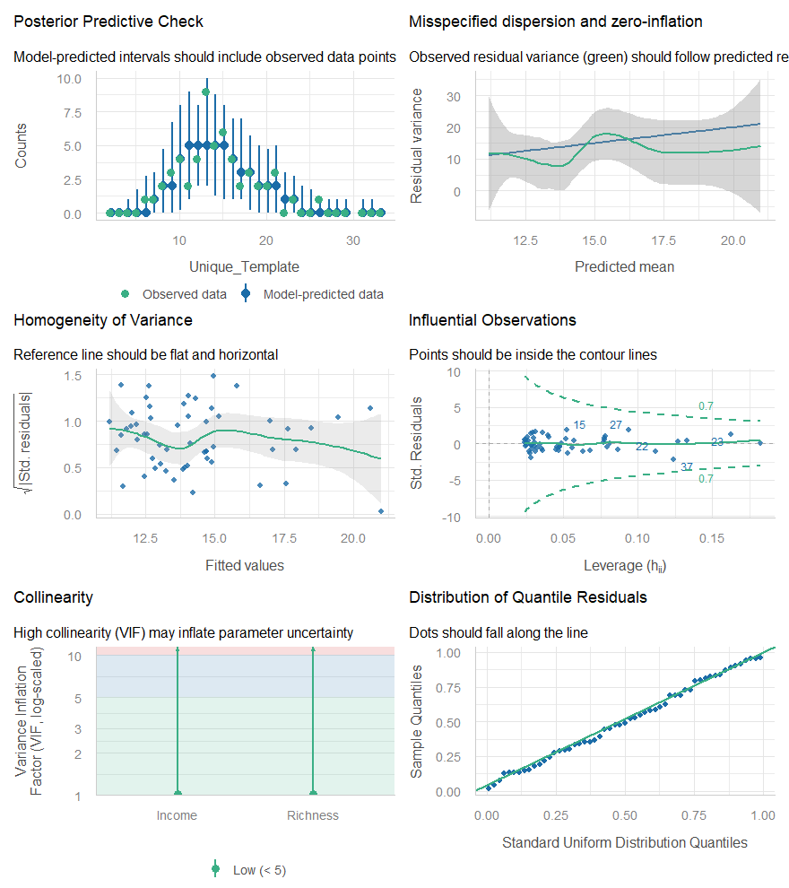

Figure S1. A Poisson generalized linear model (GLM) with a log-link function was used to evaluate the association of bacterial species richness and country income level with ARG richness (unique ARG gene families) using the ‘MASS’ package (v 7.3-65) in R. Model assumptions were checked using the ‘Performance’ package (v 0.17.1).

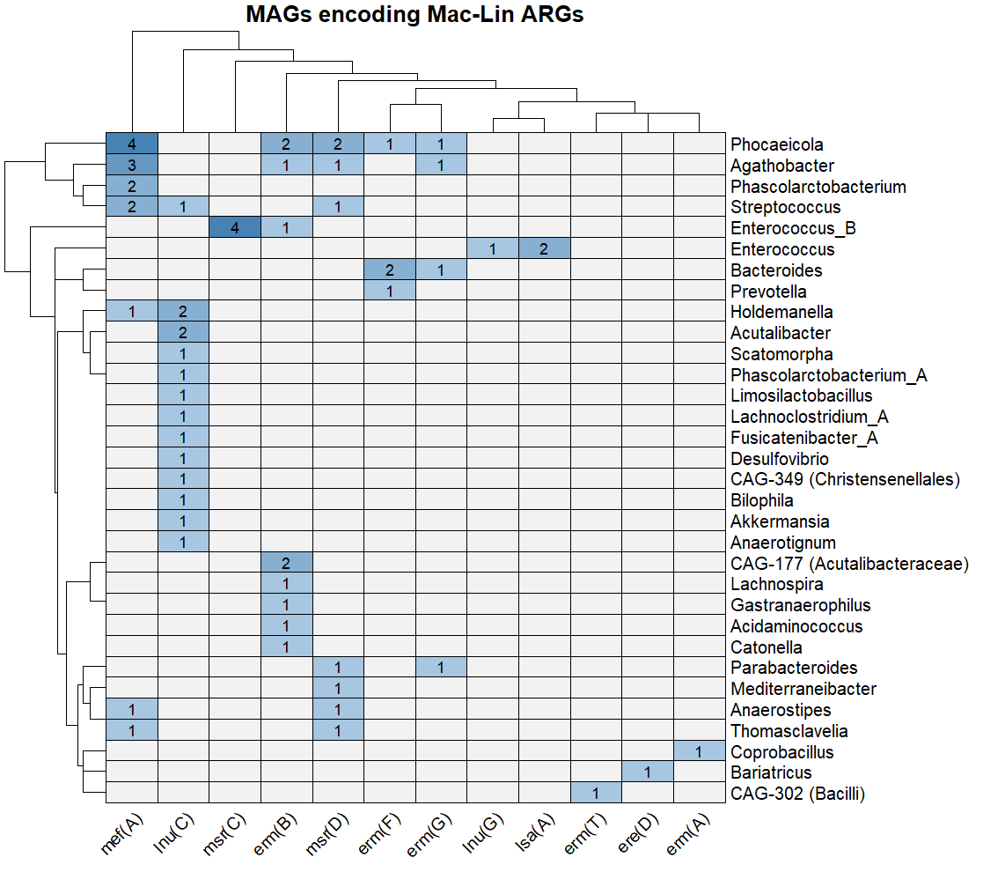
Figure S2. Heatmaps showing the taxonomy of MAGs encoding detected Macrolide-Lincosamide resistance determinants (>90% adjusted coverage). Number inside each box represents the count of assembled MAGs encoding a given ARG.

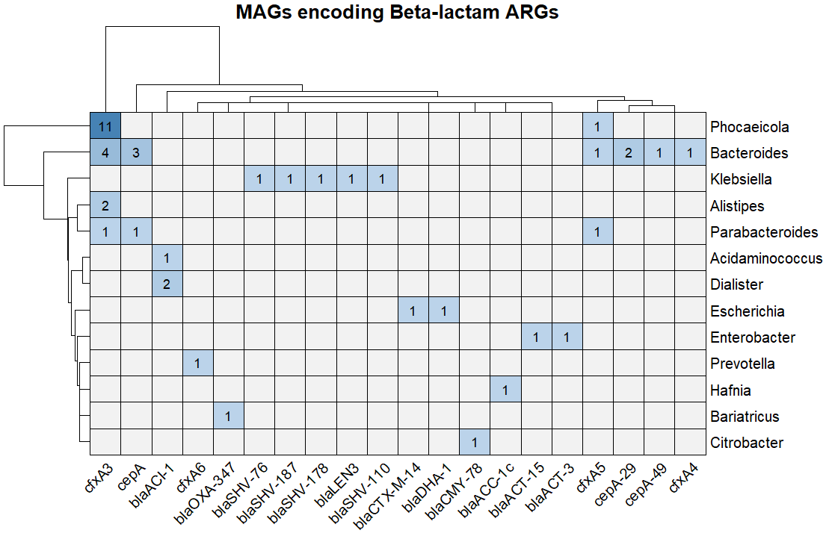
Figure S3. Heatmaps showing the taxonomy of MAGs encoding detected beta-lactam resistance determinants (>90% adjusted coverage). Number inside each box represents the count of MAGs encoding a given ARG.

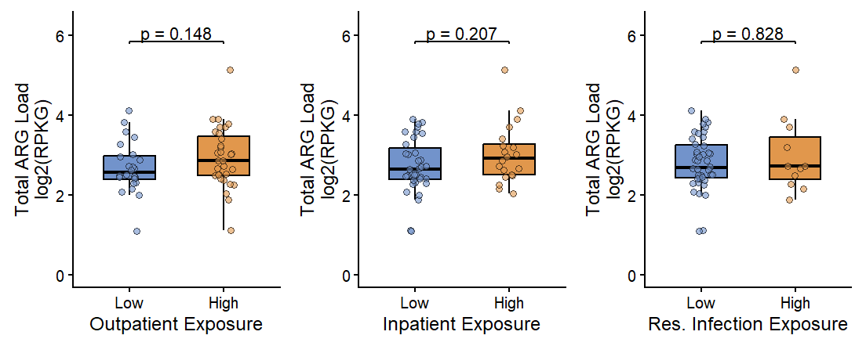Figure S4. Comparison of the total normalized ARG abundance across clinicians with low and high levels of exposure to outpatient, inpatient, and resistant infection exposure.

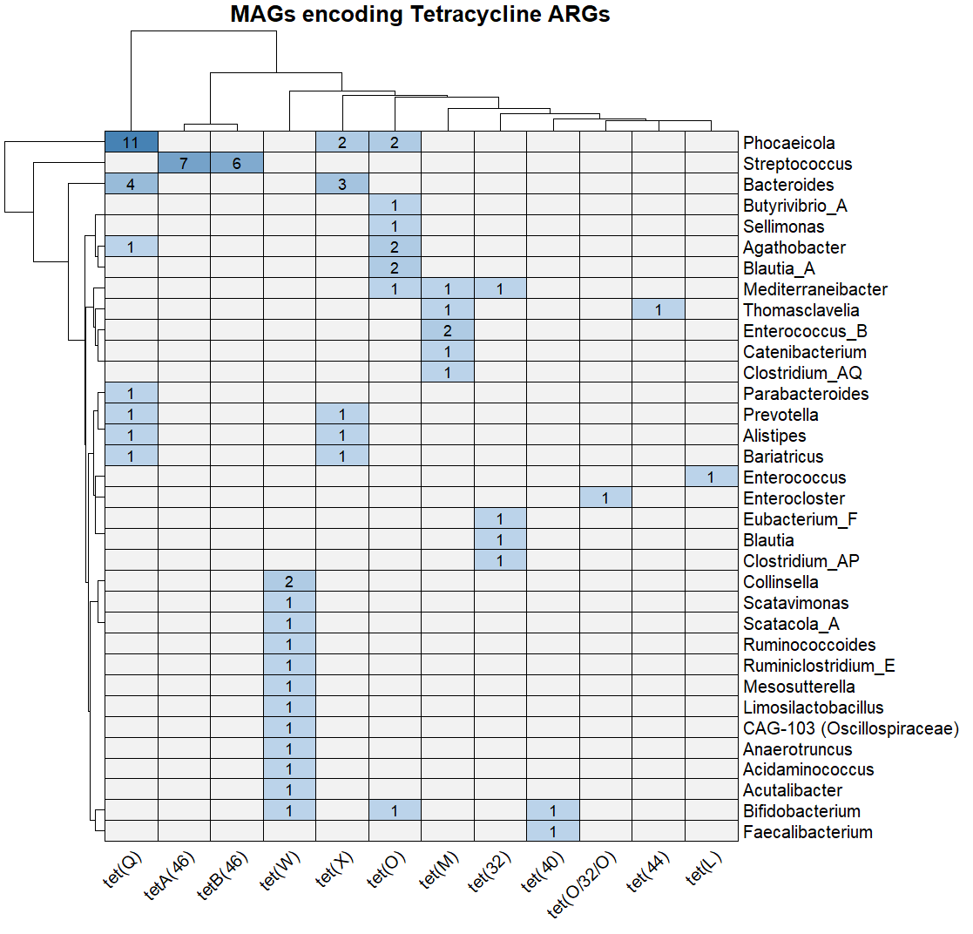
Figure S5. Heatmaps showing the taxonomy of MAGs encoding detected tetracycline resistance determinants (>90% adjusted coverage). Number inside each box represents the count of MAGs encoding a given ARG.

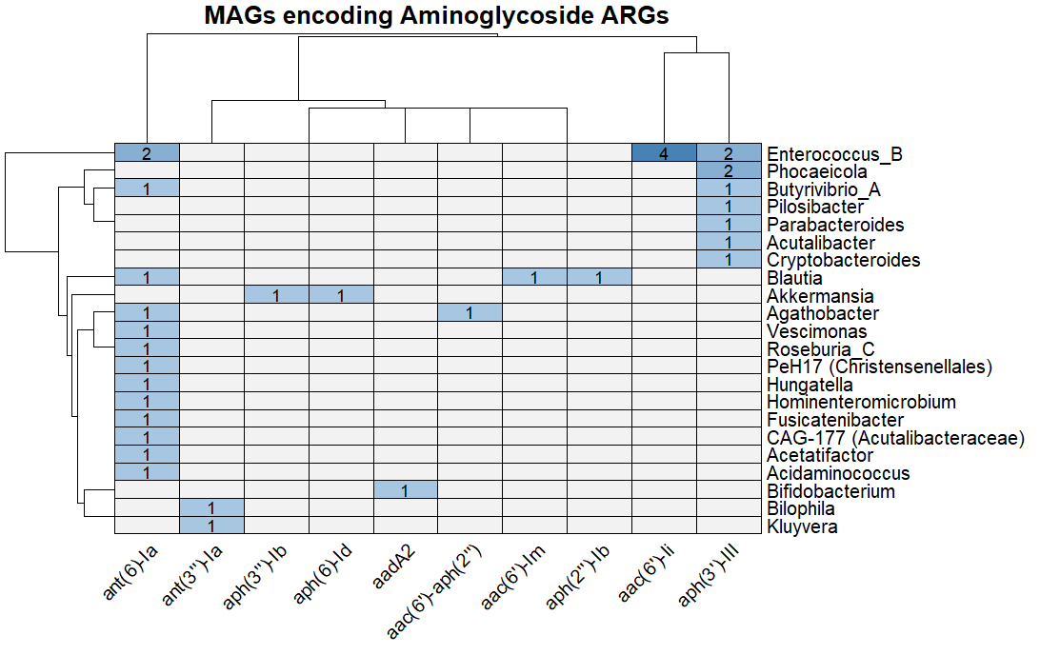
Figure S6. Heatmaps showing the taxonomy of MAGs encoding detected aminoglycoside resistance determinants (>90% adjusted coverage). Number inside each box represents the count of MAGs encoding a given ARG.

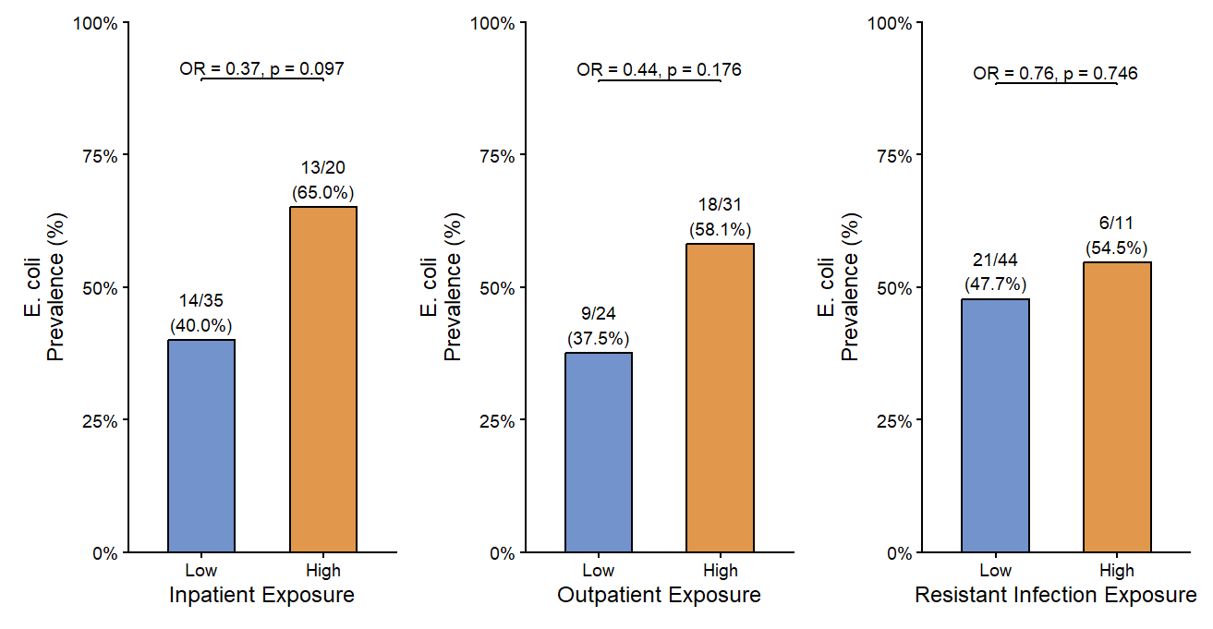
Figure S7. Prevalence of detectable E. coli in clinician samples, stratified by exposure to cirrhosis patient exposure metrics.

Figure S8. Prevalance of Enterococcus in paired samples of physicians and cirrhosis patients within the same healthcare facility. Righthand boxplot depicts the number of detectable Enterococcus-associated VFs within each sample.

Figure S9. Boxplot showing the observed species richness in fecal samples from physicians and cirrhosis patients within the same healthcare facility.

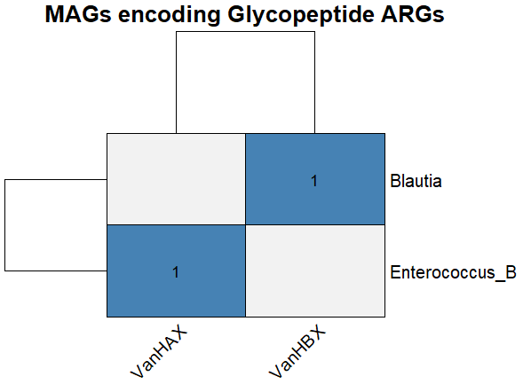
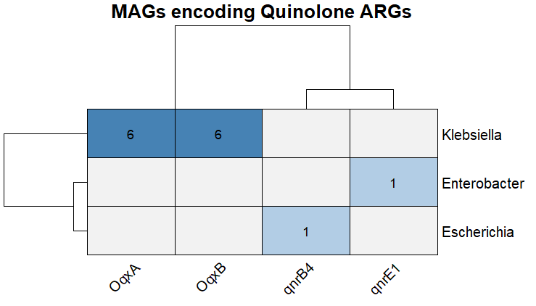

Figures S10-S11. Heatmaps showing the taxonomy of MAGs encoding detected quinolone and glycopeptide (vancomycin) resistance determinants (>90% adjusted coverage). Number inside each box represents the count of assembled MAGs encoding a given ARG.

Figures S12. Comparison of cirrhosis patients with physicians in the United States. (A). Boxplot showing the number of detected ARGs across samples. (B) Prevalance of ARGs significantly enriched (Fisher’s exact test, adjusted p < 0.05) in either decompensated cirrhosis (top) or clinician (bottom) fecal metagenomes.
Figures S13. Analysis of detected plasmid replicons on assembled contigs. (A) Prevalance of different plasmid replicons on assembled contigs. Bar color represents sample type (high income country clinician group as brown, L/M income country clinician group colored blue, decompensated samples colored red, compensated samples colored yellow). (B) Heatmap showing identified plasmid replicons on the same contig as ARG genes. Number inside the box indicates the number of samples within each plasmid and ARG were co-detected.

