Semi-field evaluation of the effect of cow and chicken dung on life history traits of Anopheles funestus in rural south-eastern Tanzania
Mary David Matovolwa ^{1,2}*, Herieth H. Mahenge ², Letus L. Muyaga ^{2,4}, Augustino Thabiti Mmbaga ², Yohana A. Mwalugelo ², Dickson S. Msaky ², Halfan S. Ngowo ^{2,5}, Stella Kessy ¹, and Emmanuel W. Kaindoa ^{2,3}*.
- School of Life Sciences and Bioengineering, Health and Biomedical Sciences, The Nelson Mandela African Institution of Sciences and Technology, Arusha, Tanzania
- Environmental Health and Ecological Sciences Department, Ifakara Health Institute, Ifakara, Tanzania
- Faculty of Health Sciences, School of Pathology, The Centre for Emerging Zoonotic and Parasitic Diseases, Wits Research Institute for Malaria, National Institute for Communicable Diseases, University of the Witwatersrand, Johannesburg, South Africa
- School of Biodiversity, One Health and Veterinary Medicine, University of Glasgow, Glasgow, UK
- Institute for Disease Modelling, Gates Foundation, Seattle, USA.

- Corresponding authors: marydvdmatovolwa35@gmail.com ; ekaindoa@ihi.or.tz

Email addresses:
- Mary David Matovolwa: marydvdmatovolwa35@gmail.com
- Herieth H. Mahenge: hmahenge@ihi.or.tz
- Letus L. Muyaga: lmuyaga@ihi.or.tz
- Augustino Thabiti Mmbaga: ammbaga@ihi.or.tz
- Yohana A. Mwalugelo: ymwalugelo@ihi.or.tz
- Dickson S. Msaky: dmsaky@ihi.or.tz
- Halfan S. Ngowo: hngowo@ihi.or.tz
- Stella Kessy: stella.kessy@nm-aist.ac.tz
- Emmanuel W. Kaindoa: ekaindoa@ihi.or.tz
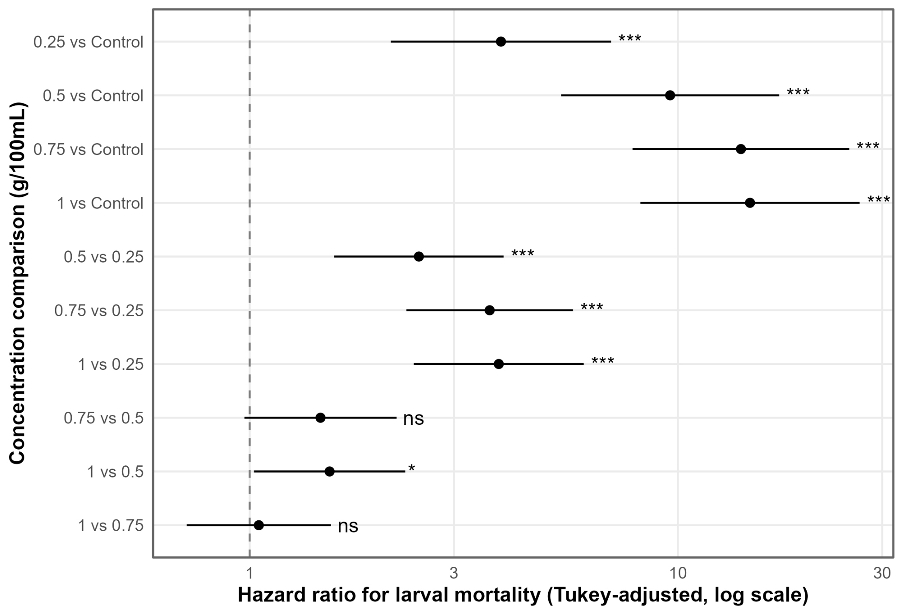
Fig. 1 Tukey adjusted hazard ratios for pairwise comparison of An. funestus larvae mortality risk across chicken dung concentrations (log scale; dashed line = HR of 1/no difference). *** p <0.001, * p < 0.05, ns = not significant.

