Supplemental Material
List of Tables
Table S1: DL model evaluation: distribution of the performance metrics across the 20 replicated RCTs summarized using mean, coefficient of variation (CV), and 95% confidence interval (CI) 4
Table S2: Mean TE values by model, sampling times and dose 5
Table S3: Overall mean TE difference between reference and DL and reference and MMRM methodologies in the 20 RCTs replicates by model, sampling times and dose. 6

List of Figures
Figure S1: RCT simulation 1 conducted with model 1 and sampling time 1 - Left panels - individual DL-predicted values versus individual simulated values, stratified by dose; Right panels - residuals versus time, stratified by dose. 2
Figure S2: Individual simulated and model-predicted HAMD-17 scores versus time on a 5 randomly selected subjects in the placebo, 20mg, and 40mg arms in the RCT simulation one. The dots represent the simulated HAMD-17 scores and the blue solid lines represent the DL model predicted values. 3

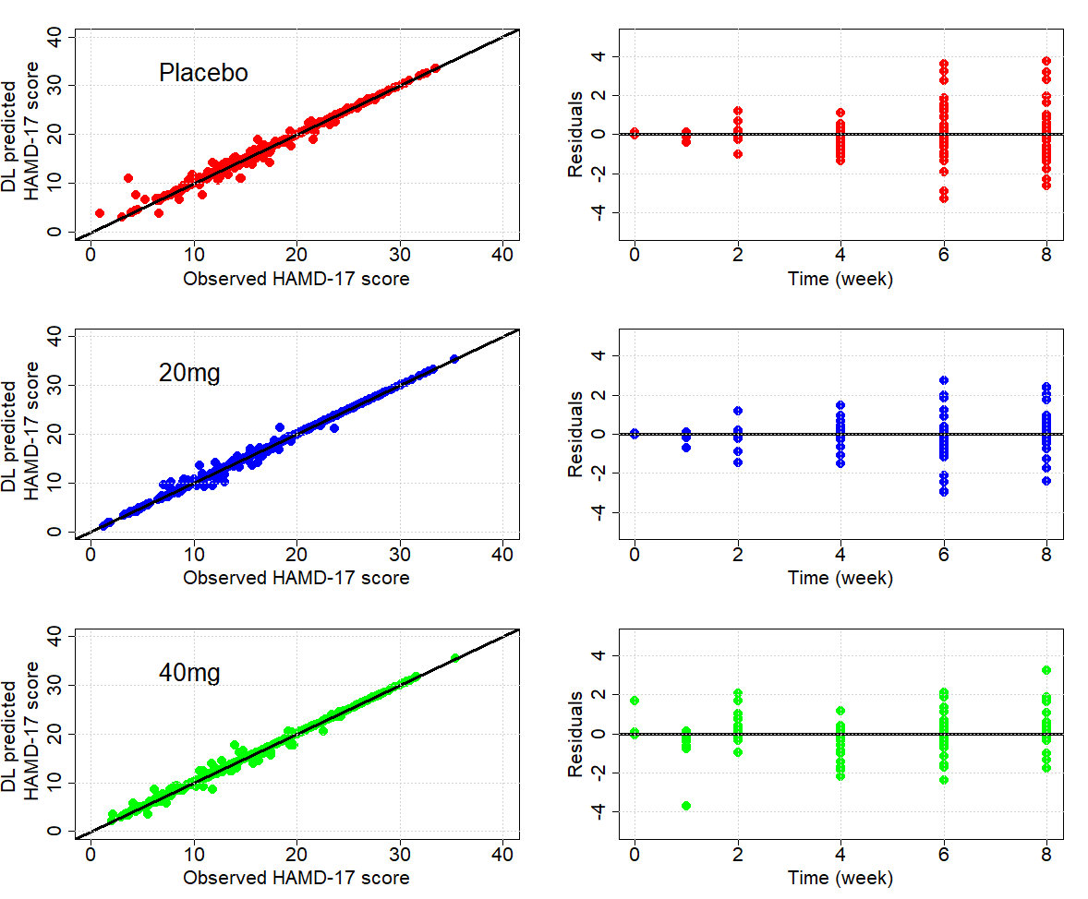
Figure S1: RCT simulation 1 conducted with model 1 and sampling time 1 - Left panels - individual DL-predicted values versus individual simulated values, stratified by dose; Right panels - residuals versus time, stratified by dose.

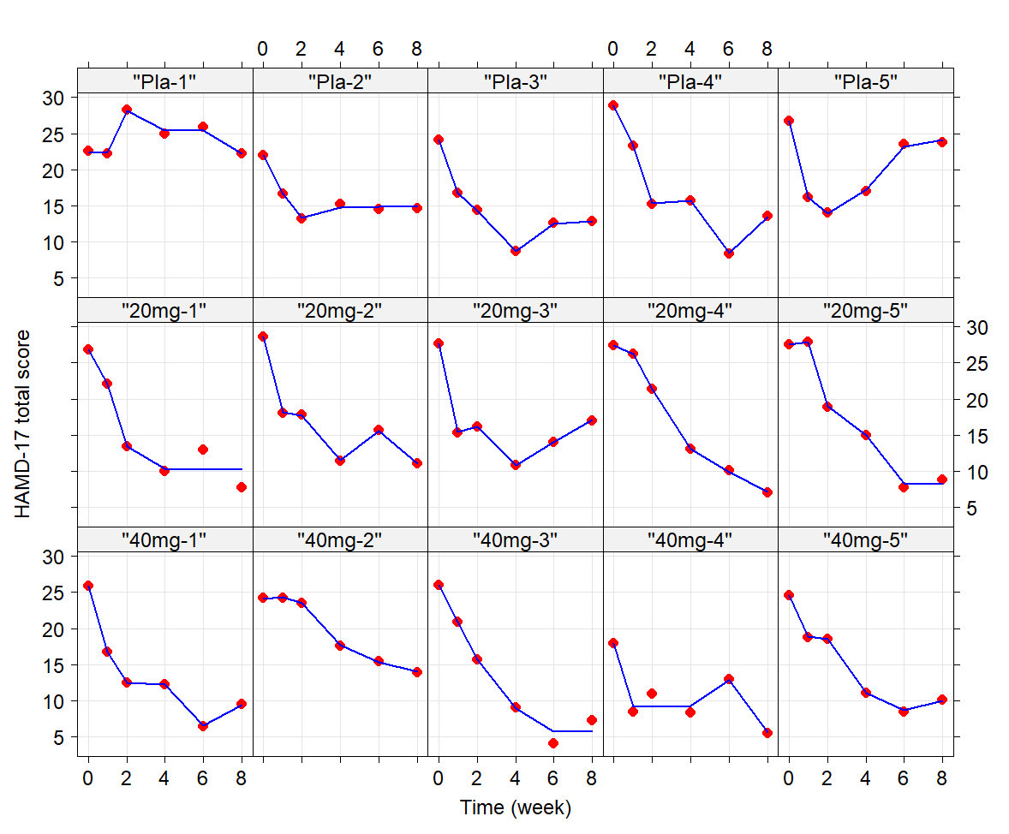
Figure S2: Individual simulated and model-predicted HAMD-17 scores versus time on a 5 randomly selected subjects in the placebo, 20mg, and 40mg arms in the RCT simulation one. The dots represent the simulated HAMD-17 scores and the blue solid lines represent the DL model predicted values.

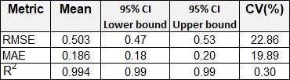
Table S1: DL model evaluation: distribution of the performance metrics across the 20 replicated RCTs summarized using mean, coefficient of variation (CV), and 95% confidence interval (CI)

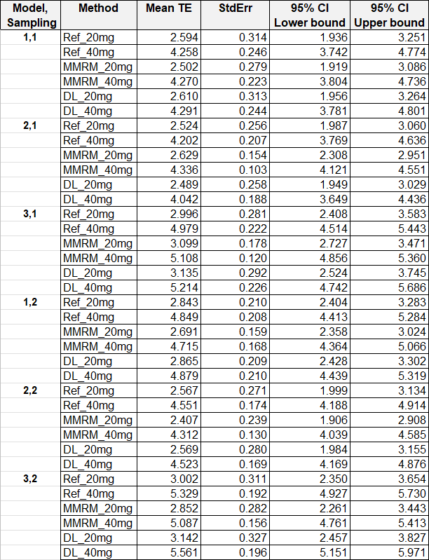
Table S2: Mean TE values by model, sampling times and dose

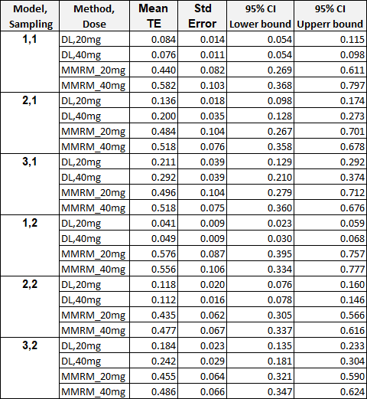
Table S3: Overall mean TE difference between reference and DL and reference and MMRM methodologies in the 20 RCTs replicates by model, sampling times and dose.

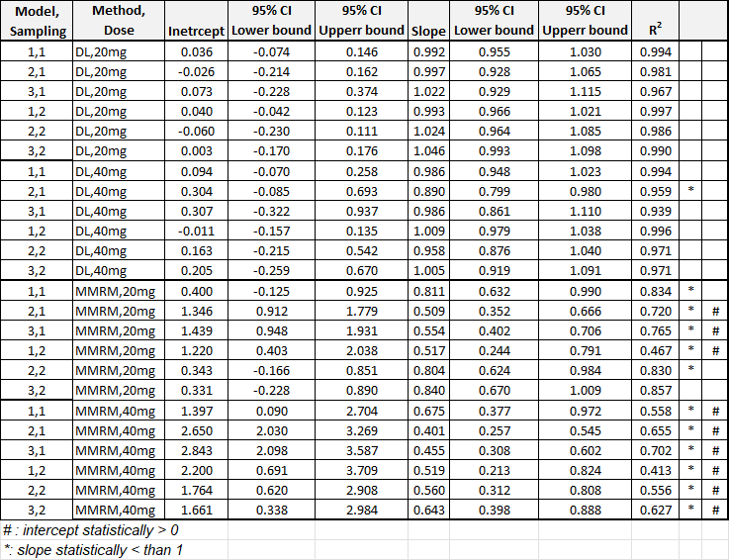
Figure SS.

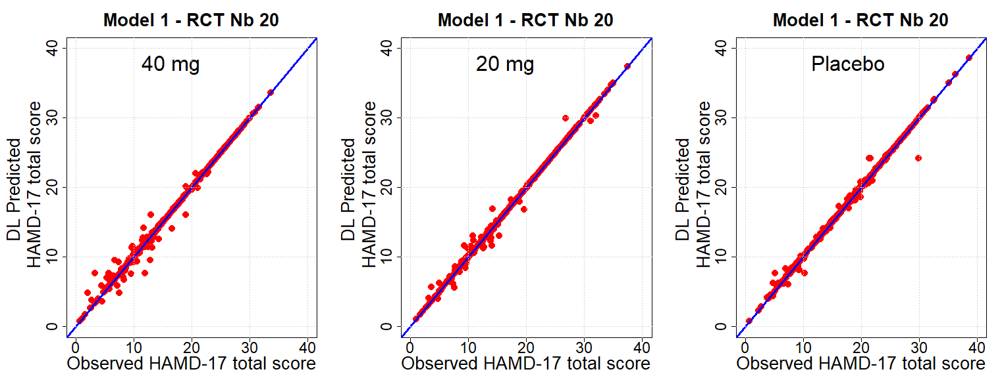
Figure S1. Plots of the individual simulated and DL model predicted HAMD-17 total score (red dots) with the identity lines (blue curves) for the of RCT number 20 using the Model 1 definition.
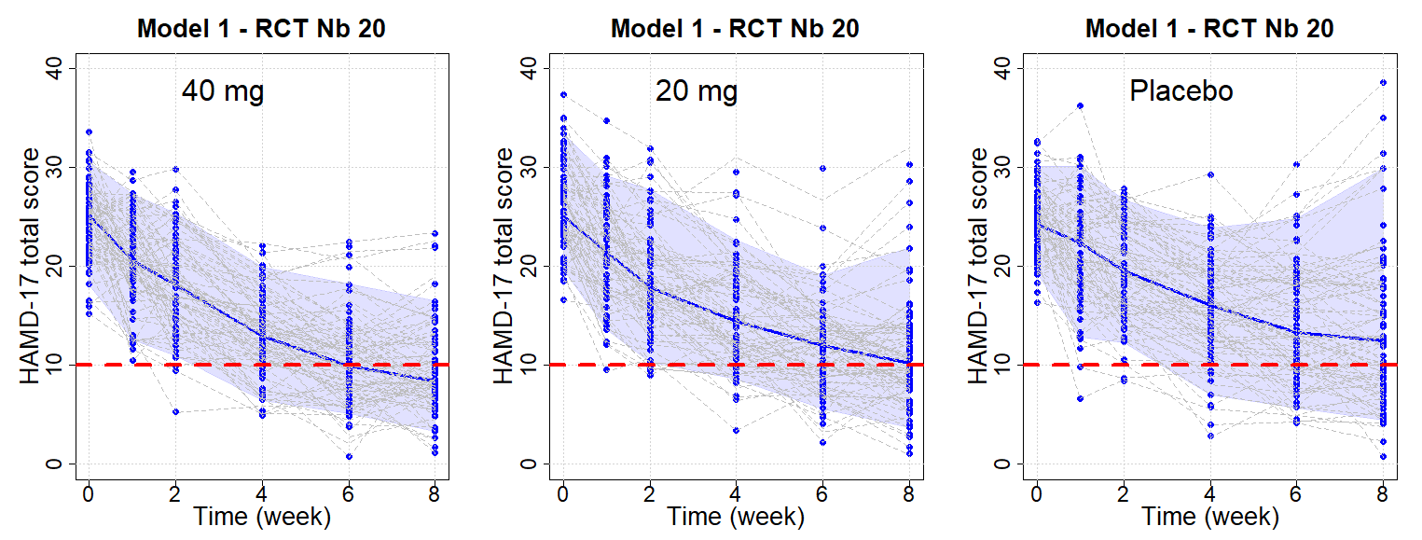
Figure S2. Plots of the individual model predicted HAMD-17 total score (blue dots) with the median predicted curves (solid blue lines) and the 95% prediction intervals (shaded area) for the simulations of RCT number 20 using the Model 1 definition. The red dotted lines represent the HAMD-17 score equal to 10 as a reference.

