Supplementary Figure 1-2

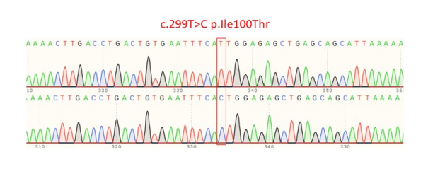
Supplementary Figure 1. Vector construction and sequencing results.
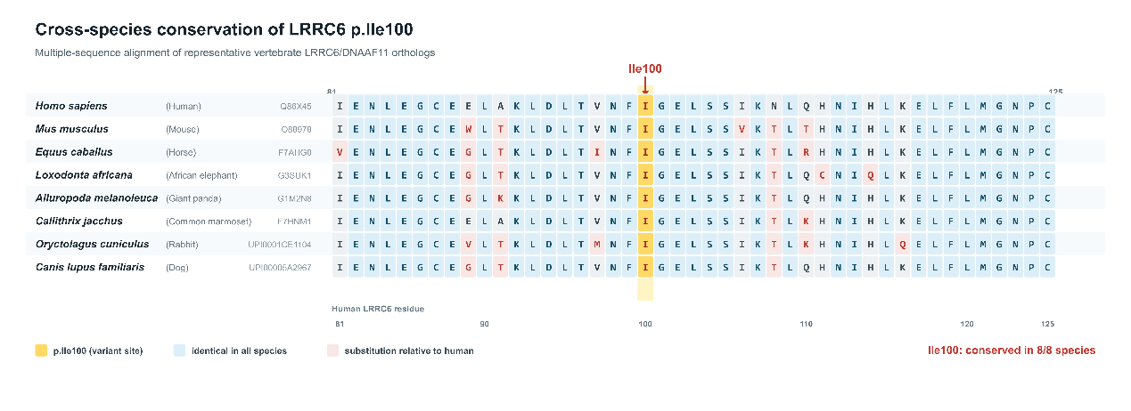
Supplementary Figure 2: Conservation analysis of DNAAF11/LRRC6 c.299T>C.

