Model evaluation of alphafold 2.2.1 modeling :

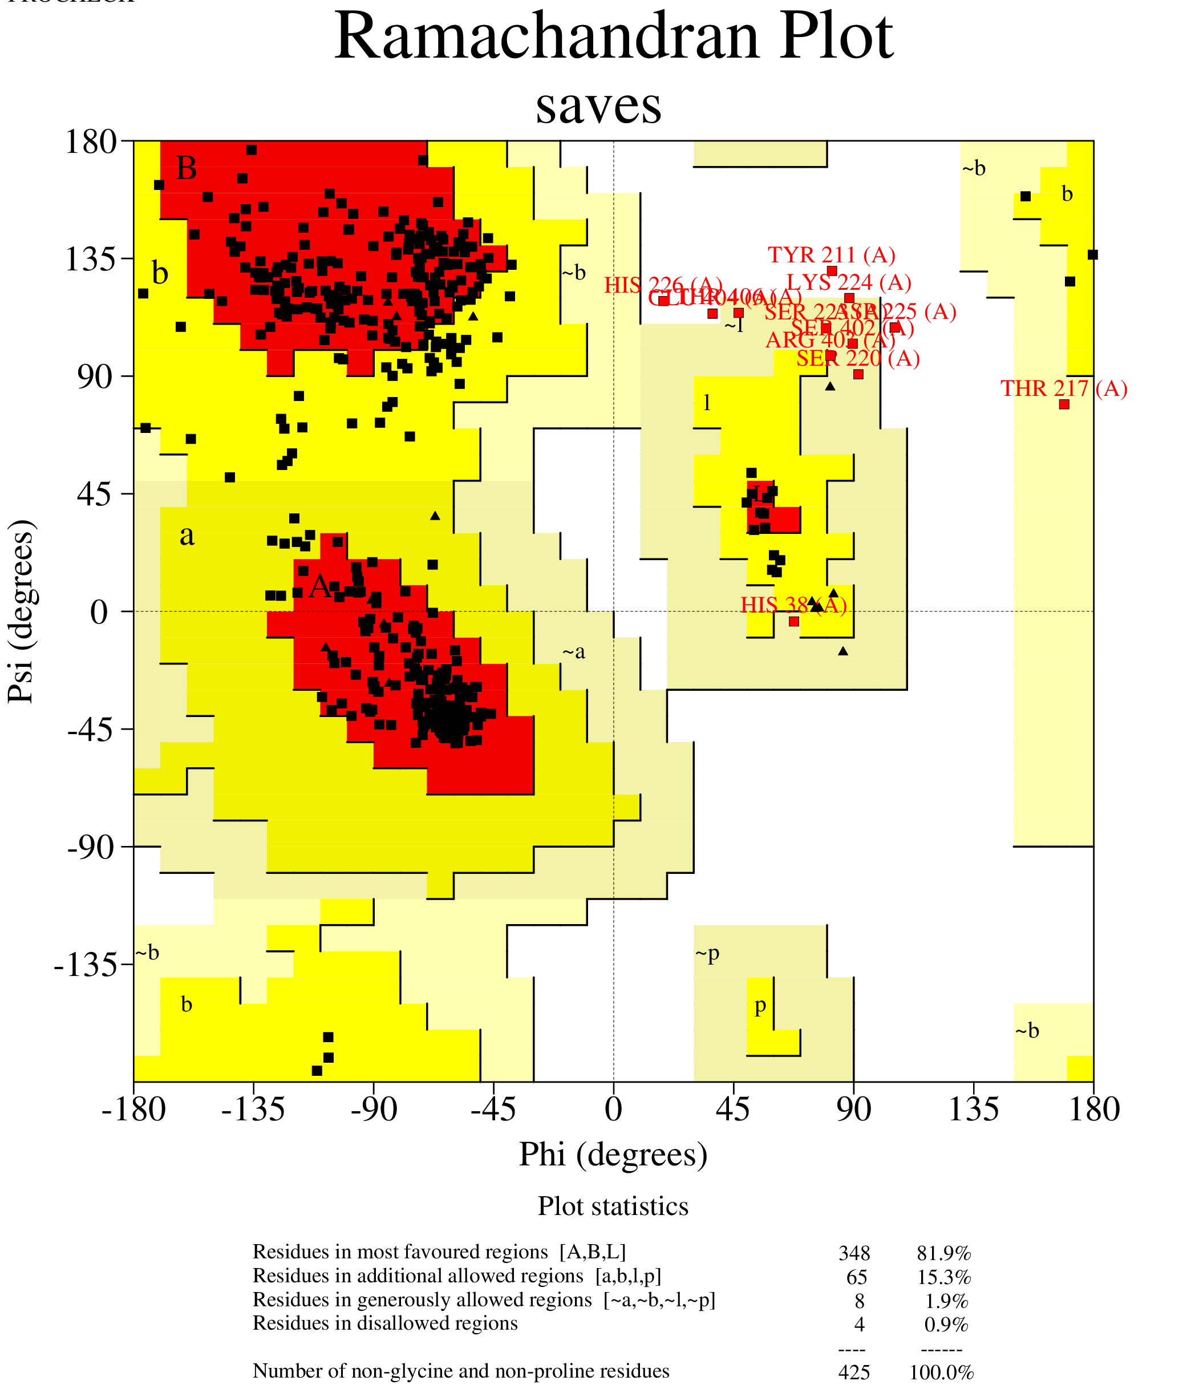
A.Ramachandran plot analysis of the AlphaFold 2.2.1
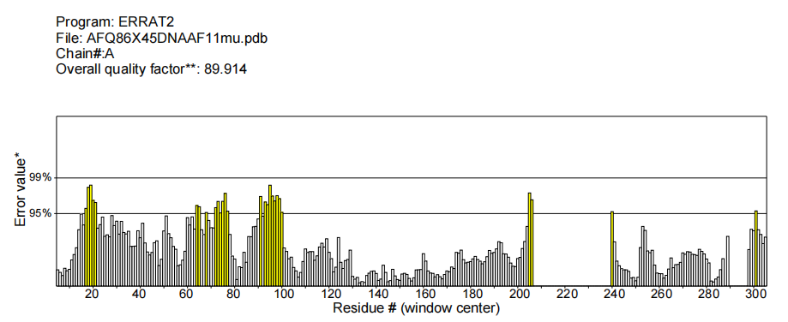
B. ERRAT analysis of the AlphaFold 2.2.1

Figure A :Ramachandran plot analysis of the AlphaFold2.2.1 predicted model showed that 100% of residues were within the allowed regions (81.9% favored, 15.3% additionally allowed, and 1.9% generously allowed), with only 0.9% in disallowed regions. Given that the combined favored and allowed regions exceeded 90%, the model was deemed structurally sound.
Figure B :The ERRAT score of 89.914 (above the 80% cutoff) further validated the model quality.

