Supplementary Information

Electrochemical activation of C–H by electron-deficient W₂C nanocrystals for simultaneous alkoxylation and hydrogen evolution
Xiu Lin¹, Shi-Nan Zhang¹, Dong Xu¹, Jun-Jun Zhang¹, Yun-Xiao Lin¹, Guang-Yao Zhai¹, Hui Su¹, Zhong-Hua Xue¹, Xi Liu¹, Markus Antonietti², Jie-Sheng Chen¹, Xin-Hao Li^{1*}
¹School of Chemistry and Chemical Engineering, Shanghai Jiao Tong University, Shanghai 200240, P. R. China.
²Department of Colloid Chemistry, Max-Planck Institute of Colloids and Interfaces, Wissenschaftspark Golm, Potsdam 14424, Germany.
*e-mail: xinhaoli@sjtu.edu.cn

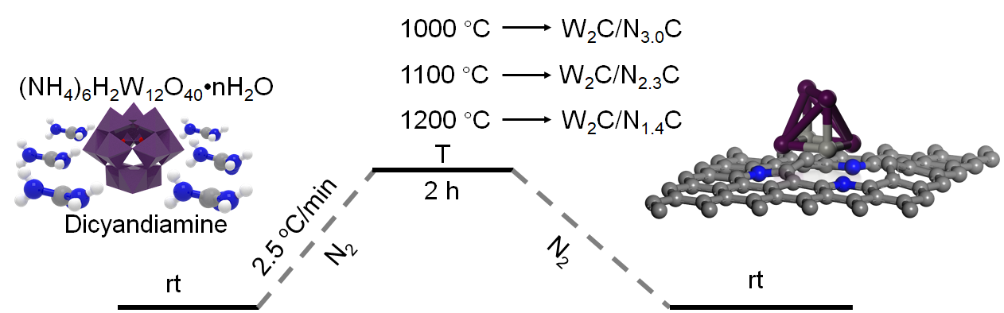
Supplementary Figure 1. Detailed synthetic route for the preparation of W₂C/N_{x}C samples, where x represents the nitrogen contents (at.%). Temperatures (T): 1000, 1100 and 1200 °C for W₂C/N_{3.0}C, W₂C/N_{2.3}C and W₂C/N_{1.4}C, respectively; Colour codes: C, grey; N, blue; H, white; W, purple.

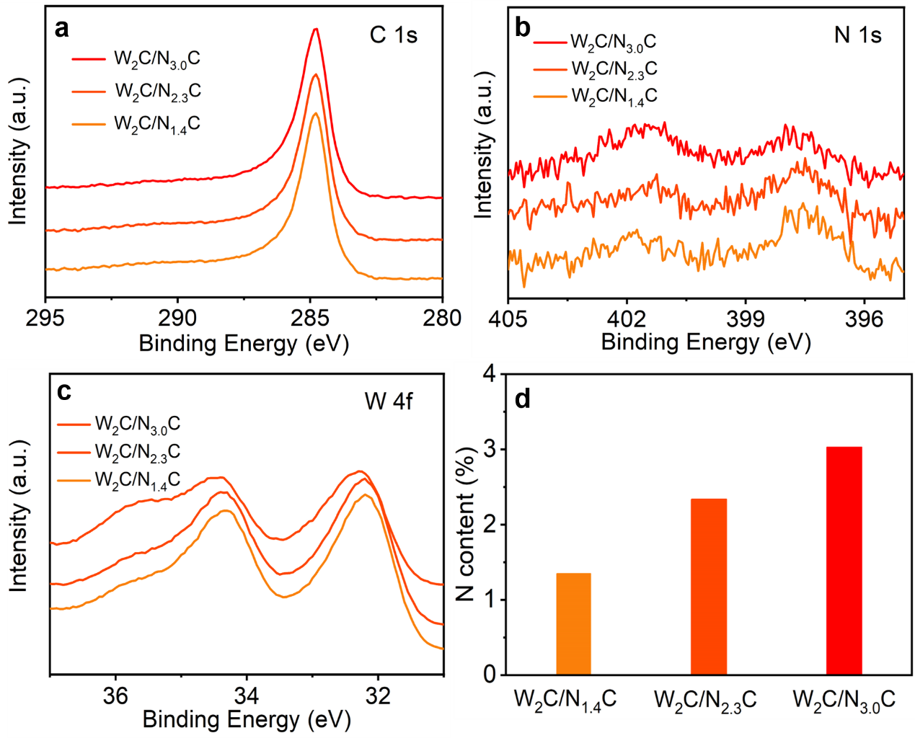
Supplementary Figure 2. High-resolution C 1s (a), N 1s (b) and W 4f (c) spectra of W₂C/N_{x}C samples. (d) Nitrogen contents estimated from the XPS analysis results. The N contents (at.%) are 3.0%, 2.3% and 1.4% for W₂C/N_{3.0}C, W₂C/N_{2.3}C and W₂C/N_{1.4}C, respectively.

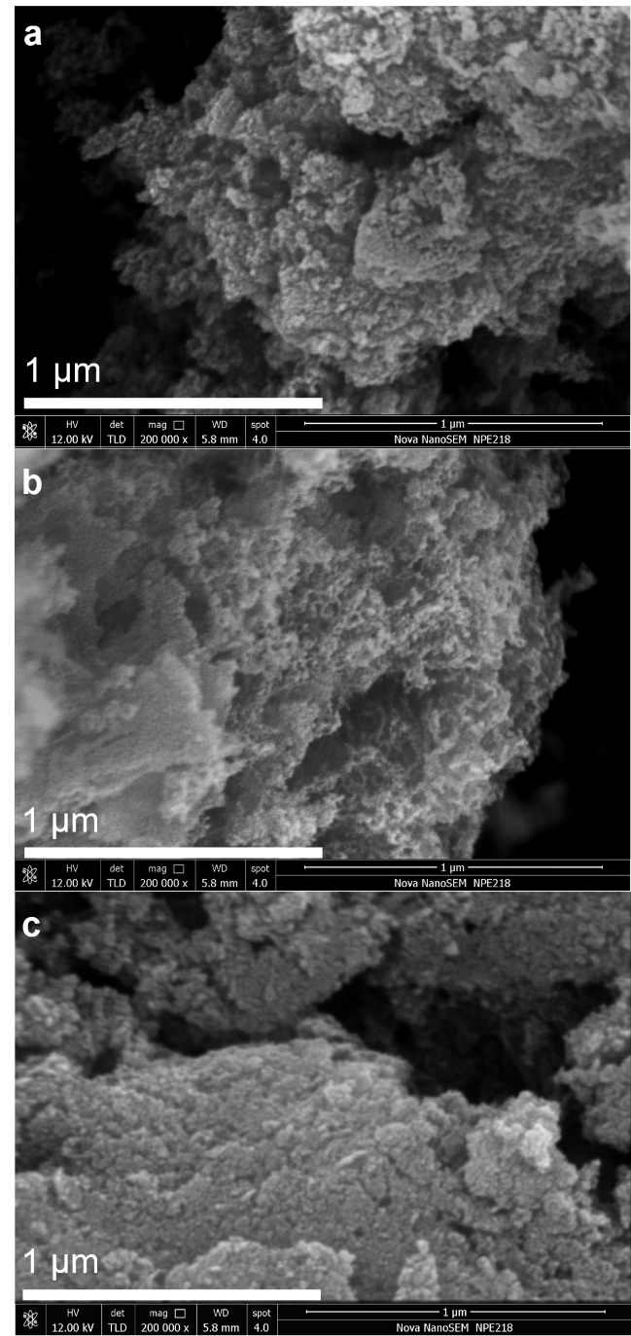
Supplementary Figure 3. (a-c) SEM images of W₂C/N_{3.0}C, W₂C/N_{2.3}C and W₂C/N_{1.4}C samples, respectively. All samples exhibit similar morphology with rough surfaces.

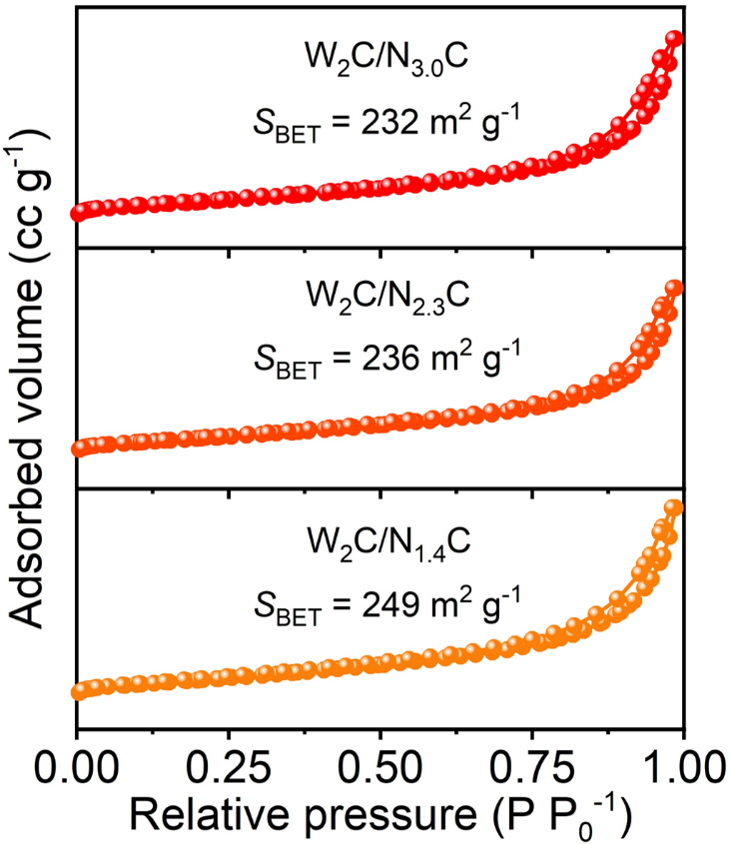
Supplementary Figure 4. N₂ adsorption-desorption isotherms and specific surface areas (S_{BET}) of W₂C/N_{x}C samples.

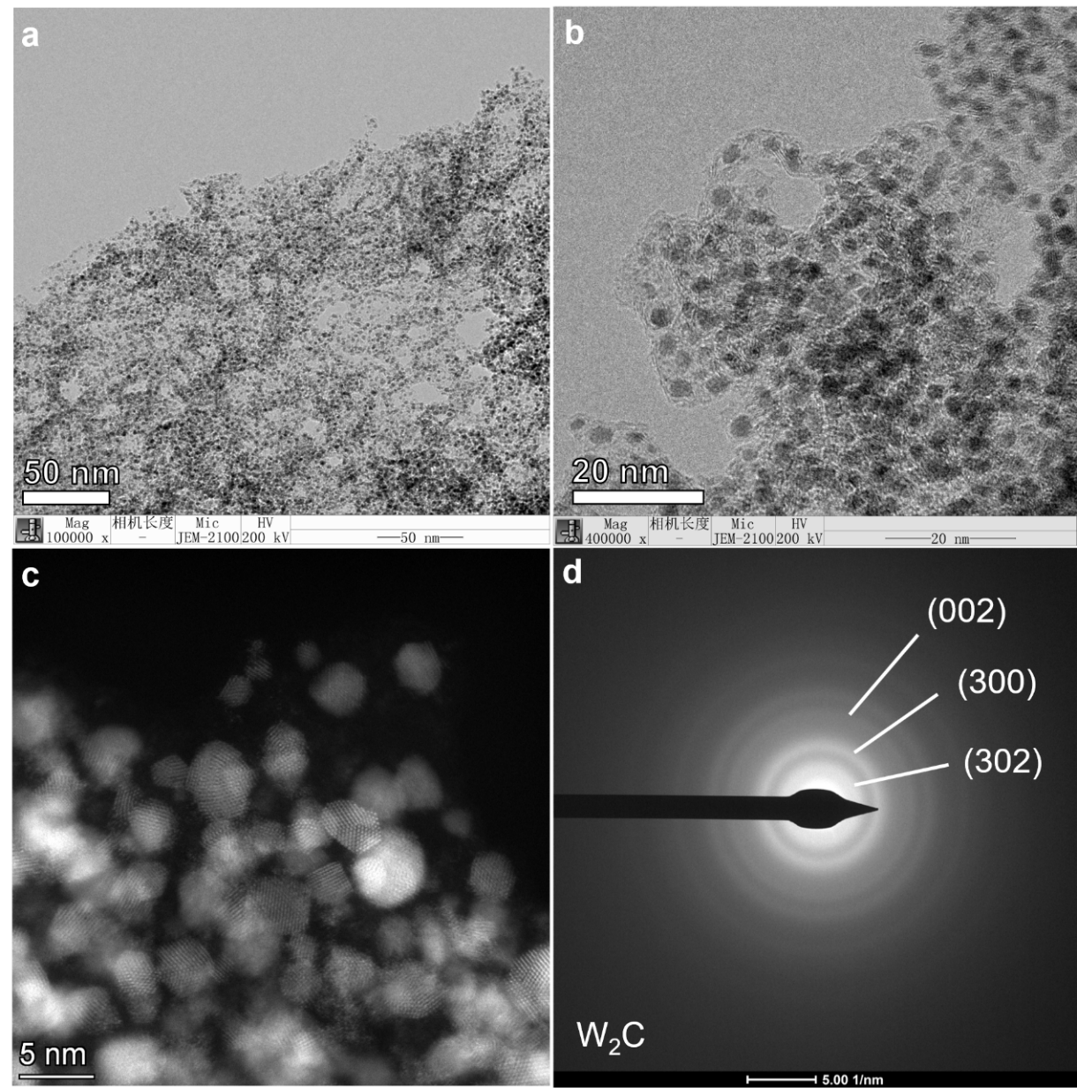
Supplementary Figure 5. (a and b) TEM images of W₂C/N_{3.0}C. W₂C particles disperse uniformly on few-layer carbon supports without obvious aggregation. (c) HAADF-STEM image of W₂C/N_{3.0}C. (d) Selected-area electron diffraction pattern illustrates the formation of W₂C nanocrystals.

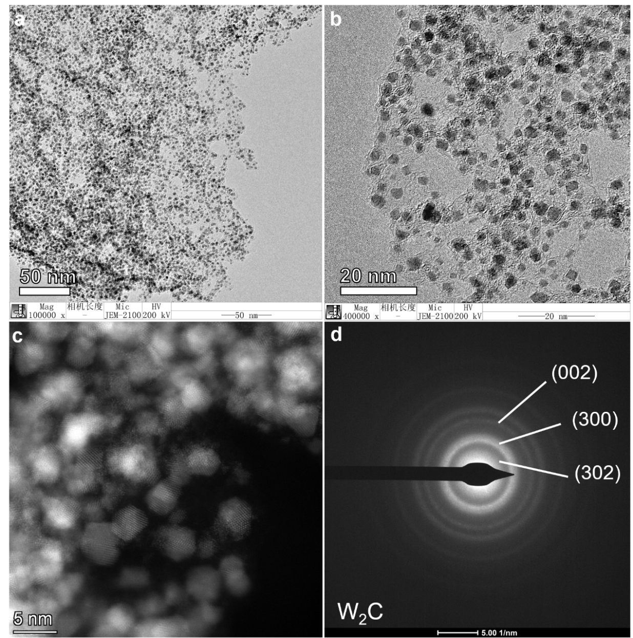
Supplementary Figure 6. (a and b) TEM images of W₂C/N_{2.3}C. (c) HAADF-STEM image of W₂C/N_{2.3}C. (d) Selected-area electron diffraction pattern illustrates the formation of W₂C nanocrystals.

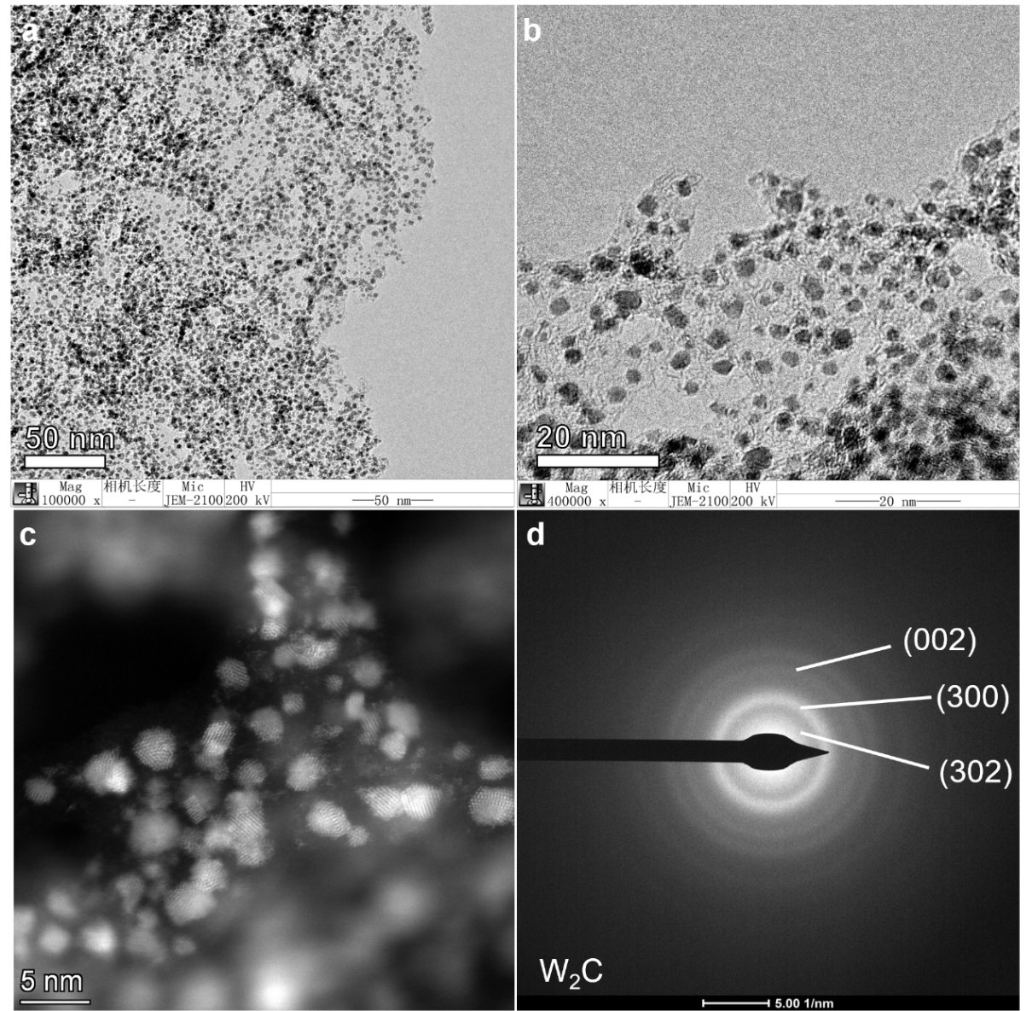
Supplementary Figure 7. (a and b) TEM images of W₂C/N_{1.4}C. (c) HAADF-STEM image of W₂C/N_{1.4}C. (d) Selected-area electron diffraction pattern illustrates the formation of W₂C nanocrystals.

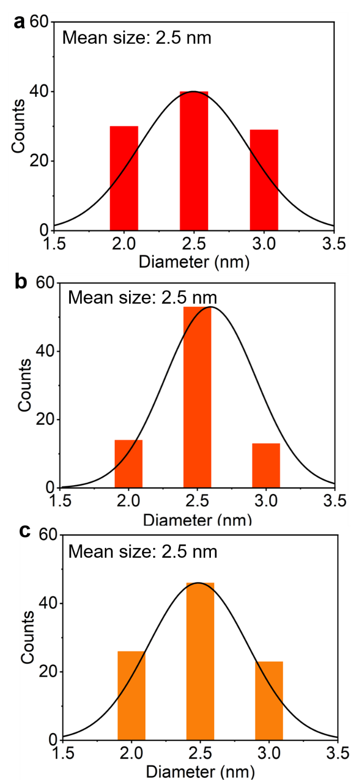
Supplementary Figure 8. The size distribution of W₂C/N_{3.0}C (a), W₂C/N_{2.3}C (b) and W₂C/N_{1.4}C (c). The gradually elevated synthetic temperatures did not change the size distribution of these samples.
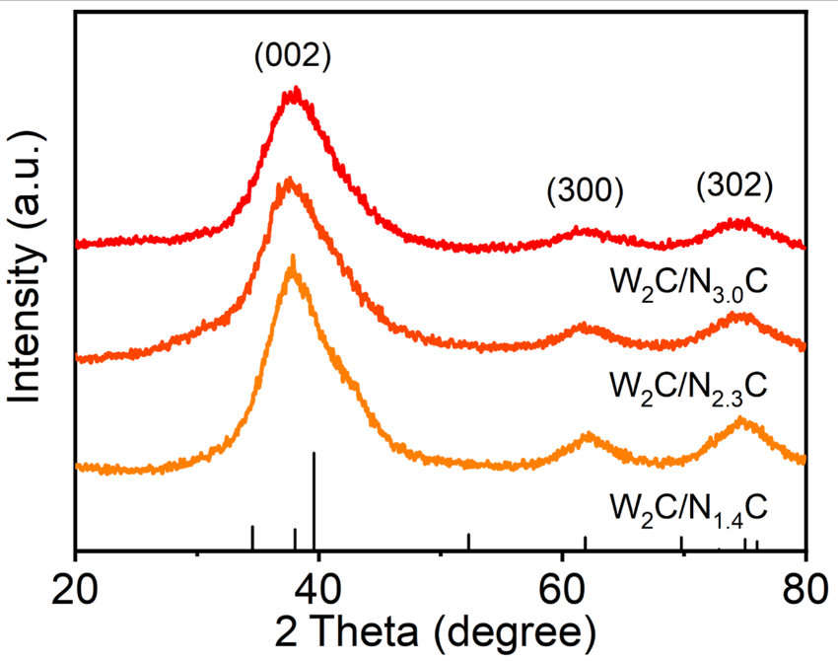
Supplementary Figure 9. XRD patterns of W₂C/N_{x}C samples. The XRD peaks of W₂C/N_{x}C samples could be attributed to the characteristic(002), (300) and (302) facets of α-W₂C (black bars, JCPDS no. 35-776).

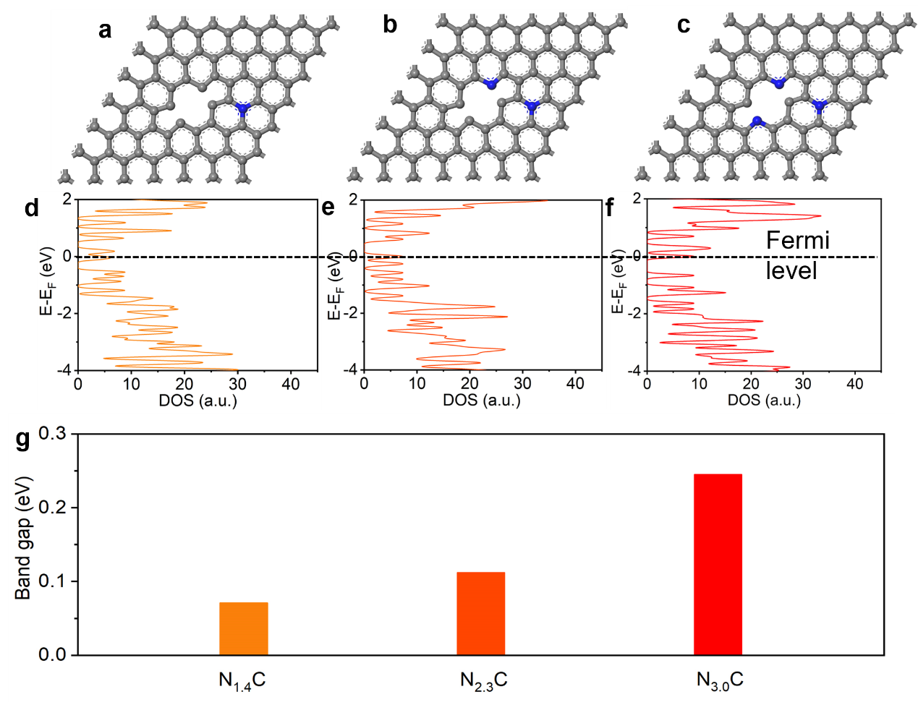
Supplementary Figure 10. Computation models and density of states of N_{1.4}C (a and d), N_{2.3}C (b and e) and N_{3.0}C (c and f). Colour code: C, grey; N, blue. (g) The band gaps of N_{1.4}C, N_{2.3}C and N_{3.0}C were 0.071, 0.112 and 0.245 eV, respectively. Doping more nitrogen atoms into the carbon support opened the band gap.

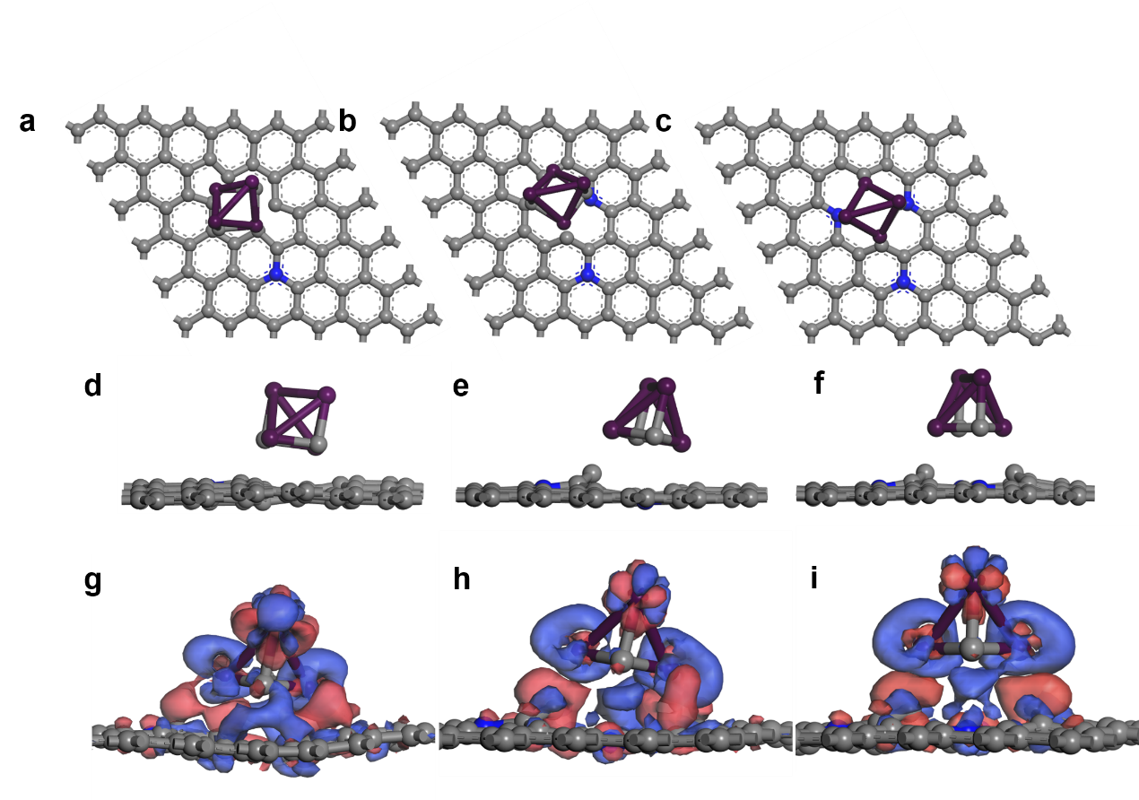
Supplementary Figure 11. The calculation models and charge density distribution of W₂C/N_{x}C models. The top view and side view of W₂C/N_{1.4}C (a and d), W₂C/N_{2.3}C (b and e) and W₂C/N_{3.0}C (c and f). Charge density difference stereograms of W₂C/N_{1.4}C (g), W₂C/N_{2.3}C (h) and W₂C/N_{3.0}C (i) models (electron-deficient area, blue; electron-rich area, red); Colour code: C, grey; N, blue; W, purple.

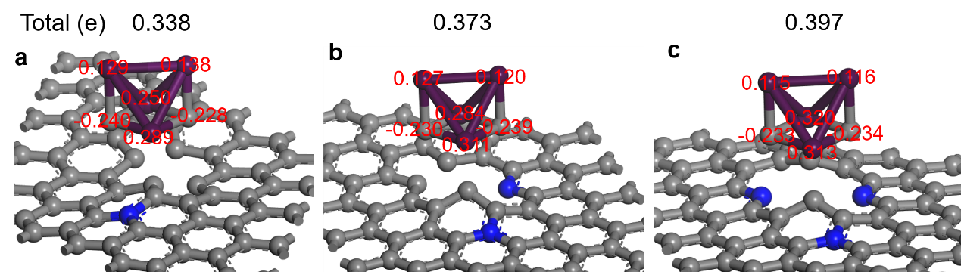
Supplementary Figure 12. Quantitative of electrons transfer from W₂C cluster to various nitrogen-doped carbon support based on DFT calculations for W₂C/N_{1.4}C (a), W₂C/N_{2.3}C (b) and W₂C/N_{3.0}C (c) models. Hirshfeld charge analysis shows that 0.338, 0.373 and 0.397 electrons were transferred from W₂C to carbon support for W₂C/N_{1.4}C, W₂C/N_{2.3}C and W₂C/N_{3.0}C models, respectively, rather speaking for the enhanced electron transfer between W₂C nanocrystals and nitrogen-doped carbons due to the formation of Schottky heterojunction at a higher nitrogen content.

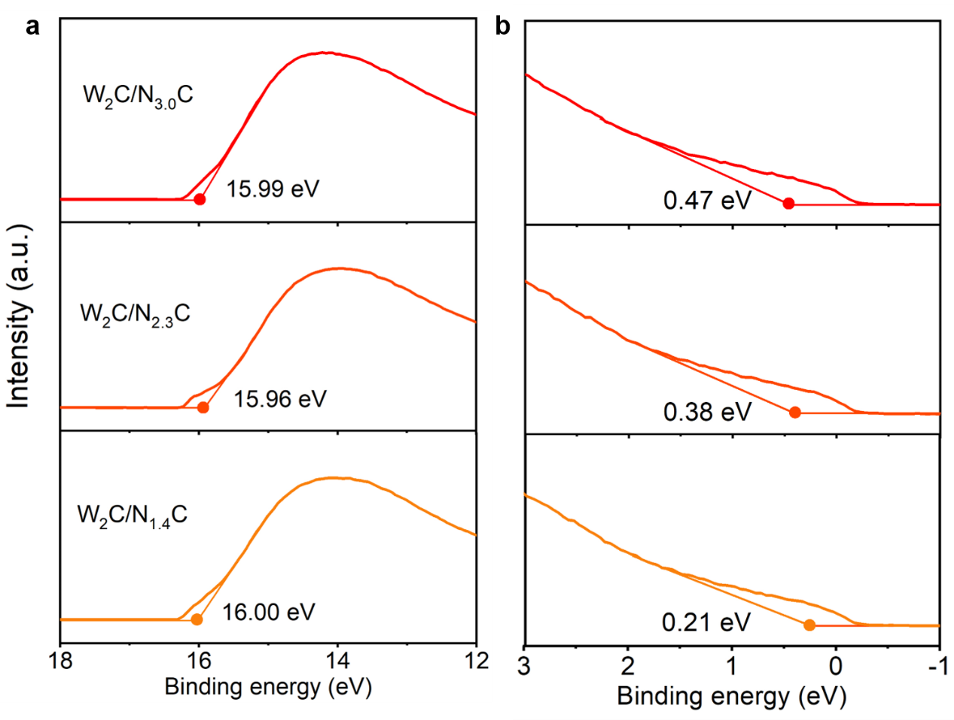
Supplementary Figure 13. UPS patterns of typical W₂C/N_{x}C samples. Secondary electron cut-off (E_{cut-off}) (a) and onset (E_{F}) energy (b). The work function (Φ), as calculated by the equation of Φ = 21.21 eV - (E_{cutoff} - E_{F})^{S1}, are 5.69, 5.63 and 5.42 eV for W₂C/N_{3.0}C, W₂C/N_{2.3}C and W₂C/N_{1.4}C samples, respectively.

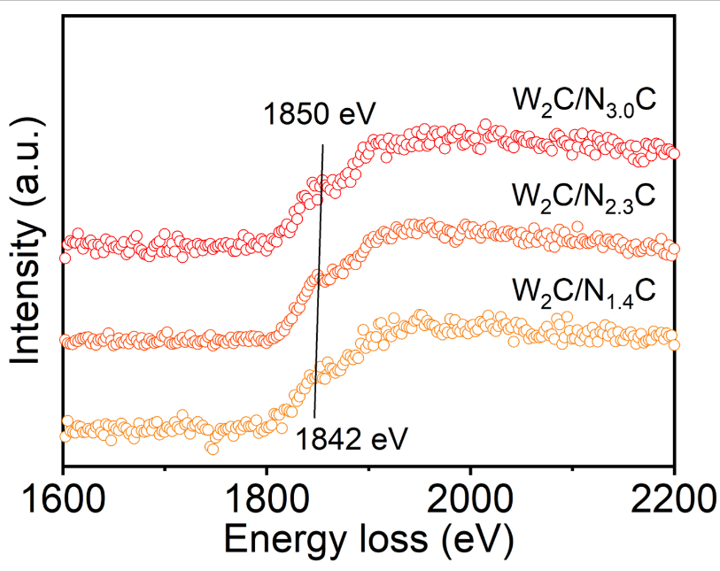
Supplementary Figure 14. EELS spectra of W₂C/N_{x}C samples. The W M4,5 peaks shift positively with the increase of nitrogen contents, which indicates that more electrons flowing from W₂C nanocrystals to nitrogen-doped carbons.
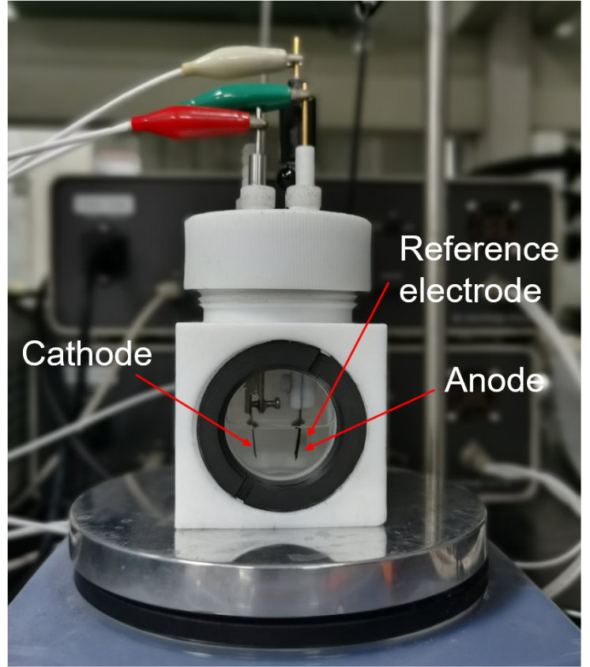
Supplementary Figure 15. Photograph of the reactor for electrochemical alkoxylation. A home-made reactor, composed of W₂C/N_{x}C anodes, Ti cathode and saturated calomel electrode (SCE) reference electrode, was used in this reaction system at room temperature. The electrolyte consisted of methanol (15 mL), ethylbenzene (0.5 mmol) and lithium perchlorate (1 mmol).

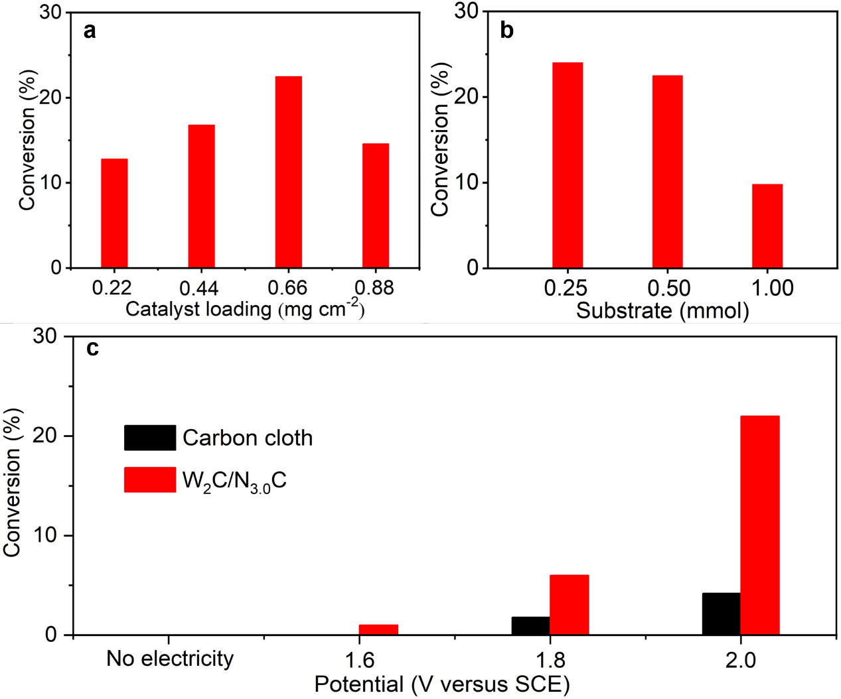
Supplementary Figure 16. Optimation of reaction conditions of W₂C/N_{3.0}C catalyst. Conversions of (1-methoxyethyl)benzene with different catalyst loadings (a), substrate contents (b) and potentials (c) for the alkoxylation of ethylbenzene. According to the results, 0.66 mg/cm² of catalysts, and 0.5 mmol of ethylbenzene were used as the optimal parameters for all subsequent reactions at 2.0 V within 3 h.
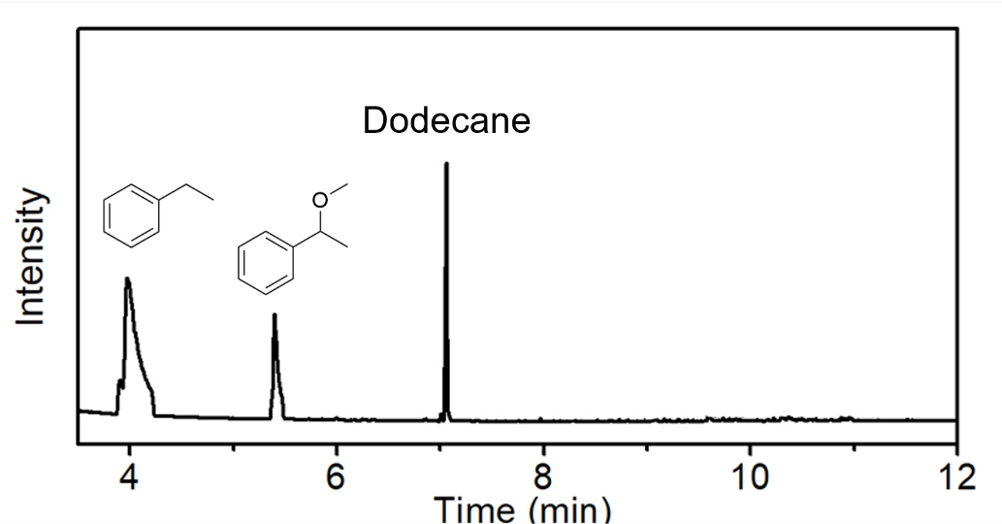
Supplementary Figure 17. Gas chromatography-mass spectrometry (GC-MS) spectrum of the electrolyte after electrochemical alkoxylation over the W₂C/N_{3.0}C for 3 h. (1-methoxyethyl)benzene as the only product demonstrates the excellent selectivity. Dodecane was used as the internal standard for quantification.

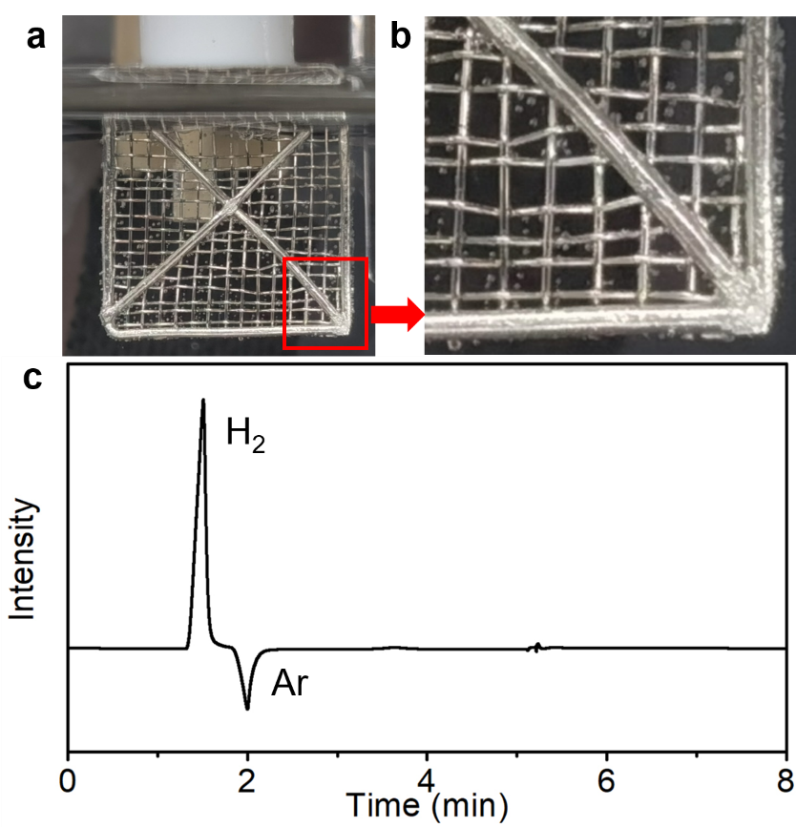
Supplementary Figure 18. Qualitative analysis of hydrogen. (a and b) The formation of hydrogen gas bubbles on the arbitrary cathode (exemplified with Pt mesh, please see Supplementary Video 1). (c) Gas chromatography (GC) spectrum of the collected gas during the alkoxylation reaction. Only hydrogen signal was detected in Ar carrier gas. GC analysis results are also used for following quantification of H₂ production.

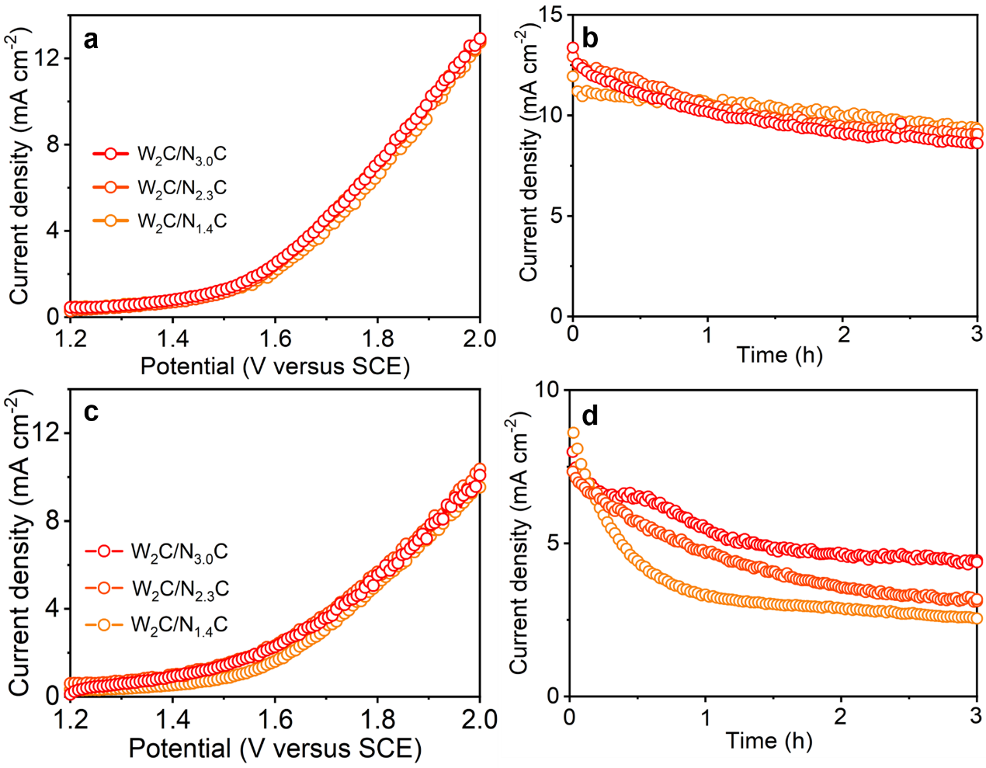
Supplementary Figure 19. Linear sweep voltammetry and chronoamperometric curves of W₂C/N_{x}C samples in the presence of ethylbenzene(a and b) and the absence of ethylbenzene (c and d) in the electrolyte.

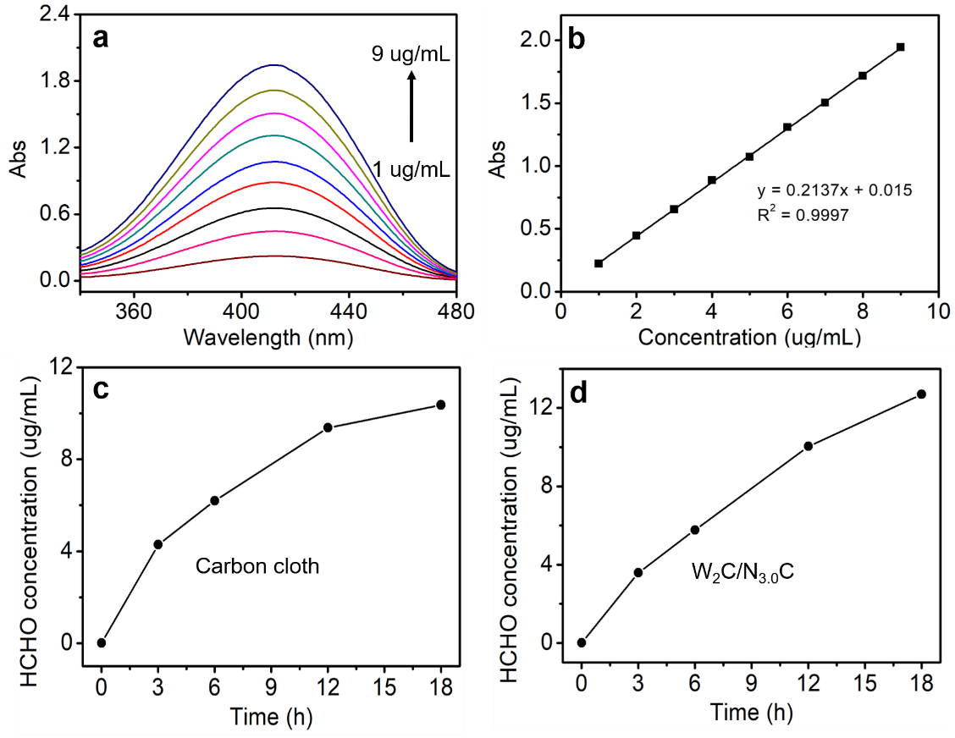
Supplementary Figure 20. Quantitative analysis of formaldehyde. (a) UV-vis absorption curves of standard solutions with known formaldehyde concentrations. The standard solutions consisted of different concentrations of formaldehyde and fixed amounts of acetylacetone solutions containing ammonium acetate (0.25 g), acetic acid (0.03 mL), acetylacetone (0.004 mL) and deionized water (2 mL). And then the pH of the solution was tuned to 6 by sulphuric acid (0.5 M). (b) Calibration curve used for the determination of formaldehyde at 413 nm. Time course of formaldehyde concentration on bare carbon cloth (c) and W₂C/N_{3.0}C (d) anodes, respectively, generating a trace amount of formaldehyde (5 and 6 μmol, respectively) within 18 h, whilst 0.5 mmol of ethylbenzene was dehydrogenated and then transformed into (1-methoxyethyl)benzene. This observation excludes the obvious contribution of direct dehydrogenation reaction of methanol to formaldehyde to the total F_{E} for hydrogen evolution reactions.
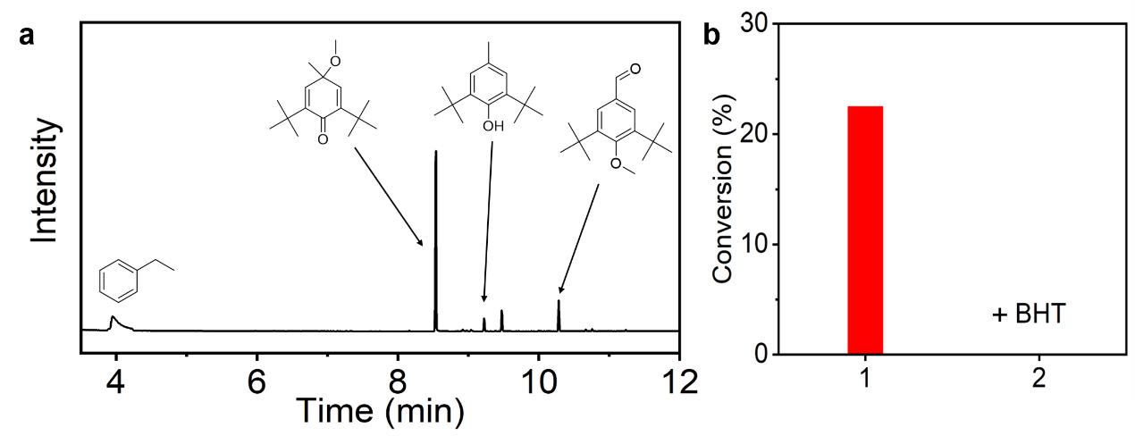
Supplementary Figure 21. Radicals quench experiments. (a) GC-MS spectrum of reaction solution with butylated hydroxytoluene (BHT). (b) Conversions of ethylbenzene over W₂C/N_{3.0}C anode under standard reaction conditions (1) and in the control reaction with the addition of BHT (0.1 mmol) (2). After the addition of BHT, 2,6-ditert-butyl-4-methoxy-4-methyl-2,5-cyclohexadien-1-one and 3,5-di-tert-butyl-4-methoxybenzaldehyde with retention time of 8.6 min and 10.3 min were observed. All these results indicate that BHT could successfully trap the methoxy radicals and quench the methoxylation reaction^{S2}. Standard reaction conditions: ethylbenzene (0.5 mmol), lithium perchlorate (1 mmol), methanol (15 mL), W₂C/N_{3.0}C anode and Ti mesh cathode with a controlled potential of 2.0 V versus SCE for 3 h at room temperature.

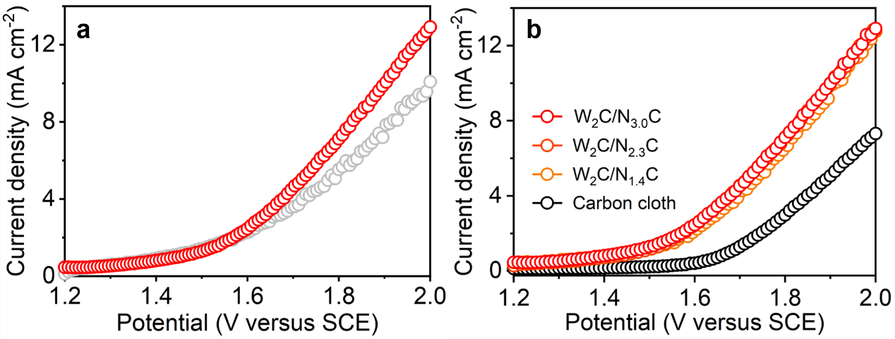
Supplementary Figure 22. (a) Linear sweep voltammetry curves of W₂C/N_{3.0}C anode before adding ethylbenzene (grey) and after adding ethylbenzene (red) under standard reaction conditions with a scanning rate of 10 mV/s. The enhanced current density after the addition of ethylbenzene suggests the activation of ethylbenzene in our electrochemical system. (b) Linear sweep voltammetry curves of W₂C/N_{x}C and bare carbon cloth as anodes under standard reaction conditions in the presence of ethylbenzene. The decreased overpotentials by the W₂C/N_{x}C-based anodes further confirm the role of W₂C/N_{x}C materials as active components for the activation of ethylbenzene.

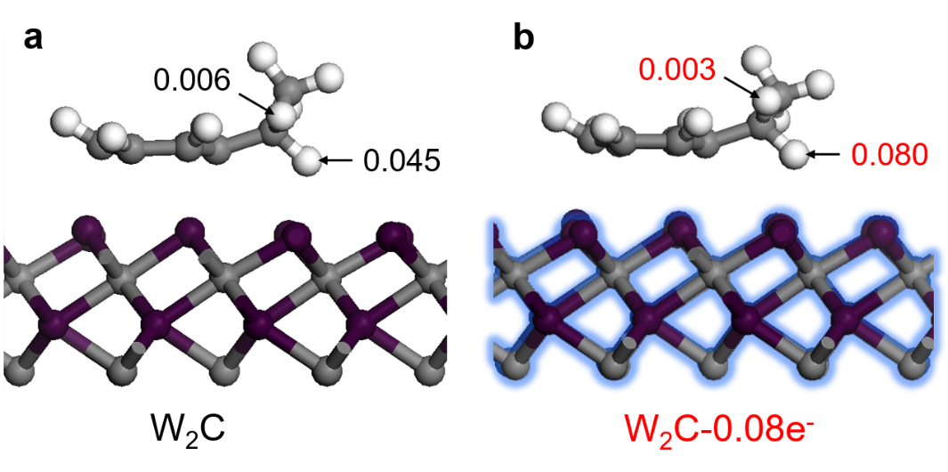
Supplementary Figure 23. The electron numbers from benzylic H atom of ethylbenzene molecule to the surface of W₂C (a) and W₂C-0.08e⁻ (b) models. The significant difference in Hirshfeld charge of benzylic H atom on the electron-deficient W₂C surface directly certifies the polarization role of benzylic C−H bonds of ethylbenzene.

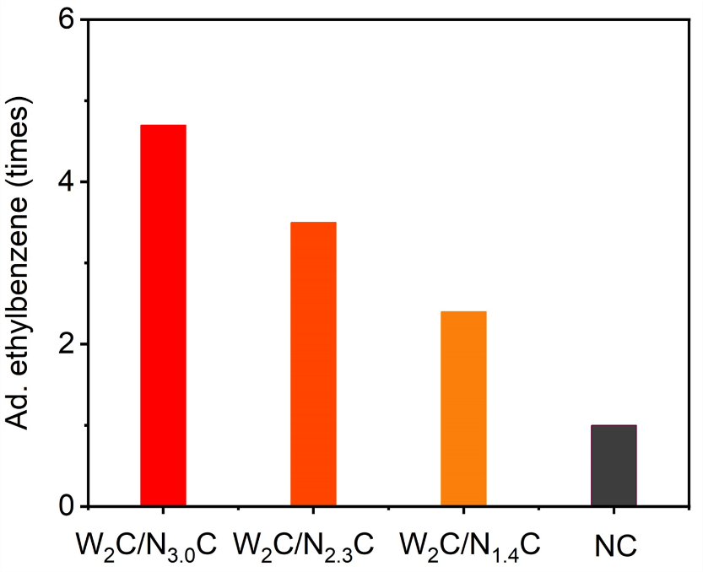
Supplementary Figure 24. The relative adsorption volumes of ethylbenzene absorbed by W₂C/N_{x}C samples and bare NC support, which are 4.7, 3.5 and 2.4 times for W₂C/N_{3.0}C, W₂C/N_{2.3}C and W₂C/N_{1.4}C, respectively.

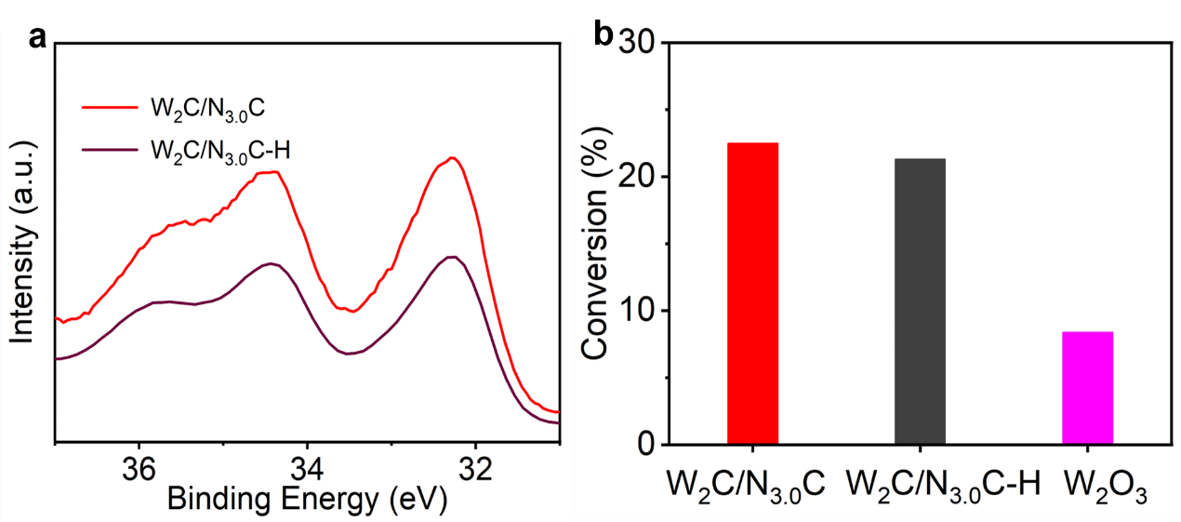
Supplementary Figure 25. The negligible effect of oxygen residues in W₂C/N_{3.0}C on the final activity. W 4f XPS spectra (a) and conversions (b) of W₂C/N_{3.0}C, the reduced W₂C/N_{3.0}C sample (W₂C/N_{3.0}C-H) and W₂O₃. The W₂C/N_{3.0}C material was reduced by a mixed gas of H₂ (5 %) and Ar (95 %) at 500 °C for 2 h to remove all exposable oxygen active species. Oxygen contents and the activity of W₂C/N_{3.0}C electrode materials remain similar after such a reduction process, demonstrating that the oxygen species, mainly in the form of metal oxides as the minority of W components, is not exposable to reaction environment for possible reactions. Moreover, a poor conversion of ethylbenzene on the control W₂O₃ anode with the same loading of W₂C/N_{3.0}C under standard conditions further exclude the possible role of W₂O₃ as active sites in our electrochemical synthesis system.

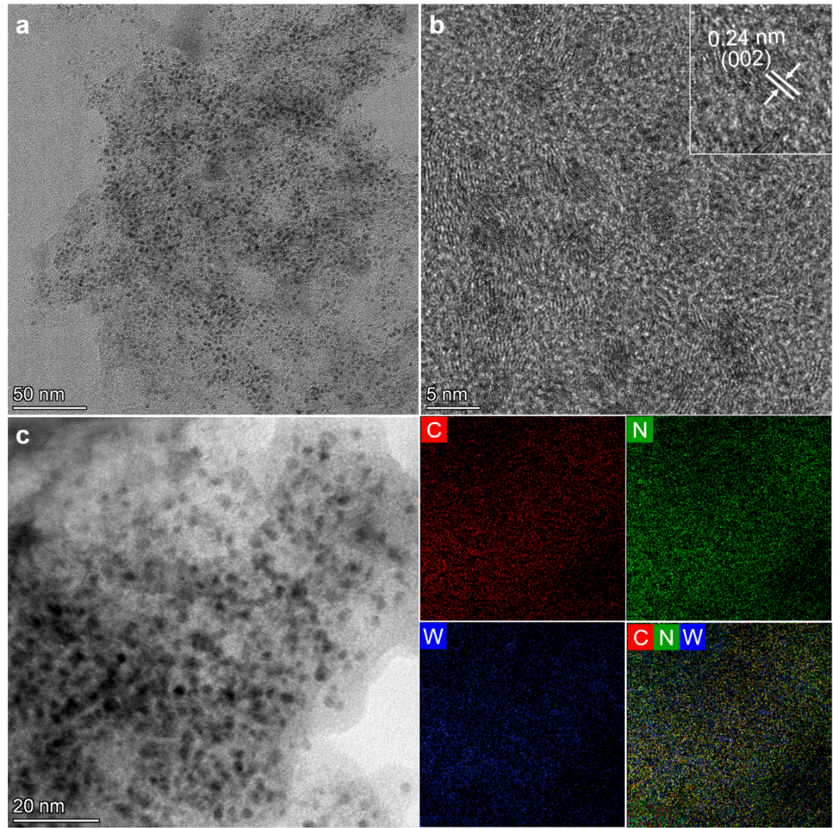
Supplementary Figure 26. TEM (a) and HRTEM (b) images of W₂C/N_{3.0}C-used (recycle 4 times). (c) STEM image and EDX elemental mapping of W₂C/N_{3.0}C-used. The sizes of W₂C nanocrystals and content of NC support in the W₂C/N_{3.0}C anode were maintained well after long-term use, demonstrating the excellent electrochemical stability of W₂C/N_{3.0}C electrode materials.

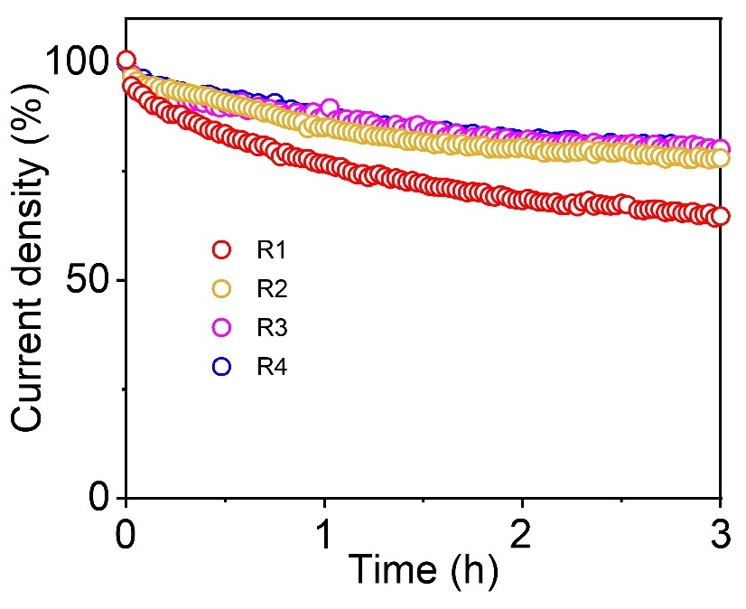
Supplementary Figure 27. Reusability of W₂C/N_{3.0}C anodes for four runs (R1-4).

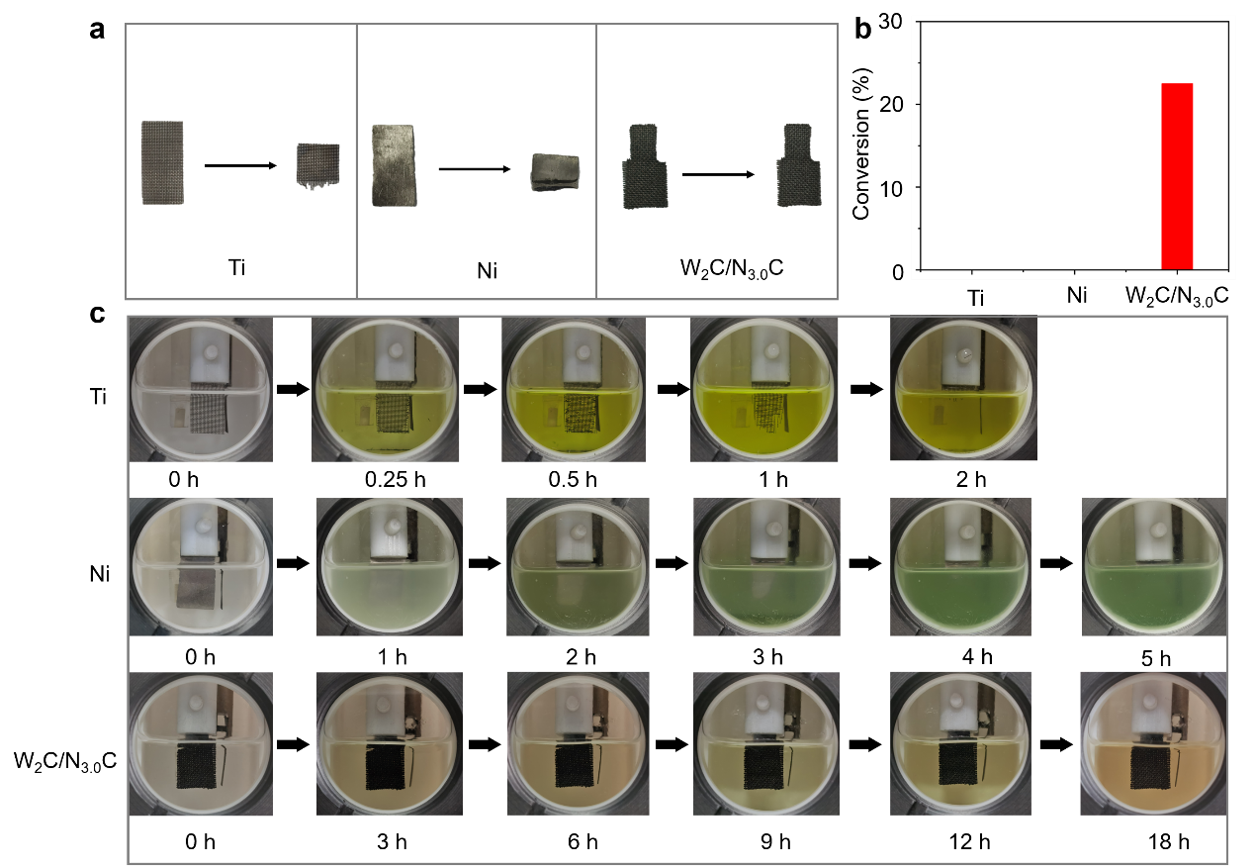
Supplementary Figure 28. The electrochemical stability of W₂C/N_{3.0}C, titanium mesh (Ti) and nickel plate (Ni) anodes. (a) The photos of electrodes before and after uses under standard reaction conditions. The Ti and Ni electrodes became decomposed during the reaction. (b) Conversions of ethylbenzene on various anodes at 2.0 V for 3 h. No products were detected Ni and Ti anodes under standard reaction conditions for 3 h, further highlighting the excellent stability of W₂C/N_{3.0}C anode. (c) The photos of Ti, Ni and W₂C/N_{3.0}C anodes during the reaction with different times.

Supplementary Table 1.Elemental compositions content of W₂C/N_{x}C samples.
Element  Sample | Atomic ratio (%) |  | W (wt%) by XPS | W (wt%) by ICP
Element  Sample | C | N | W (wt%) by XPS | W (wt%) by ICP
W₂C/N_{3.0}C | 87.2 | 3.0 | 50.7 | 65.8
W₂C/N_{2.3}C | 88.3 | 2.3 | 50.0 | 62.4
W₂C/N_{1.4}C | 89.5 | 1.4 | 50.9 | 63.2

Supplementary Table 2.Scope of substrates catalyzed by W₂C/N_{3.0}C anode.
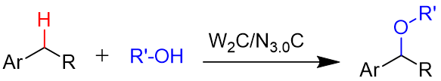
To be continued
Substrate | Conversion (%) | Products (Selectivity %)
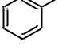 1 | 88% | 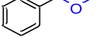69% | 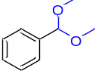31%
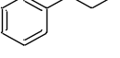 2 | 98% | 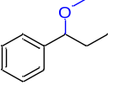99% | -
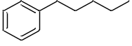 3 | 93% | 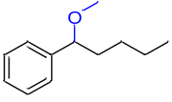99% | -
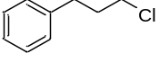 4 | 20% | 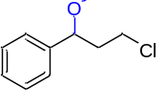99% | -
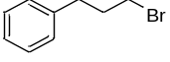 5 | 31% | 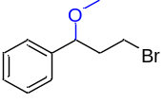99% | -
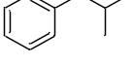 6 | 20% | 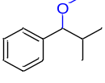99% | -
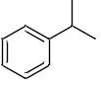 7 | 76% | 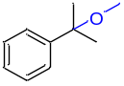99% | -
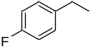 8 | 32% | 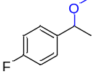99% | -
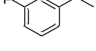 9 | 15% | 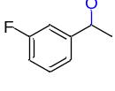99% | -
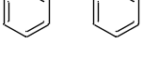 10 | 90% | 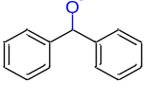 99% | -
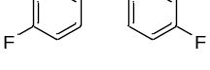11 | 99% | 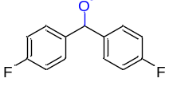 99% | -
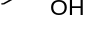 12 | 57% | 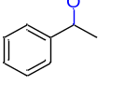99% | -
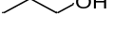 13 | 38% | 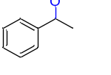99% | -
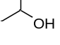 14 | 34% | 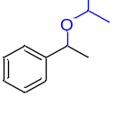99% | -
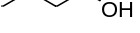 15 | 35% | 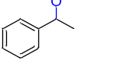99% | -
Standard reaction conditions: 1-11, substrate (0.5 mmol), lithium perchlorate (1 mmol), methanol (15 mL), W₂C/N_{3.0}C anode and Ti mesh cathode with a controlled potential of 2.0 V versus SCE reference electrode at room temperature. 12-15, ethylbenzene (0.5 mmol), alcohols (15 mL), W₂C/N_{3.0}C anode and Ti mesh cathode with a controlled potential of 2.0 V versus SCE reference electrode at room temperature.

The scope of the electron-deficient W₂C-based anode for electrochemical alkoxylation was examined with different benzylic C−H substrates with various functional groups under standard conditions. Toluene was methoxylated to (methoxymethyl)benzene and (dimethoxymethyl)benzene with a high conversion (1). Benzenes with alkyl chains, including propylbenzene, pentylbenzene, isobutylene and even halide-substituted substrates (2-6), were successfully transformed into target products with good conversions (20%-98%) and very high selectivity (> 99%). Alkoxylation of tertiary C–H in cumene (7) could also proceed smoothly with the alkoxylation product as the sole product. Alkylbenzenes with electron-withdrawing groups were also tolerated on the electron-deficient W₂C-based anode for highly selective alkoxylation reactions even with high steric hindrance (8 and 9). It is also not surprising that benzhydryls (10 and 11) with activated C-H bonds could be rapidly transformed into alkoxylation products under standard conditions with very high selectivity (>99%). Electron-deficient W₂C-based anode was also powerful for the alkoxylation of ethylbenzene with different types of aliphatic alcohols (12-15). All these results again reveal the efficiency of the electron-deficient W₂C catalyst for the benzylic C–H bonds alkoxylation with excellent chemical tolerance to various functional groups.

Supplementary Table 3. Summary of TOF values of various catalysts for the methoxylation of benzylic C–H bonds.
Catalyst | TOF (h⁻¹) | Substrate | Notes | T (°C) | Reference
W₂C/N_{3.0}C | 18.8 | Ethylbenzene | - | rt | This work
CuCl + 2,2′-bioxazoline ª | 0.5 | Ethylbenzene | NFSI, (MeO)₂P(O)H | 40 | 38
[Ir(dF(CF₃)ppy)₂(5,5’-dCF₃bpy)]  PF₆^{b} | 12.2 | 4-ethylanisole | Cu(TFA)₂(MeCN),  427 nm blue LED | rt | 39
Reaction conditions: ª substrate (0.2 mmol), MeOH (1 mmol), CuCl (10 mol%), 2,2′-bioxazoline (10 mol%), N-fluorobenzenesulfonimide (NFSI) (2.0 equiv.), (MeO)₂P(O)H (0.5 equiv.), dichloromethane (DCM): hexafluoroisopropanol (HFIP) = 4:1 (1.0 ml) and 16 h under N₂. ^{b} substrate (0.6 mmol, 1 equiv.), [Ir(dF(CF₃)ppy)₂(5,5’-dCF₃bpy)]PF₆ (1 mol%), K₂HPO₄ (3 equiv), Cu(TFA)₂(MeCN) (1.2 equiv), methanol (2 equiv), MeCN (0.2 M), 6 h.

Supplementary Table 4. TOF values of W₂C/N_{3.0}C heterogeneous catalyst in the alkoxylation of C−H bonds.
Heterogenous catalyst | TOF (h⁻¹) | Substrate | Notes | T (°C) | Reference
W₂C/N_{3.0}C | 18.8 | Ethylbenzene | 2.0 V versus SCE | rt | This work

Supplementary Table 5. Summary of TOF values of homogeneous catalyst in the functionalization of C−H bonds.
Homogeneous catalyst | Current collector | TOF (h⁻¹) | Substrate | Notes | T (°C) | Reference
Ni(DME)Cl₂ | RVC | 0.6 | Amides | NaO₂CAd,  1-AdCO₂H,  8 mA | 130 | S3
Co(OAc)₂·  4H₂O | Carbon cloth | 1.2 | N-(quinolin-8-yl)thiophene-2-carbox amide | NaOPiv·  H₂O, 10 mA | 65 | S4
Cp*Rh(OAc)₂ | RVC | 2.2 | N-(2-pyridyl) aniline | 3 mA | 65 | S5
(TAML)Fe | Graphite | 0.8 | Ethylbenzene | 1.25 V versus  Ag/AgCl | rt | S6
Pd(OAc)₂ | Graphite | 1.2 | 8-methylquinoline | Benzoquinone,  8 mA | 35 | S7
PdCl₂ | Pt | 3.1 | 2-phenylpyridine | 20 mA | 90 | S8

Supplementary References
S1. Liu, J. et al. Metal-free efficient photocatalyst for stable visible water splitting via a two-electron pathway. Science 347, 970–974 (2015).
S2. Kovarova, J., Rotschova, J., Brede, O. & Burgers, M. The effect of transformation products of the antioxidant BHT on the initial stages of thermo- and photo-oxidation of LDPE. Can. J. Chem. 73, 1862–1868 (1995).
S3. Zhang, S. K., Struwe, J., Hu, L. & Ackermann, L. Nickela‐electrocatalyzed C−H alkoxylation with secondary alcohols: Oxidation‐induced reductive elimination at Nickel (III). Angew. Chem. Int. Ed. 59, 3178–3183 (2020).
S4. Gao, X., Wang, P., Zeng, L., Tang, S. & Lei, A. Cobalt (II)-catalyzed electrooxidative C–H amination of arenes with alkylamines. J. Am. Chem. Soc. 140, 4195–4199 (2018).
S5. Wu, Z. J. et al. Scalable rhodium (III)‐catalyzed aryl C−H phosphorylation enabled by anodic oxidation induced reductive elimination. Angew. Chem. Int. Ed. 58, 16770–16774 (2019).
S6. Yang, Q.-L. et al. Electrochemistry-enabled Ir-catalyzed vinylic C–H functionalization. J. Am. Chem. Soc. 141, 18970–18976 (2019).
S7. Das, A., Nutting, J. E. & Stahl, S. S. Electrochemical C–H oxygenation and alcohol dehydrogenation involving Fe-oxo species using water as the oxygen source. Chem. Sci. 10, 7542–7548 (2019).
S8. Kakiuchi, F. et al. Palladium-catalyzed aromatic C-H halogenation with hydrogen halides by means of electrochemical oxidation. J. Am. Chem. Soc. 131, 11310–11311 (2009).

