Figure 2B
Groups: Sham, 3dpi, 7dpi, 14dpi, 35dpi
Each group has 5 replicates.

MHC Class II(26kd)
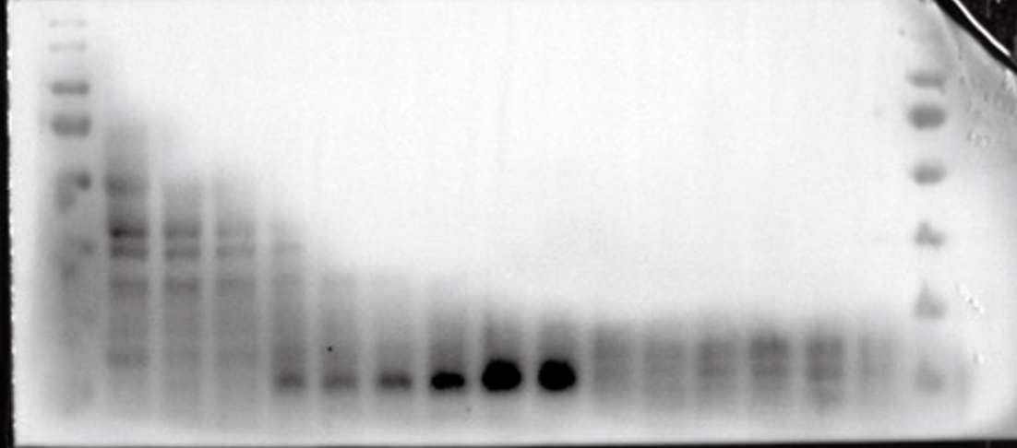
GAPDH(37KD)
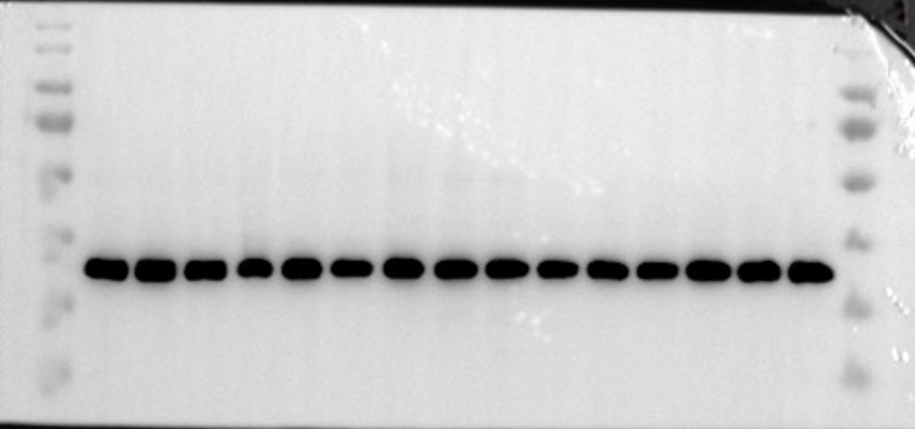

Figure 5K
Groups：Saline, LPS, Vector+LPS and shH2-Ab1+LPS
Each group has 5 replicates.
CD206(160kd)
iNOS (130kd)
TNF-a(26kd)

IL-4（17kd）
IL-1b(31kd)
GAPDH(37kd)

Figure 6F
Groups: Sham, H2-Ab1^{fl/fl}, Cx3cr1^{CreER ;}H2-Ab1^{fl/fl}, Lyz2^{Cre+/- ;}H2-Ab1^{fl/fl}
Each group has 5 replicates.
CD206(160kd)
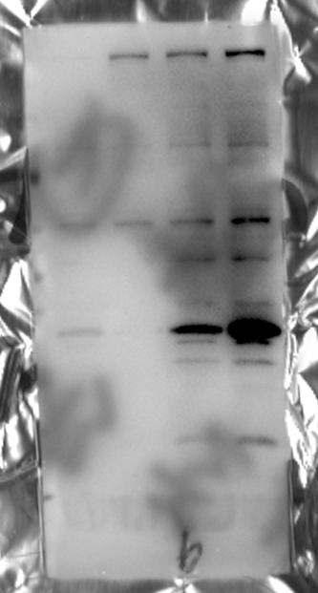
iNOS (130kd)
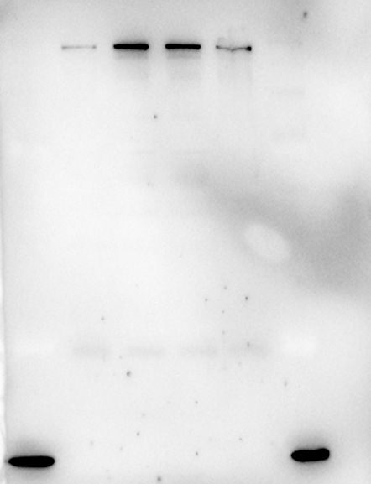
MHC Class II(26kd)
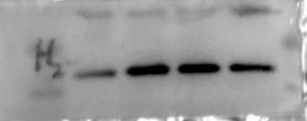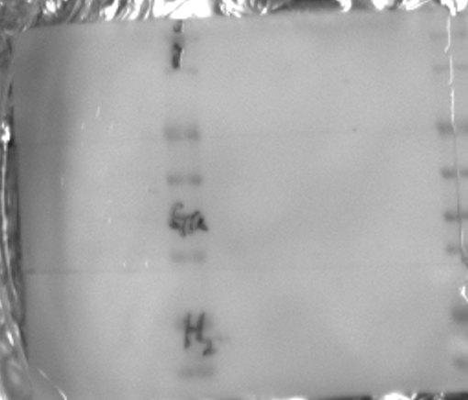
GAPDH(37kd)
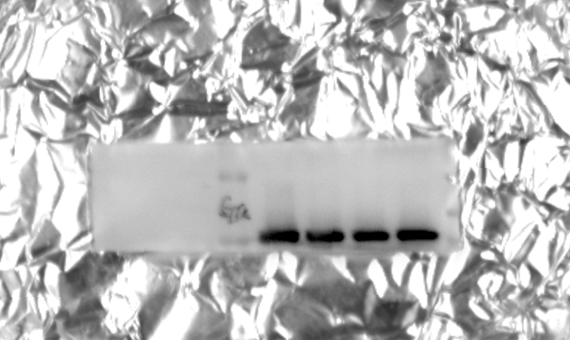

Figure 7B
Groups：Sham, H2-Ab1^{fl/fl}, Cx3cr1^{CreER ;}H2-Ab1^{fl/fl}, Lyz2^{Cre+/- ;}H2-Ab1^{fl/flIL-4(17kd)}

IL-4（17kd）
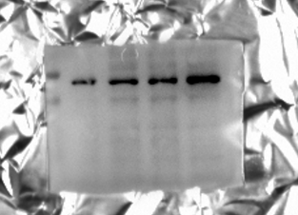
IL-1b(31kd)
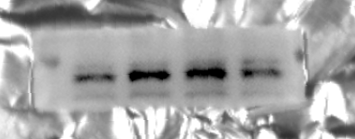
TNF-a(26kd)
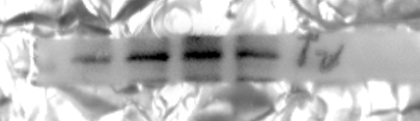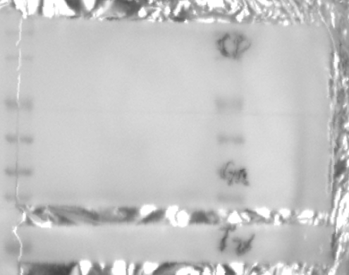
GAPDH(37KD)
