Supplementary Materials for
H2-Ab1 deficiency in macrophages ameliorates spinal cord injury by regulating phagocytosis processing

Tianlun Zhao et al.
* Limin Rong: ronglm@mail.sysu.edu.cn

This PDF file includes:

Supplementary Text
Figs. S1 to S9
Tables S1 to S3

Figure S1: KEGG enrichment analysis showing the association of H2-Ab1 with phagosomes after SCI. A-C KEGG enrichment analysis showing significant pathophysiological processes associated with H2-Ab1 at days 3, 5, and 7 after SCI.

Figure. S2: MHC Class II is localized in macrophages and microglia.
A Reclustered tSNE plots depicting WT cell populations. B Expression of H2-Ab1 transcripts in cell clusters from WT mice in sham and SCI conditions (1, 3, 7, 14, and 38 days post-SCI). C tSNE plots showing expression of H2-Ab1 at different time points before and after SCI. D MHC Class II (red) expression in macrophages/microglia (green), astrocytes (cyan), oligodendrocytes (yellow), and neurons (magenta) of WT mice 7 days following SCI. Scale bar: 100 μm. E-H Analysis of colocalization between MHC Class II and Iba1, GFAP, MBP, and NeuN at 7 days post-spinal cord injury.

Figure S3: Mouse strains and knockouts used in the study. A Schematic representation of the experimental set-up for Lyz2^{Cre}:H2-Ab1^{fl/fl} mice. B Images of Lyz2^{Cre}:H2-Ab1^{fl/fl}, Cx3cr1^{CreERT2}:H2-Ab1^{fl/fl}, Lyz2^{Cre}: R26-TdTomato, and Cx3cr1^{CreERT2} R26-TdTomato reporter mice showing the genotyping of DNA from mouse tail samples (lyz2-116bp, Cx3cr1-350bp, H2-Ab1^{fl/fl}-199bp and TdTomato-196bp). C Schematic representation of the experimental set-up for Cx3cr1^{CreERT2}:H2-Ab1^{fl/fl} mice. D Quantitative analysis of the body weights of H2-Ab1^{fl/fl}, Cx3cr1^{CreERT2}:H2-Ab1^{fl/fl}, and Lyz2^{Cre}:H2-Ab1^{fl/fl} mice at different developmental stages (n = 5 per group). E Representative images of MHC II expression in the Sham, H2-Ab1^{fl/fl}, Cx3cr1^{CreERT2}:H2-Ab1^{fl/fl}, and Lyz2^{Cre}:H2-Ab1^{fl/fl} groups at 7 days after SCI. Scale bar: 200 μm.
Figure S4: Representative images of immunofluorescence, Oil Red O, and BODIPY staining in the sham and Cx3cr1^{CreERT2}:H2-Ab1^{fl/fl} groups. A Transmission electron micrograph of foamy macrophages in the lesion sites of Sham and Cx3cr1^{CreERT2}:H2-Ab1^{fl/fl} mice on day 7 after SCI. The red arrow indicates lipid droplets in foamy macrophages. B Representative immunostaining from the Sham and Cx3cr1^{CreERT2}:H2-Ab1^{fl/fl} groups at day 7 following SCI; microglia and macrophages are indicated by Iba1 and myelin debris are indicated by MBP. Scale bar: 200 μm. C Micrographs of Oil Red O staining of the lesion sites from the Sham and Cx3cr1^{CreERT2}:H2-Ab1^{fl/fl} groups at day 7 following SCI. D Representative immunostaining of the Sham and Cx3cr1^{CreERT2}:H2-Ab1^{fl/fl} groups at day 7 following SCI; microglia and macrophages are indicated by Iba1, and lipid droplets by BODIPY. Scale bar: 50 μm.

Figure S5: Identification of the silencing efficiency of H2-Ab1 in Raw264.7 cells. A Protein levels of MHC Class II in different groups (Raw264.7 group, Raw264.7+Vector group, Raw264.7+shH2-Ab1-1 group, Raw264.7+shH2-Ab1-2 group, and Raw264.7+shH2-Ab1-3 group). B Quantification of MHC Class II protein levels in different groups. n=5. Ordinary one-way ANOVA. C Immunofluorescence staining of Iba1 and MHC Class II in different groups of Raw264.7 cells. Ordinary one-way ANOVA with two-sided comparisons. All data are mean ±SEM; Error bars represent SEMs; *p < 0.05, **p < 0.01, ***p < 0.001, ****p < 0.0001, ns > 0.05.

Figure S6: Representative immunofluorescence images of CD206 and iNOS in different groups. A Representative immunostaining from the Sham, H2-Ab1^{fl/fl}, Cx3cr1^{CreERT2}:H2-Ab1^{fl/fl,} and Lyz2^{Cre}:H2-Ab1^{fl/fl} groups at day 7 following SCI. M2 macrophages indicated by CD206. The damage boundary is indicated by GFAP. Scale bar: 200 μm. B Representative immunostaining of the Sham, H2-Ab1^{fl/fl}, Cx3cr1^{CreERT2}:H2-Ab1^{fl/fl,} and Lyz2^{Cre}:H2-Ab1^{fl/fl} groups at day 7 following SCI. M1 macrophages indicated by iNOS. The damage boundary is indicated by GFAP. Scale bar: 200 μm.
Figure S7: Flow cytometry showing the gating strategy for macrophage identification. A-C Flow cytometry showing the gating strategy for macrophage identification. SSC-A = side scatter-area; FSC-A = forward scatter-area.

Figure S8: DHE staining results for the sham group and Cx3cr1^{CreERT2}:H2-Ab1^{fl/fl} mice. A Representative image of DHE staining for the sham group and Cx3cr1^{CreERT2}:H2-Ab1^{fl/fl} mice.
Figure S9: Lyz2^{Cre}:H2-Ab1^{fl/fl} mice exhibit higher expression of 5-HT.
A Representative immunostaining of NF200 5-HT from the sham, H2-Ab1^{fl/fl}, Cx3cr1^{CreERT2}:H2-Ab1^{fl/fl} and Lyz2^{Cre}:H2-Ab1^{fl/fl} groups at day 7 after SCI. B Quantification of 5-HT⁺ area in (A). n = 5. Data are shown as mean ± SEM. n = 5. **P < 0.01, ***P < 0.001, ****P < 0.0001.

Supplementary Table 1 The sequences of primers
The primer sequences for qPCR
(Mouse) | sense 5'-3' | antisense 5'-3'
H2-Ab1 | CAGGAGTCAGAAAGGACCTCG | ACTGGCAGTCAGGAATTCGG
CD206 | AGTTGGGTTCTCCTGTAGCCCAA | ACTACTACCTGAGCCCACACCTGCT
iNOS | TGGCTCGCTTTGCCACGGAC | GCTGCGACAGCAGGAAGGCA
IL1β | CCAGCAGGTTATCATCATCATCC | CTCGCAGCAGCACATCAAC
TNFα | TACTGAACTTCGGGGTGATTGGTCC | CAGCCTTGTCCCTTGAAGAGAACC
IL4 | TCTCGAATGTACCAGGAGCCATATC | AGCACCTTGGAAGCCCTACAGA
GAPDH | CGGTGCTGAGTATGTCGTGGAGT | CGTGGTTCACACCCATCACAAA

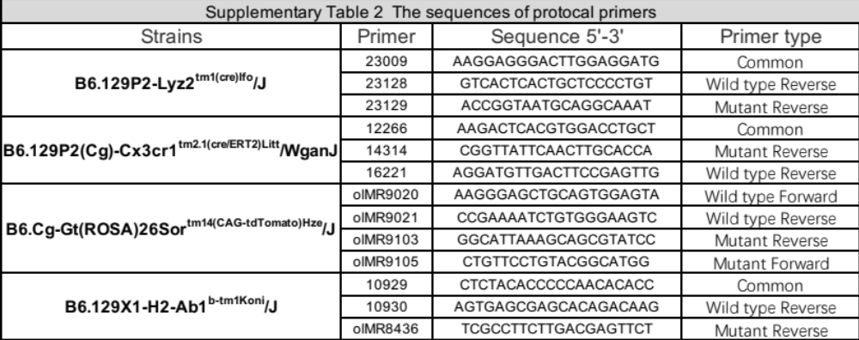

Supplementary Table 3: Antibodies resources
Antibodies | Source | Identifier
Rat monoclonal anti-MHCII | Invitrogen | Cat#14-5321-82
Chicken polyclonal anti-GFAP | Abcam | Cat#ab4674
Rabbit ab178846 anti-Iba1 | Abcam | Cat#ab178846
Rabbit polyclonal anti-NeuN | Millipore | Cat#ABN78
Chicken polyclonal anti-NF | Millipore | Cat#ab5539
Rabbit monoclonal anti-MBP | Abcam | Cat#ab218011
Rabbitpolyclonal anti-dMBP | Millipore | ab5864
Rabbit polyclonal anti-iNOS | Invitrogen | Cat#PA5-16524
Rabbit monoclonal anti-CD206 | CST | Cat#24595S
Rabbit polyclonal anti-IL-1 beta | Proteintech | Cat#26048-1-AP
Rabbit monoclonal anti-TNF-α | Abcam | Cat#ab183218
Mouse polyclonal anti-IL-4 | Proteintech | Cat#66142-1-Ig
Rabbit monoclonal anti-CD68 | Abcam | Cat#ab283654
Rabbit polyclonal anti-5-HT | Millipore | Cat#s5545
Mouse monoclonal anti-vglut2 | Abcam | Cat#ab79157
Goat anti-mouse IgG, Alexa Fluor 488 | Invitrogen | Cat#A-11001
Goat anti-rabbit IgG, Alexa Fluor 488 | Invitrogen | Cat#A-11008
Goat anti-mouse IgG, Alexa Fluor 594 | Invitrogen | Cat#A-11005
Goat anti-rabbit IgG, Alexa Fluor 594 | Invitrogen | Cat#A-11012
Goat anti-chicken IgY, Alexa Fluor 488 | Invitrogen | Cat#A-32931
Goat anti-rat Ig(H&L), Alexa Fluor 647 | Abcam | Cat#ab150167
Goat anti-chicken IgY, Alexa Fluor 680 | Invitrogen | Cat#A-32934
IL-1 beta-PE | Invitrogen | Cat#12-7114-82
IL-4-PE/Cyanine7 | Biolegend | Cat#504118
TNF-α-BV421 | Biolegend | Cat#506327
CD11b-FITC | Sigma | Cat#MABF80A
CD45-PE/Dazzle594 | Biolegend | Cat#103146
CD206-APC | Invitrogen | Cat#17-2061-80
iNOS-PE | Invitrogen | Cat#12-5920-82

