Online Resource 1
Digitally Enabled Accounts and Unsolicited Requests for Money: Exposure and Payment Response among Phone Owners in 75 Economies
Journal of Consumer Policy
This Online Resource reports an analysis map (Table A0), the sample flow, variable definitions, regional rates, full model results and the robustness, sensitivity and diagnostic analyses summarised in the article. All estimates use the Global Findex 2025 microdata (Development Research Group, Finance and Private Sector Development Unit, 2025). Unless stated otherwise, models are survey-weighted logit models with economy fixed effects, standard errors are clustered by economy, and confidence intervals (CI) are at the 95% level. Online Resource 2 contains the analysis scripts that produce every table and figure from the raw file.

A0 Analysis Map
Table A0 groups the analyses by their role in the argument. Only the primary estimates, the hypothesis tests, the decomposition, the account-type comparison and the research question are used as evidence for the claims in the article; the other analyses qualify those claims.
Table A0 Role of each analysis and what it can and cannot establish
Role | Analyses | Where reported | Can establish | Cannot establish
Primary estimates | Standardised probabilities, risk differences, risk ratios and odds ratios at the three margins | Table 3, Fig. 3; Table A9 | Size and precision of adjusted associations, pooled with economies weighted by sample size | Causal effects; population-weighted magnitudes; the size of the association in any one economy
Hypothesis tests (theory-driven; plan not preregistered) | H1 and H4 account premiums; H2 intensity trend; H3 ratio of odds ratios against unwanted messages; Holm and Benjamini–Hochberg corrections | Tables 2 and 3; Table A11; Fig. S6a | Whether patterns expected from routine-activity and compliance accounts appear in the data | The mechanisms behind them; a conversion association free of selection into targeting
Decomposing the gap (H5) | Two-part g-formula; alternative decompositions; comparison of stage-specific risk ratios | Table 4; Tables A8 and A8b | Whether the conversion part of the estimated gap is positive, and how the gap divides in this model | Which stage accounts for more of the gap; shares of consumer harm
Account type | Three-category exposure (no account, non-digital account, digitally enabled account) at each margin | Table 5; Table A4 | Whether premiums appear for accounts not used for digital payments | That the two account types are equivalent, or that digital use has no additional role
Research question | Associations of requests and payments with dormancy and distrust; minimum detectable effects | Table 6; Table A11 | Whether moderate associations with these two indicators are present in these data | Effects on trust or participation in general; temporal order
Sensitivity to observed specification | Control build-up; augmented inverse-probability weighting; specification curve; alternative weights; region fixed effects; linear probability model with wild cluster bootstrap; missing-indicator coding; estimates without the phone lock; leave-one-region-out | Table 2; Tables A4, A4b and A6; Figs. S3 and S4 | Dependence of the estimates on modelling choices among observed variables | Bias from unobserved variables
Sensitivity to unobserved confounding and selection | E-values; robustness values; coefficient-stability bounds; collider simulation; bivariate selection model | Tables 2 and 3; Tables A6b and A12; Fig. S5 | How strong unobserved confounding or selection into targeting would need to be to explain an association | Whether such confounding or selection is present
Specificity and heterogeneity checks | Unwanted messages; remittance control, subsample and interaction; subgroups; economy-level estimates and meta-analysis | Table 2; Tables A4c and A5; Figs. 4, S1, S2 and S6b | Consistency across outcomes, groups and economies | Absence of confounding; that benign requests are excluded
Descriptive and exploratory | Regional rates; unadjusted profiles; phone lock; identity misuse and PIN requests; population-scaled totals; planned analyses not used as evidence | Fig. 2; Tables A3, A6, A7, A10 and A12 | Patterns that motivate further work | Tests of hypotheses
Tables and figures without the prefix A or S are in the article. The phone lock is a diagnostic, not a hypothesis (article, Section 2.3).

A1 Sample
Table A1 Sample flow
Step | Respondents | Economies
All respondents in the public file | 144,090 | 140
Phone owners asked the targeting item (con21) | 64,663 | 75
Valid answer to con21 (excluding don't know and refused) | 64,509 | 75
Targeted (con21 = yes) | 14,359
Targeted with a valid answer to con22 | 14,347
Sent money (con22 = yes) | 1,232
Analysis sample, targeting model (Tables 1 and 3–5; subsamples in Table 6; complete covariates incl. phone lock, valid payment answer) | 62,761 | 75
Analysis sample, conversion model (targeted; economy with no payment excluded) | 13,904 | 74
Analysis sample, overall payment model (economy with no payment excluded) | 61,963 | 74
Exposure sample (Table 2 only; complete covariates, phone lock and payment answer not required) | 62,897 | 75
The conversion and overall payment models contain 1,201 respondents who sent money. The linear probability model for conversion retains all 75 economies (14,043 targeted respondents).

A2 Variable Definitions
Table A2 Variables and survey items
Variable | Item(s) | Definition
Targeted | con21 | Received a phone call or SMS or text message from someone the respondent did not know asking to send money, past 12 months. Asked of phone owners.
Sent money | con22 | Sent the money to this person. Asked of those targeted. Overall payment = targeted and sent money; 0 for all other phone owners. The items do not record deception, amount or payment channel.
Unwanted messages (specificity comparison) | con23 | Received unwanted and offensive messages, photos or videos to the mobile phone, past 12 months.
Digitally enabled account | dig_account | Mobile money account, or account at a bank or similar financial institution from which the respondent makes digital payments using a card or phone (Findex constructed indicator).
Any / financial-institution / mobile money account | account, account_fin, account_mob | Findex constructed account indicators.
Transaction intensity | fin5, fin6, fin13a–c | Most frequent of deposits and withdrawals (financial-institution accounts) and deposits, transfers and cash-outs (mobile money): never, less than monthly, monthly, weekly.
Phone lock | con18 | Phone has a lock such as a PIN, password or fingerprint. Stricter measure: lock the respondent can change (con19).
Smartphone | con9 | Main phone is a smartphone.
Online activities | con30a–h | Count (0–8) of: voice message, photo, social media, news, education, earning money, government services, job search. Not asked of respondents without recent internet use or a smartphone; coded 0.
Has sent a text message | con14, con16 | Ever sent an SMS or a message on a messaging app; 0 for respondents who never read text messages.
Phone and internet use | con12, con26 | Frequency categories: daily, weekly, monthly or less, never/none. Internet frequency is 'none' for non-users.
Demographics | female, age, emp_in, urbanicity, educ, inc_q | Sex; age and age squared/100; in the workforce; rural residence; education (primary or less, secondary, tertiary); within-economy income quintile (a separate category keeps Lesotho, which has no income data).
Dormant account | fin7, fin5, fin6 | Financial-institution account owners with no deposit or withdrawal in the past year; monthly or more frequent users coded 0.
Distrust | fin11f | Respondent without a financial-institution account cites not trusting financial institutions as a reason. Asked in 43 module economies.
Identity misuse | fin47 | Foundational ID used without permission for illegal purposes (ID owners).
PIN or password request | fin13e | Received a message from someone unknown asking for the mobile money PIN or password (mobile money owners).
Saved, borrowed | saved, borrowed | Findex constructed indicators for saving and borrowing in the past year (liquidity controls).
Don't know and refused answers are treated as missing; no values are imputed except in the missing-indicator check (Table A4). Item wording follows the World Bank codebook and DDI metadata.

A3 Regional Rates
Table A3 Targeting and conversion by region (analysis sample)
Region | Economies | Phone owners | Targeted, % | Sent money if targeted, % | Sent money, all, % | Digitally enabled account, %
East Asia & Pacific | 8 | 6,846 | 19.4 | 3.2 | 0.63 | 58.9
Europe & Central Asia | 4 | 3,461 | 9.4 | 9.4 | 0.88 | 54.3
High income (Panama) | 1 | 819 | 28.6 | 8.3 | 2.38 | 56.9
Latin America & Caribbean | 16 | 13,143 | 25.0 | 3.7 | 0.92 | 47.4
Middle East & North Africa | 7 | 6,344 | 10.4 | 6.5 | 0.67 | 20.6
South Asia | 5 | 5,111 | 9.8 | 15.4 | 1.52 | 35.1
Sub-Saharan Africa | 34 | 27,037 | 26.9 | 11.3 | 3.03 | 59.1
All module economies | 75 | 62,761 | 21.6 | 8.4 | 1.80 | 50.3
Survey-weighted percentages. Regions follow the World Bank classification in the file; Panama is the only high-income economy.

A4 Robustness of the Conversion Association
Table A4 Conversion association (sending money once targeted) under alternative specifications
Specification | N | Economies | RR (95% CI) | OR (95% CI)
Main model | 13,904 | 74 | 1.37 (1.14–1.65) | 1.44 (1.16–1.79)
Without phone lock | 13,904 | 74 | 1.39 (1.15–1.67) | 1.46 (1.17–1.81)
Without visibility block and phone lock | 13,904 | 74 | 1.44 (1.17–1.77) | 1.52 (1.20–1.93)
Unweighted | 13,904 | 74 | 1.35 (1.16–1.56) | 1.41 (1.19–1.68)
Equal weight per economy | 13,904 | 74 | 1.46 (1.16–1.83) | 1.57 (1.19–2.07)
Region instead of economy fixed effects (standard errors clustered by region, 7 clusters) | 14,043 | 75 | 1.22 (1.07–1.40) | 1.26 (1.08–1.47)
Any account | 13,904 | 74 | 1.50 (1.21–1.85) | 1.59 (1.25–2.02)
Financial-institution account | 13,904 | 74 | 1.32 (1.14–1.53) | 1.38 (1.16–1.65)
Mobile money account | 13,588 | 71 | 1.51 (1.24–1.83) | 1.60 (1.28–2.00)
Excluding East Asia & Pacific | 12,607 | 66 | 1.41 (1.17–1.70) | 1.49 (1.20–1.85)
Excluding Europe & Central Asia | 13,570 | 70 | 1.37 (1.13–1.66) | 1.44 (1.16–1.80)
Excluding Latin America & Caribbean | 10,747 | 59 | 1.38 (1.12–1.69) | 1.45 (1.14–1.85)
Excluding Middle East & North Africa | 13,226 | 67 | 1.37 (1.13–1.66) | 1.44 (1.15–1.80)
Excluding South Asia | 13,361 | 69 | 1.32 (1.09–1.60) | 1.38 (1.11–1.73)
Excluding Sub-Saharan Africa | 6,234 | 40 | 1.34 (0.98–1.82) | 1.39 (0.98–1.96)
Population-scaled weights | 13,904 | 74 | 2.14 (1.65–2.77) | 2.60 (1.82–3.69)
Missing-indicator coding | 14,098 | 74 |  | 1.42 (1.15–1.77)
+ saving and borrowing in the past year | 13,904 | 74 |  | 1.41 (1.12–1.77)
Linear probability model, all economies: 2.46 pp (0.94–3.97); wild cluster bootstrap p = 0.002 | 14,043 | 75
Account type vs no account (OR)
Financial-institution account only | 13,588 | 71 |  | 1.30 (0.97–1.75)
Mobile money account only | 13,588 | 71 |  | 1.54 (1.12–2.11)
Both | 13,588 | 71 |  | 2.03 (1.55–2.66)
Survey-weighted logit models of sending money among targeted respondents, with economy fixed effects and all controls unless stated; RR is the ratio of marginally standardised probabilities. The region fixed-effects row clusters standard errors by region; with economy-clustered errors its OR interval is 1.01–1.56 (p = 0.039). Region exclusions refer to World Bank regions in the file. Mobile money only vs financial-institution only: ratio of ORs 1.18, p = 0.28. Saving OR 1.08 (p = 0.45); borrowing OR 1.02 (p = 0.82). The account-type comparison for all three margins is in Table 5 of the article.
Table A4b All three margins under alternative weighting schemes and missing-data coding (odds ratios; risk ratios for overall payment)
Weights or coding | Targeting OR (95% CI) | Conversion OR (95% CI) | Overall payment OR (95% CI) | Overall payment RR
Survey weights (main) | 1.30 (1.22–1.40) | 1.44 (1.16–1.79) | 1.87 (1.47–2.38) | 1.83
Equal weight per economy | 1.31 (1.22–1.41) | 1.57 (1.19–2.07) | 1.93 (1.49–2.49) | 1.88
Unweighted | 1.32 (1.24–1.40) | 1.41 (1.19–1.68) | 1.84 (1.53–2.21) | 1.80
Population-scaled | 1.51 (1.21–1.88) | 2.60 (1.82–3.69) | 3.31 (1.86–5.88) | 3.18
Population-scaled, excluding India | 1.33 (1.20–1.47) | 1.82 (1.24–2.68) | 2.10 (1.46–3.02) | 2.04
Survey weights, excluding India | 1.29 (1.21–1.38) | 1.39 (1.13–1.72) | 1.78 (1.42–2.24) | 1.74
Missing-indicator coding | 1.31 (1.22–1.41) | 1.42 (1.15–1.77) | 1.88 (1.46–2.42)
Survey weights sum to the number of respondents within each economy, so the main estimand weights economies by sample size. Population-scaled weights rescale them to each economy's adult population; India holds about a third of the adult population of the 75 economies, and its own conversion premium is 15.1 pp (SE 7.1; 218 targeted respondents). Equal weights give each economy the same total weight. Conversion RRs: population-scaled 2.14; population-scaled without India 1.65 (1.20–2.26).
Table A4c Remittances: control, subsample and interaction (odds ratios for a digitally enabled account)
Margin | Remittance sample | + remittance control | Non-remitters only | Non-remitters, interaction model | Remitters, interaction model | Ratio (p)
Targeting | 1.30 (1.22–1.40) | 1.19 (1.12–1.28) | 1.10 (1.00–1.20) | 1.16 (1.05–1.28) | 1.22 (1.11–1.35) | 1.06 (0.45)
Conversion | 1.45 (1.17–1.80) | 1.42 (1.16–1.74) | 1.16 (0.86–1.57) | 1.38 (1.01–1.90) | 1.44 (1.09–1.90) | 1.04 (0.86)
Overall payment | 1.88 (1.48–2.39) | 1.72 (1.37–2.15) | 1.24 (0.90–1.70) | 1.68 (1.22–2.32) | 1.74 (1.31–2.29) | 1.03 (0.88)
Non-remitter samples: targeting 29,756, conversion 4,449, overall payment 27,456. Remittance use: sent or received a domestic remittance, or received an international one, in the past year (items fh1, fh2, fh2a; weighted share 50% of phone owners). The interaction model adds remittance use and its product with the account indicator to the main model. Remittances may themselves follow from account ownership, so the control is a bracket, not a preferred specification.

A5 Conversion Premium by Subgroup and by Economy
Table A5 Conversion premium (percentage points) by subgroup, and economy-level meta-analysis
Group | Premium, pp | 95% CI | p
Men | 2.9 | 0.9–4.9 | 0.005
Women | 2.1 | 0.6–3.5 | 0.005
Difference, women − men | −0.8 | −2.9 to 1.3 | 0.446
Under 60 | 2.4 | 0.9–3.9 | 0.002
60 and older | 3.8 | 0.6–7.1 | 0.021
Difference, 60 and older − under 60 | 1.4 | −2.0 to 4.9 | 0.410
Secondary education or more | 2.1 | 0.7–3.5 | 0.004
Primary education or less | 3.1 | 0.4–5.7 | 0.023
Difference, primary or less − secondary or more | 1.0 | −1.9 to 4.0 | 0.492
Urban | 1.5 | −0.2 to 3.2 | 0.082
Rural | 3.2 | 1.2–5.2 | 0.002
Difference, rural − urban | 1.7 | −0.8 to 4.2 | 0.173
Meta-analysis, targeting (75 economies) | 3.0 | 2.0–4.1 | I² = 31%; Q p = 0.007
Meta-analysis, conversion (58 economies) | 1.9 | 0.7–3.1 | I² = 7%; Q p = 0.321
Subgroup premiums are average marginal effects of a digitally enabled account on sending money once targeted, from models with an interaction and all controls. Meta-analysis: per-economy weighted linear probability models with the main controls and HC1 standard errors, pooled by DerSimonian–Laird random effects; inclusion requires at least 300 respondents and 20 targeted (targeting) or 60 targeted and 5 payment events (conversion). Share of economy estimates that are positive: targeting 79%, conversion 67%; none is significantly negative. Prediction intervals: targeting −1.9 to 8.0 pp, conversion −0.8 to 4.6 pp. Economy estimates are shown in Figs. S1 and S2.

A6 Exposure: Sensitivity and Convergent Outcomes
Table A6 Sensitivity of the targeting premium and convergent outcomes
Analysis | Estimate | Detail
Oster bound (R² including fixed effects), short model: adoption only; Rmax = 1.3 × R² | δ = 1.09 | β* at δ = 1: 0.003 (β = 0.041)
Oster bound (R² including fixed effects), short model: adoption only; Rmax = 2.0 × R² | δ = 0.33 | β* at δ = 1: −0.084 (β = 0.041)
Oster bound (R² including fixed effects), short model: adoption + economy FE; Rmax = 1.3 × R² | δ = 0.38 | β* at δ = 1: −0.066 (β = 0.041)
Oster bound (R² including fixed effects), short model: adoption + economy FE; Rmax = 2.0 × R² | δ = 0.11 | β* at δ = 1: −0.315 (β = 0.041)
Cinelli–Hazlett robustness value | 4.3% | 3.5% at α = 0.05; smartphone partial R² with outcome 0.08%
Augmented inverse-probability weighting, ATE (pp) | 4.47 | 95% CI 3.18–5.76; 774 observations trimmed (propensity outside 0.01–0.99)
Specification curve (Fig. S3) | 36 of 36 positive | 3 account measures × 3 control sets × weighted/unweighted × logit/LPM; AMEs 4.05–7.64 pp, all p < 0.05
Targeting premium difference, women vs men (pp) | 0.43 | 95% CI −1.28 to 2.14; p = 0.618
Targeting premium difference, 60 and older vs under 60 (pp) | −1.49 | 95% CI −3.86 to 0.88; p = 0.214
Targeting premium difference, rural vs urban (pp) | 0.84 | 95% CI −1.00 to 2.67; p = 0.366
Targeting premium difference, primary or less vs secondary or more (pp) | 2.25 | 95% CI 0.48–4.02; p = 0.014
Smartphone: OR for request for money / unwanted messages | 0.79 / 1.28 | p < 0.001 / p = 0.006
Online activities (per activity): OR for request for money / unwanted messages | 1.19 / 1.31 | p < 0.001 / p < 0.001
Has sent a text message: OR for request for money / unwanted messages | 1.43 / 1.37 | p < 0.001 / p < 0.001
Identity misuse, ID owners (OR, digitally enabled account) | 1.35 | 95% CI 1.08–1.68; N = 54,086; base rate 3.5%
PIN or password request, mobile money owners (OR per intensity step) | 1.17 | 95% CI 1.09–1.25; N = 15,398; base rate 34.5%
Exposure-stage sample (N = 62,897). Oster bounds use the linear probability model; δ is the ratio of selection on unobservables to selection on observables needed for a zero effect. The education difference in the targeting premium is reported for completeness and is not interpreted in the article.
Table A6b Coefficient-stability bounds with R² net of economy fixed effects, targeting and conversion
Margin | Rmax | δ for a zero effect | β* at δ = 1 (pp)
Targeting | 1.3 × within R² (0.046) | 1.79 | 1.78
Targeting | 2 × within R² (0.070) | 0.54 | −3.47
Targeting | 3 × within R² (0.105) | 0.27 | −10.98
Targeting | 0.10 (0.100) | 0.29 | −9.80
Targeting | 0.20 (0.200) | 0.11 | −31.14
Targeting | 0.30 (0.300) | 0.07 | −52.48
Targeting | 0.50 (0.500) | 0.04 | −95.15
Targeting | 1.00 (1.000) | 0.02 | −201.83
Conversion | 1.3 × within R² (0.014) | 51.74 | 2.41
Conversion | 2 × within R² (0.021) | 15.52 | 2.30
Conversion | 3 × within R² (0.032) | 7.76 | 2.14
Conversion | 0.10 (0.100) | 1.83 | 1.12
Conversion | 0.20 (0.200) | 0.87 | −0.38
Conversion | 0.30 (0.300) | 0.57 | −1.88
Conversion | 0.50 (0.500) | 0.33 | −4.88
Conversion | 1.00 (1.000) | 0.17 | −12.37
Linear probability models with economy fixed effects; within R² is the R² relative to a model with economy fixed effects only. Short model: account indicator and fixed effects; long model: all controls. Targeting: β short 9.13 pp, long 4.03 pp, within R² 0.0113 → 0.0352. Conversion: β short 2.59 pp, long 2.46 pp, within R² 0.0017 → 0.0106. Cinelli–Hazlett robustness value for conversion: 3.6% (2.0% at α = 0.05); benchmark, number of online activities: partial R² 0.14% with conversion and 1.67% with account ownership.

A7 Phone Lock Diagnostics
Table A7 Phone lock (PIN, password or fingerprint) and sending money
Controls | Conversion OR (95% CI) | Overall payment OR (95% CI)
Demographics | 1.41 (1.14–1.74) | 2.00 (1.59–2.51)
+ phone and internet use | 1.42 (1.16–1.75) | 1.85 (1.49–2.30)
+ smartphone, online activities, texting | 1.38 (1.11–1.73) | 1.70 (1.35–2.14)
+ digital account | 1.36 (1.09–1.70) | 1.64 (1.31–2.06)
All controls; stricter measure (lock the respondent can change) | 1.19 (0.99–1.42) | 1.35 (1.13–1.60)
Rows add controls cumulatively. Linear probability model of conversion: 2.17 pp, restricted wild cluster bootstrap p = 0.006 (999 replications, 75 clusters). Phone lock and targeting: OR 1.26 (1.17–1.37).

A8 Comparing the Two Margins
Table A8 Comparison of the two margins
Quantity | Estimate | 95% CI (analytic, stacked equations) | 95% CI (cluster bootstrap, 999 replications)
Log RR, targeting | 0.180 | 0.132–0.227 | 0.130–0.223
Log RR, conversion | 0.314 | 0.127–0.501 | 0.134–0.499
Log RR, overall payment (separate model) | 0.605 | 0.372–0.837 | 0.374–0.838
Log RR conversion − log RR targeting | 0.135 | −0.048 to 0.317 | −0.040 to 0.314
Conversion share of overall log RR (separate overall model) | 0.519 | 0.386–0.653 | 0.337–0.633
Targeting share of overall log RR (separate overall model) | 0.297 | 0.189–0.405 | 0.215–0.447
Share difference (conversion − targeting) | 0.222 | −0.010 to 0.455
Analytic intervals: targeting, conversion and overall payment logits estimated as stacked estimating equations with one economy-clustered covariance matrix (75 clusters). Bootstrap intervals: percentile intervals from 999 economy-cluster replications (seed 20261009), all of which completed; duplicated economies receive distinct fixed effects. Ratio of conversion RR to targeting RR = 1.14 (0.95–1.37), analytic p = 0.15; two-sided bootstrap p for the difference = 0.14. The two kinds of interval are not interchangeable: the article cites analytic intervals for the stacked-equation shares and bootstrap intervals for the decompositions.
Table A8b Decompositions of the overall payment gap
Decomposition or quantity | Estimate | 95% CI (cluster bootstrap)
Two-part g-formula (main, Table 4)
E11, holders (%) | 2.13 | 1.73–2.55
E00, others (%) | 1.29 | 1.02–1.62
E10, holders' targeting with others' conversion (%) | 1.55 | 1.23–1.93
E01, others' targeting with holders' conversion (%) | 1.77 | 1.47–2.09
Gap E11 − E00 (pp) | 0.84 | 0.49–1.18
Targeting part (pp) | 0.31 | 0.21–0.43
Conversion part (pp) | 0.53 | 0.23–0.81
Conversion share of the gap | 63% | 43–73%
Overall RR implied by the two-part model | 1.65 | 1.34–2.03
Alternative decompositions
Conversion share, log RR against the separately estimated overall model | 52% | 34–63%
Conversion share, sum of the two stage-specific log RRs | 64% | 43–74%
Conversion share, absolute split of p1c1 − p0c0 (stage-specific standardisation) | 63% | 43–74%
Overall RR, separately estimated overall model | 1.83 | 1.45–2.31
Overall gap, separately estimated overall model (pp) | 1.02 | 0.63–1.40
Intervals are bootstrap percentile intervals; Table 3 of the article reports delta-method intervals for the separately estimated overall payment model (gap 1.0 pp, 0.7–1.4). The g-formula standardises the product of the two stage models over all phone owners, so its parts sum exactly to its gap. The separately estimated overall payment model is a single logit for the compound outcome; it implies a larger gap because the two specifications differ in functional form. In the third alternative, the targeting probabilities are standardised over all phone owners and the conversion probabilities over the targeted, so the product is not an overall standardised quantity. The alternatives decompose different quantities, so their shares and intervals are not interchangeable. All shares describe the estimated gap; they are not causal attributions, and an interval that includes 50% does not show which stage accounts for more of the gap.

A9 Full Model Results
Table A9 Odds ratios for the three margins
Term | Targeting | Conversion | Overall payment
Digitally enabled account | 1.30*** (1.22–1.40) | 1.44** (1.16–1.79) | 1.87*** (1.47–2.38)
Woman | 0.93 (0.87–1.00) | 0.93 (0.77–1.13) | 0.88 (0.73–1.06)
Age | 1.04*** (1.03–1.05) | 1.02 (0.99–1.04) | 1.03** (1.01–1.06)
Age squared/100 | 0.97*** (0.95–0.98) | 0.98 (0.95–1.01) | 0.97* (0.94–0.99)
In the workforce | 1.24*** (1.16–1.33) | 1.10 (0.91–1.32) | 1.24* (1.02–1.51)
Rural | 0.94 (0.88–1.01) | 1.06 (0.82–1.36) | 1.04 (0.84–1.29)
Smartphone | 0.75*** (0.69–0.82) | 0.85 (0.61–1.19) | 0.68* (0.49–0.96)
Online activities (count) | 1.18*** (1.15–1.22) | 1.10** (1.03–1.17) | 1.22*** (1.15–1.30)
Has sent a text message | 1.41*** (1.27–1.57) | 0.95 (0.72–1.25) | 1.27 (0.93–1.73)
Phone lock | 1.26*** (1.17–1.37) | 1.36** (1.09–1.70) | 1.64*** (1.31–2.06)
Secondary education (ref. primary or less) | 0.95 (0.86–1.04) | 0.80* (0.66–0.98) | 0.73** (0.59–0.90)
Tertiary education | 1.02 (0.90–1.15) | 0.71 (0.49–1.03) | 0.69* (0.49–0.98)
Income quintile 2 (ref. poorest) | 1.06 (0.97–1.17) | 0.77 (0.56–1.08) | 0.81 (0.57–1.16)
Income quintile 3 | 1.00 (0.90–1.11) | 0.80 (0.57–1.11) | 0.80 (0.57–1.11)
Income quintile 4 | 0.97 (0.88–1.06) | 0.87 (0.64–1.17) | 0.82 (0.60–1.13)
Income quintile 5 | 1.00 (0.90–1.11) | 0.81 (0.60–1.10) | 0.82 (0.59–1.14)
Phone used weekly (ref. daily) | 0.92 (0.80–1.07) | 1.52* (1.08–2.13) | 1.36* (1.02–1.82)
Phone used monthly or less | 1.11 (0.91–1.35) | 1.99*** (1.38–2.87) | 2.18*** (1.48–3.21)
Phone never used | 1.07 (0.72–1.59) | 3.46 (0.92–12.93) | 2.76 (0.87–8.73)
Internet used weekly (ref. daily) | 1.20*** (1.09–1.32) | 1.01 (0.77–1.33) | 1.14 (0.88–1.49)
Internet used monthly or less | 1.19** (1.06–1.34) | 1.21 (0.86–1.70) | 1.38* (1.01–1.88)
No recent internet use | 1.23** (1.07–1.42) | 1.32 (0.86–2.04) | 1.49 (0.96–2.32)
N | 62,761 | 13,904 | 61,963
Events | 14,043 | 1,201 | 1,201
Economies | 75 | 74 | 74
Pseudo-R² vs intercept-only | 0.142 | 0.096 | 0.105
Pseudo-R² vs economy fixed effects only | 0.039 | 0.017 | 0.041
Survey-weighted logit models with economy fixed effects (not shown); 95% CIs from economy-clustered standard errors in parentheses. A separate category for missing income (Lesotho) is collinear with that economy's fixed effect and is not reported. Pseudo-R² is the weighted McFadden measure. * p < 0.05, ** p < 0.01, *** p < 0.001.

A10 Population-Scaled Totals
Table A10 Approximate number of adults in the 75 economies (millions)
Quantity | Estimate | 95% CI
Adults aged 15 and older | 3,246.5
Mobile phone owners | 2,482.3 | 2,456.8–2,507.9
Received an unsolicited request for money, past 12 months | 465.2 | 449.4–481.1
Sent money after such a request | 39.8 | 33.9–45.7
of whom hold any account (89.6% of senders) | 35.7 | 29.9–41.5
of whom hold a digitally enabled account (77.4% of senders) | 30.8 | 25.4–36.3
Weighted economy means over all adults multiplied by the adult population supplied in the file (World Development Indicators, 2023) and summed; non-owners of phones count as zero. Intervals reflect within-economy sampling only, because the public file does not identify strata or primary sampling units; the totals are approximate.

A11 Multiple Testing
Table A11 Adjustment for multiple testing across the hypothesis tests and participation associations
Test | p | Holm-adjusted p | Benjamini–Hochberg q
H1 targeting premium (exposure sample, main model) | < 0.001 | < 0.001 | < 0.001
H2 intensity trend among digital account holders | 0.005 | 0.014 | 0.007
H3 request-for-money vs unwanted-message premium (ratio of ORs) | 0.003 | 0.014 | 0.007
H4 conversion premium (payment given targeting, main model) | 0.001 | 0.006 | 0.004
RQa targeted → dormancy | 0.718 | 1.000 | 0.862
RQb targeted → distrust as reason for no account | 0.946 | 1.000 | 0.946
H5 is a decomposition reported with confidence intervals (Tables A8 and A8b) and is not included. RQa and RQb are the associational participation tests. The sent-money and weekly-use rows of Table 6 are supplementary and not included. The analysis plan was not preregistered, so the correction does not confer confirmatory status.

A12 Analyses in the Analysis Plan Not Used as Evidence
The analyses below were specified in an internal analysis plan written before estimation; the plan was not preregistered. They are reported here so that every planned analysis is visible. The article does not rely on them, for the reasons given.
Table A12 Planned analyses not used as evidence
Analysis | Result | Reason not used
Economy-level correlation between targeting and conversion rates (75 economies) | Spearman −0.30 (bootstrap 95% CI −0.48 to −0.10) with empirical-Bayes shrinkage; −0.20 (p = 0.087) on raw rates; −0.15 (p = 0.203) on adjusted economy effects | Not robust across specifications
Moderation of the targeting premium by share of SIMs in own name (per SD) | interaction OR 0.92 (0.86–0.99), p = 0.033 | Survey-based proxies for institutions; not significant after Holm adjustment across the plan's ten tests
Moderation by mobile money prevalence (per SD) | interaction OR 0.95 (0.88–1.02), p = 0.123 | Survey-based proxies for institutions; not significant after Holm adjustment across the plan's ten tests
Moderation by digital account prevalence (per SD) | interaction OR 0.91 (0.85–0.97), p = 0.008 | Survey-based proxies for institutions; not significant after Holm adjustment across the plan's ten tests
Moderation by own-name SIM registration (individual) | interaction OR 1.11 (0.94–1.32), p = 0.218 | Survey-based proxies for institutions; not significant after Holm adjustment across the plan's ten tests
Peer exposure (leave-one-out cell rates): account ownership, all adults, 10 pp higher peer targeting rate | OR 1.04 (1.00–1.08), p = 0.027 | Reflection problem; exploratory only
Peer exposure (leave-one-out cell rates): account ownership, all adults, 1 pp higher peer payment rate | OR 1.01 (1.00–1.02), p = 0.053 | Reflection problem; exploratory only
Peer exposure (leave-one-out cell rates): distrust reason, adults without FI account, 10 pp higher peer targeting rate | OR 1.02 (0.97–1.08), p = 0.423 | Reflection problem; exploratory only
Peer exposure (leave-one-out cell rates): distrust reason, adults without FI account, 1 pp higher peer payment rate | OR 1.00 (0.98–1.02), p = 0.905 | Reflection problem; exploratory only
Targeting premium by income group of economy | low 1.43, lower-middle 1.42, upper-middle 1.19; equality test p = 0.040 | Exploratory; three groups only; not part of the adjusted test family
Transaction intensity and conversion, targeted holders | OR per step 1.09 (0.95–1.24), p = 0.205 | Null; reported for completeness
Bivariate probit with sample selection (exclusion: phone-use frequency) | Exclusion restriction weak (F = 1.38, p = 0.26); error correlation not identified (95% CI −0.99 to 1.00) | Uninformative; selection is addressed by the collider simulation (Fig. S5)
The Holm adjustment in the analysis plan covered ten tests, including the moderation, peer and economy-level tests above; Table A11 reports the adjustment for the tests used in the article.

Supplementary Figures
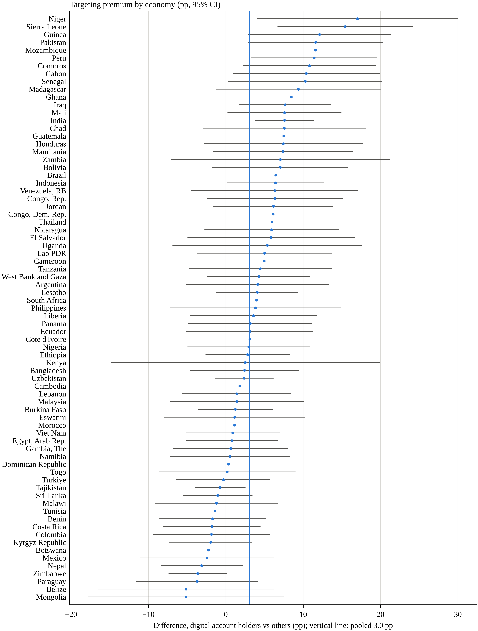
Fig. S1 Targeting premium by economy (percentage points, 95% CI). Within-economy weighted linear probability models with the main controls; the vertical line marks the random-effects pooled estimate (3.0 pp)
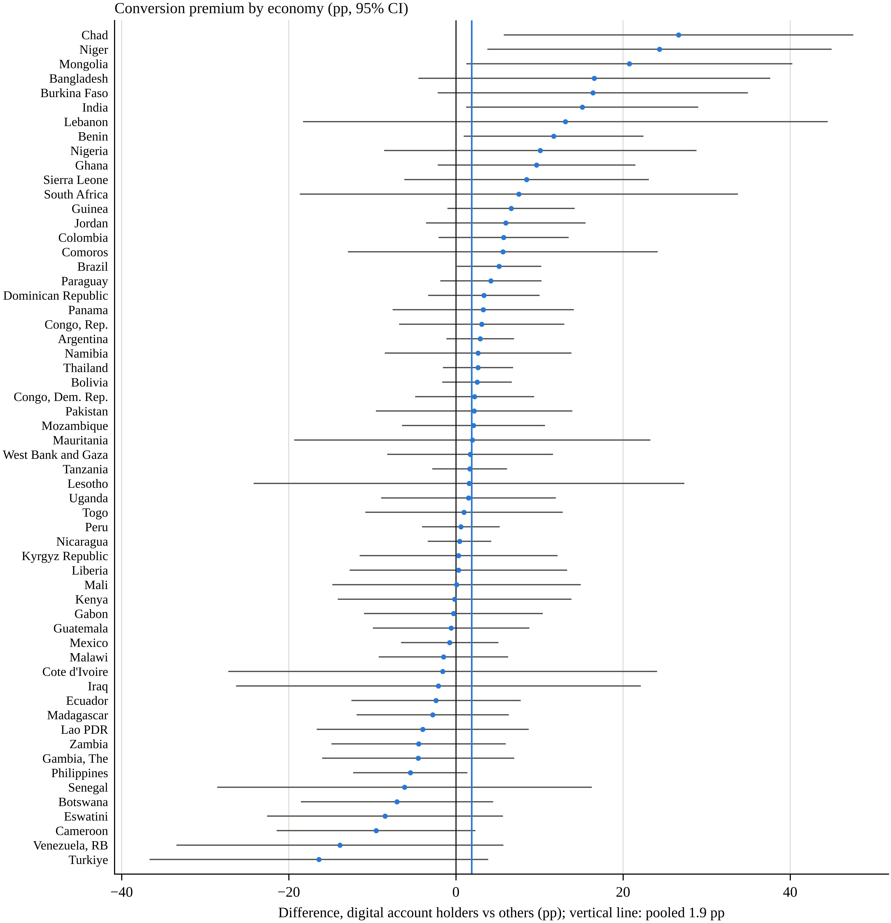
Fig. S2 Conversion premium by economy (percentage points, 95% CI), 58 economies with at least 60 targeted respondents and five payment events. The vertical line marks the pooled estimate (1.9 pp)
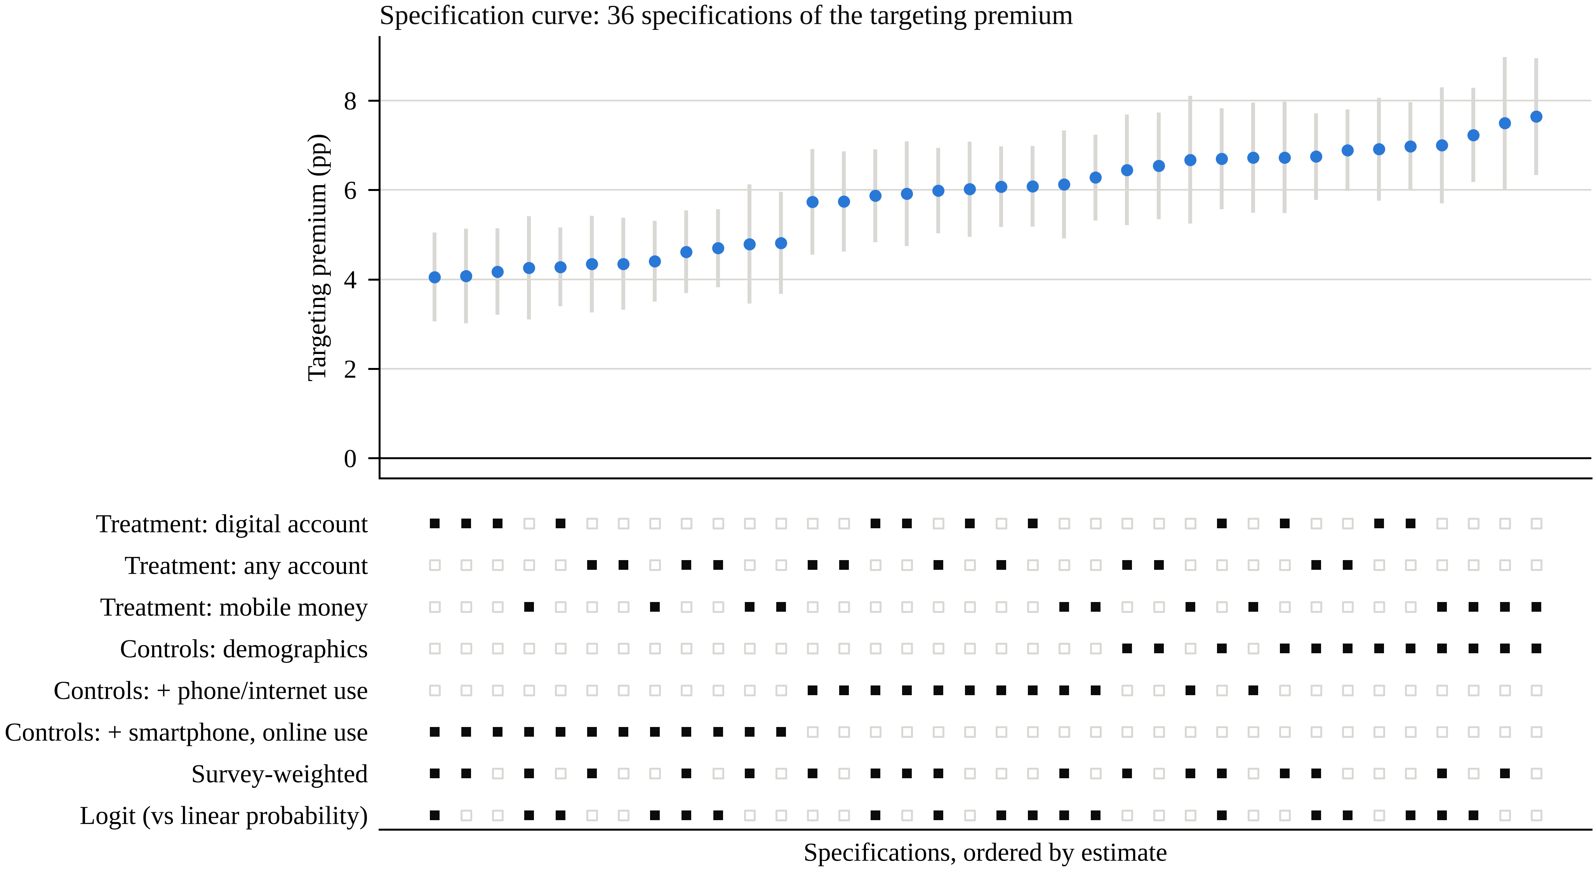
Fig. S3 Specification curve for the targeting premium. Average marginal effects (pp) with 95% CIs for 36 specifications; the lower panel marks each specification's choices
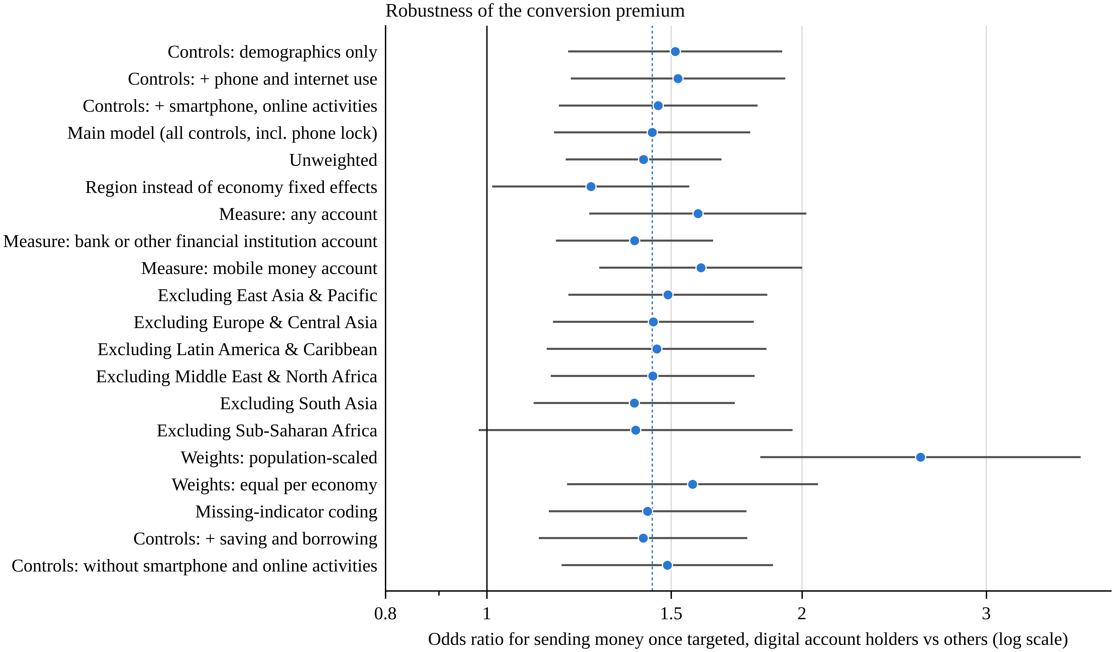
Fig. S4 Odds ratio for sending money once targeted under alternative specifications (log scale). The dotted line marks the main model (OR 1.44)
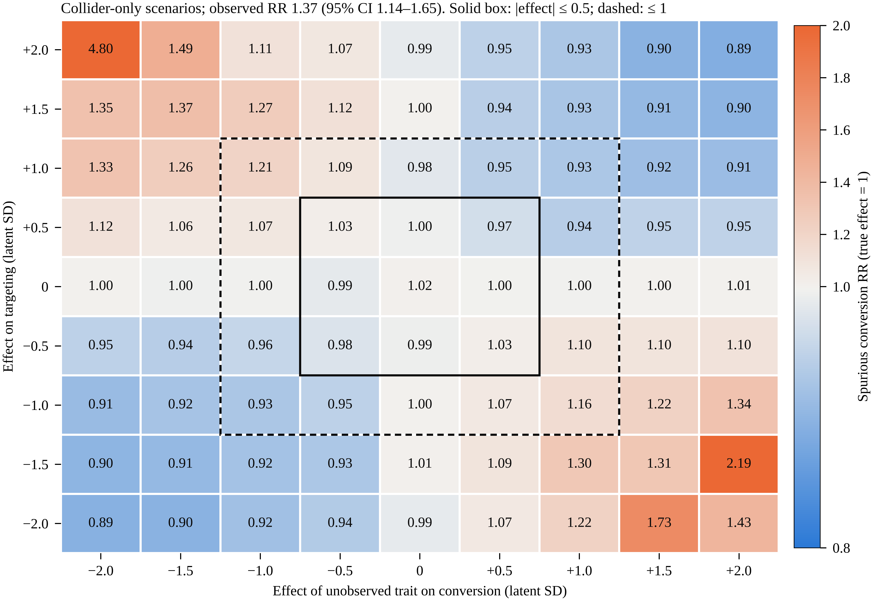
Fig. S5 Collider-only simulation. Spurious conversion risk ratios when the true effect is zero and an unobserved trait affects targeting and conversion by −2 to +2 latent SD (2,000,000 draws per cell; Monte Carlo SE at most 0.02 within the solid box and 0.04 within the dashed box, larger in the corners). The largest latent-scale effect of an observed covariate on conversion is 0.41. The observed risk ratio is 1.37 (95% CI 1.14–1.65)
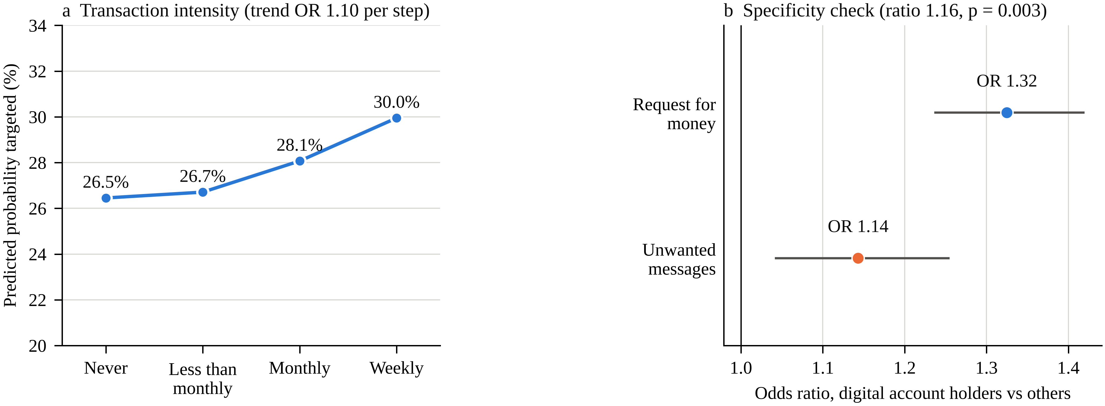
Fig. S6 a Predicted probability of being targeted among digitally enabled account holders, by transaction intensity (N = 31,066). b Specificity check: account premium for requests for money and for unwanted and offensive messages (odds ratios, 95% CI)

Reference
Development Research Group, Finance and Private Sector Development Unit. (2025). The Global Findex Database 2025: Connectivity and financial inclusion in the digital economy (WLD_2024_FINDEX_v02_M) [Data set]. World Bank, Development Data Group. https://doi.org/10.48529/bk9n-8r43

