Supplemental data

MMP3-PKM2 axis controls loading of the glycolytic system in extracellular vesicles and macrophage polarity in the tumor microenvironment

Takanori Eguchi, Eman A. Taha, Kunihiro Yoshida, Htoo Shwe Eain, Hiroki Shinchi, Lizi Xing, Mona Sheta, May Wathone Oo, Yichun Wang, Hotaka Kawai, Koji Ueda, and Kuniaki Okamoto

Table S1. Primary antibody list. Rb, rabbit. Ms, mouse. mAb, monoclonal antibody. pAb, polyclonal antibody.
Protein | Vendor | Catalog #, clone ID | Host species | Antibody type | ICC | IHC
Phospho PKM2 | Invitrogen | PA5-37684 | Rb | pAb | 1:200 | 1:200
MMP-3 | Santa Cruz | Ac-21732 | Ms | mAb | 1:100 | n.a.
MMP-3 | Abcam | Ab52915 | Rb | mAb | 1:200 | n.a.
MRC1/CD206 | Cell Signaling | #24595 | Rb | mAb | 1:500 | 1:500
MRC1/CD206 | Proteintech | 60143-1-Ig | Ms | mAb | 1:500
CD163 | Proteintech | 68218-1-Ig | Ms | mAb | n.a. | 1:2500
NOS2/iNOS | GeneTex | GTX130246 | Rb | pAb | 1:1000 | n.a.

Table S2. Secondary antibody list. Gt, goat.
Antibody type | Conjugate | Vendor | Host  species | ICC | IHC
Anti-mouse IgG | Alexa Fluor 594 | Thermo Fisher | Gt | 1:1000 | n.a.
Anti-mouse IgG | Alexa Fluor 488 | Thermo Fisher | Gt | 1:1000 | n.a.
Anti-rabbit IgG | Alexa Fluor 594 | Thermo Fisher | Gt | 1:1000 | n.a.
Anti-rabbit IgG | Alexa Fluor 488 | Thermo Fisher | Gt | 1:1000 | n.a.

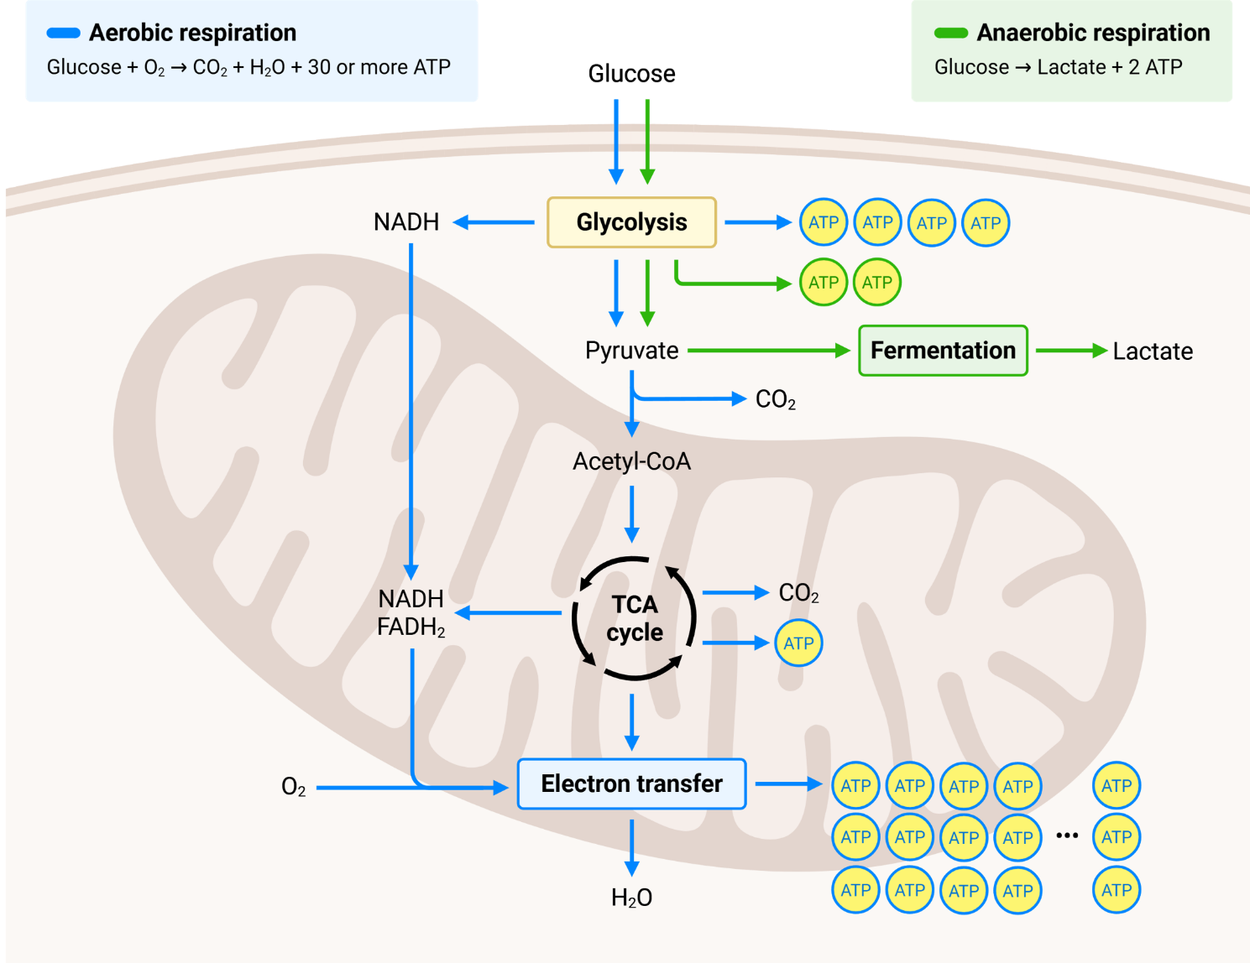
Figure S1. Overview of anaerobic and aerobic respiration systems. Anaerobic respiration consists of glycolysis, which generates 2 ATP per glucose molecule and converts pyruvate to lactate via fermentation. Aerobic respiration occurs in mitochondria and consists of the tricarboxylic acid (TCA) cycle and oxidative phosphorylation (OXPHOS), producing more than 30 ATP per glucose. Graphics were generated using BioRender.
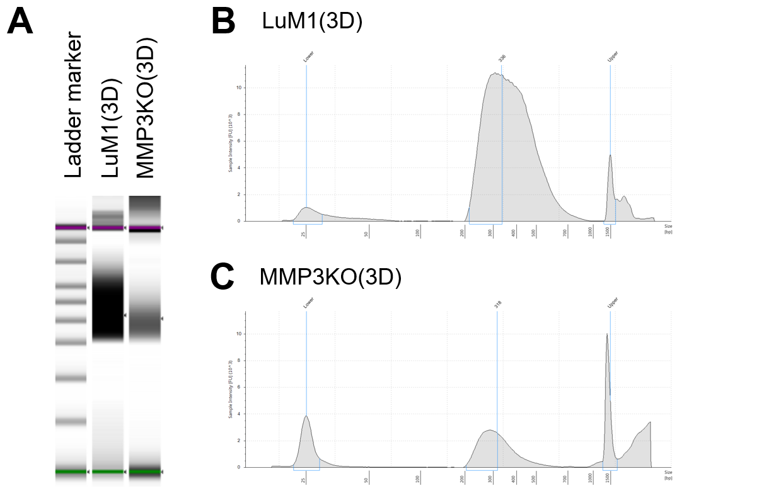

Figure S2. RNA-seq library construction for 3D-cultured LuM1 and MMP3KO tumoroids, and their EVs. (A) Gel electrophoresis image. (B,C) Electropherograms of RNA-seq libraries from 3D-cultured LuM1 (B) and MMP3KO tumorids (C).

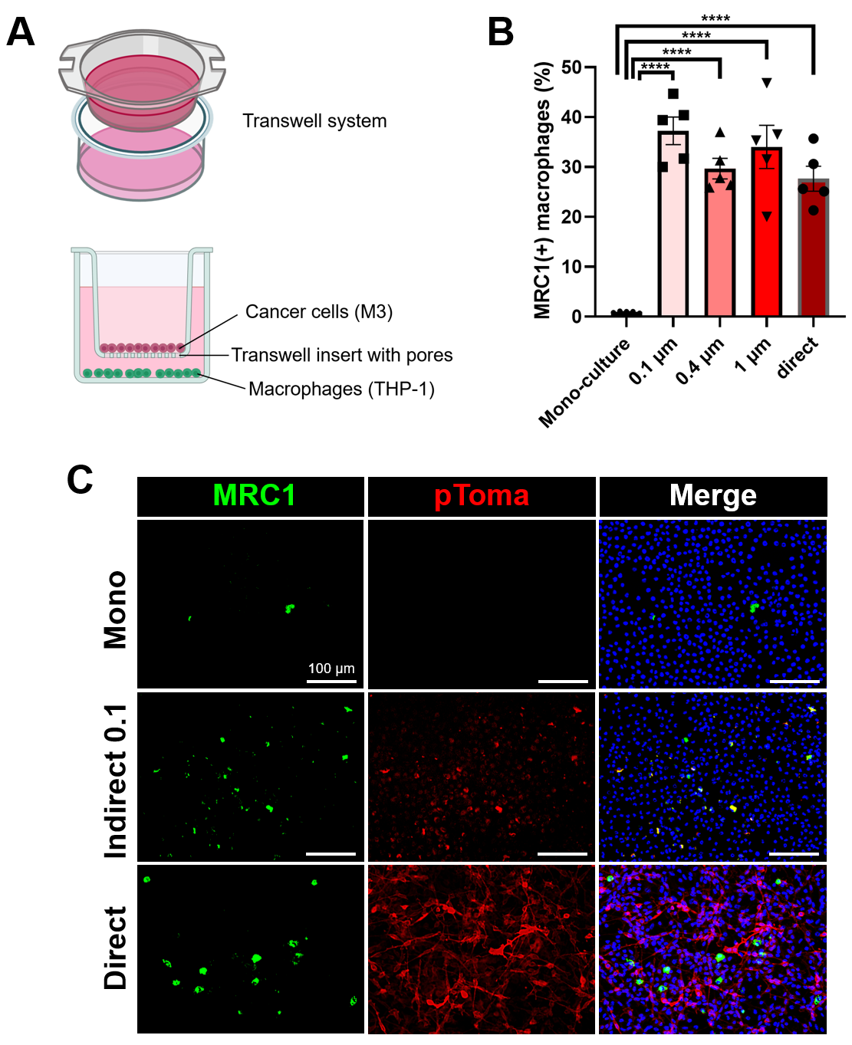
Figure S3. Coculture with cancer cells induces M2-type polarization in macrophages. (A) Schematic illustration of an indirect coculture system. (B) MRC1-positive cell rate in mono-culture, indirect coculture with different pore sizes, and direct coculture of THP-1 with M3 cells. (C) Fluorescence microscopy of pTomato and MRC1 in mono-, direct and indirect coculture systems. LuM1pToma cells and RAW264.7 were cocultured. Representative images showing MRC1 (green) and pTomato (red), with nuclei counterstained (blue). Scale bar: 100 μm.
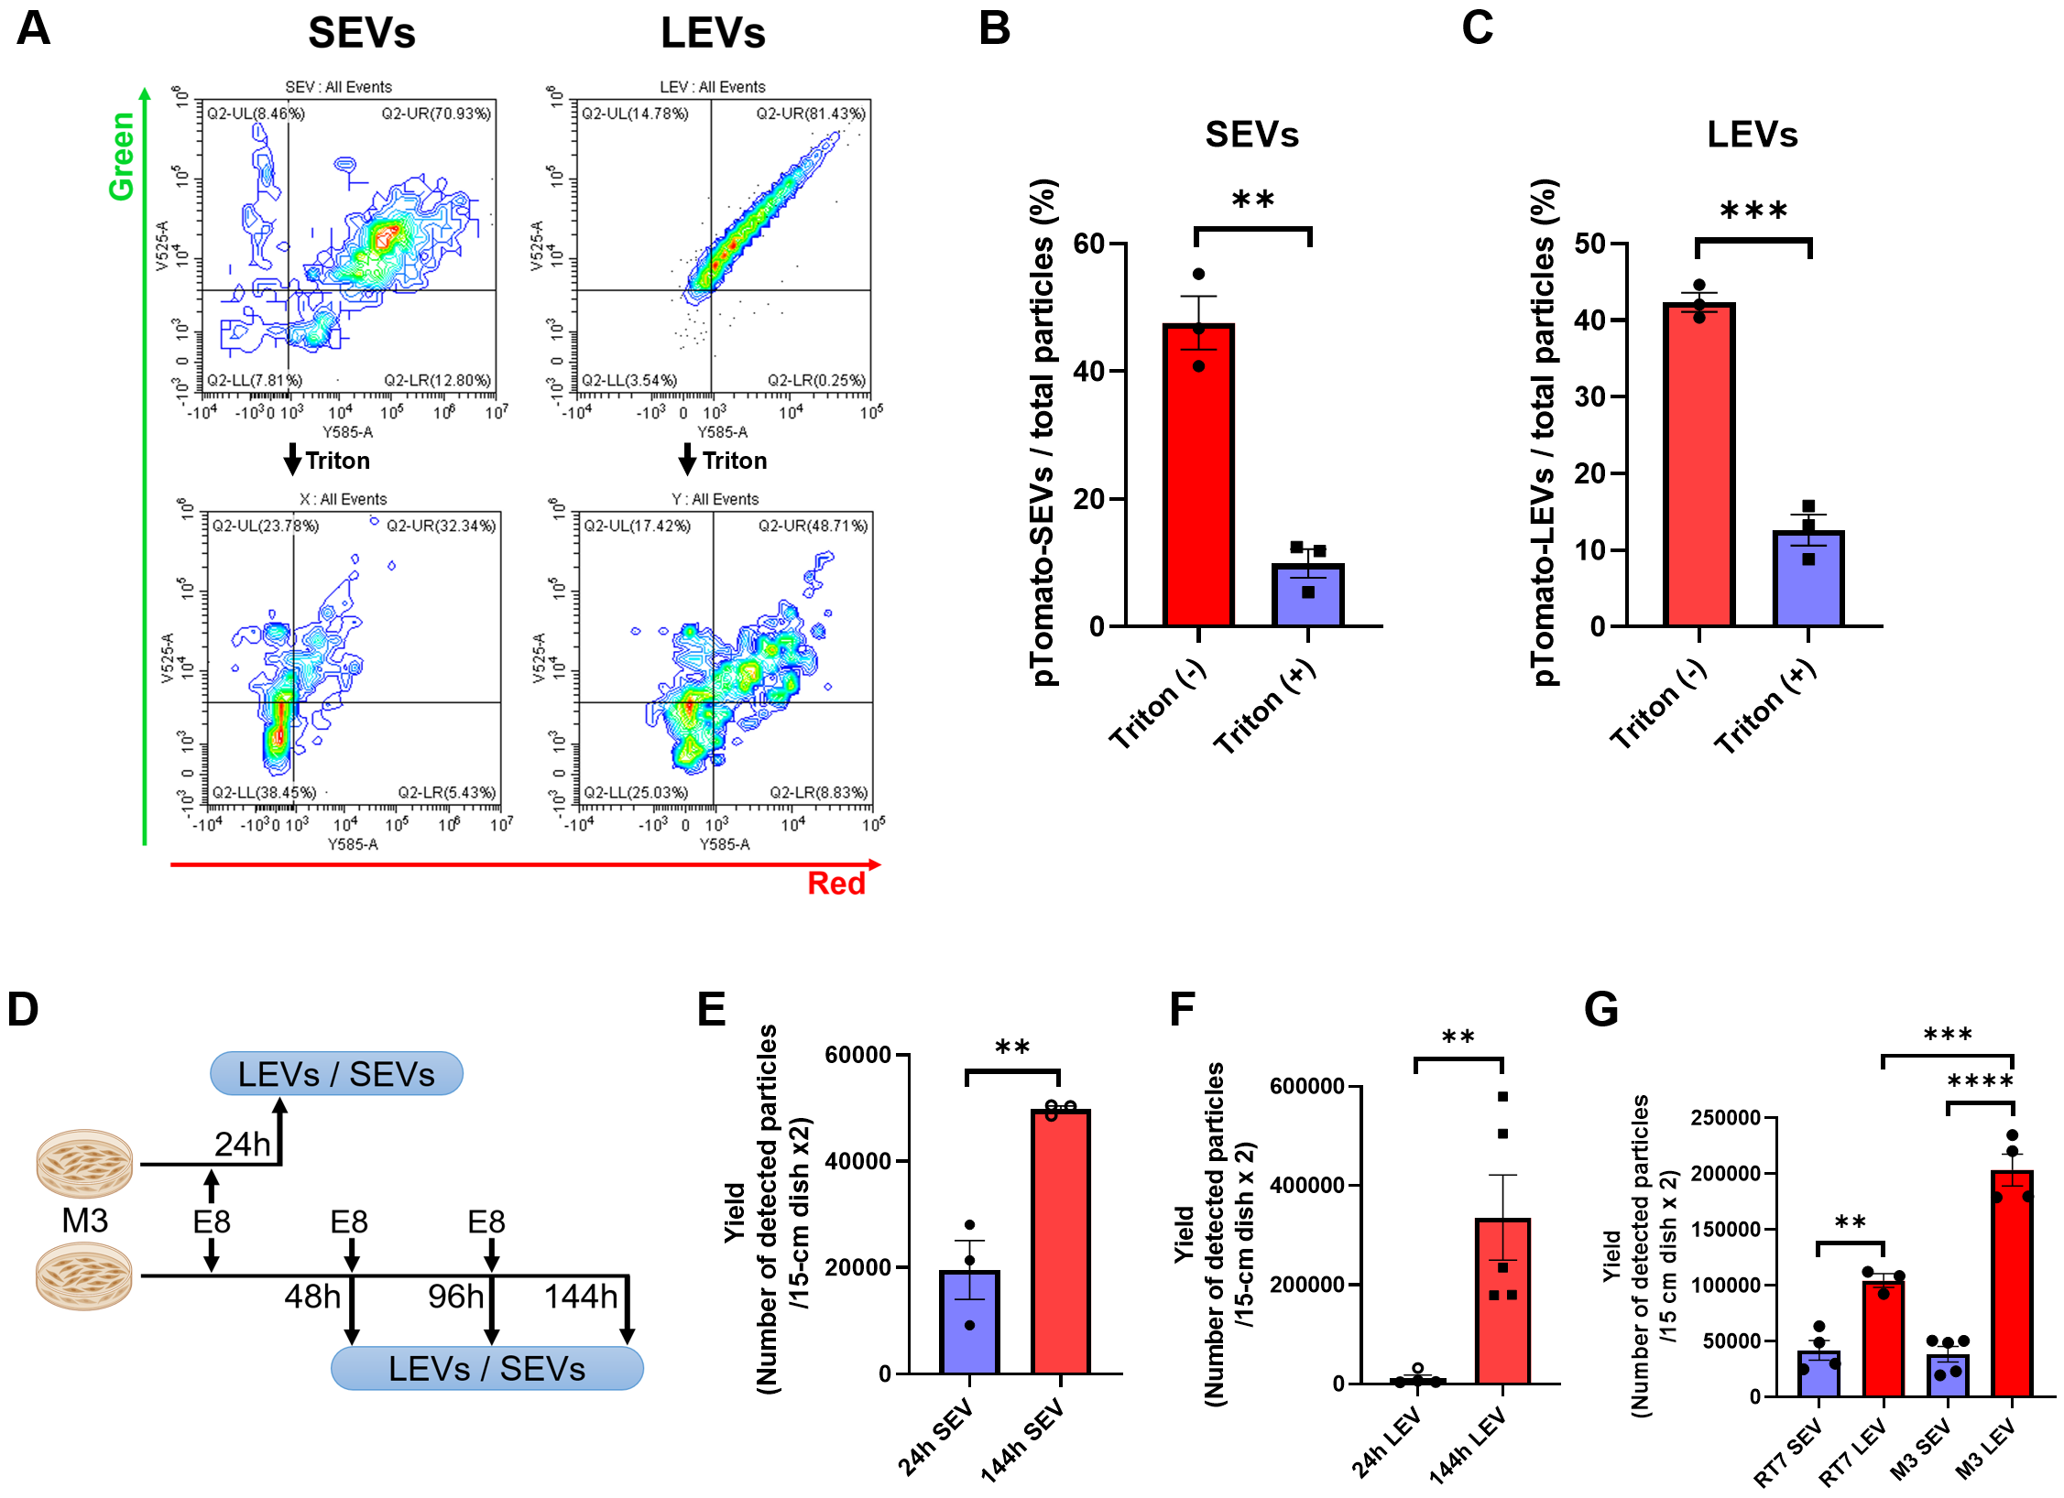

Figure S4. Flow cytometry (FCM) of large and small EVs. (A) FCM of M3pToma-derived SEVs and LEVs with or without Triton-X100 treatment. (B, C) Red-fluorescent SEVs (B) and LEVs (C) were reduced by Triton X-100 treatment. n = 3. (D) Graphical protocol of EV isolation. (E, F) Yields of SEVs (E) and LEVs (F) from 24-hour or 144-hour culture. n = 3–5. Statistical significances were analyzed using a two-tailed unpaired t-test (B–F). (G) Yield of SEVs and LEVs from RT7 and M3 cells. n = 3–5. Statistical significances were analyzed using a one-way ANOVA with Tukey’s multiple comparison test. *p < 0.005, **p < 0.01, ***p < 0.001, and ****p < 0.0001.

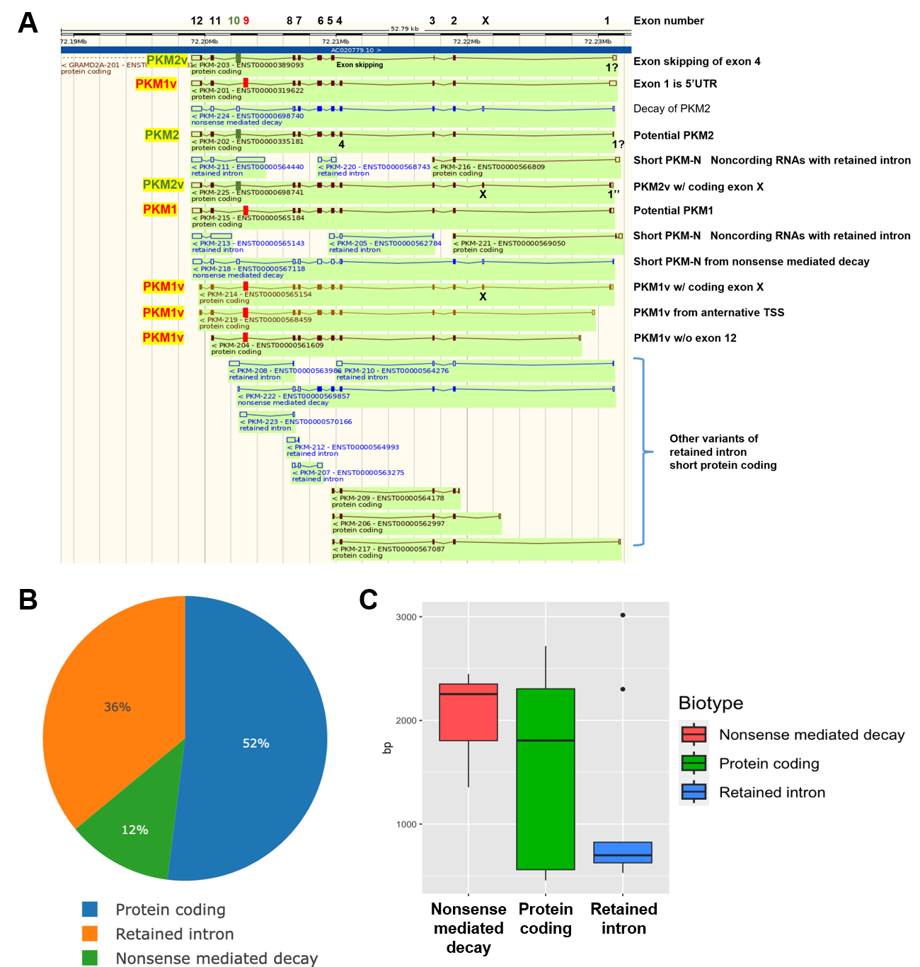

Figure S5. Alternative splicing variant analysis of PKM transcripts. (A) Genome browser visualization of PKM transcript variants, highlighting protein-coding variants, intron-retained transcripts, and nonsense-mediated decay (NMD). (B) Proportional distribution of PKM transcript biotypes, illustrating the relative abundance of protein-coding, retained intron, and NMD variants. (C) Comparison of transcript lengths (in base pairs) among PKM biotypes, showing differences between NMD, protein-coding and intron-retained transcripts.
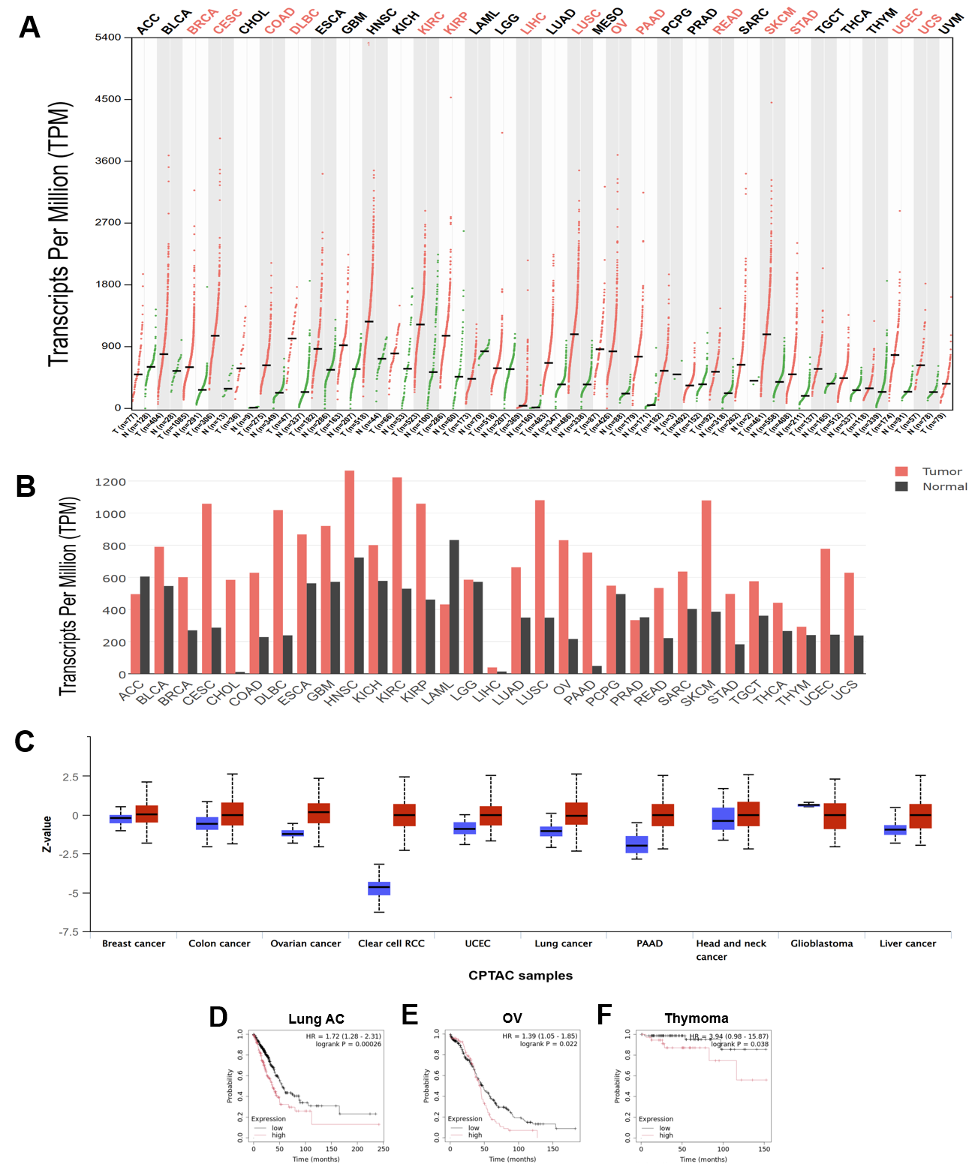
Figure S6. PKM mRNA and protein expression across various cancer types and paired normal tissues. (A) Dot plot of mRNA expression. (B) Bar graphs of mRNA expression. (C) Box-and-whisker plot of protein expression. Red boxes indicate tumor tissues. Blue boxes indicate paired normal tissues. (D–F) Kaplan-Meier survival analysis comparing patients with high (red) versus low (black) PKM expression groups. Statistical significance was assessed using the log-rank test. (D) lung AC. HR = 1.72. p = 0.00026, n = 335 (low), n = 169 (high). (E) OV. HR = 1.39. p = 0.022, n = 275 (low), n = 98 (high). (F) Thymoma. HR = 3.94. p = 0.038, n = 80 (low), n = 38 (high).
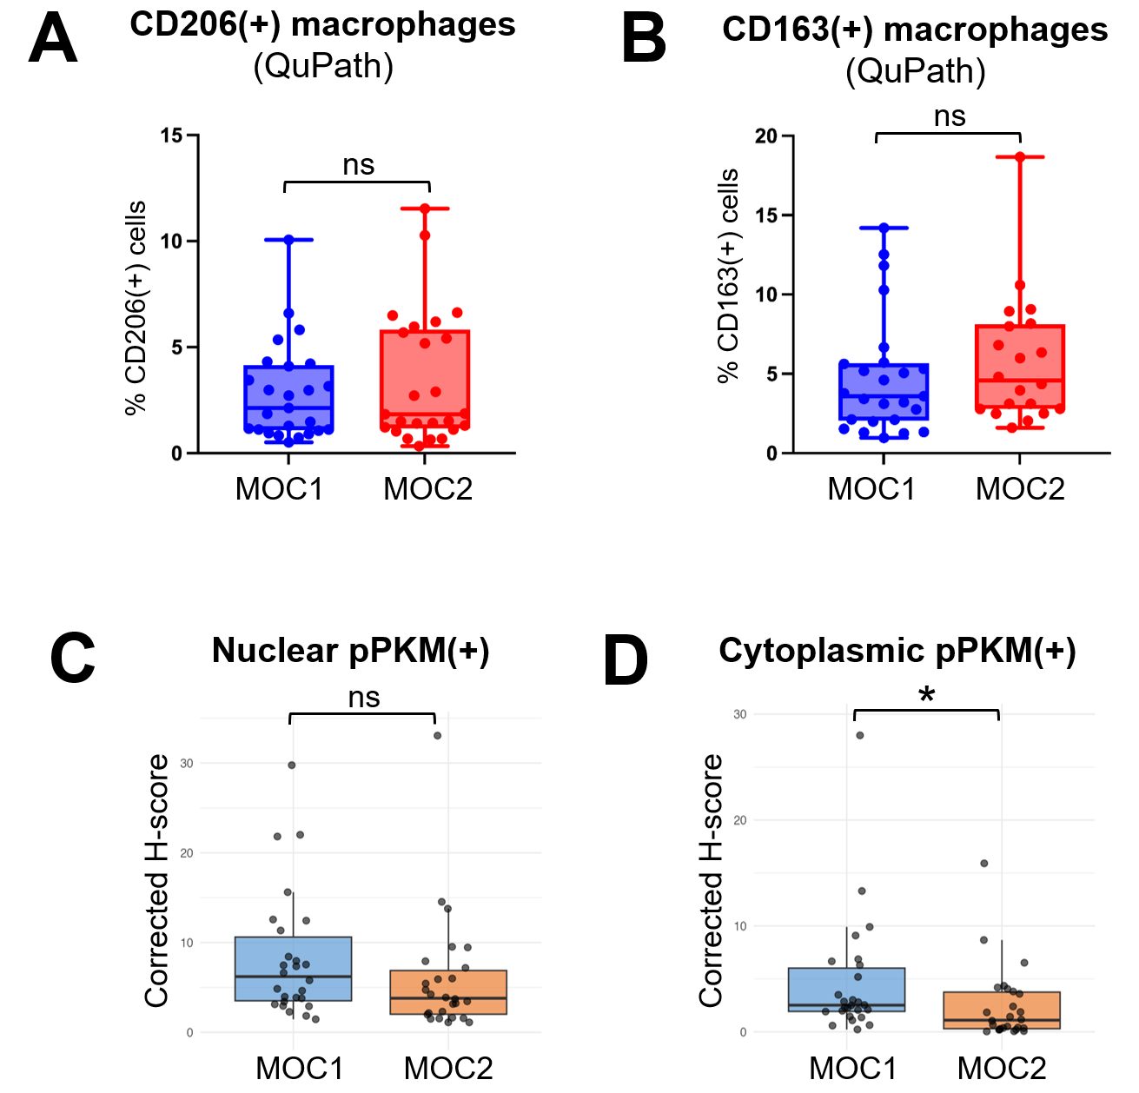

Figure S7. QuPath-based adjusted quantification of IHC in the MOC1/2 models. (A,B) The rates of CD206-positive (A) and CD163-positive cells. (C,D) Corrected H-scores of nuclear (C) and cytoplasmic (D) pPKM2-positive cells. Statistical significance was assessed using the Mann-Whitney U (Wilcoxon rank-sum) test, unpaired, two-tailed. n = 26. ns, not significant. *p < 0.05.

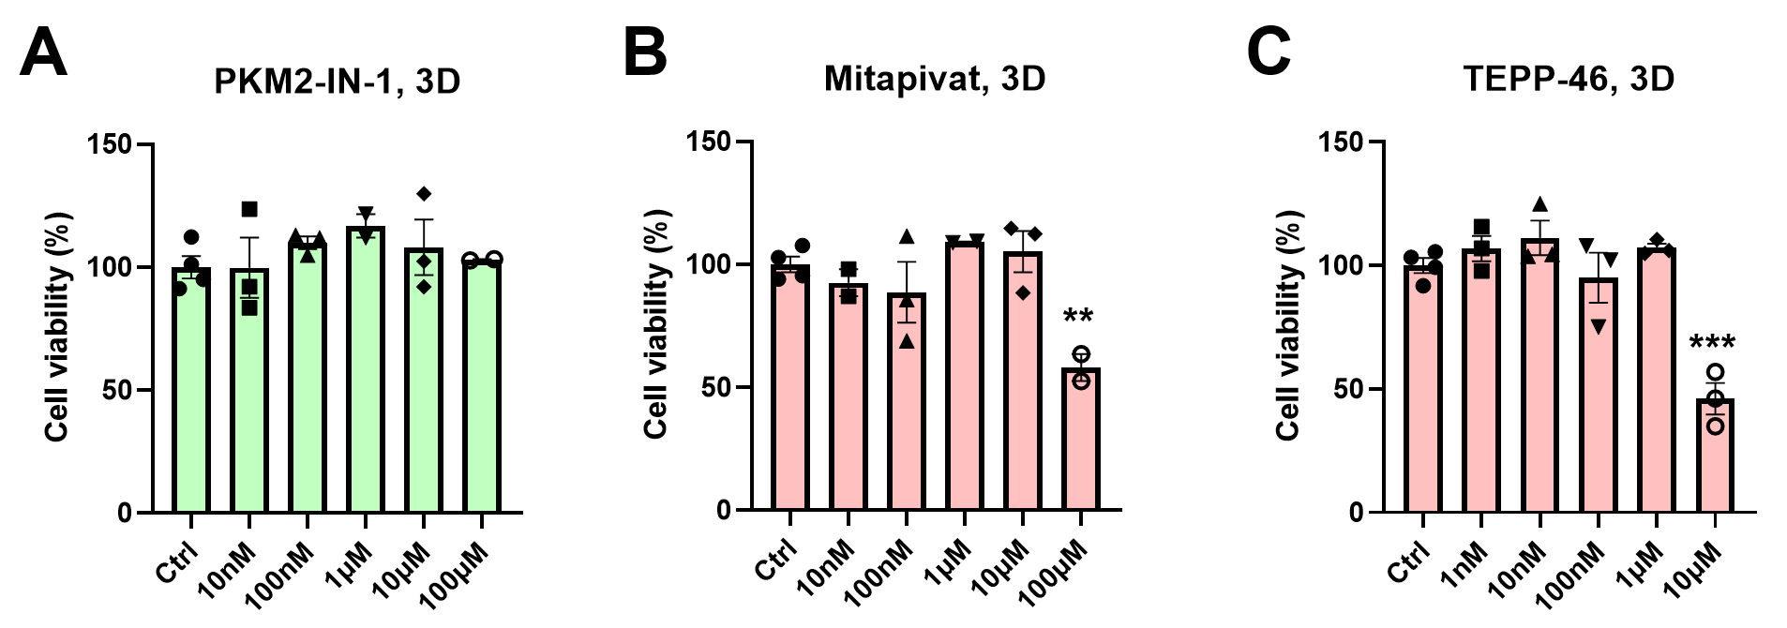

Figure S8. Effects of PKM2-IN-1 (A), mitapivat (B), and TEPP-46 (C) on the viability of 3D-cultured M3 tumoroids. Data are represented as mean ± s.e.m. Statistical significance was determined using Student’s two-tailed unpaired t-test; **p < 0.01, ***p < 0.001 (n = 3–4 independent cultures).

