Supporting information
Table S1 BET surface and pore structures of the obtained samples.
Samples | BET surface area (m²/g) | Pore volume (cm³/g) | Pore size (nm)
initial CB | 185.97 | 0.073 | 21.04
500°C-SCB | 249.01 | 0.165 | 15.61
2Au/500°C-SCB | 237.49 | 0.102 | 15.22

Table S2 Comparison of XPS components relative rations for initial CB, 500°C-SCB, and 2Au/500°C-SCB
Samples | sp² carbon  (graphitic C=C) | sp³ carbon  (hydrocarbon C-C) | C-O | π-π transition
BE (eV) | 284.6 | 285.8 | 286.9 | 289.5
initial CB | 66.1% | 9.83% | 6.43% | 17.64%
500°C-SCB | 55.59% | 28.35% | 7.91% | 8.15%
2Au/500°C-SCB | 52.62% | 22.44% | 16.81% | 8.13%
Fig. S1. Time-dependent UV-Vis absorption spectra of 4-NP adsorption by (a) 500°C-SCB and (b) 2Au/500°C-SCB. (c) UV-Vis absorption spectra of 4-NP and 4-NP + NaBH₄.
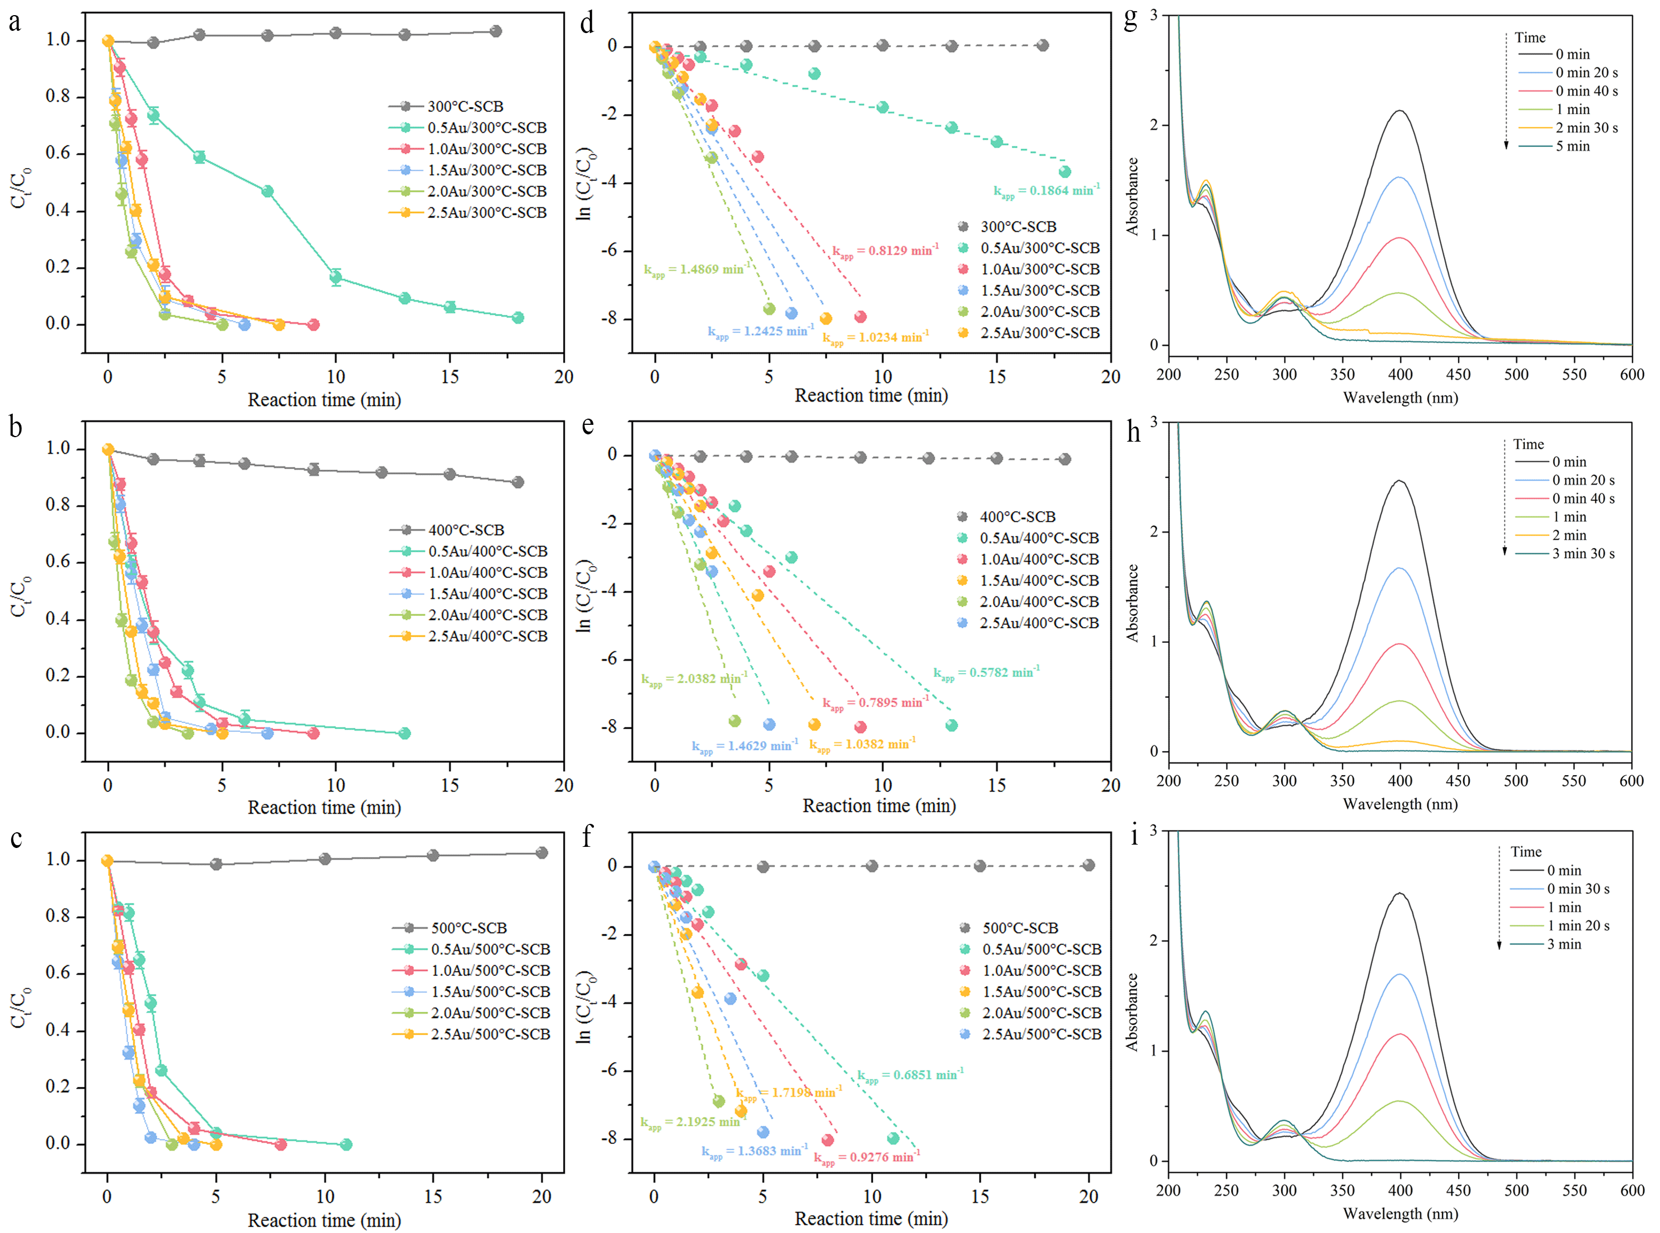
Fig. S2 (a-c) Plots of C_{t}/C₀, (d-f) -ln (C_{t}/C₀) vs. reaction time of 4-NP reduction and (g-i) Time-dependent UV-Vis absorption spectra of 4-NP reduction over xAu/T-SCB catalysts (x = 0.5, 1, 1.5, 2 and 2.5; T = 300°C, 400°C and 500°C). Reaction conditions: C(4-NP) = 0.2 mM, C(NaBH₄) = 40 mM, m(catalysts) = 10 mg, initial pH = 5.62, and room temperature.

Fig. S3. Zeta potential of 2Au/500°C-SCB at pH of 2-9.
Fig. S4. The Arrhenius plots of 2Au/500°C-SCB.
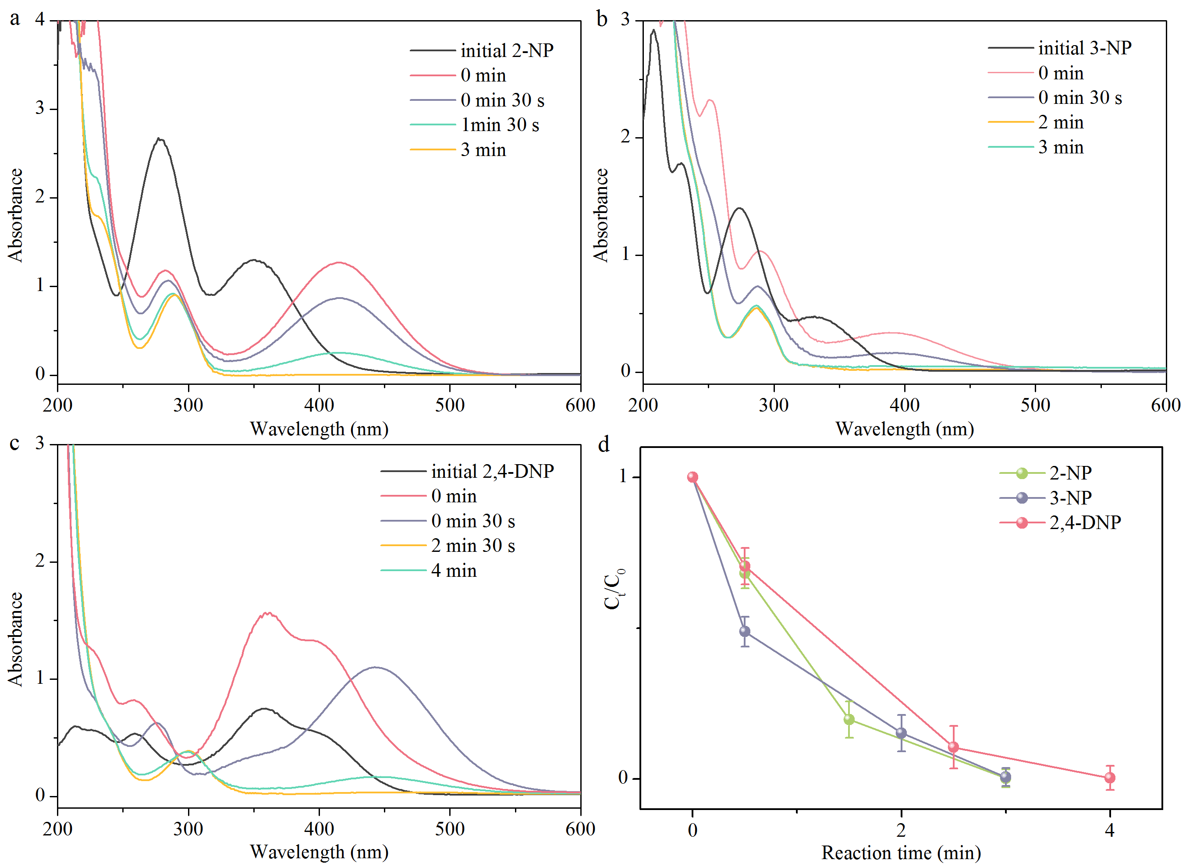
Fig. S5 Time-dependent UV-Vis absorption spectra of (a) 2-NP, (b) 3-NP and (c) 2,4-DNP reduction catalyzed by 2Au/500°C-SCB. (D) Plots of C_{t}/C₀ vs. time. Reaction conditions: C(2-NP, 3-NP and 2,4-DNP) = 0.2 mM, C(NaBH₄) = 40 mM, m(2Au/500°C-SCB) = 10 mg, room temperature.
Fig. S6. Time-dependent UV-Vis absorption spectra of (a) MO, (b) CR and (c) EBT reduction catalyzed by 2Au/500°C-SCB. (D) Plots of C_{t}/C₀ vs. time.
Fig. S7. (a) Recycling test for the catalytic reduction of 4-NP over 2Au/500°C-SCB catalysts. (b) Time-dependent UV-Vis absorption spectra of 4-NP reduction over 4-AP pretreated 2Au/500°C-SCB catalysts.

