Supplementary Materials for
Phase-locked Constructing Dynamic Supramolecular Ionic Conductive Elastomers with Superior Toughness, Autonomous Self-healing and Recyclability

Jing Chen¹, Yiyang Gao¹, Lei Shi², Wei Yu¹, Zongjie Sun¹, Shuang Liu³, Heng Mao¹, Dongyang Zhang¹, Quan Chen³, Demei Yu¹, Shujiang Ding¹*

¹School of Chemistry, Xi'an Jiaotong University, Xi'an Key Laboratory of Sustainable Energy Materials Chemistry, State Key Laboratory for Mechanical Behavior of Materials, Xi'an 710049, P. R. China
²School of Materials, Sun Yat-sen University, Shenzhen 518107, P. R. China
³StateKey Laboratory of Polymer Physics and Chemistry, Changchun Institute of Applied Chemistry, Chinese Academy of Sciences, Changchun 130022, P. R. China

* Corresponding author. Email: dingsj@xjtu.edu.cn

This PDF file includes:

Figs. S1 to S20
Tables S1 to S2
Movies S1 to S3

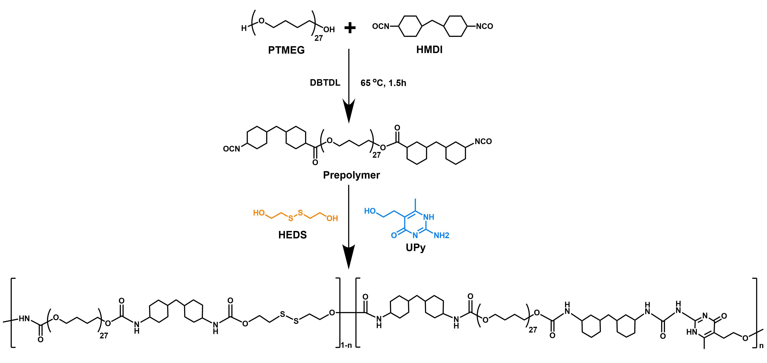

Fig. S1. Synthetic route of dynamic supramolecular elastomers (DSE) via condensation polymerization.

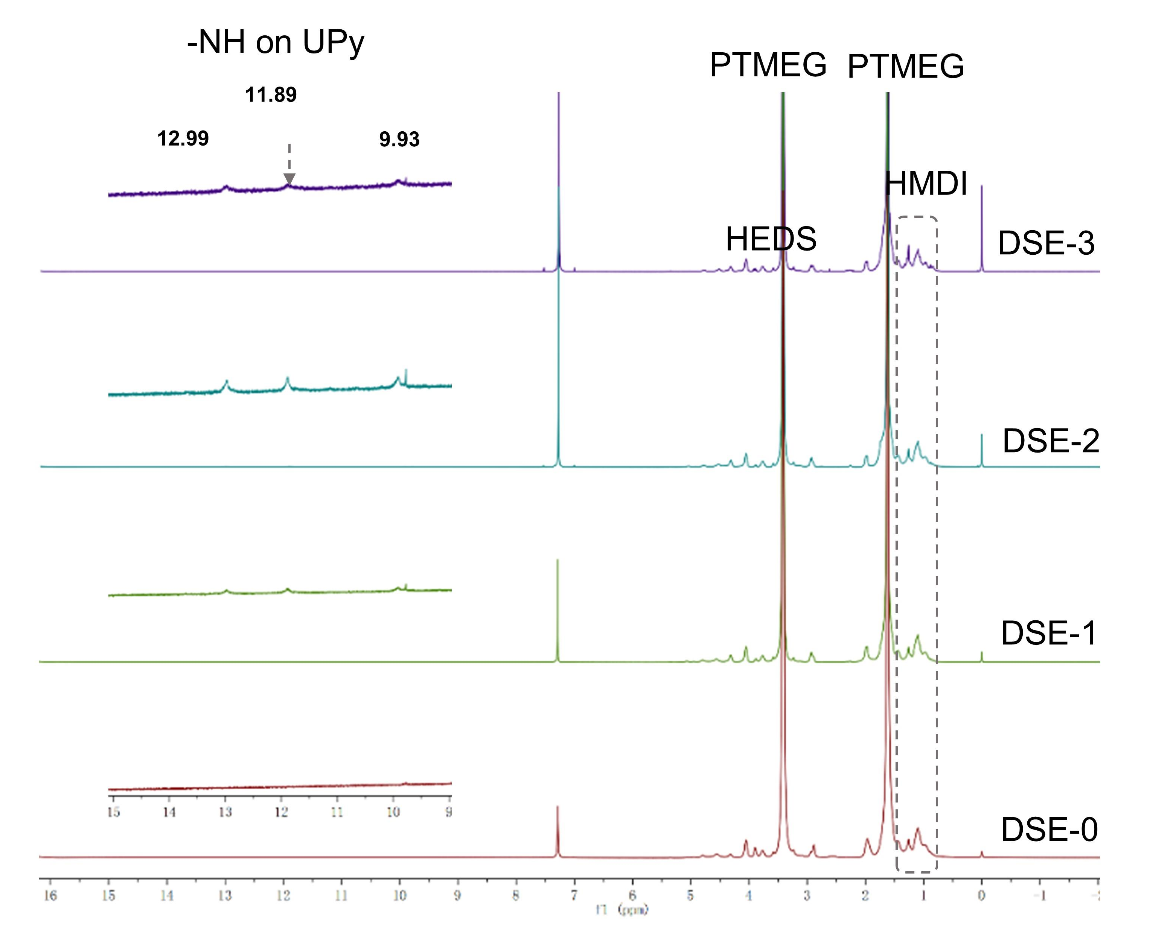

Fig. S2. ¹H NMR spectra of DSE-0~3 in CDCl₃ (400 MHz). In the ¹H NMR spectra, the peaks of PTMEG protons appeared at 3.4 and 1.6 ppm, the peaks of HMDI unit appeared at 1.1~0.9 ppm, the peaks of HEDS unit appeared at 3.7 and 2.7 ppm, the three characteristic peaks of 12.99, 11.89 and 9.93 ppm in the downfield was observed in the DSE-1, DSE-2 and DSE-3, which demonstrated the existence of the UPy motifs.

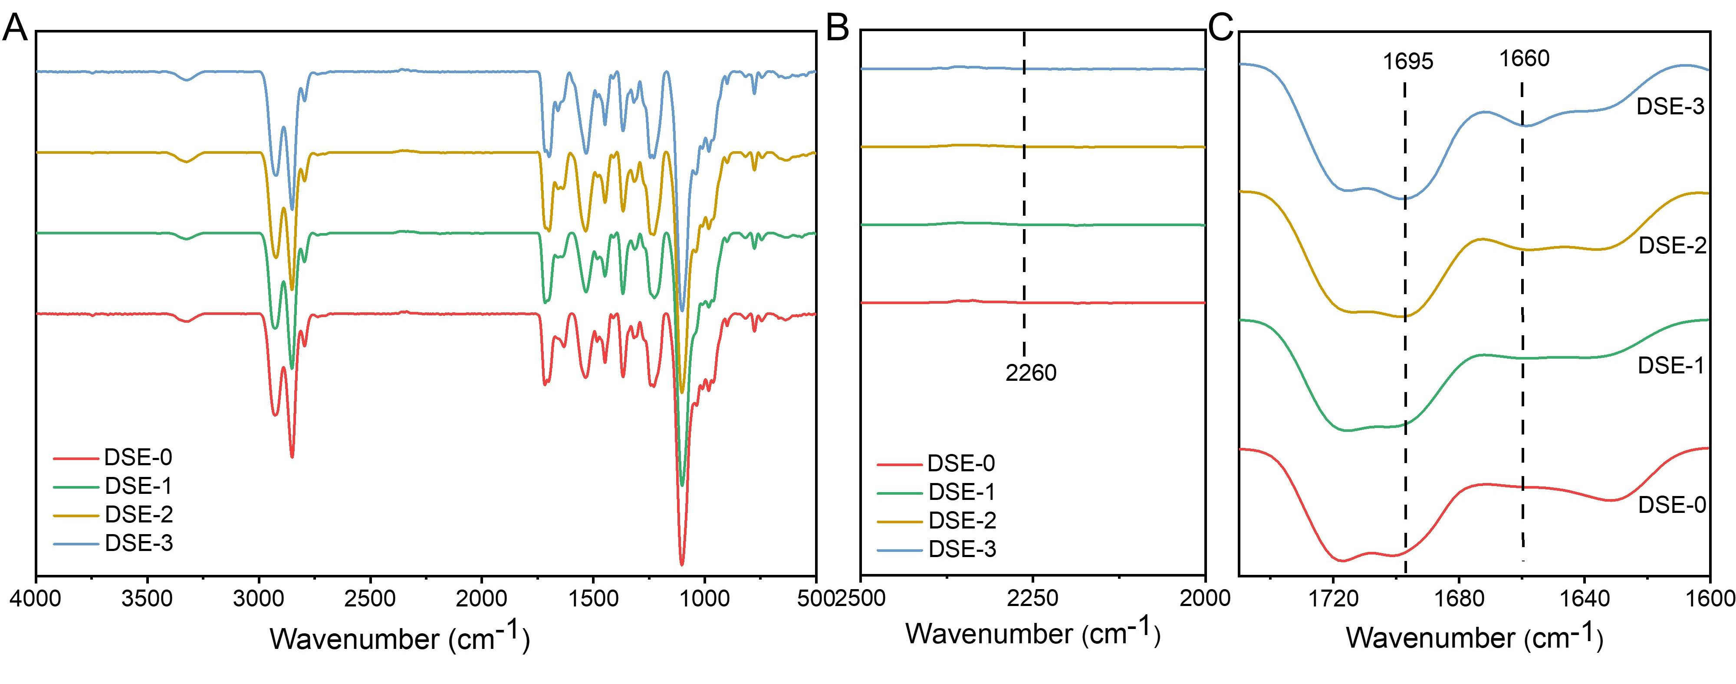

Fig. S3. ATR-FTIR characterization of all DSE samples. (A) FTIR spectra from DSE-0~3 in the range of 500-4000 cm⁻¹. The existence of N-H stretching vibration around 3315 cm⁻¹ indicated the formation of self-complementary N-H hydrogen bonds. (B) The disappearance of the peaks at 2260 cm⁻¹ (N=C=O stretching band) suggested the diisocyanate monomers conduct complete reaction. (C) The peak associated with H-bonded C=O in urea (~1660 cm⁻¹) increases from DSE-0 to DSE-3. Similarly, the peak associated with H-bonded C=O in urethane (~1695 cm⁻¹) increases as the amount of UPy in the DSE polymer increases. The increases in these peaks shows the clear increase in the amount of hydrogen bonding present in the polymers as the amount of UPy increases.

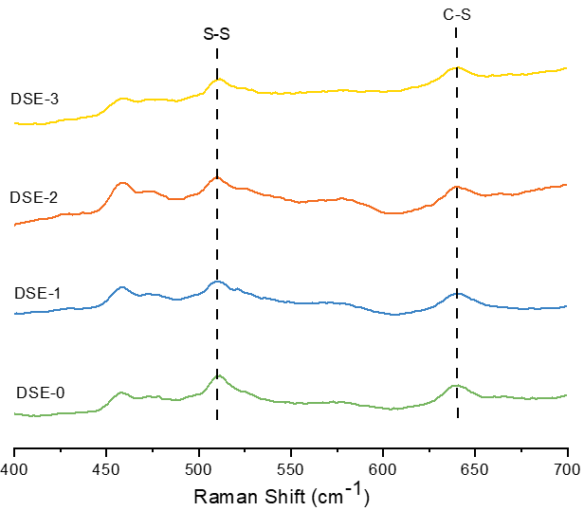

Fig. S4. Raman spectra investigation of all DSE samples. The peak appears at 510 cm⁻¹ is responsible for ν(S-S), the peak appears at 640 cm⁻¹ is responsible for ν(C-S).

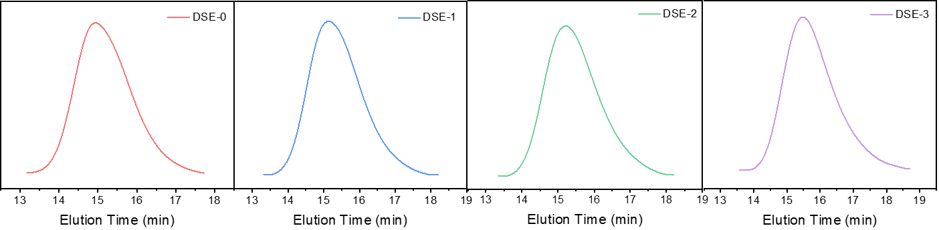

Fig. S5. GPC elution curves of DSE-0~3 with THF as the eluent and PS as the standard

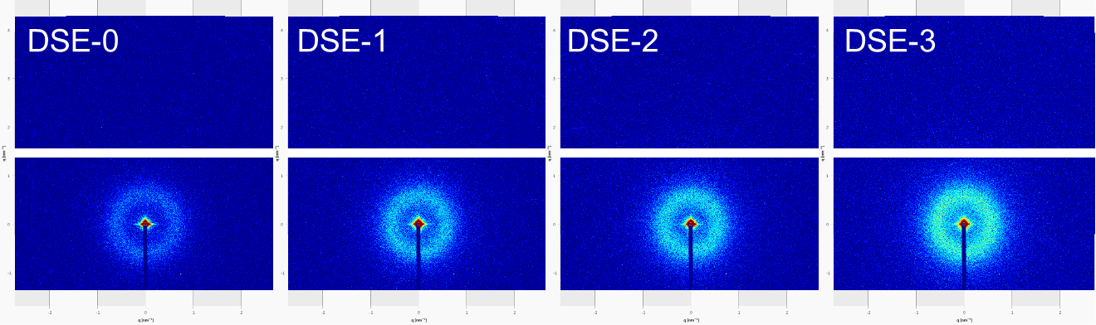

Fig. S6. 2D SAXS images of DSE samples.

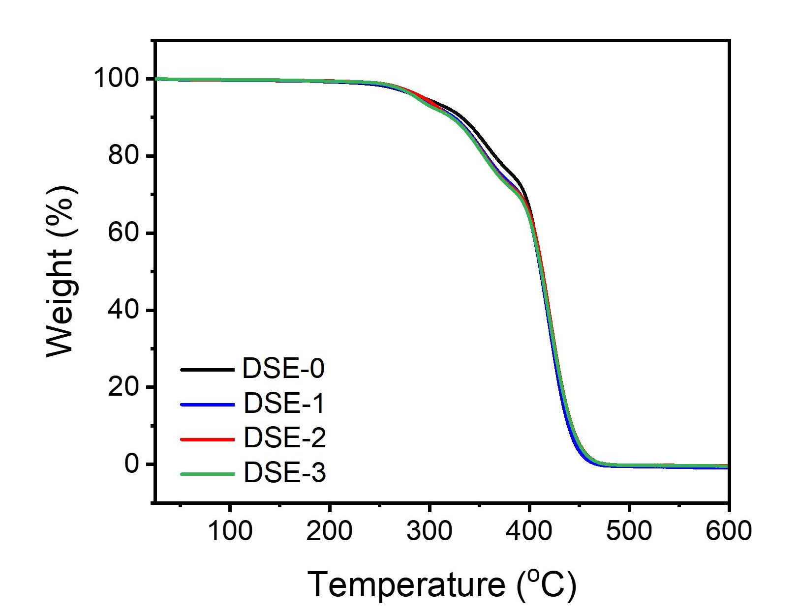

Fig. S7. TGA traces of DSE samples at 10 °C min⁻¹ under N₂ atmosphere.

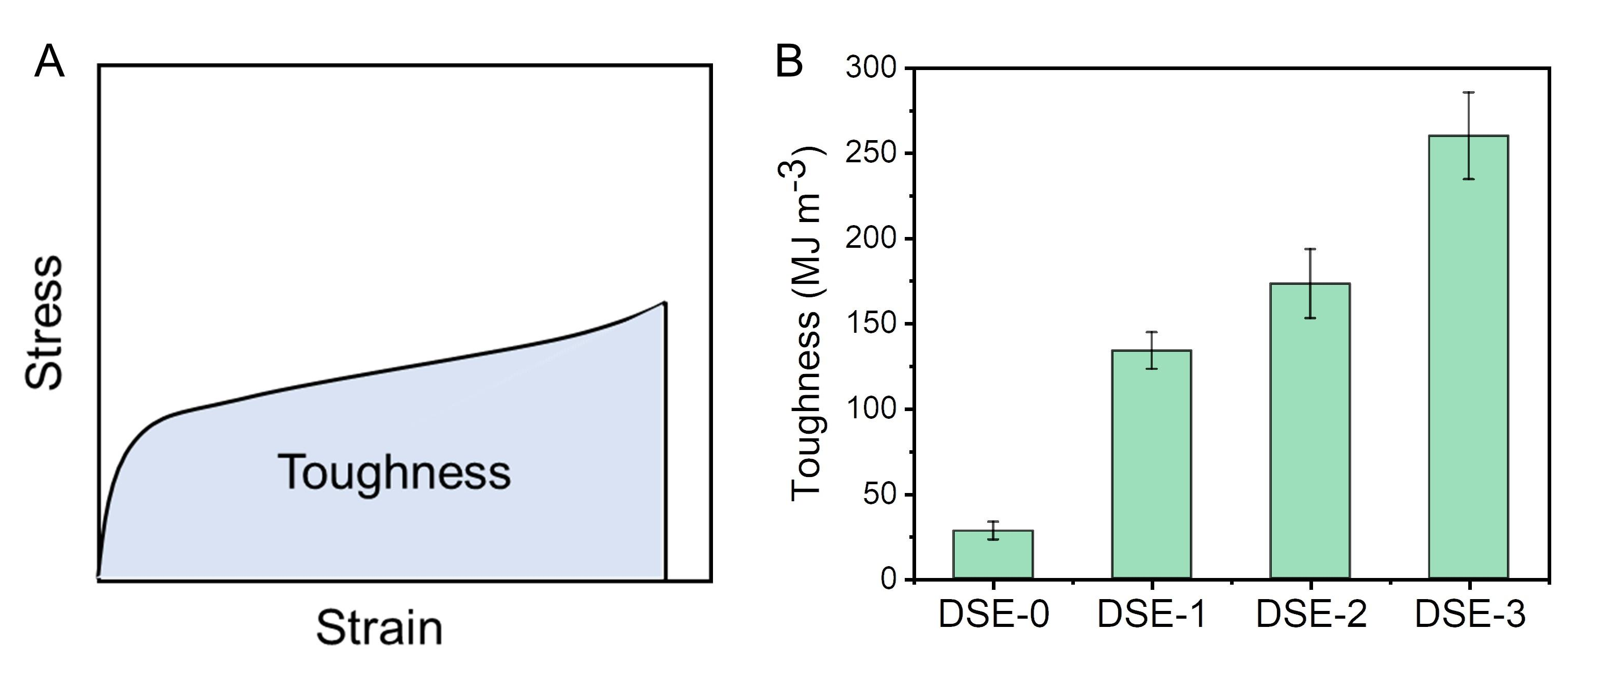

Fig. S8. (A) The calculated mechanism of toughness: integral area of stress-stain curve. (B) Toughness of DSE-0~3.

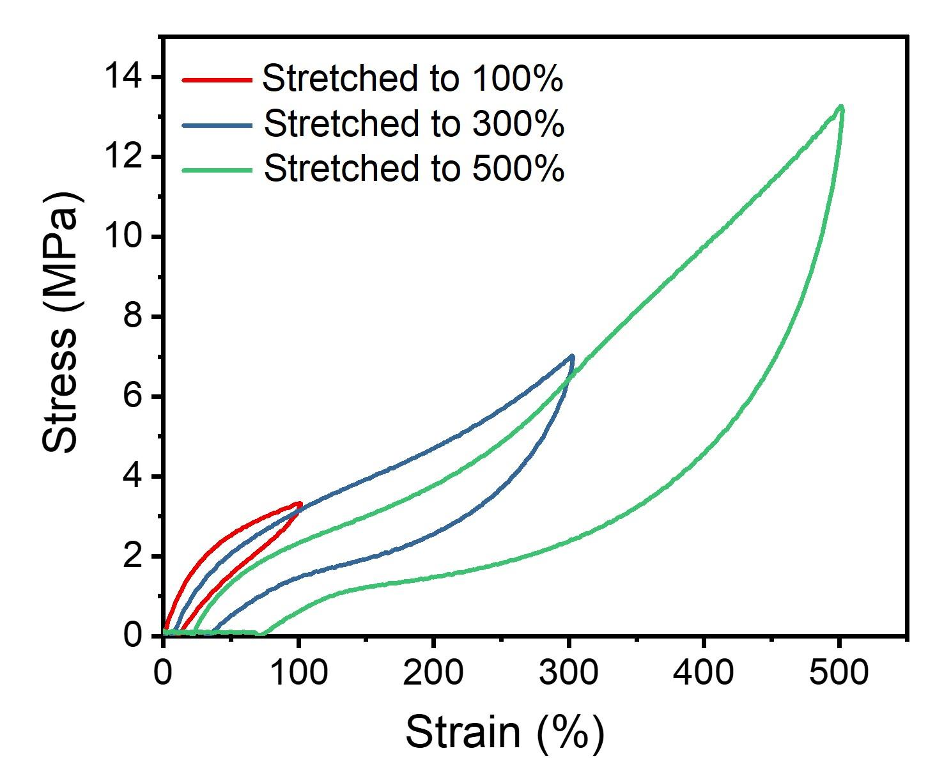

Fig. S9. Cyclic stress-strain curves of DSE-3 when stretched to 100%, 300%, 500%, respectively.

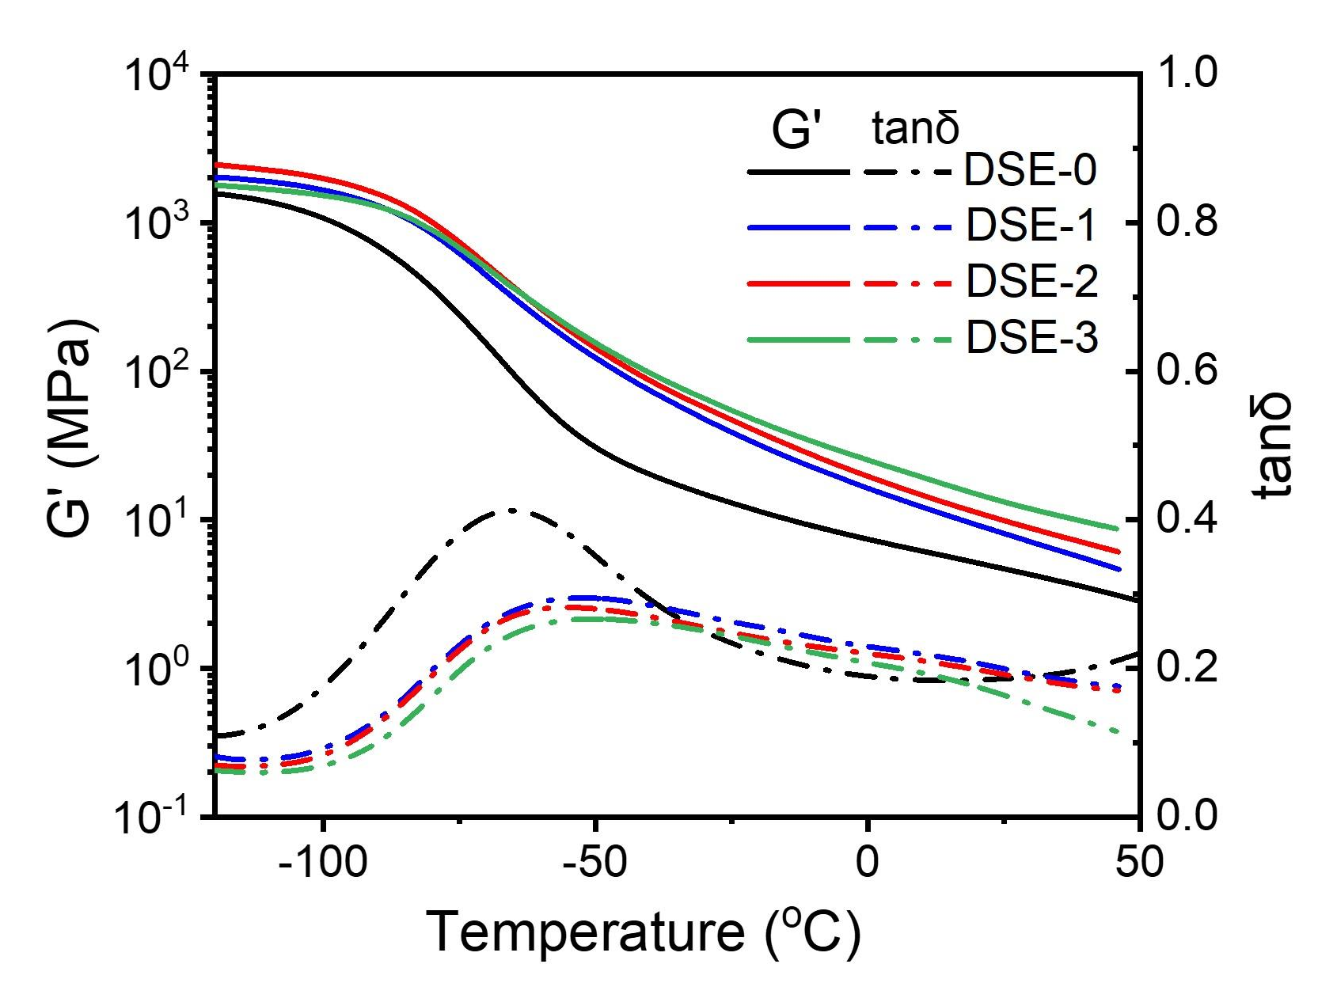

Fig. S10. DMA curves of DSE samples.

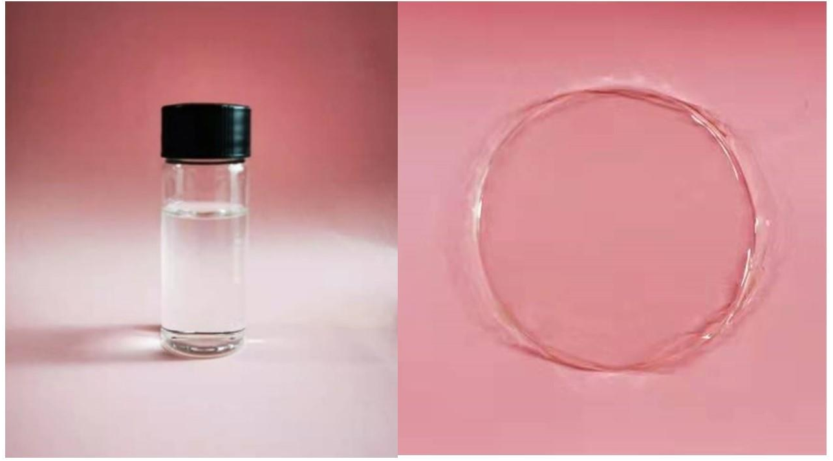

Fig. S11. Digital photos of the prepared DSICE samples: colorless transparent liquid and casting film.

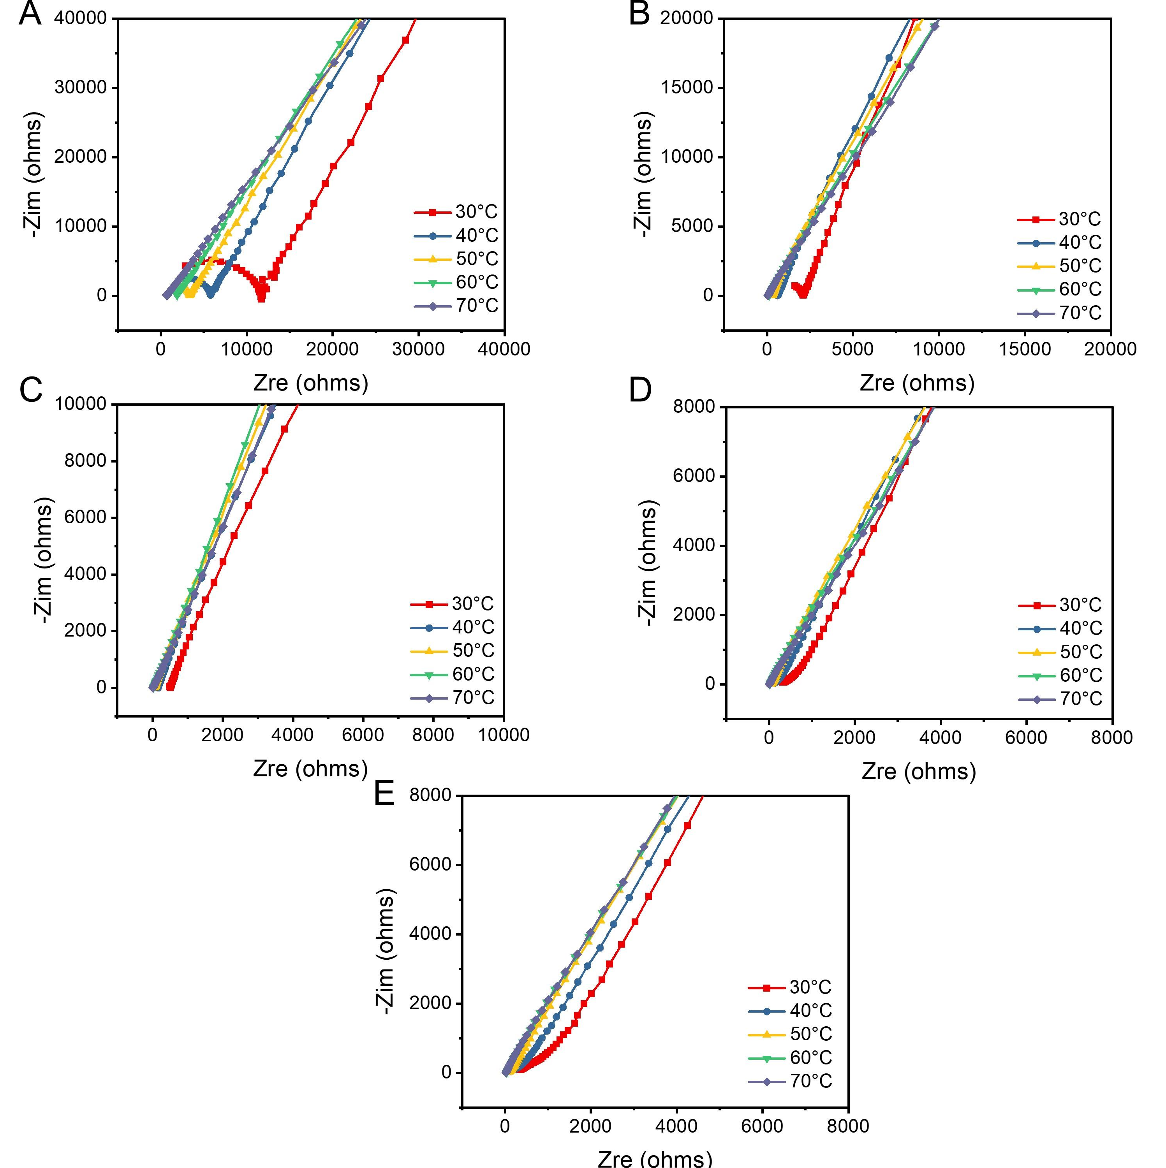

Fig. S12. EIS spectra of DSICE 10-35 samples at different temperatures from 30 °C to 70 °C. (A) EIS spectra of DSICE-10. (B) EIS spectra of DSICE-20. (C)EIS spectra of DSICE-30. (D) EIS spectra of DSICE-35. (E) EIS spectra of DSICE-40.

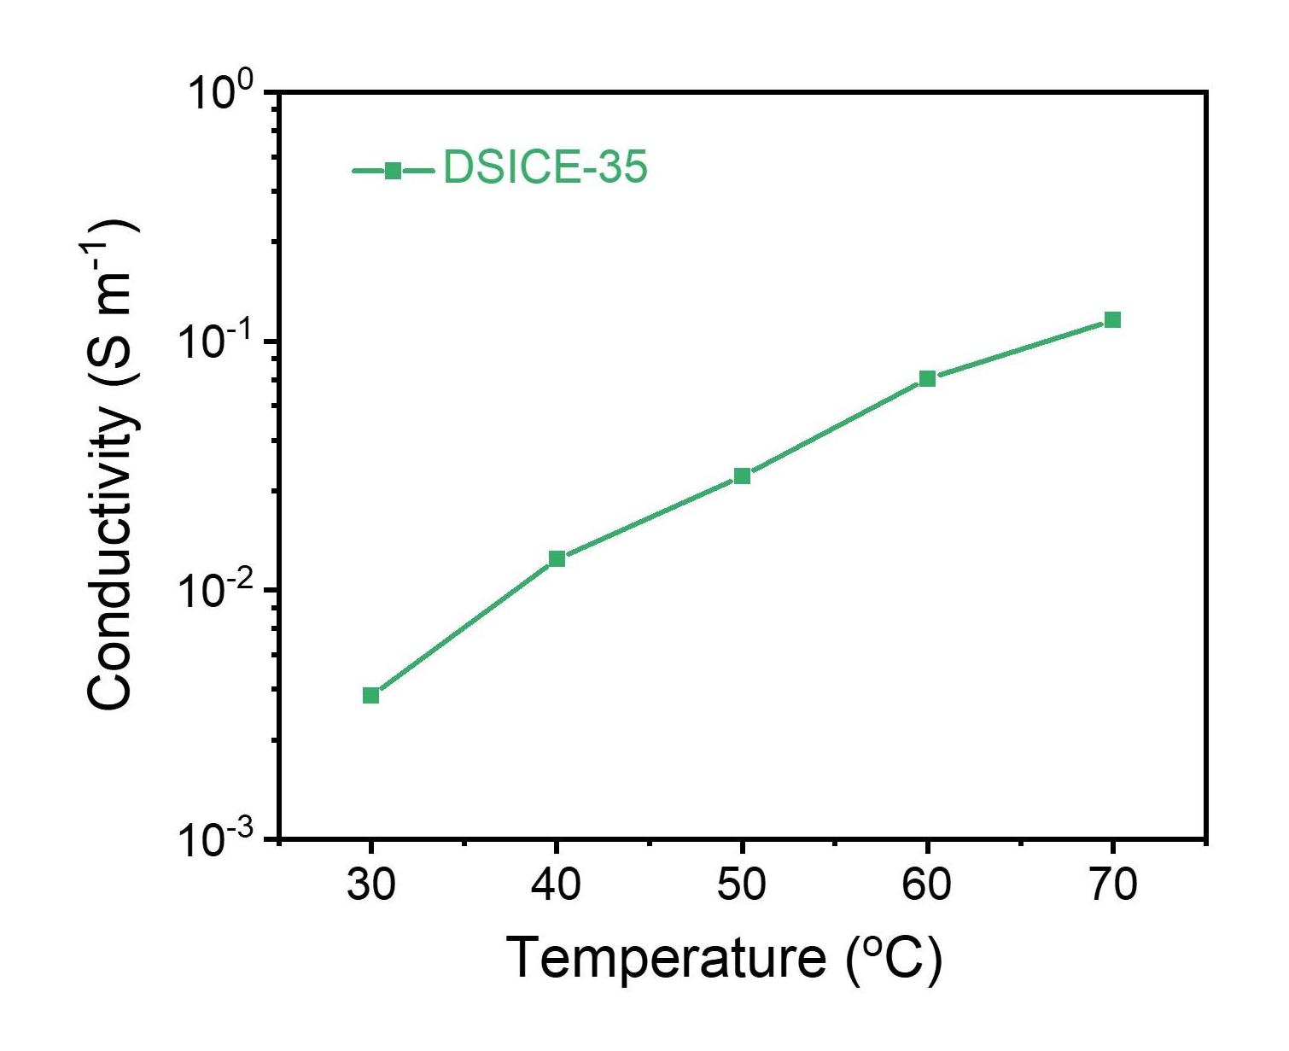

Fig. S13. Plot of DSICE-35 ionic conductivity versus the elevated temperatures (30 °C-70 °C).

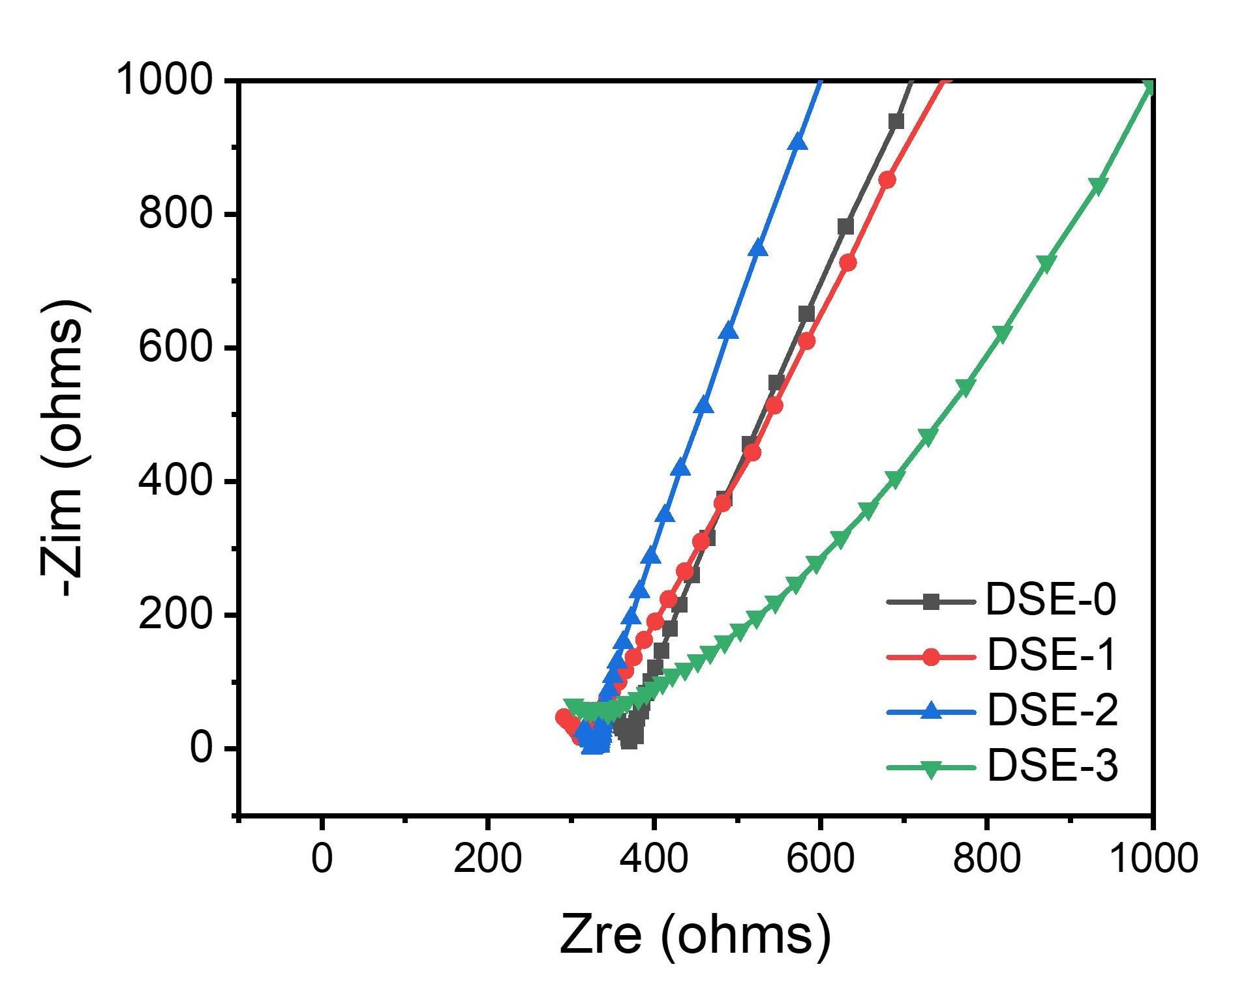

Fig. S14. EIS spectra of DSE-0~3 samples with the same 35 wt.% LiTFSI at 30 °C.

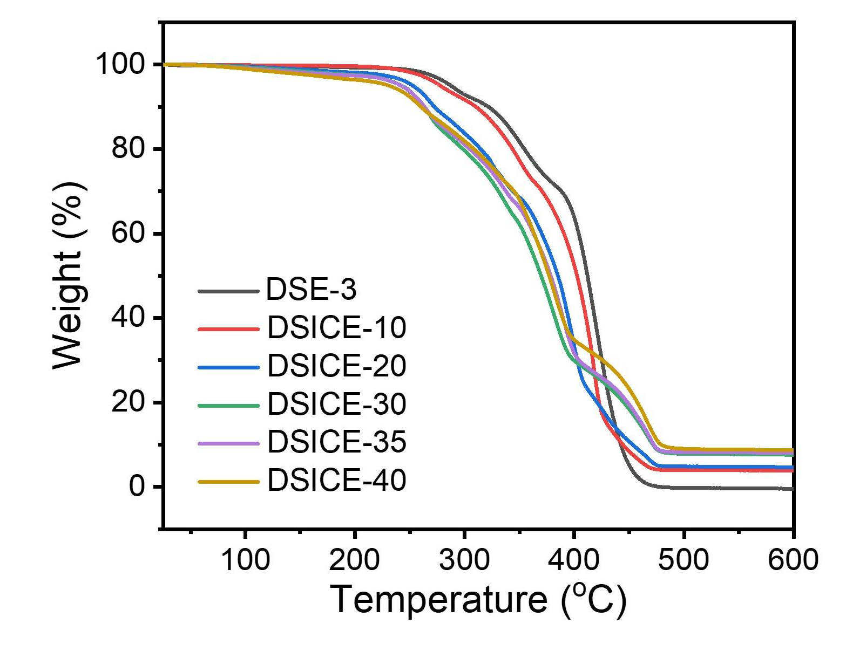

Fig. S15. TGA traces of DSICE samples at 10 °C min⁻¹ under N₂ atmosphere.

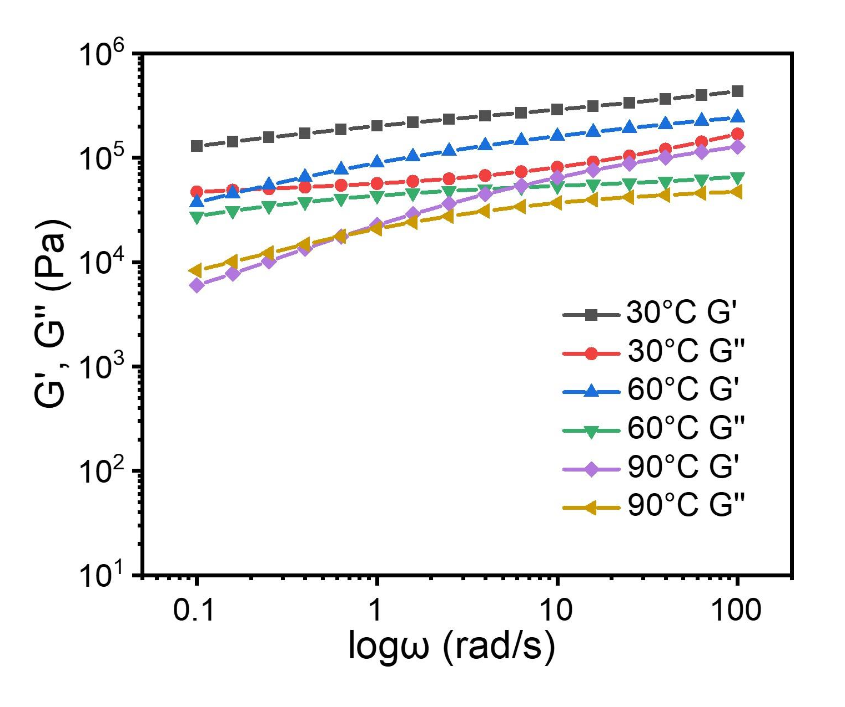

Fig. S16. Storage modulus G′ and loss modulus G″ as functions of angular frequency ω for the DSICE-30 at different sweeping temperatures.

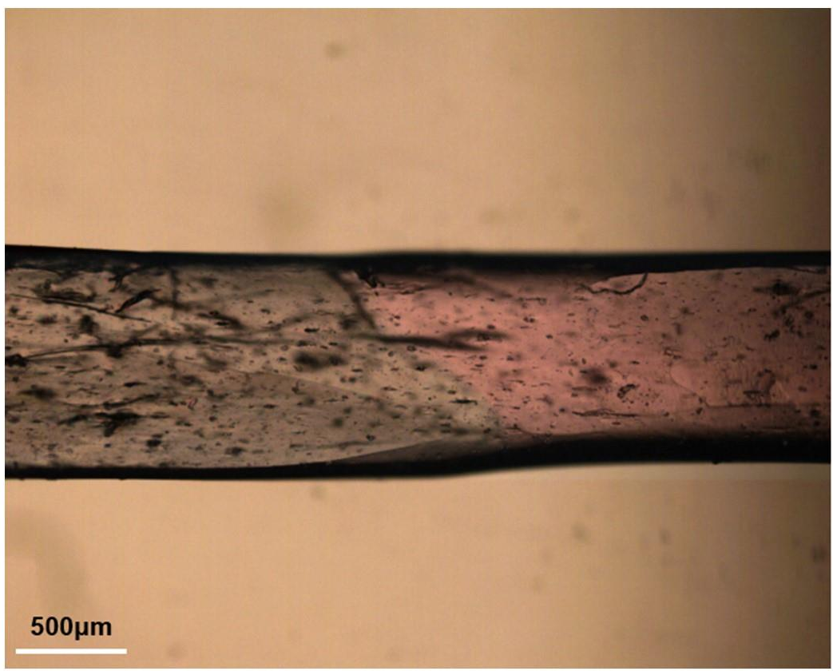

Fig. S17. Optical microscopy image of the completely self-healed cut-off DSICE-30 sample.

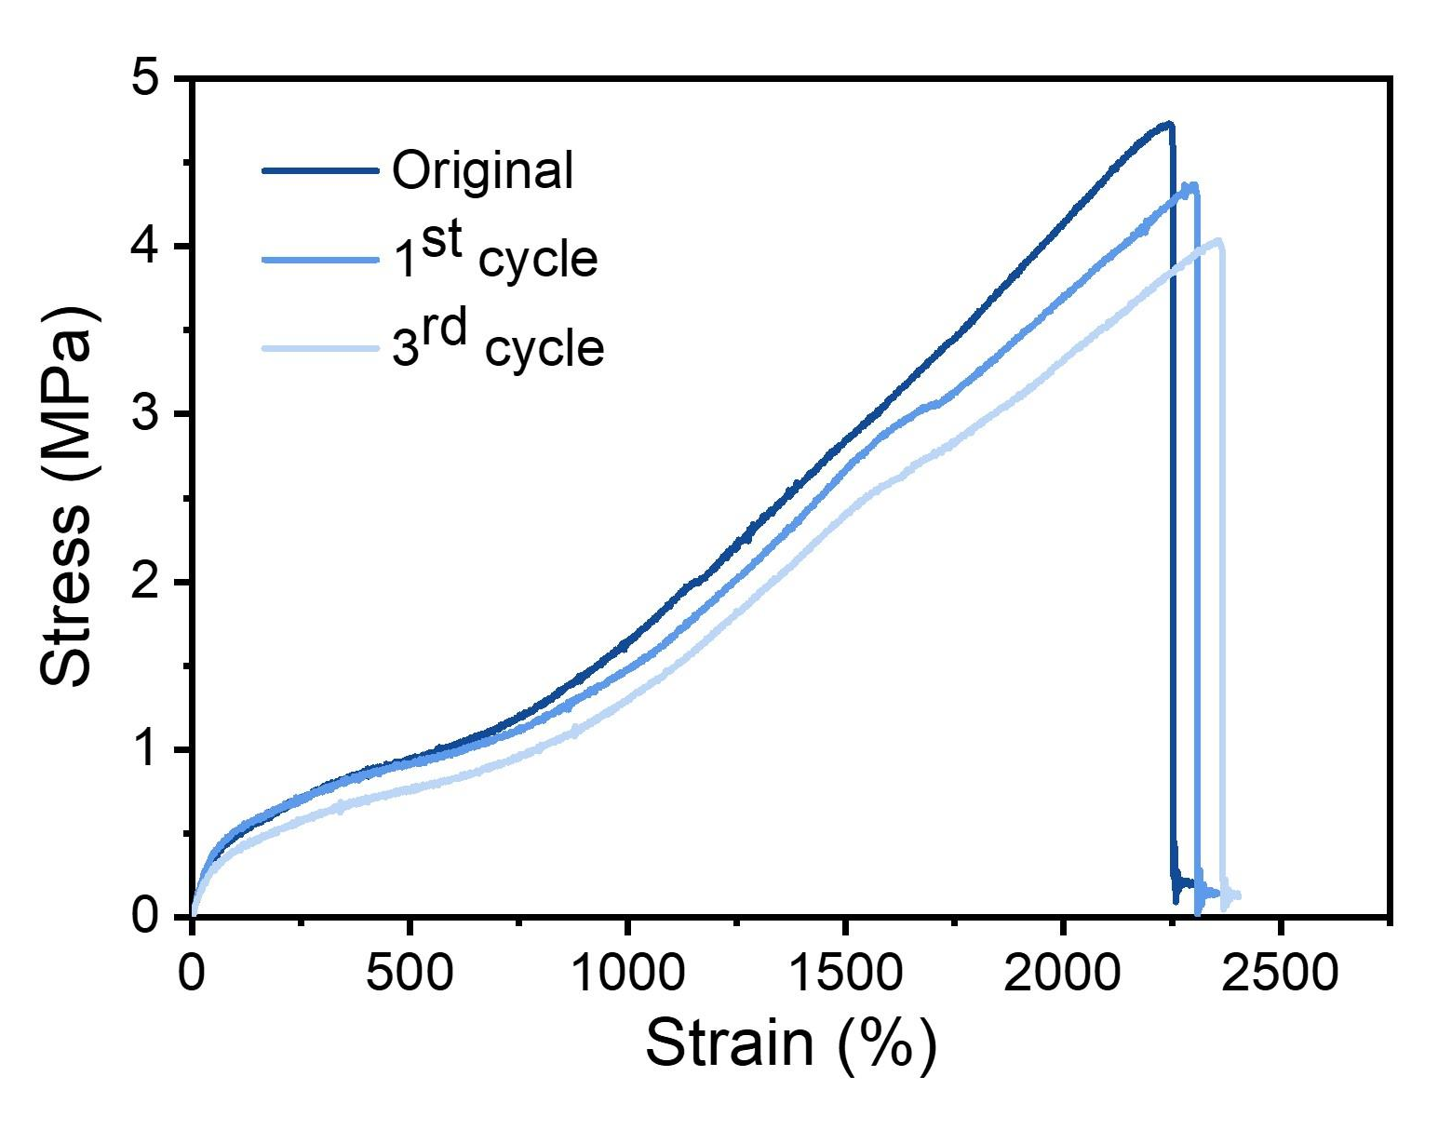

Fig. S18. Typical stress-stain curves of DSICE-35 after three recycling.

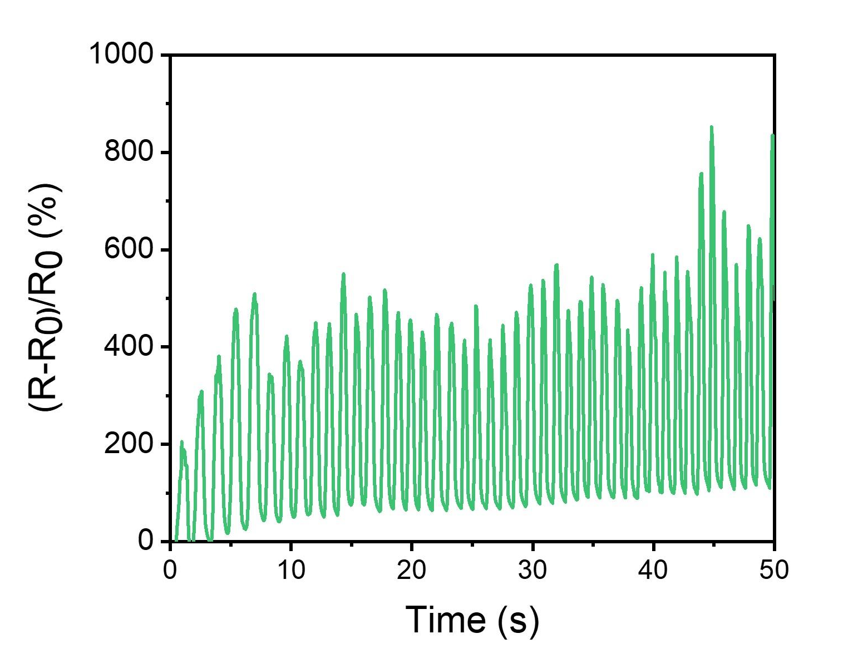

Fig. S19. The impedance change of DSICE-30 when stretched to different tensile elongation.

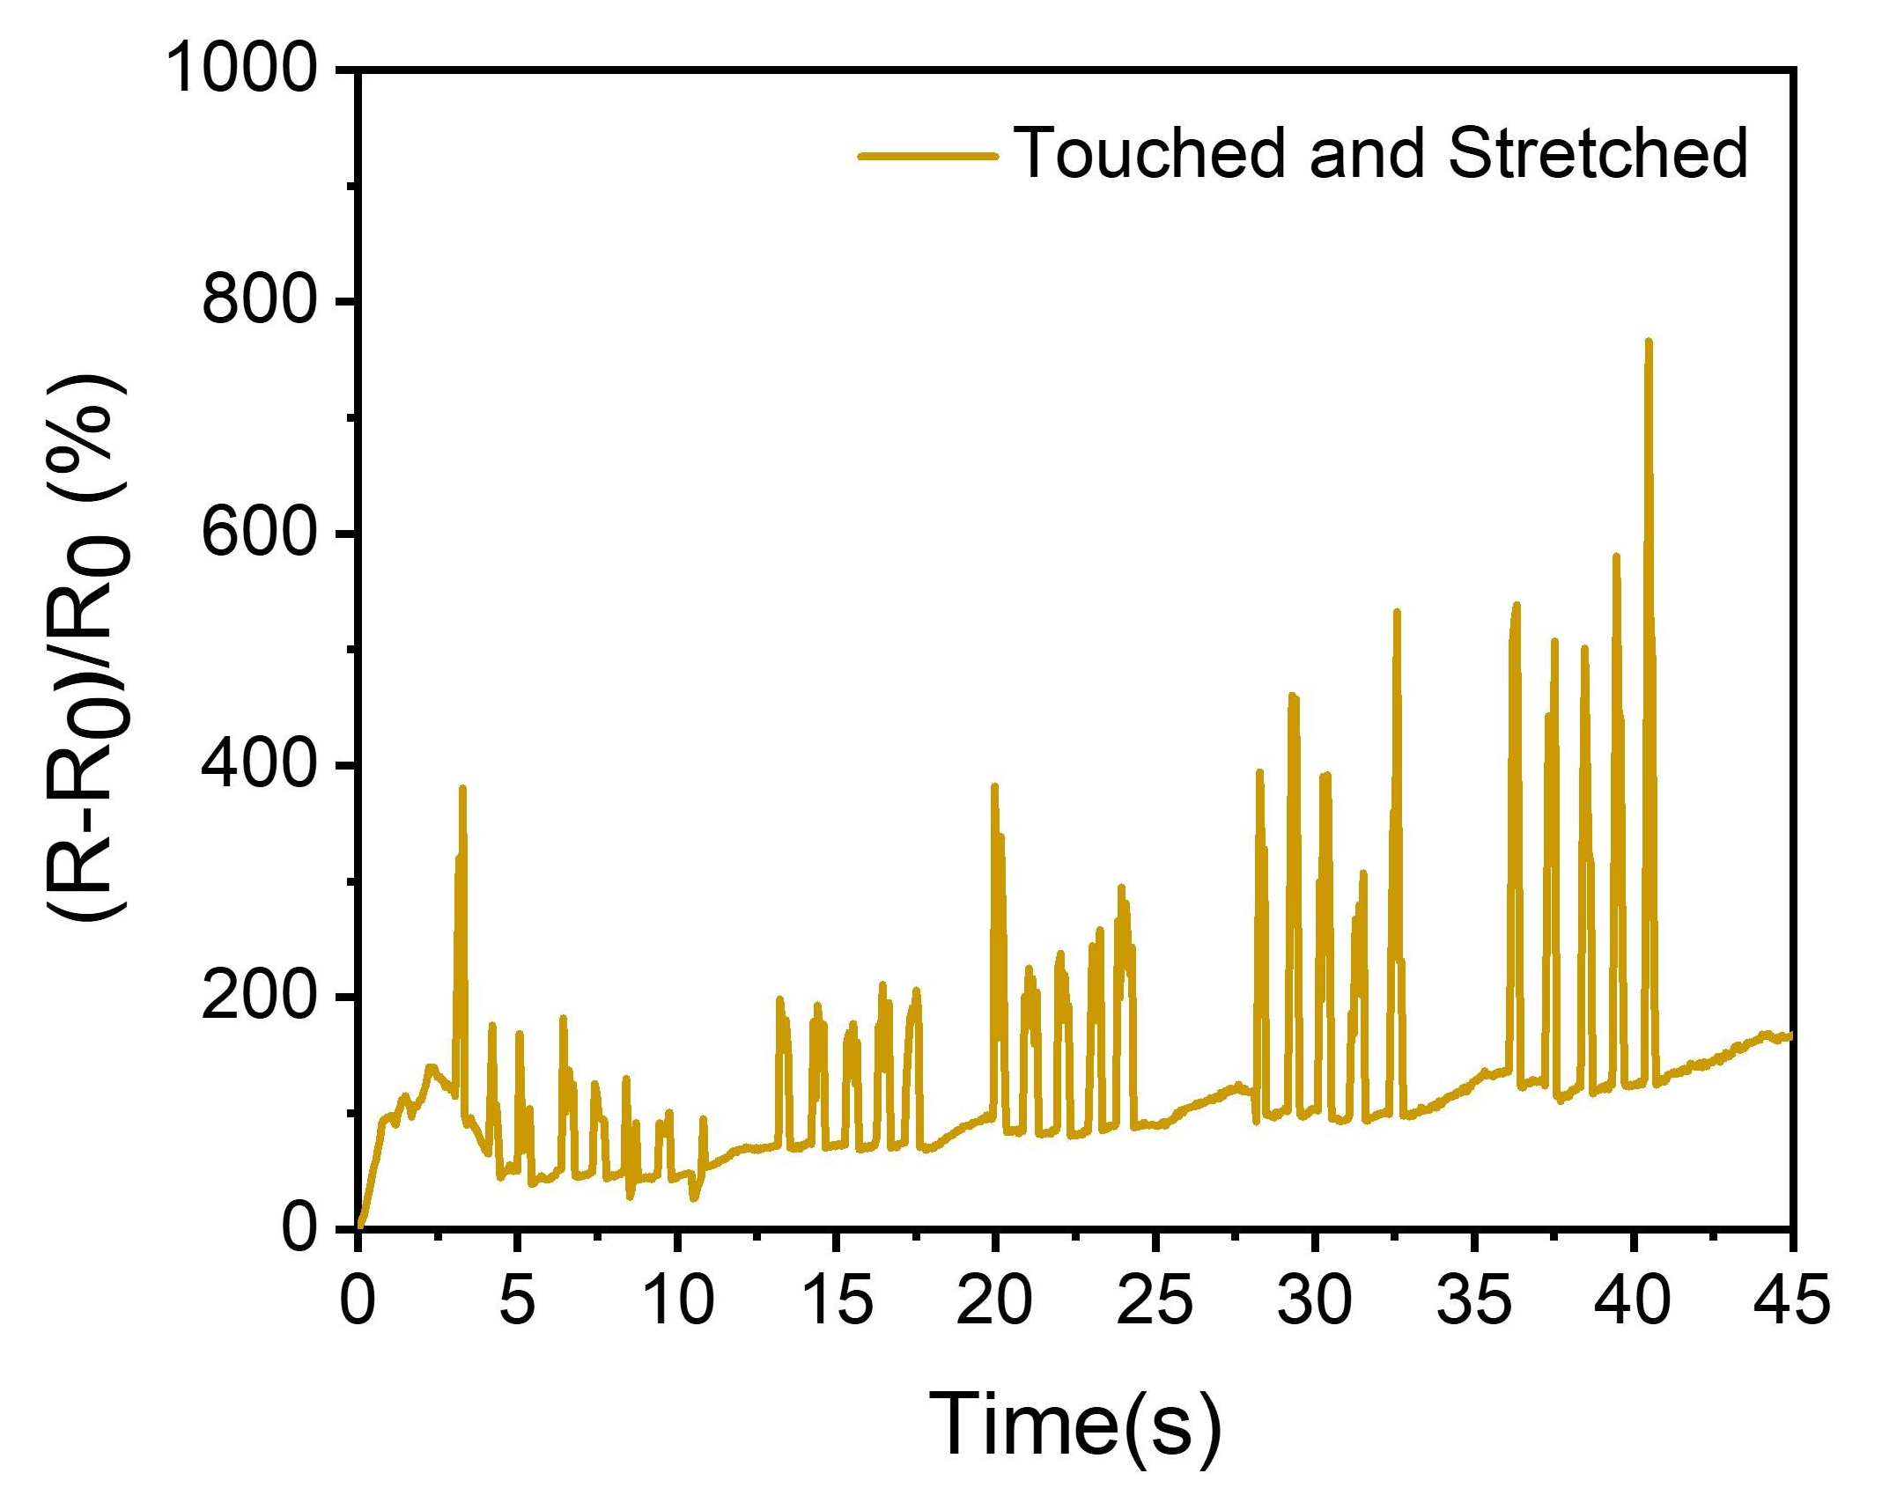

Fig. S20. The impedance change of DSICE-30 at different touched stimuli when stretched.

Table S1. Molecular weight of the synthesized DSE samples
Sample Code | Mn(g/mol) | Mw(g/mol) | Polymer Dispersity Index（PDI）
DSE-0 | 3.42×10⁴ | 6.71×10⁴ | 1.96
DSE-1 | 2.78×10⁴ | 5.37×10⁴ | 1.93
DSE-2 | 2.44×10⁴ | 5.02×10⁴ | 2.04
DSE-3 | 1.62×10⁴ | 3.60×10⁴ | 2.22

Table S2. A rough comparison of the overall performance between this work and recently reported typical ionic conductor materials
Ionic Conductors Materials |  | Ionic conductivity (S m⁻¹) | Mechanical Properties |  |  | Self-healing  (r. t.) | Recyclability |  | Transparency  (%) | Refs.
 |  | Ionic conductivity (S m⁻¹) | Stretchability (%) | Strength（MPa） | Toughness  (MJ m⁻³)
PAA/x-Ch ionogel | 5.15×10⁻³ |  | 1200 | 0.235 | NA | None | None | Opaque |  | 5
PBA ICE | 10⁻⁴~10⁻³ |  | 1100 | 0.25 | NA | None | None | 92.1 |  | 8
P(SPMA-r-MMA) ionogel | 4.1×10⁻² |  | 677 | 0.3 | 0.114 | 3 h  70.9% | None | >90 |  | 9
LM-PDES elastomer | 1.3×10⁻² |  | 2600 | 0.125 | 2.36 | 24 h, ~98% | None | 94 |  | 26
P(AAm/ChCl-co-MA/ChCl)  elastomer | 4.1×10⁻² |  | 450 | 0.6 | NA | 24 h  88.9% | None | 95.1 |  | 27
PLA ICE | 2.4×10⁻³ |  | 800 | 0.18 | 1.3 | 15 h  90.1% | Yes | 91.1 |  | 28
P(MEA-co-IBA) elastomer | 4.20×10⁻⁴ |  | 1640 | 1.05 | 0.039 | 24 h, ~30% | None | 90 |  | 29
PIL elastomer | 1.31×10⁻² |  | 540 | 0.24 | NA | 2 h  ~100% | None | Opaque |  | 46
PAA/betaine elastomer | 2×10⁻⁵ |  | 1600 | ~5 | NA | 12 h, ~100% | None | 99.7 |  | 47
DSICE | 3.77×10⁻³ |  | 2615.17 | 27.83 | 164.36 | 6 h,  ~99% | Yes | 92.3 |  | This work

Movie S1. This Movie showed excellent fast self-healing capability of DSICE-30 at ambient temperature. The dumbbell-shaped DSICE-30 film colored blue and red with standard 12 mm × 2 mm rectangular and a thickness of 0.5 mm was cut into two pieces, respectively. And then put any two colored pieces into contact for 5 min and stretched to a large strain >800%.

Movie S2. This Movie showed the impedance changes of DSICE-30 when stretched to different tensile elongation.

Movie S3. This Movie showed the impedance changes of DSICE-30 at different touched stimuli
when stretched.

