Supporting Information for

Interbrain synchronization tracks reciprocal social inference during strategic interaction

Chen Qu, Shi-zhuang Wang, Sheng-gang Cai, Zi-liang Zeng, Jean-Claude Dreher*

Corresponding author: Jean-Claude Dreher
Email: dreher@isc.cnrs.fr

This PDF file includes：
Supplementary results
- Association between sex and behavioral performance
- Relationships between model parameters and behavior
- Linear mixed-effects analysis of context effects in significant same-regional INS channels
Supplementary method
- The competitive and cooperative trade-off of the space dilemma
- Model assumptions of the sample model and the reward model
Supplementary figures
Supplementary tables

Supplementary results
Association between sex and behavioral performance
To examine whether the predominance of female participants influenced the main behavioral findings, we assessed the association between sex and behavioral performance across the three social contexts. No significant association was observed between sex and cooperation levels in any context (cooperative: r = –0.19, p = 0.074; competitive: r = –0.13, p = 0.231; flexible: r = 0.07, p = 0.513). These results suggest that the primary behavioral effects were unlikely to be explained by the sex imbalance of the sample.
Relationships between model parameters and behavior
We examined the correlations between model parameters. We observed a significant negative correlation between the social bias parameter and the TitXTat parameter (r = -0.59, p < 0.001, Supplementary Fig. 5a), and a significant negative correlation between context sensitivity (“$s_{c}$”) and the TitXTat parameter (r = -0.28, p = 0.008, Supplementary Fig. 5b). This shows that the context plays a dominant role in decision-making and that there are inter-relationships between individuals’ sensitivity of the context, their responsiveness to co-players’ behavior (“TitXTat”) and their social biases. For individuals, both social context sensitivity and social predispositions influence the extent to which co-players’ behavior affects competitive–cooperative decisions. When individuals are highly sensitive to the context or have a strong cooperative predisposition, the influence of co-players’ behavior on their decision-making tends to decrease.
In addition, we examined the correlations between model parameters and observed behaviors. We found that social bias was significantly positively correlated with individual cooperative behavior (r = 0.62, p < 0.001, Supplementary Fig. 5c). The difference in social bias between paired participants ($∆$social bias) was also significantly positively correlated with the difference in their cooperative behavior ($∆$cooperation; r = 0.46, p = 0.003, Supplementary Fig. 5d).
Linear mixed-effects analysis of context effects in significant same-regional INS channels
To further examine whether task-related INS differed across social contexts in the significant same-regional INS channels, we performed linear mixed-effects analyses on these channels. The results revealed that, compared to the cooperative context, task-related INS was significantly higher in both the competitive and flexible contexts in the mPFC (channel 2: competitive: $β$ = 0.08, p < 0.001, 95% CI = [0.056, 0.108]; flexible: $β$ = 0.10, p < 0.001, 95% CI = [0.069, 0.121]; channel 9: competitive: $β$ = 0.07, p < 0.001, 95% CI = [0.046, 0.099]; flexible: $β$ = 0.12, p < 0.001, 95% CI = [0.092, 0.145]). Similarly, in the rTPJ (channel 13), INS was significantly higher in both the competitive and flexible contexts compared to the cooperative context (competitive: $β$ = 0.07, p < 0.001, 95% CI = [0.044, 0.095]; flexible: $β$ = 0.07, p < 0.001, 95% CI = [0.040, 0.092]).
Supplementary methods
The space dilemma
The space dilemma is a task that requires a trade-off between competition and cooperation. For individuals, higher levels of cooperation were associated with lower rewards (r = –0.35, p < 0.001, supplementary Fig. 1a), whereas for pairs, higher levels of cooperation were associated with higher rewards (r = 0.22, p = 0.035, supplementary Fig. 1b).
Model assumptions of the sample model and the reward model
The first class of models, the sample models, assumes that individuals base their behavior solely on the co-player’s actions, responding to the previous position, the change in position, or a combination of both. The second class, the Bayesian models, assumes that players do not merely rely on simple behavioral feedback, but instead predict the co-player’s behavior using a Bayesian learning approach, with the environment acting as either a moderator or an independent factor. The third class of models, the reward-based models, assumes that competitive–cooperative behavior is influenced not only by the co-player’s actions but also by reward outcomes.
Simple models
The first class of models (Simple Models) assumes that a player’s position is a reciprocation of the coplayer’s last observed behavior, based either on their last cooperation level ($θ$), their last change in cooperation ($∆θ$), or a combination of both. The specific hypotheses are as follows:
- Model S1 simply assumed that players would attempt to reciprocate their co-player’s level of cooperation ($θ$) in the opposite hemifield.
- Model S2 assumed that players would attempt to reciprocate their co-player’s last change in cooperation ($Δθ$) from their previous position plus a fixed “SocialBias” parameter, capturing their a “priori” desired level of cooperation.
- Model S3 is the same formula as S2, but S3 has three different “SocialBias” parameters, one for each social context.
- Model S4 assumed that players would reciprocate their coplayer’s last level of cooperation ($θ$) scaled by a “TitXtat” multiplicative parameter.
Simple models
Model | Formula | BIC
Model S1 | $$Choice\left(t\right)\sim N\left(θ\left(t-1\right); 1/{Precision}\right)$$ | 22101.33
Model S2 | $Choice\left(t\right)\sim N\left(SocialBias + choice\left(t-1\right)+∆θ\left(t-1\right); 1/{Precision}\right)$ | 25127.88
Model S3 | $Choice\left(t\right)\sim N\left(SocialBias + choice\left(t-1\right)+∆θ\left(t-1\right); 1/{Precision}\right)$  SocialBias: one for each social context. | 24552.14
Model S4 | $$Choice\left(t\right)\sim N\left(SocialBias + TitXTat*θ\left(t-1\right); 1/{Precision}\right)$$ | 17142.31
Parameters(range):
Precision (0:10000): capturing intrinsic response variability related to the participant’s sensorimotor precision.
SocialBias (–1000:1000): representing the participant’s a priori preferred level of cooperation.
TitXTat (0:2): capturing reciprocation to others’ cooperativeness (Model S4).

Reward Models
The third class of models (Reward Models) predicts individual choices based on rewards, assuming that participants adjust their position according to the reward received in the previous trial. The specific hypotheses are as follows:
- Model R1 simply assumes that players adjust their cooperative behavior based on the outcome of the previous round: more wins, more cooperative behavior.
- Model R2 assumes that players adjust the direction of their behavior based on the outcome of the previous round: if they win, they continue shifting in the same direction; if they lose, they shift in the opposite direction.
- Models R3 and R4, building on Models R1 and R2 respectively, further assume that players consider not only wins and losses but also the coplayer’s level of cooperation in the previous round and their own social bias, reciprocating the coplayer’s cooperation via a TitXTat mechanism.
- Models R5 and R6 are identical to Models R1 and R2, respectively, except that each choice is fitted using the actual value of the previous choice made by the players rather than its predicted value, in order to prevent underfitting caused by recursive errors.
Reward Models
Model | Formula | BIC
Model R1 | $$Choice\left(t\right)\sim N\left( choice\left(t-1\right)±{Shift}_{\left(win,lose\right)}; 1/{Precision}\right)$$ | 19734.76
Model R2 | $$Choice\left(t\right)\sim N\left( choice\left(t-1\right)±{Shift}_{(win,lose,sign(∆choice(t-1))};1/{Precision}\right)$$ | 19864.95
Model R3 | $$Choice\left(t\right)\sim N\left( SocialBias+TitXTat*θ\left(t-1\right)±{Shift}_{\left(win,lose\right)}; 1/{Precision}\right)$$ | 17875.26
Model R4 | $$Choice\left(t\right)\sim N\left(SocialBias+TitXTat*θ\left(t-1\right)±{Shift}_{(win,lose,sign(∆choice(t-1))}; 1/{Precision}\right)$$ | 18011.42
Model R5 | $$Choice\left(t\right)\sim N\left( choice\left(t-1\right)±{Shift}_{\left(win,lose\right)}; 1/{Precision}\right)$$  choice(t-1): actual value | 17829.71
Model R6 | $$Choice\left(t\right)\sim N\left( choice\left(t-1\right)±{Shift}_{(win,lose,sign(∆choice(t-1))}; 1/{Precision}\right)$$  choice(t-1): actual value | 17905.82
Parameters(range):
${Shift}_{\left(win,lose\right)}$ (0:10): capturing the degree of change in cooperativeness when the player wins or loses; the change differs depending on the outcome.
${Shift}_{(win,lose,sign(∆choice(t-1))}$ (0:10): capturing the degree of positional change when the player wins or loses; the change differs depending on the outcome and the direction of the previous choice change.

Supplementary figures
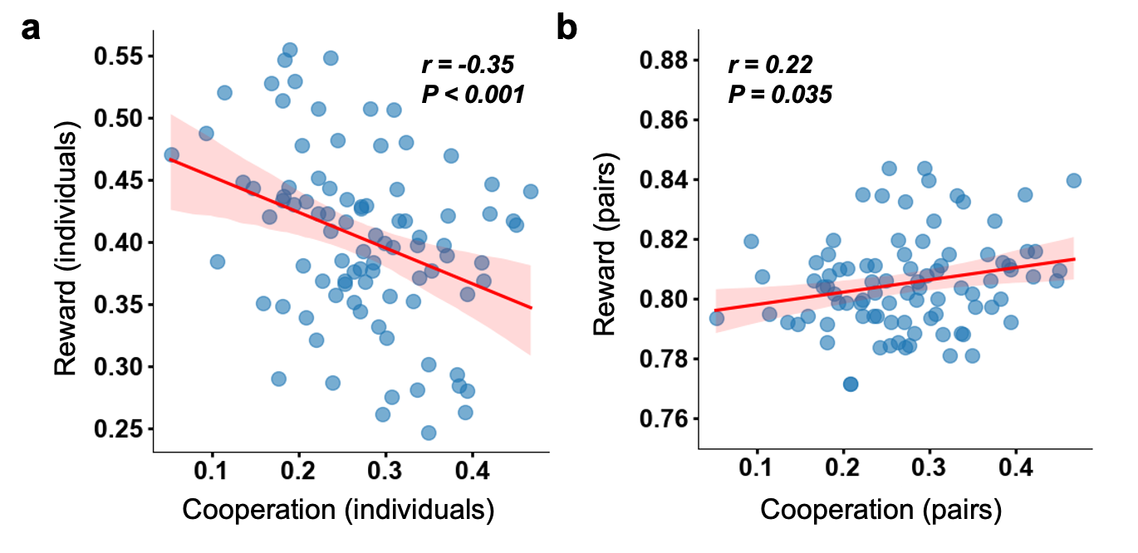
Supplementary Fig. 1. correlation among cooperation and reward. a. The cooperation of individuals was significantly negative correlated with the reward of individuals. b. The cooperation of pairs was significantly positive correlated with the reward of pairs. The solid line represents the least-squares fit, and the shading represents the 95% CI of the linear fit.
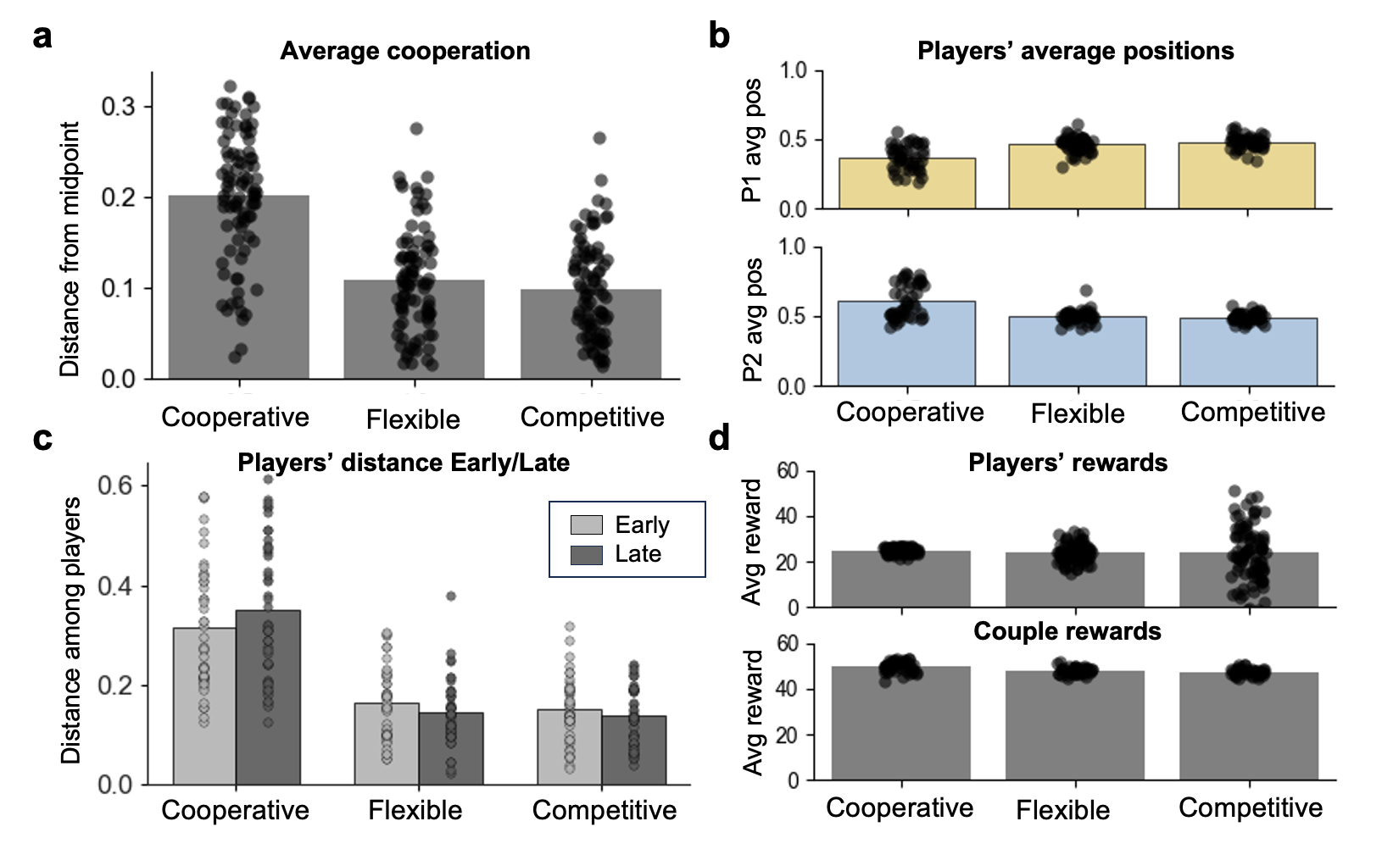
Supplementary Fig. 2. Behavioral responses. a. Behaviors in the task depend on the social context and on individual biases. In the cooperative context, players on average positioned themselves close to the middle of the hemifields (around 0.2 away from the midpoint in either hemifield). In the flexible context, players on average switched between cooperation and competition, resulting in a position closer to the midpoint (around 0.1). In the competitive context, players on average aimed for the middle of the territory. In all contexts N = 90. b. Average position split by players occupying different hemifields. The positions of left players gradually move closer to the center (from 0) as the context shifts from cooperation to competition, while the positions of right players move closer to the center (from 1) in the same context. The distance between the players decreases from cooperation to competition. In all conditions N = 45. c. In the cooperative context, participants slightly increase their distance in late trials, aiming at perfect cooperation. In the flexible and competitive context, they slightly decrease their distance in late trials. In all conditions N = 45. d. Average reward rates in three contexts for players (N = 90) or couples (N = 45).

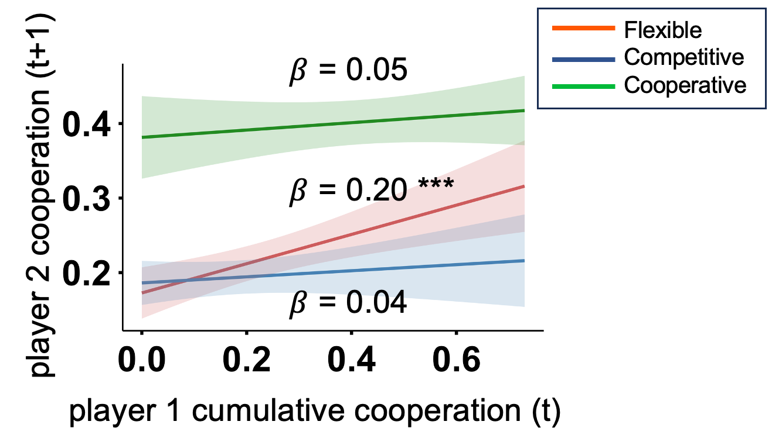
Supplementary Fig. 3. Predictive effects of co-players’ cumulative cooperation across contexts. Simple slope effects of cumulative co-player cooperation on participants’ cooperation across different contexts. Significance levels are marked as follows: *p < 0.05; **p < 0.01; ***p < 0.001.

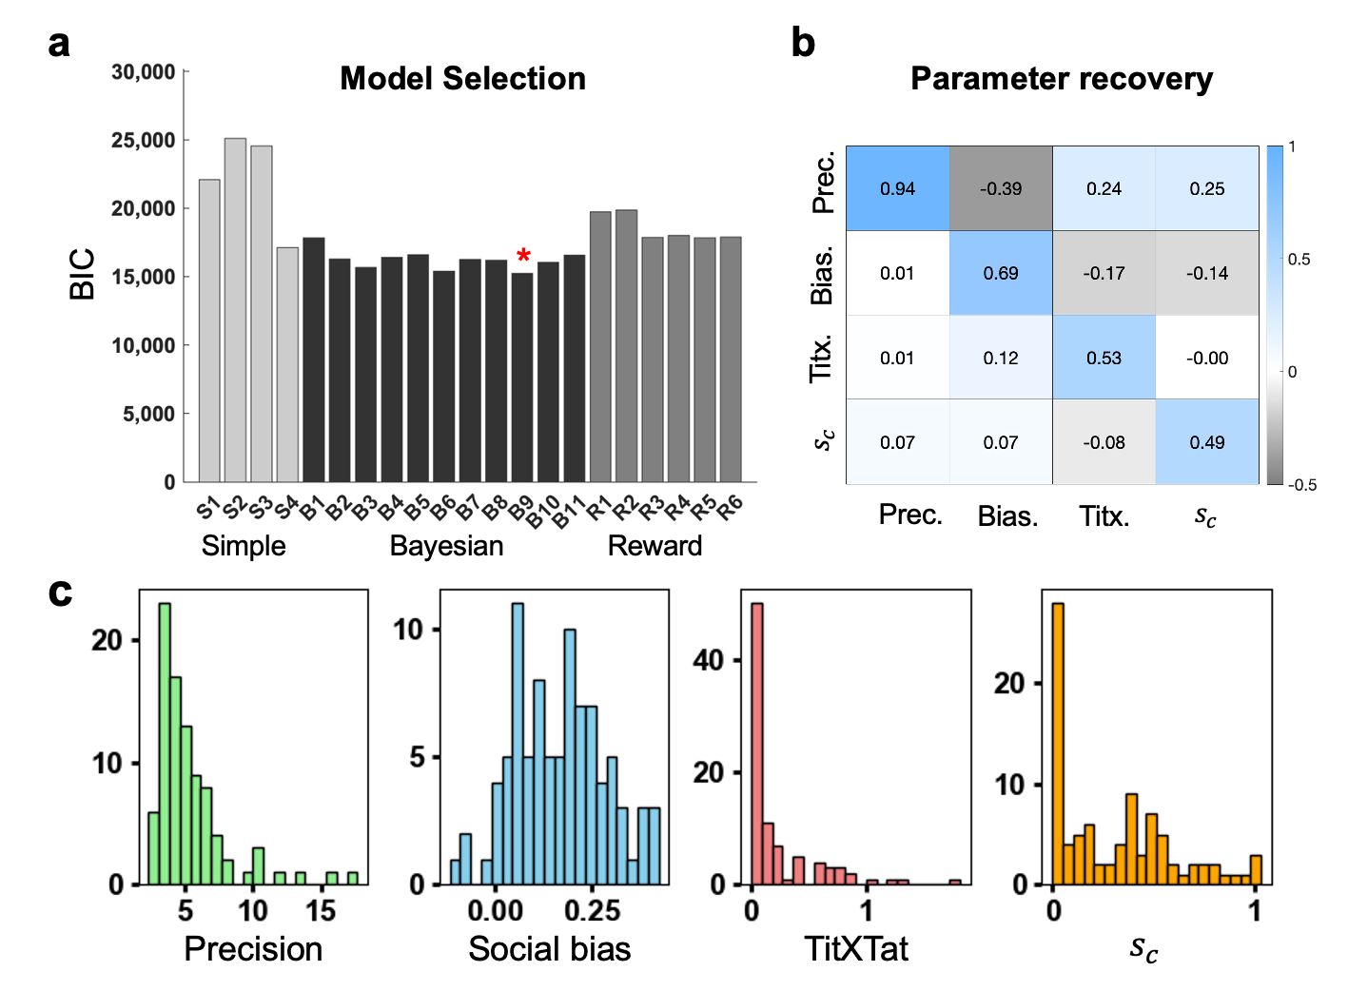
Supplementary Fig. 4. Model selection and parameter values. a. Bar plots illustrating the results of the Model Selection. Lower BIC scores indicate better fit. Models are divided into three classes, ‘Simple’ (S1–4), ‘Bayesian’ (B1–11) and ‘Reward’ (R1–6) based on their underlying logic (see method for more details of the Bayesian models and supplementary method for more details of the sample models and reward-based models). Among these, the Bayesian model B9, incorporating contextual cooperation, tit-for-tat and “SocialBias”, demonstrated the best performance (BIC = 15245.07). b. Parameter recovery for the best model is shown by the high correlations on the diagonal between simulated and recovered parameter values and the low off-diagonal correlations. c. Distribution of all parameters of the full model fitted to behaviors.

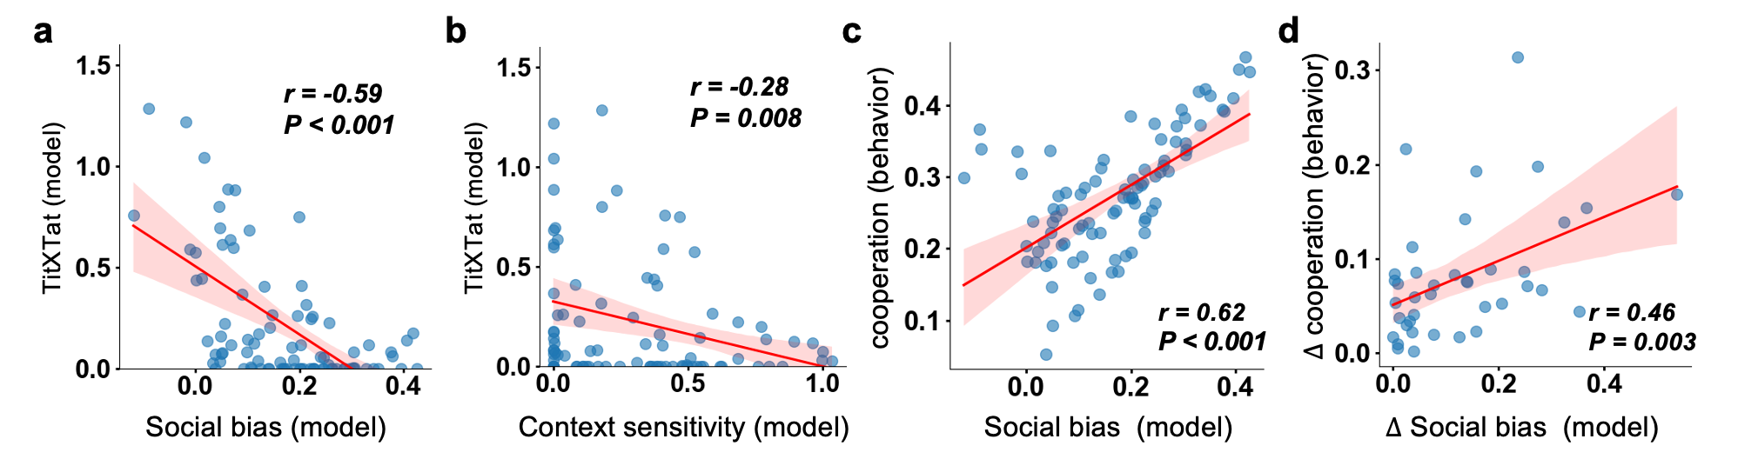
Supplementary Fig. 5. Correlation among model parameters and correlation between model parameters and behavior. a-b. The TitXTat parameter was significantly negative correlated with the social bias parameter (a) and the context sensitivity parameter (b). c. The social bias was significantly positively correlated with the cooperation of participants. d. The ∆social bias was positively correlated with the ∆cooperation of pairs. The solid line represents the least squares fit, and the shading represents the 95%CI of the linear fit.

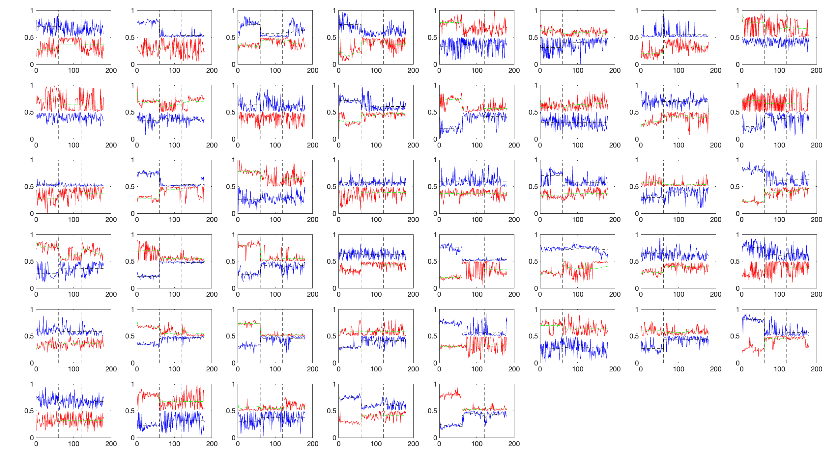
Supplementary Fig. 6. Behavioral responses and model fit. All pairs of players are represented in blue and red. The model fit is superimposed in black and green.

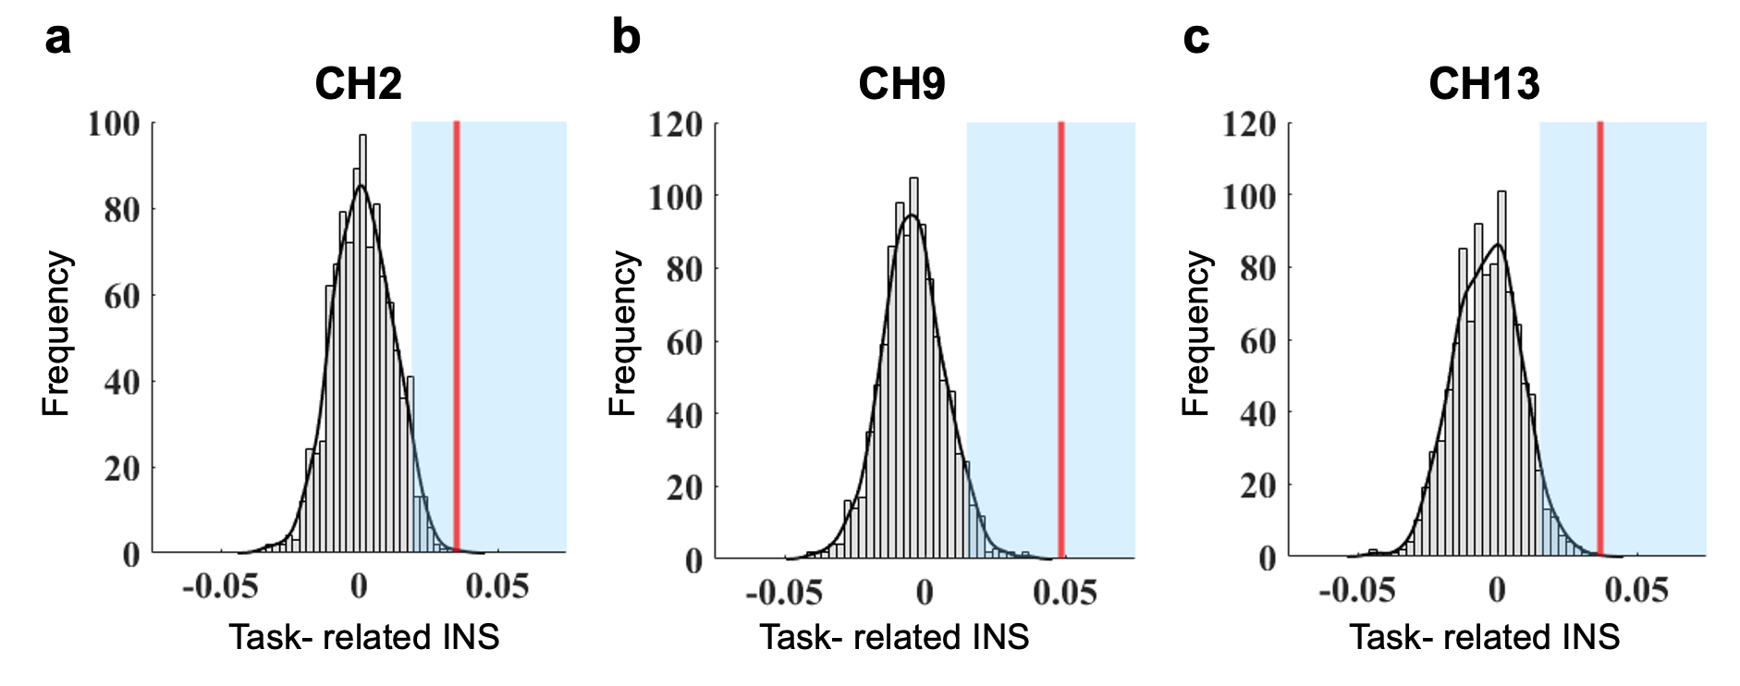
Supplementary Fig. 7. The permutation test of the channels of significant task-related INS. a-c. Validation of the interaction. We generated pseudo groups by randomly grouping the pairs to a pseudo group. The task-related INS in real group was stronger than in pseudo groups (a: channel 2; b: channel 9; c: channel 13).

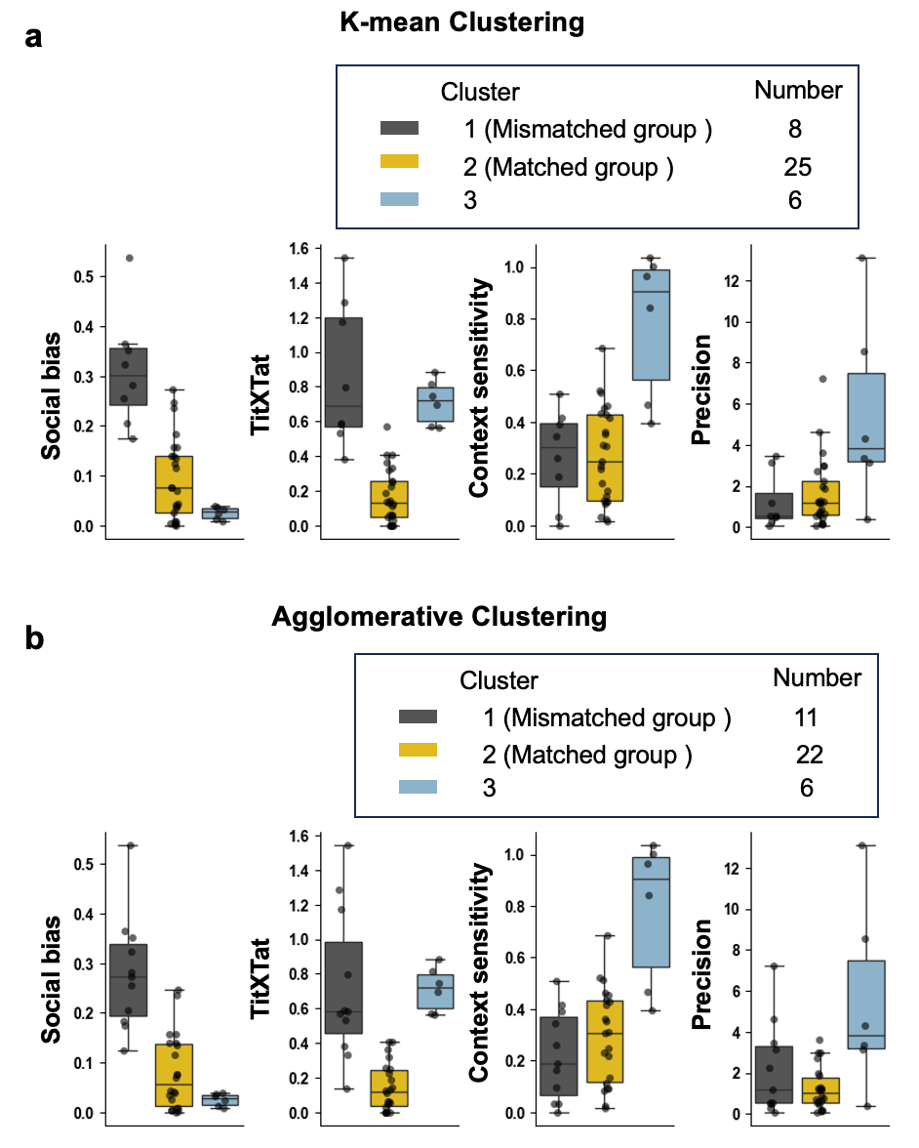
Supplementary Fig. 8. Grouping Results from the K-means and Agglomerative Clustering Algorithms. Dyads were clustered based on between-player differences in their model parameters (social bias, tit-for-tat, context sensitivity, and precision). a. Boxplots showing the differences in model parameters (social bias, tit-for-tat, context sensitivity, and precision) across the three groups identified by K-means clustering. Group 1 (Mismatched group) consists of 8 dyads, Group 2 (Matched group) consists of 25 dyads, and Group 3 consists of 6 dyads. b. Boxplots showing the differences in model parameters (social bias, tit-for-tat, context sensitivity, and precision) across the three groups identified by agglomerative clustering. Group 1 (Mismatched group) consists of 11 dyads, Group 2 (Matched group) consists of 22 dyads, and Group 3 consists of 6 dyads.

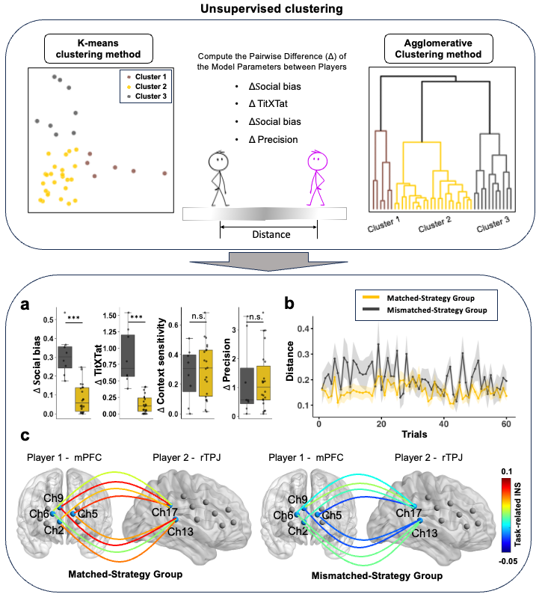
Supplementary Fig. 9. Unsupervised clustering and group differences between the matched-strategy and mismatched-strategy groups in the flexible context. Upper panel: Illustration of the unsupervised clustering procedure. Pairwise differences (Δ) were computed based on model parameters and used to perform clustering on the participant dyads. The left plot displays the results of K-means clustering, while the right plot shows agglomerative clustering results. Bottom panel: a. Between-group differences in model parameters: ΔSocial Bias, ΔTit-for-Tat, ΔContext Sensitivity, and ΔPrecision. b. Trial-by-trial changes in distance in the flexible context for both groups. The decisions of the matched-strategy group were closer (shorter distance) and were also more stable (lower Shannon entropy). c. Channel-pairwise, task-related INS between the mPFC and rTPJ across the two groups (Left: matched-strategy group; Right: mismatched-strategy group). The matched-strategy group exhibited significantly stronger mPFC–rTPJ INS at the channel-pair level compared to the mismatched-strategy group. Error bars represent the standard error of the mean. Significance levels: *p < 0.05, **p < 0.01, ***p < 0.001.

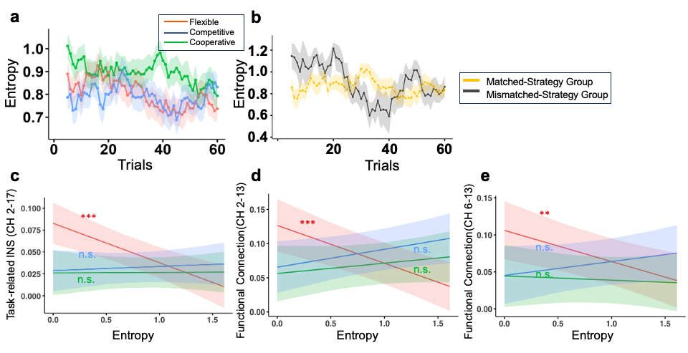
Supplementary Fig. 10. Sliding-window Shannon entropy. a. Trial-by-trial sliding-window Shannon entropy across contexts. Shannon entropy gradually decreased in both the cooperative and flexible conditions, not in competitive context. b. Changes in Shannon entropy across trials in the flexible context for both groups. The matched group exhibited more stable Shannon entropy than the mismatched group. c-e. Shannon entropy was significantly negatively correlated with task-related INS of cross-channel 2-17 (c) and functional connectivity of cross-channel 2-13 (d) and cross-channel 6-13 (e) only in the flexible context. The solid line represents the least-squares fit, and the shaded area represents the 95% CI of the linear fit. Significance levels are marked as follows: *p < 0.05; **p < 0.01; ***p < 0.001.

Supplementary tables
Supplementary Table 1
Context 3: flexible |  |  | Context 2: competitive |  |  | Context 1: cooperative |  |  | Context | The same-regional task-related INS comparisons
p_FDR | p | t | p_FDR | p | t | p_FDR | p | t |  | The same-regional task-related INS comparisons
0.042* | 0.013 | 2.62 | 0.265 | 0.212 | 1.27 | 0.741 | 0.388 | 0.87 | CH1 | The same-regional task-related INS comparisons
0.042* | 0.01 | 2.73 | 0.196 | 0.078 | 1.81 | 0.741 | 0.43 | 0.8 | CH2 | The same-regional task-related INS comparisons
0.46 | 0.37 | 0.92 | 0.27 | 0.21 | 1.28 | 0.94 | 0.92 | 0.1 | CH3 | The same-regional task-related INS comparisons
0.479 | 0.407 | 0.84 | 0.825 | 0.825 | 0.22 | 0.939 | 0.891 | 0.14 | CH4 | The same-regional task-related INS comparisons
0.08 | 0.03 | 2.2 | 0.26 | 0.17 | 1.39 | 0.74 | 0.44 | -0.77 | CH5 | The same-regional task-related INS comparisons
0.15 | 0.09 | 1.75 | 0.08 | 0.01 | 2.86 | 0.83 | 0.58 | 0.56 | CH6 | The same-regional task-related INS comparisons
0.74 | 0.71 | 0.38 | 0.1 | 0.03 | 2.2 | 0.64 | 0.15 | -1.47 | CH7 | The same-regional task-related INS comparisons
0.034* | 0.003 | 3.12 | 0.529 | 0.476 | 0.72 | 0.635 | 0.134 | 1.53 | CH8 | The same-regional task-related INS comparisons
0.042* | 0.007 | 2.85 | 0.098 | 0.025 | 2.33 | 0.826 | 0.553 | 0.6 | CH9 | The same-regional task-related INS comparisons
0.559 | 0.503 | 0.68 | 0.198 | 0.115 | 1.62 | 0.741 | 0.444 | -0.77 | CH10 | The same-regional task-related INS comparisons
0.297 | 0.208 | 1.28 | 0.077 | 0.012 | 2.65 | 0.741 | 0.254 | 1.16 | CH11 | The same-regional task-related INS comparisons
0.116 | 0.064 | 1.91 | 0.198 | 0.119 | 1.59 | 0.635 | 0.053 | 2 | CH12 | The same-regional task-related INS comparisons
0.042* | 0.012 | 2.64 | 0.098 | 0.034 | 2.2 | 0.939 | 0.912 | -0.11 | CH13 | The same-regional task-related INS comparisons
0.343 | 0.257 | 1.15 | 0.265 | 0.21 | 1.27 | 0.939 | 0.903 | 0.12 | CH14 | The same-regional task-related INS comparisons
0.08 | 0.036 | 2.18 | 0.098 | 0.031 | 2.24 | 0.635 | 0.115 | 1.61 | CH15 | The same-regional task-related INS comparisons
0.000* | 0 | 5.03 | 0.077 | 0.011 | 2.68 | 0.635 | 0.159 | 1.44 | CH16 | The same-regional task-related INS comparisons
0.077 | 0.027 | 2.3 | 0.574 | 0.545 | -0.61 | 0.741 | 0.264 | 1.13 | CH17 | The same-regional task-related INS comparisons
0.205 | 0.133 | 1.53 | 0.198 | 0.096 | 1.71 | 0.939 | 0.939 | -0.08 | CH18 | The same-regional task-related INS comparisons
0.098 | 0.049 | 2.03 | 0.198 | 0.11 | 1.64 | 0.939 | 0.82 | -0.23 | CH19 | The same-regional task-related INS comparisons
0.793 | 0.793 | -0.26 | 0.399 | 0.339 | 0.97 | 0.321 | 0.321 | -1.01 | CH20 | The same-regional task-related INS comparisons
Supplementary Table 1. Paired-sample t-tests comparing task INS and resting-state INS within the same channels. All p values were corrected using the false discovery rate (FDR) method. * P<0.05, FDR corrected

Supplementary Table 2
The cross-regional task-related INS comparisons
Context |  | Ch2-13 | Ch2-17 | Ch5-13 | Ch5-17 | Ch6-13 | Ch6-17 | Ch9-13 | Ch9-17
Context 1: cooperative | t | 0.57 | 1.60 | 0.42 | 0.06 | 0.37 | 1.24 | 0.14 | 1.23
Context 1: cooperative | p | 0.569 | 0.118 | 0.674 | 0.950 | 0.710 | 0.222 | 0.892 | 0.228
Context 1: cooperative | $$p_{FDR}$$ | 0.818 | 0.730 | 0.818 | 0.970 | 0.818 | 0.730 | 0.929 | 0.730
Context 2: competitive | t | 3.74 | 1.90 | 2.55 | 2.14 | 3.62 | 1.75 | 3.06 | 1.03
Context 2: competitive | p | 0.001 | 0.065 | 0.015 | 0.039 | 0.001 | 0.088 | 0.004 | 0.311
Context 2: competitive | $$p_{FDR}$$ | 0.023* | 0.109 | 0.044* | 0.077 | 0.023* | 0.131 | 0.025* | 0.334
Context 3: flexible | t | 3.77 | 3.43 | 2.45 | 3.05 | 1.82 | 1.65 | 3.41 | 4.57
Context 3: flexible | p | 0.001 | 0.001 | 0.019 | 0.004 | 0.077 | 0.106 | 0.002 | 0.000
Context 3: flexible | $$p_{FDR}$$ | 0.008** | 0.013* | 0.051 | 0.023* | 0.113 | 0.148 | 0.013* | 0.005**
Supplementary Table 2. Paired-sample t-tests comparing task INS and resting-state INS across channels of mPFC (channel 2, 5, 6, 9) and rTPJ (channel 13, 17). All p values were corrected by FDR.

Supplementary Table 3
The within-individual functional connection comparisons
Context |  | Ch2-13 | Ch2-17 | Ch5-13 | Ch5-17 | Ch6-13 | Ch6-17 | Ch9-13 | Ch9-17
Context 1: cooperative | t | 3.39 | 1.80 | 2.14 | 2.27 | 1.73 | 2.06 | 1.27 | 2.16
Context 1: cooperative | p | 0.001 | 0.076 | 0.035 | 0.026 | 0.088 | 0.043 | 0.206 | 0.034
Context 1: cooperative | $$p_{FDR}$$ | 0.036* | 0.131 | 0.086 | 0.079 | 0.147 | 0.092 | 0.269 | 0.086
Context 2: competitive | t | 3.88 | 2.82 | 2.85 | 3.41 | 2.44 | 2.08 | 0.86 | 1.92
Context 2: competitive | p | 0.000 | 0.006 | 0.006 | 0.001 | 0.017 | 0.041 | 0.393 | 0.059
Context 2: competitive | $$p_{FDR}$$ | 0.002** | 0.016* | 0.015* | 0.005** | 0.034* | 0.058 | 0.409 | 0.079
Context 3: flexible | t | 3.37 | 3.17 | 4.43 | 3.15 | 2.88 | 2.28 | 3.58 | 2.87
Context 3: flexible | p | 0.001 | 0.002 | 0.000 | 0.002 | 0.005 | 0.025 | 0.001 | 0.005
Context 3: flexible | $$p_{FDR}$$ | 0.016* | 0.018* | 0.003** | 0.018* | 0.022* | 0.051 | 0.012* | 0.022*
Supplementary Table 3. Paired-sample t-tests comparing task FC and resting-state FC in functional connection of mPFC (channel 2, 5, 6, 9) and rTPJ (channel 13, 17). All p values were corrected by FDR.

Supplementary Table 4
Channel location
Channel | MNI coordinates |  |  | Anatomical Automatic Labeling (AAL) atlas
Channel | x | y | z | Anatomical Label | Percentage of Overlap
CH01 | -19 | 72 | 4 | Frontal_Sup_L | 0.751
 |  |  |  | Frontal_Sup_Orb_L | 0.111
 |  |  |  | Frontal_Mid_L | 0.013
 |  |  |  | Frontal_Sup_Medial_L | 0.075
 |  |  |  | Frontal_Mid_Orb_L | 0.049
CH02 | 7 | 73 | 4 | Frontal_Sup_Medial_R | 0.576
 |  |  |  | Frontal_Sup_R | 0.085
 |  |  |  | Frontal_Sup_Orb_R | 0.079
 |  |  |  | Frontal_Sup_Medial_L | 0.112
 |  |  |  | Frontal_Mid_Orb_L | 0.030
 |  |  |  | Frontal_Mid_Orb_R | 0.118
CH03 | 26 | 70 | 1 | Frontal_Sup_R | 0.661
 |  |  |  | Frontal_Sup_Orb_R | 0.339
CH04 | -28 | 66 | 13 | Frontal_Sup_L | 0.680
 |  |  |  | Frontal_Mid_L | 0.320
CH05 | -12 | 72 | 15 | Frontal_Sup_L | 0.670
 |  |  |  | Frontal_Sup_Medial_L | 0.330
CH06 | 17 | 72 | 15 | Frontal_Sup_R | 0.547
 |  |  |  | Frontal_Sup_Medial_R | 0.453
CH07 | 35 | 66 | 8 | Frontal_Sup_R | 0.616
 |  |  |  | Frontal_Sup_Orb_R | 0.018
 |  |  |  | Frontal_Mid_R | 0.362
 |  |  |  | Frontal_Mid_Orb_R | 0.004
CH08 | -18 | 68 | 23 | Frontal_Sup_L | 0.924
 |  |  |  | Frontal_Sup_Medial_L | 0.076
CH09 | 7 | 69 | 24 | Frontal_Sup_Medial_R | 0.621
 |  |  |  | Frontal_Sup_R | 0.181
 |  |  |  | Frontal_Sup_Medial_L | 0.198
CH10 | 24 | 68 | 22 | Frontal_Sup_R | 0.743
 |  |  |  | Frontal_Mid_R | 0.208
 |  |  |  | Frontal_Sup_Medial_R | 0.048
CH11 | 60 | 30 | 5 | Frontal_Inf_Tri_R | 0.909
 |  |  |  | Frontal_Inf_Orb_R | 0.091
CH12 | 69 | -4 | 13 | Postcentral_R | 0.413
 |  |  |  | Rolandic_Oper_R | 0.240
 |  |  |  | Heschl_R | 0.016
 |  |  |  | Temporal_Sup_R | 0.331
CH13 | 72 | -33 | 13 | Temporal_Sup_R | 0.876
 |  |  |  | Temporal_Mid_R | 0.124
CH14 | 53 | 45 | 9 | Frontal_Inf_Tri_R | 0.511
 |  |  |  | Frontal_Mid_R | 0.489
CH15 | 62 | 20 | 21 | Frontal_Inf_Tri_R | 0.477
 |  |  |  | Precentral_R | 0.077
 |  |  |  | Frontal_Inf_Oper_R | 0.447
CH16 | 69 | -10 | 30 | Postcentral_R | 0.750
 |  |  |  | SupraMarginal_R | 0.250
CH17 | 69 | -41 | 32 | SupraMarginal_R | 0.860
 |  |  |  | Angular_R | 0.039
 |  |  |  | Temporal_Sup_R | 0.101
CH18 | 53 | 38 | 26 | Frontal_Inf_Tri_R | 0.506
 |  |  |  | Frontal_Mid_R | 0.494
CH19 | 61 | 8 | 36 | Precentral_R | 0.730
 |  |  |  | Frontal_Inf_Oper_R | 0.126
 |  |  |  | Postcentral_R | 0.144
CH20 | 67 | -22 | 44 | SupraMarginal_R | 0.784
 |  |  |  | Postcentral_R | 0.216
Supplementary Table 4. The channel location. The MNI coordinates and Anatomical Automatic Labeling (AAL) atlas of channels. Specifically, the medial prefrontal cortex (mPFC) corresponded to channels 2, 5, 6, and 9, while the right temporoparietal junction (rTPJ) corresponded to channels 13 and 17.

