Supporting Information

Structural, Dielectric, Optical, and Electrochemical Insights into Enhanced OER Activity of Y₃Fe₅O₁₂ over YFeO₃ Ferrite Nanoparticles for Hydroelectric Cell Applications

S1. Preparation of Electrode for OER
For the preparation of working electrode, small amount of catalyst (3 mg) was dissolved in a mixed solution of 80 μL of DDW (18.2 Milli-Q) and isopropanol of volume 120 μL. Then, the resulting mixture was readily sonicated for 30 min before the addition of 5% Nafion solution and then further sonication was done to obtain a homogenous ink of material. The as-prepared ink was then drop-casted onto the carbon paper with a surface area of 0.25 cm² and left for drying overnight in a desiccator (under mild vacuum). Then, the resultant electrode got prepared for the oxygen evolution reaction (OER) measurements and the mass loading for the catalysts was calculated was found to be 1.56 mg/cm².
Fabrication of Hydroelectric cells (HECs)
The schematic diagram of the HEC is shown in the supplementary figure Fig S1. The pre-synthesized powders of YF and YGF have been finely grounded in agar mortar pestle for 20 min each. After that, few drops of PVA binder (2 wt% solution) was added in the precursor powders and then again grounded until it turns out in its dry form. Then, using a hydraulic press, the powder was moulded into square pellets of dimensions 2 cm*2 cm and area of 4cm² under pressure of 2 tons. The prepared pellets were then sintered in a programmable muffle furnace under temperature of 600˚C for 4 h to remove the PVA binder. The sintered pellets were then pasted on a zinc sheet (which will act as anode) and then kept on a hot plate for improved adhesion. Just after that, silver paste was coated in a comb-like- pattern on the surface of the ferrite material.
S2. Calculation of electrochemically active surface area (ECSA)
Moreover, the electrochemically active surface area (ECSA) proportional to the electrochemical double-layer capacitance (Cdl) is estimated from the equation (Eq. (1)):
ECSA = C_{dl} /C_{s} (1)
Where Cs is the specific capacitance of flat working electrode and its value is 40 μF per cm² ECSA for the flat electrode [1,2]. Cdl is determined from the slope of Δj/2 (where Δj is the difference of J_{a} and J_{c}) vs. scan rate. J_{a} and J_{c} are anodic and cathodic current densities, respectively.

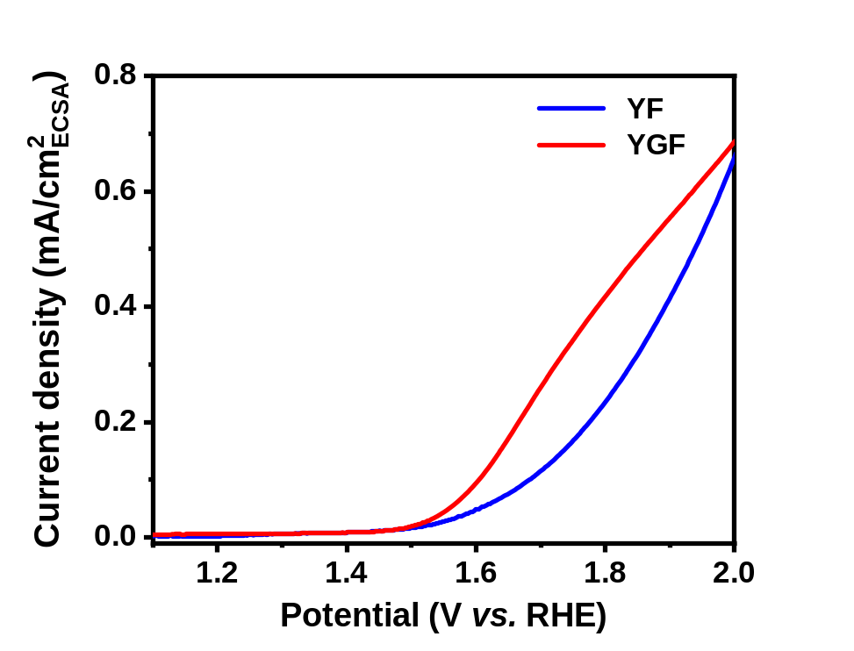
Figure S1. ECSA normalised LSV plots of YF and YGF.

Figure S2. EDX pattern of the YGF sample.

S2. M-H Hysteresis Loop

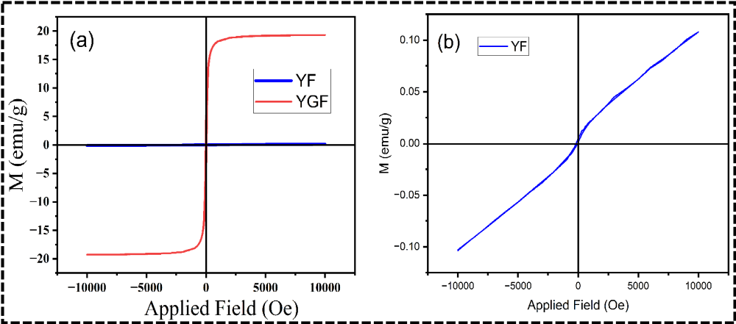
Figure S3. Comparison of the variation of M-H curve in YF and YGF samples, (b) M-H loop of YF obtained at RT.
The magnetic properties of the synthesized samples, YF and YGF were analysed using vibrating sample magnetometer (VSM) at room temperature from -1 to 1 Tesla. Fig S2 (a-b) depicts the obtained magnetization (M) vs. applied magnetic field (H) curves for YF and YGF. The various parameters such as, saturation magnetization (M_{s}), remanent magnetization (M_{r}), coercivity (H_{c}), and squareness ratio (M_{r}/M_{s}) for YF and YGF samples are tabulated in Table 3. As observed from Fig S2 (b), a narrow magnetic hysteresis loop was obtained for YF which indicates weak ferromagnetism in the sample. Further, the YF also showed very low values of saturation magnetization (M_{s} = 0.101 emu/g), remanent magnetization (M_{r} = 0.00471 emu/g), and a moderate value of coercivity (H_{c} = 56.463 Oe). On the other hand, YGF demonstrated higher values of saturation magnetization (M_{s} = 19.163 emu/g) and remanent magnetization (M_{r} = 6.295 emu/g) with a lower value of coercivity (Hc = 43.982 Oe). These results confirm the superior magnetic behaviour of YGF nanoparticles as compared to YF.
The weak magnetic behaviour of YF may be attributed to its orthorhombic perovskite crystal structure, in which the net magnetization occurs due to the canted antiferromagnetic alignment of Fe³⁺ ions in the lattice. Previous studies indicate that YFeO₃ falls under the category of diamagnetic rare-earth iron perovskites, where the weak ferromagnetism originates from the slight canting of the Fe³⁺ magnetic moments. Furthermore, the relatively higher coercivity (Hc = 56.463 Oe) in YFeO₃ is a direct consequence of its high anisotropy and low magnetization, as supported by previous studies [42]. Additionally, the square-ness ratio (M_{r}/M_{s}) for YF was determined to be 0.0466, suggesting the presence of a multi-domain structure in YF sample. Further, it also reflects the presence of weak magnetic coupling, which is a characteristic of perovskite YFeO₃ nanoparticles. The low square-ness ratio also reflects poor magnetic stability under an applied magnetic field, confirming its diamagnetic nature [43].
The magnetic properties of YGF show enormously larger saturation magnetization (M_{s} = 19.163 emu/g), remanent magnetization (M_{r} = 6.295 emu/g), and smaller coercivity (H_{c} = 43.982 Oe). Higher magnetization in YGF can be attributed to its cubic garnet structure, where Fe³⁺ ions are distributed equally in the tetrahedral and octahedral sites, resulting in higher net magnetic moment [44]. X. Z. Guo et al. have reported about saturation magnetization of YIG nanoparticles produced by a citrate-gel method near 26 emu/g, very close to the present study's obtained value of M_{s} [45]. The higher Ms as compared to YF may, however, be linked with the bigger crystallite size (35 nm) [46]. The coercivity (H_{c}) of YGF was estimated to be 43.982 Oe, which is less as compared to that of YF. The obtained coercivity is in close agreement with the work of A. Z. Arsad et al., where they have carried out temperature dependent studies on YIG thin films [47]. The lower coercivity in YGF may be attributed to the minimization of domain wall energy in the garnet structure, which facilitates easier magnetization reversal. Additionally, the lower H_{c} observed in YGF indicates the soft ferrimagnetic nature of the material, as reported in various studies. Furthermore, the higher squareness ratio (M_{r}/M_{s} = 0.328) in YGF as compared to the YF sample (M_{r}/M_{s} = 0.0466), suggests improved magnetic stability and uniaxial anisotropy in the garnet structure. If the squareness ratio is ≥ 0.5, then it implies the material is a single magnetic domain; if it is ≤ 0.5 then this implies multi magnetic domains. The squareness ratio of both YF and YGF is less than 0.5, indicating that these materials possess multi magnetic domain micro-structure.
Table S1: Various magnetic parameters obtained from VSM analysis
Sample | M_{s} (emu/g) | M_{r} (emu/g) | H_{c} (Oe) | SQR (M_{r}/M_{s})
YF | 0.101 | 0.00471 | 56.463 | 0.0466
YGF | 19.163 | 6.295 | 43.982 | 0.328

References:
- Shit, S., Chhetri, S., Jang, W., Murmu, N. C., Koo, H., Samanta, P., & Kuila, T. (2018). Cobalt sulfide/nickel sulfide heterostructure directly grown on nickel foam: an efficient and durable electrocatalyst for overall water splitting application. ACS applied materials & interfaces, 10(33), 27712-27722.
- Garcia, A. C., & Koper, M. T. (2018). Effect of saturating the electrolyte with oxygen on the activity for the oxygen evolution reaction. ACS catalysis, 8(10), 9359-9363.
- Sharma, V., Saha, J., Patnaik, S., & Kuanr, B. K. (2017). Synthesis and characterization of yttrium iron garnet (YIG) nanoparticles-Microwave material. AIP Advances, 7(5).
- White, R. (1969). Review of recent work on the magnetic and spectroscopic properties of the rare‐earth orthoferrites. Journal of Applied Physics, 40(3), 1061-1069.
- Neupane, D., Kramer, N., Bhattarai, R., Hanley, C., Pathak, A. K., Shen, X., ... & Mishra, S. R. (2023). Rare-Earth Doped Gd3− x RE x Fe5O12 (RE= Y, Nd, Sm, and Dy) Garnet: Structural, Magnetic, Magnetocaloric, and DFT Study. Ceramics, 6(4), 1937-1976.
- Guo, X. Z., Ravi, B. G., Devi, P. S., Hanson, J. C., Margolies, J., Gambino, R. J., ... & Sampath, S. (2005). Synthesis of yttrium iron garnet (YIG) by citrate–nitrate gel combustion and precursor plasma spray processes. Journal of Magnetism and Magnetic Materials, 295(2), 145-154.
- Goya, G. F., Berquo, T. S., Fonseca, F. C., & Morales, M. P. (2003). Static and dynamic magnetic properties of spherical magnetite nanoparticles. Journal of applied physics, 94(5), 3520-3528.
- Arsad, A. Z., & Ibrahim, N. B. (2018). Temperature-dependent magnetic properties of YIG thin films with grain size less 12 nm prepared by a sol-gel method. Journal of Magnetism and Magnetic Materials, 462, 70-77.

