Supplementary Material
Probabilistic recovery of high-impact urban convective rainfall from radar-assimilation experiments using conditional diffusion and distributional attribution
S1. Model and experiment configuration
Table S1 provides the model settings needed to reproduce the three WRF experiments.
Table S1. WRF and WPS configuration used for all experiments.
Item | Setting
WRF version | 4.8.0
WPS version | 4.7.0
Outer domain | 9 km grid; 121 × 101 grid points
Inner domain | 3 km convection-permitting grid; 181 × 181 grid points; Baltimore-centered
Vertical levels | 45
Projection | Lambert conformal; true latitudes 30° and 60°; standard longitude 77° W
Simulation period | CTRL from 1200 UTC 28 July to 0300 UTC 29 July 2026; radar analyses at 2100 UTC
Initial and boundary conditions | NCEP Global Forecast System 0.25° fields
Microphysics | Thompson
Cumulus parameterization | Grell-Freitas on the 9 km domain; none on the 3 km domain
Radiation | RRTMG shortwave and longwave
Boundary layer / surface layer | MYNN / MYNN
Land surface model | Noah-MP
Model time step | 45 s
Nesting | One-way
Output frequency | Hourly

S2. Radar processing and data assimilation
The same radar preprocessing, background-error covariance and analysis configuration were used for the RV and RV+RF experiments except that reflectivity was added in RV+RF.
Table S2. Radar preprocessing and WRFDA configuration.
Item | Setting
Radar | KLWX NEXRAD Level II
Radar time window | 2030–2130 UTC 28 July 2026
Selected radar volume | KLWX volume beginning 21:01:04 UTC; 64 s after the 2100 UTC analysis time
Quality-control range | 10–150 km from radar
Maximum elevation angle | 10°
Reflectivity quality control | 5–75 dBZ; copolar correlation coefficient ≥ 0.80 when available
Radial-velocity processing | Py-ART region-based velocity dealiasing
Retained gates | 787,742 reflectivity gates; 449,269 radial-velocity gates
Superobservation grid | 6 km horizontal × 500 m vertical; at least 3 gates per bin
Radial-velocity superobservation | Median; 2 m s⁻¹ observation error
Reflectivity superobservation | Mean in linear reflectivity factor; 5 dBZ observation error
RV observation set | 1,123 profiles; 8,528 vertical levels
RV+RF observation set | 1,269 profiles; 11,282 vertical levels
Background-error covariance | Domain-specific WRFDA control-variable option 7 covariance
Background-error forecast library | 25 independent pre-event initializations; 24 forecast-difference pairs (24 h minus 12 h)
RV experiment | Radial velocity assimilated using the common covariance and analysis settings
RV+RF experiment | Radial velocity and reflectivity assimilated; radar-derived humidity adjustments disabled
Forecast restart procedure | Only WRFDA-modified state fields were inserted into the pristine 2100 UTC restart; no outcome-dependent clipping

S3. Spatial validation and diffusion predictors
The five outer test folds were defined geometrically before model fitting. All hours and experiments for a physical grid cell remained in the same fold.
Table S3. Composition of the five geometry-defined outer test folds.
Outer fold | Test cells | Test cell-hours | Mean MRMS (mm h⁻¹) | Maximum MRMS (mm h⁻¹) | Cell-hours ≥10 mm | Cell-hours ≥25 mm
0 | 568 | 3408 | 3.32 | 44.17 | 413 | 68
1 | 660 | 3960 | 2.72 | 40.85 | 408 | 74
2 | 661 | 3966 | 2.82 | 48.78 | 420 | 99
3 | 666 | 3996 | 2.69 | 43.33 | 383 | 83
4 | 725 | 4350 | 3.15 | 56.64 | 531 | 83

The hourly MRMS 97.5th percentile was 23.85 mm h⁻¹, the 99th percentile was 29.58 mm h⁻¹, and the maximum was 56.64 mm h⁻¹. The 25 mm h⁻¹ DREA tail threshold therefore lies just above the 97.5th percentile.
The final diffusion model used 32 conditioning variables. For readability, Table S4 groups the exact variables by physical role. Assimilation indicators and forecast lead were used for conditioning but were not independently shuffled in DREA. Deterministically related variables were grouped into a single DREA perturbation unit where appropriate.
Table S4. Human-readable summary of the 32 conditioning variables used by the diffusion model.
Predictor group | Variables represented | Number of variables
Radar-assimilation increments | Profile summaries of graupel, rainwater and snow mixing-ratio increments; zonal- and meridional-wind increments | 5
Assimilation indicators | Indicators for velocity assimilation and reflectivity assimilation | 2
Forecast timing | Forecast lead hour | 1
Terrain | Terrain height | 1
Local precipitation | Hourly WRF precipitation and its log(1 + precipitation) transform | 2
Boundary layer | Planetary boundary-layer height | 1
Neighborhood precipitation | Mean and maximum WRF precipitation within approximately 9, 15 and 33 km neighborhoods | 6
Near-surface atmospheric state | Surface pressure, 2 m temperature and 2 m water-vapor mixing ratio | 3
Hydrometeors | Maximum cloud water, graupel, ice, rainwater and snow mixing ratios | 5
Low-level moisture | Water-vapor mixing ratio at the lowest model level | 1
Wind and vertical motion | 10 m zonal wind, 10 m meridional wind, 10 m wind speed, maximum vertical velocity and maximum absolute vertical velocity | 5

S4. Secondary verification and neighborhood skill
Stage IV provided an independent secondary precipitation analysis. Its six-hour results reproduced the main MRMS conclusions: postprocessing improved continuous skill and light-to-moderate threshold skill in all three experiments, while the 50 mm threshold remained tied at zero skill.
Table S5. Six-hour Stage IV verification before and after diffusion postprocessing. Values are raw WRF → diffusion.
Experiment | RMSE (mm) | Spatial Pearson r | CSI at 2 mm | CSI at 10 mm | CSI at 25 mm | CSI at 50 mm
CTRL | 22.86 → 17.25 | -0.056 → 0.537 | 0.200 → 0.763 | 0.005 → 0.368 | 0.000 → 0.024 | 0.000 → 0.000
RV | 22.86 → 16.91 | -0.059 → 0.559 | 0.197 → 0.795 | 0.007 → 0.383 | 0.000 → 0.036 | 0.000 → 0.000
RV+RF | 22.84 → 16.73 | -0.061 → 0.551 | 0.192 → 0.774 | 0.007 → 0.445 | 0.000 → 0.028 | 0.000 → 0.000

Across the 54 comparable Stage IV categorical metrics, 45 improved and 9 tied; all ties occurred at the 50 mm threshold.
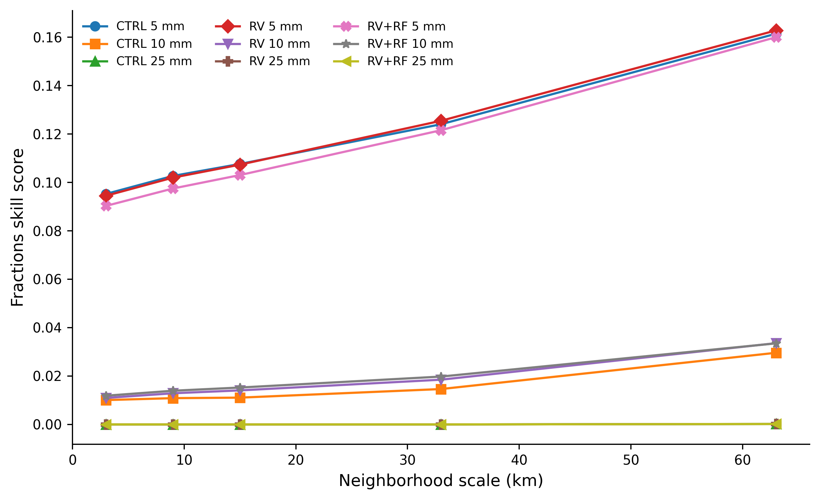
Figure S1. MRMS fractions skill score for the raw CTRL, RV, and RV+RF forecasts at 5, 10, and 25 mm six-hour thresholds across neighborhood scales. The 50 mm curves are omitted because the score was zero at all evaluated scales.
S5. Calibration diagnostics
The primary calibration used a fold-specific symmetric spread factor selected only on the inner validation fold. Table S6 reports the selected factors and their validation behavior.
Table S6. Fold-specific primary symmetric-spread calibration parameters.
Outer test fold | Validation fold | Spread factor (τ) | Validation 90% coverage | Validation interval width (mm) | Validation interval score
0 | 1 | 1.07 | 0.902 | 5.88 | 14.69
1 | 2 | 1.07 | 0.899 | 7.42 | 15.16
2 | 3 | 1.04 | 0.903 | 6.67 | 15.17
3 | 4 | 1.02 | 0.901 | 7.14 | 16.89
4 | 0 | 1.10 | 0.900 | 8.00 | 20.93

Alternative calibration methods were retained as sensitivity analyses rather than used to replace the prespecified primary method after inspection of outer-test results.
Table S7. Pooled calibration sensitivity across all outer-test predictions.
Calibration method | 90% coverage | Interval width (mm) | Interval score | CRPS (mm) | Brier score ≥25 mm h⁻¹
Asymmetric additive conformal | 0.902 | 9.58 | 16.44 | — | —
Asymmetric spread | 0.898 | 9.91 | 15.77 | 1.797 | 0.0199
Mondrian asymmetric spread | 0.897 | 9.91 | 15.78 | 1.797 | 0.0199
Probability-integral-transform recalibration | 0.880 | 7.42 | 16.44 | 1.953 | 0.0196
Primary symmetric spread | 0.887 | 6.96 | 16.93 | 1.827 | 0.0197
Raw, uncalibrated | 0.849 | 6.59 | 17.39 | 1.837 | 0.0198
Symmetric additive conformal | 0.888 | 6.67 | 17.32 | — | —

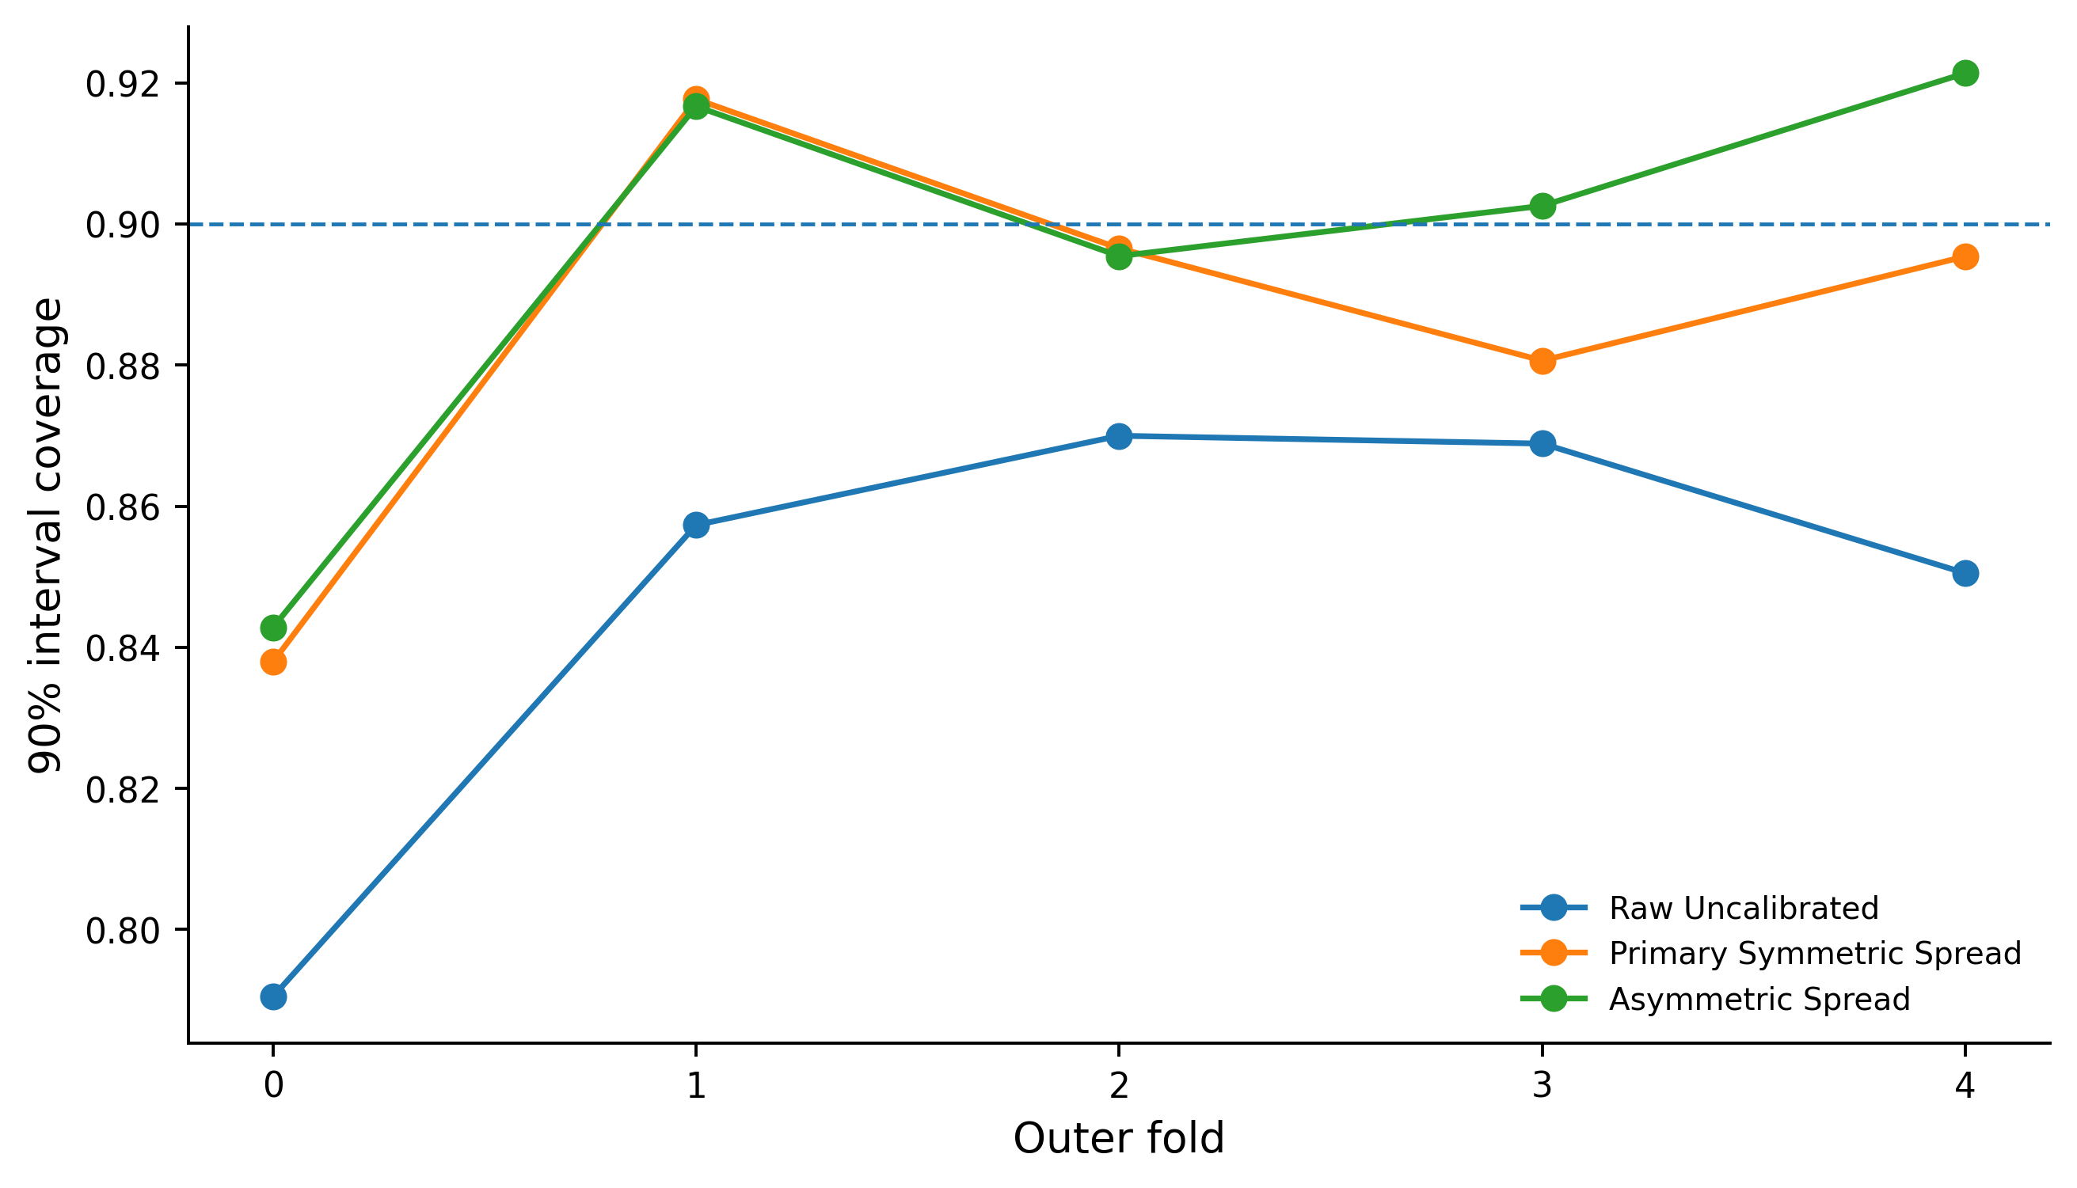
Figure S2. Fold-specific 90% interval coverage for uncalibrated diffusion predictions, the primary symmetric-spread calibration, and the asymmetric-spread sensitivity. The dashed line marks nominal 90% coverage.
S5.1 Adaptive full-distribution calibration analysis
A separate exploratory analysis examined whether the amount of recent calibration history should change as forecast conditions evolved. This analysis began from the raw 50-member diffusion predictive distributions and did not replace the prespecified symmetric-spread calibration used in the primary analysis. Because at least one previously verified forecast hour was required, evaluation was restricted to the common causal window of forecast hours 2–6.
For each target forecast hour, the algorithm considered candidate histories containing the most recent verified forecast hours. The full predictive distribution was summarized using randomized probability-integral-transform ranks. Candidate histories were compared using two quantities available before verification of the target outcome: changes in previously verified rank distributions and changes in the current WRF precipitation state relative to recent forecast hours. These changes were combined with a finite-sample uncertainty term and the discretization associated with the 50-member ensemble. The history with the smallest combined value was selected, and its empirical rank distribution was then used to recalibrate the full predictive distribution. The target-hour MRMS observation was never used to select the calibration history.
Across 49,200 common evaluation records, adaptive calibration reduced CRPS from 1.468 mm for raw diffusion to 1.432 mm, a 2.4% reduction, while increasing 90% interval coverage from 0.869 to 0.909. The corresponding 90% interval score decreased from 13.73 to 12.24. The adaptive algorithm selected one hour of history at most forecast hours but selected two hours at forecast hour 5 in all three WRF/WRFDA experiments. At that hour, CRPS decreased from 0.3234 to 0.3186 mm for CTRL, from 0.3136 to 0.3110 mm for RV, and from 0.3183 to 0.3147 mm for RV+RF relative to fixed one-hour calibration. However, the pooled CRPS difference between adaptive and fixed one-hour calibration was only −0.0007 mm, and the paired 30 km spatial-block bootstrap interval included zero. The result therefore provides evidence that the adaptive rule behaved sensibly when it changed memory but does not establish statistical superiority over fixed one-hour calibration for this single storm.
Table S7A. Calibration methods evaluated over the common causal period, forecast hours 2–6.
Calibration method | CRPS (mm) | 90% coverage | Interval score
Raw diffusion | 1.4675 | 0.8686 | 13.7253
Primary symmetric spread | 1.4596 | 0.9004 | 13.3459
PIT recalibration | 1.5814 | 0.8969 | 12.9443
Fixed one-hour full-distribution | 1.4331 | 0.9070 | 12.2636
All-history full-distribution | 1.4426 | 0.9197 | 12.3227
Adaptive full-distribution | 1.4323 | 0.9091 | 12.2365

Panel B. Forecast-hour-5 adaptation | Fixed 1-h CRPS | Adaptive 2-h CRPS | Relative change
CTRL | 0.3234 | 0.3186 | −1.48%
RV | 0.3136 | 0.3110 | −0.83%
RV+RF | 0.3183 | 0.3147 | −1.15%
The pooled CRPS difference between adaptive and fixed one-hour calibration was −0.0007 mm, with a paired 30 km spatial-block bootstrap 95% interval spanning zero; therefore, the single-event analysis does not establish statistical superiority over fixed one-hour calibration.
S6. Complete DREA ranking and stability
Table S8 reports all 26 DREA perturbation units after 80 independently retrained spatial-block-bootstrap model realizations. The minimum and maximum columns summarize the range across the five DREA components: Wasserstein displacement, interval width, variance, tail probability and CRPS response.
Table S8. Complete DREA ranking after 80 model realizations.
Rank | DREA perturbation unit | Mean DREA probability | Minimum component probability | Maximum component probability
1 | 10 m wind vector | 0.995 | 0.988 | 1.000
2 | Maximum rainwater mixing ratio | 0.943 | 0.900 | 1.000
3 | Surface pressure | 0.935 | 0.900 | 0.975
4 | 33 km mean precipitation | 0.860 | 0.787 | 0.887
5 | Maximum ice mixing ratio | 0.827 | 0.725 | 0.950
6 | Maximum snow mixing ratio | 0.642 | 0.275 | 0.762
7 | Meridional-wind DA increment (profile RMS) | 0.622 | 0.537 | 0.700
8 | Planetary boundary-layer height | 0.615 | 0.200 | 0.775
9 | Lowest-level water-vapor mixing ratio | 0.610 | 0.463 | 0.713
10 | Maximum absolute vertical velocity | 0.555 | 0.525 | 0.637
11 | Terrain height | 0.530 | 0.425 | 0.600
12 | 2 m temperature | 0.463 | 0.338 | 0.562
13 | 2 m water-vapor mixing ratio | 0.402 | 0.325 | 0.450
14 | Local hourly precipitation | 0.302 | 0.188 | 0.562
15 | 33 km maximum precipitation | 0.253 | 0.163 | 0.450
16 | 15 km maximum precipitation | 0.235 | 0.200 | 0.287
17 | 9 km maximum precipitation | 0.210 | 0.100 | 0.350
18 | 15 km mean precipitation | 0.110 | 0.037 | 0.263
19 | 9 km mean precipitation | 0.070 | 0.025 | 0.150
20 | Maximum vertical velocity | 0.052 | 0.013 | 0.100
21 | Maximum graupel mixing ratio | 0.043 | 0.000 | 0.138
22 | Snow DA increment (profile absolute maximum) | 0.035 | 0.000 | 0.138
23 | Maximum cloud-water mixing ratio | 0.030 | 0.000 | 0.087
24 | Rainwater DA increment (profile absolute maximum) | 0.028 | 0.000 | 0.100
25 | Zonal-wind DA increment (profile RMS) | 0.022 | 0.000 | 0.062
26 | Graupel DA increment (profile absolute maximum) | 0.010 | 0.000 | 0.025

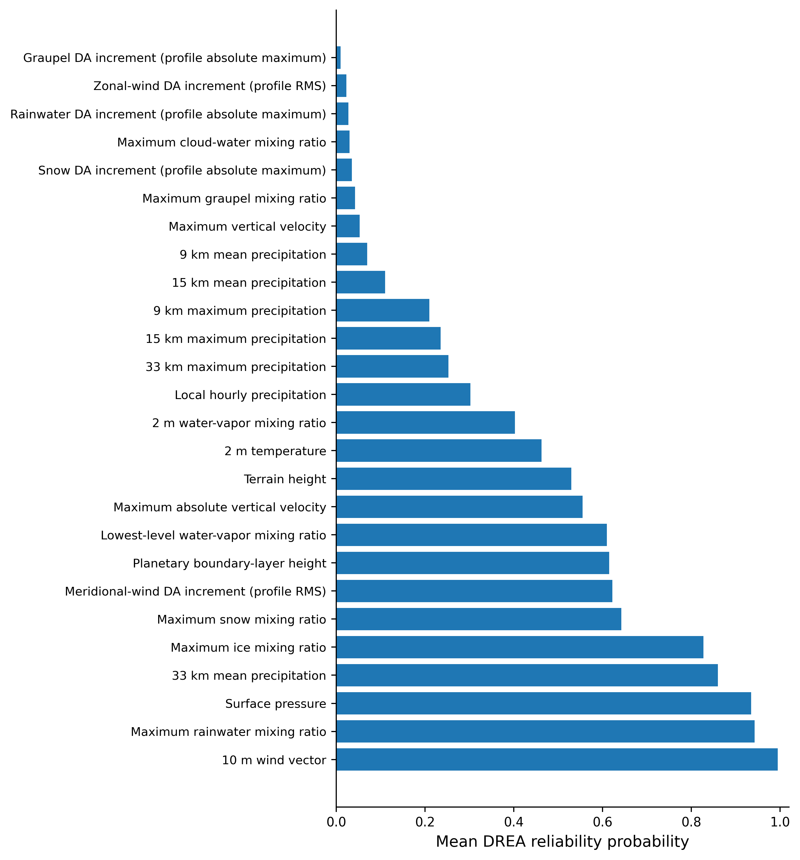
Figure S3. Complete ranking of the 26 DREA perturbation units after 80 independently retrained model realizations. Labels are written in physical terms rather than software variable names.
The ranking remained stable as the number of independently retrained realizations increased. Changing from the primary symmetric-spread calibration to the asymmetric-spread sensitivity also produced a near-identical ranking (Spearman ρ = 0.995; mean absolute Mean-DREA change = 0.018).
Table S9. DREA stability across independently retrained model realizations.
Comparison | Spearman ρ | Mean absolute probability change | Maximum absolute probability change | Top-10 overlap
30 vs 50 realizations | 0.984 | 0.024 | 0.061 | 10/10
30 vs 80 realizations | 0.979 | 0.028 | 0.143 | 9/10
50 vs 80 realizations | 0.985 | 0.016 | 0.114 | 9/10

